University of Wales Trinity Saint David

School of engineering



Group Project

Tommy-Lee Hennegan-Rosser

HEN19852873

Electrical and Electronic Engineering HND

2023/2024

Group Project and Research Methods

Table of Contents
Introduction 3
Main body 4
Research 4
Water purifier research 5
Gantt chart 5
Planning 7
Job roles 12
Coding 13
Sourcing parts 13
Bread-boarding 13
CAD design 13
PCB design 14
Sections 6 and 7 from interim report plus any amendments 14
Details of the development designs 15
Details of the final design 16
Evaluation 17
Recommendations 18
Conclusion 19
References 20

Introduction
The purpose of the group project represents an effort to design and build a project that can provide a low-cost solution that is simple to create that must relate to one of the three given realistic problems from the assignment brief.
The three given topics to choose from to create a project for are:
- Design a STEM (science, technology, engineering, and mathematics) project for school children in developing countries. The project must be easy to medium difficulty and include step by stem instructions. This project is set to encourage and promote STEM in an engaging way, aim to make the project as fun and interactive as possible.
- Design a product that is aimed at helping people to be more eco-friendly at home. This could include making people more aware to help limit the amount of water, food, or electricity wastage in the household.
- Design a low-cost assistive device to help people with an impairment or disability. The device should be aimed at improving the quality of everyday life of the individual.
After discussions were made and brief research for each topic was carried out, the group decided to create a project specialising STEM as the group found the topic the most beneficial and interesting.

Main body

Research
Firstly, before designing the project, the group had to research each topic to determine which topic to base the project on. When given the assignment brief, research was conducted for each of the topics to determine what kind of projects can be constructed with an Arduino within each of the given topics. Below are some examples of possible project ideas:
STEM research:
- Water filter
- Smart watch
- Alarm clock.
Eco-friendly research:
- Air quality monitoring system
- Water quality monitoring system
- Metal detector
Disability assistive device research:
- Door mounted room name sensor.
- Smart walking stick
- Brail box
After many research ideas, the group decided that the project should be based on a water purifier system, that would take dirty water and filter it so that it is safe to drink.

Water purifier research
Below are some of the areas that were covered when researching the design of the water purifier and how it will function and what member of the project researched each area:
- UV purification – Scott
- Water quality monitoring – Ethan
- Particle filtration – Scott
- Arduino powering – Tommy
- Water transport – Ethan
- Choosing a microcontroller – Steffan
Ultimately, the entire research aspect when exceptionally well. Everyone stuck to their research roles with accurate and concise information, the research was completed on time by everyone leading to a positive start to the project.

Gantt chart
Below is the original Gantt chart (figure 1) that was created by each member of the group, this contained each task that had to be carried out and who was assigned to each task with the progress of how far each task are from being completed. Some tasks required everyone to complete, while other tasks were individually completed. For example, the planning task required everyone to complete as a team. An example of individual task roles is the power research task, which was completed by Tommy.
The Gantt chart also includes a time schedule/plan for each task to be completed by including each week of each month from the start date of the project to the end date with the navy blocks acting as a guideline to acknowledge when each task should be started and completed roughly.

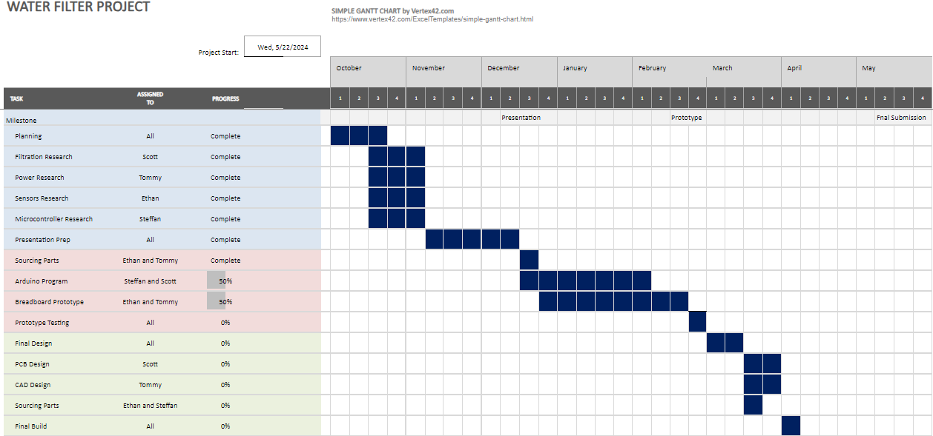
Figure 1

Below is the final Gantt chart (figure 2) with a few new key features. Orange, red, green and light blue blocks were added to the Gantt chart to represent key features:
- Orange – Half term.
- Red – Delay.
- Green – Started early.
- Light blue – Started late.

The final Gantt chart is an essential resource to reflect on what went well and what could be improved next time. Looking back at how the project went looking strictly at the final Gantt chart, the project was successful with every task being completed and done correctly, with some tasks being started early.
What could be improved? There were a few delays due to some tasks taking longer than estimated to complete along with some tasks being started later than scheduled. The cause of this were a few absences from members of the group and underestimating how long some tasks would take to complete.
Therefore, a deeper analysis of how long each task will take realistically should've been done with an expectancy of absences to occur and how to adapt to the situation when group members are absent. Another thing that should've been considered is half terms leading to group members unable to meet up to continue project work.
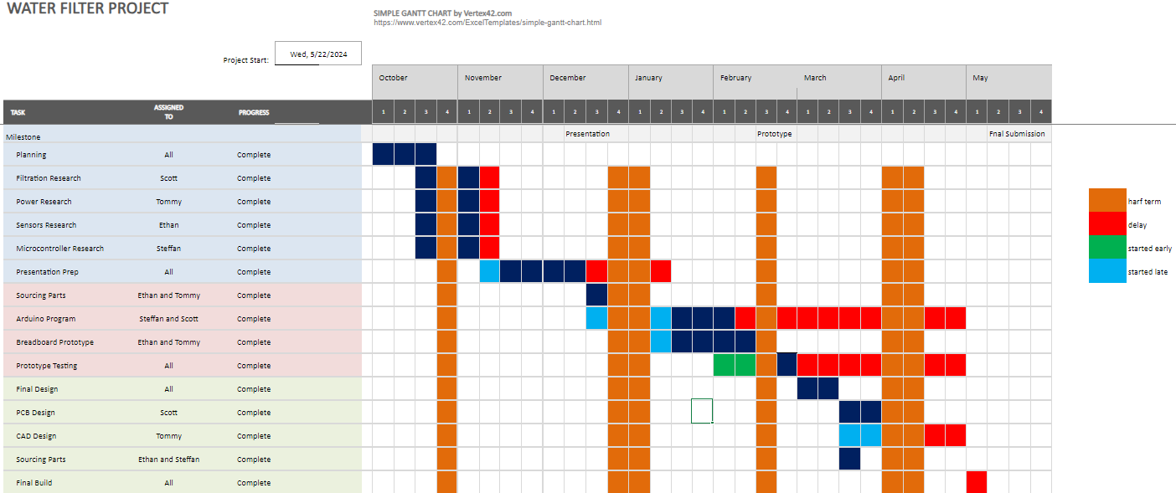
Figure 2

Planning
Once the original Gantt chart was created, the group planning throughout the whole period began.
October
October was when the group project began, the first three weeks were allocated to getting a project idea, which was completed on time and went perfectly (October planning was exactly what was talked about above, which included the research aspect of the project and the Gantt chart).
November
November went to plan to a decent extent; however, 2 weeks was used doing extra research as well as the presentation prep being delayed by a week and starting it in week 3, but the progress for the presentation prep was being completed a lot faster than expected.
Bill of materials:
Below is a table (Table 1) created that was also done in November to show the components that were required for the project with the total cost and the cost of each individual item.
Table 1
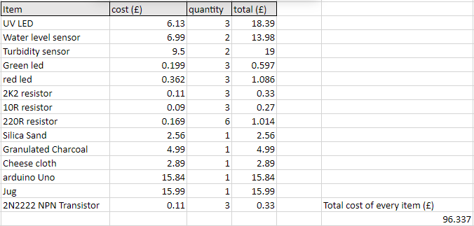

December
The group presentation prep was completed on time when compared to the Gantt chart and was ready to be presented by the group; however, the presentation had to be delayed over the Christmas holidays. The group also managed to make an order to get the pieces needed to create a prototype of the project.
January
The presentation was completed in week 2 and the parts needed for prototyping arrived, so a breadboard prototype and accompanying code began. Looking at the Gantt chart, the group was on track to have a working prototype by the end of February. The issues the group were facing are powering the board externally, as some of the LEDs were turning off with a 9V supply as well as the UVC LED being challenging to connect to the breadboard due to its surface mount soldering design. The solution to this was to analyse the cause of this problem, which was the connections with the breadboard, once they were connected correctly, the problem was solved.
February
February overall went to plan. Although there was a delay with the Arduino programming, which was due to the code being difficult, but the prototype testing began 2 weeks early and everything else went to plan. It could have been better if the Arduino programming wasn’t delayed, but overall February was successful.
March
March was the cause to many other delays, Tommy had to start the CAD design two weeks late due to struggling to find a computer with accessible CAD software. There was also a big delay in the Arduino programming and the prototype testing. This should have been acted upon fast to avoid the big delays.
April
April was a struggle with a few delays on tasks, such as CAD design, breadboard prototype and testing the prototype, this was due to absences, but they were eventually managed and it was lucky that the prototype was fantastic, this meant that there were no changes needed to be made. Tommy not being able to complete the CAD designs successfully due to struggling to use the software he had no choice to complete tasks on (Autodesk Fusion360).
May
May was the final month of the project creation, everything was supposed to be completed by May, but this wasn’t detrimental as it was completed by week 1. The final build of the project was complete, meaning the project was complete and ready to be presented after this point.
Planning conclusion
Overall, the planning went well but it could’ve went better, some months were a lot more successful than others. The main issues that caused so many delays were lack of communication skills between group members and time management. If communication and time management skills were managed better, the planning would’ve gone a lot more smoothly.

Design development (using pictures)
Breadboarding code (figure 3):
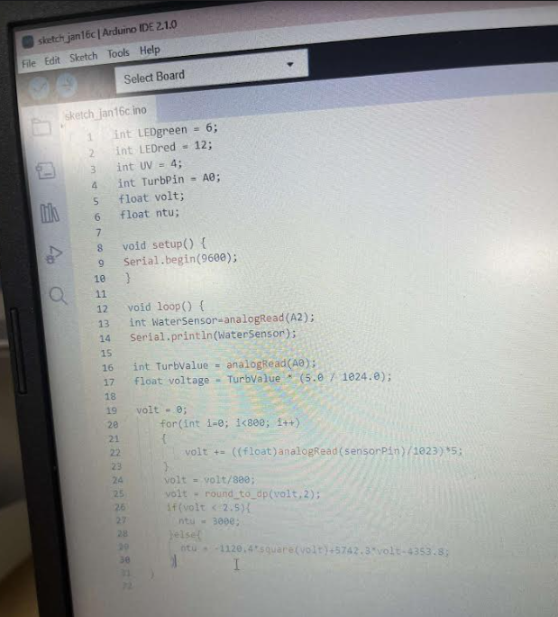
Figure 3

Breadboard (figure 4):
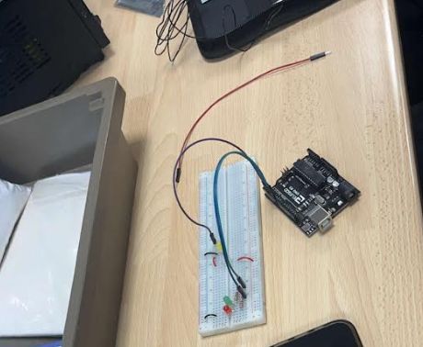
Figure 4

Soldering taking place (figure 5):
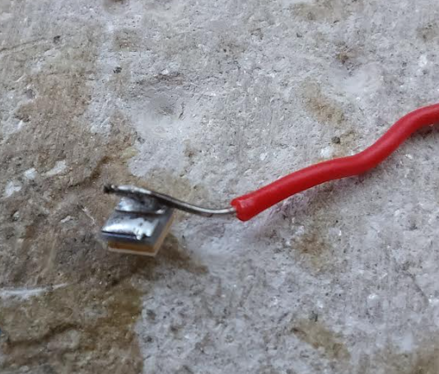
Figure 5

This is the equipment that was used for prototyping (figure 6):
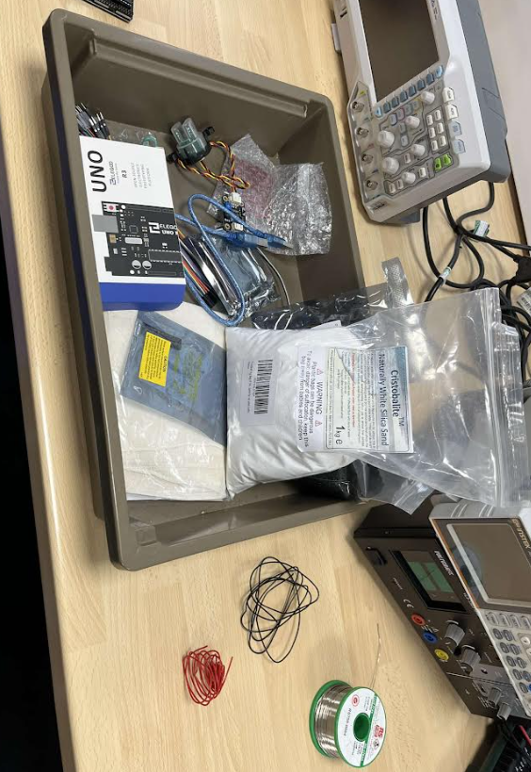
Figure 6

Job roles
There were multiple job roles for each individual when the job responsibilities were decided, with everyone in the group taking on various tasks.
Coding
Description:
Coding is the process of creating instructions for computers to follow. These instructions can be written in various programming software's such as Python, Java, C++ and JavaScript, but an Arduino device was used, therefore the coding software used was Arduino software. (Ko, 2021)
What went well and who took on this job role?
The coding went well and Steffan was the one who took responsibility in this job role and had the most experience in coding compared to everyone else and Steffan agreed that it is the easiest job for him to be able to complete, although it was difficult he managed to complete the coding task successfully, for the Arduino to operate as planned.
What could be improved?
Steffan ensured that the coding was difficult. To improve for next time, the group could’ve studied ways to make the coding seem less difficult by studying the Arduino software a bit more, preparing for any errors that can occur in the code and how to fix them, so Steffan can complete the code more efficiently and face less difficulty.

Sourcing parts
Description:
Sourcing parts aka parts advisor, is responsible for managing the sourcing, ordering and supply of automative parts. (Anon, n.d)
What went well and who took on this job role?
Scott volunteered to do this job role as he believed he could manage the role on top of his PCB design role, which he did manage to do both jobs simultaneously. Ordering equipment went well and everything was ready to be used. Tommy also helped Scott to grab equipment from the technician’s stockroom, as he was struggling with CAD software at the time and wanted to make himself useful.
What could be improved?
Next time, the time taken to source parts could be done faster, but that is a very miniscule error because finding the parts never affected time management in any way.

Bread-boarding Ethan

The purpose of breadboarding for the project was to build a prototype circuit, which allows the user to place components and connections on the board to make circuits without soldering. (Crowell, 2019)
What went well and who took on this job role?
Ethan took on the role of bread-boarding and completed the role successfully. The breadboard run as desired made it easier to complete prototype testing with the Arduino software.
What could be improved?
There were errors that were made when making the breadboard, such as connection errors and coding errors. Next time, Ethan could do a bit more research on how to successfully use a breadboard to avoid any delays and to finish the task without any connection issues or coding errors or at least keeping them to a minimum.
CAD design
Description:
CAD design is a technology used by engineers, architects and designers to create precise drawings and technical illustrations. CAD software enables users to develop detailed 2D and 3D models of physical components, which is why it is such a vital job role to be completed for the project as each part had to be designed and 3D printed. (Chai, 2020)
What went well and who took on this job role?
The CAD design was a success and Tommy was the one assigned to this role. Tommy done well at getting on with the CAD as soon as possible and managed to make a start 2 weeks earlier than planned. Scott assisted Tommy as a great team player, leading to the CAD work being completed comfortably before the delay from Tommy struggling to use Fusion became too much to handle in a short period of time.
What could be improved?
There were some problems that occurred, one of them being that Tommy had no choice but to use a software that he has no experience in, which was Autodesk Fusion 360. Tommy does have the most CAD experience, but he has only used TechSoft Design V3 for CAD work, leading to a lot of delays in terms of 3D printing the water purifier parts. Next time, Tommy could prepare for this problem by either becoming familiar with using Fusion or ensuring that a computer he is using has TechSoft V3 to avoid any delays and to leave Scott focus on his role without worrying about other job responsibilities.

PCB design Scott
Description:
Printed Circuit Board (PCB) design play an important role as they provide electrical connections between electronic components, rigid support to hold components, and a compact package that can be integrated into a product. (Altium., 2020)
What went well and who assigned to this job role?
Scott took on the PCB role and did exceptionally well. There were a few problems with the soldering aspect, but over time this was taken care of with Scott becoming more familiar with soldering correctly.
What could be improved?
Next time, Scott could ensure all of the soldering equipment will not cause any problems, but overall, Scott made the best decision to solve the problem by doing research on why the soldering wasn’t going his way and managed to implement that research to solve the problems he faced with soldering.

Details of the final design

After all the tasks were complete, it was time to build the final design. The project had to be presented to other groups and explained the story behind it and what problem the project solves (water filtering using an Arduino device).
Below are many diagrams of the design being built with a few pictures taken to understand what each component looks like and there were also pictures taken when presenting and explaining the project to people after it has been completed and created:
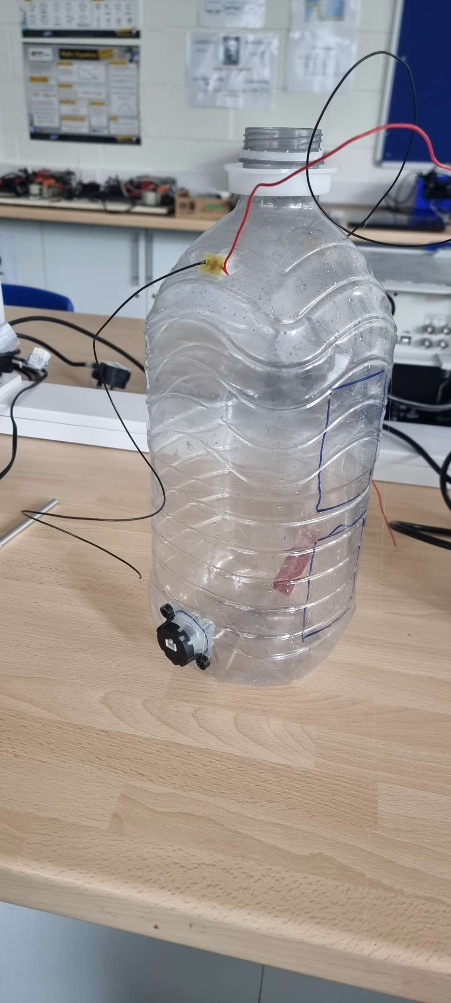
Figure 7
Water bottle (figure 7)
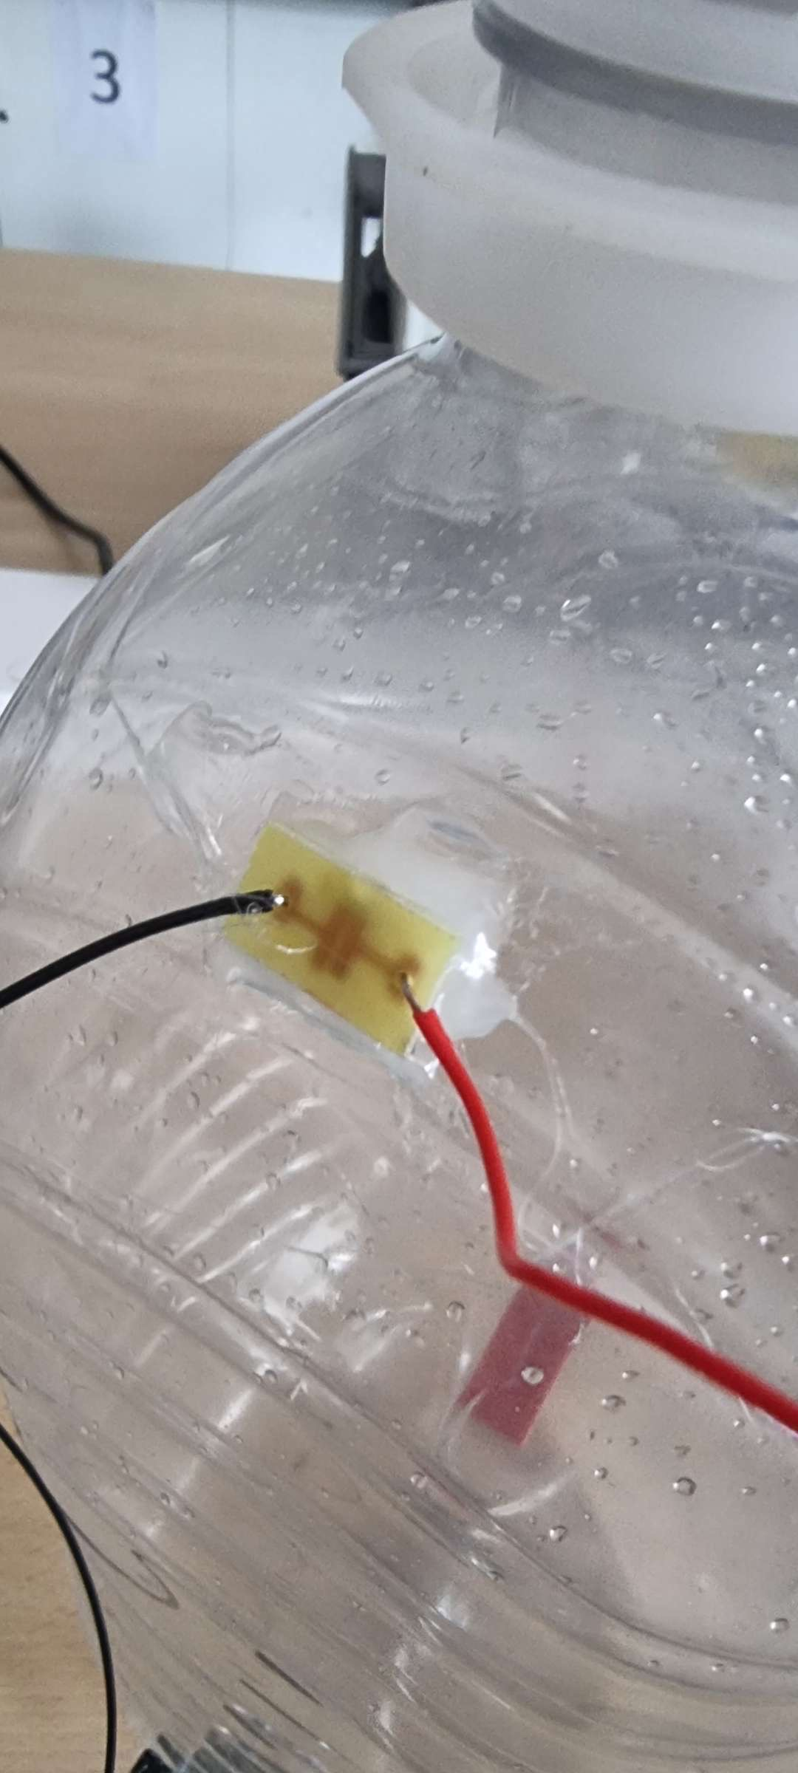
Figure 8
Water bottle with Arduino device attached (figure 8)
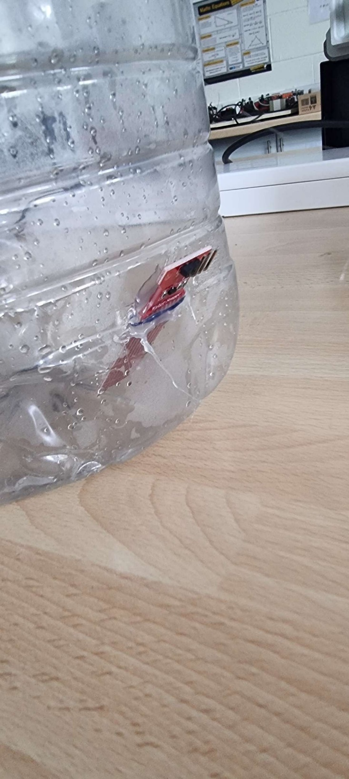
Figure 9
Another water bottle image with Arduino devices attached (figure 9)
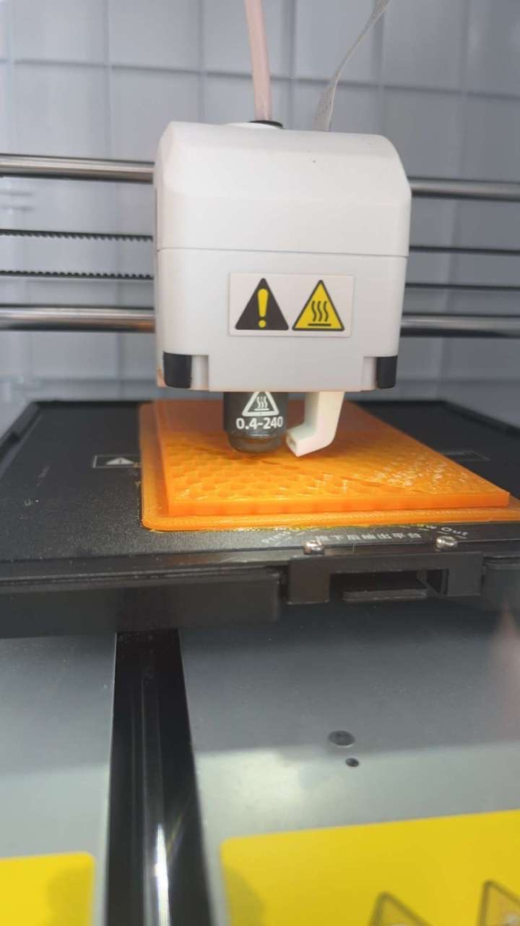
Figure 10
Picture of the 3D printer being used to print the CAD designs out (figure 10)
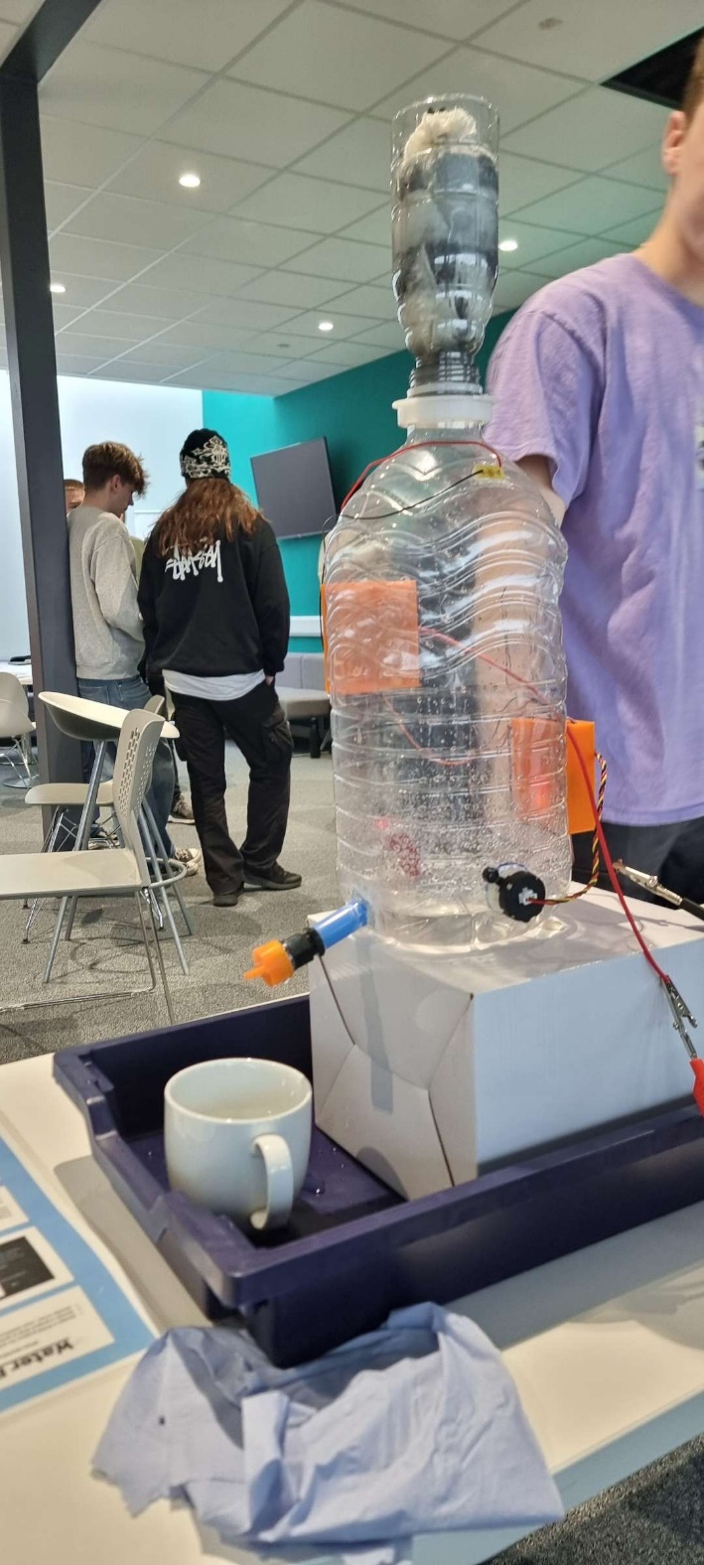
Figure 11
Picture of the project presentation taking place with the final design (figure 11)
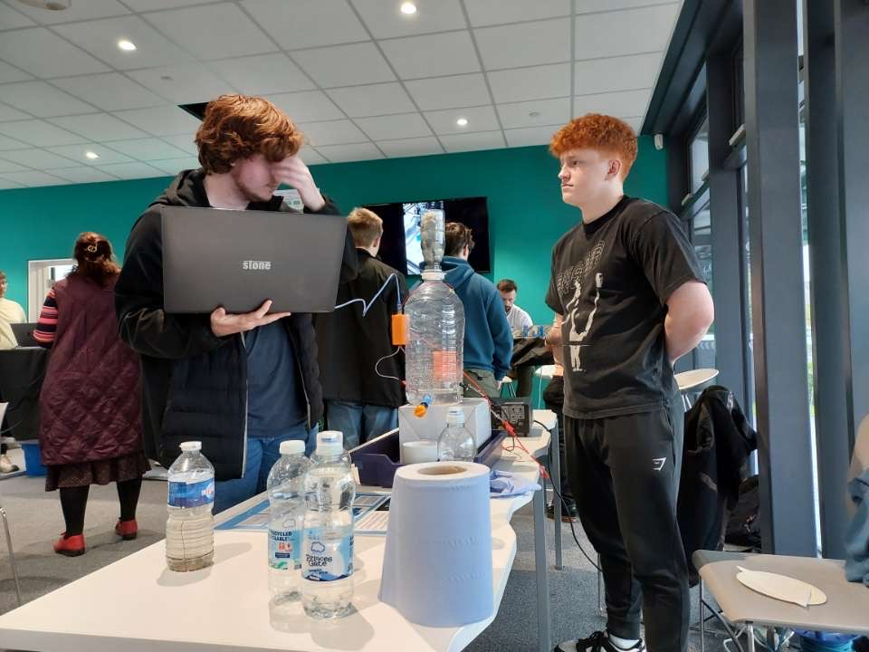

Final photo of the group presentation being explained and the operation of the project running up to standard (figure 12)

Evaluation (Project presentation)
The project presentation was a success, it was explained well with the project running successfully for other people to see, the main issue with the project presentation was Tommy being absent, which could’ve caused problems, but the rest of the group adapted and worked well to not make this a problem. Next time, Tommy could’ve been there to help the group out and make it easier for them as he was not a very good team player by not being in for the project presentation.

Conclusion
To conclude, the whole project was a success when everything was completed. The planning went well with everyone researching individually on what they need to do as well as a group. A successful Gantt chart was made to keep up with tasks as best as possible, with a breakdown of what each month is going to consist of with what tasks each member of the group was going to carry out individually and as a group, then the presentation was presented by the group, which went brilliantly looking back and then the start of creating the prototype began.
Beginning the prototype was the hardest obstacle to overcome due to time management being a struggle and the difficulty of completing each task in time come into play as well. Group members lacking in knowledge and experience in their roles also made things harder in terms of managing time and struggling to complete everything to do with the prototyping as scheduled.
Luckily, the final design did not need to be changed from the prototype design, which killed a lot of doubt and give the group relief that they will complete the project on time.
Next time, there could be a few improvements made for the project to be more successful. These include:
- Communication skills – If communication was better, the group would be able to adapt to errors and delays better.
- Time management – Time management is a difficult skill to master, but the groups biggest weakness was time management evidently, because the biggest problems the group faced was adapting to situations that caused delays in the long run of the project.
- Professionalism – The group were professional, but this could’ve been so much better if members of the group tried to avoid absences more than they did. For example, Tommy should’ve made it a high priority to turn up for the project presentation towards the end to help his group present the final design of the project more efficiently.

‌

Bibliography
Altium. (2020). What is a Printed Circuit Board? Make Circuits by Connecting Components. . Retrieved from https://resources.altium.com/p/what-is-a-pcb#:~:text=Printed%20circuit%20board%20%28PCB%29%20design%20has%20grown%20into
Anon. (n.d). Retrieved from https://uk.indeed.com/career-advice/finding-a-job/what-does-parts-advisor-do#:~:text=A%20parts%20advisor%2C%20or%20a%20motor%20vehicle%20parts,advice%2C%20handling%20inventory%20and%20ensuring%20efficient%20customer%20service..
Chai, W. (2020). What is CAD (Computer-Aided Design)? Retrieved from https://www.techtarget.com/whatis/definition/CAD-computer-aided-design.
Crowell, G. (2019). What is a Breadboard? Retrieved from https://www.circuitbread.com/ee-faq/what-is-a-breadboard.
Ko, N. (2021). What is coding and what is it used for? A beginner’s guide. . Retrieved from https://www.zdnet.com/education/computers-tech/what-is-coding-and-what-is-it-used-for/.

