

MODULE CODE: ECPT6006

ASSESSMENT COMPONENT: A Critical Evaluation of the Role of Digital Innovation in Professional Practice

STUDENT NAME: Daniel Jones

STUDENT NUMBER: 2223686

Use of Generative AI in Assessment

(Lecturer to indicate Yes or No against each element)

RESEARCH | For this assessment, you can use Generative AI to support you in research, including searching for bibliography, using tools to summarise, compare and interrogate materials. | Yes ☒  No ☐
STRUCTURE | For this assessment, you can use Generative AI to support you in structuring your submission, including creating a draft argument structure, identifying parts and headings, etc. | Yes ☒  No ☐
PROOFREADING | For this assessment, you can use Generative AI to check your own text/creation for grammatical and syntactical mistakes, including rephrasing of your own work within specific standards. | Yes ☒  No ☐
WRITING | For this assessment, you can use Generative AI to create text for submission. | Yes ☐  No ☒
CREATIVE | For this assessment, you can use Generative AI to create creative materials, such as images. | Yes ☒  No ☐
PROGRAMING | For this assessment, you can use Generative AI to create and check code. | Yes ☐  No ☒
NONE | For this assessment, you are not allowed to use any type of Generative AI support. This includes research support, structure support, writing/proofreading support and creative support. | Yes ☐  No ☒

AI Acknowledgement
I confirm that I have not used any AI tools in the research and creation of this assignment.
I confirm that I have not presented any AI generated materials as my own work.
I confirm that I have copies of my drafts, notes, and other resources I used, which I may be asked to provide in evidence.

Contents
1.Introduction
2. Literature Review
2.1Identifying relevant new technology
2.2 Defining Photogrammetry
2.3 Terminology and Data
3. Justification of the appropriate use of 3D scanning in the classroom.
3.1 TPACK
3.2 SAMR
4. Lesson Plan
5. Evaluation
6. Reflection

1.Introduction
The context of 3D art and design is becoming an increasingly digital field of study. So much so the name subject itself has changed from ‘Sculpture’ to 3D Art and Design to accommodate vast number of innovations and technological developments rapidly being integrated into the field. Innovations in technology such as the invention of 3D printing and the emergence digital contexts to present artwork - such as game design, Augmented reality and VR, along with significant developments in CAD and CAM has effected the field of 3D art and design in a similar way to the invention of photography on painting in the 1800’s (Meydenbauer, 1867). This has lead to many existential questions on the nature of facture and craftsmanship among practitioners.
The knock on effects of these emerging technologies are being felt in the classroom. With so much instability surrounding which technologies will become vital tools for the sculptors of tomorrow and which pieces of software will be obsolete by the time students graduate. The expensive equipment and software required to keep up with all of these digital innovations and new technologies can put an immense amount of pressure on departments and with budgets tightening for creative subjects, this need to keep pace with industry can put considerable pressure on teachers. (Beetham, 2019)
Finding a middle way between the cutting edge of technology and cultivating traditional skills is an essential approach to take when designing lessons which will prepare learners for the challenges they will face in industry. (Sargentis et al., 2022), for this reason: This report will focus on how to integrate accessible and affordable 3D scanning into lessons as a tool to bridge the gap between digital and traditional skills in the classroom. (Bugeja et al, 2022)
3D scanning is a technology which allows students to create physical work and scan it digitally using their phones to create a 3D model which can be uploaded digitally and saved. It opens up possibilities for use in a range of emerging contexts like VR, AR and Game Design. These scans can be digitally sculpted further using tools like Blender and Z Brush, along with a host of other uses. It can allow students to place the scan in digital environments like google earth to visualise small maquettes as large scale public sculptures or any other digital environment imaginable! Most importantly it updates traditional art and design skills taught in the classroom for the modern era.
2. Literature review
2.1 Identifying the relevant technology
3D scanning is a broad field with many different technologies and applications used in different industries. There are dozens of different technologies which come under the umbrella of 3D scanning which include (but are not limited to):
Laser 3D scanning, Structured light 3D scanning, Photogrammetry 3D scanning, Contact-based 3D scanning, Laser pulse-based 3D scanning (Bugeja et al., 2022)
In 2022 the ‘Materials Today’ invited experts to a conference on ‘3D scanning in the art & design industry’, which systematically discussed the applications of the methods mentioned above. Their findings identified Photogrammetry 3D scanning as the lowest cost method of 3D scanning and also the one which best captures textures, this makes it ideal for teaching 3D Art and Design to large classes of students since it can record 3D details with a great deal of fidelity and the class can all use the equipment at no further cost to the department. The second section of (Bugeja et al., 2022)’s paper does a good job of weighing up the pro’s and con’s of each method and how it could be applied in the Art and Design industry. The accessibility and utility of this technology make it the most suited for use in the classroom.
Bugeja et al had lots of other options and make a strong case for their usage as well but lacking the budget and resources to use light, laser or contact scanners which were provided to them by Elsevier Ltd at the conference it seems photogrammetry is certainly the most pragmatic option for use in the classroom.
So with that in mind this report will focus on photogrammetry as a method of 3D scanning because it is intuitive, does not require any specialist equipment other than a digital camera or smart phone and some free software such as Meshroom and Kiri Engine, which is easily available online and accessible to students to use in the classroom and experiment with in their own work. This ensures that students have the tools for their own development in their hands should they want to pursue this technology further in their practice.

2.2 Defining Photogrammetry
Photogrammetry originates almost as far back as photography, with various inventors experimenting with using surveying tools such as the Camera Lucida along with light reactive film to capture images in three dimensions. The term was coined by (Meydenbauer, 1867) who proposed it’s use as a time saving device for surveying and conserving historic buildings, which has long been the primary use for photogrammetry. It is still widely used in the heritage building industry a method for 3D scanning has progressed so much that it bears little relevance to its original analogue form. Despite this literature surrounding digital photogrammetry has seemed transfixed on conservation as it’s only application until recent dramatic developments in both technology and potential applications (Jeremy et al 2020).
Modern digital photogrammetry uses software to stitch together a large number of 2D digital images into a 3D model by breaking them down into textured polygons and triangulating the angles which the photographs were taken from, creating ‘building blocks’ which construct a digital 3D model or OBJ file (Bugeja et al., 2022) The technology has long been used in conjunction with arial photography for conservation, surveying and cartography with Google Earth and later Google Street view being prime examples of digital photogrammetry used in day to day life.
This technology has advanced rapidly in the last 5 years partly due to the same kind of machine learning utilised by ‘AI’ being incorporated into the software which process these models. In fact digital photogrammetry was one of the earliest proposed uses for AI dating back to (Sarjakoski, 1988) though limited applications of the technology outside the field of conservation have led to it lagging behind somewhat. Though the recent zeitgeist for AI integration into everything has finally led to the improvements proposed nearly forty years ago..
To illustrate how dramatically this technology has improves the last 5 years, below are some of the authors own attempts to 3D scan a relatively simple artifact from the National Museum of Wales in 2020 using Scann3D , Zephyr and Meshroom on specialist high powered PC’s as part of a research project. (Jones, 2020)
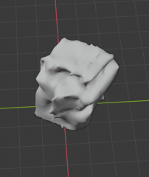
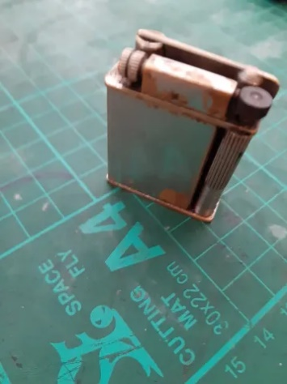
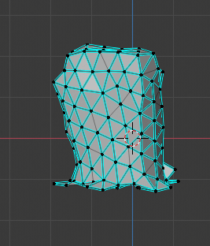

\

(Jones, 2020)

Compared this to an attempt to scan a much more complex hand made ceramic mug using a free app (KIRI Engine) and a smart phone from 2018 which cost less than £50
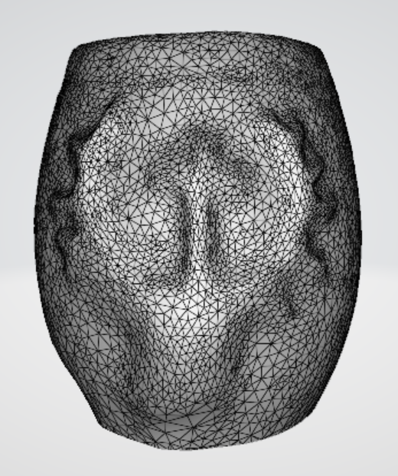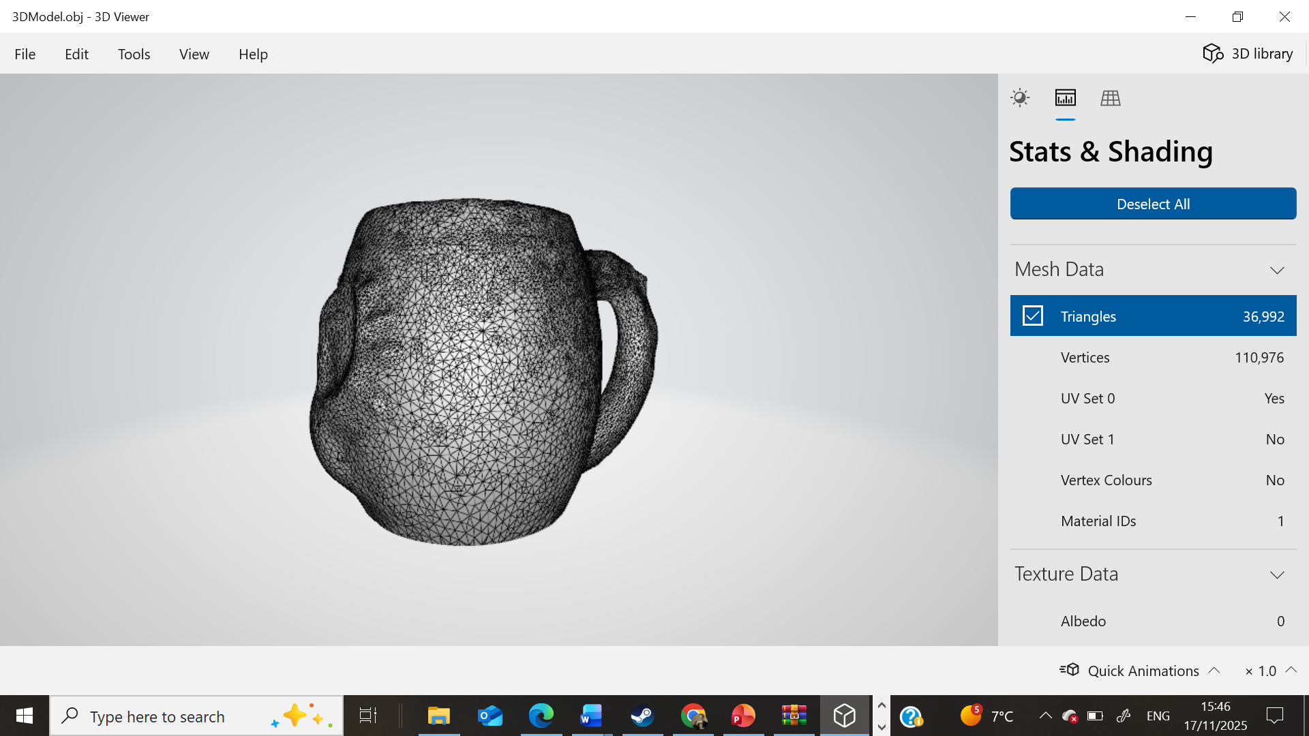
(Jones, 2025)
One of the reasons this technology has advanced so rapidly is it’s use with Unmanned Aerial Vehicles (UAV’s) also known as ‘drones’, cartography is an obvious use for this technology but UAV’s capable of mapping their environment are already being utilised in disaster relief as part of search and rescue efforts (Cheng et al., 2024).
As positive as these uses of UAV digital photogrammetry are it is impossible to ignore the chilling connotations that low-cost drones, able to rapidly scan and model their environment, and identify living people has on the context of warfare.
While reliable evidence to back this up is difficult to find, the prevalence of UAV warfare in the ongoing conflict between Russia and Ukraine likely contributes to the huge recent investment and the rapid advancement of this technology.
The links between new technologies used in both art and warfare heavily informs the concept of ‘Material poetics’ laid out by (Sargentis et al., 2022). Their study into the uses of 3D scanning and printing technology in sculpture largely focuses on identifying reasons why there has not yet been a greater uptake of sculptors using these emerging technologies and attempts to create a model for which technologies will be utilised by artist in the future, this can be helpful when deducing which techniques are worth teaching in the classroom.
Their methodology analyses the impact of historical developments in technology on the era’s sculptural works; synthesising this into the concept defined as ‘Material Poetics’, such as the development of lost wax casting being used to make the tools and weapons which defines the artwork of the bronze age, following on to the advancements in iron and later steel production in the medieval period making it easier to carve hard stone like marble and granite. (Sargentis et al., 2022) Concludes that 3D scanning and printing will go on to define the next era of sculpture as it becomes an unavoidable part of day-to-day life.
While the study could be criticised for painting with very broad historical brushstrokes, and focusing only on western (particularly Greek) artwork. It cites the prevalence of undesirable materials as a reason digital 3D printing has not greatly impacted the art world. Plastics like PLA and LSF being the main reason why sculptors avoid 3D printing their work due to the less than poetic nature of their materiality. (Sargentis et al., 2022)’s study predicts that 3D scanning and printing will become part of the toolkit of sculptors who will continue to work in traditional materials like bronze, substituting the hand carving of waxes and sprues for a 3D printed alternative, still utilising methods like investment casting in bronze but potentially 3D printing their lost waxes, or designing mould around ‘Lost PLA’ This shows the need to still teach traditional skills in the classroom while finding ways to integrate emerging technologies into the toolbox of the 3D artists and sculptors of tomorrow.

2.3 Terminology and Data
The terms ‘Digital Native’ was coined by (Prensky, 2001) to describe a post millennium generation of school students who were more familiar with technology used in the classroom than their teachers. That generation of students are of an age to be teachers now, and the term hasn’t aged particularly well either.. Partly due to its basis in a somewhat inappropriate comparison with the experience of migration, and also due to a range of other cultural and socio-economic factors identified by (Spiegel, 2021) which revealed how using the potentially problematic phrase could be reductive and overlook important factors when it comes to students ability to use technology in the classroom.
Despite issues with the term itself technology is so prevalent in the classroom that students studying art naturally use technology as a way to record and visualise their work. We are presented with the potential to use digital technology not only as a way of producing digital artwork but also as a tool for improving more traditional practical skills; synthesising new methods which draw on cutting edge technologies to surpass what was previously thought to be possible by facture alone.
The impact of 3D scanning as a teaching tool to improve design skills in the classroom has been studied by (Badaruddin et al., 2024) which found that 58.7% of students agreed that using low cost 3D scanning was beneficial for their design skills, with 14.4% going even further to strongly agree it had enhanced their design skills. With only 11.5%disagreeing moderately and 14.4% disagreeing slightly… leaving only 1% to strongly disagree that there were any benefits of low cost 3D scanning had on design skills.
To compare with Baddarudin’s findings this report will also use the same criteria to measure how useful students found digital photogrammetry. While of course the scope will be far more limited it hopes to provide a cross cultural comparison of the utilisation of this technology. And while the author had originally intended to try to compare how useful students studying at different levels of further education found this technology unfortunately due to illness this will have to focus on a much more limited sample of one UAL level 1 group.
The most relevant frameworks for integrating technology into pedagogy for the purposes of this report are TPCK (Koehler and Mishra, 2014) and SAMR (Puentedura 2006). While SAMR is the most directly applicable model, separating the levels of integration into 5 categories labelled – Substitution, Augmentation, Modification and Redefinition, further dividing these categories into Enhancement int the case of the former pair, and transformation in the case of the latter . It has only seen limited use since it was self-published by it’s author on their own website and lacks traditional publishing or peer review. Despite some amount of adoption, it has been criticised by (Hamiliton et al., 2016) for being overly hierarchical and reductive.
TPCK as a framework provides an analysis in the form of an overlapping Venn diagram categorising Knowledge into Content, Technology, and Pedagogy and showing where these areas overlap. (Koehler, and Mishra, 2014)
‘Intro to advanced practiced’ by (Puentedura, 2010) proposed a model which synthesies these two integration systems equating areas of the TPCK model with the SAMR taxonomy effectively making them compatible to use either or both. Therefore the next section of this report will use Puentedura’s advanced model to justify the appropriate use of 3D scanning via digital photogrammetry in the classroom.

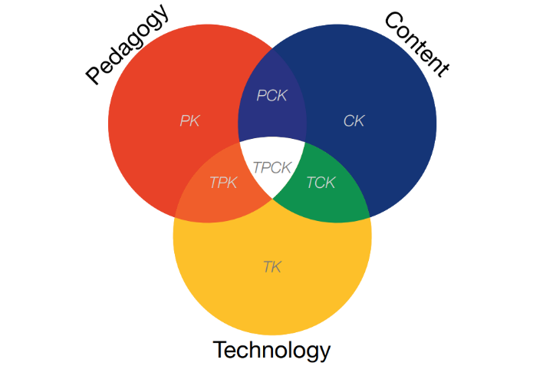
3. Justification of the appropriate use of 3D scanning in the classroom.
(Puentedura, 2010 pg. 13)
The ‘TPCK’ integration model starts by dividing the knowledge delivered during a lesson into three distinct categories as follows. (Koehler, and Mishra, 2014)
PK - Pedagogical Knowledge
Drawing on Jerome Bruner’s scaffolding approach, based on Vygotsky’s constructivist approach to learning (Wood, Bruner and Ross, 1976). The lesson will start as a lecture with a PowerPoint presenting students with the clear Aims and Outcomes structured around Blooms Taxonomy (Anderson & Krathwohl, 2001) at an introductory level – Outline, Explore, Experiment, Define, Make Use of ect.
Moving on to examples of real-world artists and then providing step by step instruction on how they can achieve similar results. And then finally allowing students to experiment with the digital tools in order to make their own 3D digital model in the class. Before taking these skills outside of the classroom to document the place relevant to their project.
Professional standards for Further education includes effectively enhancing learning by using digital tools. This lesson aims to help them to progress with this.
CK – Content Knowledge
The content of the lesson relates to the student’s current brief ‘Sense of Place’ which functions as a theme to guide their practice across disciplines. They will be presented with examples of Artists who use 3D scanning as part of their practice and different approaches they might want to take to use in their own work.
Aligning with professional standards the lesson will use examples of Welsh artists local to Port Talbot (Boysen, 2023). Providing students with examples of sculptures made using these digital tools locally. Along with subjects form welsh history and show the interplay between traditional subject matter and the use of 3D scanning to capture “Sense of Place”
TK – Technological Knowledge
The lesson focuses on teaching students how to use Digital Photogrammetry as a tool in order to create a 3D scan of their place. They have time to download the relevant software onto their phones and then they will have a chance to experiment with using it to create a 3D model of an object in the classroom.
Relating this technology to examples the students might be familiar with including Google Street View, Pokemon go, Minecraft, Roblox ect. Then showing them how it is utilized by artists
----
Like the diagram pictured above the TPCK model then focuses on the overlapping sections of the venn diagram (Koehler, and Mishra, 2014)
TCK – Technological and Content Knowledge
The artists referenced in the content of the lesson all utilize the same technology which students will be learning to utilize. Each of these represents a different context which 3D scanning can be used in.
Sebastian Boysen’s use of 3D scanning and printing integrated with traditional wax sculpting. In the ‘Crannogwen’ example in order to integrate the 3D scanned model of Crannogwen with aspects of the local environment where the sculpture is to be displayed. This shows 3D scanning being used as part of the process of creating the artwork. (Boysen, 2023)
Along with another local example of ‘Guardian’ to demonstrate how students can use this technique to play around with the scale of their pieces. Putting small models made int the classroom into google street view. (Boysen, 2010)
Examples of emerging contexts within art and design such as Lauren Moffat’s ‘Compost’ series of flowers scanned as they wilted. Which were sold as prints as well as able to be experienced in Augmented Reality by scanning a QR code at the exhibition. (Moffat, 2021)
As well as Sophie Kahn’s use of errors and glitches during the process of scanning in order to create deliberate abstraction. (Kahn, 2014)

PCK – Pedagogical and Content Knowledge
The ‘Sense of Place’ brief which students are working towards runs across the different disciplines of art and design as part of their course. There are no exams in the UAL specification so students submit coursework in their sketchbooks which should contain research, process and annotations. Each section will be assessed formatively throughout the project and as a summative assessment at the end which includes a final outcome for each discipline ( eg. 3D, Fashion, Textiles. Vis com ect) Because of this students need to evidence experimentation with using 3D scanning to document the Place which their project focuses on.
TPK – Technical and Pedagogical Knowledge
To effectively teach students how to integrate Photogrammetry into their work utilizing Bruner’s scaffolding model (Wood, Bruner and Ross, 1976) ascending through Blooms taxonomy of action verbs to the appropriate level for the class . First showing examples of practitioners who use 3D Scanning to give them ide of that they can do with the technology (Outline). Helping them to download the tool and start scanning objects to get an idea of how it works (Explore) and (Experiment) and then letting them take the digital tool outside of the classroom to scan a place relating to the brief (Anderson & Krathwohl, 2001).

Concluding by synthesizing them into the content which will inform the lesson plan and PowerPoint to go with it. (Koehler, and Mishra, 2014)
TPCK –
To bring all of these factors mentioned above together into a lesson which is introduces the use of 3D scanning via Digital photogrammetry in to document ‘Sense of Place’ as the 3D section of a module in UAL level 3 Art and design.
The lesson will start as a chalk and talk showing examples of practicing artists both local and internationally acclaimed who integrate 3D scanning into their artwork. In order to start a discussion around how they can make use of this accessible technology themselves in the upcoming project. Next they will have a chance to acquire the app on their phone which will allow them to use digital photogrammetry to scan an object as an example with help from the teacher and their peers. Moving on towards using the technology independently outside of the classroom to document their place by creating a 3D digital model of it themselves.
SAMR
According to (Puentedura, 2010)’s intro to advanced practice (he recommends using TPCK in conjunction with the SAMR model. Using TPCK in order to inform the content being integrated into the lesson and then assessing where this lesson stands on the SAMR taxonomy, creating a sliding scale of how much the new digital tools needs to be integrated into lesson..

The example of the lesson plan below would be classed as M (Modification) on the SAMR framework due to how it changes what is possible in the project vs. using older technologies to document sense of place like photography. This is because it allows for the use of merging contexts like AR and VR to modify how the work is experienced. Opening up a range of different ways to access artwork which students might want to pursue.

Placing the results of TPCK onto the SAMR framework means that the level of integration can be increased and decreased for future iterations of the lesson.



Lesson Plan

Topic: Digital Photogrammetry |  | Class: Level 3 UAL Art and design
Date:17/11/2025 | Length of lesson: 2.5 Hours |  | Number of students: 14
Resources required:

Smartphone
Internet connection
Kiri Engine App

Aim of Lesson

Explore Digital Photogrammetry as a way of documenting Sense of place.

Learning Outcomes – The Learners Should Be Able To:

Outline how photogrammetry works.

Experiment with digital photogrammetry software.

Make use of Kiri Engine to create a digital 3D model of a space or object.

Previous student knowledge required for the session:

N/A

Anticipated difficulties (if applicable):

IT errors, Eduroam going down, Lack of storage space on students phones, File formatting issues with internal IT systems.

Professional Standards (where are these being met within the session)

In my practice and with others I will :

Plan and deliver effective learning, teaching and assessment using a range of media, including digital, effectively to enhance the learning process introducing students to new ways of working which integrate digital and traditional skills.

Enable learners to share responsibility for their own learning and assessment by working with all learners to empower them by presenting accessible methods which they can experiment and develop as part of their projects.

Understand the importance of the Welsh culture and language as a bilingual nation taking opportunities to celebrate the diverse culture of Wales and its place in the world by showing examples of local artist’s work which celebrates influential Welsh historical figures.

Lesson Detail:

Stage | Focus | Strategy | Time
Introduction  Development  Plenary/conclusion | Greet class in English and Welsh  Introduce the Digital tool.  Explain the Mechanics of Photogrammetry  Artist research  Sebastian Boyesen  Crannogwen  Guardian  Time Based Artist  - Lauren Moffat  Experimental Artist  - Sophie Kahn  Introduce Practical exercise  Break  Practical task  Cubism and Colour pallets  Set Field research task | Allow class to settle down after lunch and take their seats while I load the PowerPoint presentation.  (Slide 1)  Define what 3D scanning and digital photogrammetry is and answer any questions.  (Slide 2)  Ask the class if they can think of any applications for the technology.  Try to open up a discussion about types of photogrammetry they might be familiar with – Google Earth/ Street View, Minecraft and other modifiable games like Roblox, AR and VR games like Pokemon Go, 3D printing  (Slide 3)  Show the image from Meshroom ( More visual) and explain that digital photogrammetry works but triangulating a collection of images and stitching them together to create a digital render of a 3D Objects  (Slide 4)  Show the scan of a mug made using Kiri Engine as an example of what they might be able to do by the end of the lesson.  (Slide 5)  Start with some examples of sculptures around Port Talbot by Sebastian Boysen and ask if anybody recognizes them. Some where quite controversial and see if this starts any discussion about how his work in Port Talbot is viewed.  (Slide 6-8)  Go into detail about the Crannogwen statue in Llangrannog as an example of using 3D scanning to capture a ‘Sense of Place’  Show images of Boyesen’s working process integrating 3D scans and prints of a live model wearing clothing from a museum with aspects of the environment (stones local to the area) And suggest how students might want to integrate themes like these into their work.  Show example of Boyesen’s Guardian which is made on a colossal scale, while of course they can’t work on this scale in their current project show the “slicing technique” he uses to construct the piece.  Explain that while the college might not have access to CAM equipment and £100,00’s worth of materials, They could use the same technique to make a small Marquette, 3D scan it and place it into Google earth digitally to propose work at any scale and any location using AR.  (Slides 10- 12)  Remind Students that part of their brief is to make a time-based story board. show examples of Lauren Moffat’s – Compost series where she 3D scanned flowers as they wilted and overlayed them to create haunting visuals.  Show some examples of Moffat’s work both as prints and as AR  Set expectations that all technology has the potential malfunction and that Sophie Kahn uses this deliberately in her artwork to create a forms of abstraction and show examples of how the technology of 3D printing is used in a similar way to lost wax bronze casting.  Recap previous lesson on mould making.  Ask all students to download the free Kiri Engine app by the end of the break and have a think about where they would like to scan for the exercise.  (Break)  Make sure all students have the app logged into my email address to send the files over to render on the desktop (explain that this is to save storage space on their phones) and let them experiment with using Kiri Engine.  As the scans come through load them up on the projector.  Save and print screenshots for them to use in their sketchbooks.  Once all students have sent over their 3D scans show how the computer renders these into three file types.  OBJ – Object Files (the 3D model)  JPG – Image files (the 2D texture map made from their images)  IMTL – the filetype which combines these two  Explain that they can use the JPG to make a cubist style abstract color pallet.  Compare this to George Brauque’s drawing techniques for an analog version of the same technique.  Go into detail about how they can apply these to other pieces of free software like Blender or to experiment further with digital 3D art  Add that they can also use these to make Minecraft and Roblox textures as well.  Field Research  - Make a 3D scan of the place their project focuses on.  - Print of some screenshots of the 3D rendered object  - And use this technique to make a color pallet to inform other work as part of the project. | 15 Mins  2 Mins  5 Mins  5 Mins  5 Mins  15 Mins  5 Mins  5 Mins  3 mins  15 mins  40 Mins  20 mins  10 mins

Assessment Strategies: when and how are they included within the lesson?

Ipsative assessment – ask students for examples of photogrammetry they might be familiar with

Formative assessment – The overall project is Coursework based and evidence in sketchbooks will be formatively assessed mid term.

During the lesson What evidence they have collected for there sketchbooks will help to assess their progress.

Summative Assessment – The entire project will be assessed at the end of term.

At the end of the lesson viewing their 3D model will see how successful they have been in using the new digital tool.

Informal reflection (to be completed after the session)

Who likes digital art ?
2/7
28.57%

Who enjoyed the session?

5/7
71.43

How many of you found this lesson useful?
4/7
57.14%

How many of you think this technology something you would use in your artwork in future?
3/7
42.86%

Evaluation
I will admit, I consider myself something of a luddite and integrating digital tools into a lesson was quite a challenge for me. My technophobic bias might have influenced the answers they gave at the end, though this might just be a fairly common sentiment among sculptors… When asked just under a third (28.57%) of the class said that they even liked digital art. Which is important to keep in mind when comparing how useful they found the lesson.
The use of low cost 3D scanning has been studied before by (Badruddin et al., 2024) which provides a benchmark for how helpful 3D Art and Design students found the technology as an addition to their existing arsenal of tools and techniques. When simplifying the results to a binary Agree or Disagree, Baddarudin et al.’s study of Malaysian students showed that 82.1% agreed that using low cost 3D scanning had improved their design skills in the classroom leaving 16.9% who disagreed that the technology was an effective way of teaching design.
I chose to end the lesson with more of an informal discussion with students to find out more about what they truly thought of using 3D scanning as part of their artwork. When tallying up their answers 57.14% of Welsh students who said they found the lesson useful and with 42.86% disagreeing. This means that as a whole a majority of the class thought this new digital tool was beneficial even given their aversion to digital art on the whole.
More re-assuring still is that 71.43% enjoyed the lesson even though they disliked the subject matter and when talking to them they said that they had felt that digital art was something they didn’t particularly like because it was inaccessible to them. The constantly changing software and expensive hardware means that digital 3D design is something they haven’t been able to learn before, this lesson has provided the first point of access to this skillset for some students allowing them to transfer physical skills onto digital media.
My favourite finding of all is that 42.86% of students said they would go on to use Photogrammetry in their artwork in future. Meaning that at least one student who didn’t like digital art now felt that they could and use 3D scanning to bridge that gap between physical and digital art and go on to use it in their artwork in future!
Reflection.
When utilising new technologies in the classroom it’s important the allure of modern tools doesn’t over take the aims of the lesson itself (Beetham, 2019). They might present opportunities to make things easier, save time, or even create shortcuts but it’s more important to look at the effect any digital tool has on what students learn.
There were a number of things I hadn’t anticipated like some students having no storage space on their phones to download the app. Though I feel like I dealt with this well, getting the more tech literate students to pair up with those who struggled utilising Vygotsky’s ideas of the ‘More Knowledgeable Other – MKO (Wood et al. 1976) Another was the internal antivirus of the college email not allowing OBJ files, leadin to a slightly awkward workaround of needing to open their college emails on their phones in order to view their 3D scans. I had also hoped to be able to compare and contrast the same lesson taught across different levels of study, though unfortunately due to illness and a change of deadlines caused by a bus strike I was only able to teach the class to one group. This significantly reduced the sample size making comparison’s to (Badruddin et al., 2024) reductive, though still useful to inform improvements to make to the lesson next time. With these changes in mind I look forward to teaching the next incremental improvement on this lesson next year!

Refferences
Anderson, L. W. and Krathwohl, D. R. (2001) ‘A Taxonomy for Learning, Teaching, and Assessing: A Revision of Bloom's Taxonomy of Educational Objectives’. Longman New York:.
Beetham, H. (2019) Rethinking Pedagogy for a Digital Age. London: Routledge. Available: https://tinyurl.com/ywkvupt4 Accessed 28/03/26
Boyesen, S. (2010) Guardian. Steel sculpture. Available at: https://www.boyesen.co.uk/the-guardian (Accessed: 31 March 2026)
Boyesen, S. (2023) Cranogwen. Bronze sculpture. Available at: https://www.boyesen.co.uk/cranogwen (Accessed: 31 March 2026).
Bugeja, A., Bonanno, M. and Garg, L. (2022) ‘3D scanning in the art & design industry’, pp. 718–725 Materials today : proceedings. Elsevier Ltd,. Available at: https://doi.org/10.1016/j.matpr.2022.05.069.
Badaruddin, M. I., Rosman, M. R. M., Romat, M. S., Ghazali, M. I. M., & Jamaludin, N. A. (2024). Low-Cost 3D Scanner for 3D Design Courses. APS, 6. Malaysia: Kelantan DOI: 10.5281/zenodo.11207172
Cheng, C-S., Luo, L., Murphy, S., Lee, Y-C. & Leite, F. (2024) A framework to enhance disaster debris estimation with AI and aerial photogrammetry. International Journal of Disaster Risk Reduction, 107, 104468. https://doi.org/10.1016/j.ijdrr.2024.104468
Hamilton, E.R., Rosenberg, J.M. and Akcaoglu, M., (2016). The substitution augmentation modification redefinition (SAMR) model: A critical review and suggestions for its use. TechTrends, 60(5), pp.433-441. Available at: https://link.springer.com/article/10.1007/s11528-016-0091-y Acessed:15/12/25
Jeremy, P. et al. (2020) Culture, technology and the image : techniques of engaging with visual culture. Bristol, England ; Intellect. Available at: https://doi.org/10.2307/j.ctv36xw53b
Jones, D (2020) Scanning the Museum. CardiffMet: Wordpress Availabe at: https://urbananvil.wordpress.com/category/field-5-explore/ Accessed: 18/11/2025
Kahn, S. (2014) Manifold 4. 3D printed sculpture. Available at: https://sophiekahn.net (Accessed: 31 March 2026).
Koehler, M.J. and Mishra, P., 2014. Introducing tpck. In Handbook of technological pedagogical content knowledge (TPCK) for educators (pp. 13-40). Routledge.
Meydenbauer. A (1867) Die Photometrographie. Wochenblatt: Berlin Availabe at : https://opus4.kobv.de/opus4-btu/frontdoor/deliver/index/docId/749/file/db186714.pdfhttps://opus4.kobv.de/opus4-btu/frontdoor/deliver/index/docId/749/file/db186714.pdf Accessed 14/11/25
Moffatt, L. (2021) Compost VI. Digital collage. Available at: https://commons.wikimedia.org/wiki/File:Compost_VI,_2021,_Digital_Collage_by_Lauren_Moffatt.jpg (Accessed: 31 March 2026).Prensky, M. (2001) ‘Digital Natives, Digital Immigrants Part 1’, On the horizon, 9(5), pp. 1–6. Available at: https://doi.org/10.1108/10748120110424816.
Puentedura, R. (2006). Transformation, technology, and education [Blog post]. Retrieved from http://hippasus.com/resources/tte/. Accessed 15/12/2025
Puentedura, R.R., 2013. SAMR: Getting to transformation. Retrieved May, 31, pp.265-283.
Puentedura, R., 2010. SAMR and TPCK: Intro to advanced practice [online]
Sargentis, G.-F., Frangedaki, E., Chiotinis, M., Koutsoyiannis, D., Camarinopoulos, S., Camarinopoulos, A., & Lagaros, N. D. (2022). 3D Scanning/Printing: A Technological Stride in Sculpture. Technologies, 10(1), 9. https://doi.org/10.3390/technologies10010009
Sarjakoski, T., 1988. Artificial intelligence in photogrammetry. Photogrammetria, 42: 245-270 Available at: https://doi.org/10.1016/0031-8663(88)90004-X Accessed:18/11/25
Spiegel, J. (2021) ‘Prensky Revisited: Is the Term “Digital Native” Still Applicable to Today’s Learner?’, English Leadership Quarterly, 44(2), pp. 12–15. Available at: https://doi.org/10.58680/elq202131529.
Wood, D., Bruner, J.S. and Ross, G. (1976) The role of tutoring in problem solving.
Journal of Child Psychology and Psychiatry, 17, pp. 89–100 Available : https://tinyurl.com/42pbkp3w Accessed: 29/03/2026

