PROFESSIONAL CAREER DEVELOPMENT [BMSW4005_LON]
MODULE LEADER MARY MARCH.
CANDIDATE NUMBER: JOHN PAUL MULIMBA.
CANDIDATE NUMBER :1908214.

INTRODUCTION.
I am going to write about my personal reflection and career development and let me define professional career development it is to accept a phase of study to draw a very first process of career plan of action and development .The process requires thoughtful self rating , career search, planning and follow direct with opening employment plan.
ROLE PLAY AND CAREER DEVELOPMENT.
This is a vital learning project which makes it a considerable tool for support key learning standard and agreeable with most students ,so that’s a clear added value.
Role play has helped me to develop in communication and language skills and it has been helpful to me to explore, look into and inquiry ,this has also helped me to develop in thinking and problem solving skills ,the skills which l will use for the rest of my life .
I have benefitted by gaining confidence building the great self awareness, role play training encourages you to become more confident.
By being creative and imagination is one capacity for cognitive flexibility and creativity are connected to role playing , l have learnt being creative through this role play and l will use the knowledge l have acquired in the future , because now l am able to identify situations to start the process , bring people together and introduce the problem and encourage an open discussion to uncover all the relevant issues.
UNDERSTANDING THE SKILLS AND KNOWLEDGE NEED FOR WORKING EFFECTIVELY.
In Professional career development you need to have or to gain the knowledge and skills necessary for that particular work you have decided to do ,The roles you enjoy most ,The roles you think you do well , In the section you will focus on the roles connected to work in some way.
And also to assess my skills and knowledge and the steps to build an accurate opinion of my careers skills , study on my situation explanation , consider at my well functioning assessment, Question the extra individuals for report, Take an online behaviour inspections, inspect at a different place of publishing in your manufacturing , Double down on your resume.
Being gifted to convey my undertaking capability and Learning as an administrator and in addition meet their requirements.
Team responsibilities are required to my benefit at my duty no matter your industry or position.
Higher moral next to higher employees moral increases the size of job satisfaction and common feelings of health ,they also notice more secure in their role and invest in the company , making them lead to work hard and achieve more as team.
In my understanding the skills and knowledge needed for working effectively l will use faster innovation this is also the power when it lacks concern for employees as a result of that adding to sense of attainment as well as notice of success . such effort to make work more compelling normally become the reason behind having new and out of the box on one’s desk.
l have listed a few key points of my understanding the skills and knowledge needed for working effectively in a workplace and l am willing to learn more skills as it’s a process of professional career development.
DEMONSTRATE THE READINESS FOR EMPLOYABILITY UNDERSTANDING AND PERSONAL ADVANCEMENT AND STRENGTHS AND AREAS FOR FURTHER DEVELOPMENT.
Here l am going to talk about employability skills and in my understanding , this is movable skills required by personal to make them employable , A long with good skilled understanding and learning , employers often lay out the skills that they want from an employee.
And here are the main employability skills the employers want from the Employees , Good communication skills ,Team work , Problem solving , Leadership, Ability to work under pressure and organisation.
I will start with good communication, in this case you are able to be a good listener, respect others ,confidence ,because this is the best way to be a good communicator.
Ability to work under pressure this is involves in dealing with restrictions which is even outside your control this might be method or constraints, the hardiest of the task or having light knowledge requires to complete the task or unexpected change or problems, in this case it helps anyone to grow and it also helps someone to control himself or herself as possible as it can.
The employability understanding that l need to participate and progress in my career, being prepared to acquire knowledge and develop, determine my personal muscle and scope for progress, lay out my own objectives.
THE IMPACT OF DEMONSTRATE PERSONAL ACCOUNTABILITY AND EFFECTIVE WITH HABBITS PUNCTUALITY, WORKING PRODUCTIVELY WITH OTHERS AND TIME WORK LOAD AND MANAGEMENT AND UNDERSTAND NON VERBAL COMMUNICATION.
Self Management and personal wellness : Here you have to set up an excellent progress tactical and goals with a clear focus on effectively managing, stress and balancing work and life commitments, for example, communicating clearly , managing time , resisting stress and problem solving.
The standards are organised in personal qualities and people skills, professional knowledge and Skills and technology knowledge and skills .
Understanding and improving my personal development skills can help me maximize and reach my goals . Advance in my career, improve my strength and talent.
Understand the skills I have and how to be able apply them in my workplace.
My CV is combined with my personal online brand is my left foot in my door and walk through it.
Let me also talk about Self Motivation in working productively with others and this is the foundation on how students Learn by themselves . Self Motivation Learning styles is a condition that pursuits and sustains attitude to wards a goal or goals . it is critical to Learning and gaining a cross the life time in both informal settings and formal Learning environments for example people who are self motivated have a tendency to be engaged, keep on going as longer they can ,have better learning outcomes.
As l have explained self management and self motivation these are very important in personal accountability and effective with habits punctuality , working productively with others and team work load and management and understand non verbal communication , l will be able to use the Learning styles of these two in the future .
ESTABLISH EMPLOYMENT GOALS AND DEVELOP A PERSONAL ACTION PLAN.
A personal development plan is a written account of self reflection and improvement which doubles up as a detailed action plan used to fulfil academic personal or career based goals.
Personal development skills : communication, lnterpersonal , Organisation, problem solving, Self -confidence ,Adaptability, sincerity, Work Ethnic, Leadership.
communication in personal development skills ,this is can be effective communication skills to encourage a force among a single person to develop the lnterpersonal alliance with other members, to be able to succeed in the workplace ,that’s why communication skills is needed in in our daily lives.
Secondly interpersonal skills these are skills being used in our everyday lives, when communicating and link with other people both individually and in groups ,they involve a large scale of skills , but specially communication skills such paying to some one explaining something like at work etc.
Organisation in personal development skills ,here people use separate personal development skills depending on their aims ,but here are some of the examples of skills people often aim to develop: problem solving , self confidence , work ethic, integrity etc.
Being self confidence this is a belief about your skills and power ,it means that you try and have faith in yourself and have a feeling of command in your life, here you know your strength and weakness well and l have a constructive of myself . so being self confident l am now able to establish employment goals and also be able to develop my personal action plan.
AND THIS IS HOW IT HAS HELPED MYSELF AND ADVANCE IN MY CAREER.
Be an active listener, Work well with others, Organize my time work and material, Work through challenging situations, Believe in myself , Adapt to change , Be truthful, Be committed to and passionate about my job, Guide those ones around me.
Being active listener has helped myself advance in my career ,because when you respond properly and also be able to give a correct feedback that shows how you have understood your boss or your colleagues.
Work with others in this situation , l will apply many things so that l can improve my skills , l will be a role model by giving time to own development and also engage in formal and informal learning and development activities , l will be able to engage positively with assessment process.
Organize my time work and material , l will be more organised in this process, by keeping a clear picture of what l wish to accomplish and when and also be more creative and keep time limit in order to manage my appointments with other members of the organisation. This is my key point I will focus on mainly in my personal development skills.
Working in challenging situations, ln challenging times l will be able to make new plans and l won’t be afraid to take risks , but in this situation also l will develop myself by seeking help when necessary, but l will also be to make decisions on my own and l will also work with others to be able to solve issues at my workplace.
Believing in myself , this is one of the encouraging way l can put up so that l can focus on my goals as part of my intention in life , trusting myself l will earn respect from others and also to make things done on time ,this will be my main aim in my personal development skills.
Adapt to change , adapting to change l will accept with the past, but fight for the future because in personal development skills , future is the main thing , as it is stated that we work for the future, Here l will apply it in my personal development skills , building good future has always been future ambition and l want to fulfil my dream.
Being truthful this means understanding my self and others so l will be able to apply my understanding which will help me in many ways , because understanding myself , l already know my strengths and weakness , so l will use my trustworthiness in my personal development to advance in my career.
Being committed to and passionate about my job , l have a big desire for anything in learning new things and lifting others , for example be able to guide when they ask for advise , also share my knowledge that’s how people develop through sharing information about business ,so l am willing to do so.
By also guiding those around me l have to show empathy through debate and put full consideration to everyone around me ,by setting a side my own points of aspect and seeing understanding in others , ask question about their life and opinions and also to link with their feeling and acknowledge their pain this will help in advancing in my career , because in advancing my in career l have to be sympathetic in taking action to support other people.
Conclusion: By reflecting on my role play and career development planning and l have demonstrated my understanding of my skills , l would say that this has been a great achievement in my learning this subject professional career development, through this subject , l have mastered the main key points which will help me to gain more confidence and credibility and l have improved efficiently and l will put in my workplace.

Appendix.
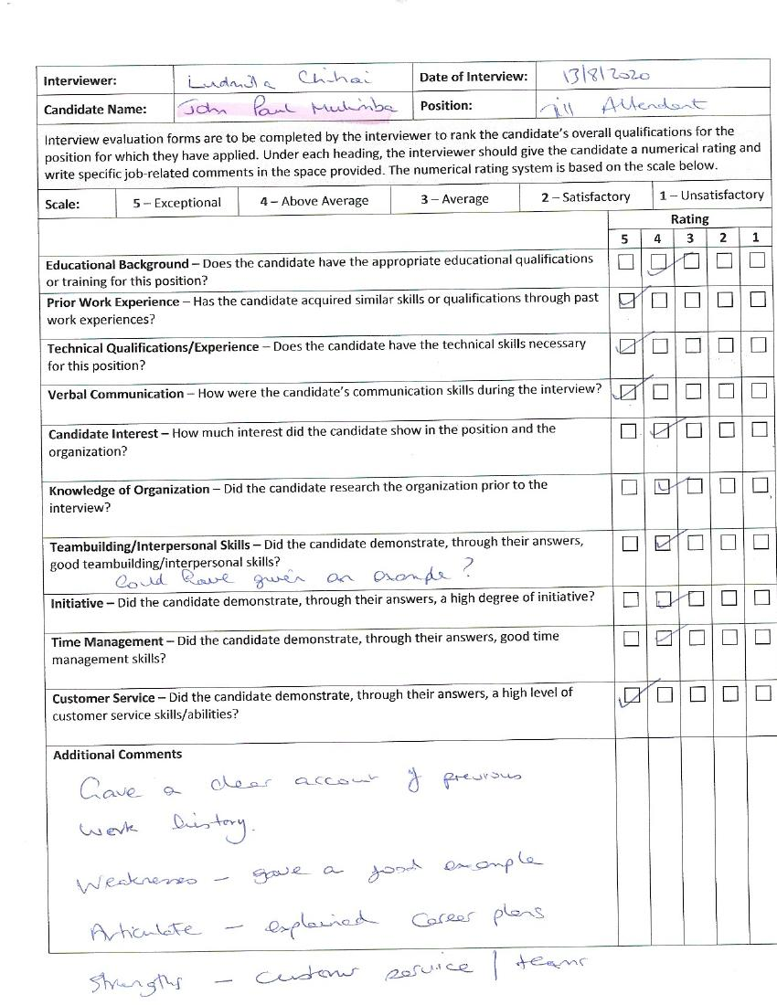

REFERENCES:
whetten .D.A. and comron,k,[1996] developing management skills.
Winstanely ,D [2005] personal effectiveness London.
www.discprofile .com[2007-2009].

