The Impact of Art Deco
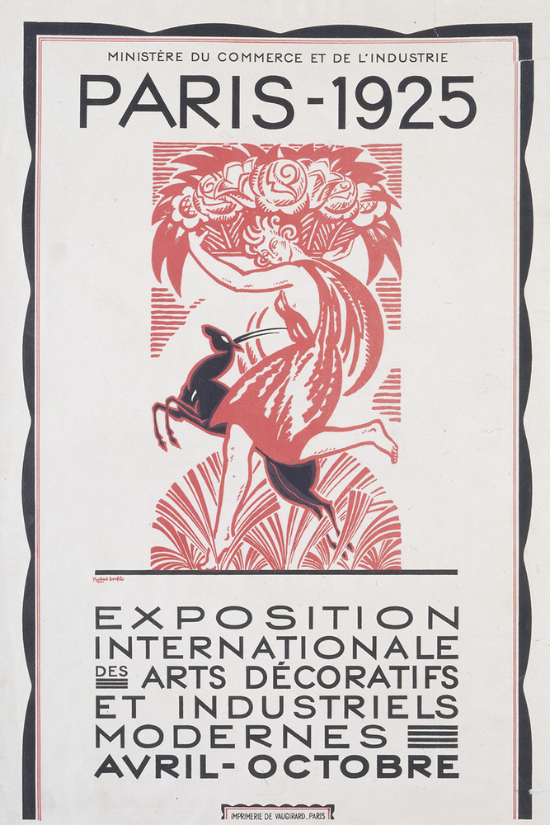
Written by Annabel Carmichael

L’ Exposition Internationale des Arts Decoratifs et Industriels Modernes – 1925 Paris
Robert Bonfils, 1925

Before receiving its current title of ‘Art Deco’ in the late 60’s, the movement of Art Deco had many different titles that it was referred to by; the charming and impressionist ’Jazz Modern’, ‘Paris 25’, ‘Style 1925’ or ‘Le Mode 1925’ due to its public origins at the Paris Exhibition of 1925, or quite simply ‘Art Nouveau’ due to the similarities between the two popular styles at the time.

Art Deco, which had its run from 1919 to 1939, derived from Art Nouveau (1890-1910), not as a continuous development, but more in the nature of a rebirth after the First World War and its aftermath. (Scarlett and Townley, 1975, p.45)

The main themes that separate these two styles are while Art Nouveau prides itself in elegance with curves and long lines in its illustrations, Art Deco consists of geometric shapes and harsh angles.

According to The Editors of Encyclopaedia Britannica (2024), among the formative influences on Art Deco were, of course, Art Nouveau, the Bauhaus, Cubism, and Serge Diaghilev’ Ballet Russes with decorative ideas coming from American Indian Egyptian and early classical sources as well as from nature. The characteristic motifs of the style are commonly seen in conventional forms through nude female figures, animals (most famously the greyhound and borzoi), foliage and sun rays.

Prior to its boom in popularity in Western Europe and the United States in the 30’s, the Art Deco style was seen across France in things such as fashion, jewellery, fine art, architecture, interior design, and graphics. Jewellery designer René Lalique is known as the ‘Father of Art Deco’ for his jewellery designs and glassware during the late 19th century, his popularity being attributed to pieces like the ‘Dragonfly’ brooch which was presented at the Paris Universal Exhibition in 1900.
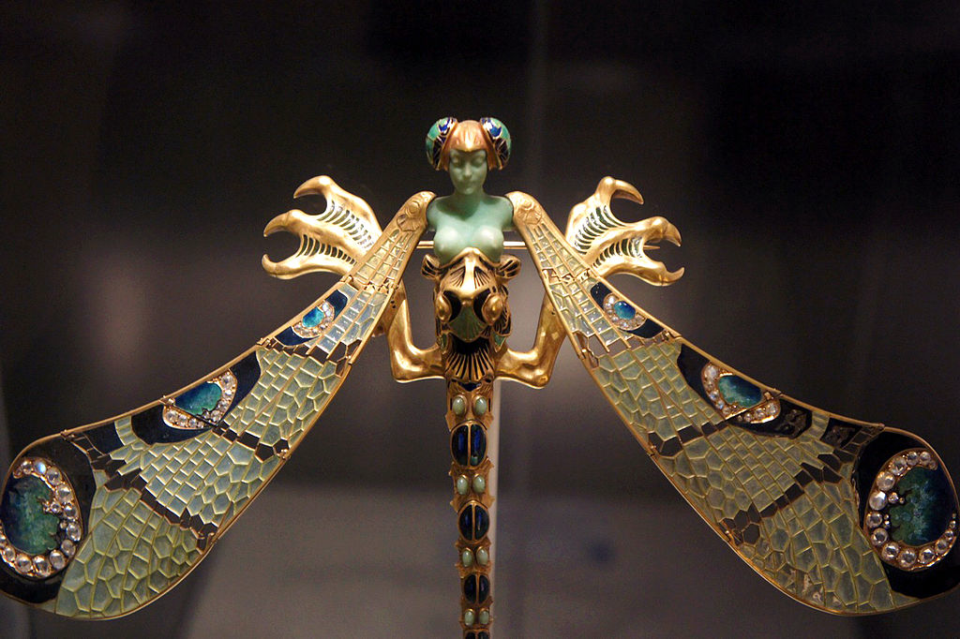

‘Dragonfly-woman’ corsage ornament

René Lalique, 1897-98

Alongside Lalique, other names which helped to pioneer Art Deco include architect Charlotte Perriand, known for the ‘LC4 Chaise Lounge’, and fashion designer Paul Poiret who was credited with freeing women from corsets and introducing new silhouettes like the harem pants, hobble skirt, and the lampshade tunic.

“It was first in fashion that Art Deco became a cogent movement.” (Robinson and Orminston, 2008) In collaboration with Poiret, who had herald himself as the ‘king of fashion’, French designer and illustrator Paul Iribe was significant in the rise of Poiret’s designs in the public eye with his illustrations drawing attention to this fresh new take on fashion, especially during the era of flat, white, and concrete socialism.

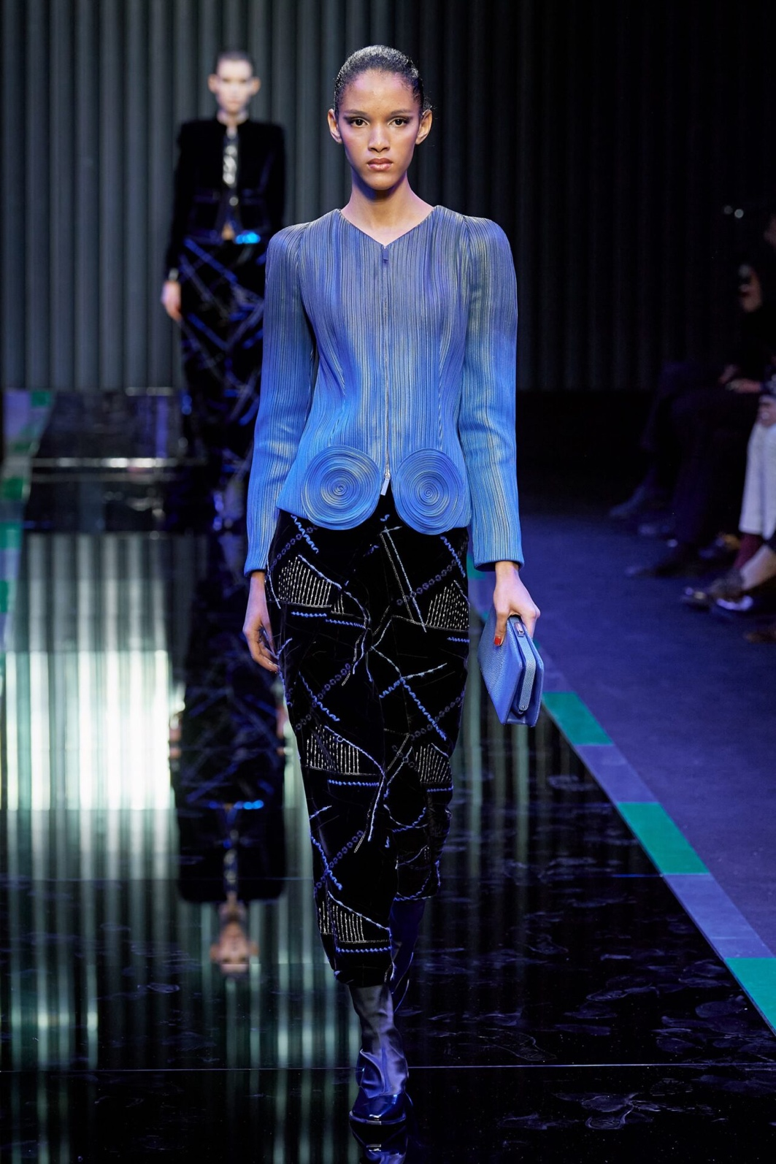
This era of design and innovation had an undeniable impact on the history of women’s clothing that is still being commemorated today- in 2022, 100 years later, Fashion Week in London, Milan, Paris and NYC revisited the maximalist shapes and rich fabrications of the Art Deco style for their FW22 line with designs from names like Saint Laurent, Giorgio Armani, and Bruno Sialelli.

FW22 Trend Takeaway: Here Comes the Art Deco Renaissance
Bailey Slater, 2022
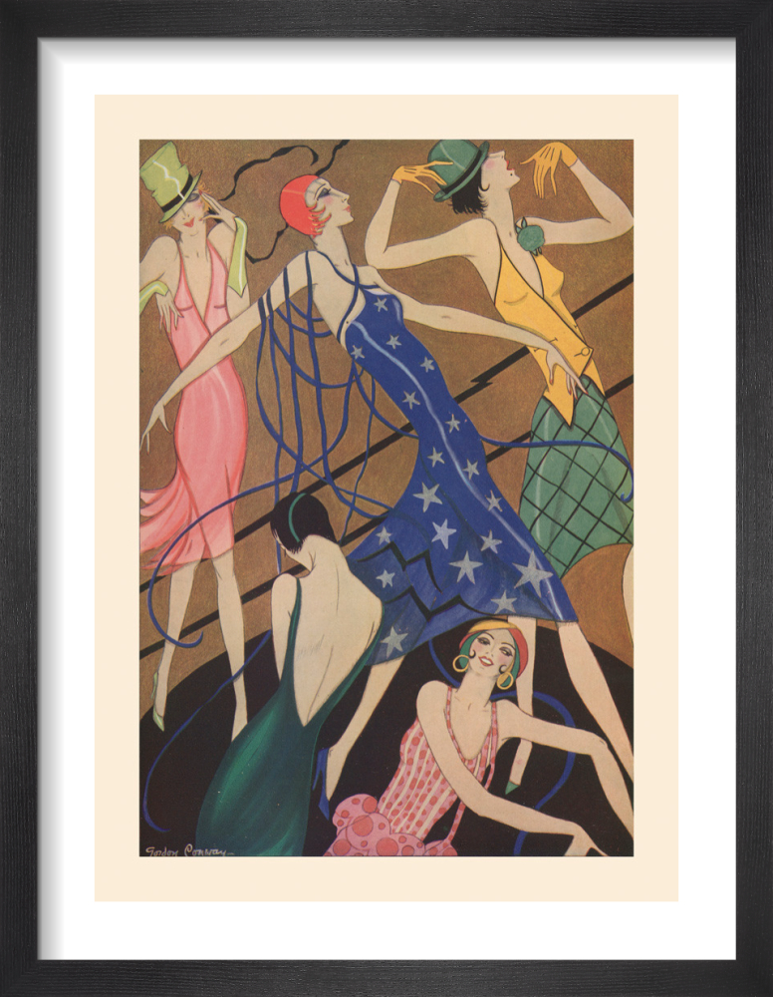
Art Deco’s luxurious spread to the west in the late 20’s and early 30’s came to fruition in the form of city skyscrapers, poster graphics and a sense of opulence and luxury to society. During the Great Depression artists found meaning in making art for ordinary Americans- idealistic visions for the future were broadcasted to those who were struggling through the extravagant lens of Art Deco in response to the changing climate.

A Fashion Phantasy
Gordon Conway, 1928

French painter A.M Cassandre, who’s piece ‘Au Bûcheron’ was awarded Grand Prix at the Paris Exposition des Arts Décoratifs, was responsible for creating some of the most recognisable graphic advertisement posters for luxury French travel companies in the Art Deco style from the 1920’s through the 1930’s with his work taking inspiration from the Cubism and Bauhaus movements. “Semiotics in graphic design is essential for conveying powerful messages through symbols and signs” (Reynolds, A. 2023.) and this is something that Cassandre does well through his communication of forms, colours, text, and imagery within his posters.
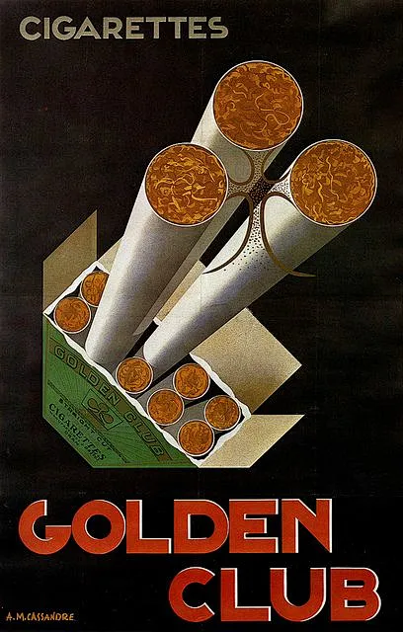
Golden Club
Cassandre (1926)
Analysing this piece using Charles Sanders Peirce’ semiotic theory we can deduce that the ‘sign’ in this poster are the protruding cigarettes, the packaging stylistic with bold typography helping to draw focus to them.

The arrangement of the cigarettes suggests a premium quality, acting as an index of luxury. The anchorage text reminiscent of traditional art deco typography which is geometrical and bold. The brand name “Golden Club” is symbolic, relying on cultural associations. The word “golden” connotes wealth, while “club” suggests belonging to a privileged group. The object is the “Golden Club” cigarette brand, which is being promoted as a desirable product, the advertisement emphasising style and exclusivity. The luxury connotations and elegant presentation evokes a sense of aspiration to belong to an elite group. According to Peirce ‘any material image’ may be perceived as looking like what is represents. The cigarettes here are being represented as an asset of the upper-class lifestyle.

The 20’s and 30’s saw the rise and spread of the American skyscraper, arguably the most complete expression of Art Deco architecture. Although the skyscraper first found its place in Chicago in the 1880’s, after the First World War with the rapid development of the technologies of steel construction and introduction of the high speed elevator, New York and other American cities saw a building boom. By the end of the war skyscrapers had become a staple of American architecture. (Benton, T. et el. 2003.)
Some of these famous buildings in New York include Raymond Hood’s ‘Radiator Building’ built in 1924 with its Gothic decoration and bold flashes of gold detailing, William Van Alen’s ‘Chrysler Building’ built in 1928 which is known as the tallest brick building in the world with steel framework and, of course, the ‘Empire State Building’ built by Shreve, Lamb and Harmon in 1930 which has been a filming location for films such as ‘King Kong’ (1933), ‘Superman II’ (1980) and ‘Percy Jackson & The Olympians: The Lightening Thief’ (2010).
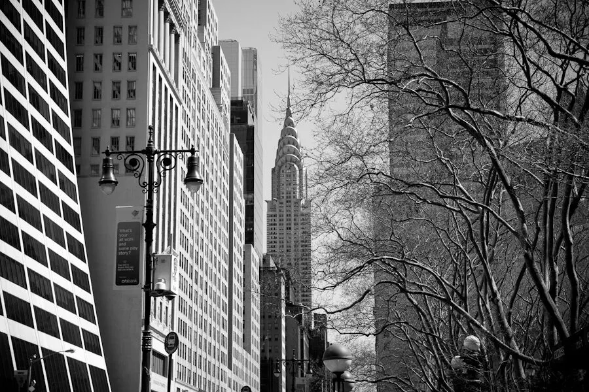
Chrysler Building from 42nd Street
Photograph: James Maher, 2012
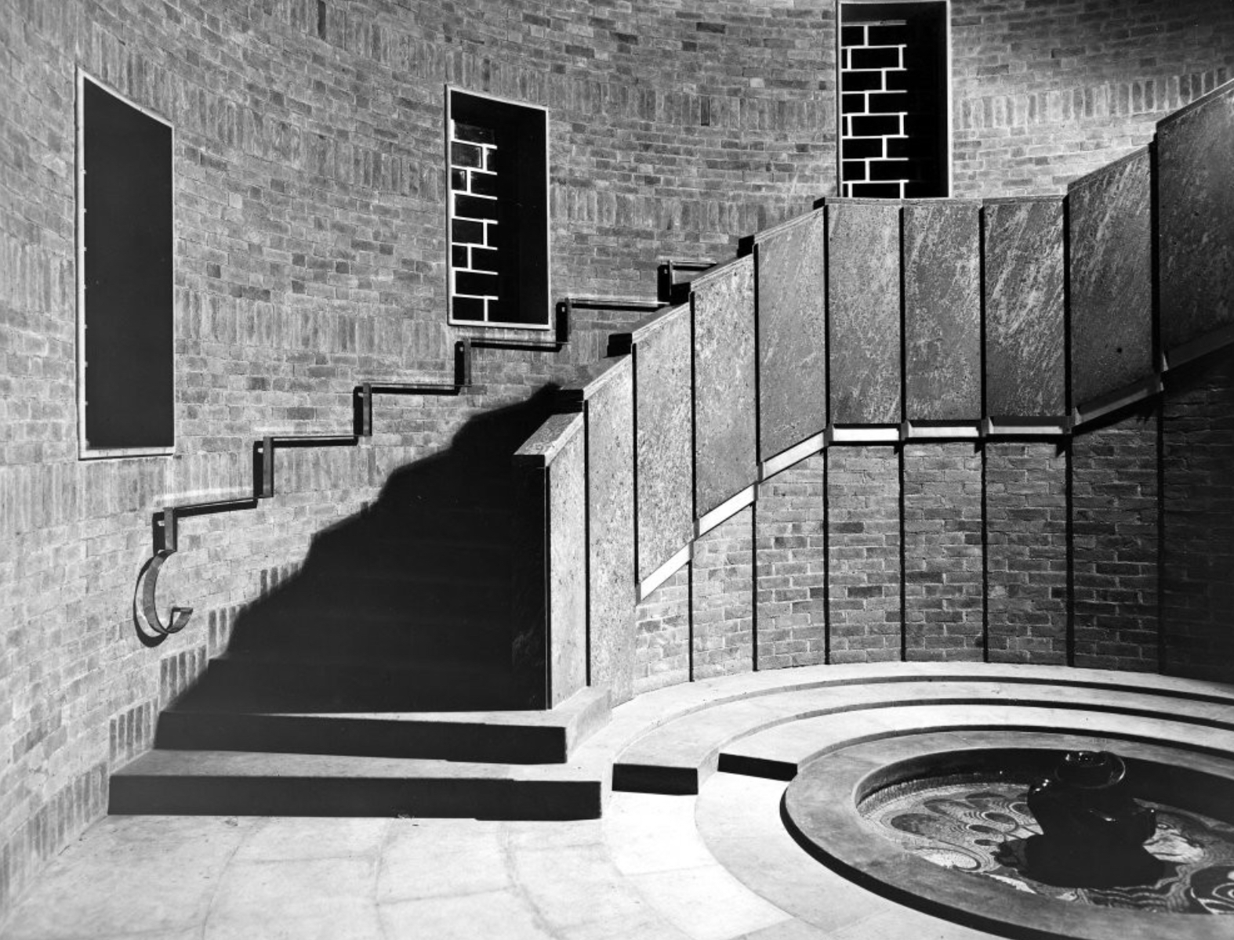
Art Deco architecture also migrated to Britain within the same timeframe with architects like Oliver Hill who designed the ‘Gayfere House’ in London in 1931 and Scott, Chesterton and Shepherd who designed the ‘Shakespeare Memorial Theatre’ in Stratford in 1932.

Shakespeare Memorial Theatre Fountain Staircase
Photograph: Felton, Leo Herbert, 1932

Art Deco also found its way to literature with works like Agatha Christie’s Hercule Poiret book series, the first of which being ‘The Mysterious Affair at Styles’ written in 1920, and F. Scott Fitzgerald’s novel ‘The Great Gatsby’ written in 1925- and later becoming film adaptations both in 1974 and 2013.

Christie’s books follow famous Belgian detective Hercule Poiret through the contemporary settings of a glittering interwar world “…but much of the credit for the symbiotic relationship between Poiret and Art Deco has to go to the makers of the long running series of dramas starring David Suchet, aired between 1989 and 2013”. (Patience, S. 2021)

Right from the opening titles, viewers are plunged into a world of high deco: the visual effects shatter Suchet’s face into shards reminiscent of Gris’s fragmentary Cubism. A steam train straight out of a Cassandre poster rockets past stylised silhouettes of Scott’s Battersea Power Station. (Patience, S. 2021)
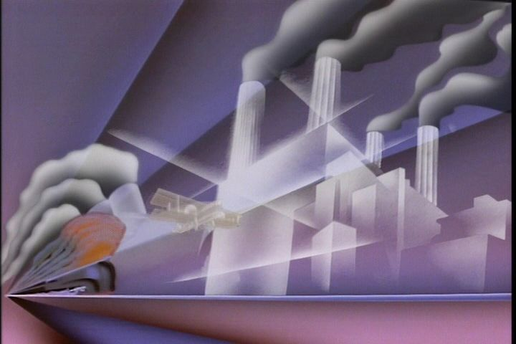Poiret Opening Sequence
Poiret, 1989

The Great Gatsby is set in the Jazz Age of New York City and explores a realm of unrestrained decadence and the glamour of post war America in the ‘roaring twenties’. In the 1925 novel by Fitzgerald, Gatsby’s mansion is stated as “…a colossal affair by any standard- it was a factual imitation of some Hôtel de Ville in Normandy, with a tower on one side, spanking new under a thin beard of raw ivy, and a marble swimming pool and more than forty acres of lawn and garden.” This fantastic show of wealth is stated throughout the settings of the book, but much like the Hercule Poiret book series, the full charm and size of these Art Deco-esque environments are depicted most faithfully in their on-screen adaptations.

A glamorous style is synonymous with the Art Deco period with designers of the time using geometric patterns, smooth lines and exotic woods in their furniture- and these pieces are perfectly placed in the sets of The Great Gatsby.

With sunshine and heat streaming through the windows of Tom’s and Daisy’s sitting room, Nick Caraway walks into the room and is immediately bathed in the privileged light of their world. Jordan and Daisy recline in the heat on an oversized cream lounge suite which was very much in vogue at the time- particularly with the matching wood arms of the sofa and chairs. (Russel, H. 2016)
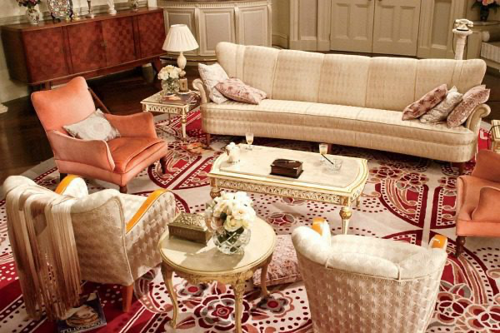
Tom and Daisy’s Sitting Room
Film and Furniture, 2016

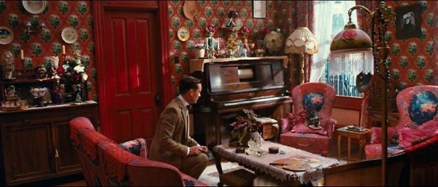
The unrestrained wealth and elegance of both Tom’s and Gatsby’s mansion are in stark contrast to the desolate, dusty streets they drive through to reach Tom and Myrtle’s secret hideaway location. The space is small and cluttered with a small Art Deco ceiling light in contrast to the exquisite glass chandeliers hanging from the ceiling in Tom’s main residence. (Russel, H. 2016)
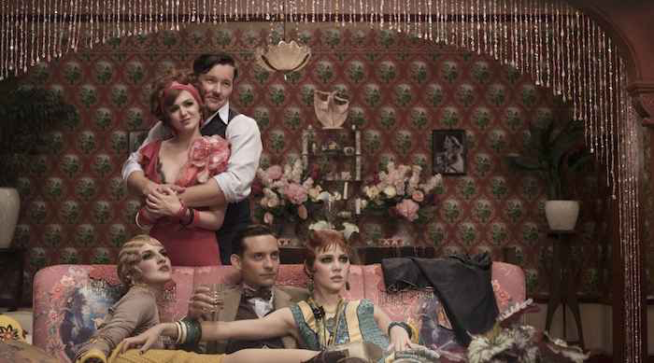
Tom and Myrtle’s Secret Hideaway Location
The Great Gatsby, 2013

In conclusion, Art Deco has significantly influenced various cultural domains, including art, fashion, literature, and architecture, establishing itself as a defining moment of the early 20th century that continues to resonate in contemporary designs and aesthetics. Its legacy is evident in the luxurious and geometric styles that emerged during its peak, reflecting the societal changes and aspirations of the time.

Wordcount: 1613

Bibliography

Benton, T. et el. (2003). Art Deco 1910-1939. London: V&A.
Boghian, I. (2010). ‘The Victorian House: Icon, Index, Symbol’, Limbaj is context, 2(1), pp.31-.
Chandler, D. (2002). Semiotics: the basics. London: Routledge.
Clark, V. (2019). Houses in literature: The Great Gatsby. House & Garden.
Cobley, P. (2012). Introducing semiotics. London: Icon Books Ltd.
Hillier, B. (1985). Art Deco of the 20’s and 30’s. Studio Vista.
Lenker, M., & Mercadante, J. (2024). The 15 best Empire State Building moments in movies and TV. Entertainment Weekly.
Patience, S. (2021). Thoroughly modern murder: how Poiret came to personify Art Deco. Apollo Magazine.
Reynolds, A. (2023). Semiotics in Art and Design: Understanding the Power of Symbols and Signs. Ren Creative Works.
Robinson, M., & Ormiston, R. (2008). Art Deco: the Golden Age of Graphic Art & Illustration. Flame Tree.
Russel, H. (2016). How the Art Deco set design of The Great Gatsby embodies the essence of the 1920’s. Film and Furniture.
Scarlett, F., & Townley, M. (1975). Arts Décoratifs 1925: A Personal Recollection of the Paris Exhibition. Academy Editions.
Slater, B. (2022). FW22 Trend Takeaway: here comes the Art Deco renaissance. Hero.
The Editors of Encyclopaedia Britannica. (2024). Art Deco. Britannica.

