Silje Gronn (P140210)
University of Wales Trinity Saint David | Change management, level 7
AIRBNB AND THE REGULATORY VIOLATIONS IN THE UNITED STATES
An analysis of regulatory violations by airbnb that forced an organisational change

Contents PAGE
Executive Summary 2
Table of Figures 4
1.0 Introduction 5
1.1 The Sharing Economy 5
2.0 Airbnb 5
2.1 Reasons for Change 6
2.2 The Continuous Transformation Model of Change 7
2.3 Stakeholders and Power Interest Grid 8
3.0 Change 9
3.1 The Change Process 9
3.1.1 Lewin’s Three-Step Change Process 10
3.1.2 Steps in the Change Process 11
3.1.3 Kotter’s Eight Step Change model 12
3.2 Lewin’s Force Field Analysis 14
4.0 Conclusion 15
5.0 Recommendations 15
6.0 Bibliography 16

Executive Summary
In 2013, Eric Schneiderman commenced his investigation of Airbnb’s presence in New York City, summoning data on approximately 15,000 Airbnb users, which can be seen as the main reason Airbnb needed to change. It was reported that the purpose of this investigation was to recover millions of dollars in unpaid taxes, and to stop Airbnb’s site as operators of illegal hotels. Airbnb was willing to pay hotel taxes to become a legitimate operating accommodation service, however, Liz Krueger, a New York State Senator stated that Airbnb is putting their hosts at risk of eviction by providing evidence that they are in violation of their lease. Airbnb wanted to sign deals with hundreds of US cities by years end to remit more hotel taxes to local government, however, this caused more suspicion towards Airbnb. A former Montana State Tax Official claimed that Airbnb’s arrangements with tax agencies would safeguard commercial hosts from inspections and back tax responsibilities. The same Montana State Tax Official said it was often the cash-stripped cities that agreed to Airbnb’s concession as they were offering a carrot in the form of a big cheque.
A number of Airbnb’s hosts’ have been notified with several violations of illegal transient hotel laws, which have resulted in fines. Mr. Nigel Warren rented out his apartment for three nights and was later fined 40,000 USD due to violations of the Multiple Dwellings Law.
Airbnb’s stakeholders can be seen as the Federal Government who sits on top, and under the Government lies the states. The Government sets the rules and regulations, and from those the states, governors, landlords and Airbnb sets their own regulations to influence Airbnb in either a positive or negative direction. Local businesses, hosts and neighbours are seen to be the stakeholders who are directly affected by decisions made by Airbnb.
Airbnb have unfreezed its current status quo due to their willingness to pay hotel taxes, however, until the discussion with the hundreds of cities regarding the hotel taxes is finalised, Airbnb will not be moving to the refreeze stage. Once their change is done, they can refreeze to a new status quo.
It was a mix of external and internal circumstances that forced Airbnb to change, whereas the subpoena by Mr. Schneiderman is seen to be the main external reason. The internal circumstances was seen to be the on-going violations by the hosts. Airbnb then announced that they will no longer permit hosts to have more than one listing at any single address in New York to try and overcome that issue.
Mr. Schneiderman analysed Airbnb bookings for private stays between January 1st 2010 and June 2nd 2014, and in his final report it was revealed that up to 72% of its listings were illegal, and that 25,532 hosts were violation the Multiple Dwellings Law.
When analysing Lewin’s Force Field Analysis, it was concluded that the driving forces for change was greater than the restraining forces against change, with a total points of 20 for the driving forces for change and total points of 16 for the restraining forces.
The researcher concludes that the feud between Airbnb and New York City was inevitable due to the continuous violations towards the Multiple Dwellings Law, and that it is questionable if Airbnb will ever comply with the regulations set by New York City due to the safety of its hosts even though they have stated that they are willing to pay hotel taxes. It can be argued that similar cases like Airbnb vs. New York City may arise in other Airbnb destinations.
It is recommended that Airbnb is clearer towards their hosts in regards to current rules and regulations in New York City by implementing technological procedures to ensure that New York hosts are aware of current rules and regulations. The researcher recommends that Airbnb tries harder to comply with the regulations set as this is seen to be Airbnb’s biggest market, but there is unfortunately a chance that hosts decides to withdraw their homes from the house sharing platform if the feud between Airbnb and New York City is not resolved.

Table of Figures
Figure 1.1 – Basic Overview of how Airbnb Started (Vital, 2014), p. 6
Figure 1.2 – Stakeholders, p.8
Figure 1.3 – Power Interest Grid, p. 9
Figure 1.4 – Lewin’s Three-Step Change Process (Lewin, 1947), p. 10
Figure 1.5 – Steps in the Change Process (Hayes & Hyde, 1998), p. 11
Figure 1.6 – Lewin’s Force Field Analysis, p. 14

Introduction
This report will focus on Airbnb and the subpoena issues by Eric Schneiderman in 2013 and how this forced Airbnb to change, as well use other case studies such as violations of the New York Multiple Dwellings Law to underpin reasons for change. It will also include key change process theories such as Lewin and Kotter.

The Sharing Economy
Allen (2015) stated that the sharing economy could be seen as a collection of evolving software platforms who acts as an intermediate between the private buyer and the private seller, which allows them to share their existing resources. It is a system that is built around the sharing of human and physical resources. It can be argued that communities have shared assets for thousands of years, however, the full extent of the sharing economy did not surface until the age of the internet. According to Yaraghi & Ravi (2016), the sharing economy is estimated to grow from $14 billion in 2014 to $335 by 2025, and this estimate is based on the rapid growth of Airbnb, and Uber. It was later reported by Yaraghi & Ravi (2016) that the prices of shared services are falling as indicated by Airbnb rates that are between 30%-60% cheaper than average hotel rates around the world.

Airbnb
Airbnb was founded in 2008, headquartered in San Francisco, California, and is privately owned by Brian Chesky, Joe Gebbia, Nathan Blecharsczyk, and Laurence Toci (Airbnb, 2017). Airbnb is a website for people to list, find and rent accommodation. Airbnb (2017) stated that they have over 3,000,000 listings worldwide, in over 65,000 cities and 191 countries.
According to Choudary (2013) in Weber and Burde (2016), Airbnb’s business model includes minimal regulatory controls in most locations where hosts and guests both have to build trust to maximise the likelihood of a successful booking. It can be argued that Airbnb has changed the traditional market for tourism by providing an online marketplace that permits large-scale rental of spaces from one ordinary person to another. With its easy access website, Airbnb is changing the travel economy around the world. Please see figure 1.1 for a basic overview on how Airbnb started.
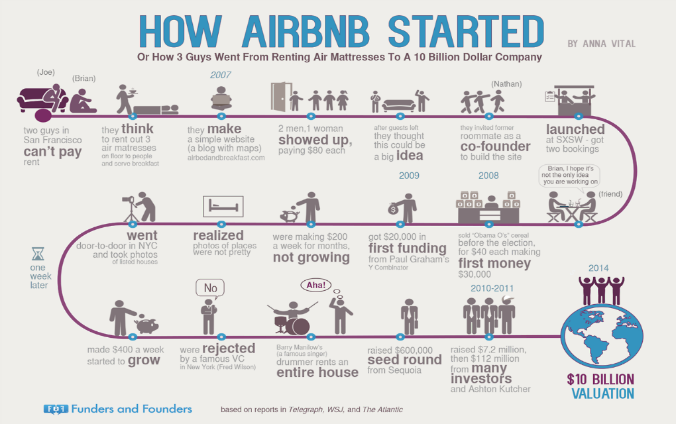 Figure 1.1 (Vital, 2014)

Reasons for Change
“A war of words between Airbnb and New York, its largest market, has escalated with the first fine issued by the city in what is expected to be a crackdown on hosts” (Walters, 2017)
Airbnb has a recognised existence in New York, and between 2012 and 2013, over 400,000 visitors used Airbnb’s services in New York City. However, in 2013, Eric Schneiderman commenced his investigation of Airbnb’s presence in New York City, summoning data on approximately 15,000 Airbnb users (Bloomberg News, 2013). Matt Mittenthal, a spokesperson for Schneiderman, stated in Harris (2013) that the purpose of the investigation was to “recover millions of dollars in unpaid taxes and to stop the abuse of Airbnb’s site by operators of illegal hotels”. Liz Krueger, a New York State Senator, in Griswold (2015) stated that Airbnb’s wish to pay hotel tax was just an effort by them to bolster their image whilst ignoring local laws they find inconvenient for their business model. By paying hotel taxes, they are putting their hosts at risk of eviction by providing evidence of lease violations; however, this does nothing to alleviate an acute shortage of reasonable housing prices.
Even though Airbnb has not been paying taxes like legitimately functioning hotels are required to do, they have now stated that they are willing to pay the hotel tax in order to be considered legitimate and operate without concern (Whitehouse, 2014). It was reported that this could bring in approximately 65 million dollars in hotel occupancy tax income for New York (Lawler, 2016).
Roberts (2016) said that Airbnb wants to sign deal with hundreds of cities by years end to remit more hotel taxes to local governments, which is a part of an effort to clear some of the regulatory hazes hanging over them. Former Montana state tax official claimed that Airbnb’s arrangements safeguard commercial hosts from certain inspections and back tax responsibilities, whilst covering the deal terms in a web of secrecy (Roberts, 2016). In some cases, Roberts (2016) reported that tax agencies, including City of Santa Fe and the Florida Department of Revenue have allegedly agreed that they will not speak to the media about these deals without Airbnb’s consent. The former Montana state tax official also stated that it was often the cash-stripped cities that agreed to this concession as Airbnb offers a carrot in the form of a big cheque, and due to lack of resources to conduct long-running investigations into Airbnb.
If their on-going issues with hotel taxes was not enough, Airbnb was hit with another problem. A number of its hosts have been notified with several violations of illegal transient hotel laws, which have resulted in fines. One of these hosts were Mr. Nigel Warren, who rented out his apartment for three nights and was later fined over 40,000 USD due to violations of the Multiple Dwellings Law Art 1, §4.8 (a), according to Lieber (2012). The Multiple Dwellings Law is defined by New York City (2017) as a law that governs the space Airbnb occupies, and it outlines the definitions of classes of apartment-style residences in New York. Already in February 2017, a property owner and estate broker were charged for 17 violations after listing several short-term apartment rentals on Airbnb, according to Gartland & Saul (2017). McKay (2017) reported that New York City authorities are organising a number of tactics designed to go after large-scale Airbnb operations due to violations of building and zoning codes. It is seen to be a part of an overall escalation in the struggle between Airbnb and New York’s local Government, which is accusing Airbnb of profiting by exploiting loopholes in zoning laws and other regulations.

The Continuous Transformation model of change
Burnes (2014) said that organisations must develop the ability to change themselves continuously in a fundamental manner, and the rationale for the continuous transformation model is that the environment in which organisations operate is changing, and will continue to change. The sector Airbnb is in is a rapidly changing sector in itself, however, as well as having to follow the fast changing tourism industry and consumer behaviour and trends, they will have to change their policies and regulations to adhere to regulatory changes that happens across the 191+ countries they have accommodation in.

Stakeholders and power interest grid
Stakeholders involved in the sharing economy, specifically in rental companies like Airbnb, range from renters to guests to The Federal Government. Given the complex nature of renting out homes in compliance with city and state guidelines, the tiered structure in Figure 1.2 below shows the relations between each actor.
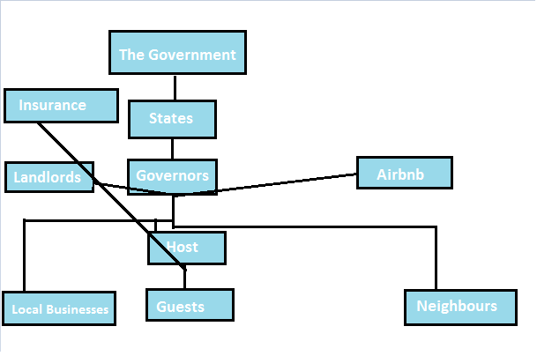Figure 1.2 – Stakeholders
According to this structure, the Federal Government sits on top, and directly under the Government lies the states. From the rules and regulations set by the Government and the states, governors, landlords and Airbnb sets their own regulations to influence Airbnb in either a positive or negative direction. Of course, Airbnb wants to positively influence its position in cities and in its terms and conditions, inform hosts of their responsibility to follow rules and regulations set by the Government and the states. The involvement of different parties will influence the relationship between local businesses, hosts, neighbours and guests.
Local businesses, hosts and neighbours are seen to be the stakeholders who are directly affected by decisions made by Airbnb. According to Weber and Burde (2016), the connections between each actor of the tier creates complicated patterns between the stakeholders, for example landlord and guests respecting the habits of neighbours and the community surrounding the hosts’ home.
Please see figure 1.3 for Power Interest Grid.
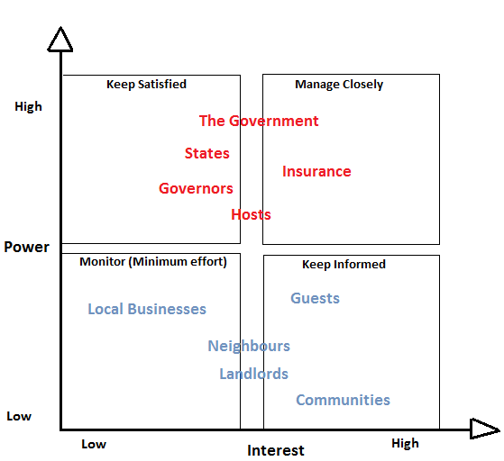
Figure 1.3 – Power Interest Grid

Change

The Change Process
Stickland (1998) stated that change has many guises, such as “transformation, development, metamorphosis, transmutation, evolution, regeneration, innovation, revolution and transition”, however, the concept of change is commonly understood, yet there is no universal definition of what is meant by change. Several authors have tried to define change management. Bartol & Martin (1994) said that change was alterations of the status quo, which supports Lewin’s Three-Step Model Change Process.
Manktelow et al (2017) stated that change management focuses on the wider impacts of change that happens within an organisation, and how this can be approached through structure of the change ensuring that it will be smoothly implemented and how the change has lasting benefits to the organisation.

Lewin’s Three-Step Change Process
Lewin (1947) argued that a successful project involves the following three steps showed in Figure 1.4;
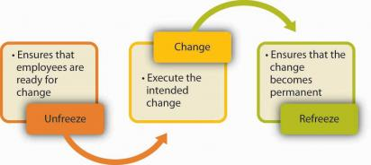
Figure 1.4 – Lewin’s Three Step Change Process
This change model includes unfreezing of the current status quo, moving and refreezing to a new status quo. The first stage involves preparing the organisation to accept that change is necessary (Lewin, 1947). In this case study, Airbnb had to unfreeze its current status quo, which involved their many years of not paying hotel taxes. It was understood that this way of doing things did not work, and it created more problems with the Federal Government and the States than what they may arguably have hoped for. It also created distress within the host communities as many hosts were charged with multiple violations of the Multiple Dwellings Law (Lieber, 2012). After Schneiderman started to summon 15,000 Airbnb hosts, and for accusing Airbnb for not paying hotel taxes, Airbnb (2017) stated that they wanted to be considered as a legitimate and fully operating accommodation organisations, and was therefore more than willing to pay hotel taxes. When they decided they wanted to pay the same amount of hotel tax, they moved forward to the Moving Stage for Lewin’s Change Model, as this is the moment they began to look for new ways to do things. It was also stated by Roberts (2017) that Airbnb has been in regular discussion with over 100 cities regarding hotel taxes, however, this is seen to be an on-going issue. Until this has been resolved, Airbnb will not move to the refreeze stage of Lewin’s Change Process. Once the change is done, they can refreeze to a new status quo.

Steps in the Change Process
Hayes & Hyde (1998) stated that the start of the process is where the organisations recognises that external events or internal circumstances require a change to take place. Please see Figure 1.5.
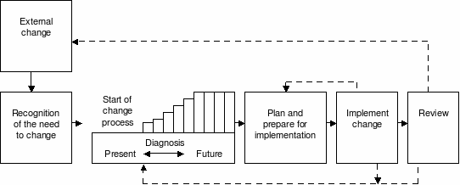
Figure 1.5 – Steps in the Change Process by Hayes and Hyde (1998)
In Airbnb’s case, a mix of external events and internal circumstances forced them to change. As previously mentioned, the subpoena by Eric Schneiderman in 2013 can be seen as the main external reasons for Airbnb’s wish to change and to start cooperating with the Federal Government and several state regarding paying hotel taxes. The internal circumstances was the on-going violations of the Multiple Dwellings Law in New York, even though Airbnb is not legally liable when this occurs, it affected their hosts greatly. In an attempt to prevent hosts from running illegal hotels, Airbnb announced that they will no longer permit hosts to have more than one listing at any single address in New York, according to Fishman (2017). However, the start phase of this change process model involves complex processes of perception, interpretation and decision making that may arguably lead to an inappropriate outcome. In Airbnb’s case, this sudden desire of change has caused further suspicion regarding their heavy emphasis on wanting to pay hotel tax, yet they are secretive around the topic of tax agencies.
When Airbnb moved forward to the Diagnosis stage, it was vital to review the present state and to identify the preferred future state. Hayes (2017) states that even though these have been seen as two separate and distinct activities, they are more often than not integrated. The common reasons to review the present state is to 1) help identify the required change by diagnosing the cause of a problem. In this case it included Schneiderman’s subpoena and the fact that Airbnb was not paying hotel taxes, 2) to establish a baseline so that it is clear what is changing, which evolves around the fact that Airbnb wants to sign deals with hundreds of cities by years end to remit more hotel taxes to local governments, and 3) to help define the future direction.
Organisational members are arguably more inclined to be motivated to let go of the status quo and seek a more desirable state if the 1) diagnostic process disconfirms their view that all is well with the existing state of affairs, 2) the challenge produce sufficient level of anxiety to motivate organisational members to search for new possibilities, and 3) the vision of what might be offers sufficient promise to make the effort of changing worthwhile, according to Hayes (2007).
Throughout 2013 and onwards, the highly secretive Airbnb and the newly known host violations towards the Multiple Dwellings Law have arguably disconfirmed Airbnb and its hosts view that all is well, and the continuous struggles and accusations that Airbnb’s arrangements safeguard commercial hosts from inspections and back tax responsibilities, while covering the deal terms in a web of secrecy, have produced sufficient level of anxiety to understand that the organisation will need to straighten out the regulatory clouds that is hanging over Airbnb before it affects the company in an even greater deal.
During the preparation and plan for implementation phase, there will be different lead-times associated with the various tasks, interdependencies between them and resource and other constraints. All of these will need to be taken into account when developing an implementation plan; however, it is important that implementation is not viewed only as a technical activity, according to Hayes (2007).

Kotter’s eight step change model
According to Kotter (1995), successful change efforts must begin with individuals and groups evaluating a company’s “competitive situation, market position, technological trends and financial performance”.
Kotter (1995) created 8 steps for a successful change, and below some of them are mentioned in detail with a direct link to Airbnb.

Establishing a sense of urgency
Schneiderman (2014), as mentioned previously, analysed Airbnb bookings for private stays between January 1st 2010 and June 2nd 2014. Schneiderman’s final report, which was published in 2014, revealed that up to 72% of Airbnb’s listings were illegal, and of the 35,354 private, short-term listings, his data suggested that approximately 25,532 of these violated New York State’s Multiple Dwellings Law (Schneiderman, 2014). When this report was published, Airbnb had to identify and discuss the organisations current crisis, which consisted of Eric Schneiderman’s findings as well as hosts being fined for regulatory violations.
Forming a powerful guiding coalition
Kotter (1995) stated that this step consisted of convincing people that change is necessary. The people Airbnb needed to convince was its hosts, as these were the ones being affected by Schneiderman’s subpoena and the fines New York State were issuing due to host violations. This step would require Airbnb to select stakeholders who would help them through the change. It can be argued that their coalition should include hosts, communities, local businesses and the local Government as these could provide the necessary direction for developing.
Creating a vision
Airbnb (2017) stated that their hosts stopped trusting each other, and the organisation. It was also stated that their relationship with people will always be the most meaningful part of their lives, so when one host after another was fined due to regulatory violations, it can be argued that their initial vision was at stake and therefore it was vital to create a new vision by wanting to pay hotel taxes and become a legitimate running accommodation service. By creating a new vision, Airbnb will provide a clear understanding of what the change is about to all its stakeholders. Airbnb must then communicate the vision to all its stakeholders, and they will need to know what is in it for them, which includes long-term security for hosts.
Empowering others to act on the vision
Kotter (1995) stated that this step included getting rid of obstacles to change, encourage risk taking and non-traditional ideas, activities, actions, and changing systems that undermine the vision. It can be argued that Airbnb identified people who resisted the change, and tried to work with them to help them see what is needed. In this case, Airbnb have tried to work with several states to introduce the hotel tax to its hosts, however, according to Liz Krueger in Griswold (2015), this is just Airbnb’s effort to bolster their image whilst putting their hosts at risk.
Institutionalizing new approaches
When the change have been successful, Airbnb will have to anchor changes within the organisational culture, and it is important that they monitor the acceptance of the change and how well the organisational culture is adapting to these changes.

Force Field Analysis
Kaminski (2011) said that Lewin extended his Three-Step Change Process Theory, as mentioned in Section 3.1.1, by introducing the force field analysis. According to Lewin’s theory, forces – beliefs, expectations, cultural norms, and the like – within ‘life space’ of an individual or society cause human behaviour. See figure 1.6 for Airbnb’s driving forces for change and their restraining forces resisting the change.
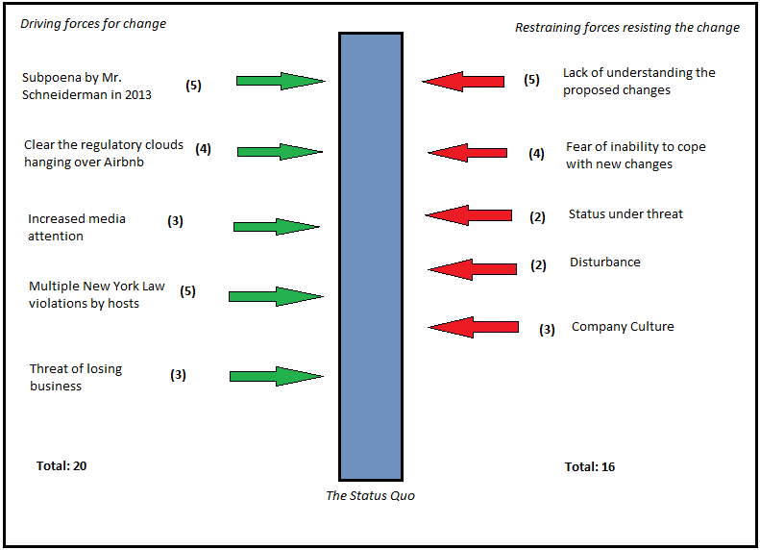
Figure 1.6 – Lewin’s Force Field Analysis
It can be argued that the driving forces for change is greater than the restraining forces resisting the change due to the big impact Airbnb have had on the sharing economy and the accommodation sector worldwide.

Conclusion
Even though Airbnb wants to pay hotel taxes like a legitimate running accommodation service, their efforts have unfortunately not been successful as this have only caused more suspicion between states and the communities. Airbnb have not completed Lewin’s Three Step Change Model due to the continuous feud with New York City, and until that situation is resolved, they will not be able to refreeze and create a new status quo. The feud between New York City and Airbnb was inevitable because their hosts are not complying with the Multiple Dwellings Law, nor the legislation New York Governor Andrew Cuomo signed in 2016. It is questionable if Airbnb will ever comply with these regulations due to the safety of its hosts, however, Airbnb are looking at a bright future overall, however, it can be argued that more cases like the ones mentioned previously may arise in other Airbnb destinations.

Recommendations
It is recommended that Airbnb is clearer towards their hosts in regards to current rules and regulations in New York City. When a host wants to rent out their home on Airbnb in New York, the rules and regulations should come up when the host is choosing New York as its location and the host must agree to those specific regulations before continuing the process. The researcher also recommends that Airbnb is kept more liable for any New York violations than what they are now, this to ensure the safety and security of its hosts as their hosts can be seen as Airbnb’s main stakeholders, and they are the ones driving the organisation forward by listing their homes. Airbnb should also help their hosts with any legal assistance necessary if they were found to be in violation with any New York City regulations. It is also recommended that Airbnb try to work harder to comply with local rules and regulations that is set by New York City as this is seen to be Airbnb’s biggest market. There is, unfortunately, a chance that hosts decides to withdraw their homes from the house sharing platform if the feud between Airbnb and New York City continues, this due to the uncertainty of the future of Airbnb in New York.

Bibliography
Airbnb, 2017. About Us. [Online]
Available at: https://www.airbnb.co.uk/about/about-us
[Accessed 29 11 2017].
Airbnb, 2017. What is occupancy tax? Do I need to collect or pay it?. [Online]
Available at: https://www.airbnb.co.uk/help/article/654/what-is-occupancy-tax--do-i-need-to-collect-or-pay-it
[Accessed 29 11 2017].
Allen, D., 2015. The Sharing Economy. Institute of Public Affaird Review, 67(3), pp. 25-27.
Appelbaum, S., Habashy, S., Malo, J.-L. & Shafiq, H., 2012. Back to the future: revisiting Kotter's 1996 change model. Journal of Management Development, 31(8), pp. 764-782.
Bartol, K. & Martin, D., 1994. Management. 1st ed. New York: McGraw-Hill.
Bergson, H., 1946. The Creative Mind. 1st ed. New York: Carol.
Botsman, R. & Rogers, R., 2011. What's mine is your; how collaborative consumption is changing the way we live, London: Collins.
Buchanan, D. & Badham, R., 2008. Power, Politics and Organizational Change. 2nd ed. London: Sage Publications.
Buchanan, D. & Huczynski, A., 2017. Organizational Behaviour. 9th ed. Harlow: Pearson.
Burnes, B., 2004. Kurt Lewin and the Planned Approach to Change: A Re-appraisal. Journal of Management Studies, 41(6), pp. 978-1002.
Burnes, B., 2014. Managing Change. 6th ed. Harlow: Pearson.
Cameron, E. & Green, M., 2009. Making Sense of Change Management. 2nd ed. London: Kogan Page.
Cameron, E. & Green, M., 2015. Making Sense of Change Management. 4th ed. London: Kogan Page.
Carman, A., 2017. New York City issues first illegal Airbnb fines. [Online]
Available at: https://www.theverge.com/2017/2/7/14532388/nyc-airbnb-first-illegal-renting-fines-issued
[Accessed 04 12 2017].
Choudary, S. P., 2013. The Airbnb Advantage: How to avoid comptetition and become a multi-billion dollar startup. [Online]
Available at: https://thenextweb.com/insider/2013/03/10/the-airbnb-advantage-how-to-avoid-competition-and-become-a-multi-billion-dollar-startup/
[Accessed 02 12 2017].
Ert, E., Fleischer, A. & Magen, N., 2016. Trust and Reputation in the Sharing Economy: The Role of Personal Photos in Airbnb. Tourism Management, 55(2016), pp. 62-73.
Fincham, R. & Rhodes, P., 2005. Principles of Organizational Behaviour. 1st ed. Oxford: Oxford University Press.
Fishman, S., 2017. How to: Airbnb in New York City. [Online]
Available at: https://www.nolo.com/legal-encyclopedia/overview-airbnb-law-new-york-city.html
[Accessed 06 12 2017].
Gartland, M. & Saul, E., 2017. Anti-Airbnb law claims its first casualties. [Online]
Available at: https://nypost.com/2017/02/05/anti-airbnb-law-claims-its-first-casualties/
[Accessed 04 12 2017].
Greenfield, A., 2008. The 5 Forces of Change: A blueprint for leading successful change. 1st ed. Gloucestershire: Management Books 2000 Limited.
Greiner, L., 1967. Patterns of Organizational Change. Havard Business Review, 45(3), pp. 119-130.
Griswold, A., 2015. Why Airbnb Desperately Wants to Pay Hotel Taxes. [Online]
Available at: http://www.slate.com/business/2017/12/senate-republicans-may-have-made-a-usd260-billion-mistake-in-their-tax-bill.html
[Accessed 06 12 2017].
Guttentag, D., 2015. Airbnb: Disruptive Innovation and the Rise of an Informal Tourism Accommodation Sector. Current Issues in Tourism, 18(12), pp. 1192-1217.
Hamari, J., Sjoklint, M. & Ukkonen, A., 2015. The Sharing Economy: Why People Participate in Collaborative Consumption. Journal of the Association for Information Science and Technology, 67(9), pp. 2047-2059.
Harris, E., 2013. The Airbnb Economy in New York: Lucrative but often illegal. [Online]
Available at: http://www.nytimes.com/2013/11/05/nyregion/the-airbnb-economy-in-new-york-lucrative-but-often-unlawful.html
[Accessed 04 12 2017].
Hayes, J., 2007. The Theory and Practice of Change Management. New York: Palgrace Macmillan.
Hayes, J., 2014. The Theory and Practice of Change Management. New York: Palgrave Macmillan.
Hughes, M., 2006. Change Management: A Critical Perspective. 1st ed. London: CIPD.
Jabri, M., 2012. Managing Organizational Change. 1st ed. New York: Palgrave Macmillan.
Jonas, A., 2016. “Share and Share Dislike: The Rise of Uber and AirBNB and How New York City Should Play Nice. Journal of Law and Policy, 24(1), pp. 205-239.
Kaminski, J., 2011. heory applied to informatics – Lewin’s Change Theory. Canadian Journal of Nursing Informatics, 6(1), pp. 1-5.
Kotter, J., 1995. Leading change: why transformation efforts fail. Boston: Harvard Business Review.
Kotter, J., 1996. Leading Change. Cambridge: Harvard Business School Press.
Lawler, R., 2015. As It Seeks New Regulations In NY, Airbnb Estimates It Would Collect $65 Million In Taxes There. [Online]
Available at: https://techcrunch.com/2015/01/16/airbnb-65-million-in-ny/
[Accessed 04 12 2017].
Lewin, K., 1947. Frontiers in group dynamics. In: Field Theory in Social Science. London: Social Science Paperbacks.
Lewin, K., 1951. Field Theory in Social Science. New York: Harper & Row.
Lieber, R., 2012. A Warning for Hosts of Airbnb travelers. [Online]
Available at: http://www.nytimes.com/2012/12/01/your-money/a-warning-for-airbnb-hosts-who-may-be-breaking-the-law.html
[Accessed 04 12 2017].
Lunenburg, F., 2010. Approaches to Managing Organizational Change. International Journal of Scholarly Academic Intellectual Diversity, 12(1), pp. 1-10.
McGarry, C., 2014. New York court sides with Airbnb over host records subpoena. [Online]
Available at: https://www.pcworld.com/article/2154662/new-york-court-sides-with-airbnb-over-host-records-subpoena.html
[Accessed 29 12 2017].
McKay, T., 2017. Report: New York Police are cracking down on Small-Scale Airbnb Rentals. [Online]
Available at: https://gizmodo.com/report-new-york-police-are-cracking-down-on-small-scal-1819040385
[Accessed 30 12 2017].
Murray, A., 2017. Budget 2017: up to 50,000 Airbnb hosts could pay between £400 and £3,300 more tax. [Online]
Available at: http://www.telegraph.co.uk/tax/income-tax/budget-2017-50000-airbnb-hosts-could-pay-400-3300-tax/
[Accessed 24 11 2017].
News, B., 2013. Schneiderman investigating Airbnb users. [Online]
Available at: http://www.crainsnewyork.com/article/20131007/REAL_ESTATE/131009911/schneiderman-investigating-airbnb-users
[Accessed 04 12 2017].
Plant, R., 1987. Managing Change and making it stick. 1st ed. Hants: Gower Publishing Company Limited.
Price, D., 2009. The Principles and Practice of Change. Milton Keynes: Palgrave Macmillan.
PwC, 2017. The sharing economy grows up: how the UK has embraced the sharing economy. [Online]
Available at: https://www.pwc.co.uk/issues/megatrends/collisions/sharingeconomy/outlook-for-the-sharing-economy-in-the-uk-2016.html
[Accessed 2 12 2017].
Robers, J. J., 2017. Airbnb Faces Scrutiny Over Secret Tax Deals With Cities. [Online]
Available at: http://fortune.com/2017/03/07/airbnb-hotel-taxes/
[Accessed 04 12 2017].
Schein, E., 1996. Kurt Lewin's Change Theory in the field and in the classroom: notes towards a model of management learning. Systems Practice, 9(1), pp. 27-47.
Schneiderman, E., 2014. A.G. Schneiderman Releases Report Documenting Widespread Illegality Across Airbnb's NYC Listings. [Online]
Available at: https://ag.ny.gov/press-release/ag-schneiderman-releases-report-documenting-widespread-illegality-across-airbnbs-nyc
[Accessed 29 12 2017].
Schneiderman, E., 2014. Airbnb in the city, New York: New York State Attorney General.
Senior, B. & Fleming, J., 2006. Organizational Change. 3rd ed. Harlow: Pearson Education Limited.
Shead, S., 2016. BUDGET: People in the UK who let out their homes on Airbnb got a £1,000 tax break. [Online]
Available at: http://uk.businessinsider.com/budget-people-in-the-uk-who-let-out-their-homes-on-airbnb-got-a-1000-tax-cut-2016-3
[Accessed 2 12 2017].
Somerville, H. & Bellon, T., 2016. New NYC law, San Francisco lawsuit highlight global risks for Airbnb. [Online]
Available at: https://www.reuters.com/article/us-airbnb-regulation-insight/new-nyc-law-san-francisco-lawsuit-highlight-global-risks-for-airbnb-idUSKCN12L0DY
[Accessed 02 12 2017].
State, N. Y., 2017. Multiple Dwelling Law. [Online]
Available at: https://www1.nyc.gov/assets/buildings/pdf/MultipleDwellingLaw.pdf
[Accessed 01 12 2017].
Stickland, F., 1998. The Dynamics of Change. 1st ed. London: Routledge.
Ting, D., 2016. Airbnb vs New York City: The Complete Battle up to now. [Online]
Available at: https://skift.com/2016/10/25/airbnb-vs-new-york-city-the-complete-battle-up-to-now/
[Accessed 30 12 2017].
Ting, D., 2016. Measuring the Impact of New York’s New Short-Term Rental Law on Airbnb. [Online]
Available at: https://skift.com/2016/07/18/measuring-the-impact-of-new-yorks-new-short-term-rental-law-on-airbnb/
[Accessed 02 12 2017].
Tussyadiah, I., 2015. An Exploratory Study on Drivers and Deterrents of Collaborative Consumption in Travel. Information and Communication Technologies in Tourism, pp. 817-830.
Van de Ven, A. & Poole, M. S., 1995. Explaining Development and Change in Organizations. Academy of Management Review, 20(3), pp. 510-540.
Vital, A., 2014. How Airbnb started - infographic. [Online]
Available at: https://blog.adioma.com/how-airbnb-started-infographic/
[Accessed 02 12 2017].
Walters, J., 2017. Something in the Airbnb: hosts anxious as New York begins crackdown. [Online]
Available at: https://www.theguardian.com/technology/2017/feb/12/airbnb-hosts-new-york-fines-government-illegal
[Accessed 02 12 2017].
Weber, A. & Burde, A., 2016. Room for Compromise: A Logical Approach to Regulating Airbnb, Durham: Duke University.
Whitehouse, K., 2014. Airbnb aims to start taxing renters by July 1. [Online]
Available at: https://nypost.com/2014/04/14/airbnb-aims-to-start-taxing-renters-by-july-1/
[Accessed 04 12 2017].
Yaraghi, N. & Ravi, S., 2016. The Current and Future State of the Sharing Economy. [Online]
Available at: https://www.brookings.edu/research/the-current-and-future-state-of-the-sharing-economy/
[Accessed 06 12 2017].

