

CERTIFICATE OF HIGHER EDUCATION IN SKILLS FOR THE WORKPLACE

THE IMPACT OF VIRTUAL LEARNING ENVIRONMENT

Module: Digital Skills and Research Methods
Module code: BMSW4003
Lecture name: Ejiro Esohwode
Assignment Title: DSR Assessment 2 Individual Report 2000 word
Student Number: 2023024
Student Name: Maria Vitoroi

TABLE OF CONTENTS

INTRODUCTION 1
LITERATURE REVIEW 2
METHODOLOGY 3
RESULTS 4
CONCLUSIONS 8
REFERENCES 8
APPENDIX 9

INTRODUCTION
With the development and advancement of communication and information technology, Rahmany et al. (2014) express that there is a surge of interest in how computers and Internet resources can support and enhance educational processes, as well as encourage the use of technology in educational settings. Specifically, Al-hariri and Al-hattami (2017) emphasize that the advent of digital and information technologies, along with the use of the internet, has emerged as a modern teaching method that has the potential to revolutionize conventional teaching methods.
Moreover, Mishra et al. (2020) point out that the consequences of the COVID-19 situation has evolved online education from a conventional way to a new approach to teaching learning, moving from classrooms to online networks, from personal to interactive, and from seminars to webinars. The authors in addition report that in the previous years, non-formal education included e-learning and distance education, but on the other hand if the current situation continues, it appears that non-formal education will eventually overtake the formal education system.
Both teachers and students face difficulties while transitioning from conventional classroom to online learning. Many of them are facing this modern mode of teaching and studying for the first time. The aim of this assignment is to understand the way of perception and to explain the point of view of the students regarding the impact of the virtual learning environment.

LITERATURE REVIEW
Virtual learning environment (VLE) is a method for providing learning materials to students over the internet that they can utilize anywhere and anytime, according to Oxford University Press (2015). Sneha and Nagaraja (2013) support that VLEs are virtual platforms that help the teachers and the students to exchange information and to communicate, with the purpose to make learning more enjoyable, motivating, and engaging outside of the classroom. According to Kanimozhi (2018) there are four main segments and techniques that may be used in a VLE, such as resources, administerial tools, assessment tools and communication tools.
Herrador-Alcaide et al. (2019) state that digital learning environments in universities have benefits over conventional face-to-face student learning. Any student can access online training from any place. The virtual learning experience is a fully personalized way of studying at any time that provides customizable training tailored to everyone's individual needs, as a result greater specialization and ability to provide virtual interaction with the instructor through teaching e-tools such as digital whiteboards, talks or web-videos. Digital learning environments, according to Dalgarno and Lee, can facilitate collaborative learning as well as creativity and the development of new ideas. Simamora (2020), in addition states that virtual learning environment broaden the variety of lessons available to students, including those who live abroad or far away from the university. Online learning offers convenience to students with overloaded schedules of parallel lessons, improves the teaching of technology skills by incorporating computer knowledge and creates professional development tools for teachers.
These virtual students, according to Martnez-Cerdá et al. (2018), must be familiar with virtual worlds and be able to use computers, the Internet, chat rooms, and other information technology resources, in order to be competitive in the work market, clarify Drennan and Kavanagh (2008). Zhu et al. (2020) point out that university administrations should develop a comprehensive online learning strategy and provide appropriate and focused support to teachers and students who have faced issues such as technology discomfort and emotional stress as a result of online teaching and learning.
On the other side, Nambiar (2020) explains that in a classroom environment, teachers and students may receive direct input on the content of the lecture, execution, and experience. The author in addition states that a teacher can observe students' body language in a classroom, and these nonverbal signals help him make quick adjustments in their learning method to best satisfy the needs of the students. As compared to online channels, more probing and individualized focus in the classroom allows for a more thorough understanding of the student's perception of topics being taught. Moreover, in an online class, what is quickly perceived and approached in a classroom, takes a bit more examination and alertness. According to Dung's findings (2020), students perceive long-hour online courses as a disadvantage while they create exhaustion, boredom, and a lack of focus. Furthermore, the author notes that students' concerns about lack of opportunities for social communication and engagement were increased.
According to Li and Lalani (2020), the COVID-19 has forced schools all over the world to close and especially more than 1.2 billion children are out of school around the world. Consequently, education is facing significant transformations, with the advent of online learning, in which teaching is done remotely and through interactive platforms. According to the research of the authors, online learning increases knowledge acquisition while taking less time, implying that the developments brought on by COVID-19 will remain.

METHODOLOGY
A combination of qualitative and quantitative research was used for this assignment. More specifically, a questionnaire with 15 questions was created, which is located in the appendix (Table 1). Due to the situation of Covid 19 the questionnaire was processed online in the Forms of the Microsoft Office, which started on 2 April 2021 for one week. This platform was selected because it saves all of the responses to an Excel file automatically. The link of the questionnaire was sent via Facebook to friends.
The questionnaire was answered by 47 people, as criteria the participants were considered to be 18 years old and over and to have attended at least one fully online course. The average completion time was 5 minutes and 16 seconds. Anyone who did not meet these two criteria was not taken into consideration. As a result, of the 47 participants, 22 were rejected, who had no experience in online courses and had experience in a virtual environment for personal reasons or for professional reasons. This fact was done because the purpose of the questionnaire was the students' answers to reflect their experience on their online lessons and to be found what was the impact of the virtual learning environment on them. The data that was collected from the participants were saved in a file and was used only for this assignment. The completion of the questionnaire was interpreted as a permission to participate.
The assignment's main goal was to collect evaluative information from students about their online learning experiences. For data processing, a descriptive method was adopted. Within each question, responses to questions were classified to determine related responses. The quality of answers was found to be repetitive. Finally, for reporting purposes, frequency counts of regularly occurring responses are tabulated and translated to percentages.

RESULTS
Graph 1 shows that in general men are more active regardless of age. However, it is observed that the largest percentage who attend online courses are men between 18 – 25 (34,4%). In Graph 2 the majority of students declare that started online courses because of “Covid – 19”.
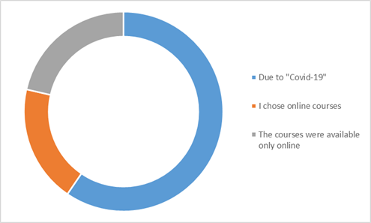
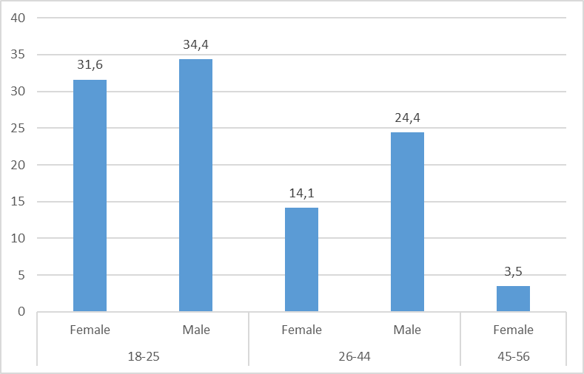
Graph 1: Graph 2:

When they were asked how they think that “Covid 19” influenced the education, according to the Graph 3, it is illustrated that there is a confusion of views. Women (31,6%) and men (37%) between 18 – 25 consider that there are negative impacts on education. Women (18,75%) between 26 – 44 believe that there is positive influenced and men between 26 – 44 (30,5%) couldn’t evaluate this situation neither positive nor negative. In addition, women between 45 – 56 (3,5%) were the opinion that there is a negative impact.
Students were asked to report how was the experience of virtual learning environment the first time, as it is shown in Graph 4, men between 18 – 25 (41%) and 26 – 44 (31%) find it not so easy to adapt in this new environment. Women between 18 – 25 (33%) find it difficult to adapt but on the other hand women between 26 – 44 (24,6%) find it easy. In addition, women between 45-56 (5%) find it very difficult.

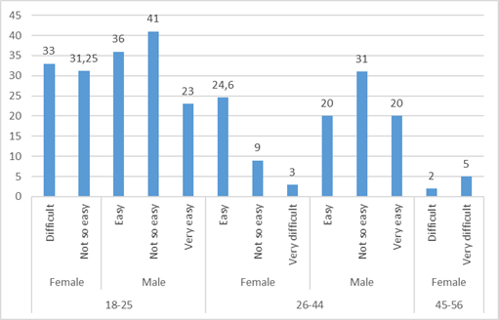
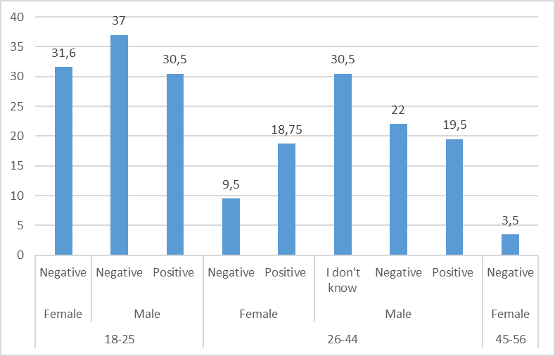
Graph 3: Graph 4:

According to Graph 5, when students were asked to report how long needed to adapt to this new environment most men between 18 – 25 (41%) needed more than two weeks to adapt and men between 26 – 44 (40%) needed more than a month. On the other side many women between 18 – 25 (32%) and 26 – 44 (19,75%) needed less than two weeks. While women between 45 – 56 (5%) needed a lot of time to adapt.
In Graph 6 students after the experience of virtual learning were required to answer if they were willing to continue learn in virtual environment or to learn in a classroom. The biggest percentage of men between 18 – 25 (38,3%) and 26 – 44 (27%) would like to continue to learn in a classroom. On the other side women between 26 – 44 (20,3%) and 45 – 56 (5%) would like to continue to learn in a virtual environment, but women between 18 – 25 (32,25%) would like to learn in a classroom.

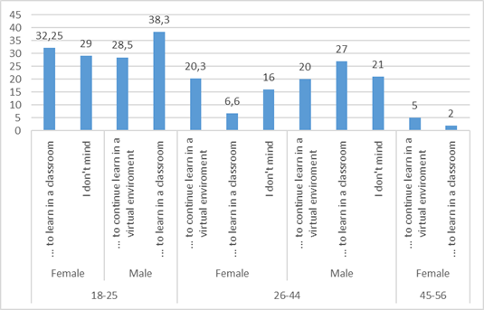
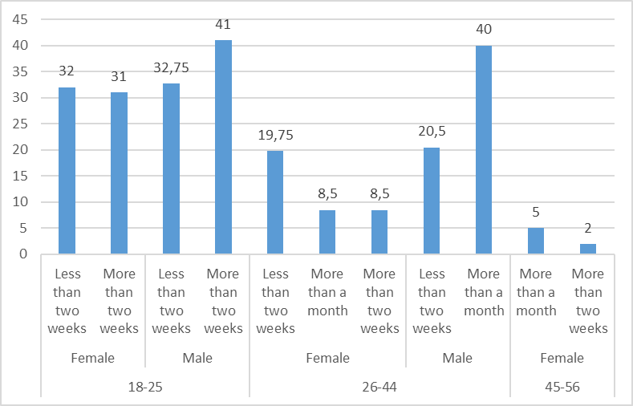
Graph 5: Graph 6:

According to Graph 7 women and men between 18 – 25 have an opposite opinion when was asking if the virtual learning environment can offer advantages to the users. Women with 46% considerate that can gain advantages while men with 47% considerate that VLE cannot offer advantages for the users. Between 26 – 44 the majority of women (18,6%) and men (25,5%) have the same positive opinion while women between 45 – 56 (5%) are not sure.
More specifically, as it is shown in Graph 8, the majority of students voted as advantages that can gain from a virtual learning environment the flexibility in learning and the possibility of saving money (from public transportation, air tickets, accommodation). Then the second advantage that was voted is the facilitation of people with disabilities. In addition, through this process the students encouraged their independent learning and developed new skills. Finally, the minority voted as advantage that through VLE students can combine work and courses more convenient.

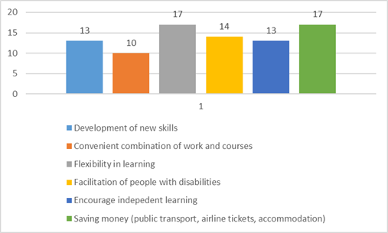
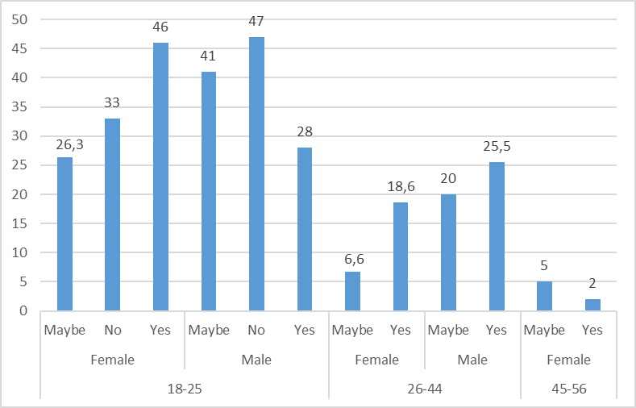
Graph 7: Graph 8:

The disadvantages in Graph 9 clearly illustrate that most students report that through VLE there is lack of social interaction, isolation, and lower quality of communication. Moreover, this process it is uncomfortable technologically for some people, virtual learning it is not suitable for all learners and there are high demands of self-discipline.
To the question if the students would prefer the educational system to remain digitized in the future the biggest percentage voted positive. A big part could not decide, and a small part voted negative, according to the Graph 10.

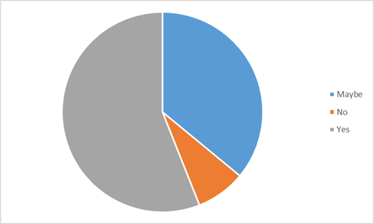
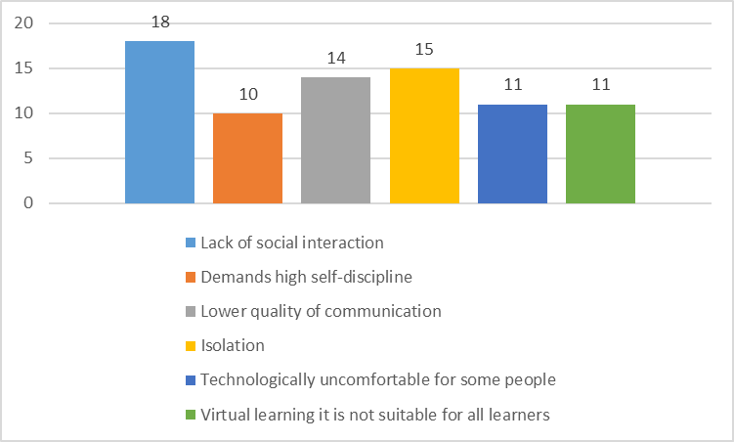
Graph 9: Graph 10:
Students who were asked how will affect the VLE the worldwide world in the future, the majority answered that this process will familiarize the people with the technology and through that online working will advance. In addition, they state that existing jobs will be replaced by technology, new jobs will appear, new criteria for jobs will be required and increase of social distance, as it is shown Graph 11.
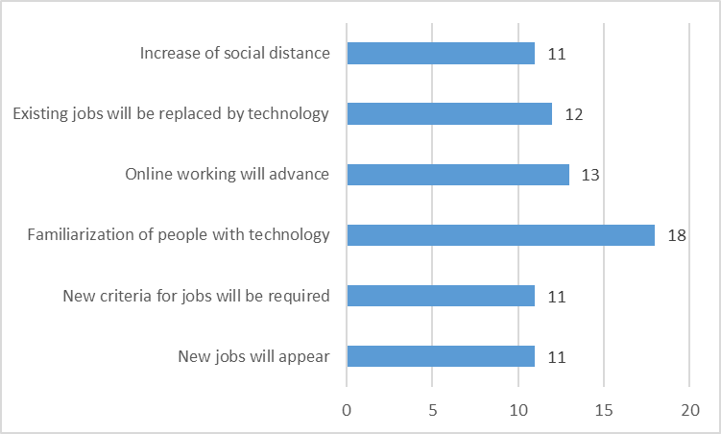
Graph 11:
This questionnaire, however, has its limitations. The relatively small sample could not be entirely reflective of most online students. Furthermore, because Covid 19 has created a state of uncertainty and exhaustion due to lockdown, it is likely that the students who responded were motivated by their feelings and did not answer the questions critically.

CONCLUSIONS
In terms of social interaction and engagement, classroom learning was viewed more favourably than online learning, according to the findings of this report. Even though online courses are convenient in terms of saving time and money, many students stated that they would like to return to traditional classroom learning.
More specifically, most students considerate as advantages from VLE the flexibility in learning and the possibility of saving money (from public transportation, air tickets, accommodation), as also state Simamora (2020) in his research. On the other side the biggest disadvantages through VLE focus on the lack of social interaction, the isolation, and the lower quality of communication.
Even though Mishra et al. (2020) stated that due to "Covid 19" there is a huge evolution in education, the findings from questionnaire showed that education was influenced in a negative way. However, a big percentage would prefer the educational system to remain digitized in the future.
The impact of VLE to students is that through process they will familiarize with the technology and that online working will advance. In addition, existing jobs will be replaced by the technology, new jobs will appear, new criteria for employees will be required, but will be increased the social distance among people.

REFERENCES
Science Articles:
Al-hariri, M.T. and Al-hattami, A.A., 2017. Impact of Students’ Use of Technology on Their Learning Achievements in Physiology Courses at The University of Dammam. Journal of Taibah University Medical Sciences. Vol. 12, No 1, 82–85.
Dalgarno, B. and Lee, M. J., 2010. What are the learning affordances of 3‐D virtual environments? British Journal of Educational Technology. Vol. 41, No 1, pp. 10-32.
Dung, D. T., 2020. The Advantages and Disadvantages of Virtual Learning. Journal of Research and Method in Education. Vol. 10, No 3, pp. 45-48.
Herrador-Alcaide, T.C., Hernández-Solís, M. and Sanguino Galván, R., 2019. Feelings of satisfaction in mature students of financial accounting in a virtual learning environment: an experience of measurement in higher education. International Journal of Educational Technology in Higher Education. Vol. 16, No 20, pp. 2-19.
Kanimozhi, 2018. Virtual Learning Environment. International. Journal of Advanced Research in Computer Science. Vol. 9, No 1, pp. 11–14.
Kavanagh, M. H. and Drennan, L., 2008. What skills and attributes does an accounting graduate need? Evidence from student perceptions and employer expectations. Accounting and Finance. Vol. 48, No 2, pp. 279–300.
Martínez-Cerdá, J. F., Torrent-Sellens, J. and González-González, I., 2018. Promoting collaborative skills in online university: Comparing effects of games, mixed reality, social media, and other tools for ICT-supported pedagogical practices. Behaviour and Information Technology. Vol. 37, No 10-11, pp. 1055-1071.
Mishra, D. L., Gupta, D. T. and Shree, D. A., 2020. Online Teaching-Learning in Higher Education during Lockdown Period of COVID-19 Pandemic. International Journal of Educational Research Open. Vol. 1, 100012.
Nambiar, D., 2020. The International Journal of Indian Psychology. The impact of online learning during COVID-19: students’ and teachers’ perspective. Vol. 8, No 2, pp. 783-793.
Rahmany, R., Sadeghi, B. and Chegini, A., 2014. Normalization of CALL and TPACK: Discovering teachers’ opportunities and challenges. Journal of Language Teaching and Research. Vol. 5, No 4, pp. 891-900.
Simamora, R.M., 2020. The Challenges of Online Learning during the COVID-19 Pandemic: An Essay Analysis of Performing Arts Education Students. Studies in Learning and Teaching. Vol. 1, No. 2, pp. 86-103.
Sneha, J.M. and Nagaraja, G. S., 2013. Virtual learning environments: a survey. International Journal of Computer Trends and Technology. Vol. 4, No 6, pp. 1705-1709.
Zhu, L. C., Wang, N. and Du, Y. T., 2020. Research on the Influencing Factors and Promotion Strategies of Online Learning Satisfaction of College Students. Journal of National Academy of Education Administration. Vol. 5, pp. 82−88.
Online Resources:
Li, C. and Lalani, F., 2020. The COVID-19 pandemic has changed education forever. This is how. World Economic Forum. [Online]. [Access 15 April 2021]. Available at: https://www.weforum.org/agenda/2020/04/coronavirus-education-global-covid19-online-digital-learning/
Oxford University Press, 2015. Learn about virtual learning environment. Course Management System content. [Online]. [Access 12 April 2021]. Available at: http://tinyurl.com/o54enla

APPENDIX
- Table
Questionnaire about Virtual Learning Environment
- Sex
- Female
- Male
- Age
- 18-25
- 26-44
- 45-56
- 57-75
- Do you know what virtual learning means?
- Yes
- No
- Did you have any experience of learning in virtual environment?
- Yes
- No
- If you picked the answer “Yes” for which purpose, did you use it?
- Educational
- Professional
- Personal reasons
- How do you think "Covid-19" influenced the education?
- Positive
- Negative
- I do not know
- Why did you attend any course in a virtual environment?
- Due to "Covid-19"
- The courses were available only online
- I chose online courses
- How was the experience of virtual learning environment the first time?
- Very difficult
- Difficult
- Not so easy
- Easy
- Very easy
- How long did you need to adapt in this new environment?
- Less than two weeks
- More than two weeks
- More than a month
- After the experience of virtual learning would you like...
- ... to continue learn in a virtual environment
- ... to learn in a classroom
- I do not mind
- Do you consider that virtual learning environment can offer advantages for the users?
- Yes
- No
- Maybe
- Which advantages in your opinion can offer the virtual learning? (Please name up at least three)
- Flexibility in learning
- Saving money (public transport, airline tickets, accommodation)
- Development of new skills
- Facilitation of people with disabilities
- Convenient combination of work and courses
- Encourage independent learning
- Other
- Which disadvantages in your opinion can offer the virtual learning? (Please name up at least three)
- Isolation
- Lack of social interaction
- Lower quality of communication
- Demands high self-discipline
- Virtual learning it is not suitable for all learners
- Technologically uncomfortable for some people
- Other
- Would you prefer the educational system to remain digitized in the future?
- Yes
- No
- Maybe
- How will affect the VLE the worldwide world in the future? (Please name up at least two)
- New jobs will appear
- New criteria for jobs will be required
- Existing jobs will be replaced by technology
- Familiarization of people with technology
- Online working will advance
- Increase of social distance
- Other

