Student Name: Ewan Coombs
Student ID: 2003649
Lecturer’s Name: Ryan L Moule
Module Name: Ways of Perception

“Mortality (from the perspective of female and non-binary artists)”

Figures:

- Roni Horn, Pink Tons, 2009, Glass, Object: 1100 × 1200 × 1200 mm, 4514 kg

- Roni Horn, Opposite of white, v.1, 2007, solid cast black glass with fire-polished top, (height by diameter): 53.98 × 142.88 cm (21 1/4 × 56 1/4 in.), 2041.187 kg

- Helen Frankenthaler, Mountains and Sea, 1952, Oil and charcoal on unsized, unprimed canvas, 86 3/8 x 117 1/4 inches (219.4 x 297.8 cm)

- Joanna Piotrowska, Untitled (2016), 16mm film projection, 03 min

- Zanele Muholi, Beloved V (From the series “Only half the picture”), 2015, Silver gelatin print, 274 x 390mm

- Rachel Whiteread, Shallow Breath, 1988, plaster and polystyrene, 185 x 90 x 20 cm. (72 13/16 x 35 7/16 x 7 7/8 in.); weight: 305 kg.

- Dione Jones, Lapse, 2020, Polaroid I-Type Film, 350mm x 790mm

- Installation view of Exhibition

The curatorial theme which I have based my exhibition on is of mortality and the many facets which both construct and refer to it. I have chosen female and non-binary artists as to provide a new or often overlooked perspective on this thematic curatorial choice. My reasoning behind my choice of focusing on female and non-binary creatives derives from a need to contribute to the greater discussion at hand on the ongoing fracture of representation of people of colour, female, and non-binary creatives; and those apart of LGBTQIA+ groups. As emphasised as forms of curatorial activism, making a change with what is shown within the gallery space; “Full equality has not been achieved and there are still major systemic problems that need to be addressed” (Reilly, 2021)

My own sexuality and growing awareness of the need more than ever to join in on the discussions of representation and lack their off, therefore I have chosen within this exhibition to represent artists who themselves are a part of this discussion, but this is by no means stating these artists are spokespeople for each discussion but chosen highlights of just artists apart of them. It is presenting a collection of artworks from a perspective that has and still is subjected to discrimination and a lack of representation within the media.

It needs to be discussed to be brought to the fore front, through inclusion, discussion can occur, through discussion, change can be enabled, but this is only one exhibition, this is something which I can see be extended to an either travelling or biennial event, with hopes of continuation of conversation, “where society’s evolutions are shaped and charted in styles both nuanced and grand-scale, it is not always the case that proclamation equals transformation.” (Enninful, 2022), through reprisal of such an exhibition, it could act as a marker-point to perform a form of social/cultural litmus test, drawing similarities to the Guerrilla Girls report cards assessing change in inclusivity of galleries (Manchester, 2005).

These artists have experienced inequalities with representation and discrimination within the media, art world, and life in general, when taking in regard the theories outlined within ‘Curatorial Activism’, I as a bisexual white male though have experienced forms of discrimination, I still am privileged, “there is a pressing need for further curatorial activism that focuses exclusively on works by artists who are not white, heterosexual, Western males.” (Reilly, 2021), this is an issue which I feel I face, but through this exhibition, I look to highlight both artists who have, and still are facing prejudices, their mortality often brought to the forefront within the social and cultural discourse, “to reveal the structures and operations that tend to marginalize certain kinds of artistic production while centralizing others.” (Nochlin and Grant, 2021). It is through mortality that these issues are brought into discussion with the audience. Through primarily nonfigurative works (with exception to Muholi (figure 5.) and Jones (figure 7.)), and a ‘rhizomatic’ exhibition structure (Colebrook, 2001), it is allowing these narratives to play out and enter the spectators view all whilst encourage audience to interact and look longer than typically expected within a smaller space, “visual judgments are not contributions of the intellect, added after the seeing is done. They are immediate and indispensable ingredients of the act of seeing itself.” (Arnheim, 1956).

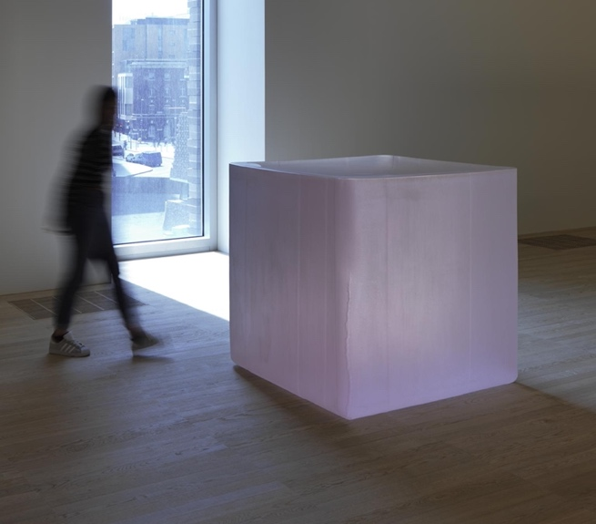

Figure 1.
(Tate, 2016)

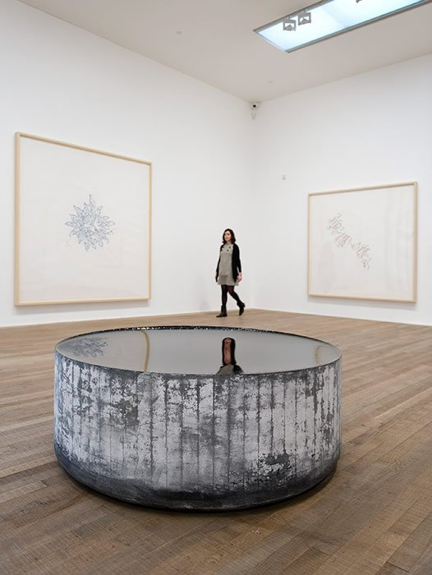
Figure 2.

(Tate, 2009)

Below is an accompanying digital playlist, that coincides with the inclusion of a record player and set selection of records to allow both an interactive feature for the audience, with the audience enabled to change the record at their choosing, with a minimum of at least one song being played before changing. This discission to include a record player draws inspiration from both Theaster Gates exhibition ‘A Sermon in Clay’, the use of music to transcend the prescribed gallery space, “The wheel performs a similar function, acting as a proving ground, spinning out possibility in what seems like an unending circular motion or loop…” (Gates and Miller, 2021). Our experience informs our work it shapes it into something, but we are not tethered to this structure, we often transcend it, drawing reference on post-structuralist theories, “The fact that we cannot secure a foundation for knowledge means that we are given the opportunity to invent, create and experiment.” (Colebrook, 2001).

https://open.spotify.com/playlist/2PmMFYJuvLQuL0tQ2R8x7W?si=e13cfd49ae884844

(Coombs, 2022)

With this, to accompany the physical exhibition the inclusion of a QR code for gallery visitors to scan to both access further resources on the exhibition along with the digital Spotify Playlist, provides audiences with the ability to interact with out of the physical exhibition; whilst providing a call-back mechanism of sorts to the physical exhibition and the interaction of music within it.

Though a smaller gallery space in comparison to the National Gallery of London or even closer to home Glynn Vivian Art Gallery; Mission Gallery originally ‘St Nicholas Church’ a Seaman’s Mission built 1868, (About Mission Gallery, n.d.). It becomes a personal space, a retaining of the original humanistic feeling, the physical gallery can become a construct for formation of thought, “the line, mass, space, and coherence of the form itself—as we transcribe the compositions of physical contours “into terms of ourselves and ourselves into terms of architecture.”” (Hart, 2016).

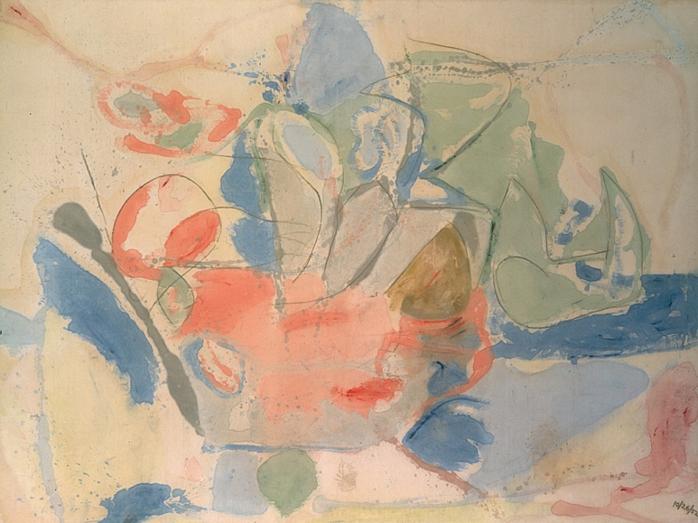
Figure 3.

(Guggenheim Bilbao, n.d.)

I have chosen this work for its raw ability to make sense through the abstract a merger of the sense of nature through the stain, these swathes of colour, put you at peace, they come from the mountains and the sea, this is something that is tranquil, but can it hold a sense of the unpredictable. “My work is a not a matter of direct translations, but something is bound to creep into your head or heart” (Mattison, 2010). A change of a tide, the cracking of the rock face can place our presence in these environments in harm’s way, but we are also reminded that we are not in control, we are but purveyors. Frankenthaler’s work comes from a period in the abstract expressionist period where women painters were often pushed aside with focus given to the hypermasculine action paintings of Pollock or De Kooning. Frankenthaler’s paintings I found embodied how nature is something that is wrought with both beauty and death, the pure exhilaration of colour, the tell-tale signs of pigment soaked into raw un-primed canvas, this scale of the work something almost overwhelming in its exploration of nature, it places us within a space; this intrinsic endowment undo the viewer gives one a sense of placement within one’s own reality.

In conversation with this, is the work of Roni Horn (figures 1 & 2.) and Rachel Whiteread (figure 6.), their sculptural dialogue of the subversion of materiality’s. Horn’s structures, solid masses that are both divisive in their materiality, and its usage of space; the presence it can take on, its physicality disrupts the space both in movement but also in visual interplay of light. This blot on the landscape, the radiance of light from the apse of the gallery, it almost becomes a reflecting pool of sorts to allow the audience to investigate the sculptures as how we may gaze unto the ocean. “Looking though the surface, into the depths of the casting, you can examine the cracked glass and understand the vulnerability in the otherwise stolid structural mass.” (Harty, 2010). ‘Shallow breath’, a rectangular mass lent against a whitewall, almost tilted on a moment of collapse, it can have connotations of the collapsing lung or figure, the slouch of the mattress, this work comes not long after the death of Whiteread’s father by Heart failure, this work a statement or vistas to memento mori, “The objects employed by Whiteread are utilitarian, generic things that belong to a whole post-war generation. The loss she speaks of is collective rather than personal” (Mullins, 2017). Her work become “Distillations of life” (Gross, 2004).

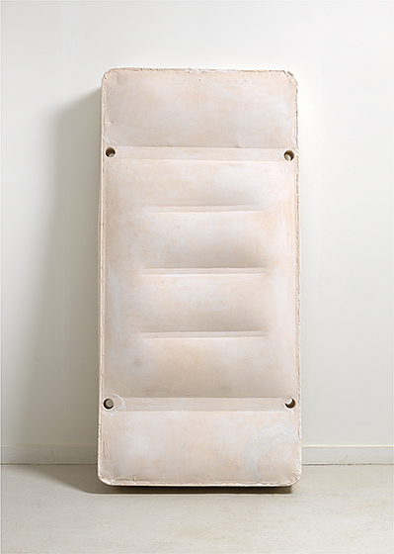
Figure 6.
(Whiteread, n.d.)

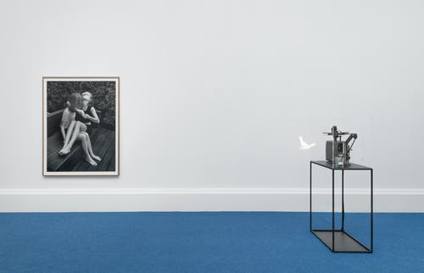
Figure 4.
(Tate, 2019)

Joanna Piotrowska performative documents (figure 4.) once placed in the inlet provide a further auditory interaction with the clicking of the film passing through the projector, we see a figure mapping out parts of their body, “‘target areas of the body’, candidly exposing her vulnerability, staging a defenceless self.” (Piotrowska, 2021), this revelation of the artworks meaning in contrast to its visual nature, transporting us from an initial reading of some meditative actions to a rereading of a women training themselves, to protect themselves, it is this subversive reminder of many woman’s realties, as reflected in the multitude of criminal case where women were target with one example being the murder of Sarah Everard (Laville, 2022). Piotrowska’s work looks to bring both this global issue into continued discussion, “We need to defend ourselves and use our bodies as a weapon.” (Judah and Piotrowska, 2019).

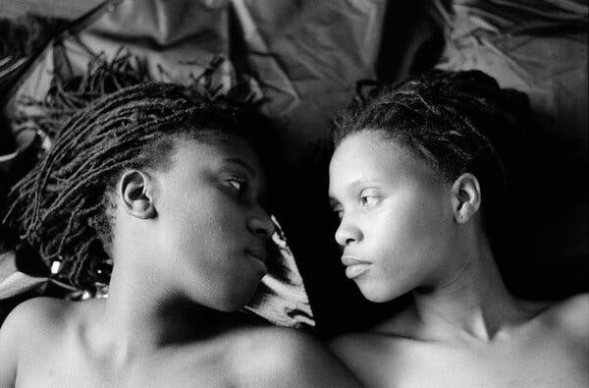
Figure 5.

(Muholi, 2005)

Muholi’s work as previous denoted is both a record for the future, something which in context of the artists own experience as a non-binary lesbian creative of South African heritage, their subjects, and models of their photographs themselves have been killed for being the ‘other’, it is through fear of both death and persecution, but the fight for one’s voice; “we cannot be denied existence.” that Muholi (Muholi, 2017). That this work brings forth a glimpse of positive change, for this motion has not ceased, the fight for one’s voice, one’s representation; “[T]he relationship between photography and reality is not perfect evidence but it is nonetheless a substantial link to what-has-been, like a footprint or a death mask” (Taylor 1999, p296, cited in Sealy, 2019). In dialogue with this work, Jones’s exploration of the degradation of one’s medium, and dissociation of one’s identity to take on an externalised introspection, their destruction of the conventions of photography, pealing the developed emulsion from its ‘bed’ of sorts, gives to the work, a physical mortality of the medium, this intended damage and thus manipulation of chosen medium gives way to a new way of expressing ones emotional identity and placement in their life, it is something both tender and abrasive. For it is giving the work a structure or timeline of existence, for natural degradation is enabled to come into play; “to play with reality, separating myself from my form and then reconnecting it again. A barrier between myself and my inability to articulate in words the state of my being.” (Jones, 2021). Muholi and Jones’s personal connection and interplay with their use of photography gives way to new ways of perceiving life as we know it.

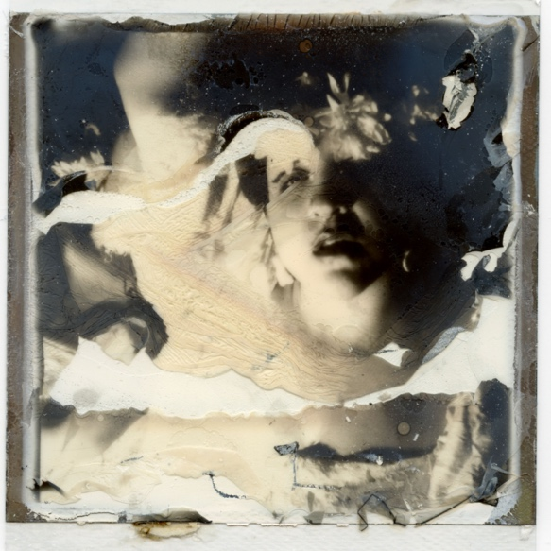
Figure 7.

(Jones, 2020)

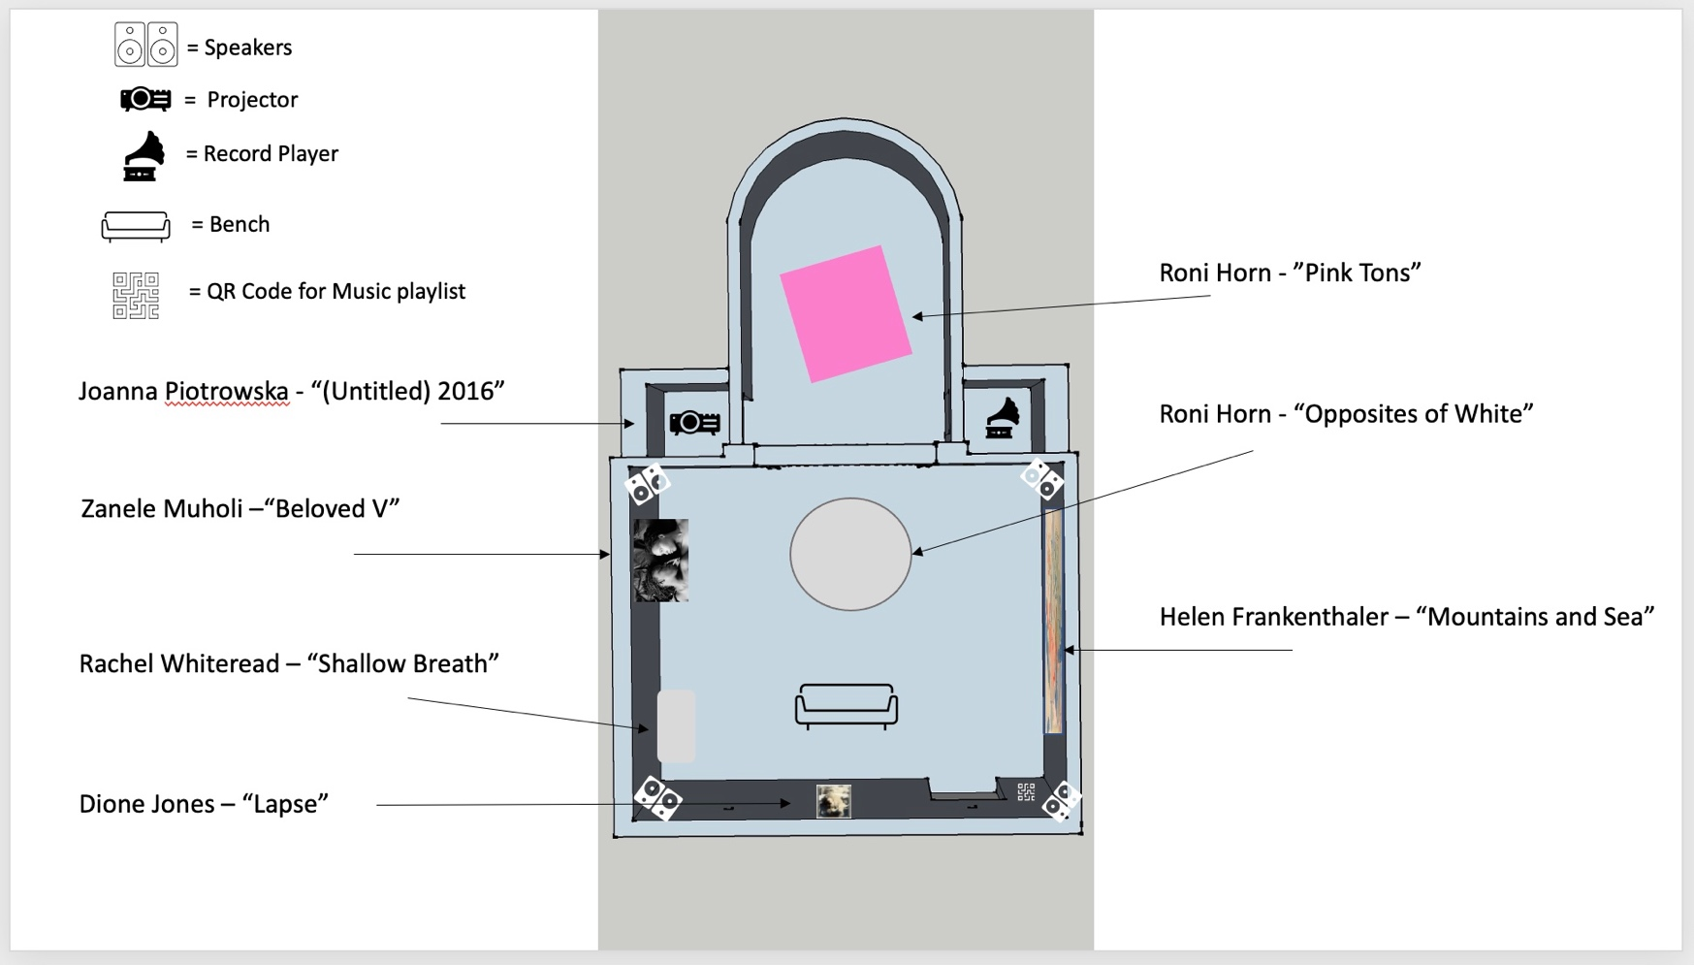
Installation View:
Figure 8.

Bibliography:

Images

Jones, D., 2020. Lapse. [image] Available at: <https://www.instagram.com/p/CGHuR7OFlVu/> [Accessed 13 March 2022].

Guggenheim Bilbao, n.d. Mountains and Sea, 1952 Oil and charcoal on unsized, unprimed canvas. [image] Available at: <https://www.guggenheim-bilbao.eus/en/exhibitions/after-mountains-and-sea-frankenthaler-1956-1959> [Accessed 6 February 2022].

Tate, 2016. Pink Tons, Glass, 2009. [image] Available at: <https://www.tate.org.uk/art/artworks/horn-pink-tons-t14525> [Accessed 31 January 2022].

Tate, 2009. Opposite of white, v.1 2007 Solid cast glass. [image] Available at: <https://www.tate.org.uk/whats-on/tate-modern/exhibition/roni-horn-aka-roni-horn/roni-horn-aka-roni-horn-explore-21> [Accessed 31 January 2022].

Tate, 2019. Installation views, Art Now: Joanna Piotrowska All Our False Devices. [image] Available at: <https://www.tate.org.uk/art/artists/joanna-piotrowska-28684/conversation-joanna-piotrowska> [Accessed 8 March 2022].

Muholi, Z., 2005. “Beloved V, 2005”. [image] Available at: <https://artblart.com/tag/zanele-muholi-beloved-v/> [Accessed 8 March 2022].

Whiteread, R., n.d. Shallow Breath, 1988, plaster and polystyrene. [image] Available at: <https://www.nga.gov/features/slideshows/rachel-whiteread.html#slide_1> [Accessed 31 January 2022].

Websites

Coombs, E., 2022. Mortality Exhibition Playlist. [online] Spotify. Available at: <https://open.spotify.com/playlist/2PmMFYJuvLQuL0tQ2R8x7W?si=e13cfd49ae884844> [Accessed 7 March 2022].

Jones, D., 2021. Dione Jones — On your face. [online] Onyourfacecollective.org. Available at: <https://onyourfacecollective.org/Dione-Jones> [Accessed 13 March 2022].

Gates, T. and Miller, M., 2021. Soul Man: A playlist inspired by Theaster Gates and guest DJ Jason Moran. [online] Whitechapel Gallery. Available at: <https://www.whitechapelgallery.org/about/blog/soul-man-a-playlist-inspired-by-theaster-gates-and-guest-dj-jason-moran/> [Accessed 22 February 2022].

Harty, K., 2010. Opening: Roni Horn’s cast glass sculptures at Boston’s ICA | UrbanGlass. [online] UrbanGlass. Available at: <https://urbanglass.org/glass/detail/opening-roni-horns-cast-glass-sculptures-at-bostons-ica> [Accessed 14 March 2022].

Hart, R., 2016. Architecture: The Body-Centered Art - Metropolis. [online] Metropolis. Available at: <https://metropolismag.com/viewpoints/architecture-the-body-centered-art/> [Accessed 14 March 2022].

Judah, H. and Piotrowska, J., 2019. 'We need to use our bodies as weapons': Joanna Piotrowska's unsettling family photographs. [online] The Guardian. Available at: <https://www.theguardian.com/artanddesign/2019/mar/07/we-need-to-defend-ourselves-joanna-piotrowska-family-photographs-tate-britain> [Accessed 7 March 2022].

Laville, S., 2022. A year after Sarah Everard’s murder, we’re talking directly to men. But it’s not enough | Sandra Laville. [online] The Guardian. Available at: <https://www.theguardian.com/commentisfree/2022/mar/03/sarah-everard-murder-government-ad-campaign-male-violence-abuse> [Accessed 15 March 2022].

Manchester, E., 2005. Guerrilla Girls "Guerrilla Girls’ 1986 Report Card" 1986. [online] Tate. Available at: <https://www.tate.org.uk/art/artworks/guerrilla-girls-guerrilla-girls-1986-report-card-p78808> [Accessed 15 March 2022].

Mission Gallery. n.d. About Mission Gallery. [online] Available at: <https://www.missiongallery.co.uk/about/> [Accessed 22 February 2022].

Muholi, Z., 2017. ‘Photography saved my life’ – the year-long exposure of visual activist Zanele Muholi. [online] The Guardian. Available at: <https://www.theguardian.com/artanddesign/2017/jul/14/zanele-muholi-365-protest-photographs> [Accessed 14 March 2022].

Books

Arnheim, R., 1956. Art and visual perception: A psychology of the creative eye.. Berkeley: University of California Press, p.2.

Colebrook, C., 2001. Gilles Deleuze (Routledge Critical Thinkers). 1st ed. London: Routledge, p.15, 169.

Gross, J., 2004. The Art of Rachel Whiteread. 1st ed. London: Thames & Hudson Ltd, p.35.

Mattison, R., 2010. Helen Frankenthaler Paper is Painting. 1st ed. London: Bernard Jacobson Gallery, p.5.

Mullins, C., 2017. Rachel Whiteread (Modern Artists Series). 2nd ed. London: Tate, p.12.

Nochlin, L. and Grant, C., 2021. Why have there been no great women artists?. 1st ed. London: Thames & Hudson Ltd, pp.110.

Piotrowska, J., 2021. Stable Vices. 1st ed. MACK, p.8.

Reilly, M., 2021. Curatorial Activism: Towards an Ethics of Curating. 2nd ed. London: Thames & Hudson Ltd, p.36, 165.

Sealy, M., 2019. Decolonising the camera: Photography in Racial Time. 1st ed. London: Lawrence & Wishart, p.104.

Magazine

Enninful, E., 2022. British Vogue’s February Issue Celebrates The Rise Of The African Model. Vogue, [online] (February 2022), p.26. Available at: <https://www.vogue.co.uk/news/article/february-2022-vogue-editors-letter> [Accessed 15 March 2022].

