Vasile Ene
1817171

DISSERTATION
HOW ARE BUSINESS STRATEGIES AND DECISIONS AFFECTED BY THE MANAGEMENT OF DEMOCRATIC OR AUTOCRATIC LEADERSHIP? A CASE STUDY OF THE LONDON HEATHROW MARRIOTT HOTEL

UWTSD
module leader: Dr Anupam Mazumdar
lecturer: Tushara Balendran

Abstract

Through this paper, we want a study about leadership, their influence on the decisions and strategies assumed, new methods between directive leadership and accountability regarding work, behaviour at the workplace and their moderator role, especially in the past and the affected present of the COVID-19 pandemic. During the study, it is analysed how a certain democratic or autocratic leadership style can influence the strategy and most of the business decisions that are made in an organization. In this study to present the most popular approaches to leadership, together with the concept of positive leadership, and through this way of leadership the way in which it influences the effectiveness of the activity within the organization. For the study we proposed the London Heathrow Marriott Hotel. The research was carried out with the help of 25 employees of this organization who were chosen by the convenience sampling method because it was desired that a smaller number of participants act as a representative sample. Following the study, the collected data research, they were analysed using MS Word and Excel and the results are presented using tables and diagrams. Thus, it was established that the leadership style adopted by the organization is the democratic leadership style, in this way the organization succeeds through this approach in offering increased motivation to employees who, through diversity and by including employees in assuming certain decisions, managed to improve the performance of the organization. The study further recommends the adoption of various employee training programs to increase employee awareness of their roles and responsibilities while implementing democratic leadership models. Further research is also recommended to assess how other leadership styles influence organizational decision-making and strategy.

Acknowledgment

I want to thank God for the strength with which he has endowed me to see this project completed successfully, for the patience and understanding with which I was guided in this study by my supervisor, and finally, I thank my colleagues and everyone who was involved in this study as well as the family that supported and motivated me throughout this period.

Table of Contents

Abstract 2
Acknowledgment 3
Introduction 8
Background of London Heathrow Marriott Hotel 9
Background of the study 10
Statement of the problem 10
Research aims and objectives 12
Importance of the study 12
Literature review 13
Conceptual framework 17
Methodology 18
Findings 23
Discussion of the findings 28
Conclusion 30
Recommendations 31
References 32
Appendices 35

List of tables
Table 1: Questionnaire return rate 23
Table 2: Gender of the respondents 24
Table 3: Respondents’ period of service at the organisation 25
Table 4: Leadership styles utilised by the organisation 26
Table 5: Impact of democratic leadership on decision-making and strategies 27
Table 6: Influence of democratic leadership style on employee performance and motivation 27

List of figures
Figure 1: Conceptual framework 17

List of charts
Chart 1: The gender of the respondents 24
Chart 2: Respondents’ period of service 25
Chart 3: Leadership styles by the organisation 26
Chart 4: Impact of democratic leadership on decision-making and strategies 27
Chart 5: Influence of democratic leadership style on employee performance and motivation 28

Chapter 1

1.1 Introduction
The main objective of an organization or a company is to make profit or achieve its stated objectives to satisfy the needs of consumers, company employees as well as company shareholders. Achieving goals in today's fast-paced world can be an elusive goal for any organization. Because of the alert environment, many things out of control can lead to economic, social, and environmental imbalances. Any crisis of any nature and in any area or region, such as Russia's war against Ukraine in South-East Europe or the recent global crisis triggered by the coronavirus pandemic, which brought the world to a standstill, can affect any organization, regardless of the nature , its shape or size, and can disrupt and affect the business environment, members of any organization, consumers, up to undermining the political environment, regional or global instability. For these moments of instability, organizations are looking for effective management solutions. The activity carried out by the attitude managers, the actions of the leaders, the efficient use of experts and the training of the staff, together they can prevent the impact of these crises on the organization or company. The most important resource of an organization are its employees, they must be led in this competitive business system by the leaders or managers of these organizations using this important resource effectively through their actions and decisions. Shafie et al. (2013) describes that the most important asset of a business is the employees, who are the most important resource of any firm, because they are the main factors and give life to the business and provide goals, from which they can gain a lot of benefits is business leadership.
Xu & Wang, (2008) say that the importance of leadership in an organization is essential in creating a vision, mission, determining and setting goals, designing strategies, policies, and methods to achieve the organization's goals effectively and efficiently, along with directing and coordination of organizational efforts and activities. Due to the problems faced by organizations, many of their actions can be associated with unethical practices towards the employee, financial management that can destabilize the organization and all of them can have a common denominator, that is ineffective management or leadership. Harris, et al. (2007) say that high-quality leadership is essential to accomplishing the mission and vision, along with coping with changes in the external environment. According to Igbaekemen and Odivwri (2015) leadership is the ability to transform the vision of an organization into reality. It comes from a point of view of social influence and not of power. An effective leadership an effective leader, a rigorous management can improve the performance of the organization in today's business environment. The business environment is increasingly evolving, and the customer environment is becoming more diverse. Furthermore, the London Heathrow Marriott Hotel is currently seeking to expand and establish its operations into the UK market which presents it with an even more diverse operating environment. To enhance the adoption of a democratic leadership style into the new markets, the organisations can also adopt a local employee acquisition strategy where the employees selected to operate local markets will be obtained from the local community. This will help the organisation empower the local community and effectively establish itself in the new markets. Furthermore, the organisation may adopt an employee training program to enhance employee knowledge about democratic leadership responsibilities and skills to enhance success. Since this research has adopted a case study strategy, it is recommended that further studies be conducted on other organisations and sectors to provide a broader perspective on how democratic leadership affects other organisations. Denscombe (2017), states that successful performance in business today is largely based on the leadership strategies and approaches adopted. Boal and Hooijberg, (2001); Osborn, Hunt and Jauch, (2002) as well as Porter and McLaughlin, (2006) say that these challenges come from areas such as emerging technologies, newly discovered technologies and globalization, has led to a significant increase in the exchange of goods in search of new markets of selling products, the rapid exchange of information and various communication channels, in addition to the life cycles of services and products are significant changes and all this in a business world hit by various crises, stronger or not but leading to a relationship important between leader and employee. As a result, leaders in various organizations continue to face numerous difficulties and challenges, Bhargavi and Yaseen (2016) also argue.
Faced with these major changes faced by organizations, their leaders adopt different management approaches, the choice of subordinates who can lead to the fulfilment through decisions and strategies of the organization's objectives and improve the adaptability and efficiency of employees at work. Building on this theoretical overview, this research seeks to explore the democratic leadership approach and how it affects organisation decisions and strategies, with a focus on the London Heathrow Marriott Hotel.

1.2 Background of the London Heathrow Marriott Hotel
The London Heathrow Marriott Hotel is part of the Marriott Resorts and Hotels International Brand. The hotel is considered to be one of the best in London, with easy accessibility and state-of-the-art features including digital keys and smart rooms. The company is guided by a unique operational model called the Marriott way which is built around people, products, excellence, and sustainability (Marriott, 2022). The brand has been able to establish a strong reputation and market position not only due to the excellent services and products provided to its consumers but also in the way the organisation incorporates its employees in the decision-making and daily running of the organisation. According to Liu, (2020), employees at Marriott are considered to be partners in the company and their opinions are always taken into consideration whenever the company is formulating new policies. Due to this, the company has been able to record minimal employee turnover – according to a report by Fortune Magazine released in 2020, the Marriott brand has one of the lower employee turnover rates in the hospitality industry at 18% (Fortune, 2020). These characteristics make Marriott the best-case organisation for the study.

1.3 Background of the study
Organizational performance includes organizational results that are measured in terms of desired results, targets and objectives. In this direction, decisions are made within an organization regarding how the best strategies can be applied to improve organizational performance (Arham, 2014). Leadership creates a strong impact on the attitude of employees working in the organization. There is considerable impact of leadership styles on organizational performance. Leadership style influences organizational culture which in turn influences organizational performance. Style influences the strategies that are used in leading an organization. Various leadership styles have different strengths and weaknesses, and using an effective style helps promote organizational success (Igbaekemen, 2014). In this regard, this study aims to understand the democratic leadership style and how it affects decisions and strategies. Conducting this study is crucial to conclude whether the style is an effective one for the company and the hospitality industry.

1.4 Statement of the problem
Harris et al (2007) established that leadership style can be defined as the type of relationship that is used by an individual to get people to work together for a common goal or objective.
Those who lead the organization can have a decisive role in success, employee satisfaction and employee engagement. Some researchers have concluded that by using effective leadership styles, leaders inspire and enable their staff to be successful (Bhargavi and Yaseen, 2016).
Mitonga-Monga & Coetzee, (2012) say that leadership has a direct effect on the success of an organization and is seen as a combination of different characteristics, traits and behaviours that are used by leaders to interact with their subordinates.
Leaders by the decisions they make, the way they manage to pass on job duties to subordinates through human relationships. together they establish and create the environment and smooth functioning of an organization's performance (Van Wart, 2013). According to Arham (2014), the influence of leaders and their effectiveness in moving people towards a shared vision shapes an organization and consequently performance.
There are numerous theoretical studies that investigate the influence of different leadership styles on the performance of the organization, and this paper also makes its modest contribution to the enrichment and elimination of a gap in the specialized literature due to the period of the Covid-19 pandemic, as well as the current war in Ukraine.
There are minimal supported empirical studies that investigate the association between leadership styles and organizational performance, especially during this period, and previous works are subject to contextual limitations due to new external factors. Leaders during crises are those who hold many roles and tasks under the pressure of constraints. of time and resources. Therefore, for effective crisis management, leaders must have “a complex leadership skill”, (Mutch, 2015).
Therefore, this study attempts to bridge this gap by investigating the influence of democratic or autocratic leadership styles on strategic decision making and organizational performance, with a focus on the London Heathrow Marriot Hotel.

1.5 Rationale of the study
In the previous periods, the world faced several crises in various forms and aspects of life, but the COVID-19 Pandemic produced a new type of crisis that surprised everyone by its nature and by the negative effects it brought, and they succeeded. It affects not only a certain area or region, but the whole world on a global scale. For this type of crisis, in order to survive, companies must have effective crisis management to ensure their continuity and operation.
This study aims to explain how the management team can face the crisis period and how the quality of communication in the organization plays an important role in the effectiveness of the measures taken by the leadership. The Covid-19 pandemic has amplified the importance of effective leadership styles on business performance, as only those organizations that were able to take quick leadership actions were able to respond effectively to the impact of the pandemic.
In Great Britain as well as all over the world, the COVID-19 pandemic hit a lot of businesses in different industries and disrupted economic activities at national and international level. Due to the lockdowns instituted as measures to prevent the spread of the pandemic, the circulation of tourists at the local, regional, and global level has dropped drastically and travel agencies, airlines and the hotel industry have recorded colossal losses and a dramatic decrease in the number of customers.
This study aims to help inform those who are able to make decisions and those who manage organizations regarding the ways to effectively implement strategic leadership styles to help better anticipate the measures that are required following the global events that will follow. In addition, it will also help other organizations to use information for effective management, and the restoration of organizations by returning to normality after the long Pandemic period. In addition, scholars and researchers can also build upon and critique research findings and discussions while conducting future research.
As I said before, due to these events with global impact and recently some ongoing ones create deficiencies in the data from different fields, the information, the studies are missing, thus gaps are discovered in the specialized literature in all economic and business fields, environmental and political.
The dissertation is a study on the advantages and disadvantages of the different strategies that leaders, managers in the field of accommodation and hospitality have adopted during the crisis as a frugal measure or try to find the solution that will direct the industry of hotels, hostels, and hospitality towards the return to normality, to the period before Covid-19. The drastic decrease in hotel activity through the reduction of tourism and circulation at the global and regional level has forced agencies, hotels, in fact the entire industry in the field to adopt drastic measures to reduce employees, to close hotels, hostels, restaurants and everything that involves the industry of tourism. The reduction of the number of active personnel as well as keeping the connection with the one who was laid off pending the resumption of the activity made leaders and managers the people who, through the actions undertaken and the decisions adopted, managed to motivate their employees and the pandemic period to be overcome and thus the activity to return to normality. This study is not accidental because I want to combine the knowledge of Business Management with the hotel and hospitality field to achieve a career in the future. The study and deeper knowledge of the motivation of those who work in the industry, their hopes and expectations will develop my knowledge in this field, and this can contribute to my professional and personal development. All the data and information in the field can ensure my chance of success in this industry.

1.6 Research aims and objectives
This research aims to investigate how business strategies and decisions are affected by democratic or autocratic leadership, with a focus on the London Heathrow Marriott Hotel. In realising this aim, the study is guided by the following objectives:
- To investigate the leadership style utilised by the London Heathrow Marriott Hotel.
- To investigate the impact of the selected leadership style on decision making
- To investigate the influence of chosen leadership style on employee performance and motivation

1.7 Research questions
- What is the leadership style utilized by the London Heathrow Marriott Hotel?
- What is the impact of the selected leadership style on decision-making and strategies?
- What is the influence of chosen leadership style on employee performance and motivation?

1.8 Chapter overview
This dissertation is made up of five chapters.
The first chapter provides an introduction to the research problem with details on the case organisation and the research objectives.
The second chapter is the literature review and provides an overview of the literature collected from peer-reviewed articles, journals, and previous studies in relation to the study’s dependent and independent variables.
The third chapter is the methodology section which offers an analysis of the research design, research philosophy, and approach together with the methods of data collection and analysis.
The fourth chapter is the data analysis and discussion section; the analysed data is represented using tables, charts, and graphs and the later section of the chapter provides a research discussion where primary and secondary data are compiled to determine the extent of association between the study variables.
The five chapter – the final chapter – provides the study’s conclusion and recommendations.

Chapter 2

2.1 Literature Review
This chapter will review the set of both theoretical and conceptual frameworks that are the basis of the conclusions and discussions from the study carried out on the different management styles approached by the leaders of the organizations as well as the results or performances of the organization due to the decisions taken by them. From the past to the present leadership has been theorized, analysed and these older and contemporary approaches will be identified for a better understanding of the subject. For any organization, it is imperative to have a management that, through communication skills with employees, by motivating and empowering them, contributes to the success of the organization.

2.2 The Concept of Leadership
According to Ibrahim and Daniel (2019), leadership is the ability of an individual to lead a group of people towards the achievement of an organization's mission. Sethibe (2018) further states that leadership includes a wider scope of responsibility compared to traditional management approaches. Gains et al., (2020), on the other hand, define leadership as the ability to be flexible enough to realize when to use different approaches in addressing different problems within the organization. The authors further state that today's business environment is influenced by numerous and volatile external factors and the success of an organization is defined by the ability of its leaders to shape different approaches to suit different situations. This research adopts the definition of leadership presented by Sethibe and Steyn, (2017) who define leadership as the ability of individuals to make decisions and provide direction to other individuals in a professional manner. To become a leader, it is important to identify the most effective leadership model and apply it to a specific set of people and situations.

2.3 The Difference Between Leadership and Management
According to Bargau (2021), management and leadership have similarities, but they also have important differences, so they are not the same thing, they are distinct as an approach to leadership. Liphadzi et al., (2017) states that exceptional leadership is based on creating an environment where every employee feels motivated to develop and become better and Kotterman, (2016) says that managers always focus mainly on using maximum use of tangible resources, such as equipment, to achieve productivity. While managers come up with structures and delegate responsibilities and authority, leaders focus on providing strategic direction to facilitate the achievement of set goals and inspire employees to perform. According to Bargau, (2021) the employee is put at the centre of decision-making management focuses mainly on establishing relationships, listening to the needs of employees, teamwork, persuasion and motivation. Contemporary leadership theories increasingly define leadership as a dynamic, shared social process, rather than a quality of specific individuals per se (Avolio, Walumbwa, & Weber, 2009). An organization must ensure a balance between management and leadership to achieve maximum performance.

2.4 The Qualities of an Effective Leader
Some people believe that leaders are born – naturally influential, charismatic and inspiring. Basefsky et al., (2018) argue that even with the possession of exceptional leadership traits, it is important for an individual to cultivate and shape these traits in specific situations to improve performance.
According to Bachiochi et al., (2020) leadership is characterized by building trust and influencing others to accept established goals and visions.
According to Abraham Maslow's hierarchy of needs theory, different individuals manifest different needs that must be met to achieve motivation (Gawel et al., 2017). Effective leadership may require hierarchical and distributed forms of influence (Pearce, 2004). These needs are organized in a hierarchical pyramid, ranging from the most basic, such as food and shelter, to the most self-fulfilling, such as the need for status, reputation, and power. An effective leader should be able to determine the levels of needs occupied by an individual and create strategies to help the individual achieve these needs.
Transparency is the path to establishing employee trust. According to a survey by Arham and Muenjohn (2021), 80% of employees ranked integrity as the most important leadership quality. Leadership integrity demonstrates a commitment to equality and fairness.

2.5 Leadership Styles
The leadership style involves achieving a synchronization between the needs of the organization and the employees in order to achieve the established standards and objectives. Huertas-Valdivia et al., (2019) say that leadership styles provide an essential structure for explaining management approaches that suit an organization's work style and individual personalities.
The Laissez-Faire leadership style is a hands-off strategy that is underscored by a high level of trust for employees. Team members are free to take decision in their own way and leaders provide complete freedom to subordinates to work as per their own way and take major decisions (Coyle‐Shapiro, 2013). Laissez-Faire leadership style usually leads to increased chaos in the organization as every individual believe him or her as own leader (Monzani, 2015)
Democratic leadership, on the other hand, is a more participative approach to leadership that is characterized by employee involvement in decision-making. Democratic leadership is also known to motivate employees to perform better, but the big problem associated with democratic leadership is the assumption that everyone involved has an equal stake in decision-making - with a shared level of expertise (Rukmani, et al, 2010). It is an innovative and creative approach to leadership to help improve performance (Huertas-Valdivia et al., 2019).
Autocratic leadership is characterized by leadership independence where leaders do not seek the opinion of other employees when making decisions. An autocratic leader mostly makes selection based on his own judgments and ideas which rarely include the advice of followers and these leaders have absolute control over the group (Zareen, et al., 2015). This style is associated with cases that require quick decision-making in fields such as medicine.
The downside of this leadership style is that sometimes subordinates can end up feeling neglected and invisible, thus destroying their motivation to perform. This study focuses on autocratic and democratic leadership styles and a detailed presentation of the two styles is provided in the subsequent sections.

2.6 Democratic leadership style
Democratic leadership, also known as participative style, is one in which members of a group or organization are involved in the decision-making process (Jan DeBell, 2019). Democracy still allows followers to perform exemplary because there is minimal supervision, thus allowing them to develop decision-making skills. Nishi (2013) points out that the democratic leadership style has three characteristics:
1) members are encouraged to share their opinions and ideas.
2) creativity is encouraged and rewarded.
3) group members feel more involved in the decision-making process.
Even though democratic leadership is effective, it also has some shortcomings (Jan DeBell, 2019). For example, it leads to poor communication in cases where roles are not clear. Furthermore, it is not certain that the members would have the necessary expertise in decision-making; therefore, the decisions made may not be the best.
In the democratic leadership style, the potential for poor execution and decision-making is high. However, democratic leadership is also known to motivate employees to perform better because their views and opinions are valued. According to Choi (2019), democratic leadership gives employees a high rate of participation in the management of a business, thereby creating a sense of belonging and meaning. Maslow's hierarchy of needs recognizes belonging as a human need and a subsequent source of motivation (Bhatti et al., 2021). Hence, with increased engagement and a sense of belonging, employees are poised to increase their productivity.

2.7 Autocratic Leadership Style
Obiwuru et al., (2011) says that autocratic leaders usually retain their decision-making rights. Autocratic leaders are leaders by nature, they want subordinates to be docile and obedient and conform to the leader's demands. Iqbal, Anwar and Haider (2015) conducted a study to determine the impact of leadership styles on organizational performance:
1) Autocratic leadership is also known as authoritarian leadership.
2) Autocratic leaders are less creative and promote only one-sided conversation. This severely affects employee motivation and satisfaction.
3) The autocratic leadership style, however, is known to be effective in the short term.
Autocratic leadership restricts socialization and communication in the workplace, which is beneficial for effective organization and employee performance, but also, autocratic leadership leads to organizational conflicts that negatively affect overall organizational performance (Iqbal, et al., 2015).
Bhargavi and Yaseen (2016) suggested that autocratic leadership style has a positive impact on organizational performance. This leadership style is more suitable when projects need to be completed within a certain time frame, when they need to be completed on time (Bhargavi & Yaseen, 2016).
Igbaekemen and Odivwri (2015) stated that an autocratic leader is one who determines the activities, techniques and policies for employees and expects employees to follow them.
Elon Musk, CEO of Tesla, is considered one of the most successful autocratic leaders in the world (Molero et al., 2020). Elon is considered to be persistently ambitious and intensively scrutinizes any new products and ideas before implementing them (Van Engen and Willemsen, 2020). Besides being effective in situations that require instant decision-making, autocratic leadership is always associated with low employee motivation and cases of employee rebellion, as they may tend to feel suffocated by decisions made without their consent (Yao et al., 2017).

2.8 Business decision making and strategies and how they are influenced by democratic leadership styles
The strategy serves as a basis for determining the goals of an organisation (Van Wart, 2013). Organisations need to adopt various strategies to make it easier in measuring performance instead of a single strategy that can be used in the longest time possible. Decision-making, on the other hand, entails the process of selecting the best choice (Iqbal, Anwar, and Haider, 2015). There is a relationship between decision-making and business strategies because strategies are evaluated, and the best choice is selected, which is implemented within an organisation, like Iqbal, Anwar, and Haider (2015) explain.
Democratic leadership allows employees to take part in decision-making. This means that the process is impacted as every member has to be included; otherwise, decisions cannot be made with fewer individuals, as elaborated by Van Wart (2013). The style also affects decisions by giving all members equal opportunities to contribute their ideas and opinions before the best one is settled on. Therefore, the style promotes effectiveness in decision making, hence, leading to the best choices (Igbaekemen, 2014). In terms of business strategies, democratic leadership gives room to the members and their leaders to evaluate the best choices, hence, settling on the most efficient ones. Generally, the style of leadership affects strategies and decisions by taking a lot of time making consultations; however, it allows selection of the best choice, which helps in enhancing performance (Iqbal, Anwar, and Haider, 2015).

Conceptual framework
The study seeks to investigate the influence of democratic leadership style on organisation decision-making, strategies, and performance. The leadership style makes the study's independent variable while organisation decision making, strategies, and performance make up the study's dependent variable as they relied on the democratic leadership style:
Democratic leadership style – independent variable
Organisation decision-making, strategies, and performance

Figure 1: a conceptual framework
Source: (Research, 2022)

Chapter 3
3.1 Introduction
This section provides an outline of the research philosophy, the research approach, the adopted research strategy and method, the data collection methods, the sampling procedures and study sample size, the procedures for data analysis and presentation, and the study ethical consideration and limitations. In general, research methodology refers to the overall rationale and strategy adopted by the researcher throughout the research. This section is also guided by Saunders’ research onion model; the model asserts that the research methodology formulation process should provide a procedural yet holistic overview of the research process. The diagram below provides a visual representation of this model:
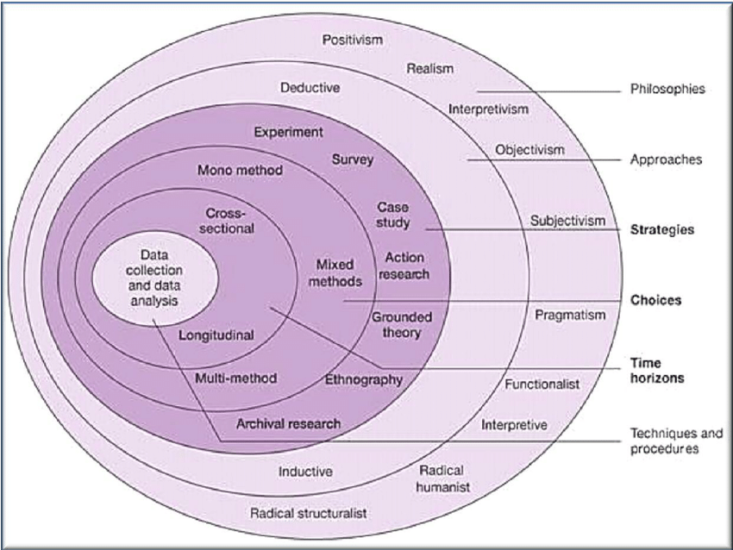
Image 1: Saunders research onion
Source: Saunders et al., (2016).

3.2 Research Philosophy
Research philosophy is the belief in how knowledge has to be generated and developed. There is positivism, realism, interpretivism philosophies (Saunders, Lewis, and Thornhill, 2016). The positivism philosophy was used because it depends on statistical analysis and depends on quantifiable observations. Positivism relies on the utilisation of quantitative information which is believed to be more reliable compared to qualitative information. Furthermore, quantitative data is more objective and gives the researcher the ability to utilise scientific assumptions in the discussions. Furthermore, positivism adheres to a well-defined structure during the process of discussions and studies giving little room for drastic changes in the variables thus enhancing the accuracy of the study.

3.3 Research Approach
The research approach encompasses the concepts important in a study (Bryman and Bell, 2015). The approaches are abductive, inductive, and deductive. The deductive research approach was used because it begins with generalising and ends up with specific observations. Furthermore, the approach focuses on testing different hypotheses and offers the researcher the possibility of explaining causal associations between different variables and concepts. Thus, with this approach, it was easier for the researcher to establish the association between democratic leadership style and organisation decision making, strategic direction, and performance.

3.4 Research Design
The research designs could be mixed, quantitative, and qualitative. By using the quantitative design, quantifiable data are collected, which are statistically analysed to reach conclusions (Creswell, 2013). This paper utilised a quantitative research design to examine and explore in-depth the experience of each individual, especially those who through their work lead the destinies of an organisation and its employees, in a given circumstance and that one event causes another event or activity. This research design provides statistical data that can be used to quantify the relationship between variables making it easy to explain the extent of their relationships. Moreover, this design provides an accurate and objective approach towards examining study variables in an easier and faster way.

3.5 Research Strategy
Research strategy focuses on how the research is conducted. The strategies include ethnography, action research, case study research, grounded theory, experimental research, and archival research (Bryman and Bell, 2015). This study used a case study strategy because the main focus is on a specific organisation- The London Heathrow Marriott Hotel. This strategy provided the researcher with an opportunity to intensively investigate the relationship between the variables as primary data was being collected from only one organisation. It also provided the researcher with an opportunity to formulate recommendations on areas of further study.

3.6 Sample size and Sampling Procedure
Sampling is how the respondents are attained to take part in the research. Numerous sampling methods can be used in research, and some of them are convenience sampling and stratified sampling (Denscombe, 2017). This research utilised convenience sampling. This is because the method allows the respondents to be part of the research depending on their availability. In regard, a sample size of 25 respondents was selected from different departments within the organisation to take part in the study. The main advantage of this sampling approach is that it gave the researcher an opportunity to select the study population based on their willingness and easy availability, ultimately eliminating any probability of missing the required number of respondents to infer to. However, this approach exposed the research process to the probability of bias as not all the respondents within the study population were given an equal opportunity to participate in the study.
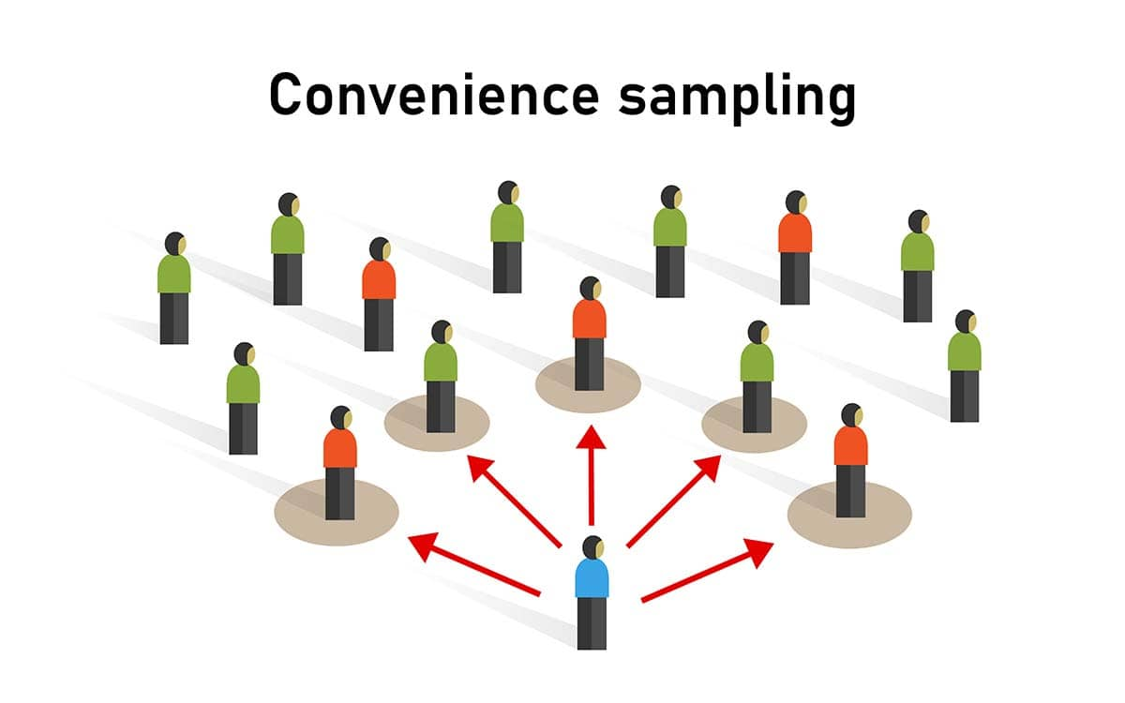https://www.simplypsychology.org/Convenience_sample.jpg
The researcher chose this method of data collection, Convenience Sampling because this technique is simple, uncomplicated, and real-time information is obtained, prompt because the answers provided by the 25 colleagues were used depending on their availability, to questions about to leadership styles. In this way researcher can gather opinions, reviews in a simple, prompt, and efficient way.
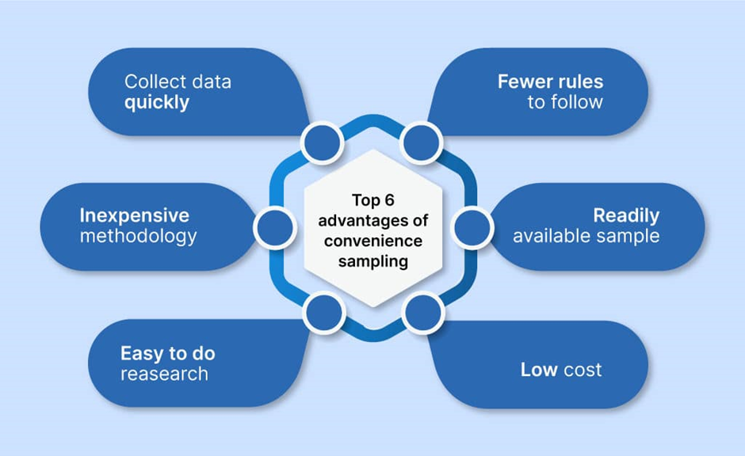
Image 2: convenience sampling approach
Source: (Denscombe, 2017).
https://www.voxco.com/wp-content/uploads/2021/03/Convenience-Sampling2-1024x628.jpg.webp
However, the result of the survey is edifying only for a part of the employees, so the result of the convenience sampling may be disturbed by the small number of respondents who can provide biased answers, this is the disadvantage of convenient sampling but can be prevented by using probability sampling in conjunction with convenient sampling.

3.7 Data Collection
The study made use of both secondary and primary data. Primary data was collected with the use of closed questionnaires while secondary data was collected from previously conducted studies, peer-reviewed articles, and journals. Questionnaires were selected because they provided the researcher with an economical approach to collecting primary data. Furthermore, they provided an opportunity for the researcher to reach out to a wide population base that could not otherwise be accessed using other data collection instruments.
To obtain the necessary information, the researcher used questionnaires as a working method because they are an effective method since their invention in the nineteenth century by Sir Francis Galton (1822-1911), it is a simple method, respondents are approached directly, standardized responses are received that make data collection and compilation easier. The questionnaires used for the research use a series of questions that the respondents have to answer and here a distinction is made between closed and open-ended questionnaires, for open-ended questions the respondent has to formulate his answer and for closed-ended questions the respondent answers by selecting the answer from a given number of answers, the researcher in this case used closed questionnaires. The closed questionnaire was made up of two sections, with the first section having two questions inquiring about the demographic information of the respondents while the second section was made up of three sets of questions – the first two question sets had three respondent sections while the last question set had twelve respondent sections. The questionnaires were prepared and distributed online through Google Forms and the respondents were given two weeks to respond to the questions.

3.8 Data Analysis
After data has been gathered, it was in-put and coded into MS Word and MS Excel tools. The results were then presented using pie charts, graphs, and tables. This helped create a simple and comprehensible presentation of the relationship between democratic leadership styles and organisation decision-making, strategies, and performance.

3.9 Research Ethical Guidelines
It is the responsibility of any researcher to ensure that research is conducted ethically. As this research was conducted in and after the pandemic, the main responsibility of the researcher was to protect respondents from being exposed to situations that could cause the virus to spread and to adhere to government regulations associated with social distancing. Therefore, the researcher designed and distributed the questionnaires through Google Forms, an online questionnaire distribution tool. Communication between respondents and the researcher was also limited to online means, such as e-mail and WhatsApp groups, and when possible, through direct survey of respondents by handing over and collecting questionnaires in person, this being possible after the pandemic period. Before the researcher engaged in collecting the primary data, respondents were provided with information about the purpose of the research and a consent form to sign. Finally, once the data was collected, the researcher saved it in a secure flash drive using a strong password to prevent it from falling into the wrong hands. The information was then ethically removed once the research was completed.

3.10 Research Limitations and Delimitations
The main limitation faced by the researcher was the probability of accessing the study participants, as most employees work in shifts or in different departments and others work from home. However, the use of a convenient sampling procedure helped the researcher to select individuals for the study by the method that was easily accessible. Among the characteristics considered were participants who worked in the same shift as the researcher and responses who worked in the same department or user accessible to the researcher. This allowed the researcher to track progress and ensure that the questionnaires were completed and returned during the stability period. The study was also at risk of inaccurate information being provided in response. To overcome this, respondents were given ethical and consent forms that required them to provide the researcher with true and correct information.

3.11 Research Time Prospects
The study was carried out for a total of eight weeks. During the time, various activities were carried out, and this included topic selection and specification of the objective, proposal writing, reviewing of the literature, research methodology writing, data collection, data analysis, report compilation, report review, and submission.

Chapter 4

Analysis and Findings
This section provides an overview of the findings including respondents' demographic information, the responses to each study variable, and a discussion of the findings. The data is presented using tables, and charts, and has been summarised using percentages.

Respondents’ demographic information
Questionnaire return rate
The table below represents an overview of the study’s questionnaire return rate:

Description | Frequency | Percentage
Issued questionnaires | 25 | 100
Filled and returned questionnaires | 25 | 100
Unreturned questionnaires | 0 | 0

Table 1: questionnaire return rate
Source: (research data, 2022)
The research recorded a 100% response rate which can be attributed to the debriefing session provided to the respondents before issuing the research instruments. Moreover, this can also be attributed to the use of a convenience sampling approach which made the respondents easily accessible; this allowed the researcher to follow up on the respondents and motivate them to complete the instruments on time.

Respondents’ gender distribution
The respondents were then probed to indicate their gender in the questionnaires and their responses have been summarised in the table below:

Gender | Frequency | Percentage
Male | 17 | 68
Female | 8 | 32

Table 2: Gender of the respondents
Source: (research data, 2022)

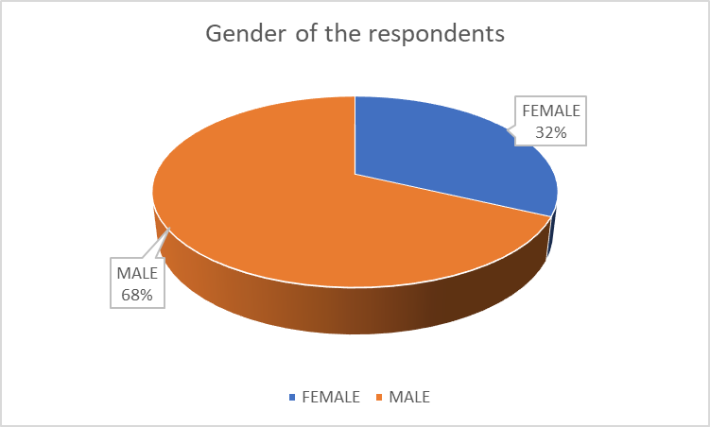

Chart 1: the gender of the respondents
Source: (research data, 2022)
68% of the respondents were male while
32% of the respondents were female.
This imbalanced gender distribution demonstrates a male-dominated working environment at the London Heathrow Marriott Hotel. This creates the need for the organisation’s leadership to develop strategies that would encourage the acquisition of female personnel to help create a more gender-balanced working environment.
Respondents’ period of service in the organisation
The respondents were also asked to indicate the period of service within the case organisation. The results are presented in the table below:

Period | Frequency | Percentage
less than 5 years | 7 | 28
5 to 10 years | 8 | 32
More than 10 years | 10 | 40

Table 3: Respondents’ period of service at the organisation
Source: (research data, 2022)

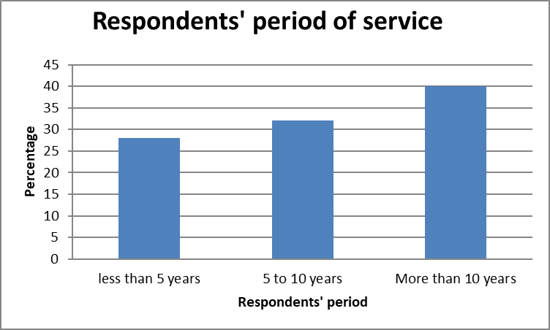
Chart 2: respondents’ period of service
Source: (research data, 2022)
The responses demonstrated a relatively balanced service period within the focus organisation, with 28% of the respondents working in the organisation for less than 5 years, 32% working in the organisation for between 5 to 10 years, and 40% of the respondents working in the organisation for more than 10 years. This demonstrates an active recruitment policy together with a well-established employee retention policy adopted by the organisation.

The leadership style utilised by the London Heathrow Marriott Hotel
The first study objective sought to establish the leadership style utilised by the London Heathrow Marriott Hotel. Two leadership styles were measured using a two-point 'yes-no' answer scale and the outcomes are represented in the table below:

Response | frequency | percentage
Democratic leadership style | 20 | 80
Autocratic leadership style | 5 | 20

Table 4: leadership styles utilised by the organisation
Source: (research data, 2022)

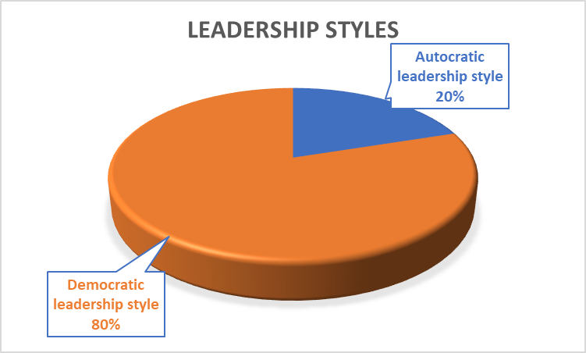
Chart 3: leadership styles by the organisation
Source: (research data, 2022)

Impact of democratic leadership on decision-making and business strategies
The second objective sought to investigate the impact of democratic leadership on decision-making and business strategies at the London Heathrow Marriott Hotel. The respondents were provided with an opportunity to measure the accuracy of three statements related to the objectives using a 5- item Likert scale where 1 = Strongly Disagree (SD), 2 = Disagree (D), 3 = Neutral (N), 4 = Agree (A) and 5 = Strongly Agree (SA). The outcomes are represented in the table below:

Statement | 5 | 4 | 3 | 2 | 1
Democratic leadership has led to the generation of more creative ideas | 16 (64%) | 5 (20%) | 2 (8%) | 2 (8%) | 0 (0%)
Through democratic leadership, strategies and responsibilities at the organisation are delegated more | 17 (68%) | 4 (16%) | 2 (8%) | 1 (4%) | 1 (4%)
Democratic leadership at the organisation gives a lot of emphasis on human values | 20 (80%) | 2 (8%) | 1 (4%) | 1 (4%) | 1 (4%)

Table 5: impact of democratic leadership on decision-making and strategies
Source: (research data, 2022)

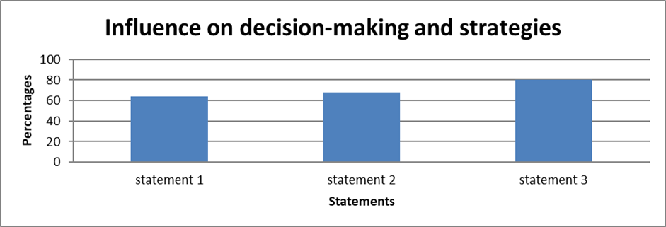
Chart 4: impact of democratic leadership on decision-making and strategies
Source: (research data, 2022)

Influence on democratic leadership style on employee performance and motivation
The final objective sought to establish the influence of democratic leadership on employee performance and motivation. The respondents were probed to measure different statements using a 5- item Likert scale where 1 = Strongly Disagree (SD), 2 = Disagree (D), 3 = Neutral (N), 4 = Agree (A) and 5 = Strongly Agree (SA). The outcomes are represented in the table below:

Statement | 5 | 4 | 3 | 2 | 1
The democratic leadership style has helped enhance performance within the organisation | 18 (72%) | 5 (20%) | 1 (4%) | 1 (4%) | 0 (0%)
Democratic leadership has helped enhance employee motivation within the organisation | 20 (80%) | 3 (12%) | 1 (4%) | 1 (4%) | 0 (0%)

Table 6: influence of democratic leadership style on employee performance and motivation
Source: (research data, 2022)

Chart 5: influence of democratic leadership style on employee performance and motivation
Source: (research data, 2022)

Discussion of the findings
The study established that 80% of the respondents agreed that the organisation utilises a democratic leadership style in overseeing daily business activities and processes while only 20% of the respondents agreed that the organisation utilises an autocratic leadership style. According to Molero et al., (2020), democratic leadership is a participative approach to leadership aimed at keeping everyone in the loop about the business decisions and values. Furthermore, this approach is important in modern-day business activities as it makes employees feel valued and motivated. Autocratic leadership, on the other hand, is also referred to as authoritarian leadership where decision-making is conducted by specific individuals and the function of the subordinate task is to implement the decisions made. While the London Heathrow Marriott Hotel has adopted a democratic leadership style, certain instances call for an autocratic leadership style to facilitate organisation survival. These instances included making short-term decisions to facilitate hedging against the short-term impacts of the Covid-19 pandemic.
The respondents were then probed on the influence of democratic leadership on decision-making and strategies. They were presented with three statements that characterise decision-making and democratic leadership with a five-point Likert scale to measure the association between the two variables. 64% of the respondents agreed that using a democratic leadership style, the organisation has been able to realise more creative and diverse ideas during the decision-making process. According to Huertas-Valdivia et al., (2019), a democratic leader seeks to incorporate the participation of others in an organisation's decision-making process. Through this, everyone is encouraged to participate leading to increased involvement and the generation of different ideas due to the different personalities expressed by the involved parties. Yao et al., (2017) further assert that drawing from a wider pool of opinions and experiences brings more ideas to the table during the decision-making process. This open idea flow, enhanced by the different perspectives reflecting workplace diversity, may result in the adoption of the best idea which has been exposed to numerous scrutiny levels, ultimately increasing the probability of success.
A further 68% of the respondents agreed that through democratic leadership style, responsibilities and strategies within the focus organisation are delegated more. Delegation is the process of empowering other individuals within the workplace to accomplish specific responsibilities and tasks. According to the leadership model put forth by Daniel Goleman, effective democratic leadership is founded on the ability to value other people’s contribution and giving them the ability to actively participate in the production and decision-making process through delegation. Furthermore, Molero et al., (2020) asserted that delegation is an important strategic tool used by leading multinational organisations to not only enhance productivity but also improve employee motivation and retention. Through the adoption of democratic leadership, the London Heathrow Marriott Hotel has been able to advance responsibility delegation, empowering employees across all levels of production and building a collaborative company culture. This has greatly contributed to the organisation’s success in the UK and across Europe.
Finally, 80% of the respondents agreed that using a democratic leadership style, the London Heathrow Marriott Hotel has been able to give a lot of emphasis on human values in its strategies. According to Bhatti et al., (2021), the success of the democratic leadership style is influenced by the ability to convince the employees into adopting the set visions and objectives. It is a human-centred approach founded on empowering others (Bhargavi and Yaseen, 2016). By creating a working environment where individuals can openly communicate, an organisation increases the chances of realising a collaborative working environment. According to Huertas-Valdivia et al., (2019), to enhance employee knowledge and participation in strategic decision making, Google has adopted different employee training and mentorship programs that help employees advance their skills and abilities in specific areas. Through this, Google's employees have a strong sense of attachment to the organisation as they feel valued by the organisation's leadership. At London Heathrow Marriott Hotel, the needs of the employees are always taken into consideration when making decisions. The company's employees are also encouraged to communicate to the supervisors in case of any issues and changes they feel should be done to the organisation's operating models and this involvement makes them more connected to the organisation.
The study established that 72% of the respondents strongly agreed that the democratic leadership style helped enhance performance within the organisation. Bhargavi and Yaseen, (2016) asserted that since employees are involved in the decision-making process when using a democratic approach, they feel motivated to implement the outcomes as they played a part in their formulation. Furthermore, a democratic leadership style gives employees a sense of belonging and recognition which empowers productivity. 80% of the respondents agreed that using a democratic leadership style, the organisation had been able to realise employee motivation. According to the Maslow hierarchy of needs, the need for association or belonging is one of the basic human needs (Yao et al., 2017). Through a democratic leadership style, employees are always involved in company operations and strategic decision making which gives them the feeling of belonging. This ultimately motivates them to deliver exceptional outcomes.

Conclusion
Leadership provides an organisation with the strategic direction and vision needed to overcome competition and establish exceptional performance parameters within today’s dynamic business environment. While there are different leadership styles and approaches an organisation can adopt, the London Heathrow Marriott Hotel has adopted a democratic leadership style where employees within the organisation are given a participatory role when it comes to decision making and strategy formulation. Through the adoption of this leadership style, the organisation has been able to enjoy responsibility delegation, enhanced advancement of employee values, and diversity and innovation when it comes to decision making. Furthermore, the leadership style also makes employees feel involved in the business operation, creating a sense of belonging which ultimately enhances productivity, motivation, and employee retention. The London Heathrow Marriott Hotel mostly uses the democratic leadership approach in overseeing its daily operations. Under this style, the specific needs and preferences of the employees are taken into consideration during the decision-making process. the democratic leadership style borrows closely from the Hierarchy of needs theory by Abraham Maslow which asserts that an effective organisation is that which understands unique employee needs and creates an environment that would encourage each employee to realise their needs. Through democratic leadership, the organisation has been able to generate diverse and creative ideas on how to not only keep up with market trends but also stay competitive in an extremely dynamic and competitive industry. Furthermore, democratic leadership has made the hotel’s employees feel valued and this has played a part in encouraging loyalty and minimising the employee turnover rates – the company has an average annual employee turnover rate of 18% which is the lowest in the hospitality industry. In sum, the success realised by London Heathrow Marriott Hotel over the years can largely be associated with the democratic leadership style which has created a collaborative working culture within the organisation.

Recommendations
The business environment is increasingly evolving, and the customer environment is becoming more diverse. Furthermore, the London Heathrow Marriott Hotel is currently seeking to expand and establish its operations into the UK market which presents it with an even more diverse operating environment. To enhance the adoption of a democratic leadership style into the new markets, the organisations can also adopt a local employee acquisition strategy where the employees selected to operate local markets will be obtained from the local community. This will help the organisation empower the local community and effectively establish itself in the new markets. Furthermore, the organisation may adopt an employee training program to enhance employee knowledge about democratic leadership responsibilities and skills to enhance success. Since this research has adopted a case study strategy, it is recommended that further studies be conducted on other organisations and sectors to provide a broader perspective on how democratic leadership affects other organisations. Moreover, future research needs to be conducted on other leadership styles, other than democratic leadership style to establish how they affect business decision making and strategies.

References

Al Khajeh, E.H. (2018). Impact of leadership styles on organizational performance. Journal of Human Resources Management Research, 2018, pp.1-10.
Arham, A.F. (2014). Leadership and performance: The case of Malaysian SMEs in the services sector. International Journal of Asian Social Science, 2(3), pp.343-355.
Arham, A.F. and Muenjohn, N. (2021). Leadership and organisational performance in Malaysian SMEs: The mediating role of entrepreneurial orientation. Business and Information, 2012, pp.31-41.
Bachiochi, P.D., Rogelberg, S.G., O'Connor, M.S., and Elder, A.E. (2020). The qualities of an effective team leader. Organization Development Journal, 18(1), pp.11-28.
Bargau, M.A. (2021). Leadership versus management. Romanian Economic and Business Review, pg.182, 10(2), p.197.
Basefsky, M., Post, A., Maxwell, J.L. and Turner, B.G. (2018). What are the five most important qualities of an effective leader? American Water Works Association. Journal, 96(7), p.34.
Bhargavi, S. & Yaseen, A., (2016). Leadership Styles and Organizational Performance. Strategic Management Quarterly, 4(1), pp. 87-117.
Bhatti, N., Maitlo, G.M., Shaikh, N., Hashmi, M.A., and Shaikh, F.M. (2021). The impact of autocratic and democratic leadership style on job satisfaction. International business research, 5(2), p.192.
Boal, K. B., & Hooijberg, R. (2001). Strategic leadership research: Moving on. Leadership Quarterly, 11(4), 515–549.
Bryman, A., and Bell, E. (2015). Business research methods. Oxford: Open University Press.
Choi, S. (2019). Democratic leadership: The lessons of exemplary models for democratic governance. International journal of leadership studies, 2(3), pp.243-262.
Creswell, J. W. (2013). Research design: qualitative, quantitative, and mixed-method approaches. 3rd ed. London, Sage.
Coyle-Shapiro & J (2013). The impact of a TQM intervention on teamwork: A longitudinal assessment. Team Performance Management: An International Journal
Denscombe, M. (2017). EBOOK: The Good Research Guide: For Small-Scale Social Research Projects. McGraw-Hill Education (UK).
Foels, R., Driskell, J.E., Mullen, B. and Salas, E. (2020). The effects of democratic leadership on group member satisfaction: An integration. Small-Group Research, 31(6), pp.676-701.
Gains, F., Greasley, S., John, P., and Stoker, G. (2020). The impact of political leadership on organisational performance: Evidence from English urban government. Local government studies, 35(1), pp.75-94.
Gawel, J.E. (2017). Herzberg's theory of motivation and Maslow's hierarchy of needs. Practical Assessment, Research, and Evaluation, 5(1), p.11.
Harris, A. et al., 2007. Distributed leadership and organizational change: Reviewing the evidence. Journal of Educational Change, 8(4), pp. 337-347.
Huertas-Valdivia, I., Gallego-Burín, A.R. and Lloréns-Montes, F.J. (2019). Effects of different leadership styles on hospitality workers. Tourism Management, 71, pp.402-420.
Ibrahim, A.U. and Daniel, C.O. (2019). Impact of leadership on organisational performance. International Journal of Business, Management and Social Research, 6(2), pp.367-374.
Igbaekemen, G. O. & Odivwri, J. E., (2015). Impact of leadership style on organization performance: A critical literature review. Arabian Journal of Business and Management Review, 5(5), pp. 1-7
Igbaekemen, G.O. (2014). Impact of leadership style on organisation performance: A strategic literature review. Public Policy and Administration Research, 4(9), pp.126-135.
Iqbal, N., Anwar, S. and Haider, N. (2015). Effect of leadership style on employee performance. Arabian Journal of Business and Management Review, 5(5), pp.1-6.
Jan DeBell, C.D.A. (2019). Democratic leadership. Dental Assistant, 88(2), pp.6-7.
Johnston, M. P. (2014). Secondary data analysis: A method of which time has come. Qualitative and Quantitative Methods in Libraries
Kabir, S.M.S. (2016). Basic Guidelines for Research: An Introductory Approach for All Disciplines. Book Zone Publication, ISBN: 978-984-33-9565-8, Chittagong - 4203, Bangladesh.
Kesting, P., Ulhøi, J.P., Song, L.J. and Niu, H. (2020). The impact of leadership styles on innovation-a review. Journal of Innovation Management, 3(4), pp.22-41.
Kotterman, J. (2016). Leadership versus management: what's the difference? The Journal for Quality and Participation, 29(2), p.13.
Liphadzi, M., Aigbavboa, C.O. and Thwala, W.D. (2017). A theoretical perspective on the difference between leadership and management. Procedia Engineering, 196, pp.478-482.
Martins, F., Cunha, J., & Serra, F. (2018). Secondary Data in Research – Uses and Opportunities. PODIUM Sport, Leisure, and Tourism Review
Marriott Hotels International. (2022). About us [Online] available at https://www.marriott.com/en-us/hotels/lhrhr-london-heathrow-marriott-hotel/overview/ [Accessed on 21st August 2022]
Molero, F., Cuadrado, I., Navas, M. and Morales, J.F. (2020). Relations and effects of transformational leadership: A comparative analysis with traditional leadership styles. The Spanish journal of psychology, 10(2), pp.358-368.

Monzani & L. (2015). The moderator role of followers’ personality traits in the relations between leadership styles, two types of task performance and work result satisfaction. European Journal of Work and Organizational Psychology. Vol. 24(3) pp. 444-461
Nishi, T. (2013). Unconditional Democracy: Education and Politics in Occupied Japan, 1945-1952. Hoover Press.
Osborn, R. N., Hunt, J. G., & Jauch, L. R. (2002). Toward a contextual theory of leadership. Leadership Quarterly, 13, 797–837.
Pearce CL. The future of leadership: Combining vertical and shared leadership to transform knowledge work. Academy of Management Executive. 2004;18(1):47–57. [Google Scholar] [Ref list]
Porter, L. W., & McLaughlin, G. B. (2006). Leadership and the organizational context: Like the weather? Leadership Quarterly, 17(6), 559–576.
Rukmani, K., Ramesh, M. & Jayakrishnan, J., 2010. Effect of leadership styles on organizational effectiveness. European Journal of Social Sciences, 15(3), pp. 365-369.
Saunders, M., Lewis, P., and Thornhill, A. (2016), Research Methods for Business Students. Harlow, Pearson.
Sethibe, T. and Steyn, R. (2017). The relationship between leadership styles, innovation, and organisational performance: A systematic review. South African Journal of Economic and Management Sciences, 18(3), pp.325-337.
Sethibe, T.G. (2018). Towards a comprehensive model on the relationship between leadership styles, organisational climate, innovation, and organisational performance. International Journal of Innovation Management, 22(02), p.1850021.
Shafie, B., Baghersalimi, S., & Barghi, V. (2013). The relationship between leadership style and employee performance: Case study of real estate registration organization of Tehran Province. Singaporean Journal of Business, Economics and Management Studies, 51(1119), 1-9.
Van Engen, M.L. and Willemsen, T.M. (2020). Sex and leadership styles: A meta-analysis of research published in the 1990s. Psychological Reports, 94(1), pp.3-18.
Van Wart, M. (2013). Lessons from leadership theory and the contemporary challenges of leaders. Public Administration Review, 73(4), pp.553-565.
Yao, L., Woan, K.S., Li, F., Ahmad, M.H. and Kuantan, G. (2017). The relationship between leadership styles and employee engagement: evidence from construction companies in Malaysia. The Social Sciences, 12(6), pp.984-988.
Xu, G. Y. & Wang, Z. S., 2008. The impact of transformational leadership style on organizational performance: The intermediary effects of leader member exchange. Long Beach, CA, USA, IEEE Xplore, pp. 1090-1097.
Zareen, M., Razzaq, K. & Mujtaba, B., 2015. Impact of Transactional, Transformational and Laissez-Faire Leadership Styles on Motivation: A Quantitative Study of Banking Employees in Pakistan. Public Organization Review, 15(4), pp. 531-549.
https://www.researchgate.net/publication/325734954_IMPACT_OF_LEADERSHIP_STYLE_ON_EMPLOYEE_PERFORMANCE_A_CASE_STUDY_ON_A_PRIVATE_ORGANIZATION_IN_MALAYSIA
https://www.simplypsychology.org/Convenience_sample.jpg
https://www.voxco.com/wp-content/uploads/2021/03/Convenience-Sampling2-1024x628.jpg.webp

Appendices

Questionnaire
SECTION A: Demographic information
Gender
- Male [ ]
- Female [ ]
How long have you worked at the London Heathrow Marriott Hotel?
- Less than 5 years [ ]
- 5-10 years [ ]
- More than 10 years [ ]

SECTION B: Influence of leadership styles on organisation decision making and strategies
What leadership style is utilised by the London Heathrow Marriott Hotel? (Tick where appropriate)

Leadership style | Tick where appropriate
Democratic leadership
Autocratic leadership

Please indicate with a tick the level of your agreement with the following statements related to democratic leadership style and decision making and strategy (Key: 1 = Strongly Disagree, 2 = Disagree, 3 = Neutral, 4 = Agree, 5 = Strongly Agree)
- Impact of democratic leadership on decision making and business strategies

Statements | 1 | 2 | 3 | 4 | 5
Democratic leadership has led to the generation of more creative ideas
Through democratic leadership, strategies and responsibilities at the organisation are delegated more
Democratic leadership at the organisation gives a lot of emphasis on human values

Through democratic leadership, strategies and responsibilities at the organisation are delegated more
Democratic leadership at the organisation gives a lot of emphasis on human values
- Influence of democratic leadership on employee performance and motivation

Statements | 1 | 2 | 3 | 4 | 5
The democratic leadership style has helped enhance performance within the organisation
Democratic leadership has helped enhance employee motivation within the organisation

Leadership Styles Questionnaire
Purpose:
1. To identify the leadership style at the organizational level, London Heathrow Marriott Hotel
2. What is the impact of leadership style on employee performance and motivation through business decisions and strategies outlined by leaders.
Directions:
1. Please indicate with "X" what you think corresponds to the following statements
2. Read the questions and give the answer that you think is correct or correct your opinions - immediate impression.
Leadership Style Explanation:
Autocratic Style:
• Supervisor / Leader dictates policies and procedures. Execution and fulfilment of tasks by strict observance of the rules.
• Managers / Supervisors do not tolerate mistakes expect employees to make the right decisions.
• Managers / Supervisors outline the tasks to be accomplished and by what work methods.
• Managers / Supervisors direct and control most activities with minimal employee input.
Democratic Style:
• Managers / Supervisors ensure the contribution of employees to the production process
• Managers / Supervisors involve employees in the decision-making process.
• Managers / Supervisors share responsibility among employees
• Departments / Teams set goals together with the manager / supervisor, they support employees in their work to achieve the goals of the organization.

Leadership Styles Questionnaire - NR. 1 – 25

Gender |  | Period of service in the organisation
Male | Female | Less than 5 years | 5-10 years |  |  | More than 10 years
Which leadership style is utilised in your department
Response |  |  | Yes |  |  | No
Democratic leadership style
Autocratic leadership style
Impact of democratic leadership on decision-making and business strategies
Statement |  |  |  | 5 | 4 |  | 3 | 2 | 1
Democratic leadership has led to the generation of more creative ideas
Through democratic leadership, strategies and responsibilities at the organisation are delegated more
Democratic leadership at the organisation gives a lot of emphasis on human values
Influence on democratic leadership style on employee performance and motivation
Statement |  |  |  | 5 | 4 |  | 3 | 2 | 1
The democratic leadership style has helped enhance performance within the organisation
Democratic leadership has helped enhance employee motivation within the organisation
Leadership Styles Questionnaire
Statement |  |  |  | 5 | 4 |  | 3 | 2 | 1
1. The Supervisor / Manager made his / her decisions in an authoritative manner
2. The Supervisor / Manager allows the employees to take part in the decisions within the department
3. The Supervisor listens to and takes into account the opinions of employees in voting for major decisions
4. The Supervisor / Manager does not reserve time to ask for the employee's opinion
5. The Supervisor / Manager asks you for advice due to your experience when the work process does not go according to schedule.
6. The Supervisor / Manager takes corrective action against the person who is wrong or has a different opinion
7. For Supervisor / Manager is important and respects your opinion and vision
8. The Supervisor / Manager determines whether a working procedure is inefficient or incorrect and personally establishes a new one
9. The Supervisor / Manager gets involved when there are conflicting opinions and tries to resolve and reconcile the parties
10. The Supervisor / Manager uses the power offered to him / her by the management position
11. The Supervisor / Manager allows you free will in decisions regarding the achievement of the organization's objectives
12. The presence of the Supervisor / Manager creates a state of insecurity and stress

Autocratic Style: responses for questions 1, 4, 6, 8,10 and 12
TOTAL:
Democratic Style: responses for questions 2, 3, 5, 7, 9 and 11
TOTAL:

