Networks and Cyber security Essentials

Student name
Student ID
Module Code
Lecturer

Contents

- Build a Simple Network (include Wired and Wireless device)
- Addressing Scheme to the Network
- Configure the IP address
- Use necessary command to check if the connection is successful and document the results.
- Use appropriate capture
- Draw both Physical and Logical Topology and document the successful.

I Built My Simple Network My House Physical
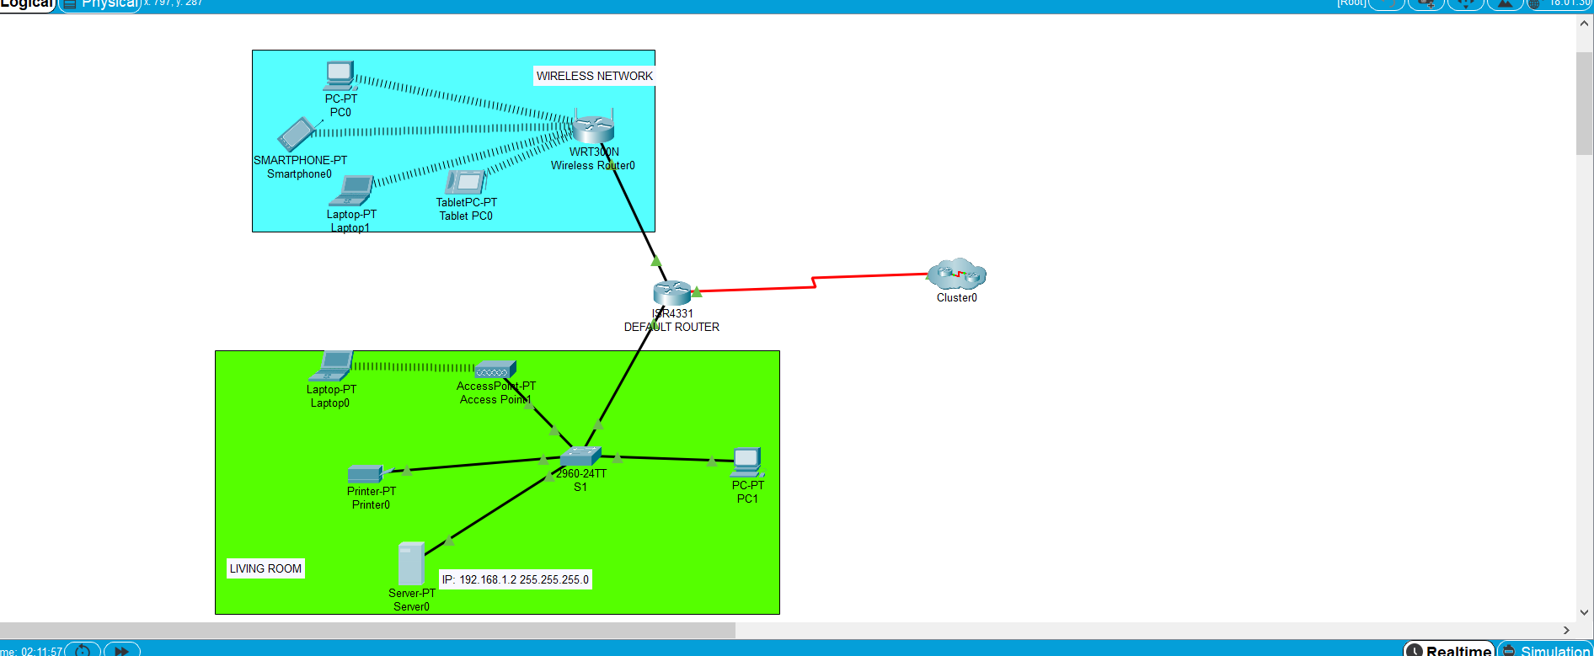
I Built My Simple Network My House Logical
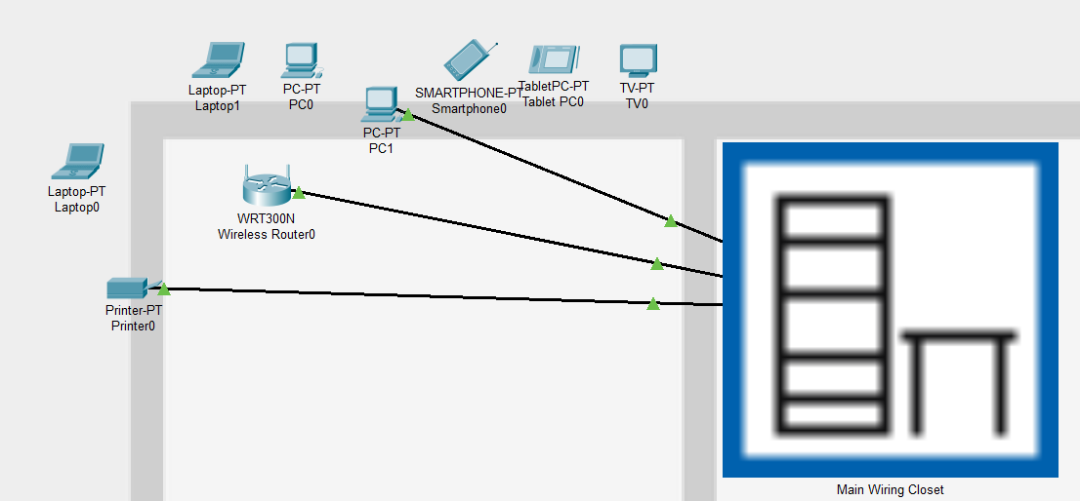

DEVICE | INTERFACE | IP ADDRESS | SUBNET | DEFAULT GETAWAY
PC 1 | NIC | 192.168.1.1 | 255.255.255.0 | 255.255.255.0
PC 2 | NIC | 192.168.2.100
PRINTER | NIC | 192.168.1.2 | 255.255.255.0 | 192.168.1.1
TABLET | NIC | 192.168.2.102 | 255.255.255.0 | 192.168.2.2
WIRLESS ROUTER | NIC | 192.168.2.2 | 255.255.255.0



