Name | Jamil Manoga
Module Code | LCMB7003
Program | MBA- Masters of Business Administration.
Module | Strategic Management
Lecturer | Gladius Kulothungan
Assignment Title.

Executive Summary.
Netflix, the developers of video streaming services, are renowned for their innovative strategies that have set the base for Over-the-Top services and major trends in the online video streaming sector. Their adaptive and proactive business strategies have enabled the company to sustain their supremacy in the sector for the last two decades.
Netflix was founded by Hastings Reed to offer a home movie service which would easily satisfy its subscribing customers than the retail rental traditional model. It however faced a lot of challenges which it had to encounter with several strategic shifts until it finally developed an operational strategy and business model which were quite disruptive to the rental video retail chains.
Netflix started a power revolution never experienced before in the industry which was composed of a massive national inventory, a gigantic customer base, and recommendation mechanism which guided viewership across an extensive catalogue. The largest national rental video retailer at the time, Blockbuster, was not proactive in its response at the time, though it subsequently rolled out a mixture of measures which included an online project with an aggressive pricing strategy which pulled in millions of subscribers but at a massive cost for both Blockbuster and Netflix.
Netflix’s rapid online streaming service growth was eventually turning into a fresh challenge because of its uniqueness as a business model. Management’s efforts to isolate the activities of the online streaming and video rental service into two separate entities encountered a strong pushback from both, the media and subscribers.
Two decades later Netflix is one of the most successful start-ups in the world, spreading its wings in over 160 countries, showing no sign of fatigue, and on its way to “conquer” Bollywood!
This report is an over view of one of the most successful start-ups that has been able to evolve many times through proactively changing strategies and defying status quo on many occasions.
Company Background.
Netflix is a media global entertainment entity founded by two American entrepreneurs, Reed Hastings and Marc Randolph in 1997 with an e-commerce business model geared towards disrupting traditional video rental industry (McFadden, 2020). Netflix is today popular and famous for its global subscription video streaming online service (SVOD) in over 190 countries but its humble beginning was simply an online DVD rental service the first of its kind.
From its headquarters at Los Gatos California, Netflix management is responsible manning a world leading video streaming service in 30 languages and 190 countries, 14 office locations, to a whopping 209 million subscribed membership and 9,400 strong workforce (Netflix.com, 2022)
Relating to its Motto and mission statement, “We want to entertain the world” (Netflix.com, 2022), Netflix’s initial strategy was to avail a ‘customer experience’ identical to movie rental stores, through their website and mailing service, with a wider selection of television programs and movies but unique in convenience. Netflix changed the world’s entertainment industry in 2007 with its launch of the first video streaming service offering customers a new experience of watching television programs and movies over the internet (McFadden, 2020). Benefiting form its first mover advantage and dominance in USA, 2010 saw Netflix’s launch of its aggressive global expansion strategy campaign starting with Canada which has ended up in over 190 countries (Netflix.com, 2022).
Its unique overall business strategy includes; customers paying a monthly non-commitment charge for streaming commercial free unlimited content, provision of DVDs by mail (USA), advertisement free space on its site, and not selling user data. The purpose of this strategy is to give customers a ‘fulfilling complete user experience’ and freedom to secure and develop content with ease. (Evans, 2016)
Customer subscription for a three-tier video streaming service which has exceeded $25 billion (2020) is Netflix’s primary source of revenue which generally varies from country to country. Its global aggressive expansion strategy has now adapted offering cheaper mobile-only services in new markets particularly India to boost its finances and customer base. For now, USA still remains its biggest source of revenue though the Asia-Pacific segment is the fastest growing market. Two decades ago, Netflix’s first public offering was at $15.00 USD for 5,500,000 shares, however as of 2021 September its offering had risen to a staggering $588 USD (Stoll, 2022). Covid-19 home confinement restrictions worked in Netflix’s favour increasing its subscription membership by almost 20 million globally particularly aided by vast content accumulated and internal supply of original content (Walsh, 2020).
Strategy.
Earlier Strategies:
Price Discrimination. Price differentiation has also been effectively used by Netflix particularly in 2014 while revising its price range for its HD new and old subscriptions, being charged $10 and $8 respectively. Existing users enjoyed a two-year advantageous position, being rewarded for their loyalty, which made them feel valued and enabled Netflix to keep their valued customers and raising their revenue (Evans, 2016).
Industry Analysis.
External Analysis.
Pestel Analysis:
PESTEL is an acronym for Political, Economic, Social, Environmental and Legal. The analysis is used for assessment the macro-environment (environment that indirectly influences business decisions) where the business operates. Management has to identify changes in macro-environment that influence their business operations and decision making. With the aid of the Pestel analysis, organisations can identify and analyse their external environments helping them maximise opportunities as well as minimising the threats organisation is likely to face.
Political: Political factors analyse extent to which authorities (government or regional bodies like European Union) can influence their industry and economy as a whole. There are a lot government regulations preventing TV or movie industry companies expanding in certain markets (Sharma & Minaya, 2016). The banning of Russia Television (RT) in UK and EU because of disinformation and war Ukraine (Reuters, 2022) in particular is one of the latest examples.
Political factors generally determine (hinder or facilitate) the extent to which government policies are likely to influence the economy or industry. The ease of securing of licences, restrictions on certain content and watersheds and movement of staff (visas) may favour or hinder Netflix’s operations. Such policies may also include new tax or duty, exceptions on certain goods and services, trade tariffs, and Brexit hindering movement of goods and people within the European Union.
Social:
Social factors like demographics, population analytics, and cultural trends play a key role in the success of the movie (streaming) and tv industry. The youths for example, are continuously moving away from traditional television and cable companies to streaming while others prefer to use mobile gargets. Therefore, the variations in social trends calls for need to regularly and widely analyse the market for changing appetites and responding spontaneously (Fleischman, et al., 2021).
Economic:
Subscription is one of the most important avenues for revenue in the movie industry. The economic climate in the country, fluctuating exchange rates, inflation and financial wellbeing of its customers will all impact Netflix’s operations and strategies. The general economic atmosphere in the country will determine the expansion, stagnation or decline of movie companies hence the need to regularly analyse the economic factors prevailing.
Technological:
Netflix and movie industry in particular relies heavily on technological innovation to enhance its streaming quality and minimal data usage. Customer experience trends, subscription, virtual reality and choice of programmes are all dependent upon ability of technology to evolve at a faster pace. In order to keep up with customers changing taste (trends), remain competitive, widen market, and keep customers satisfied, research and development into faster and better technological advancements is key. Hence the need to regularly analyse industry’s technological factors and responding proactively (Sharma & Minaya, 2016).
Legal:
Since inception, Netflix has been working on protection of its content and services particularly through licensing, patents and copyrights. It is very important that company gets exclusive rights to content hence being able to fight crimes like piracy which are responsible for massive losses to the industry and individual companies.
Netflix also has to abide by laws governing countries and industry which vary from country to country. Many of the policies, practices, and content which are legal in one country, region or state might end up being otherwise in another which might result into massive fines or ban.
Issue to do with operational licensing, employment and workers’ rights in many cases might end up in court costing a lot of money and time.
Industry Analysis
Porters Five Forces Analysis.
Porter’s analysis unifies several distinct factors to assess basic competitive state of a particular sector or industry. It analyses five key sources of competition namely; bargaining power of buyers, bargaining power of suppliers, threat of substitutes, threat of new entrants, and competition among existing competitors (Fleischman, et al., 2021).
Bargaining Power of suppliers.
The SVOD market bargaining power of its suppliers is quite high partly due to the increasing number of competitors and diminishing content licensing offered by third parties. From 2013 to 2019 Netflix had spent more on producing its own original content than any other competitors, a change in strategy purposely to over come supplier challenges and high costs involved (Aversa, et al., 2019). Some of its suppliers like Disney have started their own SVOD platforms to become direct competitors resulting into pulling out of supply contracts creating a shortage hence need to continue using other suppliers. Because of the restrictions, Covid-19 pandemic also resulted into massive Netflix original content shortage, though not as devastating compared to its competitors because of higher stocks it had accumulated.
Bargaining Power of buyers.
Bargaining power of buyers in the SVOD industry is high mostly due to the business model which imposed no long-term contracts, and freedom of customers to cancel subscriptions whenever they wished hence low switching costs. (Katz, 2021) The price wars and high competition from competitors like Disney offering monthly subscriptions at half Netflix’s, has intensified bargaining power to the buyers in the SVOD industry which can old be balanced with innovative content, and lowering of tier pricing strategy (Erhard, 2015).
Threat of new entrants.
The need for heavy upfront investment in the global SVOD industry to rival key players like Amazon, Netflix and Disney is helping hinder high numbers of new entrants hence the medium threat of new entrants. The very low competitive prices, and, government bureaucracy and regulation are also playing a key role in making the industry unattractive to new entrants. Netflix’s economies of scale; experience, infrastructure and brand equity it has built as a result of being first movers, gives it an added advantage over any new entrants (Katz, 2021)
Threat of substitutes
The SVOD industry is quite vulnerable to a variety of substitutes which may include YouTube, traditional television, video games, Facebook, reading, clubbing, and other forms of socialising. Piracy style of substitution is on the rise in developing countries, coupled with Advertising-Based Video on demand (AVOD), Online streaming paid TVs, (AT&T AND Comcast), and Free Ad-Supported TV (FAST) which all put together make industry very challenging and requiring constant evolution which Netflix has so far excelled in (Barney & Hesterly, 2019)
Competitive rivalry
The entry of very competitive and financially stable media giants (conglomerates) like Disney and Apple into the SVOD industry has raised the bar in terms of competition and rivalry (Barney & Hesterly, 2019). For almost a decade, Netflix enjoyed the first mover advantage, almost facing no serious threat to their industry status, however, with such a high level of fragmentation in the entertainment services, and competition from fellow giants, the need for innovation and high-level strategic planning has never been greater.
Internal Analysis
McKinsey 7S Model
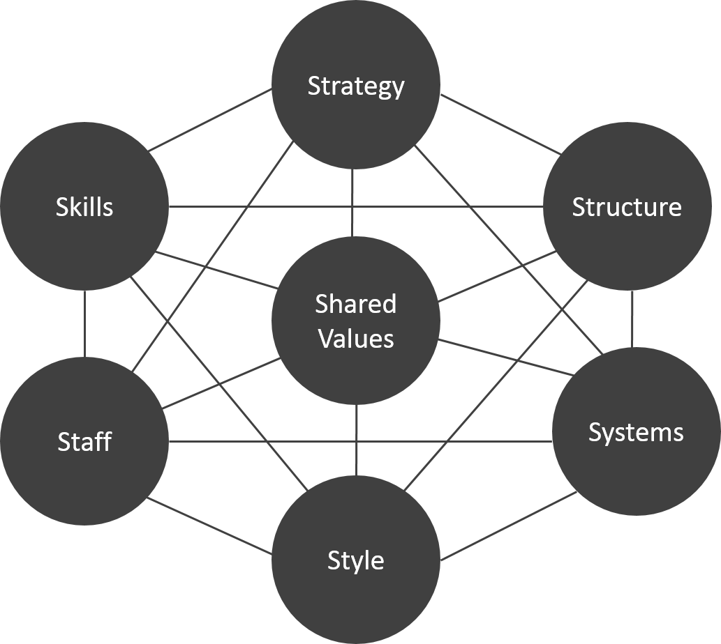
McKinsey 7s model in an analytical tool which can be vital in analysing Netflix’s organisational effectiveness and ability to sustain its competitive advantage and overcoming challenges particularly from competitors. The analysis looks at its strategies, structure, systems, style, staff, skills and shared values (Kenton, 2021).

Strategy:
Netflix’s (corporate) strategy and decisions mainly rotate around; Product, Vertical and Geographical scope. Netflix offers a service “Streaming Video On-demand Service” (SVOD) offering limited product scope both as a distributor and creator of SVOD. It is currently involved in licensing of agreements for content related to its original productions and recently decided to venture into online gaming supported by its infrastructure and mechanisms (delivery network). In summary it has moved from renting DVDs, to online streaming using content from third parties, now produces its own content, ventured out of USA, Advert-free services, offers service in other languages to mention but a few. Netflix is proactive in terms strategic decisions and has been effective hence its sustainability.
Netflix Human Resource Management.
McCord, (2014), the genius behind Netflix’s 129 PowerPoint slides management style wrote;
“Hire, reward, and tolerate only fully formed adults. Ask workers to rely on logic and common sense instead of formal policies, whether the issue is communication, time off, or expenses”
and
“Talent managers should think like businesspeople and innovators first, and like HR people last. Forget throwing parties and handing out T-shirts; make sure every employee understands what the company needs most and exactly what’s meant by “high performance.”
‘Netflix’s Human Resource Management (HRM) has reinvented HRM practices to a distinctive Netflix culture within the Silicon Valley. ‘Netflix employs exceptional people with a view that ‘one outstanding employee can do the work of many’ (Hastings, 2020). As a result, workers are paid an attractive salary as an incentive to increase the speed of innovation hence the increase in productivity and output.
Netflix only hires highly skilled and elite employees in addition to removing underperformers. These employers work tirelessly to cut out rigid policies and processes to adapt innovation. Despite its efforts, to maintain a unique Netflix HRM strategy, it doesn’t take long for its competitors to copy and adapt (McCord, 2014).
Corporate culture
Innovation is at the heart of Netflix’s corporate culture. It’s a unique, innovative corporate culture which continuously focuses on improvement of performance, leading to high productivity. Netflix continues to enjoy ‘two sustainable competitive advantages over other companies; Its innovative technology and its original content’. This somehow makes it hard for other competitors to imitate Netflix’s strategies (Netflix.com, 2022).

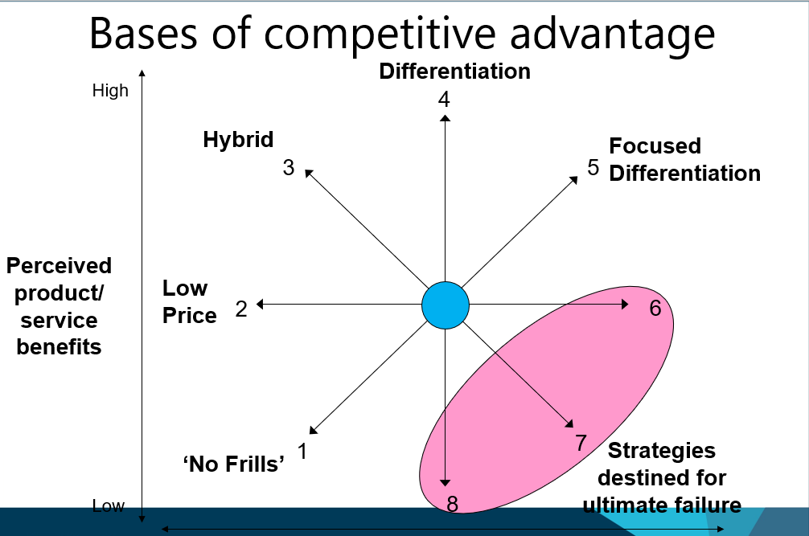
(uwtsd, 2022)

SWOT Analysis
Strengths
Industry market share leadership of Netflix’s in terms of video streaming still rotates around 50% and a whopping global customer base of 221 million and revenue of $25 billion in 2021 (Stoll, 2022). It has easy customer recognition, brand equity, which is its biggest asset, streaming industry’s customer ‘top-of-mind and ‘first movers’. Netflix is recognised for its technological advancement and innovation which since inception have been their key pillars for market leadership. Their decision making in terms of strategy is guided by a fountain of priceless viewer data collected over a period of time. It has also built offices, warehouses, and other facilities supported by a state-of-the-art IT infrastructure providing customers with high quality streaming services.
Weaknesses
The dependence on external supply for content is Netflix’s biggest weakness which is starting to bite as some of the suppliers like Disney are now becoming competitors. The exorbitant costs involved in external production of content, and licencing is way beyond $15 billion however the cost is expected to come down as internal takes root. The need for high-speed internet to access Netflix services is another worry which is hindering market expansion and a bigger threat in case of innovation which requires less internet speeds.
Opportunities
The SVOD global market and demand is rapidly expanding and projected to exceed 1.5 billion in next 3 years (2025) (Canal, 2022) Netflix’s aggressive global expansion strategy particularly in India with a population of 1.5 billion people and projected to exceed 900 million internet users by 2025, is part of its positioning plan to exploit the opportunity.
Digital global media market is rapidly expanding with gaming (revenue of $21 billion in 2020) which Netflix has recently promised to adapt accounting for market revenue’s biggest share. Its global vast internet infrastructure, economies of scale and content delivery systems all seem to support a successful diversification strategy (Patel, 2021). Though Netflix and industry as a whole faced some challenges in last two years, Yahoo finance senior reporter, Canal Alexandra reports analysts projecting a better 2022 and beyond (Canal, 2022)
The prospect for Netflix to expand globally is one of the biggest opportunities, being able to exploit virgin regions, where they can as well produce new and reproduce old content in local dialects. Many internet-based companies and governments are also expanding internet infrastructure (4 and 5G) to other regions which could not be reached before hence market expansion and being first movers. The rapid expansion of economies particularly after covid19 has also created advertisement opportunities which help in boosting revenue (Adgate, 2020) in case of a strategy rethink.
Threats
One of the key worries (threats) Netflix has to battle or plan for is competition by big industry players like Disney, Apple and Amazon which is quite intense in streaming services. They are bound to take a share of the market (subscribers), content suppliers and technical manpower. Many legal issues are likely to arise particularly from copyright infringement, piracy and regulations. Other competitors like Disney are starting their own streaming services which means taking away some of the content they have been supplying to Netflix customers.
Financial and Business Highlights
According to Netflix’s financial statements of 2019, the company has a net worth of more than $142 billion which makes Netflix one of the wealthiest streaming service providers. In the same year, Netflix generated more than $20 billion and EBIT of $2.6 billion. Although the company had a negative cash flow of $3.3 billion due to funds invested in new content creation. Financially Netflix has an upper hand in the SVOD market thus they can spend huge funds for content creation. Reports suggest that Netflix has spent $13 billion in 2018, $15 billion in 2019, and $17 billion in 2020 (Canal, 2022). The researchers projected the spending on content creation can spend up to $26 billion per year by the year 2028. The business Netflix gets from its new and original content makes the spending justified. Netflix had 68 million paid memberships in only the USA and Canada whereas the number of international paid members was around 100 million. The entry into the Indian SVOD market and their movie industry helped Netflix to attract South Asian viewers. The number of paid memberships has only increased ever since. By the end of the year 2019, Netflix had 16 million subscribers from the Asia Pacific region (Netflix.com, 2022).

Strategic resources and capabilities
VRIO Framework.
The VRIO Framework is an analytical tool used by organisations to assess and identify their internal ability/resources to maintain and chieve a competitive advantage. VRIO is an acronym for Value, Rarity, Imitability and Organisation. It a vital tool that can help analyse Netflix’s resources to ascertain if they can be relied on or be improved to guarantee sustainability and a competitive advantage.
Value: The service of VSOD Netflix is offering to global markets particularly India is on high demand and high quality which has attracted over 150 million customers all over the globe. Despite challenges from other competitors Netflix has been able to keep its subscribers and even added more over time a testimony to its quality and demand. Change of strategy to start producing their own content helps in personalising it and having an upper hand in controlling the quality, and quantity hence ensuring its relevancy to specific audiences.
Rare:
The service and content Netflix is offering is quite unique though not rare. A lot of effort is being done to licence their content, get patents and copyrights. This way company will be able to minimise piracy and increase value and rarity of their valuable resources a key source of their competitive advantage. The ability to hire quality local and international entertainers, musicians, actors etc to be part of their internal production process of content will also go along away in ensuring rarity of their content.
The infrastructure and internet network Netflix is using is also quite rare and expensive to build. A lot has been invested in research and development to boost innovation which has been a pillar in the success and sustainability of the company.
Imitable.
Many of Netflix’s resources like service, infrastructure, network, original content, corporate culture, innovativeness, and skilled manpower are very difficult to imitate or copy. It has also made an effort to legally make it difficult for competitors to duplicate their efforts through acquiring copyrights and patents which is a very common problem in new market like India. Though threat is medium and an effort has been made to make it difficult to imitate, its vital that Netflix continues to innovate as away of protecting its business.
Organisation.
The level of management and organisation at Netflix is almost next to none. The manpower managing everything they do is phenomenal which has been a key pillar in their longevity and sustainability. As indicated above Netflix only hires the best and keep recruiting and letting weak one go (McCord, 2014)
Recommendations.
Despite its success and longevity, Netflix needs to persist, offering particularly original, high-quality and regionally personalised content to its loyal customers to guarantee its competitive advantage.
As well as continuing to grow its market share in its current operations, Netflix must expand its global market to non- English-speaking countries in Asia and Africa.
In addition to the above, Netflix must endeavour to offer live entertainment (diversify) such as live news and sports to attract new niche of customers.
Furthermore, Netflix must deploy advanced technology and ‘utilise isolating mechanisms to sustain its technological competitive advantage’ (Grant, 2018)
It should be noted that ‘Virtual reality (VR) and augmented reality (AR) technology are more widely used. Netflix should consider diversifying its technology and services to exploit these resources/options to provide the consumers with a range of choices.
Netflix should maintain its commercial-free streaming policy to attract more subscribers and maintain those are attracted to it. It must also study the strategies other competitors use and either adopt them or develop better.
Maintaining a global market share in a volatile competitive market is a very challenging. Netflix must therefore adapt the above strategies in unison so as to maintain its competitive advantage particularly in a fragmented market like India.
The success, competitiveness and sustainability of Netflix is generally attributed to its corporate culture and HRM policies and practices which have resulted into an innovative phenomenal seeking to take over Bollywood.
Conclusion.
Despite its success and being pioneer of VSOD, Netflix has never become complacent and continues to do everything within their means to succeed. They have defied logic and status quo in many aspects initiating and innovating on their way to the top.
They have faced a lot of challenges which has led to proactively changing of their strategies on many occasions and results have always gone their way. Netflix and its workforce are always on their toes trying out different ways to adapt in a volatile evolving business environment.
The global aggressive expansion policy however needs to be implemented with care and may need changing a few policies like allowing advertisements, a lot of local materials and cheaper (differentiated) pricing in order to effectively fit in the Indian market.

References.
Adgate, B., 2020. TV Networks Look Toward Ad Supported Streaming To Grow Revenue. [Online]
Available at: https://www.forbes.com/sites/bradadgate/2020/09/17/tv-networks-look-toward-ad-supported-streaming-to-grow-revenue/?sh=64e80fca664d
[Accessed 5 May 2022].
Aversa, P., Drane, A. & Evenou, M., 2019. Business Model Responses to Digital Piracy. SAGE journals, 61(2), pp. 30-58.
Barney, J. B. & Hesterly, W. S., 2019. Strategic management and competitive advantage : concepts and cases. 6 ed. Harlow: Pearsons.
Canal, A., 2022. Netflix had 'tough 2021' but here's why analysts expect 2022 to 'get better'. [Online]
Available at: https://finance.yahoo.com/news/netflix-had-tough-2021-but-heres-why-analysts-expect-2022-to-get-better-201756528.html
[Accessed 6 May 2022].
Erhard, V. K., 2015. Business planning and market strategy. Los Angeles: SAGE.
Evans, P., 2016. Netflix to phase out $7.99 HD plan for long-term members starting in May. [Online]
Available at: https://www.cbc.ca/news/business/netflix-price-hike-1.3527171
[Accessed 5 May 2022].
Fleischman, B., Ondracek, J., Saeed, M. & Bertsch, A., 2021. Netflix: Strategising Corporate Resources and Capabilities.. Splint International Journal of Professionals., 8(4), pp. 363-375.
Foysal, M. C., 2020. An Analysis of Netflix’s Business Strategy and How the Company is Coping with the Challenges Posed by the Coronavirus Crisis. American International University-Bangladesh, 17(2), pp. 239-257.
Gautam , K. M., Fabio , D. & Prof Rekha, J., 2017. Netflix: An In-Depth Study of their Proactive & Adaptive Strategies to Drive Growth and Deal with Issues of Net-Neutrality & Digital Equity. IRA International Journal of Management & Social (IR, 8(2), pp. 152-161.
Gerry, J., 2017. Exploring strategy : text and cases. 11 ed. Harlow: Pearson.
Hastings, R., 2020. Netflix CEO on paying sky-high salaries: ‘The best are easily 10 times better than average’. [Online]
Available at: https://www.cnbc.com/2020/09/08/netflix-ceo-reed-hastings-on-high-salaries-the-best-are-easily-10x-better-than-average.html
[Accessed 6 May 2022].
Johnson, et al., 2012. Fundamentals of strategy. s.l.:Financial Times /Prentice Hall.
Katz, B., 2021. State of the Streaming Wars in 2021: It’s Netflix vs HBO Max vs Everyone Else. [Online]
Available at: https://observer.com/2021/09/amazon-apple-netflix-disney-hbo-max-streaming-wars/
[Accessed 6 May 2022].
Kaufman, S. & Shih, W., 2011. Netflix in 2011. [Online]
Available at: https://www.hbs.edu/faculty/Pages/item.aspx?num=47834&utm_campaign=Insights&utm_source=hs_email&utm_medium=email&_hsenc=p2ANqtz--lu_3SkcJfYcOx0afOxHx_VzG_uBY4_Vu1XQMt-MuipLCt1PNEpxEsp_s7unrU-kEBxBJW
[Accessed 6 May 2022].
Kenton, W., 2021. McKinsey 7S Model. [Online]
Available at: https://www.investopedia.com/terms/m/mckinsey-7s-model.asp
[Accessed 6 May 2022].
Lynch, R. L., 2018. Strategic management. 8 ed. Harlow: Pearson.
McCord, P., 2014. How Netflix Reinvented HR. [Online]
Available at: https://hbr.org/2014/01/how-netflix-reinvented-hr
[Accessed 6 May 2022].
McFadden, C., 2020. The Fascinating History of Netflix.. AIUB Journal of Business and Economics, 17(2), pp. https://interestingengineering.com/the-fascinating-history-of-netflix.
Morden, T., 2016. Principles of strategic management. 3 ed. London: Routledge.
Netflix.com, 2022. The Story of Netflix. [Online]
Available at: https://about.netflix.com/en
[Accessed 6 May 2022].
Patricia, O. d. P., 2014. International business strategy and entrepreneurship : an information technology perspective. Hershey: Business Science Reference.
Ralph , S. D., 2011. Strategic management and organisational dynamics : the challenge of complexity to ways of thinking about organisations. Financial Times : Financial Times Prentice Hall.
Rameshwar, D., 2016. Strategic management of sustainable manufacturing operations. Hershey: Business Science Reference.
Reuters, 2022. EU bans RT, Sputnik over Ukraine disinformation. [Online]
Available at: https://www.reuters.com/world/europe/eu-bans-rt-sputnik-banned-over-ukraine-disinformation-2022-03-02/#:~:text=%20Russian%20state-controlled%20media%20outlets%20RT%20and%20Sputnik,bloc%20said%20on%20Wednesday%20in%20an%20unprecedented%20move.
[Accessed 5 May 2022].
Sharma, A. & Minaya, E., 2016. Netflix Expands to 190 Countries. [Online]
Available at: https://www.wsj.com/articles/netflix-expands-to-190-countries-1452106429
[Accessed 6 May 2022].
Stoll, J., 2022. Netflix - statistics & facts. [Online]
Available at: https://www.statista.com/topics/842/netflix/#dossierKeyfigures
[Accessed 5 May 2022].
Walsh, J., 2020. Netflix Subscriber Growth Slows After Surging During Pandemic. [Online]
Available at: https://www.forbes.com/sites/joewalsh/2020/10/20/netflix-subscriber-growth-slows-after-surging-during-pandemic/?sh=274268b9244e
[Accessed 6 May 2022].
Whittington, R., 2020. Exploring strategy: text and cases. 12 ed. Harlow: Pearson.
Zana, M. S., 2013. Analysising Netflix " s Strategy. International Journal of Science and Research (IJSR), 4(3), pp. 4-438.

