

Understanding the importance of effective communication for young children’s learning and development during transitions.

EAEE4003
1705498
Contents page

Introduction and aims ………………………………………………………………….. 3

The outcomes.……………………………….………………………………………….. 4

Effective communication……………………………………………………………….. 4

The handover ………………………………………………………………………… 6

Communication between staff and parents …………………………………………. 6
The importance of working together …………………………………………………. 7

The needs of a child……………………………………………………………………. 8
Transition strategies …………………………………………………………………… 9

What if a child doesn’t wish to engage? ............................................................. 11

What do the theorists say ? …………………………...……………………………. 12
Appendix ………………………………………………………………………………...14

Reference list ……………………………………………………………………………16

Half day Nursery to a full day in reception

Introduction and aims

This is a hand book for staff and employees working with children with in a school nursey setting who will be transitioning to reception in September. The aim of this hand book is to be a usable document underpinning the work place practice, that can be used to reference back upon daily. The text with in the document will be evidence based and supported with examples of transitioning techniques, that will allow key workers and staff to deliver the best possible practice when working with young children during periods of transition.
Burns (ed) (2010) believes that all transitions involve change that can cause children to feel a sense of loss and separation from what they are used to, because of this it is important that all children get careful preparation and reassurance to help them remain safe and secure and to manage the change as well as possible.
The transition period that will be discussed in this hand book will be from Nursery to reception in a mainstream primary school setting.
For a successful transition it is imperative that both nursery and reception staff work together to allow the transition to be as smooth as possible. This hand book is going to show how effective communication between the departments can support this and allow this to happen along with the different techniques and resources that aid effective communication between staff and the pupils as well as between staff and parents.
This handbook has been designed as an easy to use, every day document. Due to the setup and easy to read headings and corresponding contents sheets staff will be able to easily navigate through out to find the desired information. All of the different aspects that can both aid and hinder a transitional process for a child will be discussed to ensure that there is a happy state of transition and the child is looked at as a whole child to allow their holistic needs to be met.

The outcomes

Leaving nursery and entering Reception is a big step for children, but schools can do so much to ensure that their new pupil’s experiences are positive. (Ephgrave, no date). The aims of a successful transition are to ensure that the child progresses on to their new class in a calm and fun way that causes as little stress and upset as possible. In 2003 the UK government published a paper called ‘every child matters’ this is the new approach to ensuring the wellbeing of a child as well as ensuring all professionals working with children are working together as a team for the best of the individual. Doherty and Hughes (2014) This type of positive practice can be seen in educational settings when school staff communicate together as well as with different agencies that may be supporting the individual, through the use of Looked after child (LAC) meetings for children who are in care or annual reviews for children who have additional needs. These meetings are often held in the school, so the relevant professionals can attend and present a united front for the good of the child. These meetings consist of, social workers, (both for the child and the parents/carer’s), teachers, the head teacher, educational psychologists and the care giver of the child, although this can differ depending on the child. Through talking to children and young people the government has chosen 5 outcomes that they believe to be the most essential, these are to be healthy, stay safe, enjoy and achieve, make a positive contribution and achieve economic wellbeing. Every child matters (2003). These outcomes are usually at the for front of everything the school does to benefit and assist the child in their development.

Effective Communication
Kirklees council suggests that ‘There are many people involved with the child as they start school and lots of information that needs to be transmitted.’ Due to this the progression from a half day in nursery to a full school day in reception can be just as emotional and traumatic for the parent as the child. Therefore, establishments like to invite parents in to the school once the new September classes have been decided. The parents are welcomed in to their child’s new classroom where they get the opportunity to meet the class teacher and the support staff their child will be working with for that year and are talked through the transition that their child will be going through. As well as being invited in for formal talks, It has been observed that some schools will then welcome the new parents and carer’s in along with their child for an informal ‘getting to know you’ meeting. Due to the work of John Bowlby and his attachment theory there is now a strong understanding of the importance of secure attachments with the primary caregivers. Mac Naughton (2010). Johnston 2009, believes that Bowlby has not only put emphasis on the importance of early attachments but also of safe and secure relationships. The importance of strong and secure relationships can be experienced in settings as mentioned above in the form of getting to know you meetings that are based around a theme. An example of this type of meeting would be based around a teddy bear’s picnic. The picnic allows the child to come in to their new classroom with their parents and cuddly toys, is allows them to enter the new room in a calm and relaxed environment. This can be seen through the experiment based on a theory by Mary Ainsworth who elaborated on the work of Bowlby called strange situations, this experiment shows that a child who is securely attached to its caregiver will explore freely while the caregiver is present and will engage with strangers such as their new teacher. This is opposed to when their caregiver is not in the room, the child is then more reluctant to socially interact with unknown people. (Brodie No date) Therefore for successful effective communication between the individuals involved in the process it is recommended that for the first time the child meets their new teacher and class friends their caregiver should be present.
The teddy bear picnic allows the teacher to establish good working relationships with the child’s care giver as well as observing the children and building positive relationships with them. The reception staff can then pick out the children who may be finding the transition period difficult and are acting out different emotions through their teddy, along with those who are not socialising with other children when maybe they would normally. Dowling (2010;217) suggests that ‘The ability to read young children’s behavior and to communicate with them is at the basis of successful practice’ These meetings have been proved to be irreplaceable during the transition period due to the relationships that are formed through them, both with staff, pupils and parents.
Throughout the attachment theory Bowlby talks about the importance of strong relationships and that they are useless to the child if they are formed after 2 and half years. Therefore, there is a huge push by the government to work with parents and children to help them achieve these relationships eg, attending flying starts or attending mother and baby groups from early in. Once these relationships are formed it then makes transitions easier as the caregiver will have a strong bond with the child and will have a genuine interest in what is happening in their child’s life, similarly you can see the parents who are not invested in their child as they are usually the parents who do not turn up to these parent/ teacher meetings or other events for the child.
Please see appendix 1 for an example of the letter’s sent out to parents inviting them in to the department.

The handover

Effective communication is a crucial tool between staff when handing pupils over during the transition period. An example of when this is evident in settings is when staff are allocated time for transition evenings or inset days where the current and former staff get together and discuss the children one by one. They will talk through things such as allergies, health care plans, medication as well as discussing how they learn, who they work well with, who they don’t work well with as well as looking at where they are currently performing at with in the Literacy, numeracy frame work which indicates what year the child is working at. All this information is crucial for new teachers as it ensures that the child’s needs are being looked at as a whole and their holistic wellbeing is being taken in to account.

Communication between staff and parents
As well as effective communication taking part between school staff, to ensure a smooth transition there must be effective communication between the teachers and the parents.
‘If a community values it’s children so must it cherish their parents’ (Bowlby, 1951:84)
A teacher named Mathew Callison realised the importance of effective communication between staff and parents and therefor worked with his colleagues to create a systemic approach which has come from years of successful practice in a variety of settings. This approach that they come up with is called SMART.
SMART is a step-by-step process that teachers use to establish effective parent and teacher relationships (teachers and parents 2017) The term smart is an acronym as shown below in figure 1.

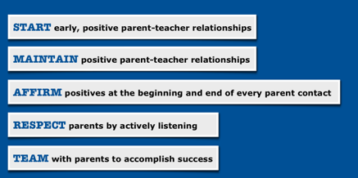
Figure 1

(Source: Callison, 2010)

The importance of working together
The role of an adult during the transition process is crucial, but this is both for the role of the teacher and the parents/key carer. Palaiologou (2010) has emphasised the importance of parents in the foundation phase and has suggested that parents should be encouraged to remain actively involved with their child during the educational process. This is because a parent or key carer are the first educators in a child’s life regardless of the social background they come from or whether practitioners think they are ‘good parents’ or not. Due to this, is it imperative that they remain in the process with the child and are kept up to date with their child’s progress and development throughout the year. Examples of effective communication between parents and school are through the simple use of home school books, which the teachers and parents use to communicate back and fore, as well as when parents are offered to help their child with work out of the school environment by taking the class bear home and asking the care giver to work with the child to make a diary of the things they have done with that bear over the weekend. Using the bear, the parents and child are not only working together for the good of the child’s education, but it also provides them with the ability to
form relationships with their child as they bond over the bear. There are similar style tasks that parents are asked to help with that have been observed in settings, these are often the child’s sound of the week. This is the sound that the class with be working on for that week, so parents are often asked to help their child think of things that start with that letter or sound and complete a sticking and cutting activity which also improves a child’s fine motor skills as well as being a fun interactive task for them to do with their caregiver.

The needs of a child
Bronferbrenner created the bioecological model (as pictured below) Within this model he discusses his thoughts on a child’s development and the factors which enhance it. The inner section of this system is called the microsystem. This looks at the immediate surroundings of a child, such as Family, friends, nursery and school. Crowley (2014)
By looking at this model you can clearly see that the key influences in a child’s life from an early age are parents and practitioners whether that be in schools or day nurseries. This shows why it is so important for parents and teachers to communicate and work effectively together as it is they are the core relationships that work together for the good of the child and to create a holistic atmosphere. ‘The most important aspect of the ecological model is it’s child-centered focus across settings, with the family environment exerting the greatest emotional influence on the individual.’ (Vogler, 2008:9)

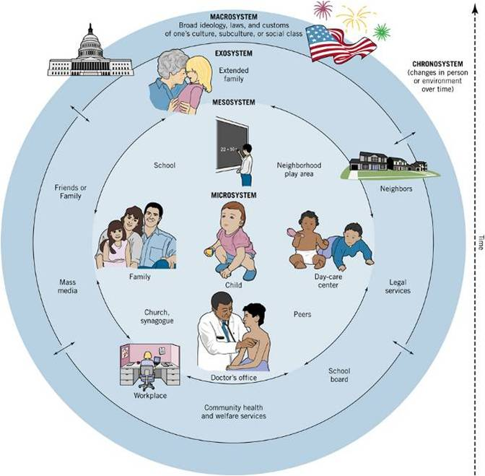

Figure 2- The bioecological model.

Transition strategies

Hume,K. Ph.D has studied transition time with children who are on the autistic spectrum and the difficulties they can endure at different periods of the day. Children who have additional needs can find any kind of change or disruption too much to cope with, which can often lead to challenging behaviors. To reduce the amount of stress and anxiety that can be caused to a child if they are uncertain about what is happening, establishments use transition strategies, which can be used on a daily basis for simple tasks like moving between activities, but they can also be adapted to assist children with larger transitions like moving classrooms and having new teachers. ‘Transition strategies are techniques used to support individuals with additional needs during changes in or disruptions to activities, settings, or routines.’ (Hume,2008)
Transitions can be an uncertain experience for all pupils regardless of their needs, this is why there is a huge amount of effort on the transition process and ensuring all children are as comfortable with the process as possible. Most establishments will allow children transition mornings and then progress to full days depending on what class they are transitioning to. This allows there to be continued effective communication between the staff and pupils so that they feel they are in involved with the process and are aware of what is going on. During these sessions it has been observed that the nursey staff follow a routine similar to the one below:
- Nursery staff will talk about the transition daily in the lead up to the end of term.
- Pictures of the new teachers will be shown in class.
- As the nursery pupils usually have a separate playground, they will now spend their morning break in the ‘big yard’ with the rest of the foundation phase. This usually happens every other day for one week and then progressively occurs more over the following weeks.
- The following week the pupils are usually taken for a walk to see their new classroom.
- They will then spend a full morning on the last week of term in their new class.
This constant repetition of the child visiting their new class and spending time with the older children is seen as a positive reward for the child and if their behavior is not suitable the teacher may then use this as a reward system to work towards and they will only get to visit their new class and go out to play on the ‘big yard’ if they show positive behavior in class. This theory is associated with Pavlov’s idea of classical conditioning. So, the child just like the dog in Pavlov’s experiment would see the new class room as a positive place to go and would therefor adapt its’s behavior to give the desired behavior to receive their reward. This constant repetition of doing the same activity of visiting their new class over again not only prepares the child for the future as they now know what to expect they also get a reward out of it. Although Pavlov did not experiment on humans, his theory can be adapted.

What if a child doesn’t wish to engage?

For the children with additional needs they are usually given more time and information to process the changes and are often supported by visuals. An example of a transition sheet can be seen in the appendix (2). This sheet is given out to the pupils who require more support and will include pictures of their new class room, the pupils in their class, the teachers they will be working with, as well as information about what they will be learning about and trips they will be going on next term. To keep the excitement and positive attitude towards the new class transition, children are not forced to part take it transition activities although they are encouraged. As well as transition class sheets which are sent home, the school also uses Now and then cards. These are simply used to show children what is expected of them. So, a picture of the class room would be put on the now section of the card and then the child’s choice on the then. You then explain to the child in simple terms to not confuse them that they need to visit Mrs Jones’ class and then they can have free time when they return. The child may even like to carry these with them during the transition to remind them what they have been asked. Figure 4 shows a now and then card that is used during transitions.
Then
Now
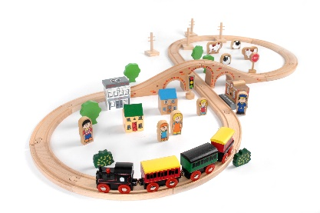
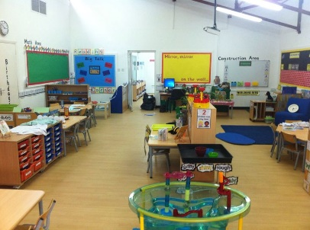

What do the theorists say?
Bronfenbrenner had very similar views to Vygotsky, who believed that children construct their learning through a social context. Vygotsky had a theory that children learn first with people and then learn to function by themselves. He supported his theory with a diagram he created where the inner circle between what the child can do for themselves and the things that they can’t do. Vygotsky suggested that for children to learn they must pass through the zone of proximal development. This is distance between the child operating independently and the potential for learning if they have guidance from another. Figure 3 shows Vygotsky’s Zone of proximal development.
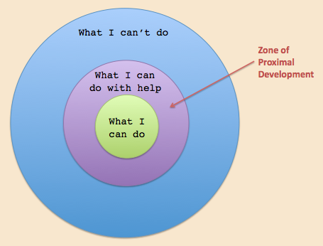

(Source: Culatta, 2001)

This theory can be backed up by Bruner’s thoughts towards ‘scaffolding’. Scaffolding was introduced in 1976 and refers to an adult observing what a child is able to do for themselves and then offering support in order for the child to complete the task or a more challenging task. Dowling (2014). This is often observed in schools and is usually how a lot of assessments are carried out with in the foundation phase. Staff will watch and see if a child can do their zip up by themselves and once they have tried and are unsuccessful only then will the adult step in, the child is always encouraged to carry out tasks independently before adult assistance is given. By empowering a child to participate in activities and to try themselves first and then giving them options such as offering help. If a child says no, as a practitioner (as long as situation is safe) you should allow the child to try again themselves because by letting them figure out the situation and make their own decisions are you then empowering the child’s sense of agency. Waller,T has said that that ‘agency involves a child’s capacity to understand and act upon their world’. Children should be in control of their own lives and should be allowed to make decisions for themselves without adults taking this power away from them. The national quality standard (2013) in Australia agrees with this statement and believes that we only truly have a sense of agency when we feel we are in control and have an influence on decisions being made around us.

Appendix

1-


2-

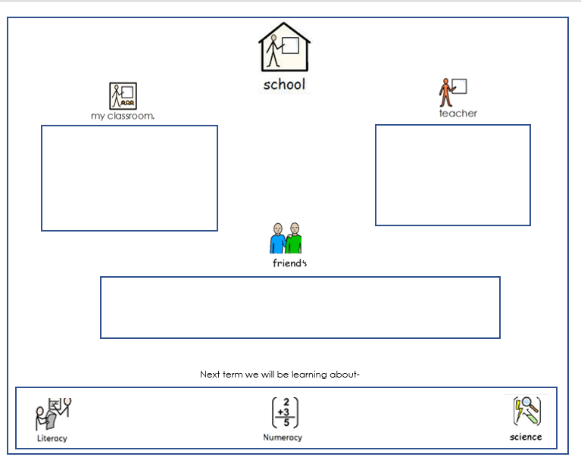

Reference list.

Brodie,R. (No date) ‘Mary Ainsworth and attachment theory’ http://www.childdevelopmentmedia.com/articles/mary-ainsworth-and-attachment-theory/ [Accessed 27th October 2017 ]
Bronfenbrenner,U. (1979) The ecology of human development. Cambridge, MA: Harvard University Press.
Brookson,M. (2010) ‘Working as a teaching assistant’, in T. Bruce (ed) Early childhood A guide for students. London: Sage publications, pp. 289-311
Bowlby,J. (1951). Maternal care and mental health. World health organisation Monograph (Serial No.2)
Callison,M. (2010) ‘Establishing effective parent-teacher relationships. Image of the anagram SMART’ http://teachersparents.com/ [accessed on 20th October 2017].
Conrad,S. (2017) ‘Join us for a teddy bear’s picnic letter’ http://www.st-teresas.com/pre-prep-and-prep/teddy-bears-picnic-2/ [accessed on 16th October 2017]
Crowley,K. (2014) Child development a practical introduction. London: Sage publications.
Culatta,R. (2001) ‘Vygotsky’s zone of proximal development. Diagram of ZPD’ http://www.innovativelearning.com/educational_psychology/development/zone-of-proximal-development.html [Accessed; 31st October 2017].
Doherty,J. and Hughes,M. (2014) Child development theory and practice 0-11. Harlow: Perason.
Dowling, M. (2010) Young Children’s Personal, Social and Emotional development (3rd Edition). London: Sage Publications Limited.
Dowling, M. (2014) Young Children’s Personal, Social and Emotional development (4th Edition). London: Sage Publications Limited
Ephgrave,A. (No date) ‘Transition to reception’ http://www.teachearlyyears.com/a-unique-child/view/transition-to-reception. [accessed: 8th October 2017]
https://www.free-vectors.com/images/fv-images/1371-modern-abstract-blue-circle-background-illustrator-image.png [accessed 15th October 2017]
Hume,K. (2008). Transition Time:Helping Individuals on the Autism Spectrum Move Successfully from One Activity to Another. The Reporter 13(2), 6-10.
Great Britain: Department of education (2003) Every child matters. Cm 5860. Norwich, TSO.
Kirklees council, Kirklees guidance for transition in the early years. (2013) Huddersfeild: Kirklees council.
Mac Naughton,G.,Rolfe,S.A and Blatchford,I,S. (2010) Doing early childhood research. Berskshire: Open university press.
National quality standard, professional learning program (2013) ‘Promoting independence and agency’ No.64, pp.1. [on-line] http://www.earlychildhoodaustralia.org.au/nqsplp/wp-content/uploads/2013/10/NQS_PLP_E-Newsletter_No64.pdf [accessed 31st October 2017].
No author (2017) Bronfenbrenner’s Bioecologial model. [online] Available at: http://lifeinstructionmanual.wikispaces.com/file/view/Bronfenbrenner_Bioecological_Model.jpg/136148877/Bronfenbrenner_Bioecological_Model.jpg Accessed on [24th October].
Palaiologou,I and Hallowes,A. (2010) ‘Effective transitions in to and out of the early years foundation phase’ in I. Palaiologou (ed) The early foundation stage theory and practice. London: Sage, pp. 94-105.
Teachers and parents (2017) ‘establishing effective parents teachers relationships’ http://teachersparents.com/ [accessed 16th October 2017]
Vogler,P. et al (2008) ‘Early childhood transitions research: A review of concepts, theory and practice’. Early childhood development, volume 48, May. [Online]. Available at: http://files.eric.ed.gov/fulltext/ED522697.pdf [Accessed 20th October].
Waller,T. (2009) ‘Contempory theories and children’s lives’ (2nd ed) in T, Waller (ed). An introduction to early childhood. London: Sage, pp. 2-11.

