

‘An investigation into how software can support sports therapists and their clients’.

by
Adam Marc Thomas
225473

Supervisor: Andrew Green

Second Marker: John Williams

Project submitted as part of the requirements for the award of BSc (Hons) Applied Computing

April 2021

DECLARATION FORM AND FORM OF CONSENT

DECLARATION
I, Adam Marc Thomas declare that I am the sole author of this Project; that all references cited have been consulted; that I have conducted all work of which this is a record, and that the finished work lies within the prescribed word limits.

This work has not previously been accepted as part of any other degree submission.

FORM OF CONSENT
I, Adam Marc Thomas hereby consent that my Project, submitted in candidature for the B.Sc. (Hons) Applied Computing degree, if successful, may be made available for inter-library loan or photocopying (subject to the law of copyright), and that the title and abstract may be made available to outside organisations.

ABSTRACT

The aim of this project is to investigate how software can support sports therapists and their clients. There will be several objectives that will need to be met to make this project successful. This project consists of research into sports therapists, their background, and the typical injuries they treat. After these have been identified, further research will be conducted on the treatments and preventions of the injuries. Furthermore, the current applications available are analysed and a summary of the literature review is conducted. The application is developed via Java. Concluding this, primary research has been conducted via a questionnaire to see if the data gathered backs up the literature review.

The philosophy that was applied was phenomenology with a deductive approach leading to a case study. To gather the data, a questionnaire has been constructed. After the data was collected, the application was thoroughly tested, using unit, system, usability, and acceptance testing.

It was found that technology does support sports therapists and their clients. The primary research backed up the literature review as the participants in the questionnaire all said that the treatments in the application were beneficial.

- CONTENTS PAGE
Contents
1. DECLARATION FORM AND FORM OF CONSENT 2
2. ABSTRACT 3
3 CONTENTS PAGE 4
1. CHAPTER 1 - INTRODUCTION 7
1.1 Aims 7
1.2 Objectives 7
1.3 Following chapters 7
2. CHAPTER 2 - RESEARCH & REVIEW OF LITERATURE 8
2.1 What is sports therapy? 8
2.2 Typical injuries 8
2.2.1 Muscular 9
2.2.1.1 Hamstring 9
2.2.1.2 Adductor injuries 9
2.2.2 Joint 10
2.2.2.1 Knee cartilage damage 10
2.2.2.2 ACL 10
2.2.2.3 Rotator cuff 11
2.3 Treatments and recovery 11
2.3.1 Muscular 11
2.3.1.1 Hamstring 11
2.3.1.2 Adductor injuries 11
2.3.2 Joint 12
2.3.2.1 Knee cartilage damage 12
2.3.2.2 ACL 12
2.3.2.3 Rotator cuff 12
2.4 Prevention of injuries 13
2.4.1.1 Mobility and Flexibility 13
2.4.1.2 Strength training 13
2.4.1.3 Warmups 14
2.5 The Client 14
2.6 Current tools available 15
2.6.1 Physio Adviser 15
2.6.2 Pain Therapy 16
2.6.3 Physiopedia 16
2.7 Potential technologies 17
2.7.1 Java 17
2.7.2 C++ 17
2.8 Summary 17
3. CHAPTER 3 - RESEARCH AND/OR DEVELOPMENT METHODOLOGY 19
3.1 Research Methodology 19
3.1.1 Philosophy 19
3.1.2 Approach 19
3.1.3 Strategy 19
3.1.4 Time Horizon 19
3.1.5 Data Collection 20
3.1.6 Evaluation Criteria 20
3.1.7 Methods of Testing 20
3.1.7.1 Unit Testing 20
3.1.7.2 System Testing 21
3.1.7.3 Usability Testing 21
3.1.7.4 Acceptance Testing 21
3.1.8 Ethical warnings 21
3.2 Development Methodology 22
3.2.1 Time boxing 22
3.2.2 Software 22
3.2.3 Hardware 22
3.2.4 Materials and Tools 22
4. CHAPTER 4 - DESIGN & IMPLEMENTATION 23
4.1 Design 23
4.1.1 Project Requirements 23
4.1.2 System Models 24
4.1.2.1 Use Case 24
4.1.2.2 .Dat files 24
4.1.2.3 DFD 25
4.1.2.4 Application Logic Flow Diagram 25
4.1.3 System Interfaces 28
4.2 Implementation 33
4.2.1 Problems and Successes 33
4.2.2 Software Testing 33
4.2.3 Time boxes 34
5. CHAPTER 5 – EVALUATION 36
6. CHAPTER 6 - CONCLUSIONS AND RECOMMENDATIONS 38
6.1 Conclusions 38
6.2 Recommendations 38
7. CHAPTER 7 – REFLECTION 39
8. CHAPTER 8 – REFERENCES 40
9. CHAPTER 9 – BIBLIOGRAPHY 43
10. DEMONSTRATION FILE 44
11. APPENDICES 45

CHAPTER 1 - INTRODUCTION

This project consists of the various topics surrounding sports therapy and importantly how it is applied in applications to see if it helps therapists. Analysis below will present different areas that need to be researched and discussed to progress this project.

Aims
The aim of this project is to investigate how software can support sports therapists and their clients.

Objectives
Conduct an initial literature review into the subject area of sports therapy and analyse the sub-topics in question. These topics consist of:
  - Sports therapy
  - Injuries and preventions
  - Recovery
  - Current applications available
  - Analyse existing research into sports therapy and the links to applications.
- Develop an application guided by the research conducted into the topic areas.
- Evaluate the final application with the client, and report back with any future iterations needed.

Following chapters
Chapter two consists of the literature review where the bulk of the research is conducted. Following the research, a summary will be made consisting of the current findings.

Chapter three examines the methodologies used for the research and development. After this, the testing methods will be determined.

Chapter four contains the designs to develop the application and carries out the testing.

Chapter five is the evaluation of the project and chapter six includes the conclusion and recommendations.

Chapter seven follows up with the reflection of the project.

CHAPTER 2 - RESEARCH & REVIEW OF LITERATURE

The following topics will research sports therapy and the common injuries and treatments. Research will be conducted on how to prevent injuries. Current applications will be looked at to see what is already on the market. After this, a brief summary will conclude this research.

What is sports therapy?
According to the governing body ‘society of sports therapists’, sports therapy is “An aspect of healthcare that is specifically concerned with the prevention of injury and the rehabilitation of the patient back to optimum levels of functional, occupational and sports specific fitness, regardless of age and ability.” (1). This suggest that sports therapy is looking into anatomy, studies the injuries and gives a diagnosis. With this expert knowledge, they will give a rehabilitation plan to their clients, that will get them recovered and back to normal.
A sports therapist will have vast knowledge of the human anatomy and will have studied to an educational standard. “Degree courses in sports therapy accredited by The Society of Sports Therapists are available at a number of universities. These qualifications enable you to gain membership with the society”. (2). They will be with a governing body that will help them. There are multiple governing bodies in sports therapy.

They will know the key areas of competency.
- Prevention
- Recognition and evaluation
- Management, treatment, and referral
- Rehabilitation
- Education and professional practice issues.

Typical injuries
Understanding the common injuries that occur is key as these are the type of injuries that the client will need on the application. The most common injuries have been examined below.

Muscular

Hamstring
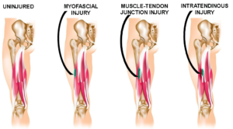
These can occur when playing any sport and are the most common type of injuries. Muscular injuries can occur at any moment. After researching muscular injuries, the most common injury of any sport was a hamstring injury. A paper called ‘using platelet-rich plasma in treating muscular injuries’ suggested that “Over the course of each competitive season, a team of elite footballers consisting of 25 players may expect 4–6 injuries of hamstring muscles alone – these are the most common football-related injuries” (3). (4).
This suggests that hamstring injuries are the most common muscular injuries of any sport. This will be one of the more common injuries that the client will need to diagnose.

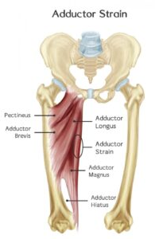
Adductor injuries
Another common injury that will need to be diagnosed is adductor injuries. According to Lars Peterson, he suggests that “A sudden strain on the adductor longus may occur when the leg gets drawn inwards. Overloading can be caused by sideways kicks in football. Symptoms of overusing the adductor longus consist of tenderness of the pubic bone and pain can occur at the origin of the muscle tendon and radiate down the leg”. (5). This suggests that adductor injuries are common and therapists will have to treat.

(6).

Joint

Knee cartilage damage
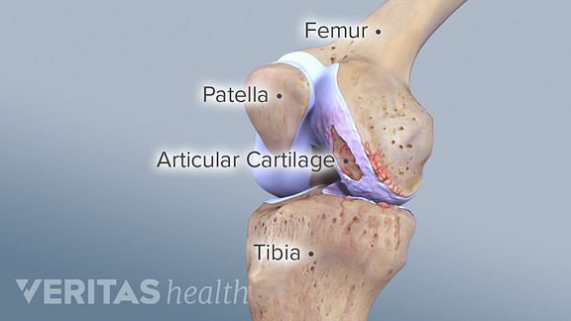
Another common injury that will need to be diagnosed is joint injuries, especially the knee. Knee pain is a common complaint for sporting participants. “Cartilage damage is a relatively common type of injury. It often involves the knees, although joints such as the hips, ankles and elbows can also be affected”. (7). On the NHS website, a common injury that their physiotherapy staff treat is joint pain. Cartilage damage is one of the most major knee injuries, and if left untreated, major damage can occur.
(8).

A paper that was found called ‘Evidence-based concepts for prevention of knee injuries’ suggested that “jumping, running and flexibility exercises as well as balance and strength training are proven to reduce the incidence of knee injuries and should, therefore, be integrated into the regular warm up program.” (9). To prevent anymore knee injuries, warmups should be undertaken with balance and flexibility techniques, especially after injury.

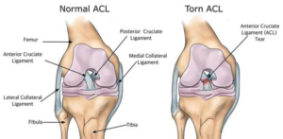
ACL
One of the most common knee injuries is the anterior cruciate ligament. This is common in sports where there is weight and agility from the knee. “ACL injuries can occur with a twisting motion of the knee, either internal rotation or hyperextension.
Diagnosing and symptoms include, a ‘popping’ sound from the knee, the knee may give way and (10). swell after a few hours caused by hemarthrosis and the ranges of motion are extremely limited”. (11).

This suggests that there are a number of symptoms of an ACL and the athlete may be able to walk around, but the range of motion is limited. If they do hear a ‘popping’ sound from the knee, and cannot maintain balance, it is most likely an ACL tear. The athlete will need to have a scan to show the injury and diagnose it.

Rotator cuff
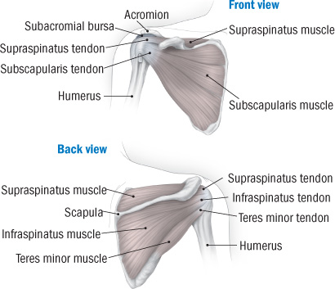
A common injury that therapists are likely to see is rotator cuff injuries. “Rotator cuff tears affect a significant portion of the tendon, cause weakness of the shoulder, limiting your ability to hold your arm out to one side or to lift an object” (12). Harvard medical school suggests that having a rotator cuff injury can limit the movement of the shoulder and the arm. This needs to be looked at by a therapist to try and diagnose the issue and get the patient back to optimum health.
(13).

Treatments and recovery
To gain better knowledge into building an application for the client, typical treatments and recovery for the most common injuries was explored.

Muscular

Hamstring
After researching treatments available after an injury, an article was found by ‘NHS UK’ called “hamstring injuries”. This article suggested that a person should use the “Rice” therapy. “During the first 2 or 3 days, you should care for your injury using RICE therapy: Rest, Ice, Compression and elevation” (14). This urges that after injury, the client should rest their muscle and apply cold packs to the surrounding area. After this is completed, they should bandage it to try and prevent any other swelling. After this, they should keep the leg raised, so swelling is reduced.
The length of time that a person needs off from sport can very and depends on the category of the injury. Many therapists will grade the injury severity. grade 1 – a mild muscle pull, grade 2 – a partial muscle tear and grade 3 – a complete muscle tear.
Depending on the category, therapists urge you to try and stretch the muscles when it is possible to do. “Returning to strenuous exercise too quickly could make your injury worse but avoiding exercise for too long can cause your hamstring muscles to shrink and scar tissue to form around the tear” (15). This can be prevented by going walking or doing stretches.

Adductor injuries
To treat an adductor strain, according to the book ‘Sports injuries, their prevention and treatment’, the patient should “Rest the muscle, as the condition will resolve itself quickly without any other treatment and use general heat treatment in the form of hot baths and after sufficient rest, begin cycling (preferably on an exercise bike) or swimming to strengthen the adductor, without overstraining”. (16). This suggests that treating an adductor strain will consist of rest, so the athlete does not make the injury worse, and reduce the swelling by hot therapy treatment. After the swelling has gone down, start basic fitness such as cycling or swimming, nothing strenuous.

Joint

Knee cartilage damage
After completing research into knee injuries and treatments it was found that the best way for treating knee cartilage injuries is through proprioceptive exercises. After an MRI scan has been conducted to see the severity of the injury, the client will then be placed on the RICE method. Rest, Ice, compression, and elevation. When the patient physically is enable to, then the proprioceptive treatment starts.

After an interview with Mr Kerry Nicholas – Owner of Next Step Sports Therapy and professional sports therapist and lecturer, he said that “Proprioceptive treatment is an exercise-based rehabilitation where you will use equilibrium techniques, such as wobble boards, balance beams and leg hops. This will be conducted to correct the landing technique on the knee, to prevent any more cartilage damage” (17). After this, the patient will undergo training such as agility, accelerating and decelerating. This then gets the patient back to full health and strengthens the injured knee to prevent it from happening again.

ACL
After conducting research into ACL injuries, a scan is needed to confirm the injury. If it is a torn ACL, the athlete will be injured for many months and will need surgery to reattach the ligament. After surgery, they will then be sent to a sports therapist after rest, to start rehabilitation. According to Per Renstrom “Rehabilitation following ACL surgery starts with early range of motion exercises. Most commonly the surgeon allows 0–70-degree range of motion but the most important aspect is to avoid muscle inhibition. A brace can be worn to support the knee. The most important muscles to rehab first is the hamstring as it works as an agonist to the ACL, so should be used early, but the swelling needs to be treated firstly. When the range of motion is 100 degrees and has been a minimum of four weeks post op, the patient can begin cycling”. (18). This suggest that after the patient has had the operation, the range of motion needs to start, but not to the full extent. The patient needs to work up to 100 degrees of motion. When this has been achieved, the patient can then begin cycling to strengthen the muscles, and the knee itself.

Rotator cuff
To treat rotator cuff tears, a study was found called “Rehabilitation after rotator cuff repair”. This study looked at the rehabilitation of the injury and looked at the best ways to treat it. “Early passive range of motion (ROM) following arthroscopic cuff repair is thought to decrease postoperative stiffness and improve functionality. However, early aggressive rehabilitation may compromise repair integrity” (19). This suggests that after the patient has been diagnosed, the best possible way to get the patient back to optimum health, the therapist should start moving the shoulder as early as possible, to prevent stiffness and give full range of motion back to the client.

To prevent a rotator cuff injury, an article by “Harvard medical school” was conducted saying “Physical therapy that strengthens the rotator cuff muscles can make your shoulder less vulnerable to injury” (20). This suggests that therapists can give you a range of exercises to prevent this. One of the exercises is arm circles.

Prevention of injuries
Injuries can occur to the healthiest person, but some preventative measures can be implemented. After conducting some research, the preventative measures are listed below.

Mobility and Flexibility
Researchers suggests that mobility and flexibility training can reduce the strain on the body, to prevent injuries. Most people work 9-5 office jobs with limited movement. Then, in their free time, they will try and exercise or play sport on the weekend. The lack of movement throughout the week impacts the body. According to ‘elite myotherapist’, “By having that flexibility and mobility, our body is free to move without straining or forcing muscles to stretch beyond their capable range. This will prevent injuries and allow you to keep doing what you love” (21). This suggests that doing mobility and flexibility exercises can prevent getting injured, as the body is used to the movement.

Another source confirming this is by Grayson Wickham, D.P.T., C.S.C.S., a New York-based physical therapist, suggests that “Inadequate mobility and stability lead to about 90% of the injuries that come into our physical therapy practice” (22). This suggests that doing mobility exercises will prevent injury, and get the body moving in the right way, so you do not hyperextend the body.

Graham Wickham also suggest that “Just 15 minutes of mobility warmup work every day can prevent a devastating injury—torn rotator cuff, slipped disc—that’ll keep you out of the gym (and in a lot of pain) for months” (23). This means that even doing 15 minutes of mobility work a day, can prevent big injuries. This includes novices and experts, whatever sport you play.

Strength training
To prevent the body from injury, keeping the body strong using strength training is important. After conducting research, Lars Petersen, MD, PHD and professor of orthopaedics suggested that “Strength training is the ability of a muscle to generate force against some resistance. Muscle weakness or imbalance can result in abnormal movement or impaired performance and could lead to injury” (24). This suggests that strength training should be conducted to prevent any injury to the body.

Not only does strength training strengthen the muscles, but it also has an impact on joints and tendons. Lars Petersen suggests that “Strength training increases the strength not only of the muscles but also of their attachments. The strength of tendons, ligaments and the skeleton are all put under stress to grow” (25). Petersen suggests that to keep the body strong, and free from injury, strength training is needed. Not only does the muscles increase in strength, but the ligaments, tendons and joints are put under tension to grow, albeit slower than the muscles, but still shows significant strengthening over time.

Warmups
Another way to prevent injury is by warming up the body before sport. Most people get injureId because the body is not ready to perform. To prevent injury, warming up is vital. Per Renstrom, PhD in sports medicine says that “Warmup exercises are designed to prepare the body for ensuring sporting activity. They have two functions: to prevent injury and enhance performance” (26). This suggests that a warmup prevents injuries to the body and are needed to make sure the body is ready to play sport. Another book written by Dr Chris Morris called ‘sports injuries: diagnosis and management’ suggests that “A warmup of sufficient intensity will cause an altercation in regional blood flow. A muscle can achieve maximum performance only when all its blood vessels are functional” (27). This suggests that a warmup changes the blood flow in the muscles, and when there is adequate blood flow to the muscle, it will prevent injury and make the sporting performance more efficient.

The Client

Next step sports therapy is a sports therapy company that is looking to take their business online. They are currently based out of LLandarcy academy, and are owned by sports therapist and lecturer, Mr Kerry Nicholas. He currently has two sporting ambassadors working with the company, in Welsh professional referee Mr Craig Evans, and Wales and Ospreys scrum half Mr Rhys Webb.

They requested an application that will focus on the recovery of clients and will allow them to input their details to get a diagnosis, and the application will give them feedback to recover. After the diagnosis, the user will have an opportunity to book a slot. After the booking has been completed, that time slot will be removed, so there are no duplicate bookings.

Current tools available
There are a number of sports therapy applications available, and these are becoming popular due to the current p1andemic. There are various ways an application can be developed, and there are three examples of these below.
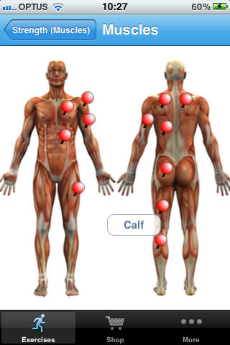

Physio Adviser
This shows a simple application that shows exercises for rehabilitation. It pinpoints the major muscles that will be subject to normal injuries, and when the body part is clicked on the image, it goes into more detail on how to begin rehabilitation on the given muscle. According to MAS medical, “All of the content is constructed by highly experienced physical therapists, with more than 500 exercises with 800 images provided, including detailed instructions on how to perform the exercises correctly” (28). However, this application costs £2.99, whereas it is not subjective to the client, and there are many better free alternatives out there. Also, this is not a personalised application, this is built so everyone can use it. (29).

Another disadvantage is the interface looks cluttered. According to Jakob Nielsen, he has ten design principles. One of the design principles is ‘Aesthetic and minimalistic design’. This suggests that “Interfaces should not be cluttered and contain irrelevant information” (30). This suggests that the application should not be cluttered.

Pain Therapy
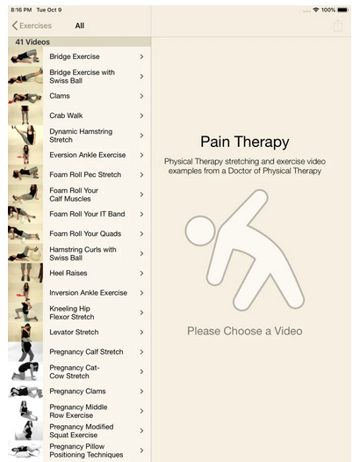
This application, only available on iOS, is another type of application available. It has a better menu on the side with a list of different exercises available. This is backed up by Donald Norman’s affordance of ‘visibility’. “Functions and menus need to be clearly visible to the user”. (31). This provides videos to show you how to do each exercise. Other media is available on the application such as pregnancy therapy which involves more complex levels pf therapy. According to MAG online library, “The sports therapy learning application was received very positively, with both the visual and practical nature of online instructional videos deemed important” (32). The additional videos on the application can help the client to rehabilitate in their own time, using the media provided. This will increase the users rehab time, and get them back to full health quicker, especially in the current pandemic. (33)

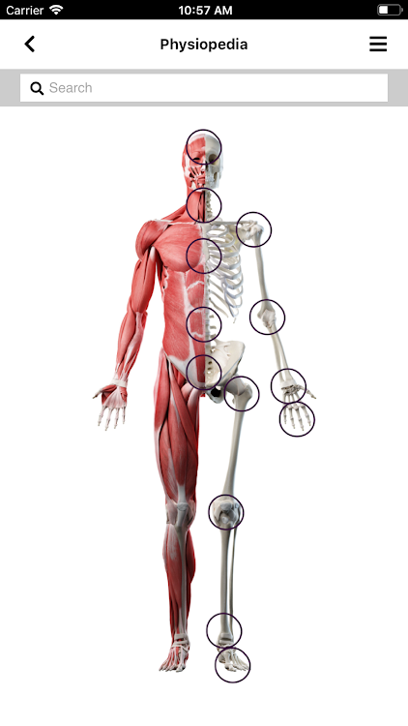
Physiopedia
Physiopedia is an application that brings all sports therapy together without having to go and see a physiotherapist, but does not have a booking option, so this made for everybody, and not client specific. It has an image of a skeleton/muscles on the homepage, and you can select what part of the body that is required. This gives a list of each injury and a video to recover. “A Sports Therapist, who is a Member of The Society of Sports Therapists is an allied health professional who has the knowledge, skills and ability to utilise sports and exercise principles to optimise performance, preparation and injury prevention programmes.” (34). This application belongs to the society of sports therapists and this is the most popular governing body. (35).
After conducting research into the apps, this application had a good user interface as it is very minimalistic, with no excess writing. This follows Jakob Nielsen’s design heuristic of ‘Aesthetic and minimalistic design’. “Interfaces should not be cluttered and contain irrelevant information” (36). This follows the design principle and has no excessive writing or unnecessary information on the interface, meaning it is not cluttered and clearly usable and the information is visible. This will be added to the application.

Potential technologies
In this section, research for the possible technologies for mobile applications is conducted.

Java
The first technology that is considered is java. Java is “a cross-platform object-oriented programming language that was released by Sun Microsystems in the year 1995. Today, Java is needed to run various applications such as games, social media applications, audio, and video applications” (37). This suggests that java is a programming language that can be used across many platforms. The advantage of this is if java is used to build the app, then it can run on multiple devices to do many things. Another advantage of using java is that it is free to download, and it is economical to maintain. Some of the applications that java has been used for are banking, ICT, android, big data, and mobile apps. “Since its inception, Java has been the language of choice for mobile app development cantered around Google's Android platform” (38). This suggests that Java is one of the best programming languages for mobile applications.

C++
The other language considered was C++. C++ is “a cross-platform language that can be used to create high-performance applications” (39). C++ is one of the most popular languages in the world and it is used for multiple applications. As C++ is close to C# and Java, it makes it easy for programmers to switch to C++ or vice versa. Some of advantages of C++ is the portability. Multiple devices can be used to run C++. “C++ offers the feature of portability or platform independence which allows the user to run the same program on different operating systems or interfaces at ease” (40). This suggests that C++ can be used to run the application with different devices. The disadvantage is that it can have security issues. “Certain security issues still exist due to the availability of friend functions, global variables and, pointers” (41). This suggests that this language could have security issues, and being an application, which will hold medical details, if it goes live, then this is a big concern.

Summary
In summary, sports therapy is a constantly changing area, especially in the current pandemic, as some patients cannot go to see their therapists. Therapists are at the front of sports injuries and need the qualifications to diagnose and treat the injuries to get the patients back to optimum health. The client will need to be with a governing body that will help the business, and in order to be qualified, complete a degree to be accepted into the governing body.

To conclude from the previous sub-topics, the chosen technology will be a mobile application conducted via java. Java will be chosen as it is one of the most popular languages used to create mobile applications, and it can be used on multiple devices. Java is also a secure language, and it is easy to maintain. After research was conducted, it was found that all the applications were generic, and not subject to one client. They were aimed at a wide audience that could not book, after they looked at an injury on the application. To overcome this, the application could be based off ‘pain therapy’, as this had all the information that the client would need and add a booking system at the back end of the application, so it would be more personal to the client.

CHAPTER 3 - RESEARCH AND/OR DEVELOPMENT METHODOLOGY

3.1 Research Methodology

Philosophy
The philosophy that will be used throughout this project will be phenomenology. “Phenomenology is a form of qualitative research that focuses on the study of an individual's lived experiences within the world.” (42). This suggests that phenomenology considers beliefs and thoughts. This will be used as this research was conducted from past experiences from people and analysing their findings. The advantage is that it helps to adjust to new issues and ideas as they emerge, or any changes over the project. This will be efficient for this project as if any problems occur, they can be rectified. The disadvantage is that data gathering can take up time. To counterbalance this, a Gantt chart will be made to help stay on track.

Approach
The approach that will be used is deductive approach. This will be used as it will help to build an application similar to others but looks at the issues the other applications struggle with. “Deductive approach relies on a general statement or hypothesis—sometimes called a premise or standard—held to be true. The premise is used to reach a specific, logical conclusion” (43). This suggests that deductive approach is when the researcher already has a theory before, they start the research project. The advantage is it gives a possibility to generalize research findings to a certain extent I.e., back up original theory. The downside of this is it is a very rigid approach but fits this project to keep it on track.

Strategy
A case study will be used in unison with the secondary research to gain a better understanding of the development of the application. A case study is “an intensive, systematic investigation of a single individual, group, community or some other unit in which the researcher examines in-depth data relating to several variables” (44). This will be used as there are many other case studies and examples of the chosen subject. The advantage is that it provides detailed information and gives insight for further research. The disadvantage is that it is time-consuming, but to overcome this, the Gantt chart will be followed.

Time Horizon
The time horizon will be longitudinal as this will factor in the prototypes and different iterations of the application. This combined development method will be time boxing. An advantage is that any changes that will be taken into consideration when building the application, can be completed. The disadvantage of time boxing is quality may be sacrificed due to the priority placed on achieving milestones, but a Gantt chart will be used to counterbalance this.

Data Collection
The data collection method that will be used is a questionnaire. This is because it is a more viable way of gathering the data, especially in the current pandemic, and make it more scalable. The questionnaire will be trialled first, so it is not biased, then the data can be analysed more efficiently than an interview. This will gather quantitative and qualitative data, so the research will be well-rounded. The questionnaire will be sent out to around 15 people. This sample group was chosen as it can be sent out to the owners clients.

Evaluation Criteria
Below is a list of criteria that the application will be measured against to see if it is successful.

- The application must meet the project aims
- Must meet the project objectives
- Must meet the user requirements
- Must meet the purpose of a sports therapy application
- Must be data driven and offer a booking system
- Must detail injuries and treatments in an easy way for the user to understand
- Must be easy to navigate the interface
- Must be efficient to maintain to keep the client and users happy
- Must be updated with solutions to the problems the user faces
- Must consider design principles to improve user experience and navigation

Methods of Testing
There are four elements of testing that the application will go through.

Unit Testing
Unit testing will be conducted as the application can be broken down into units and then tested. When each unit passes the test, the next unit can be tested. Unit testing is “a testing technique using individual modules that are tested to determine if there are any issues by the developer themself. It is concerned with functional correctness of the standalone modules. The main aim is to isolate each unit of the system to identify, analyse and fix the defects” (45). This suggests that unit testing is when individual source code gets tested. This is conducted to see if the units of code can be validated. This will be conducted throughout the development stage. The advantages are running the test is repeatable, so the application can be tested multiple times. Another advantage is it reduces defects in newly developed code, so will be efficient for this build.

System Testing
System testing will be conducted. “A black box testing technique performed to evaluate the complete system and the system's compliance against specified requirements. In System testing, the functionalities of the system are tested from an end-to-end perspective” (46). This suggests that system testing is testing the finished application to see if it meets the requirements. To make sure the system is working, it will be tested against the evaluation criteria in section 3.1.6. An advantage is it covers complete end to end software testing.

Usability Testing
Usability testing will be conducted next. It is “a non-functional testing technique that is a measure of how easily the system can be used by end users” (47). This suggests that usability testing is testing the functionality of an app by observing real users as they attempt to complete tasks. The app will be given to different users and the feedback given will be used to make the app more efficient. This feedback will determine if the usability is viable. The advantage is it can confirm the app meets the expectations. It will also stop errors from happening.

Acceptance Testing
The last test that will be conducted is acceptance testing. This is “a testing technique performed to determine whether or not the software system has met the requirement specifications” (48). This suggests that acceptance testing is conducted in the final phase of testing and is used to test and ‘accept’ the application before it goes live. The reason for this is to evaluate the application with the requirements and verify it has met the criteria for delivery to end users. An advantage is it reduces the errors found before it goes live, so this will be used before it goes to the client.

Ethical warnings
After researching medical applications, it showed that they use ethical warnings to take accountability away if something goes wrong. Even though this application will not be live, and will be tested with dummy data, an ethical warning will be included, so the user accepts the warning, if they are going to use the application.

According to Florida tech university, “Medical errors are the third leading cause of death in the United States. Ordinary negligence can be due to defective medical equipment, a misdiagnosis or a delayed diagnosis” (49).

This suggests that a warning will be included in the application so the users will do the exercises (without speaking to a sports therapist at Next Step) at their own risk. If they diagnose their own injury, and do the exercises associated with the wrong injury, then Next step will not be accountable.

3.2 Development Methodology

Time boxing
Time boxing will be used to keep on track with the development of the application. Time boxing is “an approach to task and time management that sets rigid constraints on how long a given task or project can take to complete. The term comes from agile software development, in which a time box is defined period during which a task must be accomplished” (50). This suggests that a timebox can be set up for a specific time frame and when a task has been completed, the user can end that time box and create another for the next task. The advantage is that it is less stressful because the project can be broken down into milestones, so the user does not get overwhelmed by the whole project and It is a way of focusing on achieving what needs to be done without delay or procrastination. This is good for the project as there are a number of different stages the project needs to go through, so splitting these into time boxes can display the goals for that time box clearly. This will allow to not be overwhelmed with all the different sections to complete the project. A disadvantage is quality could be sacrificed due to the high priority placed on achieving deadlines. This can be prevented by making sure the deadlines give adequate time to be achieved.

Software
Windows 10 – Operating system required in order to use an application when it is completed. This is needed as it is the latest and most secure operating system for windows. It allows the developer to run NetBeans.
NetBeans– IDE program that allows for development and running of the application. The developer can input the code and run the application from the same place/software. This is used as it has been used for projects and it is familiar.

.dat file– This will store the data needed and links with NetBeans. This is suitable as it has been used in the past, so it is familiar to the developer.

Internet – To conduct research and use the IDE’s to create the application.

Hardware
- Processor – i5 6700 Quad Core (3.2GHz)
- Storage – 2TB Hard Drive to store the code and application.
- 8GB RAM – to run the PC and application.
- Laptop
- Second Monitor (optional)

Materials and Tools
- Toms’ planner
- Sports injuries, their prevention and treatment (Lars Peterson and per Renstrom, 3rd edition)
- Online library

CHAPTER 4 - DESIGN & IMPLEMENTATION

4.1 Design

4.1.1 Project Requirements
After speaking to the client, the user requirements and system requirements were detailed below.

ID | User Requirements | Required
1.1 | Ease of use | Yes
1.2 | Input Details such as Name and Email | Yes
1.3 | Select their own Booking | Yes
1.4 | Select their own date | Yes
1.5 | Select their own time | Yes
1.6 | Diagnosing their own injury | Yes

ID | System Requirements | Required
2.1 | Store Customer Details  ID (Auto Generated)  Name  Email | Yes
2.2 | Store Reservation Details  ID (Auto Generated)  Name  Email  Date  Time | Yes
2.3 | Save Records | Yes
2.4 | Delete Records | Yes
2.5 | Edit Records | Yes
2.6 | Add Records | Yes
2.7 | Navigation Menu | Yes
2.8 | Ethical acceptance warning | Yes
2.9 | Selectable skeleton interface | Yes
3.0 | Email reservation number to user | No

4.1.2 System Models

4.1.2.1 Use Case
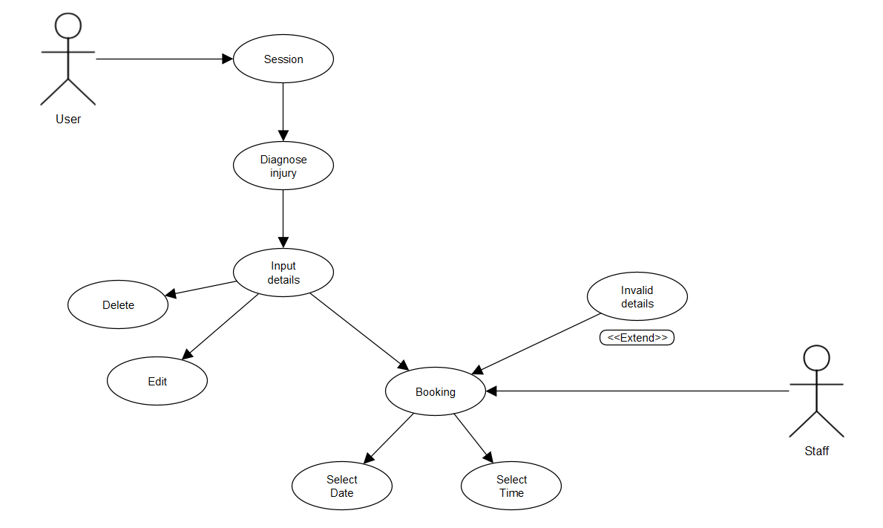
Below shows the use case for the application.
This diagram was used as it captures the functionalities of the system. The user starts a session, then the app diagnoses the injury with the input of the user. After the user diagnoses the injury, the user can see the treatments and recovery. After this, the user can make a reservation by inputting details. They can also amend and cancel reservations. They will need to select a date/time. The session gets extended if the user inputs incorrect details. The staff can enter the application to add new reservations or delete old dates/times.
4.1.2.2 .Dat files
The data will be stored in four separate .dat files as this is the most simple database to store the information. The data that is stored is the customer’s name, booking ID, email, time, and date. This is used as this is what other booking apps have used and this is all the data that is needed to store a booking. The file is structured:

- Booking ID
- Name
- Email
- Time
- Date

There is a gap, then the next booking will appear in the same format underneath this booking.

4.1.2.3 DFD
A DFD was created to help visualise the flow of data to help the development. The app can follow the DFD to make sure the data usage is correct. Below shows the DFD at level two. This starts as a user makes a reservation for an appointment on the app. The system takes the data that the user entered, and the reservation details are checked make sure the reservation.dat file is present. If present, the data gets saved to the file. When this is complete, the user gets a confirmation message containing a reservation ID. Reservation gets added to the database and user goes back to main menu. To amend new/old availability, the staff can do so at the staff part of the system. Staff can add new dates and times, then these are checked to see if the availability.dat file is present. If present, new dates/times are saved which is then updated on the system so users can see the updated availability.

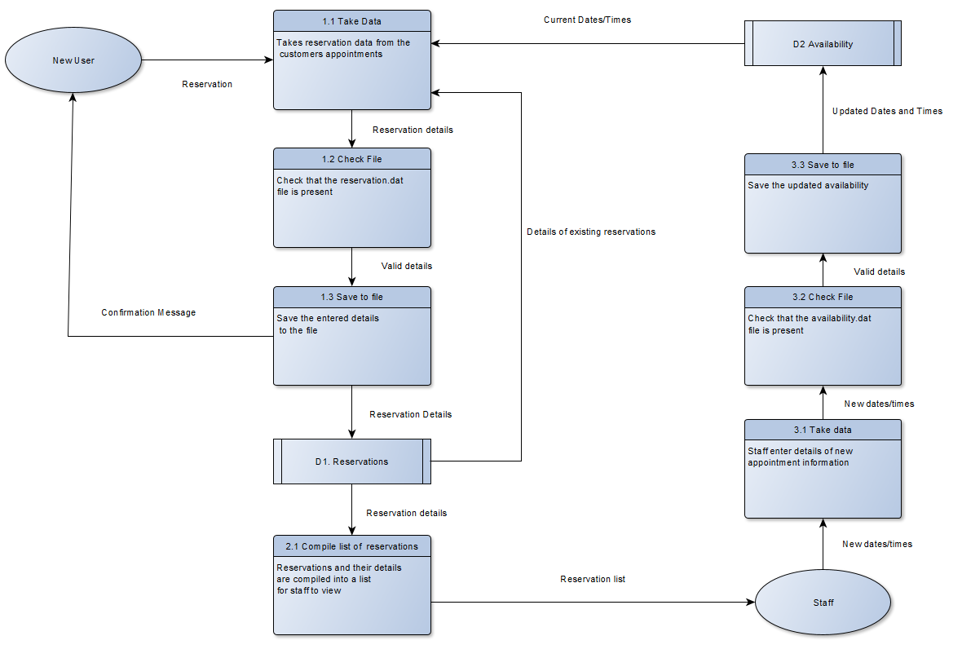
4.1.2.4 Application Logic Flow Diagram
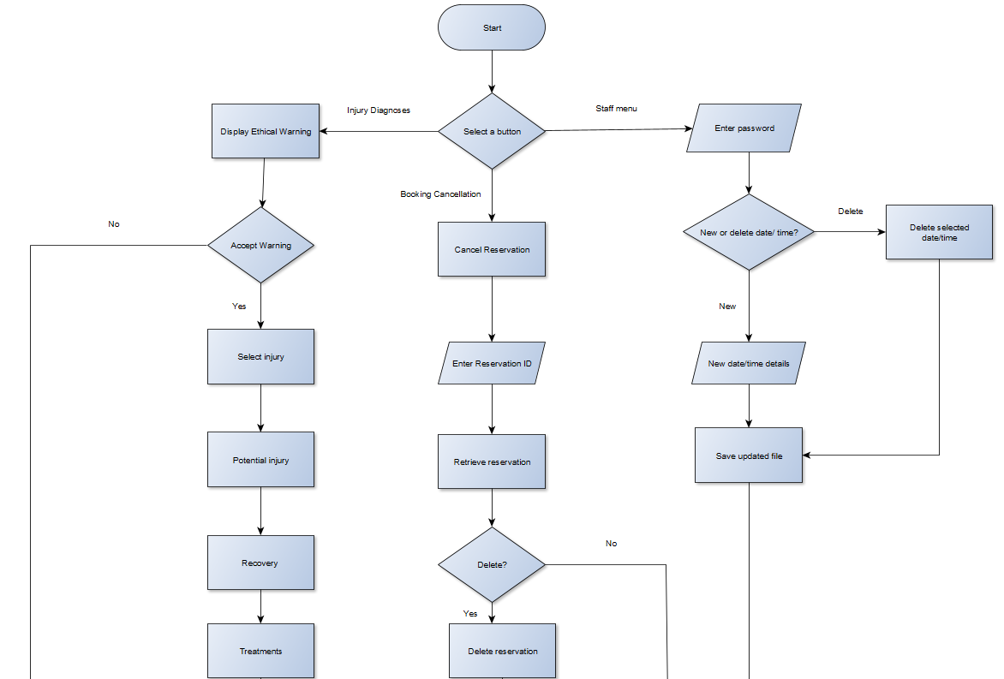
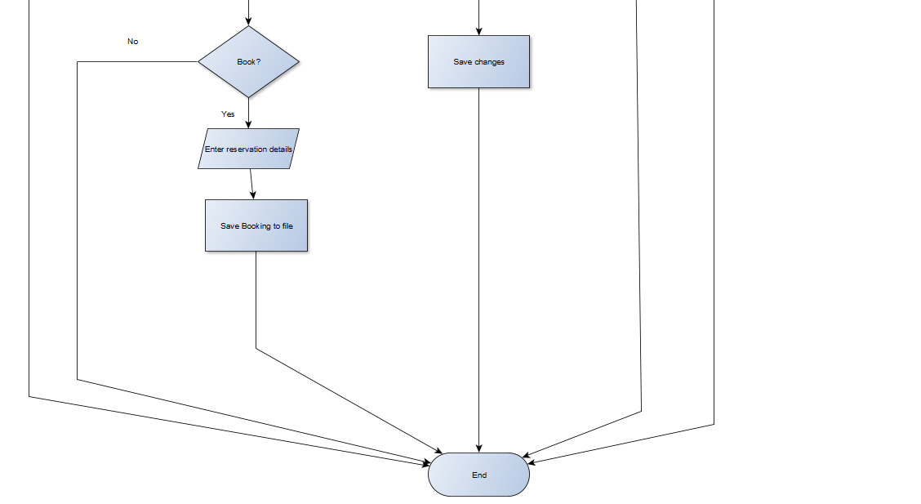

This chart was used to plan the logic of the booking system.
The user begins with a navigation decision (injury diagnoses, cancel reservation or staff meu). If the injury diagnoses is clicked, the user comes to another decision. Ethical warning needs to be accepted, if not, user goes to the end. If accepts, the user will begin the process of diagnosing, recovering, and treating the injury. After this is complete, the user has a decision to book. If yes, user enters reservation details and gets saved to the file and ends. If no, the user goes back to the main menu.
If user selects booking cancellation, they enter the reservation ID and system retrieves the data. If user decides to delete reservation, they save the changes and go to the end. If user does not delete reservation, they go to the end.
If staff goes to staff menu, the decide to delete or add new availabilities. If delete, they delete old appointments and save the file and proceed to the end. If new, staff add dates/times and save file and proceed to end.

4.1.3 System Interfaces
Below are the mock-up designs for the application.

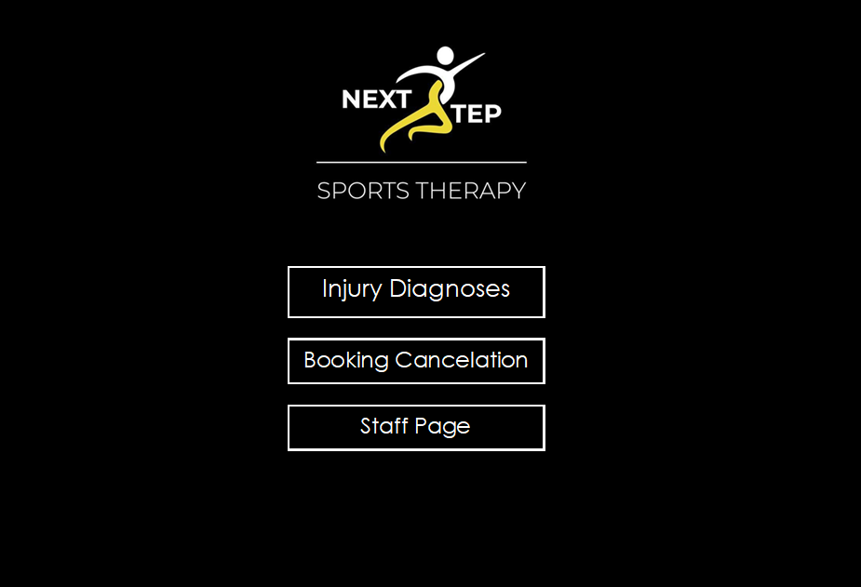
Main Menu Page
This is the first page the user will see when they open the app. The interface has three buttons taking you to different sections of the app. The clients logo is on every page and the colour scheme is kept throughout.

Ethical Warning Page
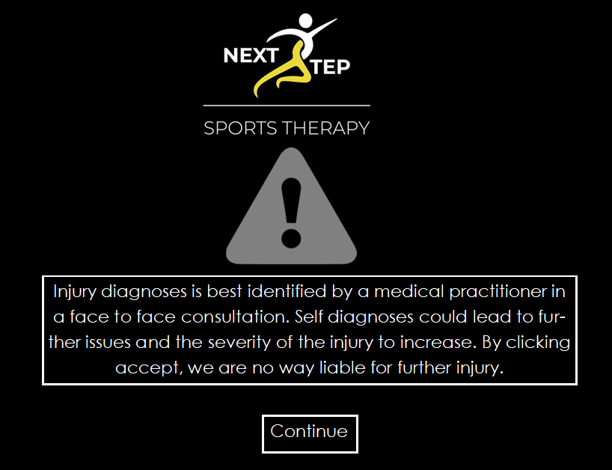
When the ‘injury diagnoses’ button is clicked, this is what the user will see. An ethical warning in large writing with a bold warning sign is displayed. The user has to click continue to accept the ethical issues.
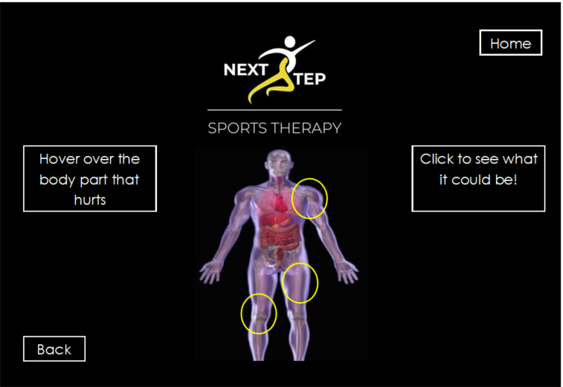
Injury Diagnoses Page
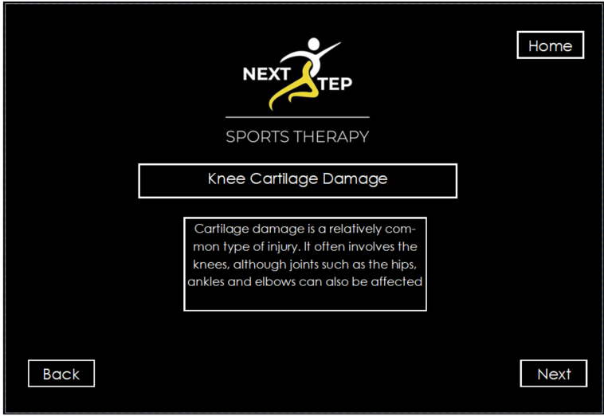
After the warning is accepted, the interface gives instructions, and the user needs to select a part of the body that is injured. Back button is added so the user can go back. Home button takes user to main menu.
Potential Injury
When skeleton is clicked, the app will give a diagnosis for the potential injury with the symptoms. User can click next if it is the injury, back to go to select another part of the body, or home to go back to the main menu.
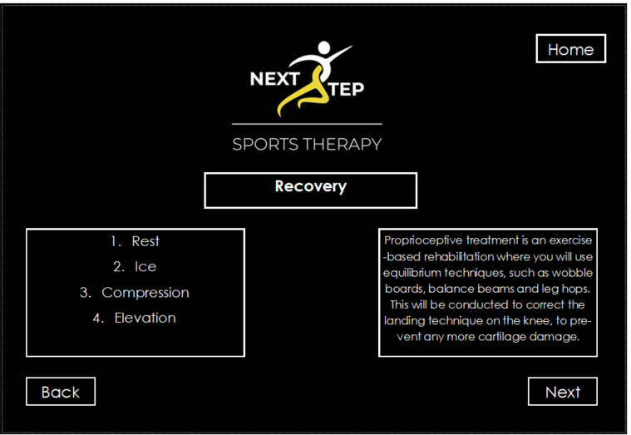
Recovery Page
Tells user how to recover and what the techniques are. Back, home, and next buttons throughout.
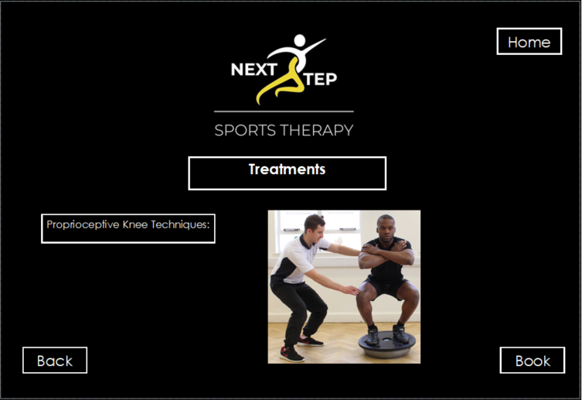
Treatment Page
Shows how to treat the injury.
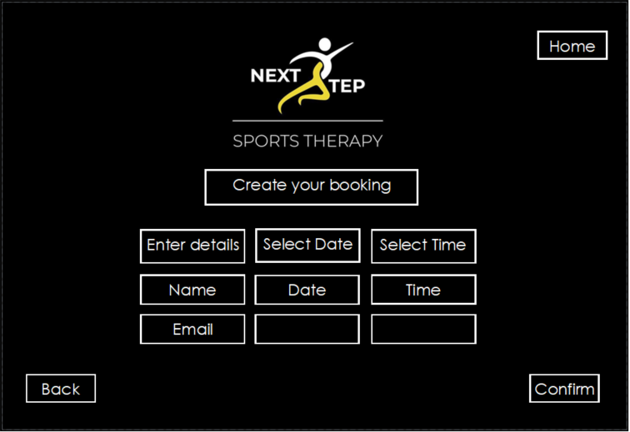
Booking Page
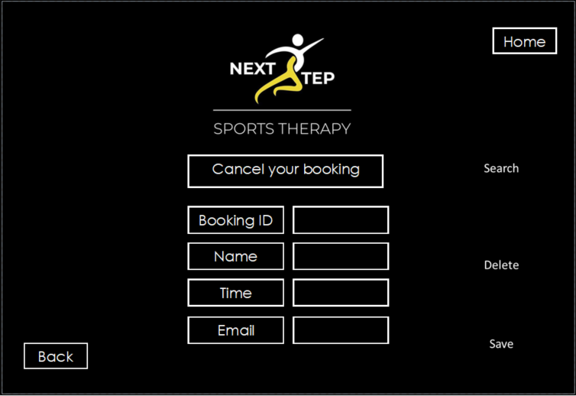
User can make an appointment for further treatment inputting their credentials and selecting the drop-down menus for availability.
Cancel Booking Page
From the main menu, user clicks ‘cancel booking’ button, and the cancellation menu appears. User needs to input their ID and search and the booking appears. User can then delete booking.
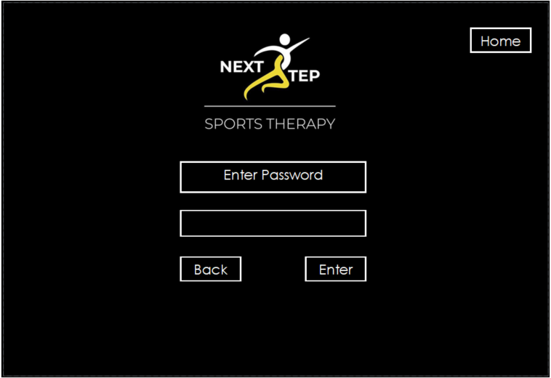
Staff Menu Password Page
Booking Time
When staff select ‘staff menu’ this password is prompted. Staff enters password and enters the page below.
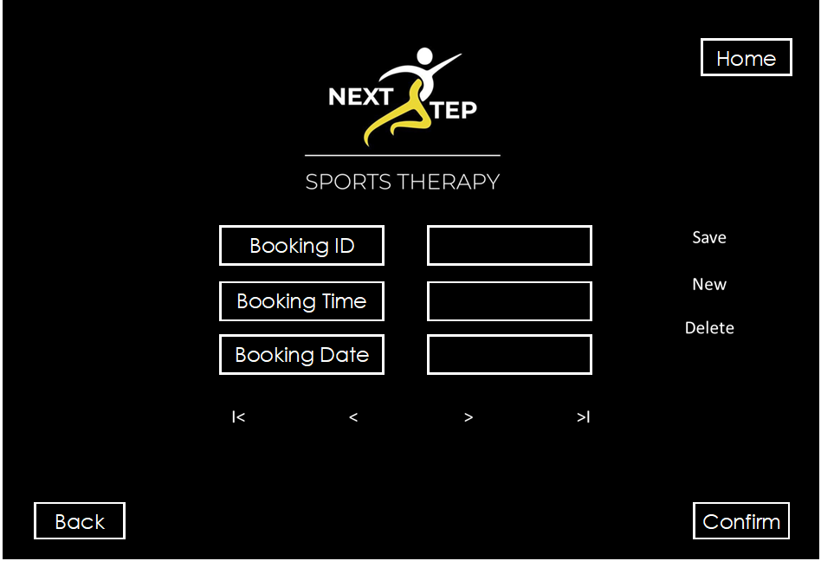
Staff Menu Page
Staff can add new bookings and delete appointments.

4.2 Implementation

4.2.1 Problems and Successes
The first problem that occurred coding the application was the skeleton feature. The client wanted a different interface for the user to interact with. The problem occurred when putting the buttons behind the skeleton.

To overcome this problem, the settings had to be changed to allow the buttons to go behind the image, so further research was conducted to overcome this. This was successful and the skeleton was used to navigate the interface.

The second problem faced was the IDE (NetBeans) would not allow to input a video into the app. To get around this, the video had to be embedded into the code, and the client did not want this. The other option was to have a link to a video, but the client also did not want this, so images were used instead to show the exercises.

The last problem was potentially to email the user their ID’s, so they do not have to remember them. The extra coding was not worth it, so the user needs to remember their ID in the booking confirmation.

4.2.2 Software Testing
Below is the testing of the application.

4.2.2.1 Unit Testing
The different units of code were tested individually to see if they worked. The units were split into staff login, validation, booking acceptance and booking cancellation. The strategy that was used to test the units was in a tabular format below. “A test table is used to perform unit tests on applications, with a test name, description and the result” (51). Each test was named and numbered, then described and the expected result and actual result was recorded. If the test failed, it would be rectified and retested again. All tests met the expected results, so this meant the units were successful.

Test | Description | Expected result | Actual result | Re-test?

4.2.2.2 System Testing
After testing the different units individually, the system was tested as whole multiple times. This proved successful. This was tested as if there was a problem with a specific unit, this was rectified, and this could affect a different unit. This meant that the whole system had to be tested multiple times. Overall, the system worked and was successful.

4.2.2.3 Usability Testing
The same strategy for unit testing was used for usability testing. “A common approach for organizing usability tests, used by Lewis and Sauro in the book Quantifying the User Experience, is to plot the tests in a table” (52). All the buttons and actions the user can perform were listed into a table, then tested against the success criteria. Again, if the test failed, it was rectified and retested. All actions the user could perform were successful.

Test | Description | Expected result | Actual result | Re-test?

Another way of finding out if the navigation worked, was via the questionnaire. There were questions about navigation and usability. Feedback was considered and tailored, meaning usability was successfully tested.

4.2.2.4 Acceptance Testing
There were two different strategies that were used for the acceptance testing. The first was testing the application against the user and system requirements at section 4.1.1. When all the requirements were successful, the application was shown to the client for a walkthrough. The client accepted the application, meaning the application was successfully tested and accepted. The questionnaire was sent out to Next Steps users to trial/test, and they were happy with it, meaning it was accepted by his clients.

4.2.3 Time boxes
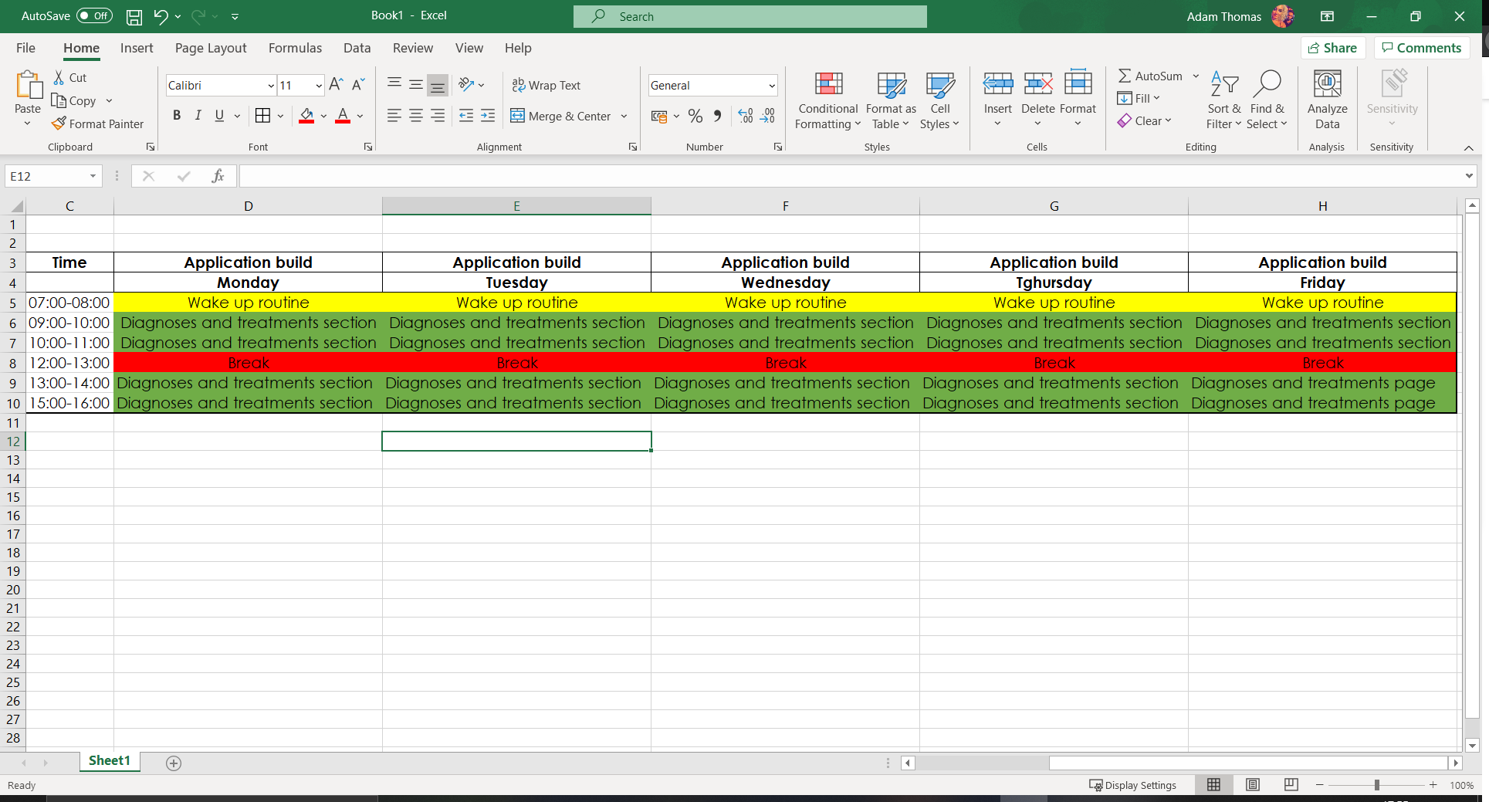
The timeboxes were split up below. First time box for building the app was the injuries and diagnoses pages. A week was given for the deadline for this time box, and this was successfully met. The injury and treatment pages were completed.
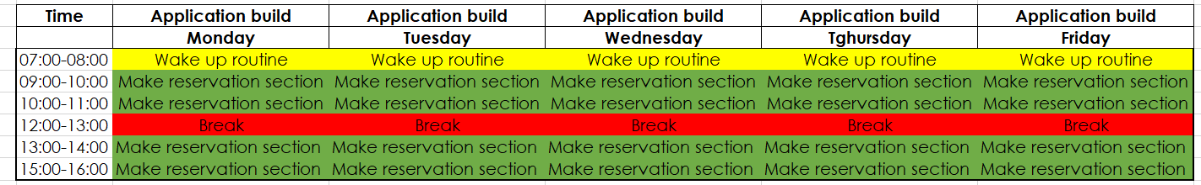
The next time box was to make an appointment. This was also given a week to complete, and this was successfully met.

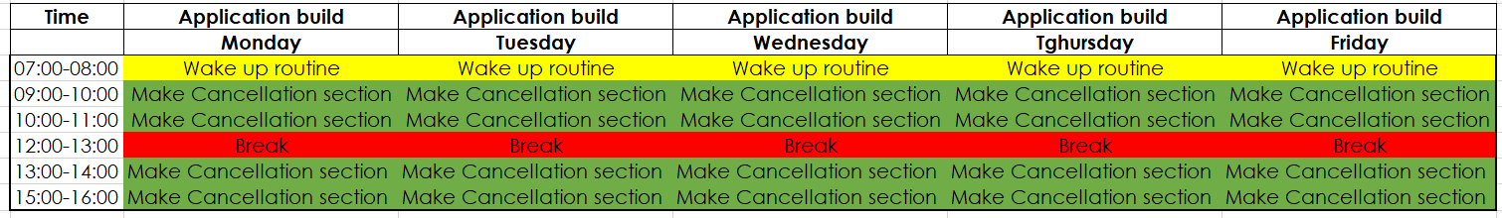
The next time box was the cancellation booking section of the app. This was given a week to complete as extra time was allocated for any issues that may have occurred. This was successfully completed within the time frame.
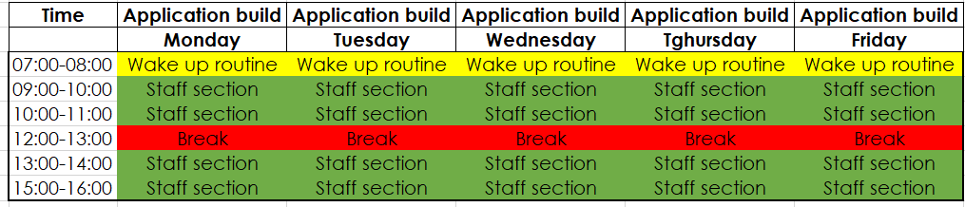
The next time box was the staff menu. This was also given a week to complete and was successfully met.

Overall, the different timeboxes added up to a month for the build of the project. This helped to keep the project on track as the deadlines helped to keep the build on time.

CHAPTER 5 – EVALUATION
The data shows that software can support sports therapists and their clients. The secondary research looked at similar applications which helped sports therapist, especially in the current pandemic where the clients are unable to see their therapists. Analysing the current applications, none of them were bespoke, they were all generic. This showed that there was a need for a client specific application. The primary research shows that all the clients that were asked, all of them said that they think that application helps sports therapist, and they all will continue to use the application in the future. The primary research also backed up the data from the secondary research, as it showed the different injuries and how to treat them. The clients then thought the treatments in the application helped them and the information was successful.

Throughout the research, the data was based on the objectives. The first objective was to research sports therapists. The background and education of sports therapist was researched. Another objective that was met was to research the most popular injuries and their preventions. This was broken down into joints and muscles. After this was completed, it showed how to successfully prevent the injuries. The next objective that was met was to show how to treat the injuries, and in the primary research, this was successful.

See appendix B for analysis.
The primary research was successful as it asked a mix of qualitative and quantitative questions. A range of answers came back. The question “As a client, would you continue using the application?”. The answer was either yes or no, and immediately followed up with “why?”. 100% of the responsive said yes. Some of the responses to ‘why?’ were “because it gives the therapist more time to treat clients”. This suggests that they will continue to use the application as the therapists can treat more people. Another response was “The booking system is more accurate and is available 24/7”. This response suggests that software does help sports therapists and their clients. Another question that backed up the success of the primary research was “Do you think technology supports sports therapists?”. 100% of the participants said that it does support sports therapists, answering the project question. The qualitative answers “They can easily create and cancel bookings without contacting the therapists directly”. This suggests that the therapist will not need to be contacted directly to amend a booking.

The primary research also showed the positives of the application, as the question “rate the navigation out of 5”. 5 people rated the usability a 4 and 10 rated it a 5. This shows the navigation of the application was successful. The question “was the app easy to use? Why?”. 100% of the participants said yes, “easy to navigate with clear instructions for the treatments”. This means the questionnaire showed the positives of the application.

The primary research also suggested how to improve the application. The question “What would you like changed or added to the application?”. The majority of the people suggested that more instructions were needed to cancel a booking. Another participant suggested that “email booking reservation ID, so you do not have to remember”. This will be considered for the build in the future, and implemented to improve the app.

The next objective that was met was to research the current applications, and this gave a better understanding of what the client wanted. The best parts of each application were taken into consideration to build the application. The next objective that was successfully met was to build the application guided by the research, which meant that the client was happy when it came to the acceptance testing as the application was walkthrough with the client.

The overall aim of the project was to investigate how software could support sports therapists and their clients, and this was successful as the primary research showed that all the clients answered yes to this question. The answers to this were expected as technology aids everyone, as it can be more accurate than humans, with less mistakes, e.g., the booking system will help the therapists to focus more on treating, rather than the administration side.

If the project were to be conducted again, the development of the application would be different. Taking into consideration the feedback, such as having videos to show the treatments, this would have been followed. Emailing the client, the reservation ID would also be implemented in the application, but as it is a prototype then the client was happy with it.

CHAPTER 6 - CONCLUSIONS AND RECOMMENDATIONS

Conclusions
The project met the objectives set out in the introduction, successfully meeting the aim. The aim was to see if technology helps sports therapists and their clients. The literature review showed that there was a need for a sports therapist application, showing that technology does help sports therapists and their clients. The current applications available were all generic applications, with no booking system to help sports therapists, they just showed the treatments. The primary research shows that Next step sports therapy’s clients benefitted from using the application, as they all said that they would continue using the application, and all the participants said they think technology supports therapists. They also stated they found the treatments helpful, linking the literature review to the primary research. The research papers conducted by Lars Petersen, Kerry Nicholas, Per Renstrom, Christopher Norris, NHS and Harvard medical school helped to give the clients the best possible treatments and rehabilitation techniques.

The development of the application was successful, as it met all the requirements set out by the client. Using the diagrams and the mock-ups created, this helped to guide the development. Using time boxes, this kept the development on schedule. Following the testing methods that were researched, the testing of the application was successful, as the client accepted the application.

Recommendations
Taking in the feedback from the primary research, it is recommended that the final application has an email function that emails the reservation ID to the user. It is recommended that the anatomy is kept simple. Basic terms for the body should be used, not Latin names.

It is vital that ethical issues are researched, as participants could injured themselves further, while conducting the treatments. They should see a sports therapist if they are unsure.

CHAPTER 7 – REFLECTION

Gibbs reflective cycle will be used to reflect on the project as “it is one of the most famous cyclical models of reflection leading you through six stages exploring an experience: description, feelings, evaluation, analysis, conclusion and action plan” (53).

Recalling the project, there were many things that went well, and I felt good about conducting the secondary research. I found academic and medical sources available to treat the injuries and how to prevent them as there were many studies conducted on the subject. I felt I should have added an extra sub-topic into the literature review looking at studies into how applications help businesses. This would look at the effects on business, linking them to sports therapy, tying up the secondary to the primary research even more, but overall, I am happy about the literature review. I learned the background into sports therapists and ethical issues that they have to adhere.

Next was the build, I felt this went well and was finished ahead of schedule, meaning I felt accomplishment and confidence about the project. Looking back, I felt I should have added the email confirmation for the reservation, and videos for the treatments. This would have left me feeling even more accomplished, but further learning was required, and could be implemented in the future. I would have built the app via Java again but would not use NetBeans as the IDE as it was sometimes problematic creating the interface.

Recalling the primary research, I was happy how that was handled, especially in a pandemic. I had the responses I needed, without being affected by COVID. I learned how to conduct primary research in a pandemic. I would allocate more time for this section next time. If there was no pandemic, I would interview the clients next time instead of using a questionnaire to get more in-depth feedback.

CHAPTER 8 – REFERENCES
- Sports therapist governing body. Society of sports therapist. [Online]. Available from: https://society-of-sports-therapists.org/public-information/what-is-sports-therapy/ [Accessed 1 April 2021].
- Sports therapist job profile. Prospects.ac.uk [Online]. Prospects.ac.uk. 2021 [Accessed 6 April 2021]. Available from: https://www.prospects.ac.uk/job-profiles/sports-therapist
- Eduard Nikolayevich Bezuglov. Using platelet-rich plasma in treating muscular injuries in professional football. [Online]. Available from: [Accessed 6 April 2021].
- Tracy ward. Hamstring injuries: why location and anatomy matters! [Online]. Available from: https://www.sportsinjurybulletin.com/hamstring-injuries-why-location-and-anatomy-matters/ [Accessed 6 April 2021].
- Peterson L, Renström P. Sports injuries, their prevention, and treatment. 3rd ed. 2001.
- Adductor Injuries in Soccer Players. Active PT & Sports [Online]. Active PT & Sports. 2021 [Accessed 6 April 2021]. Available from: https://www.activeptandsports.com/adductor-groin-injuries-in-soccer-players/
- NHS. Cartilage damage. [Online]. Available from: https://www.nhs.uk/conditions/cartilage-damage/ [Accessed 5 April 2021].
- Sports health. Cartilage damage. [Online]. Available from: https://www.sports-health.com/blog/can-damaged-cartilage-be-fixed [Accessed 5 April 2021].
- Julian Mehl. Evidence-based concepts for prevention of knee injuries. [Online]. Available from: https://link.springer.com/article/10.1007/s00402-017-2809-5 [Accessed 5 April 2021].
- Peterson L, Renström P. Sports injuries, their prevention, and treatment. 3rd ed. 2001.
- Peterson L, Renström P. Sports injuries, their prevention, and treatment. 3rd ed. 2001.
- Harvard medical school. Rotator Cuff. [Online]. Available from: https://www.health.harvard.edu/a_to_z/rotator-cuff-injury-a-to-z [Accessed 5 January 2021].
- Harvard medical school. Rotator Cuff. [Online]. Available from: https://www.health.harvard.edu/a_to_z/rotator-cuff-injury-a-to-z [Accessed 5 January 2021].
- NHS. Hamstring injuries. [Online]. Available from: https://www.nhs.uk/conditions/hamstring-injury/ [Accessed 5 January 2021].
- NHS. Hamstring injuries. [Online]. Available from: https://www.nhs.uk/conditions/hamstring-injury/ [Accessed 5 January 2021].
- Christopher Norris. Sports injuries, diagnoses, and management. 3rd ed. 2004.
- Kerry Nicholas. Proprioceptive treatment. An interview with proprioceptive treatments [Masters level]. Next Step Sports Therapy Owner and College Lecturer; 2021.
- Peterson L, Renström P. Sports injuries, their prevention, and treatment. 3rd ed. 2001.
- Ourania Nikolaidou, Stefania Migkou, and Christos Karampalis. Rehabilitation after Rotator Cuff Repair. [Online]. Available from: https://www.ncbi.nlm.nih.gov/pmc/articles/PMC5366376/ [Accessed 5 April 2021].
- Harvard medical school. Rotator Cuff. [Online]. Available from: https://www.health.harvard.edu/a_to_z/rotator-cuff-injury-a-to-z [Accessed 5 April 2021].
- The Importance of Flexibility and Mobility for Injury Prevention [Online]. Elite Myotherapy. 2021 [Accessed 6 April 2021]. Available from: https://elitemyotherapy.com.au/the-importance-of-flexibility-and-mobility-for-injury-prevention/
- The Importance of Flexibility and Mobility for Injury Prevention [Online]. Elite Myotherapy. 2021 [Accessed 6 April 2021]. Available from: https://elitemyotherapy.com.au/the-importance-of-flexibility-and-mobility-for-injury-prevention/
- How to start mobility training [Online]. Men's Journal. 2021 [Accessed 6 April 2021]. Available from: https://www.mensjournal.com/health-fitness/how-to-mobility-flexibility-strength-mens-fitness/
- Peterson L, Renström P. Sports injuries, their prevention, and treatment. 3rd ed. 2001.
- Peterson L, Renström P. Sports injuries, their prevention, and treatment. 3rd ed. 2001.
- Christopher Norris. Sports injuries, diagnoses, and management. 3rd ed. 2004.
- Christopher Norris. Sports injuries, diagnoses, and management. 3rd ed. 2004.
- Mas. MAS Medical. [Online]. Available from: https://www.masmedicalstaffing.com/2018/03/01/physical-therapy-apps-for-patients/ [Accessed 5 April 2021].
- Mas. MAS Medical. [Online]. Available from: https://www.masmedicalstaffing.com/2018/03/01/physical-therapy-apps-for-patients/ [Accessed 5 April 2021].
- Jakob Nielsen. Nielsen's heuristics. [Online]. Available from: https://www.nngroup.com/articles/ten-usability-heuristics/ [Accessed 19 March 2021].
- Mas. MAS Medical. [Online]. Available from: https://www.masmedicalstaffing.com/2018/03/01/physical-therapy-apps-for-patients/ [Accessed 5 April 2021].
- Donald Norman. Norman's affordances. [Online]. Available from: https://www.csun.edu/science/courses/671/bibliography/preece.html [Accessed 1 April 2021].
- Lindsay Wilson et al. Students' experience of the use of an online learning channel in teaching and learning: A sports therapy perspective. [Online]. Available from: https://www.magonlinelibrary.com/doi/abs/10.12968/ijtr.2017.24.7.289 [Accessed 5 April 2021].
- Sports therapist governing body. Society of sports therapist. [Online]. Available from: https://society-of-sports-therapists.org/public-information/what-is-sports-therapy/ [Accessed 5 April 2021].
- Mas. MAS Medical. [Online]. Available from: https://www.masmedicalstaffing.com/2018/03/01/physical-therapy-apps-for-patients/ [Accessed 5 April 2021].
- Jakob Nielsen. Nielsen's heuristics. [Online]. Available from: https://www.nngroup.com/articles/ten-usability-heuristics/ [Accessed 19 March 2021].
- Java [Online]. Java.com. 2021 [Accessed 6 April 2021]. Available from: https://www.java.com/en/download/help/whatis_java.html
- Top 5 programming languages mobile app developers should learn [Online]. TechRepublic. 2021 [Accessed 6 April 2021]. Available from: https://www.techrepublic.com/article/top-5-programming-languages-for-mobile-app-developers-to-learn/
- C++ Introduction [Online]. W3schools.com. 2021 [Accessed 6 April 2021]. Available from: https://www.w3schools.com/cpp/cpp_intro.asp
- Advantages and Disadvantages of C++. Make your Next Move! – Data Flair [Online]. Data Flair. 2021 [Accessed 7 April 2021]. Available from: https://data-flair.training/blogs/advantages-and-disadvantages-of-cpp/
- Advantages and Disadvantages of C++. Make your Next Move! – Data Flair [Online]. Data Flair. 2021 [Accessed 7 April 2021]. Available from: https://data-flair.training/blogs/advantages-and-disadvantages-of-cpp/
- Brian Neubaeur. How phenomenology can help us learn from the experiences of others. [Online]. Available from: https://link.springer.com/article/10.1007%2Fs40037-019-0509-2 [Accessed 5 April 2021].
- Deductive approach. Deductive reasoning. [Online]. Available from: https://www.thebalancecareers.com/deductive-reasoning-definition-with-examples [Accessed 5 April 2021].
- Roberta Heale. What is a case study? [Online]. Available from: https://ebn.bmj.com/content/21/1/7 [Accessed 5 April 2021].
- Unit Testing - Tutorials point [Online]. Tutorialspoint.com. 2021 [Accessed 7 April 2021]. Available from: https://www.tutorialspoint.com/software_testing_dictionary/unit_testing.htm
- System Testing – Tutorials point [Online]. Tutorialspoint.com. 2021 [Accessed 7 April 2021]. Available from: https://www.tutorialspoint.com/software_testing_dictionary/system_testing.htm
- Usability Testing – Tutorials point [Online]. Tutorialspoint.com. 2021 [Accessed 7 April 2021]. Available from: https://www.tutorialspoint.com/software_testing_dictionary/usability_testing.htm
- Acceptance Testing – Tutorials point [Online]. Tutorialspoint.com. 2021 [Accessed 7 April 2021]. Available from: https://www.tutorialspoint.com/software_testing_dictionary/acceptance_testing.htm
- Florida Tech University [Online]. Floridatechonline.com. 2021 [Accessed 7 April 2021]. Available from: https://www.floridatechonline.com/blog/healthcare-management/current-ethical-issues-in-healthcare/
- What is Timeboxing? [Online]. Askinglot.com. 2021 [Accessed 7 April 2021]. Available from: https://askinglot.com/what-is-timeboxing-in-agile
- Unit testing techniques. Unit testing tables. [Online]. Available from: https://medium.com/@vadimpushtaev/unit-tests-cases-table-924b3e55300c [Accessed 12 April 2021].
- Ui. Usability Testing Techniques. [Online]. Available from: https://www.toptal.com/designers/usability/turning-usability-testing-data-into-action [Accessed 12 April 2021].
- University of Edinburgh. Gibbs' Reflective Cycle. [Online]. Available from: https://www.ed.ac.uk/reflection/reflectors-toolkit/reflecting-on-experience/gibbs-reflective-cycle [Accessed 15 April 2021].

CHAPTER 9 – BIBLIOGRAPHY

- Sports injuries, their prevention, and treatment. 3rd ed. 2001.
- Sports injuries, diagnoses, and management. 3rd ed. 2004.

DEMONSTRATION FILE

- https://youtu.be/EWGbKS_-DWY

APPENDICES

- Primary research questionnaire
- Do you think technology supports sports therapists? Why?
- Does the app support you as a client at next step sports therapy? Why?
- Was the application easy to use?
- What did you like about the app?
- What did you dislike about the app?
- What would you like changed or added to the application?
- Rate the navigation of the app
- Would you prefer using the app to book or phoning up the therapist? Why?
- As a client, would you continue to use the app? Why?
- Did you find the treatments helpful?

- Primary Research analyses
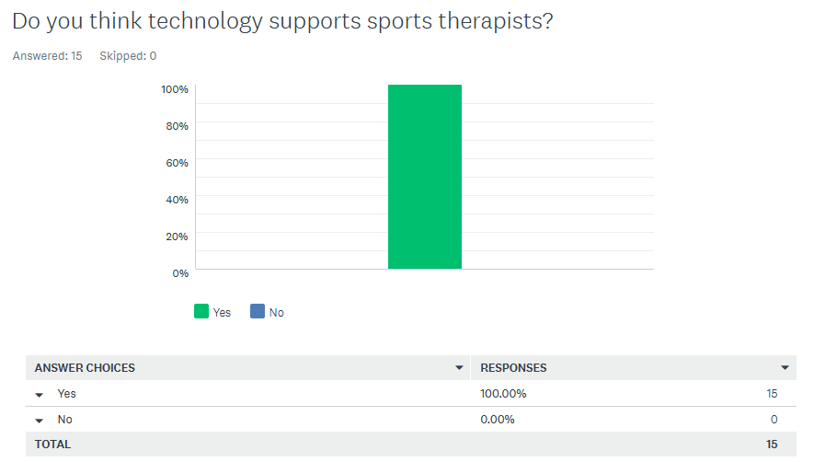
The questionnaire will be analysed below. The answers were put into graphs for the more efficient analyses. The application and questionnaire were sent out to 15 of Next Steps clients to use. Qualitative and Quantitative questions were asked and followed with a comment box for a well-rounded approach.
This suggests that 100% of the people say that technology supports sports therapists. This was asked as the overall aim was to find out if software supports therapists, and this suggests that it does.
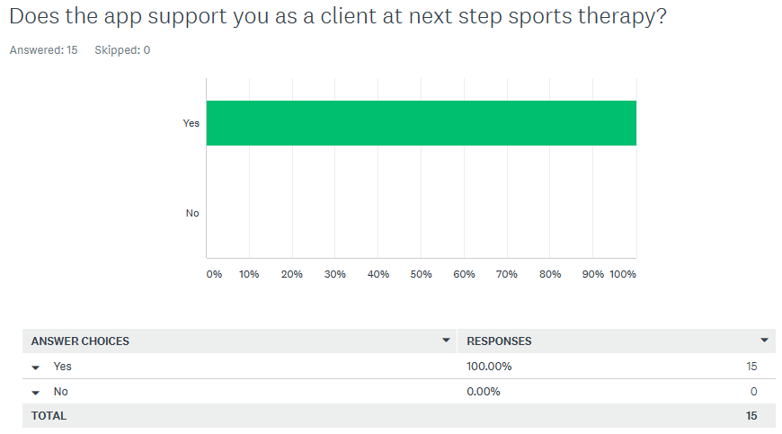
This was asked to and answer the project question. Out of the 15 people that answered, they all said that they felt supported via the app with

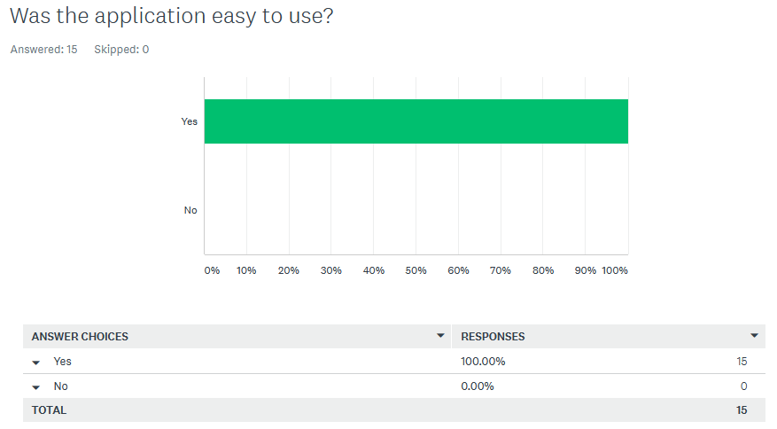
This was asked to try and gain feedback for the application and for the usability testing. 100% of the 15 people said that the app was easy to use.
This was asked as the app needed feedback for any iterations and for the testing. This shows that out of the 15 people, 6 people liked the booking feature, 3 liked the navigation, 2 liked the efficiency of use, 2 liked the treatments available, 1 person liked the ability of diagnosing in a pandemic and 1 liked the potential issues before seeing the therapist.

This was an open question so the user could say what they wanted for more analyses and testing. This could then be considered and changed in the future. 6 people said that more instructions were needed for cancelling a booking, 4 said they wanted an email sent with their reservation ID, 4 people wanted videos for the treatments and 1 person liked everything about the app.
This was asked for any future iterations as the clients will be the ones using the application, so they need the best experience. 5 people said they wanted videos for the treatments, 4 wanted the email sent for the reservation ID, 3 wanted instructions for the cancellation page, 2 wanted the booking option on the home page and 1 wanted an option for video calling the therapists.

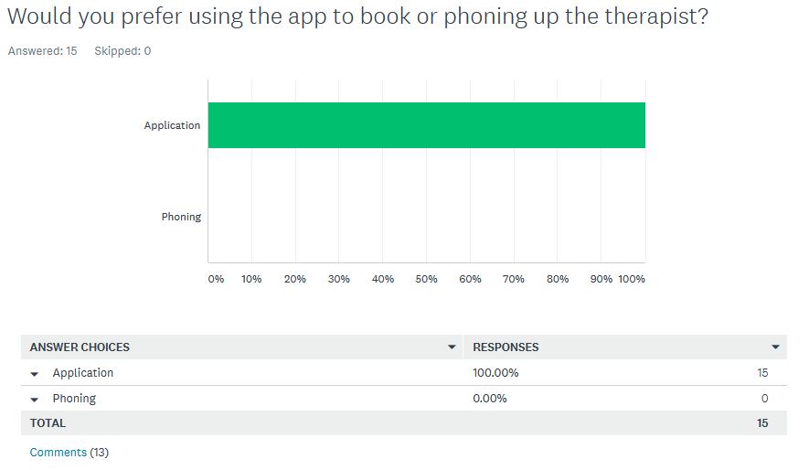
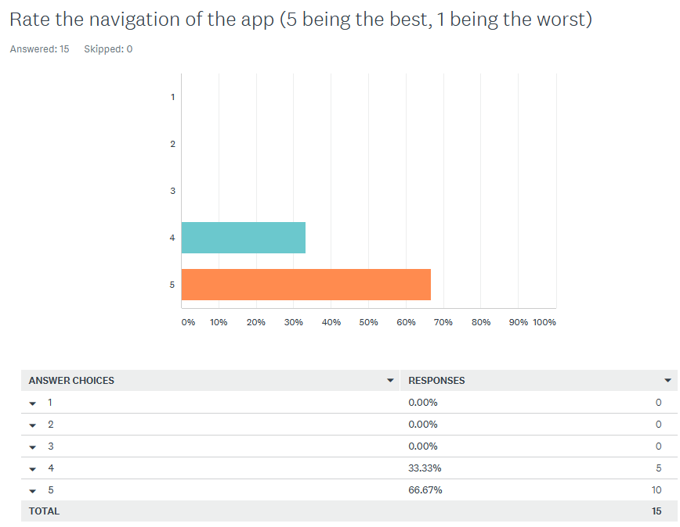
This was asked to test the usability of the application. 5 people rated the usability a 4 and 10 rated it a 5. This shows the navigation of the application was successful.
This was asked as this helped to answer if software supports therapists and their clients, and this suggests it does as 100% of the participants would prefer using technology to book as it was more efficient and available 24/7.

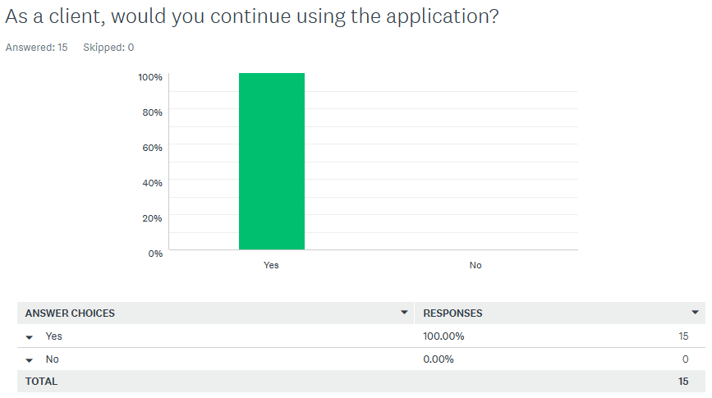
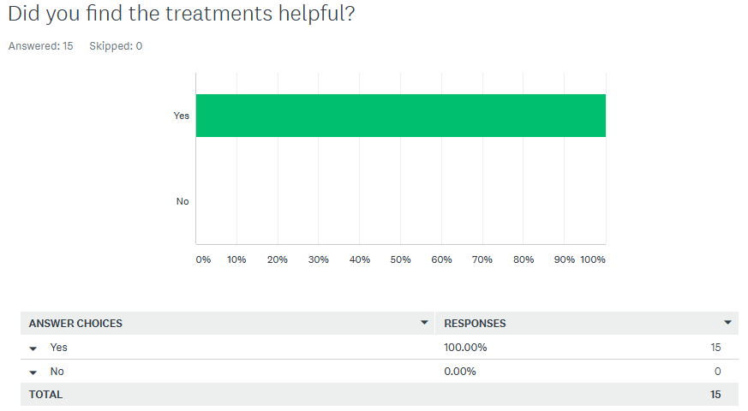
This was asked to see if the client would continue to use the app if it went live. 100% of the clients would still use the application, suggesting that technology does support sports therapists and their clients.
This was asked to see if the treatments researched in the literature review had any correlation with applications treatments. 15 of the participants said that they found the treatments helpful.

