DATA PRIVACY AWARENESS AMONG SOCIAL MEDIA USERS

Name: Vishal Bapodara
Student Id: 2514482
Module: Research Method and Professional Development

Table of Contents
1. Introduction 3
1.1. Context and Background 3
1.2. Research Problem 3
1.3. Research Aim and Objectives 4
1.4. Significance of the Research 5
2. Literature Review 5
3. Research Design and Methodology 9
3.1. Research Design 10
3.2. Research Methods and Materials 11
4. Expected Outcome 14
5. Timeline 15
6. Conclusion 16
7. References 17

1. Introduction

1.1. Context and Background
The aspect of life that characterizes the digital environment of the modern world is the ubiquitous nature of the social media. These sites are no longer the tools of communication but, in fact, the primary objects of the information consumption, not only the case of socialization but also of self-expression. These services are increasingly becoming an inseparable component of the present society since billions of people all over the world use them to communicate with others, exchange experiences, and consume content [1]. This model of business, commonly known as the data economy, allows users to have free access to services in exchange of the personal information which is consequently monetized, mainly via targeted advertising and market analytics.
The paradigm has established a complicated situation of data privacy. The amount of personal information being transferred has never been as high as it is now, and it will include not only user-created content, such as posts and photos, but also an enormous number of metadata, such as location, device details, browsing history, and network connectivity. Much of this information is gathered in complete ignorance or even without understanding of the long-term consequences by the user. App permissions and data collection policies are the main mechanisms by which this exchange can be governed [2]. The two are the key concepts on the contemporary privacy landscape. Regulatory authorities have responded to these concerns by implementing laws such as the General Data Protection Regulation (GDPR) in Europe, which is indicative of an international move toward increased regulation and the realization of a higher demand on data protection policies.

1.2. Research Problem
The fundamental issue this study is attempting to solve is the vast gap between the privacy issues that the users of social media worry about and their real lifestyles on the internet. Most users might claim that they are concerned about the collection and use of their data, but they often do not follow through on these intentions by, for example, regularly choosing the default privacy settings and giving the app permission to access their data blindly [3]. The root cause of such behaviour is a poor data privacy awareness, which is felled by the most basic understanding of the complicated policies that exist in such platforms.
The effects of such knowledge gap are drastic and manifold. By accepting long and incomprehensible terms of service with the button of agree, the users are signing an agreement without being informed, which undermines the moral principles of the data collection process. Such blind agreement results in the various distribution of personal data, and people are predisposed to the danger of data assaults, identity theft, and manipulations. The platforms have a profound knowledge on what information they capture and the value, whereas users get a shallow or a wrong knowledge thus failing to make significant decisions to safeguard their digital identities [4]. The main problems that are leading to this problem are the formulation and the way the policies are written; they are usually very long and full of legal and technical jargons and they are usually written in a manner that does not encourage the proper reading of them, thus posing a systemic hurdle to actual understanding [20].

1.3. Research Aim and Objectives
This research will be conducted with the purpose to examine and quantify the degree of awareness of the social media users connected with the app permissions and data collection policies, detect the main causes of the lack of understanding. In order to meet this general purpose, the study will seek four distinct objectives that will systematically deconstruct the issue to generate actionable knowledge. All the objectives address different aspects of the issue, shifting between the quantification of the existing state of knowledge to the creation of appropriate solutions on how it can be changed in a practical way.
The specific objectives are as follows:
- Objective 1: To measure social media users' current understanding of app permissions through a quantitative survey.
- Objective 2: To assess users' comprehension of data collection policy clauses using scenario-based knowledge tests.
- Objective 3: To identify common misconceptions and gaps in knowledge related to data sharing and privacy settings.
- Objective 4: To provide evidence-based recommendations for social media platforms to develop more transparent permission flows and for creating educational user-support materials.

1.4. Significance of the Research
This study has three-fold value and its potential contribution to the academic community, the society on the whole, and the technology industry is immense. To the research community, the study will provide new and valuable empirical evidence about the particular rate of user understanding in relation to technical permission of the app and dense language of policies.
To society, the findings will assist in making society more responsible and aware of their online behaviour by shedding light on knowledge gaps. This study can help to make the digital citizenship more responsible by providing users with a better idea of what they post online. To the industry, the study will bring practical pieces of information that can help inform how the privacy interface can be designed more clearly, ethically, and user-focused [5]. The implications of the findings are practical and tangible and provide a way through which social media platforms and policymakers could enhance transparency and regain user trust that would eventually result in a safer and more transparent online space to all [21].

2. Literature Review
The present literature review is a critical evaluation of the literature relating to the topic of data privacy awareness of social media users. The nature of the current research is to create an academic contextualisation of the particular research by examining three main thematic issues: the behavioural phenomenon of the privacy paradox, the issues of whether the privacy policy is understood by the user, the technical aspects of the app permissions and data collection.
The Privacy Paradox
The core themes of the scholarly literature on the topic of digital privacy is the phenomenon so-called “privacy paradox”. The term is used to refer to the common gap existing between the privacy concerns that people raise to and the privacy habits that they are engaged in on the internet. A substantial number of studies have continually observed that although the users tend to be anxious about the data gathering, surveillance and the possibility of their personal information being misused, they also tend to perform activities which are contrary to the feelings [6]. These involve posting personal information that is sensitive and use of weak passwords as well as the inability to use privacy-saving tools and settings that are available [22].
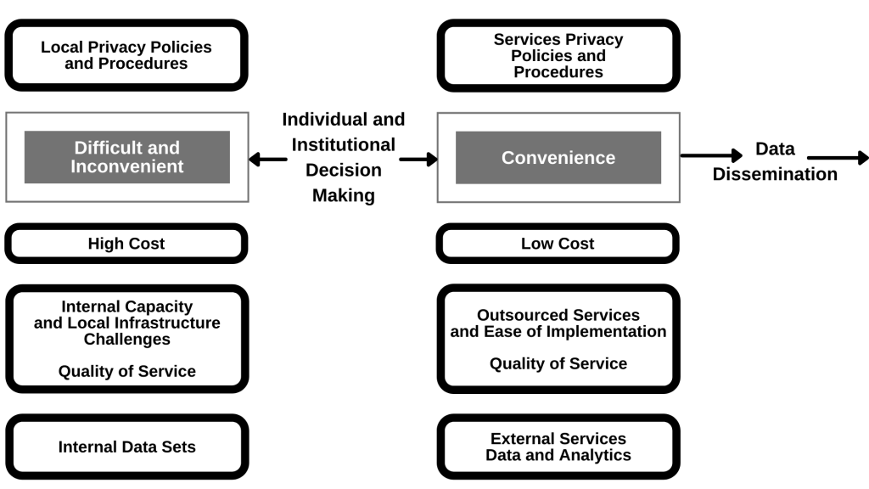
Figure 1: The Privacy Paradox
(Source: ecampusontario.pressbooks.pub, 2025)
A number of theoretical models have been developed to explain such behaviour. Among the most notable is the privacy calculus which assumes that users are implicitly doing a cost benefit analysis when making their decision to disclose information or not. The perceived benefits, including social connection, entertainment, convenience, and ability to access free services, are usually immediate, tangible and highly valued. Conversely, the possible expenses, like generation of breach of data in the future, or a possibility of being observed in general, are usually deferred, probabilistic, and immeasurable [7]. Therefore, the short-term satisfaction of the consumption of a platform can easily prevail over the indistinct and far-off dangers resulting in users being more inclined to safeguard functionality over privacy [23].
User Comprehension of Privacy Policies
The framework of legal and ethical standards that help to ensure informed consent on the internet is anchored on the model of notice and choice whereby the sites give the user a privacy policy (the notice) and the user assent to the policy (the choice). Nonetheless, an extensive body of literature illustrates the fact that this paradigm is practically flawed by way of gross ignorance among users [8]. The research on the user interaction with privacy policy and terms of service document invariably indicates a low reading and comprehension of the documents.
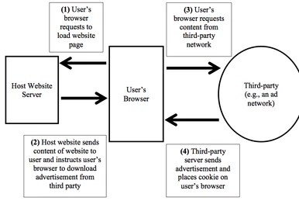
Figure 1: Notice-and-choice model
(Source: itlaw.fandom.com, 2025)
This has been caused by systemic reasons and is well documented. The greatest obstacle is the very structure of the policies. They are infamously time-consuming, and studies have indicated that the average policy is either of university reading level and takes extensive time to read, which users are not willing or incapable to dedicate to every other service accessed. Even the format of the presentation, a block of text that opens in a small pop-up window with pre-assigned agree button discourages interaction even more [9]. In this design commonly known as a click-wrap agreement, the focus is made on user onboarding without any friction rather than on meaningful consent. This is such a widespread failure of the notice and choice model that it is a causal reason of the issue of poor privacy awareness [24].
App Permissions and Data Collection Practices
Continuing to leave the legal aspect and move to the technical side of the process, another important area where the user’s awareness becomes weak is the system of app permissions on the mobile devices. Permission requests are the most common way to provide mobile apps with access to a sensitive hardware, software, and data of a device, such as the microphone, camera, GPS location, contacts, and storage. Although it is meant to serve as a protection mechanism as the user is in control, the studies show that these mechanisms fail to do their intended purpose [10]. Research has revealed that users often give permission without having a complete knowledge of what they were consenting to and the reason why an application needs access of a given nature [25].
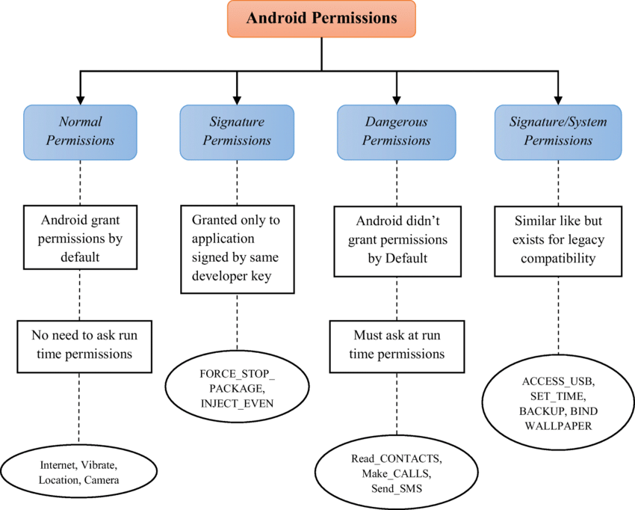
Figure 3: Types of Permissions in Android
(Source: researchgate.net, 2025)
The problems identified in the literature is the so-called permission fatigue. It can also be annoying to see as many permission requests as users do, especially at the beginning of the first installation. It is this bombardment that may cause them to cease making conscientious and thoughtful decisions and instead use a trait of wholesale approval merely to reach the functionality they desire in the application as quickly as possible [27]. The design of these prompts is also a consideration; in the past, requests could be clustered together and the user had to grant extensive permissions in one go and even now, they might not have the context to make an informed choice [12]. An example will be a request to access the contacts of a user to a simple photo-editing application, which may sound as unnecessary without a clear and instantaneous explanation, a user will allow it by default or by the fact that they have not understood the reasons [26].
Gaps in Existing Research
Although the current literature has been very efficient in developing the bigger picture of the data privacy concern, there has been a notable gap. The presence of the privacy paradox has been solidly proven through scholarly work on the existence of behavioural disconnect between concern and action. It has also adequately reported the structural weakness in privacy policies and permission systems as one of the major obstacles to understanding on the part of the user. The literature manages to identify that there is an issue and describe its major causes on a broad level [28].
These basic insights the research is somewhat deficient to take the next step as to actually quantifying the exact dimensions of user comprehension under applied practical conditions. Much of the available data is based on self-reported surveys which can accurately determine the attitudes of users and their perceived knowledge but are less accurate in determining actual functional knowledge. Although it has been observed that users are confused by policies, little is known concerning the particular concepts and the type of clauses that are most confusing [13]. On the same note, although we are aware of the liberal way in which users give permissions, more specific data of how they can interpret what the permissions really mean in the real world is required. Practical and scenario-based knowledge tests are a poorly used methodology in this area.
Literature Summary
To conclude, the scholarly sources demonstrate that there is also a major issue of data privacy, which lies in the behavioural trends of the privacy paradox. Systemic problems, such as the unreadability of privacy policies and the bewildering nature of app permission systems have a strong effect on this behaviour, as they both compromise the principle of informed consent. In spite of this strong background, however, there is an obvious gap in the research: more investigations are needed that would empirically determine the nature and extent of user misunderstanding in a more practical, scenario-based evaluation. The existing literature is sufficient to explain the problem, and additional research is required to measure its individual elements [29].

3. Research Design and Methodology
This section outlines the systematic research plan to be used. It presents the general research design, the detailed procedures of data collection and analysis, the materials to be used, and the ethical procedures to be observed during the research.

3.1. Research Design
The research design that will be used in this paper is that of a mixed-method study, which will involve both quantitative and qualitative aspects in order to get a complete and multi-faceted perspective of data privacy awareness among users of social media. This approach is philosophically based on pragmatism, which acknowledges that the integration of various research methods can give a more complete picture on a complicated phenomenon compared to a single research method [30].
The main research method will be a survey, cross-sectional survey. The methodology of this strategy implies that a representative sample of social media users is collected at one time, which will make it possible to efficiently and effectively evaluate the current attitude, self-perception, and knowledge level of various demographic groups [14]. The main merit of a cross-sectional survey is that it will enable gaining the picture of the existing level of awareness which is necessary to create a background and determine the magnitude of the issue. High level of statistical generalizability of the sampled population is achieved through this method [31].
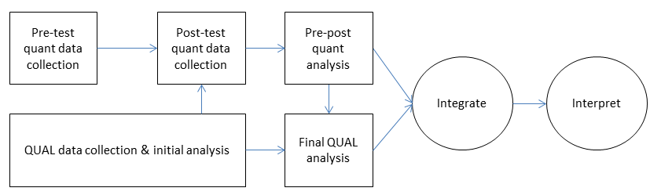
Figure 4: Diagram of mixed methods research design
(Source: researchgate.net, 2025)
The justification of the use of a mixed-method methodology lies in the complementary nature of the two parts. The quantitative survey will be aimed at quantifying the scope of the problem- determining the difference between the perceived knowledge of the users and their real knowledge of the app permissions and data policies. It will respond to questions of what and how much. On the other hand, the qualitative analysis of open-ended questions of the survey and the secondary sources will give more understanding of the causes of these quantitative results. This element will cover the component of why by discussing the context, subjective experiences as well as reasoning that inform the privacy behaviours of users [32].

3.2. Research Methods and Materials
Methods
The quantitative and qualitative data collection and analysis of this study will be done in different ways to engage in its practical implementation.
The quantitative part will be implemented by way of a designed online survey. This survey will be carefully constructed to be concise, understandable and interesting to get the highest completion rates and quality of data. The tool will be segmented into three parts. To start with, the demographics section will provide anonymous information about the age, gender, educational background, and frequency of the use of social media of the participants, which will be essential to perform the correlational analysis afterward. Second, a questionnaire consisting of a list of questions based on the 5-point Likert scale will be used to measure the self-perceived privacy knowledge and the intensity of concerns and the attitudes of the participants towards data collection [15]. As an example, the participants will be requested to score their agreement with the statements like, “I believe that I have a good idea about the information that data social media apps capture about me”. Section three and the most important one will be multiple-choice and scenario-based questions that will clearly and strictly measure the actual knowledge about permissions in the apps and the policies of data collection among the participants [33].
The secondary research will be used to collect the qualitative data. It will entail a literature review and analysis of available public sources of data to source out deep and contextual information about the lived lives of the social media users. The sources will consist of published scholarly journal articles, reports created by the industry on the topic of user privacy, as well as open-ended user forums (e.g., Reddit threads) where people discuss their misinterpretations, worries, and experiences with privacy policies and application permits [34].
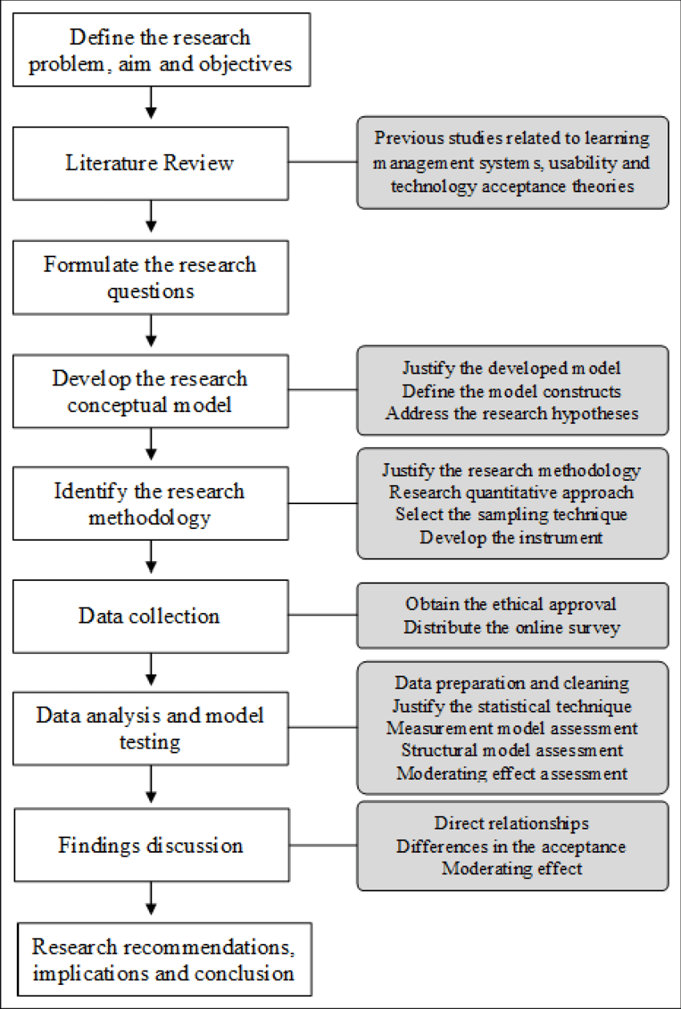
Figure 5: Flow Chart of Research Process
(Source: researchgate.net, 2025)
The data analysis is going to be performed in two streams. The online survey will be analysed using descriptive statistics with the use of such software as SPSS. This will be done by computing frequencies, mean and percentages to describe the demographic data and Likert scale responses. T-tests or ANOVA, as inferential statistics, can be applied to investigate the relationships between demographic variables and knowledge scores. Thematic analysis [16] will be implemented as the qualitative method of analysing the qualitative data collected in the secondary sources. It is a systematised process of determining, examining and presenting repetitive patterns (or themes) that crop up through the text data, which will assist in elucidating the underlying causes of the trends found in the quantitative analysis [35].
Materials
Implementing this research successfully will demand the use of certain materials, a strictly outlined target population, and the right software.
This study will target the active social media users of age 18 and above because they are old enough to agree to terms of services. A non-probability convenience sample will be used to recruit participants. There will be distribution using the university email networks, professional social media like LinkedIn and those communities online related to technology and privacy. Although this approach is viable and enables the ability to recruit a heterogeneous sample of participants, it is necessary to note that it may be limiting to the generalizability of the results.
Strict ethical guidelines are most important in this study. To begin with, formal ethical approval will be obtained and invited by the concerned institutional review board prior to the collection of any data. The informed consent form will be elaborated to all the participants before the online survey takes place. This form will clearly define the aim of the study, affirm the voluntary participation and clearly define the right of the participant to drop out of the study any time without any penalty [17]. It will also describe the actions to be undertaken to facilitate anonymity and confidentiality. Participant privacy will be maintained by ensuring that all the data obtained will be anonymized during the collection process and this data will be kept in a secure place in an encrypted hard drive.
A number of standard software tools will be useful in the implementation of this research. The survey will be prepared as an online survey and will be conducted with the help of a reliable service like Google Forms or SurveyMonkey. A statistical software will be used to analyze the quantitative data such as SPSS or R. The data that will be collected using the qualitative method will be coded and arranged through the use of the common office software.

4. Expected Outcome
The general expected result of the study is the empirical confirmation of the fact that the perceived and the actual practical knowledge of the social media users are widely diverged on the issue of their privacy. When the respondents are subjected to the real life situation based questions, it is feared that the respondents will not know in general the particular implication of the common permissions attached to the use of apps, and the ambiguous wording of the data collection policies. Hopefully, the study can reveal some of the main myths about the third-party data sharing, its building, and formation of the user profiles that can be utilized in the advertisement. Moreover, the results will be also contrary to the previous assumption according to which the younger generations being more technology savvy are more privacy savvy [18]. As can be estimated, this generation, despite being educated on the use of the social media will lack as many knowledge bases, and misconception, as the older generations using social media, and the technical knowledge will not necessarily create a critical idea of how data privacy operates.
The conclusions of the findings are titanic and findings have theoretical and practical input. Ideally, the proposed research will provide a small and quantitative data to go an extra mile to provide a more comprehensive view of the cognitive inhibitions that lead to privacy paradox. The quantification of certain sectors of confusion will provide an essential level of elaboration to the scholarly conversation regarding informed consent in the digital era. In practice, the findings will give a list of practical recommendations to the stakeholders of the industry [19]. The findings can be used by the designers and developers as a direct evidence base to develop more transparent, user-oriented privacy interfaces and streamlined permission flows. This study will make policymakers realize the shortcomings of the current notice and choice model and can aid in the creation of rules that would require more explicit and transparent data disclosure requirements.
This research recognizes the possible limitations of this research and they should be put into consideration when interpreting the findings. The main limitation is the convenience sample that will be used in recruiting participants and this may not be enough to represent the general population of social media users and therefore, this reduces the statistical generalizability of the results. Further, the survey-based design, although a controlled approach, might not be the best choice to reflect the impulsive in-the-moment decision-making procedures that users adopt in real-world scenarios when approaching a permission request.

5. Timeline
This research project will be carefully scheduled to be carried out in a shortened three-month time, with a start date of November 17, 2025, and ending date of February 17, 2026. Gantt chart is a visual representation of the plan in terms of schedule, which is organized into four particular and sequential stages in order to guarantee logical and efficient flow of work. Phase 1: the planning and setup, which occurs within 15 days and is characterized by preparation tasks of such activities as literature review, protocol design, survey design, and ends with ethics submission at the beginning of December. The next stage will be the Phase 2: Data Collection that will last 23 days. It is a highly important measure that will initially start with a pilot test that will be expedited and the actual online survey will be sent and data shall be collected in the first week of January.
The project progresses to Phase 3: Data Analysis, which is another 15 days in mid-January aimed at quantitatively interpreting the results of survey and conducting qualitative thematic analysis. The last phase, Phase 4: Reporting, will be done over 12 days in February. The latter stage will be used to finalize the interpretation of all findings and to write and complete the entire research report, which should entail all the project objectives being achieved within the stipulated period.
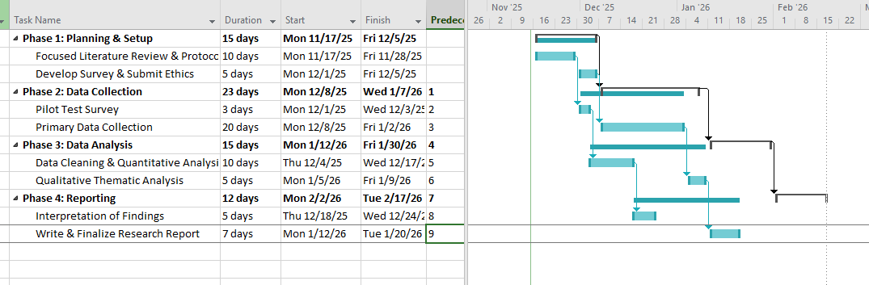
Figure 4: Gantt Chart – Timeline
(Source: Self-Created)

6. Conclusion
The objective of this study was to examine the gap between perceived versus real app permissions and app policy awareness regarding data collection among social media users. The systemic barriers identified in the literature analysis include incomprehensible privacy policies, the use of long permission forms and the behavioural gap or privacy paradox. To demonstrate to users that they are over-confident in their knowledge of the nature of their knowledge of privacy, and low in their understandings of key concepts, language and data sharing, the research will produce empirical evidence through both survey and scenario-based evaluation in a mixed-method research design.
Older and younger users are achieving equivalent misconceptions to prove that digital intimacy does not necessarily assume a knowledge of privacy, these approximated results. Such lessons will contribute positively to the academic conversation of informed consent and provide a framework of practical implications to social media, designers and policymakers. Its outcomes may be utilized to develop simpler interface design, enhance permission flow and more direct communication approach regarding privacy.
The convenience sample restricts external validity, but the study offers a viable basis to future research utilizing larger or experimental designs. All in all, the study is expected to establish a safer and more transparent online space where people can make responsible choices regarding their data.

7. References
- “AI Applications in Cyber Security and Privacy of Communication Networks,” Google Books, 2024. https://books.google.com/books?hl=en&lr=&id=vNWDEQAAQBAJ&oi=fnd&pg=PA125&dq=DATA+PRIVACY+AWARENESS+AMONG+SOCIAL+MEDIA+USERS&ots=MKM8oMN2Pq&sig=eBuovF4iYAtg2jQYrqybY9K1_c4 (accessed Nov. 18, 2025).
  - Chaudhari et al., “Cyber Security Challenges in Social Meta-verse and Mitigation Techniques,” vol. 8, pp. 1–7, Apr. 2024, doi: https://doi.org/10.1109/mitadtsocicon60330.2024.10575295.
- Singhal, N. Neveditsin, H. Tanveer, and V. Mago, “Toward Fairness, Accountability, Transparency, and Ethics in AI for Social Media and Health Care: Scoping Review,” JMIR Medical Informatics, vol. 12, no. 1, p. e50048, 2024, doi: https://doi.org/10.2196/50048.
- Adebola Folorunso, “Assessment of Internet Safety, Cybersecurity Awareness and Risks in Technology Environment among College Students,” Jan. 2024, doi: https://doi.org/10.2139/ssrn.4955615.
- Cengiz, A.B., Kalem, G. and Boluk, P.S., 2022. The effect of social media user behaviors on security and privacy threats. Ieee Access, 10, pp.57674-57684.
- Chen, X., Zou, D., Xie, H. and Wang, F.L., 2023. Metaverse in education: Contributors, cooperations, and research themes. IEEE Transactions on Learning Technologies, 16(6), pp.1111-1129.
- Conti, M., Gathani, J. and Tricomi, P.P., 2022. Virtual influencers in online social media. IEEE Communications Magazine, 60(8), pp.86-91.
- D. H. Lan and T. M. Tung, “Exploring fake news awareness and trust in the age of social media among university student TikTok users,” Cogent Social Sciences, vol. 10, no. 1, pp. 1–24, 2024, doi: https://doi.org/10.1080/23311886.2024.2302216.
- D. I. Peter and Ben-Collin Emeka Ndinojuo, “Privacy Awareness and Social Media: Personal Data Protection among Facebook** and Instagram** Users,” Galactica Media: Journal of Media Studies , vol. 6, no. 3, 2024, Available: https://cyberleninka.ru/article/n/privacy-awareness-and-social-media-personal-data-protection-among-facebook-and-instagram-users
- D. Nugroho and P. Angela, “The Impact of Social Media Analytics on SME Strategic Decision Making,” IAIC Transactions on Sustainable Digital Innovation (ITSDI), vol. 5, no. 2, pp. 169–178, Mar. 2024, doi: https://doi.org/10.34306/itsdi.v5i2.664.
- Di Pietro, R. and Cresci, S., 2021, December. Metaverse: Security and privacy issues. In 2021 third IEEE international conference on trust, privacy and security in intelligent systems and applications (TPS-ISA) (pp. 281-288). IEEE.
- Gao, Y., Li, Y., Sun, Y., Cai, Z., Ma, L., Pustišek, M. and Hu, S., 2022. IEEE access special section: privacy preservation for large-scale user data in social networks. IEEE access, 10, pp.4374-4379.
- Golda, A., Mekonen, K., Pandey, A., Singh, A., Hassija, V., Chamola, V. and Sikdar, B., 2024. Privacy and security concerns in generative AI: a comprehensive survey. IEEE Access, 12, pp.48126-48144.
- Holmes, D., Papathanasaki, M., Maglaras, L., Ferrag, M.A., Nepal, S. and Janicke, H., 2021, September. Digital twins and cyber security–solution or challenge?. In 2021 6th South-East Europe Design Automation, Computer Engineering, Computer Networks and Social Media Conference (SEEDA-CECNSM) (pp. 1-8). IEEE.
- Hu, J., Liao, X., Wang, W. and Qin, Z., 2021. Detecting compressed deepfake videos in social networks using frame-temporality two-stream convolutional network. IEEE Transactions on Circuits and Systems for Video Technology, 32(3), pp.1089-1102.
- J. R. Saura, D. Palacios-Marqués, and D. Ribeiro-Soriano, “Privacy concerns in social media UGC communities: Understanding user behavior sentiments in complex networks,” Information Systems and e-Business Management, Mar. 2023, doi: https://doi.org/10.1007/s10257-023-00631-5.
- J. T. Dicolen, “Social Media Practices among HUMSS Students in a Private School in Cabuyao City,” International Journal on Integrated Education, vol. 8, no. 4, pp. 413–424, May 2025, doi: https://doi.org/10.31149/ijie.v8i4.5470.
- Khan, A.A., Bourouis, S., Kamruzzaman, M.M., Hadjouni, M., Shaikh, Z.A., Laghari, A.A., Elmannai, H. and Dhahbi, S., 2023. Data security in healthcare industrial internet of things with blockchain. IEEE Sensors Journal, 23(20), pp.25144-25151.
- L. Sanbella, I. V. Versie, and S. Audiah, “Online Marketing Strategy Optimization to Increase Sales and E-Commerce Development: An Integrated Approach in the Digital Age,” Startupreneur Business Digital (SABDA Journal), vol. 3, no. 1, Mar. 2024.
- M. H. Nguyen, M. Büchi, and S. Geber, “Everyday disconnection experiences: Exploring people’s understanding of digital well-being and management of digital media use,” New Media & Society, vol. 26, no. 6, p. 146144482211054, Jul. 2022, doi: https://doi.org/10.1177/14614448221105428.
- Nikitha Sreekanthaswamy et al., “Digital Tools and Methods,” IGI Global eBooks, pp. 25–48, Feb. 2025, doi: https://doi.org/10.4018/979-8-3693-8392-6.ch002.
- Omrani, N., Rejeb, N., Maalaoui, A., Dabić, M. and Kraus, S., 2022. Drivers of digital transformation in SMEs. IEEE transactions on engineering management, 71, pp.5030-5043.
- R. Scharlach, B. Hallinan, and L. Shifman, “Governing principles: Articulating values in social media platform policies,” New Media & Society, vol. 26, no. 11, p. 146144482311565, Mar. 2023, doi: https://doi.org/10.1177/14614448231156580.
- Rahmad Solling Hamid, Imran Ukkas, Goso Goso, Abror Abror, S. M. Anwar, and Abdul Razak Munir, “The role of social media in building trust, self-perceived creativity and satisfaction for millennial entrepreneurs,” Journal of Small Business and Enterprise Development, vol. 31, no. 2, Aug. 2023, doi: https://doi.org/10.1108/jsbed-11-2022-0482.
- Rostami, M., Oussalah, M., Berahmand, K. and Farrahi, V., 2023. Community detection algorithms in healthcare applications: a systematic review. IEEE Access, 11, pp.30247-30272.
- Rozak, H.A., Adhiatma, A., Fachrunnisa, O. and Rahayu, T., 2021. Social media engagement, organizational agility and digitalization strategic plan to improve SMEs’ performance. IEEE Transactions on Engineering Management, 70(11), pp.3766-3775.
- Sai Dikshit Pasham, “Scalable Graph-Based Algorithms for Real-Time Analysis of Big Data in Social Networks,” The Metascience, vol. 2, no. 1, pp. 92–129, 2024, Accessed: Jun. 05, 2025. [Online]. Available: http://yuktabpublisher.com/index.php/TMS/article/view/128
- Saidi, H., Labraoui, N., Ari, A.A.A., Maglaras, L.A. and Emati, J.H.M., 2022. DSMAC: Privacy-aware Decentralized Self-Management of data Access Control based on blockchain for health data. IEEE Access, 10, pp.101011-101028.
- Samuel, O., Omojo, A.B., Onuja, A.M., Sunday, Y., Tiwari, P., Gupta, D., Hafeez, G., Yahaya, A.S., Fatoba, O.J. and Shamshirband, S., 2022. IoMT: A COVID-19 healthcare system driven by federated learning and blockchain. IEEE Journal of Biomedical and Health Informatics, 27(2), pp.823-834.
- Sufi, F.K. and Khalil, I., 2022. Automated disaster monitoring from social media posts using AI-based location intelligence and sentiment analysis. IEEE Transactions on Computational Social Systems, 11(4), pp.4614-4624.
- Syafitri, W., Shukur, Z., Asma’Mokhtar, U., Sulaiman, R. and Ibrahim, M.A., 2022. Social engineering attacks prevention: A systematic literature review. IEEE access, 10, pp.39325-39343.
- Wang, M., Yu, H., Bell, Z. and Chu, X., 2022. Constructing an edu-metaverse ecosystem: A new and innovative framework. IEEE Transactions on Learning Technologies, 15(6), pp.685-696.
- X. Zhang, J. Abbas, Muhammad Farrukh Shahzad, A. Shankar, Sezai Ercisli, and D. C. Dobhal, “Association between Social Media Use and Students’ Academic Performance through Family Bonding and Collective learning: the Moderating Role of Mental well-being,” Education and Information Technologies, vol. 29, Jan. 2024, doi: https://doi.org/10.1007/s10639-023-12407-y.
- Y. Lian, H.-B. Tang, M. Xiang, and X. Dong, “Public attitudes and sentiments toward ChatGPT in China: A text mining analysis based on social media,” Technology in Society, vol. 76, pp. 102442–102442, Dec. 2023, doi: https://doi.org/10.1016/j.techsoc.2023.102442.
- Zhou, X., Liang, W., Luo, Z. and Pan, Y., 2021. Periodic-aware intelligent prediction model for information diffusion in social networks. IEEE Transactions on Network Science and Engineering, 8(2), pp.894-904.
- Zhou, X., Liang, W., Ma, J., Yan, Z. and Wang, K.I.K., 2022. 2D federated learning for personalized human activity recognition in cyber-physical-social systems. IEEE Transactions on Network Science and Engineering, 9(6), pp.3934-3944.

Websites:
- ecampusontario.pressbooks.pub, 2025. The Privacy Paradox [Online]. Available at: https://ecampusontario.pressbooks.pub/digitalprivacyleadershipandpolicy/chapter/the-privacy-paradox-present-and-future/ [Accessed on: 15.11.2025].
- itlaw.fandom.com, 2025. Notice-and-choice model [Online]. Available at: https://itlaw.fandom.com/wiki/Notice-and-choice_model [Accessed on: 15.11.2025].
- researchgate.net, 2025. Types of Permissions in Android [Online]. Available at: https://www.researchgate.net/figure/Types-of-Permissions-in-Android-20_fig1_335251045 [Accessed on: 15.11.2025].
- researchgate.net, 2025. Diagram of mixed methods research design [Online]. Available at: https://www.researchgate.net/figure/Diagram-of-mixed-methods-research-design_fig1_262451336 [Accessed on: 15.11.2025].
- researchgate.net, 2025. Flow Chart of Research Process [Online]. Available at: https://www.researchgate.net/figure/Flow-Chart-of-Research-Process_fig1_334898544 [Accessed on: 15.11.2025].

