

Student name: Iohana-Eleonora Popa
Srudent number: 1921952

Modle title: Community engagement
Assigment title: Save the children from Africa (Part II)
Module lectuer’a name: Riaz Bhatti

Date: 18.12.2020

Foreword…

In the next following paper, I will continue to discuss about Save the Children from Africa reflecting on the best practice of the community and on my personal development on how/what will I change and/or do things differently to increase the organization’s employability.
The paper contains three parts and will focus on the main subjects requested:
• Introduction (set the scene for the reader)
• Reflection on personal experience with reference to the social project/ business discussed in outcome 1 (provide relevant headings and adopt a reflective learning cycle
• Conclusion (cogent summary)

Thank you,
IOHANA

I. Introduction

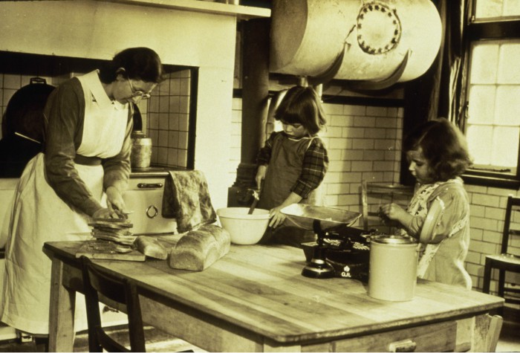 Save the Children Foundation’s roots, begin after the First World War ended, when Eglantyne Jebb together with her sister Dorothy Buxton fight for the Children rights. In April 1919, Jebb was arrested for handing out leaflets in Trafalgar Square, bearing photos of hungry children from Austria, who had not been cleared by government censors. The judge was impressed with her commitment and paid her fine after Jebb was found guilty. 1923, was the year when Eglantyne Jebb’s Declaration of the Rights of the Children was accepted by The League of Nations and in the following year, became widely known to nations across the globe. (DeAirra, 2017).

After Eglantyne Jebb death in 1928, her compelling vision of breaking the cycle of poverty that shattered the lives of so many children remain still. She comments:

"If we accept our premise, that the Save the Children Fund. must work for its own extinction, it must seek to abolish, for good and for all, the poverty which makes children suffer and stunts the race of which they are the parents. It must not be content to save children from the hardships of life - it must abolish these hardships; nor think it suffices to save them from immediate menace - it must place in their hands the means of saving themselves and so of saving the world." (Save the Children, 2020)

Save the Children Fund., recognized for its dedication to its values such as accountability and innovation. The organization’s staff are working in the heart of the communities across 120 countries where vulnerable children and families need help. Moreover, while maintaining its independence, free of political agendas and/or religious orientations, Save the Children Fund. works also alongside with other organizations, governments, non-profits, and a range of local partners which have a major contribution in the foundation’s projects. (Save the Children, 2020).
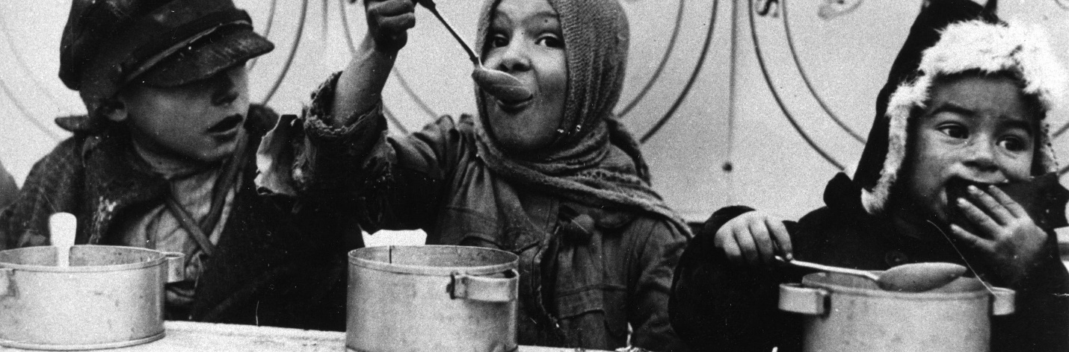(*Fig. 1 & Fig 2 source : Save the Children (2020) Available at: https://www.savethechildren.org.uk/about-us/our-history?ppc=true&matchtype=b&s_keyword=&adposition=&gclid=EAIaIQobChMI8baE49jN7QIVjt_tCh3NVQpsEAAYASAAEgKR6vD_BwE&gclsrc=aw.ds#arrestedhistory (Accessed on: 14 December 2020)
II. Reflection on personal experience with reference to the social project/ business discussed in outcome 1

An article written by Save the Children’s chief executive (1995-2005) Mike Aaronson, highlights via the prism of Save the Children UK's 100-year past, a recent conference that explored the interplay between governance, humanitarianism, and children's rights. The goal was to help the current generation appreciate the variables that influenced the history of Save the Children UK (SCUK), to provide a better understanding of its present intent and potential future directions. (openDemocracy, 2019). In one of his blogs, Mike Aaronson is relating that the interests of children should only be ensured within the framework of children's families, societies, and larger society; without considering greater social, economic, cultural, and political considerations. Children's rights, therefore, represent a particularly strong organizational term for relief and development work, partially because childhood crises and disturbances have a more devastating impact than at any other point of development. Early action makes sense from a realistic viewpoint, and the protection for the future of humanity by caring for our children. This was a strong plank in the philosophy of Dorothy and Jebb, which claimed that the younger generation had the greatest chance of restoring the tremendous harm incurred by the war. (Mike, 2019)
5th of March 2020, Maggie Baska, reveals shocking information about HR practices. According to a scathing report by the Charity Board, Save the Children UK "let down" workers and the public over the treatment of harassment against senior employees between 2012-2015. In England and Wales, the regulator for charities found "serious failures" in how the children's organization dealt with complaints brought by staff members against Justin Forsyth, the former chief executive of the charity (Maggie, 2020). The Commission has conducted 37 interviews of the Foundation’s employees and trustees and about 15,000 records relating to the procedures of the charity and the execution of internal staffing inquiries by Save the Children UK were reviewed. The regulator also found flaws in the workplace culture of the charity and claimed the treatment of complaints was so poor in certain respects that it amounted to mismanagement," and that these charges had a "corrosive effect on its internal culture and the way the charity reacted. In their conduct and actions, Helen Stephenson, (CEO) of the Charity Commission, said charities should be "distinct" from all forms of entities as they are kept to a higher degree by the public, their service customers, and their employees. Stephenson added that outside the company itself the effects of leadership deficiencies in charity and weak workplace culture may also have consequences for public trust and trust. (The Charity Commission, 2020, p. 6-9). Following the Charity Commission investigation into claims of sexual abuse at the charity, announced in 2018, the charity claimed that the latest approach resulted from assessments of the corporate culture. Save the Children vowed that a fifth of its executive leadership committee will be made up of people of color by the end of 2021 and that will reduce its wage differential for race, which presently sits at 4.9% of the overall wage. The approach explores the present "state of play" objectively and deals with a variety of concerns, including sexual assault. It also admits that in UK culture, the charitable sector and association, "institutional racism exists." (Val, 2020).
For a better understanding and reflection of a situation, professor, Gibbs Graham published in his book, ‘Learning by doing, a reflective cycle that is structured in 6 stages. Any stage has an important meaning, and it needs to be followed to have better results. (Gibbs, 1988, p. 49-51)
Next, I will try to apply the method published by Professor Gibbs in his book and evaluate the situation above.
Stage 1. Description
Between January and April 2018, national media scrutiny of charities and numerous individual charities was extensive. This covered Save The Children UK. Media’s attention concentrated on the allegations of abuse, intimidation and staffing in the organization and raised questions and doubts regarding the handling and reaction of Save The Children Fund. to these problems. It also highlighted the essence of past personnel issues involving two senior staff (the Chief Executive Officer and the Director of Strategy and Advocacy) from 2012 and 2015 and their exits from the charity. It was also alleged in the media that one of these senior workers had obtained a recommendation from Save The Children UK which did not alert the new employer to related matters. The case was undertaken by the Commission Charity and involved the victims and other witnesses for an interview and documents investigations.
Stage 2. Feelings
The Charity Commission find it hard for the victims to recall the memories. They felt uncomfortable and awkward because of the senior staff behavior.
Stage 3. Evaluation
After the Commission Charity investigation regarding the victims complains against the senior staff, results that 2 females were going through similar situations. Concerns posed over the actions of team members ought to be properly considered and answered by a charity. Organizations should be extremely aware about how to properly adapt their practices and strategies to concerns about senior personnel, specifically the CEO. It is necessary to ensure that the correct protocols and practices are implemented, for the good of everyone. In this situation, provided that the complaints of 2015 materialized from a mediated conversation with workers about the results of the personnel survey and the office's intimidation and corruption, it was very important that the charity was organized and ready to cope quickly and appropriately with problems posed.
Stage 4. Analysis
On a personal point of view, it is unacceptable those actions in a charity with a great reputation as Save the Children. The employers should not get into any forms of harassment t and/or other forms of discrimination. Moreover, they should be an example of a good will, hard work and sacrifice for the vulnerable children and families. Also, having an amazing journey that impact the history thanks to the activist Eglantyne and a good reputation, they should be aware of the consequences and of their image. A charity is a transparent organization where people choose to give a hand and change people lives for better. The trust and engagement after those actions presented above, are not helping the charity to progress and improve. However, the charity’s staff and trustees should try to maintain their good image and continue to be an example for everyone, because as many other people need their services, we do need their trust.
Stage 5 Conclusion
For trustees, day-to-day staff problems are not typically a matter, although serious claims against the CEO, especially of a major charity, fall into a separate category. The trustees are in charge for the governance and maintenance of the organization and needs to be immediately aware of specific questions about the actions of the CEO to be able to decide how best to protect the interests of the charity, its staff, and its beneficiaries.
Stage 6 Action Plan
In the case presented, I would be more careful and aware about the situation. First step that needs to be done when any form of harassment is taking place, is to take legal advice and action.
(Charity Commission for England and Wales, 2020)
According to the research presented above, in the next following paper, I will try to make a SWOT analysis of Save the Children from Africa which will point the strengths, weaknesses, opportunities and threats of the organization.
Strengths  - 100 years old charity which impact the history  - Worldwide departments  - Non-profit charity supporting children globally, providing resources such as preschool, schooling, nutrition, fitness, safety, and numerous other opportunities for long-term rehabilitation. | Weaknesses  - Employees engagement and trust
Opportunities  - Provide each child around the world with unique care and attention  - Working with the foundation  - Volunteering  -Help save the lives of disadvantaged families and children. | Threats  - Insufficient funds  - The effects of leadership deficiencies and bad culture in the workplace  - Damage Reputation
*table made by Iohana Popa, according to the research presented above
*The analysis below, is based by articles and report. (Maggie B. (2020); Val Cipriani (2020); DeAirra G. (2017); Charity Commission for England and Wales (2020)

Conclusion

As discussed in the assessment I, Save the Children Foundation, is known as the oldest charity with a great story which started from its beginnings. Eglantyne should be an example for everyone that ‘nothing is impossible if you have faith’. Power-Sacrifice-Commitment-Faith and Love are the main ingredients that should be in everyone’s strengths. A charity workplace must remain transparent with their actions and be vigilant with their organization’s future and reputation. Employers and trustees should work close to each other and try to do the best they can to increase their employability and development. We need charities to help children and families in need, we need people that we can trust they will provide their services and care, we need to fight for a better life and be respectful and treat everyone equal. As the famous Indian lawyer, Mahatma Gandhi comments:

"We but mirror the world. All the tendencies present in the outer world are to be found in the world of our body. If we could change ourselves, the tendencies in the world would also change. As a man changes his own nature, so does the attitude of the world change towards him. This is the divine mystery supreme. A wonderful thing it is and the source of our happiness. We need not wait to see what others do.” (Indian Opinion, 1913, p. 241)

Reference:

- DeAirra G. (2017) ‘Global issues. Human rights. Save the Children’ Learning to give; Available at: https://www.learningtogive.org/resources/save-children, Indiana University (Accessed: 14 December 2020)

- Gibbs, G., & Great Britain. Further Education Unit. (1988). Learning by doing: a guide to teaching and learning methods. FEU. (p. 49-51)

- Maggie B. (2020)’ Save the Children had ‘serious weaknesses’ in HR practices’ 5 March Available at: https://www.peoplemanagement.co.uk/news/articles/save-the-children-had-serious-weaknesses-in-hr-practices (Accessed: 14 December 2020 )

- Mike A. (2019) ’Are children’s rights history?’ 1 April
Available at: https://blogs.lse.ac.uk/africaatlse/2019/04/01/childrens-rights/ (Accessed: 14 December 2020)
Mike A. (2019) ‘100 years of Save the Children UK: what have we learned?’ 22 April Available at: https://www.opendemocracy.net/en/transformation/100-years-save-children-uk-what-have-we-learned/ (Accessed: 14 December 2020)

- Indian Opinion, (1913) The Collected Works of Mahatma Gandhi, vol. 13, chapter 153, 9 August Available at: http://www.gandhiashramsevagram.org/gandhi-literature/mahatma-gandhi-collected-works-volume-13.pdf (page 241)

- Val Cipriani (2020) ‘Save the Children unveils strategy to tackle institutional racism and lack of inclusion’ 10 December Available at: Save the Children unveils strategy to tackle institutional racism and lack of inclusion (civilsociety.co.uk) (Accessed: 14 December 2020)

- Save the Children (2020) ‘About us-our history’
Available at: https://www.savethechildren.org.uk/about-us/our-history?ppc=true&matchtype=b&s_keyword=&adposition=&gclid=EAIaIQobChMI8baE49jN7QIVjt_tCh3NVQpsEAAYASAAEgKR6vD_BwE&gclsrc=aw.ds#arrestedhistory (Accessed: 14 December 2020)

- The Charity Commission for England and Wales (2020) ‘The Save the Children Fund (Save the Children UK): Statement of the results of an Inquiry’ 5 March. Available at: https://www.gov.uk/government/publications/charity-inquiry-the-save-the-children-fund-save-the-children-uk (Accessed: 14 December 2020)

