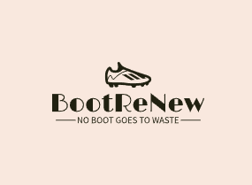
Promotional Material
Dylan Thomas Student Number: 2103225

Contents Page:
- Promotion Calendar 2
  - Gantt Chart
    - Phase 1
    - Phase 2
    - Phase 3
  - Reasoning
    - Phase 1
    - Phase 2
    - Phase 3
- Events 4
  - Large Events
  - School Visits
  - Festivals
- Website 6
  - Logo
  - Link
  - Key features
- Social Media 6
  - Instagram
    - Marketing Campaign
    - Key features of Marketing
    - Selection
    - Key features of Selection
    - Tutorials
    - Key features of Tutorials
- Appendices 12

1. Promotion Calendar
  - Gantt Chart
* Note: Zoom in to better read dates and titles *
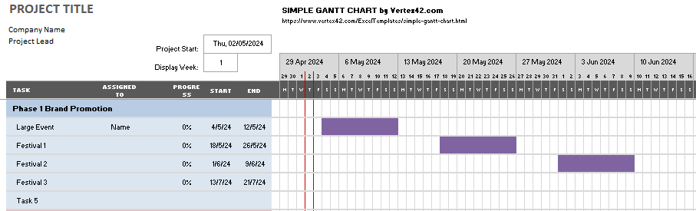
    - Phase 1

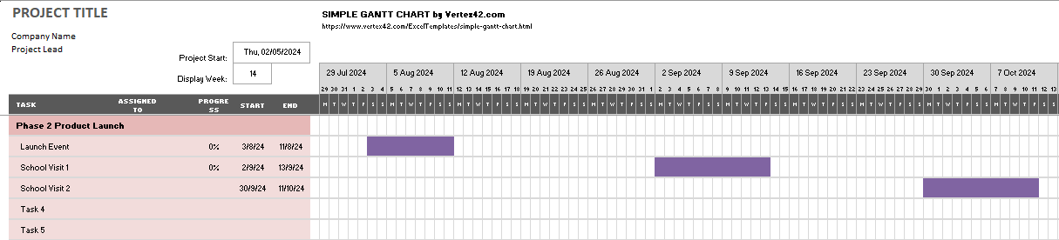
    - Phase 2

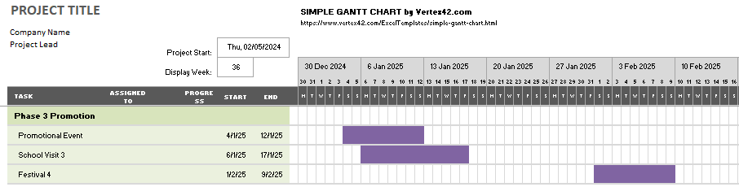
    - Phase 3

  - Reasoning

1.2.1 Phase 1:
Phase 1 consists of increasing brand promotion and acquiring enough product to start the business. To begin, a large fun day event will be organized to engage and interact with as many potential consumers as possible. At this event we will launch our boot acquisition incentive, purchasing boot for up to £10. We will also be accepting donations, both financial aid and physical pairs of boots gifted. At this event, we want to emphasize that every player has a story to tell and that the equipment an athlete uses can become a medium to tell that story. As such, fun, family-friendly games and activities will be arranged with a multitude of different entertainment available as well as food and beverage.
Following the stir that the large event creates, several smaller local events will be targeted. Events such as football festivals are ideal targets as minimal planning is required. BootReNew would have a popup tent on site that would collect boots and hand out flyers. It is critical to have the smaller events around the same time period of the larger event to maintain engagement with consumers. In addition, one last smaller-scale event is scheduled just at the end of the brand promotion phase to help rebuild engagement with consumers and transition into the launch of BootReNew.

1.2.2 Phase 2
Phase 2 is the actual launch of BootReNew as a business. To launch our business another large scale event will be organised. This event will mirror the original one, with any improvements from the first being implemented in the second. Additionally, this event will prioritise signing families and athletes up to our service. To emphasize the necessity for different footwear, different activities will be specially designed to benefit from different shoes. For example, an especially muddy area may be used to distinguish larger, metal studs, while another area may be purposely dried out to emphasise molded studs advantage.
Following the large launching event of BootReNew, several school visits will be arranged over the first two weeks school return from summer break. Not only does this serve as a good transition for schools to bring pupils back into the schedule of school, but also introduces new opportunities for pupils who thought they wouldn’t be able to participate in sports due to increasing costs of equipment. In turn, this drives participation in after school activities and local sports clubs, benefiting all parties.

1.2.3 Phase 3
The third phase is to reignite and reengage with our consumer base. Following a similar strategy to Phase 1, Phase 3 will begin with a larger-scale event, likely a schools festival, where local schools are invited to a tournament with family-orientated crafts and activities set up alongside the competition. The goal for this event is to again collect more boots as many families may of purchased new boots for Christmas and have additional boots they are unsure what to do with. Alternatively, this allows for families who could only afford a single set of boots the opportunity to purchase another set for a fraction of the cost. Following the large event, a mixed approach will be taken. Both school visits and festival partnerships will be organised to reengage all previously established consumers and reach out to potential new customers.

2. Events

2.1 Large Events
The three large events planned by BootReNew are all forecasted to make a profit. This profit is then going to be reinvested into the business and help minimise expenditure. To earn a profit, BootReNew are going to create raffles, introduce food and beverage at all events, introduce pay-to-play schemes at selected activities, and entrance charges for tournaments. All charges are going to be minimal to reduce the barrier to the enjoyment families will experience.
The first event is targeted at collecting as many boots as possible. To promote as much success as possible, the event is scheduled to start at the very end of the football season. A pivotal point where many athletes might have outgrown their old boots or are looking for new boots for the upcoming summer festivals. Additionally, boot will be purchased for up to £10 per pair with an unlimited number of pairs until BootReNew has reach its quota of 1,000 pairs. At this event, a raffle will begin to win a year's subscription with BootReNew. This raffle will have 3 winners, each being decided at the launching event. Other raffles that may be incorporated include equipment, shoes, shorts, socks, shirts, etc, signed by professional athletes. This would have a profound impact due to Swansea having a successful professional football team.
The second event will be the official launching of BootReNew. At this event, the raffle winners will be selected in groups. One raffle winner will be selected from all the previous raffle tickets. The other two winners will be selected from raffles generated by customers signing up to BootReNew’s subscription. In theory, this allows for paying customers to have a higher probability of being selected and winning the raffle than normal raffle ticket holders. Other benefits that may be implemented include discounted food at the event and free or discounted admission to the various activities. Any improvements that could be made from the first event will be implemented where possible. The timing of this event is critical. Being at the first two weeks of August encourages customers to think to the future. What activities are they/their kids going to participate in? What footwear is required to participate? These concerns are common among sporting families. By providing a solution with ample time to consider allows for an informed decision from the customers. A decision that many customers will realise that BootReNew is a cheaper alternative that delivers quality products
The third large event will differ from the first two. Instead of a family fun day, the third event will prioritise competition. Several schools will be invited to attend a schools festival and compete against each other across various age ranges. The timing of this festival is directly correlated to when schools begin again after Winter break. Similarly to the second event, the third event will aim to captivate a younger audience who will relay our message to their guardians. As our message is about storytelling and recycling, there is limited ethical importance. The stronger our message of storytelling is relayed, the more customers BootReNew can expect. The third event will support our story telling message with various memorabilia being available. In addition to the competition, memorabilia, food, and beverage; family-friendly activities will be present. The theme of these activities will be renewable resources. Having consistent themes across events and promotions ensures BootReNew’s message is clearly understood and interpreted.

2.2 School Visits
School visits are a critical part of BootReNew’s promotional strategy. BootReNew’s primary target audience consists of athletes aged 6-16, the large majority of whom will still be in education. By engaging potential customers in the environmental benefits BootReNew offers, pupils learn of the importance for environmentally sustainable business practices while also being introduced to BootReNew's founding principles. This culminates in our customers making a more informed decision, one that BootReNew is confident will result in generating revenue. Ethically, BootReNew is committed to ensuring the well-being of vulnerable people, including pupils. As such BootReNew’s interaction with pupils will remain as educational as possible. By prioritising education over profit, BootReNew will gain access to a wider range of schools and inadvertently generate a larger potential customer base.
2.3 Festivals
While school visits are meant to bring attention to the environmental impact businesses have, festivals are meant to showcase BootReNew’s message and subscription in action. Generating engagement with customers at the very source of their needs creates a strong attachment between brand image and consumption. Few other subscription businesses have the opportunity to engage consumers in such a direct manner. This allows BootReNew the opportunity to share their message of storytelling. BootReNew believes every athlete tells a story. From every goal and assist, to every tackle and foul. All of these stories are written and stored by the athletes in the very equipment used; their boots.
Additionally, these events serve as an opportunity to acquire additional stock. Brand-new boots can cost several times more than BootReNew’s monthly subscription. To help keep BootReNew’s monthly subscription costs low and to maintain an environmentally friendly business model, BootReNew relies on second boots being donated. To further incentivise the donation of boots, BootReNew has implemented a £10 voucher scheme. Consequently, these festivals prove to serve as bursts of engagement with customers and a resupply of stock, while costing minimal amounts of capital.
3. Website
3.1 Logo
3.2 Link to Website
https://lewispritchard623.wixsite.com/bootrenew
* Screenshots of the website are in the appendices if the live link is not working *

3.3 Key Features of Website
The Website is another tool utilised to broadcast BootReNew’s message. From giving instructions on how to donate, to providing BootReNew’s contact information, to advertising our events, the website gives an in-depth look at what BootReNew’s core foundation looks like. The core values are then explicitly highlighted further on in ‘Our Vision’ and our background information can be found in ‘About BootReNew’. Complete with a seamless payment system and contact information, the website is a fantastic resource to manage memberships and gain a better understanding of who BootReNew is and what BootReNew stands for.

4. Social Media
4.1 Instagram
BootReNew will look to showcase the potential boots available and engage with our audience through Instagram, encouraging our consumers to make videos of their purchases to reach more potential consumers (Tuten, 2024). Brand awareness is key in building a strong customer base as the more people aware of the brand would lead to more sales and being talked about through friendship groups, as an example leading to more potential consumers (Barreda et al, 2015).
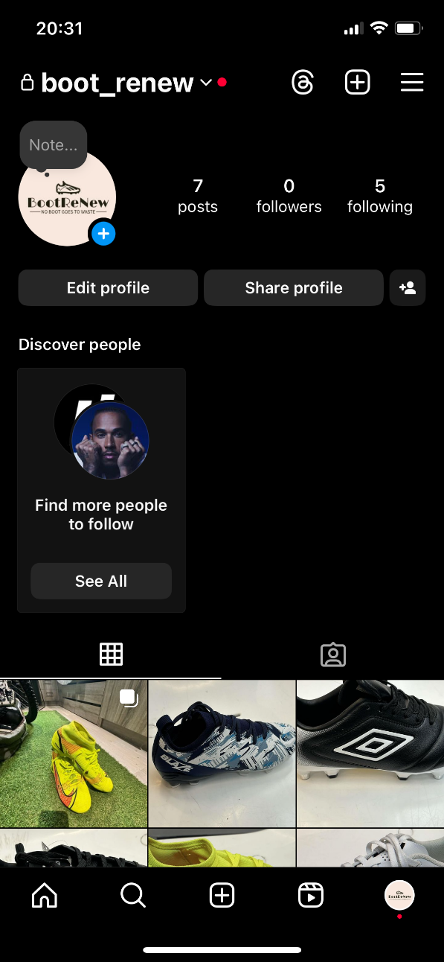

4.1.1 Marketing Campaign
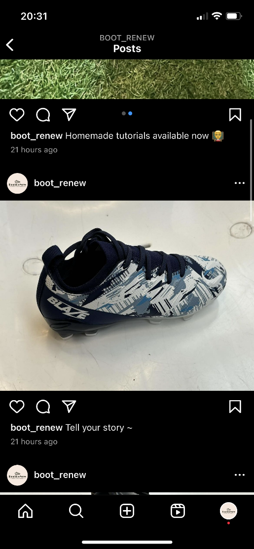

4.1.2 Key Features of Marketing Campaign
Starting from basics, the ‘Tell your Story ~’ campaign is designed to interact more with subscribers. This not only provides feedback on which BootReNew can analyse, but also develops a strong emotional tie to the brand. To potential subscribers, having a platform to share their stories and connect with other like-minded athletes can be a welcoming prospect. Ultimately, through sharing and posting their stories, BootReNew’s subscribers act as advertising in the local community with the potential to develop BootReNew communities outside of Swansea and South Wales. To propel this campaign the hashtag #BootReNew_Stories will be introduced. Finally, a clear focus for some of our content will be pushing the message of sustainability in all aspects of life with the key brand message to ensure no boot goes to waste.

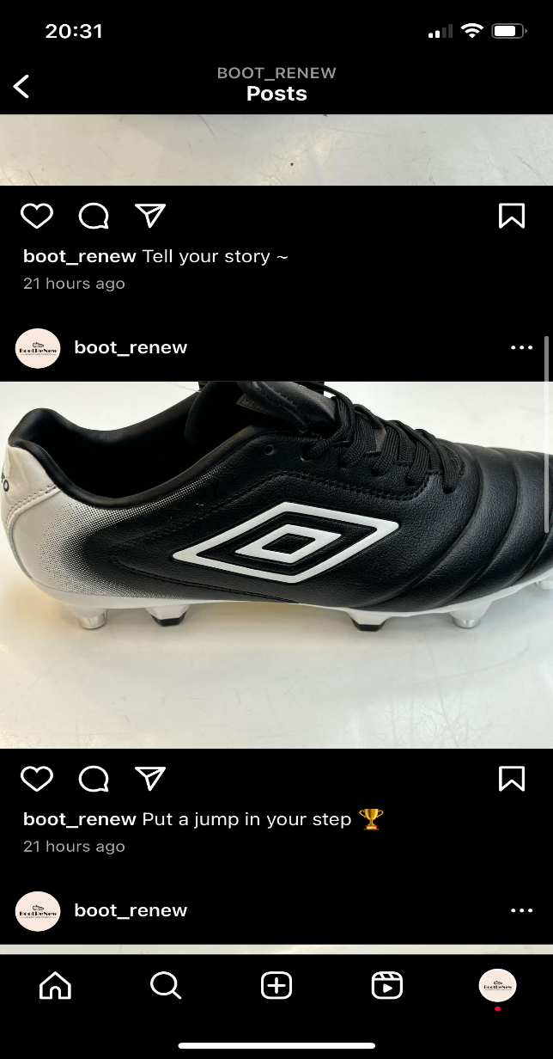
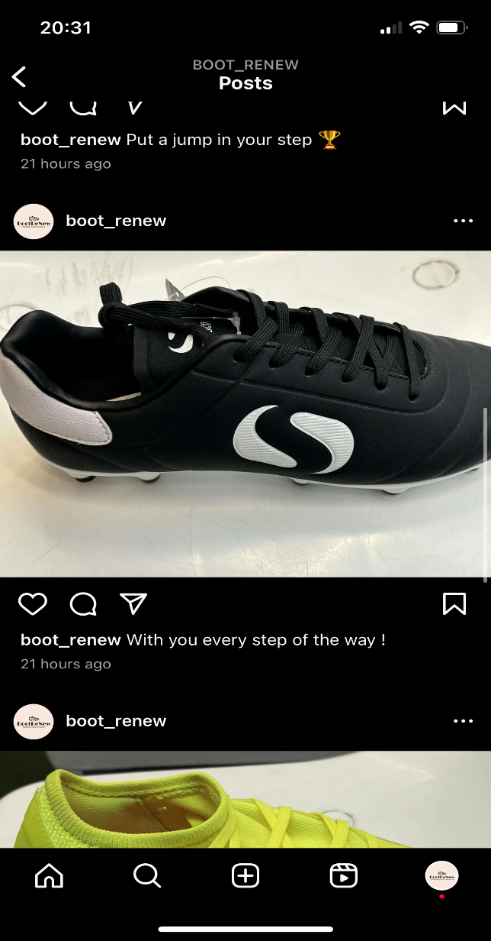
4.1.3 Product Selection

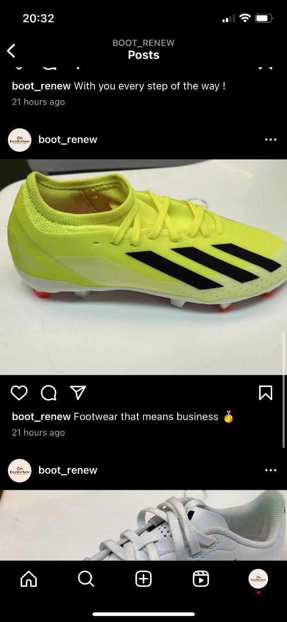
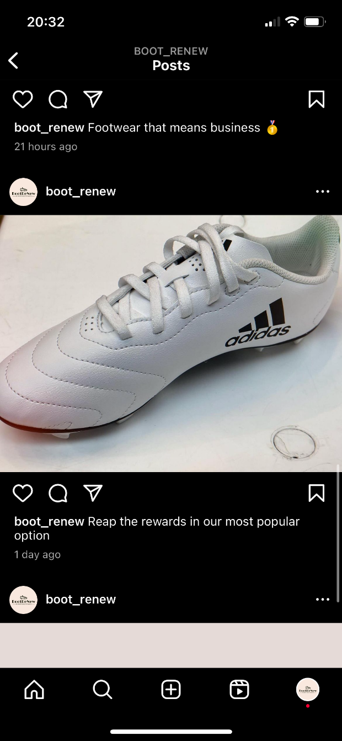

4.1.4 Key Features of Product Selection
All products available to subscribers must be of high quality. Despite utilising second-hand boots, each pair will be washed and refurbished as best as possible before being sent out to a new subscriber. This ensures each customer receives the highest level of customer satisfaction possible, a critical component to a business that will grow from customers sharing their experiences. Additionally, having a wide selection of boots to choose from will allow each subscriber to select a pair of boots that match their style. To further ensure compatibility with customers, and to ensure availability, subscribers can reserve boots up to 3 months in advance. Reserving boots ahead of time will allow athletes to select which brand, color, or design they desire. As well as choosing what type of boot they require for example firm ground or soft ground bottoms.

4.1.5 Tutorials
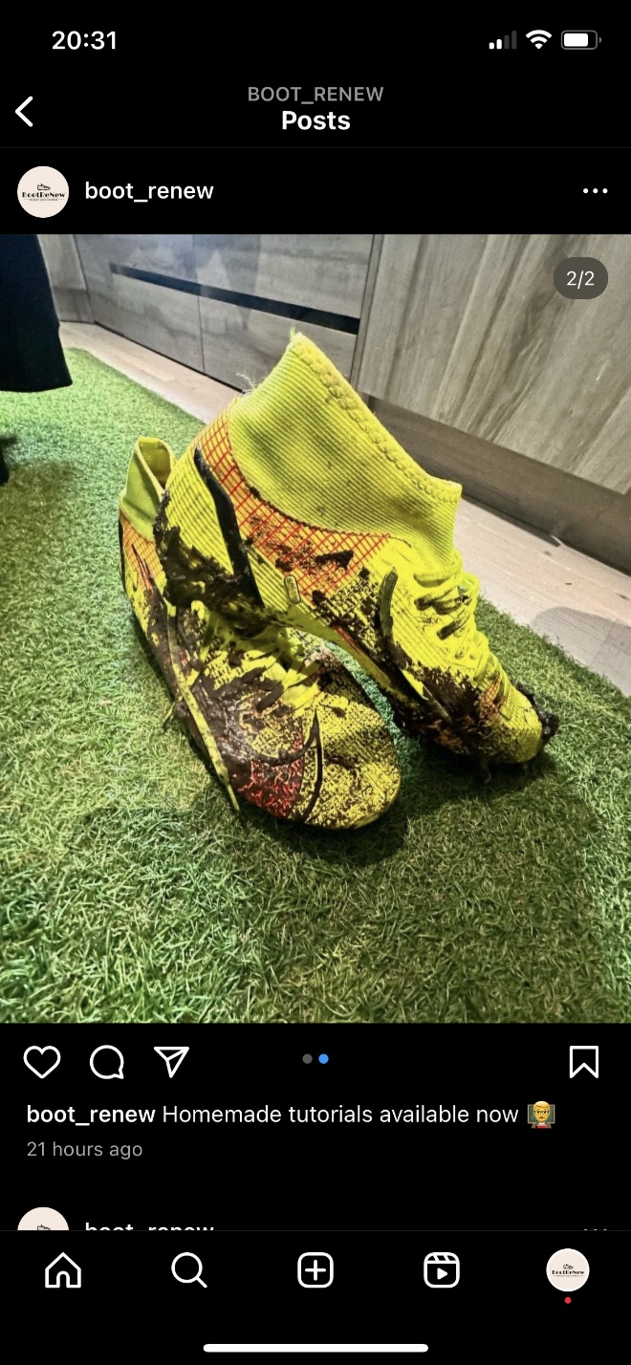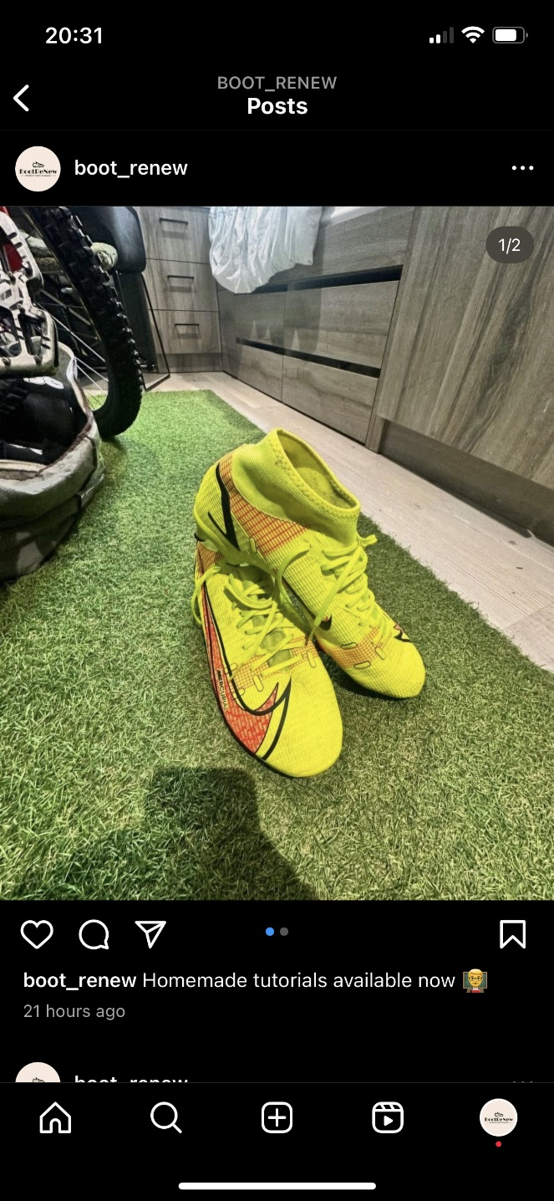

4.1.6 Key Features of Tutorials
As part of the operating costs of BootReNew cleaning and managing each pair of boots that are sent in is a cumbersome process. Not only does it require additional time and energy, but also additional costs. In an attempt to limit the amount of operational costs, as well as demonstrate how to properly clean a pair of boots, BootReNew will promote tutorial videos on how to clean boots. Additional videos showcasing how to manage and take care of boots will also help to prevent additional wear and tear, allowing for a longer product life of each pair of boots.

5. Appendices
Website Screenshots:


