

Design and Development of PIC Controlled Screw-Propelled Robot

by
Ryan Stapleton

Supervisor: Stephen Mosey

Project submitted as part of the requirements for the award of
BEng (Hons) Electrical and Electronics Engineering

April 2024

Contents
1.0 Introduction 1
2.0 Background Research 2
2.1 Screw Design and Geometry 3
2.1.1 Single Threaded Screw 3
2.1.2 Multi-Threaded Screw 3
2.1.3 Helical Fluted Screw 4
2.2 Drive Mechanism 4
2.2.1 DC Motors 4
2.2.2 AC Motors 5
2.2.3 Hydraulic Systems 6
2.2.4 Rotary Actuation 7
2.3 Power Source 8
2.3.1 Batteries 8
2.3.2 Electric Power Supply 9
2.3.3 Solar Power 10
2.4 Control System 11
2.4.1 PIC Microcontroller 11
2.4.2 Arduino 13
2.4.3 Programmable Logic Controller 14
2.5 Component Research 16
2.5.1 Microcontroller 16
2.5.2 Sensors 17
2.5.3 DC Motors 18
2.5.4 Power Source 18
3.0 Development Methodology 19
3.1 Research Methods 19
3.2 3D Modelling 19
3.3 3D Printer 20
3.4 Proteus 21
3.5 MPLAB X IDE 22
4.0 Product Design Specification 24
4.1 Overview 24
4.2 Objectives and Goals 24
4.3 Scope 24
4.4 User Requirements 24
4.5 Technical Requirements 24
4.6 Design Specifications 24
4.7 Functional Requirements 25
4.8 Performance Criteria 25
4.9 Testing and Validation 25
4.10 Timeline and Milestones 25
4.11 Budget and Resources 25
4.12 Risk Management 25
4.13 Document Control 26
5.0 Design & Implementation 27
5.1 CAD Models 27
5.2 2D Drawing Generation 28
5.2.1 Robot Body Drawing 28
5.2.2 Robot Screw Drawing 28
5.2.3 Robot Rear Support Drawing 29
5.2.4 Robot Lid Drawing 29
5.2.5 Robot Front Support Drawing 30
5.2.6 Robot Final Assembly Drawing 30
5.3 Proteus Schematics 31
5.4 Easy PC Schematics 32
5.5 PCB Board Design 33
5.6 Implementation 34
5.7 Microcontroller Code 41
6.0 Cost 45
7.0 Reflection 46
8.0 Conclusion 47
References 48

Figure 1- CAD Isometric View 27
Figure 2- CAD Rear View 27
Figure 3- CAD Top View 27
Figure 4- Proteus Schematic 31
Figure 5- Easy PC Schematic 32
Figure 6- Easy PC PCB Board Design 33
Figure 7- PIC PCB Board 34
Figure 8- Motor Drive PCB Board 35
Figure 9- Programming PCB Board 36
Figure 10- Final Assembly Isometric View 37
Figure 11- Sigma D25 3D Printer 38
Figure 12- Final Assembly Rear View 39
Figure 13- Final Assembly Top View 40

Introduction

The development of robotic systems has undergone significant advancements in recent years, fuelled by innovations in design, materials, and propulsion technologies. Among the emerging trends in robotics, the utilization of screw propulsion systems has garnered considerable attention due to their capability to traverse challenging terrains with enhanced efficiency and manoeuvrability. This report presents a comprehensive analysis of the components essential for the successful construction and operation of a screw-propelled robot, aimed at providing insights into the design considerations, material selection, and performance optimization of such systems.
The primary objective of this report is to conduct a comprehensive examination of the key components required for the construction and operation of a screw-propelled robot. By focusing on the fundamental elements of the propulsion system, including the screw design, drive mechanism, power source, and control system, this study aims to provide valuable insights into the design principles, performance characteristics, and operational considerations of screw-propelled robots.

Background Research
Screw propulsion, also known as auger propulsion, involves the use of helical screw-like structures to generate thrust and propel a vehicle forward. This propulsion mechanism offers distinct advantages over traditional wheeled or tracked systems, particularly in environments characterized by soft or uneven terrain, such as sand, mud, or snow. Screw-propelled robots have demonstrated remarkable capabilities in various applications, including agricultural robotics, search and rescue operations, planetary exploration, and military reconnaissance.
Before starting the project, some research was needed to identify some key factors that might occur along the timescale of the project.
- Understanding the Scope and Requirements: Research helps in understanding the scope and requirements of the project. It allows you to gather information about what needs to be accomplished, the objectives of the project, and the resources required. This clarity helps in setting realistic goals and expectations.
- Identifying Potential Challenges and Risks: Research enables you to anticipate potential challenges and risks that may arise during the project. By identifying these early on, you can develop strategies to mitigate them and plan accordingly, reducing the likelihood of delays or setbacks.
- Gathering Information and Resources: Researching provides access to valuable information, data, and resources relevant to the project. This includes existing literature, case studies, best practices, methodologies, and tools that can inform your approach and decision-making process.
- Exploring Different Approaches and Solutions: Research allows you to explore different approaches and solutions to address the project requirements. By examining various methodologies, techniques, and technologies, you can make informed choices about the most suitable strategies to achieve your goals effectively and efficiently.
- Learning from Previous Projects and Experiences: Researching previous projects and experiences, whether within your organization or in the industry, helps in learning from past successes and failures. This knowledge can guide your decision-making process, enabling you to adopt proven practices and avoid repeating mistakes.
- Staying Updated with Industry Trends and Innovations: Researching keeps you updated with the latest industry trends, innovations, and advancements relevant to your project. This knowledge allows you to incorporate cutting-edge practices, technologies, and methodologies into your project, enhancing its quality and competitiveness.
- Building a Strong Foundation for Decision Making: Research provides a solid foundation for decision-making throughout the project lifecycle. Whether it's choosing the right approach, selecting the appropriate tools and technologies, or making strategic decisions, the insights gained from research enable you to make informed and evidence-based choices.
- Enhancing Creativity and Innovation: Researching exposes you to diverse perspectives, ideas, and insights, stimulating creativity and innovation. By exploring different concepts and solutions, you can generate novel approaches and ideas that add value to your project and differentiate it from others.
The scope of this research encompasses a thorough investigation of each component essential for the functionality and performance of a screw-propelled robot. This includes:
- Screw Design and Geometry: Analysis of various screw configurations, including single-threaded, multi-threaded, and helical fluted designs, to determine their suitability for different terrains and applications.
- Drive Mechanism: Examination of drive mechanisms, such as electric motors, hydraulic systems, and pneumatic actuators, to assess their efficiency, torque output, and reliability in driving the screw propulsion system.
- Power Source: Evaluation of power sources, including batteries, fuel cells, and internal combustion engines, to provide the necessary energy for propulsion and auxiliary systems.
- Control System: Investigation of control algorithms, sensors, and feedback mechanisms to ensure precise navigation, obstacle avoidance, and stability control of the screw-propelled robot.

Screw Design and Geometry
As there are various types of screw design that could be implemented into the robot, it is important to select the one most suited for the desired application of the robot.

Single Threaded Screw
Advantages

- [1]Simplicity: Single-thread screws are straightforward in design, making them easy to manufacture and maintain.
- Lower Friction: They typically have lower friction compared to multi-thread designs due to their simpler geometry, which can be advantageous in certain applications.
- Cost-effective: Single-thread screws are generally more cost-effective to produce compared to multi-thread or helical fluted screws due to their simplicity.

Disadvantages

- [2]Slower Speed: Single-thread screws may have slower operation speeds compared to multi-thread designs since they move less material per revolution.
- Less Efficient for Heavy Loads: They might not be as efficient for applications requiring high torque or handling heavy loads due to their single-thread design.

Multi-Threaded Screw
Advantages

- Higher Efficiency: Multi-thread screws can move more material per revolution, making them more efficient for applications requiring faster operation or handling heavier loads.
- Reduced Backlash: They can reduce backlash and axial play due to the multiple threads engaging simultaneously.
- Faster Operation: Multi-thread screws can achieve faster speeds compared to single-thread designs due to their ability to move more material per revolution.

Disadvantages

- Complexity: Multi-thread screws are more complex in design and manufacturing, which can increase production costs and maintenance requirements.
- Higher Friction: They may experience higher friction compared to single-thread designs due to increased contact surfaces between threads and the mating part.
- Potential for Jamming: The multiple threads can increase the likelihood of debris or contaminants getting trapped between the threads, potentially causing jamming or interference issues.

Helical Fluted Screw
Advantages

- [3]High Precision: Helical fluted screws can provide high precision and accuracy in motion control applications due to their fine pitch and helical flutes.
- Self-locking: Depending on the design, helical fluted screws can exhibit self-locking properties, preventing back-driving when the load is removed.
- Smooth Operation: They can offer smooth and quiet operation due to the helical flutes guiding the motion.

Disadvantages

- Complex Manufacturing: Helical fluted screws are more complex to manufacture compared to standard single or multi-thread screws, which can increase production costs.
- Limited Load Capacity: Depending on the design and materials used, helical fluted screws may have a limited load-bearing capacity compared to some multi-thread designs.
- Potential for Wear: The helical flutes can be susceptible to wear over time, especially in high-load or high-speed applications, requiring regular maintenance and inspection.

Drive Mechanism
There are multiple options with regards to the drive mechanism of the screw of the robot. As this is an essential operation of the robot, it is vital to select the correct type motor, with the right amount of torque and RPM to allow the robot to operate as intended.

DC Motors
Advantages

- [4]Simple Control: DC motors are relatively easy to control compared to other types of motors. By varying the voltage applied to the motor, you can control its speed efficiently.
- High Torque at Low Speeds: DC motors offer high torque at low speeds, making them suitable for applications requiring precise control over speed and torque, such as in robotics, conveyor systems, and elevators.
- Ease of Reversal: Reversing the direction of rotation in a DC motor is straightforward by simply reversing the polarity of the applied voltage, making them ideal for applications where bidirectional movement is required.
- Compact Size: DC motors tend to be compact in size relative to their power output, making them suitable for applications with limited space constraints.
- Cost-Effective: DC motors are often more cost-effective compared to other types of motors, especially for smaller-scale applications.
- Availability of Speed Control: Unlike some other types of motors, DC motors can be speed-controlled over a wide range without significant loss of efficiency.

Disadvantages

- [5]Brush Maintenance: Most traditional DC motors use brushes and a commutator, which require periodic maintenance and replacement due to wear and tear. This maintenance can increase operating costs and downtime.
- Electromagnetic Interference (EMI): DC motors can generate electromagnetic interference, which may interfere with nearby electronic devices or sensitive equipment if not properly shielded.
- Limited Lifespan: The brushes and commutator in DC motors have a limited lifespan, which can affect the overall longevity of the motor and require regular replacement.
- Lower Efficiency at High Speeds: DC motors may experience lower efficiency at high speeds compared to other types of motors, such as AC motors.
- Limited Speed Range: While DC motors offer excellent speed control, they may have a limited speed range compared to some other types of motors, particularly at higher speeds.
- Complexity in High Power Applications: In high-power applications, such as industrial machinery or electric vehicles, DC motors may require additional components like cooling systems and more sophisticated control mechanisms, adding complexity and cost.

AC Motors
Advantages

- [6]No Brushes: Unlike DC motors, most AC motors operate without brushes and commutators. This design feature reduces maintenance requirements and eliminates issues related to brush wear and arcing.
- High Efficiency: AC motors typically operate at high efficiency, especially when running at full load. This efficiency can result in lower energy consumption and reduced operating costs over time.
- Long Lifespan: AC motors generally have a longer lifespan compared to DC motors, primarily due to the absence of brushes and the resulting reduction in wear and tear.
- Suitable for High Power Applications: AC motors are well-suited for high-power applications, such as industrial machinery, HVAC systems, and electric vehicles, where they can provide the necessary torque and power output reliably.
- Smooth Operation: AC motors typically provide smoother operation compared to DC motors, especially at higher speeds. This smooth operation is beneficial for applications requiring consistent motion, such as pumps and fans.
- Variable Speed Control: AC motors can be easily controlled for variable speed operation using techniques such as frequency control (VFD - Variable Frequency Drive) or voltage control. This flexibility in speed control makes them versatile for a wide range of applications.

Disadvantages

- [7]Complex Control Systems: AC motors often require more complex control systems, such as VFDs, to achieve variable speed operation. These control systems can add to the initial cost and complexity of the motor setup.
- Higher Initial Cost: Compared to DC motors, the initial cost of AC motors and associated control equipment may be higher, particularly for high-performance or specialized applications.
- Lower Torque at Low Speeds: AC motors generally provide lower torque at low speeds compared to DC motors. This limitation may affect their suitability for applications requiring high torque at low speeds, such as in certain industrial processes or robotics.
- Limited Efficiency at Low Loads: AC motors may experience reduced efficiency when operating at low loads or speeds. In such cases, energy losses due to factors like windage and friction can be relatively higher compared to when the motor is running at its rated capacity.
- Requires Synchronization: Synchronous AC motors require synchronization with the power supply frequency, which can be a limitation in some applications where precise speed control is necessary.
- More Susceptible to Overheating: AC motors can be more susceptible to overheating under certain conditions, especially if operated at low speeds for extended periods without adequate cooling.

Hydraulic Systems
Advantages

- [8]High Torque: Hydraulic systems can provide high torque, making them suitable for driving screw-propelled systems, which require significant torque to move through challenging terrain such as mud, snow, or sand.
- Variable Speed Control: Hydraulic systems allow for precise control over the speed and direction of the screw-propelled system, enabling operators to adjust the speed according to the terrain conditions and operational requirements.
- Smooth Operation: Hydraulic systems generally provide smooth and consistent power delivery, which can result in smoother operation of the screw-propelled system, reducing wear and tear on components and enhancing overall efficiency.
- Compact Design: Hydraulic components, such as pumps, motors, and cylinders, can be compactly designed, allowing for more flexibility in the layout and integration of the screw-propelled system, particularly in constrained spaces or mobile applications.
- High Power Density: Hydraulic systems can achieve high power density, meaning they can deliver a large amount of power relative to their size and weight. This characteristic is advantageous for screw-propelled systems where power-to-weight ratio is crucial for mobility and performance.
- Adaptability: Hydraulic systems can be easily adapted to accommodate different types and sizes of screw-propelled systems, making them versatile for various applications, including agriculture, construction, military, and exploration.

Disadvantages

- Complexity: Hydraulic systems can be complex, requiring a network of hydraulic hoses, pumps, valves, and actuators. The complexity of the system increases the risk of potential leaks, failures, and maintenance requirements.
- Hydraulic Fluid Maintenance: Hydraulic systems require regular maintenance of hydraulic fluid, including monitoring fluid levels, checking for contamination, and replacing fluid as needed. Failure to maintain proper fluid levels and cleanliness can lead to system inefficiency and component damage.
- Potential for Fluid Leaks: Hydraulic systems are prone to fluid leaks, which can result in environmental contamination and pose safety hazards to operators and nearby personnel, particularly in sensitive ecosystems or hazardous work environments.
- Temperature Sensitivity: Hydraulic systems may be sensitive to temperature fluctuations, with extreme temperatures affecting the viscosity and performance of the hydraulic fluid. In cold environments, fluid viscosity may increase, leading to sluggish system response, while in hot environments, fluid viscosity may decrease, increasing the risk of fluid leakage and system overheating.
- Noise and Vibrations: Hydraulic systems can generate noise and vibrations during operation, which may be undesirable in certain applications where noise levels need to be minimized, such as stealth operations or noise-sensitive environments.
- Energy Efficiency: Hydraulic systems may have lower energy efficiency compared to other power transmission systems, such as electric or mechanical systems, particularly in situations where energy losses occur due to hydraulic fluid friction, leaks, or inefficient component design.

Rotary Actuation
Advantages

- [9]Simplicity: Rotary actuation systems are often simpler in design compared to hydraulic or pneumatic systems, requiring fewer components such as pumps, hoses, and valves. This simplicity can lead to easier maintenance and reduced risk of system failure.
- High Torque: Rotary actuators can provide high torque output, making them suitable for driving screw-propelled systems through challenging terrain such as mud, snow, or sand.
- Ease of Control: Rotary actuation systems allow for straightforward control of the screw-propelled system's speed and direction, typically achieved through the control of electric motors or mechanical linkages. This ease of control facilitates precise manoeuvrability in various operating conditions.
- Energy Efficiency: Electric rotary actuators, in particular, can offer high energy efficiency compared to hydraulic systems, as they do not require the continuous operation of pumps and do not suffer from fluid leakage issues.
- Quiet Operation: Rotary actuation systems generally produce less noise and vibration during operation compared to hydraulic or pneumatic systems, making them suitable for applications where noise levels need to be minimized.
- Environmental Friendliness: Electric rotary actuators produce zero emissions during operation and do not rely on hydraulic fluids, reducing the risk of environmental contamination and simplifying disposal at the end of their lifecycle.

Disadvantages

- [10]Limited Torque Range: While rotary actuators can provide high torque output, they may have limitations in torque range compared to hydraulic systems, particularly in applications requiring extremely high torque for heavy loads or extreme terrain conditions.
- Limited Speed Range: Rotary actuators may have limitations in achieving high speeds compared to hydraulic systems, which can be a disadvantage in applications where high-speed operation is critical.
- Mechanical Complexity: In some cases, rotary actuation systems can be mechanically complex, especially if they involve gearboxes, transmissions, or other mechanical components to achieve the desired torque and speed characteristics. This complexity can increase manufacturing costs and maintenance requirements.
- Space Requirements: Rotary actuators, especially those incorporating gearboxes or other mechanical components, may require more space compared to hydraulic systems, limiting their suitability for applications with tight space constraints.
- Weight: Depending on the design and materials used, rotary actuators may add significant weight to the screw-propelled system, which can affect mobility and energy efficiency, particularly in mobile or portable applications.
- Limited Environmental Adaptability: Rotary actuation systems may not be as adaptable to extreme environmental conditions as hydraulic systems, which can operate effectively in a wide range of temperatures, pressures, and terrain types.

Power Source
There are a few options for power source that could be implemented into this project. The selection of power source will be determined by factors such as complexity, cost and weight. Due to this robot having to be manoeuvrable, this is also going to be a factor for selecting a power source. The advantages and disadvantages of potential power source are listed below.

Batteries
Advantages of Using Batteries

- [11]Portability: Batteries provide a portable power source, allowing the robot to operate without being tethered to a fixed power supply. This portability enables mobility and flexibility in various environments and applications.
- Ease of Use: Batteries are relatively easy to use and install, requiring minimal setup and maintenance compared to other power sources such as internal combustion engines or fuel cells. This simplicity makes batteries suitable for a wide range of robotics projects, including hobbyist and educational applications.
- Silent Operation: Battery-powered robots operate silently, making them suitable for indoor environments or noise-sensitive applications where quiet operation is desired.
- Environmentally Friendly: Battery-powered robots produce zero emissions during operation, making them environmentally friendly compared to internal combustion engines or fuel-powered systems.
- Scalability: Batteries come in various sizes and capacities, allowing for scalability to meet the power requirements of different robotics projects, from small-scale hobby robots to large industrial systems.
- Low Operating Costs: Once batteries are purchased, there are typically minimal ongoing operating costs compared to other power sources that require fuel or maintenance. Rechargeable batteries can be recharged multiple times, reducing the overall cost of power consumption over the lifespan of the robot.

Disadvantages of Using Batteries

- [12]Limited Energy Storage: Batteries have a limited energy storage capacity, which can constrain the operating time and range of the robot. Larger batteries with higher capacities may be heavier and bulkier, affecting the robot's mobility and performance.
- Limited Lifespan: Batteries have a finite lifespan and degrade over time with each charge-discharge cycle. As batteries age, their capacity and performance may decrease, requiring replacement or refurbishment.
- Charging Time: Rechargeable batteries require time to recharge, which can result in downtime for the robot. Fast charging technologies exist but may have limitations in terms of battery lifespan or energy efficiency.
- Safety Concerns: Improper handling or charging of batteries can pose safety risks, including the risk of fire, explosion, or chemical leakage. Proper battery management systems and safety precautions are necessary to mitigate these risks.
- Weight and Size: Batteries add weight and bulk to the robot, which can affect its mobility, agility, and overall design. Designing lightweight and compact battery packs while balancing energy requirements can be challenging, especially for small or aerial robots.
- Limited Power Density: Batteries may have lower power density compared to other power sources, such as internal combustion engines or fuel cells, which can limit the performance of high-power robotics applications.

Electric Power Supply

Advantages of Using an Electric Power Supply

- [13]Continuous Power: Electric power supplies provide a continuous and reliable power source for robotics projects, eliminating the need for batteries or periodic recharging. This ensures uninterrupted operation, particularly for stationary or semi-stationary robots.
- High Power Output: Electric power supplies can deliver high power output, suitable for driving motors, actuators, and other high-power components in robotics projects requiring significant torque or force.
- Unlimited Operating Time: Unlike batteries, which have limited energy storage capacity and require recharging, electric power supplies can provide unlimited operating time as long as they are connected to a stable power source.
- Consistent Performance: Electric power supplies offer consistent voltage and current output, ensuring stable and predictable performance of the robotics system without fluctuations due to battery discharge or depletion.
- No Weight Constraints: Since electric power supplies do not rely on onboard batteries, there are no weight constraints imposed on the robot's design, allowing for more freedom in component selection, payload capacity, and overall design flexibility.
- Lower Operating Costs: Electric power supplies typically have lower operating costs compared to batteries, as there is no need to replace or recharge batteries regularly. This can result in long-term cost savings, especially for robots operating continuously or in fixed locations.
Disadvantages of Using an Electric Power Supply

- [13]Limited Mobility: Robots powered by electric power supplies are tethered to a power source, limiting their mobility and range of operation. This constraint makes them less suitable for applications requiring extensive mobility or outdoor use.
- Safety Concerns: The use of electric power supplies introduces safety concerns, particularly in environments where electrical hazards exist. Proper insulation, grounding, and safety protocols are necessary to mitigate the risk of electric shock or fire hazards.
- Dependence on Infrastructure: Electric power supplies rely on the availability of electrical infrastructure, such as power outlets or generators. In remote or off-grid locations where access to electricity is limited, electric-powered robots may not be feasible without additional power generation or storage solutions.
- Installation Complexity: Setting up an electric power supply for robotics projects may involve installation of wiring, connectors, and safety features, adding complexity and time to the setup process compared to battery-powered systems.
- Space Constraints: Electric power supplies may require dedicated space for installation, such as wall outlets or power distribution units. This requirement can limit the deployment of electric-powered robots in environments with limited space or access to power sources.
- Environmental Considerations: The use of electric power supplies contributes to energy consumption and may have environmental impacts, depending on the source of electricity generation (e.g., fossil fuels, renewable energy). Efforts to minimize energy consumption and increase efficiency are necessary to mitigate environmental effects.

Solar Power
Advantages of Using Solar Power

- [14]Renewable Energy Source: Solar power is a renewable energy source, harnessing energy from the sun, which is abundant and freely available. This reduces reliance on finite fossil fuels and contributes to sustainability and environmental conservation efforts.
- Cost Savings: Once installed, solar power systems have minimal ongoing operating costs, as sunlight is free and abundant. This can result in long-term cost savings compared to other power sources that require fuel or regular maintenance.
- Remote Operation: Solar-powered robots can operate in remote or off-grid locations where access to traditional power sources is limited or unavailable. This makes solar power ideal for field research, environmental monitoring, agriculture, and disaster response applications.
- Low Environmental Impact: Solar power generation produces no greenhouse gas emissions or air pollutants, contributing to cleaner air and reduced environmental impact compared to fossil fuel-based power generation.
- Modular and Scalable: Solar power systems can be modular and scalable, allowing for flexibility in design and deployment. Additional solar panels can be added to increase power output as needed, making it adaptable to varying energy requirements.
- Silent Operation: Solar-powered robots operate silently, without the noise and vibrations associated with combustion engines or mechanical systems. This makes them suitable for noise-sensitive environments or applications requiring stealth operation.
Disadvantages of Using Solar Power

- [15]Intermittent Energy Source: Solar power is an intermittent energy source, dependent on sunlight availability and weather conditions. Cloud cover, shading, and night-time periods can affect solar panel output, leading to fluctuations in power generation and potential downtime for the robot.
- Energy Storage Requirement: Solar-powered robots require energy storage systems, such as batteries, to store excess energy generated during peak sunlight hours for use during periods of low or no sunlight. Battery systems add complexity, cost, and weight to the robot's design.
- Limited Power Density: Solar panels have limited power density, meaning a large surface area of solar panels may be required to generate sufficient power for high-demand robotics applications. This can increase the size, weight, and cost of the solar-powered system.
- Space Requirement: Solar panels require adequate space for installation, which may be challenging in compact or space-constrained environments. Additionally, the orientation and tilt angle of solar panels must be optimized for maximum sunlight exposure, further impacting space requirements.
- Weather Dependence: Solar power generation is affected by weather conditions, including clouds, rain, snow, and dust, which can reduce solar panel efficiency and energy output. Extreme weather events, such as storms or hurricanes, may also damage solar panels or disrupt operation.
- Initial Cost: The initial cost of installing a solar power system, including solar panels, inverters, mounting hardware, and energy storage systems, can be relatively high compared to other power sources. However, decreasing costs of solar technology and potential long-term savings offset this disadvantage over time.

Control System
The control system for this project needs to be compact and simple to integrate into the design of the robot. With these specifications, there are a few options to be considered for controlling the operation of the robot.

PIC Microcontroller
Advantages of Using PIC Microcontroller

- [16]Cost-Effective: PIC microcontrollers are often cost-effective solutions for robotics projects, offering a good balance of performance, features, and price. This makes them suitable for hobbyist, educational, and small-scale projects with budget constraints.
- Wide Availability: PIC microcontrollers are widely available from various manufacturers and distributors, along with a wealth of supporting documentation, tutorials, and community forums. This accessibility simplifies the procurement process and provides ample resources for learning and troubleshooting.
- Low Power Consumption: PIC microcontrollers are designed for low-power operation, making them suitable for battery-powered or energy-efficient robotics projects. They can operate in sleep modes to conserve power when idle and wake up in response to external stimuli or events.
- Versatility: PIC microcontrollers come in various models with different features, peripherals, and performance characteristics. They can be tailored to meet the specific requirements of the robotics project, including sensor interfacing, motor control, communication protocols, and data processing.
- Integration with Development Tools: PIC microcontrollers are supported by a range of development tools, including integrated development environments (IDEs), compilers, debuggers, and programming software. These tools streamline the development process and facilitate code writing, debugging, and optimization.
- Reliability: PIC microcontrollers are known for their reliability and robustness, with built-in features such as hardware watchdog timers, brown-out detection, and fail-safe mechanisms. These features enhance the overall stability and resilience of the robotics project, particularly in harsh or unpredictable environments.

Disadvantages of Using PIC Microcontroller

- [17]Limited Processing Power: Some PIC microcontrollers may have limited processing power and memory compared to other microcontroller families, such as ARM Cortex-M or Atmel AVR. This limitation can constrain the complexity and performance of robotics projects, especially those requiring advanced computation or multitasking capabilities.
- Limited Peripheral Support: Certain PIC microcontrollers may have limited support for advanced peripherals or communication interfaces, such as USB, Ethernet, or advanced analogue-to-digital converters (ADCs). This can restrict the functionality and connectivity options of the robotics project, requiring additional external components or workarounds.
- Steep Learning Curve: For beginners or those unfamiliar with PIC microcontrollers, the learning curve may be steep due to the complexity of the architecture, programming language (typically assembly or C), and development environment. This can pose challenges for novice users and may require additional time and effort to overcome.
- Vendor Lock-In: Choosing PIC microcontrollers may result in vendor lock-in, as projects developed for specific PIC models may be less portable to other microcontroller platforms. This lack of interoperability can limit flexibility and future scalability of the robotics project, particularly if requirements evolve or alternative solutions become available.
- Limited Community Support: While PIC microcontrollers have a large user base and community support, they may have less extensive documentation, libraries, and online resources compared to other popular microcontroller families. Finding solutions to specific problems or getting timely support may be more challenging as a result.
- Debugging Complexity: Debugging and troubleshooting PIC microcontroller-based projects may be more complex compared to other platforms, especially if real-time debugging features are limited or if hardware-related issues arise. This can prolong development time and increase frustration, particularly for less experienced users.

Arduino
Advantages of Using Arduino

- [18]Ease of Use: Arduino is known for its user-friendly development environment, which includes a simple-to-use integrated development environment (IDE) and a beginner-friendly programming language based on Wiring/C++. This makes Arduino suitable for beginners and hobbyists with limited programming experience.
- Abundance of Resources: Arduino has a large and active community of users, developers, and enthusiasts who share code, tutorials, and projects online. This abundance of resources provides valuable support, guidance, and inspiration for robotics projects, regardless of skill level.
- Wide Range of Shields and Modules: Arduino-compatible shields and modules are readily available, providing plug-and-play solutions for interfacing with sensors, actuators, communication protocols, and other peripherals. These shields and modules simplify the hardware integration process and expand the capabilities of Arduino-based robotics projects.
- Versatility: Arduino boards come in various models with different features, form factors, and processing capabilities, allowing users to choose the most suitable board for their specific requirements. Arduino boards can be used for a wide range of robotics applications, from simple sensor-based projects to complex autonomous systems.
- Affordability: Arduino boards and components are generally affordable and widely accessible, making them a cost-effective option for robotics projects, especially for hobbyists, students, and educational institutions with budget constraints.
- Rapid Prototyping: Arduino facilitates rapid prototyping and iterative development of robotics projects, thanks to its quick setup, easy-to-use software environment, and extensive library of pre-written functions and examples. This enables users to quickly test ideas, iterate on designs, and troubleshoot issues in a timely manner.

Disadvantages of Using Arduino

- Limited Processing Power: Arduino microcontrollers, particularly the entry-level models, may have limited processing power, memory, and computational capabilities compared to more advanced microcontroller platforms. This limitation can restrict the complexity and performance of robotics projects, especially those requiring advanced computation or multitasking.
- Limited I/O Pins: Arduino boards typically have a limited number of digital and analogue input/output (I/O) pins, which may be insufficient for complex robotics projects with multiple sensors, actuators, and communication interfaces. This limitation may require the use of multiplexers, port expanders, or external controllers to expand the I/O capabilities of the Arduino.
- Real-Time Constraints: Arduino's operating system, based on a single-threaded execution model, may not be suitable for real-time control applications requiring precise timing and responsiveness. While Arduino can handle many real-time tasks, it may struggle with highly time-critical applications or tasks requiring deterministic behavior.
- Vendor Lock-In: Arduino's proprietary ecosystem may result in vendor lock-in, as projects developed for Arduino boards may be less portable to other microcontroller platforms. This lack of interoperability can limit flexibility and future scalability of robotics projects, particularly if requirements evolve or alternative solutions become available.
- Debugging Complexity: Debugging and troubleshooting Arduino-based projects may be challenging, especially for complex or intermittent issues. Limited debugging tools, such as serial output and LED indicators, may hinder the diagnosis of hardware or software-related problems, leading to prolonged development time and frustration.
- Limited Performance for Advanced Applications: While Arduino is suitable for many robotics projects, it may lack the performance and capabilities required for advanced applications such as computer vision, machine learning, or high-speed control. In such cases, more powerful microcontroller platforms or dedicated hardware solutions may be necessary.

Programmable Logic Controller
Advantages of Using a PLC

- [19]Robustness and Reliability: PLCs are designed for industrial applications and are known for their robustness, reliability, and durability in harsh environments. They are built to withstand temperature fluctuations, humidity, vibration, and electrical noise, making them suitable for robotics projects operating in challenging conditions.
- Real-Time Control: PLCs offer deterministic real-time control capabilities, ensuring precise and predictable execution of control logic and timing requirements. This is critical for robotics applications requiring high-speed motion control, synchronization, and coordination of multiple actuators and sensors.
- Modularity and Scalability: PLC systems are modular and scalable, allowing users to easily expand and customize the control system to accommodate changing requirements or additional functionality. Expansion modules, such as I/O modules, communication modules, and special function modules, can be added as needed to enhance the system's capabilities.
- Built-in Safety Features: PLCs often include built-in safety features, such as redundant processing, watchdog timers, hardware interlocks, and fail-safe relay outputs, to ensure safe operation and prevent accidents or equipment damage. These safety features are essential for robotics projects involving human interaction or working in hazardous environments.
- Integrated Development Environment (IDE): PLC programming is typically done using specialized software with an integrated development environment (IDE), providing tools for programming, simulation, debugging, and monitoring. This simplifies the development process and enables rapid prototyping, testing, and deployment of robotics applications.
- Industrial Communication Protocols: PLCs support a wide range of industrial communication protocols, such as Ethernet/IP, Modbus, Profibus, and DeviceNet, allowing seamless integration with other industrial automation equipment, sensors, actuators, and supervisory control systems. This facilitates interoperability and data exchange between different components of the robotics system.

Disadvantages of Using a PLC

- [20]Cost: PLC systems can be more expensive compared to other control solutions, particularly for small-scale or non-industrial robotics projects. The initial cost of PLC hardware, software licenses, and specialized peripherals may be prohibitive for projects with limited budgets or resources.
- Complexity: PLC programming requires specialized knowledge and training, as well as familiarity with ladder logic, function block diagrams (FBD), or structured text (ST) programming languages. The complexity of PLC programming may pose a challenge for beginners or users accustomed to other programming paradigms.
- Vendor Lock-In: PLC systems are often proprietary and vendor-specific, which may result in vendor lock-in and dependency on a single supplier for hardware, software, and support services. This lack of interoperability can limit flexibility and future scalability of robotics projects, particularly if requirements change or alternative solutions become available.
- Limited Processing Power: Some PLCs may have limited processing power and memory compared to other control platforms, which can constrain the complexity and performance of robotics applications, especially those requiring advanced computation or multitasking.
- Limited Flexibility: PLCs are optimized for industrial automation tasks and may lack the flexibility and versatility required for certain robotics applications, such as advanced motion control, computer vision, or machine learning. Customization options may be limited, and complex algorithms may be challenging to implement within the constraints of PLC programming languages.
- Long Development Cycle: PLC-based robotics projects may have longer development cycles compared to other platforms, due to the complexity of PLC programming, testing, and commissioning processes. This can result in extended project timelines and increased time-to-market for robotics applications.

Component Research
Various components are required for the robot to function as required. The list of components required include items such as Microcontrollers, sensors, motors etc.

Microcontroller
The robot is to be controlled by a microcontroller. The microcontroller selected must meet a few parameters for it to be feasible for use for this project. The criteria are as follows:
- Number of I/O (digital and analogue)
- Memory size
- MCU bit size
PIC18F26K22 | PIC18F26Q10 | PIC18F44K22
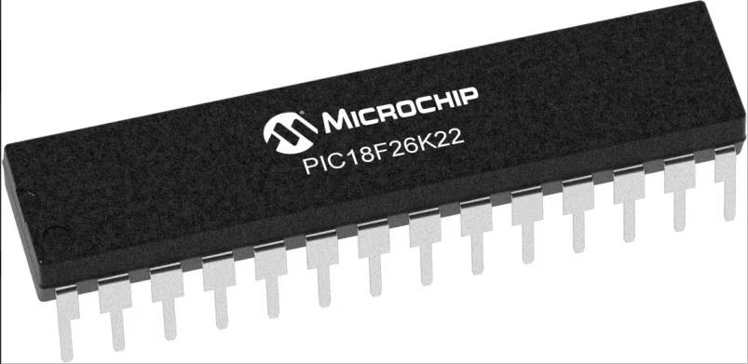 | 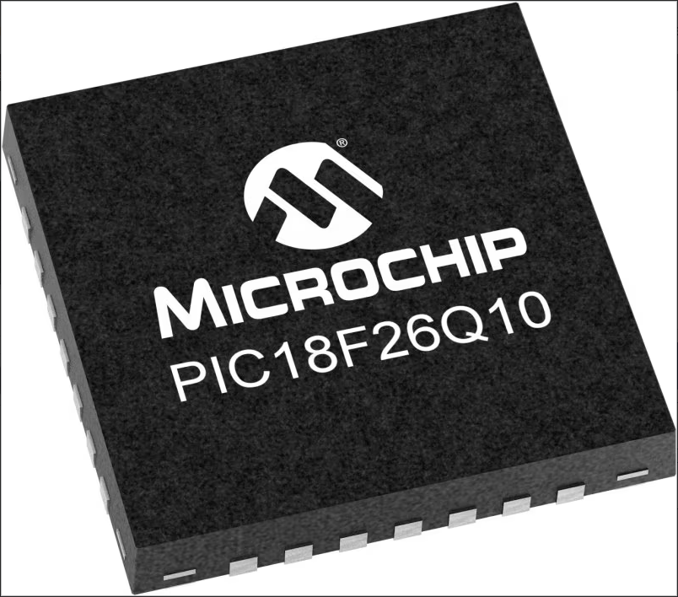 | 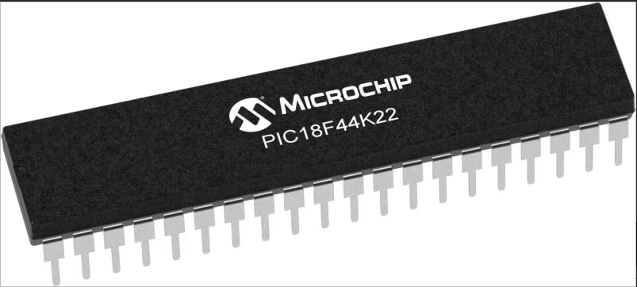
- [21]Program Memory Size (KB) - 64  - RAM - 3896  - Data EEPROM (bytes)-1024  - Pin Count-28  - Operation Voltage Max.(V)-5.5  - Operation Voltage Min.(V)-1.8  - ADC Resolution Max -10  - ADC Channels-17  - Zero Cross Detect-False  - Number of Comparators-2  - SPI-2  - I2C-2  - Standalone PWM-0  - Low Power-Yes  - Numerically Controlled Oscillator (NCO)-0  - Data Signal Modulator (DSM)-0 | - [22]Program Memory Size (KB) 64  - RAM 3615  - Data EEPROM (bytes) 1024  - Pin Count 28  - Operation Voltage Max.(V) 5.5  - Operation Voltage Min.(V) 1.8  - ADC Resolution Max 10  - ADC Channels 24  - Zero Cross Detect True  - Number of Comparators 2  - SPI 2  - I2C 2  - Standalone PWM 2  - Low Power Yes  - Numerically Controlled Oscillator (NCO) 0  - Data Signal Modulator (DSM) 1 | - [23]Program Memory Size (KB) 16  - RAM 768  - Data EEPROM (bytes) 256  - Pin Count 40  - Operation Voltage Max.(V) 5.5  - Operation Voltage Min.(V) 1.8  - ADC Resolution Max 10  - ADC Channels 28  - Zero Cross Detect False  - Number of Comparators 2  - SPI 2  - I2C 2  - Standalone PWM 0  - Low Power Yes  - Numerically Controlled Oscillator (NCO) 0  - Data Signal Modulator (DSM) 0

The microcontroller selected for the control system of the robot is the PIC18F26K22. This was selected due to its pin count, and the inputs and outputs being compatible for both digital and analogue. This microcontroller also has sufficient program memory at 64Kb, which is an ample amount required for this project.

Sensors
For the robot to operate as ‘self-aware’, sensors are required to allow the robot to ‘see’ if obstacles are blocking its path. There are various sensors that are feasible to carry out this operation.
[24]Ultrasonic Sensor | Infrared Sensor | Proximity Sensor
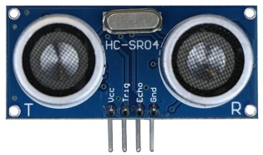 | 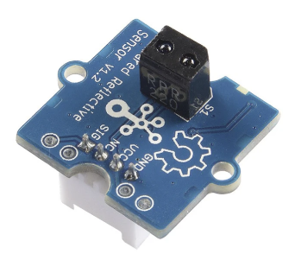 | 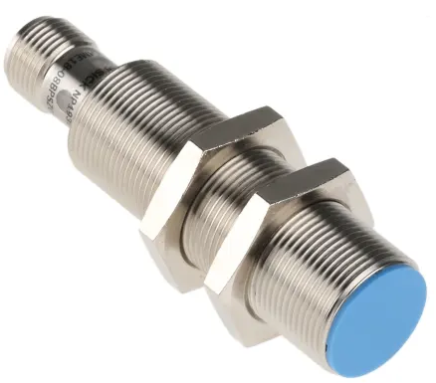
- [25]Working Voltage DC 5V  - Working Current 15mA  - Working Frequency 40Hz  - Max Range 4m  - Min Range 2cm  - Measuring Angle 15 degree  - Trigger Input Signal 10uS TTL pulse  - Echo Output Signal Input TTL lever signal and the range in proportion | - [26]Panel-mounting Grove interface  - Digital output: 0 or VCC  - Built-in indicator LED  - Threshold adjustable via potentiometer  - Power supply: 3.5 – 5.5V DC  - Reflective Photo sensor: RPR-220  - Effective working distance: 4-15mm  - Minimum detectable width for monochrome lines: 10mm  - Connector: 4 pin Buckled Grove interface  - Dimension: 20mm*20mm | - [27]Extended sensing ranges: 1.5 mm to 38 mm  - Enclosure rating: IP 67  - Nickel-plated brass housing with a plastic sensing face  - High machine availability thanks to a rugged design  - High positioning accuracy thanks to precise switching behaviour

The sensor of choice for this project is the Ultrasonic Sensor. This is due to its simplistic operation and mounting capabilities. This sensor is easily compatible with the microcontroller of choice, and relatively easy to program. This sensor was also the cheapest out of the 3 choices, and more readily available.

DC Motors
To provide motion to the screws on the robot, two DC motors will be used (one supplied to each lead screw). These motors have to provide enough torque to allow the robot to move through difficult terrain, such as sand or mud, whilst having a low enough supply voltage to not overpower the circuitry controlling it. A comparison table is shown below:

[28]RS PRO Brushed Geared DC Geared Motor | [29]Mellor Electric Brushed DC Motor | [30]DOGA Geared DC Geared Motor
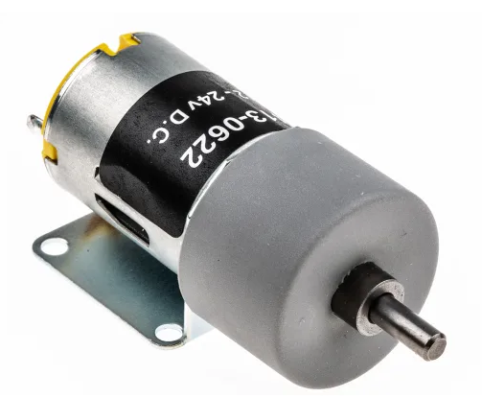 | 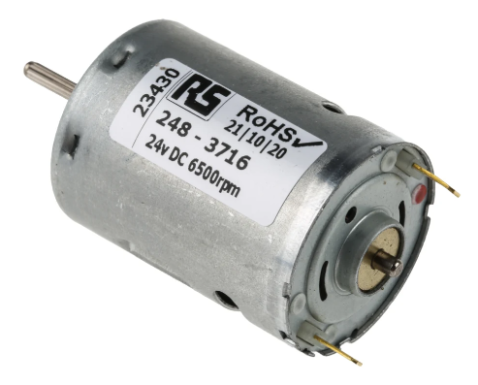 | 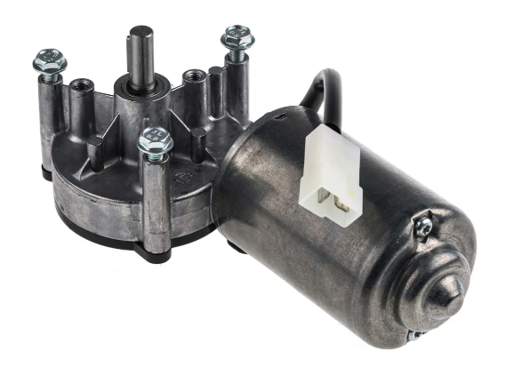
- Supply Voltage – 12-24V  - Shaft Diameter – 4mm  - RPM – 82-164  - Torque – 10Ncm  - Power Output – 1.31W | - Supply Voltage – 24V  - Shaft Diameter – 2.3mm  - RPM – 6500  - Torque – 3.5Ncm  - Power Output – 4.5W | - Supply Voltage – 12V DC  - Shaft Diameter – 9.3mm  - RPM – 40  - Torque – 5Nm  - Power Output – 20W

The motor of choice for this project is the RS Pro brushed geared motor. This motor was selected due to it having the correct supply voltage range, whilst providing an ample amount of torque. Price was also a factor, with this motor being the cheapest from the table, and they are readily available.
The motor will be controlled by a motor drive circuit, control by a L298N motor driver. Controlled by the microcontroller, this will send the desired commands to the motors for them to respond accordingly.

Power Source
The robot will require a power source to operate. As most of the components are TTL logic and require a maximum of 5V, the power source shouldn’t exceed 24V. Voltage regulators will be used to prevent a power surge from damaging the TTL logic components.
2x 12V batteries will be used to provide the power source to the robot. The motors used have a supply voltage range of 12V-24V. Using two 12V batteries will allow the motors to operate at their highest capacity, whilst voltage regulators will prevent anything more than 5V entering the TTL logic components.

Development Methodology
This section of the report will outline the various techniques and applications to be used to develop the robot such software, machinery and research techniques.

Research Methods
Firstly, research was required on the various aspects of completing this project. This includes researching components required. This was done by using current items on the market as a reference to lay the foundations of how this device will work.
Once this was understood, research into components was completed, by looking at datasheets and comparing against similar products to find which ones suits the application the best.

3D Modelling
To model the prototype robot, [31]Catia V5 was used. Catia V5 is 3D modelling package used within SAFRAN Seats GB. The robot was modelled in individual parts and then later brought into an assembly as the final product. The robot underwent numerous revisions until the final product was fit for purpose. The models of the individual parts were also used for the 3D printing of this.

Advantages

- [32]Comprehensive Design Capabilities: CATIA V5 offers a wide range of design tools and features, allowing users to create complex 3D models with precision. It supports parametric modelling, surface modelling, assembly design, and drafting, among other functionalities.
- Industry Standard: CATIA V5 is an industry-standard CAD software used by many companies, particularly in aerospace, automotive, and manufacturing sectors. Learning CATIA V5 can enhance job prospects and collaboration opportunities within these industries.
- Integration with PLM Systems: CATIA V5 seamlessly integrates with product lifecycle management (PLM) systems, allowing for efficient management of design data, revisions, and collaboration among team members throughout the product development lifecycle.
- Customization and Automation: CATIA V5 provides extensive customization options through its scripting language (CAT Script) and Application Programming Interface (API). Users can automate repetitive tasks, create custom features, and tailor the software to suit specific workflow requirements.
- Large User Community and Support: Due to its widespread adoption, CATIA V5 has a large user community and extensive online resources, including forums, tutorials, and user groups. This makes it easier for users to find help, share knowledge, and troubleshoot issues.

Disadvantages

- Steep Learning Curve: CATIA V5 has a reputation for having a steep learning curve, especially for beginners or users transitioning from other CAD software. Mastering its extensive toolset and complex workflows may require significant time and effort.
- Resource Intensive: CATIA V5 is a resource-intensive software, requiring powerful hardware specifications to run smoothly, especially when working with large assemblies or complex models. This can be a limitation for users with limited computing resources.
- License Cost: CATIA V5 is a proprietary software developed by Dassault Systèmes, and obtaining licenses can be expensive, particularly for individual users or small businesses. The cost of licenses and maintenance fees may deter some potential users.
- Limited Compatibility: While CATIA V5 supports various file formats for importing and exporting, seamless compatibility with other CAD software may be limited. This can pose challenges when collaborating with partners or clients who use different CAD tools.
- Updates and Compatibility Issues: Upgrading to newer versions of CATIA V5 or transitioning between versions can sometimes lead to compatibility issues with existing designs or third-party plugins. This may require additional time and effort to resolve.

3D Printer
The manufacturing of the robot is to be done using a 3D printer. The printer in question is a [33]BCN3D Sigma D25 printer. This printer is relatively inexpensive, and is mainly targeted for prototyping parts. This is due to the material used being PLA, which is a biodegradable plastic.
This printer uses a 0.4mm hot end extruder. This means that each layer of material extruded from the hot end will be 0.4mm in diameter.

Advantages

- [34]Independent Dual Extruder (IDEX) System: One of the main advantages of the BCN3D Sigma d25 is its Independent Dual Extruder system. This allows for multi-material and multi-colour printing without the risk of cross-contamination between materials. It also enables printing of support structures with soluble materials, making post-processing easier for complex prints.
- Large Build Volume: The Sigma d25 offers a relatively large build volume for a desktop 3D printer, allowing users to print larger parts or multiple smaller parts simultaneously.
- High-Quality Prints: With a sturdy frame and precise motion system, the Sigma d25 is capable of producing high-quality prints with fine details and smooth surfaces.
- Wide Range of Compatible Filaments: This printer can handle a variety of filaments, including PLA, ABS, PETG, TPU, and more, giving user’s flexibility in material choices for their prints.
- Open Source: BCN3D provides open-source software and firmware for the Sigma d25, allowing users to customize and modify their printing experience according to their needs.

Disadvantages

- Price: The BCN3D Sigma d25 is relatively expensive compared to some other desktop 3D printers, which may put it out of reach for some hobbyists or small businesses.
- Complexity: While the IDEX system offers versatility, it also adds complexity to the printer, which may require more knowledge and experience to operate effectively. Users may need to spend more time calibrating and troubleshooting compared to simpler single-extruder systems.
- Large Footprint: Although it has a large build volume, the Sigma d25 also has a correspondingly large physical footprint. This may be a drawback for users with limited workspace.
- Software Limitations: While BCN3D provides open-source software, some users may find the provided slicing software lacking in features compared to other slicers available on the market.
- Maintenance: Like any 3D printer, the Sigma d25 requires regular maintenance to keep it running smoothly. The dual extrusion system may require additional maintenance compared to single-extruder printers, such as purging and cleaning to prevent clogs and jams.

Proteus
Proteus is a popular software suite used for electronic design automation (EDA), particularly for simulating and designing electronic circuits. Here are some advantages and disadvantages of using Proteus:

Advantages

- [35]Simulation Capabilities: Proteus offers powerful simulation features that allow designers to simulate and test their electronic circuits before prototyping them physically. This helps in identifying and resolving issues early in the design process, saving time and resources.
- Mixed-Signal Simulation: Proteus supports mixed-signal simulation, enabling designers to simulate both analogue and digital circuits in the same environment. This is beneficial for designing systems that contain both analogue and digital components, such as microcontroller-based systems.
- Large Component Library: Proteus comes with an extensive library of electronic components, including microcontrollers, sensors, actuators, and other discrete components. This vast component library makes it easy for designers to quickly prototype and simulate various types of circuits without the need to create custom components.
- Ease of Use: Proteus has a user-friendly interface that is relatively easy to navigate, making it suitable for both beginners and experienced designers. The software provides various tools and features that streamline the design process and make circuit simulation and debugging more efficient.
- PCB Design Integration: Proteus seamlessly integrates circuit simulation with PCB layout design. Designers can transition from circuit simulation to PCB layout design within the same software environment, allowing for a more cohesive design workflow.
- Interactive Debugging: Proteus provides interactive debugging features that allow designers to monitor circuit behaviour in real-time during simulation. This helps in identifying and troubleshooting issues quickly, leading to faster design iterations and improvements.
Disadvantages

- Limited Accuracy: While Proteus offers powerful simulation capabilities, the accuracy of simulations may sometimes be limited, especially for complex circuits or high-frequency designs. Designers should validate critical circuit parameters with physical prototypes or more advanced simulation tools for high-precision designs.
- Limited Flexibility: Although Proteus has a large component library, it may not always include the specific components or models required for certain designs. Designers may need to create custom models or components, which can be time-consuming and require additional expertise.
- Cost: Proteus is a commercial software suite, and obtaining a license may incur costs, especially for professional or commercial use. While Proteus offers a free trial version with limited features, access to the full suite of capabilities requires purchasing a license, which may be a barrier for some users.
- Learning Curve: While Proteus has an intuitive interface, mastering its advanced features and capabilities may require some learning curve, especially for beginners or users transitioning from other EDA tools. Adequate training and resources may be necessary to fully utilize Proteus' potential.
- Limited Collaboration Features: Proteus may lack robust collaboration features compared to some other EDA tools. Collaborative design workflows, such as real-time collaboration and version control, may be limited or require additional third-party tools.

MPLAB X IDE

MPLAB X IDE is an Integrated Development Environment (IDE) specifically designed for programming and debugging Microchip's PIC microcontrollers and dsPIC digital signal controllers. Here are some advantages and disadvantages of using MPLAB X IDE:

Advantages

- [36]Comprehensive Development Environment: MPLAB X IDE provides a comprehensive environment for developing embedded firmware for Microchip microcontrollers. It integrates various tools such as editors, compilers, assemblers, and debuggers, streamlining the development process.
- Wide Support for Microchip Devices: MPLAB X IDE supports a wide range of Microchip microcontrollers and digital signal controllers, including PIC, dsPIC, and AVR devices. This broad support makes it suitable for a variety of embedded applications across different industries.
- Feature-Rich Editor: MPLAB X IDE includes a feature-rich code editor with syntax highlighting, code completion, and code navigation features, making it easier for developers to write and maintain code efficiently.
- Integrated Debugger: MPLAB X IDE integrates powerful debugging tools, including a simulator and in-circuit debugger (ICD), allowing developers to debug their code interactively. This helps in identifying and resolving issues quickly during the development phase.
- Plugin Support: MPLAB X IDE supports plugins, allowing developers to extend its functionality and customize their development environment according to their requirements. Plugins can add additional features, tools, or support for third-party devices and peripherals.
- Version Control Integration: MPLAB X IDE seamlessly integrates with version control systems such as Git, enabling developers to manage their code repositories directly within the IDE. This facilitates collaborative development and version control management.

Disadvantages

- Steep Learning Curve: MPLAB X IDE can have a steep learning curve, especially for beginners or developers who are new to embedded programming or Microchip devices. Understanding its various features and tools may require some time and effort.
- Resource Intensive: MPLAB X IDE can be resource-intensive, especially when working with large projects or debugging complex code. Developers may experience slowdowns or performance issues, particularly on less powerful hardware configurations.
- Limited Cross-Platform Support: While MPLAB X IDE is available for multiple operating systems including Windows, macOS, and Linux, the user experience and feature parity may vary across platforms. Some features or tools may be better supported on certain platforms than others.
- Documentation and Community Support: While Microchip provides extensive documentation and resources for MPLAB X IDE, including tutorials and user guides, the availability of community support and resources may vary compared to other IDEs with larger user bases.
- Integration with Third-Party Tools: While MPLAB X IDE integrates well with Microchip's ecosystem of tools and devices, integration with third-party tools or hardware may not always be straightforward and may require additional configuration or setup.
- Updates and Stability: Some users have reported issues with stability and occasional bugs in certain versions of MPLAB X IDE. While Microchip regularly releases updates and bug fixes, users may encounter issues that require troubleshooting or workaround solutions.

Product Design Specification

4.1 Overview
The purpose of this document is to outline the requirements and specifications for the design and development of a 24V PIC-controlled screw-propelled robot. The robot is intended for outdoor exploration and navigation over challenging terrain, such as mud, sand, and snow. The robot will be controlled by a PIC microcontroller and powered by a 24V battery system.

4.2 Objectives and Goals
- Design and build a rugged and reliable screw-propelled robot capable of traversing various types of terrain.
- Implement precise control and manoeuvrability using a PIC microcontroller.
- Ensure the robot is capable of operating autonomously
- Integrate sensors for obstacle detection and navigation
- Optimize power efficiency to maximize operating time and range on a 24V battery system.

4.3 Scope
The scope of this project includes:

- Design and fabrication of the mechanical structure and screw propulsion system.
- Integration of PIC microcontroller-based control system for motor control, sensor interfacing, and data processing.
- Incorporation of sensors for obstacle detection and environmental sensing.
- Testing, validation, and optimization of the robot's performance under various terrain conditions.

4.4 User Requirements
- The robot should be able to navigate through mud, sand, snow, and other challenging terrain.
- The robot should be capable of autonomously avoiding obstacles and navigating to predefined waypoints.
- The robot should be durable, weather-resistant, and able to withstand harsh environmental conditions.

4.5 Technical Requirements
- Screw propulsion system capable of providing sufficient thrust for propulsion over various terrain types.
- PIC microcontroller with sufficient processing power, memory, and I/O capabilities for motor control, sensor interfacing, and communication.
- 24V battery system with capacity for extended operating time and quick recharge capability.
- Sensors for obstacle detection (e.g., ultrasonic or infrared sensors),
- Rugged and weatherproof mechanical enclosure to protect internal components from environmental hazards.

4.6 Design Specifications

- Mechanical structure constructed from lightweight yet durable materials such as PLA 3D Print material
- Screw propulsion system consisting of helical screw blades driven by high-torque DC motors.
- PIC microcontroller programmed in C or assembly language to control motor speed, direction, and sensor data processing.
- Integration of obstacle detection sensors (e.g., ultrasonic or infrared) mounted on the front and sides of the robot.

4.7 Functional Requirements

- The robot should be able to move forward, backward, and turn in place using the screw propulsion system.
- Obstacle detection sensors should provide real-time feedback to the PIC microcontroller to avoid collisions.

4.8 Performance Criteria

- The robot should be able to traverse at least 100 meters over challenging terrain on a single battery charge.
- Obstacle detection sensors should reliably detect obstacles up to 30cm away with an accuracy of ±1cm
- The robot should be capable of operating in temperatures ranging from -10°C to 50°C without performance degradation.

4.9 Testing and Validation
- Conduct extensive field testing of the robot in various terrain conditions, including mud, sand, snow, and rocky terrain.
- Verify the performance of obstacle detection, terrain mapping, and environmental sensing subsystems under real-world conditions.
- Validate the accuracy and reliability of the PIC microcontroller-based control system for motor control and sensor integration.
- Ensure compliance with relevant safety standards and regulations for outdoor robotic systems.

4.10 Timeline and Milestones
- Design and Prototyping Phase: 3 months
- Testing and Validation Phase: 2 months
- Finalization and Deployment Phase: 1 month

4.11 Budget and Resources

Budget Allocation: £250
Required Resources: Mechanical engineers, electrical engineers, software developers, fabrication tools, materials, sensors, PIC microcontroller development kit and batteries.

4.12 Risk Management

- Identify potential risks such as mechanical failure, sensor malfunctions, software bugs, and environmental hazards.
- Develop mitigation strategies and contingency plans to address identified risks and minimize their impact on the project timeline and budget.

4.13 Document Control

Maintain version control and document tracking to ensure all changes and revisions to the product design specification are properly documented and communicated.

Design & Implementation

CAD Models
Below showcases the 3D models of the Robot. This was modelled using Catia V5 3D modelling software.
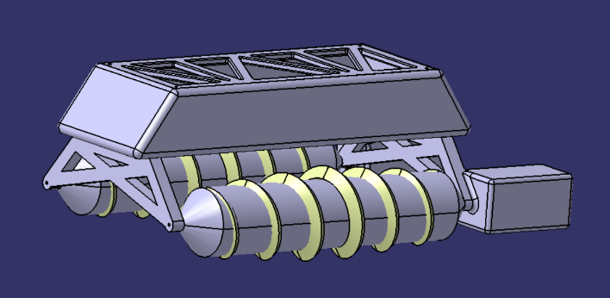
Figure 1- CAD Isometric View

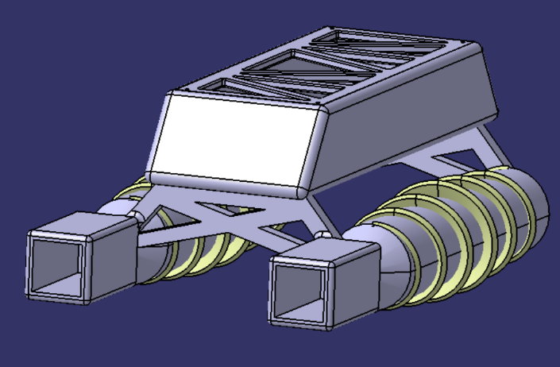
Figure 2- CAD Rear View

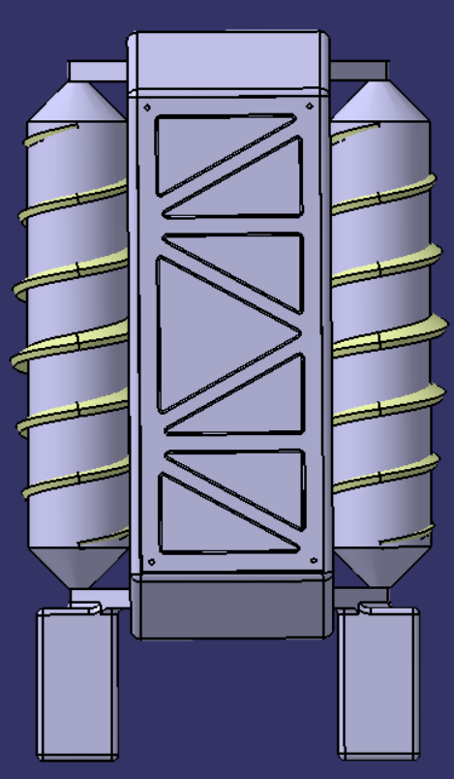
Figure 3- CAD Top View

2D Drawing Generation

Robot Body Drawing

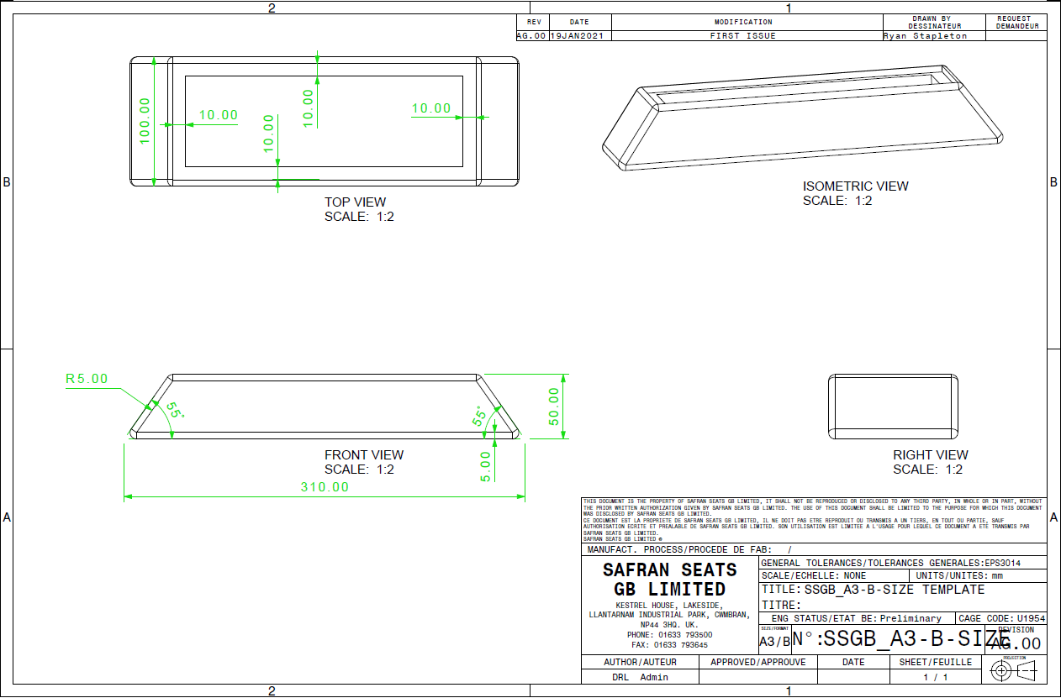

Robot Screw Drawing
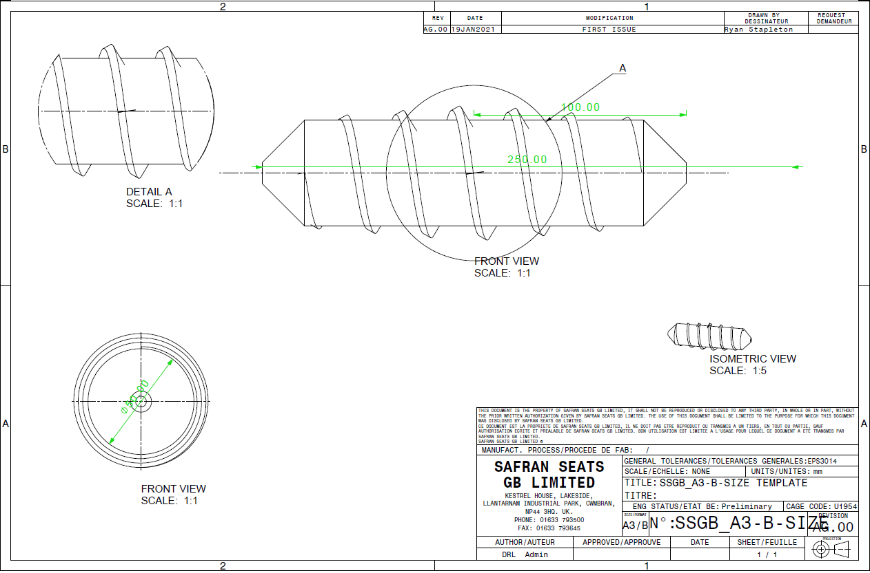

Robot Rear Support Drawing
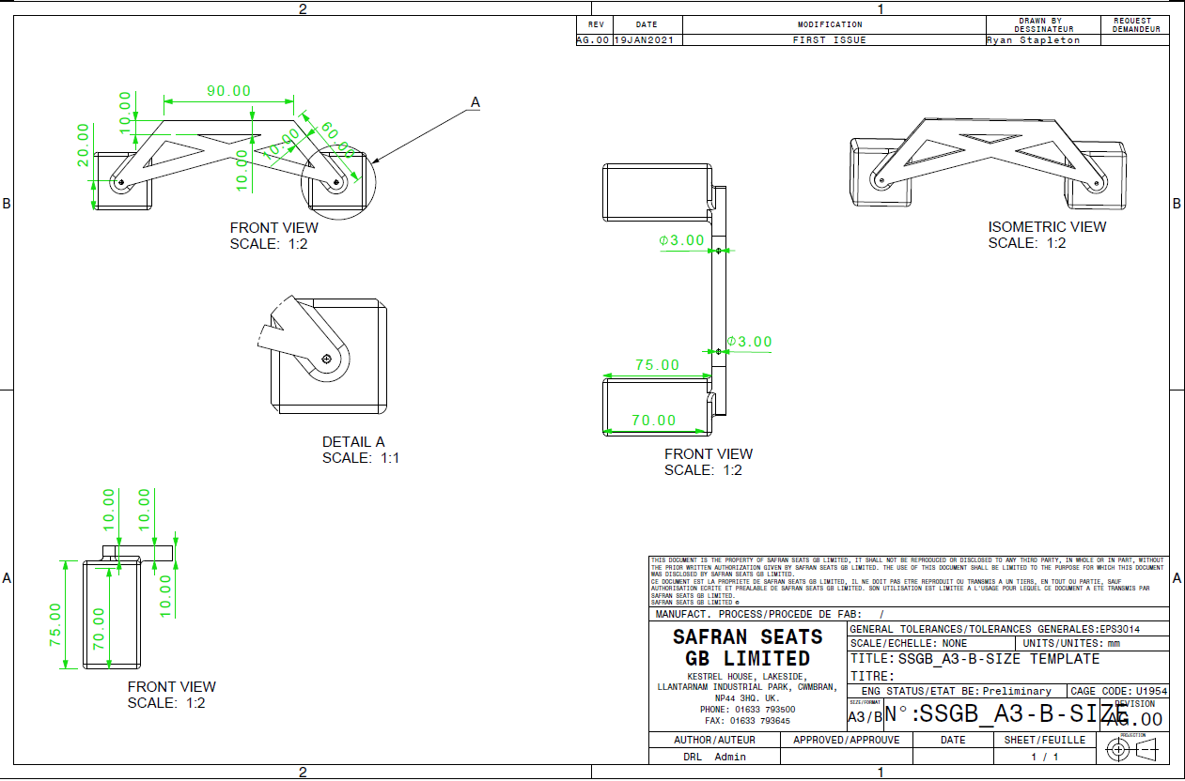

Robot Lid Drawing
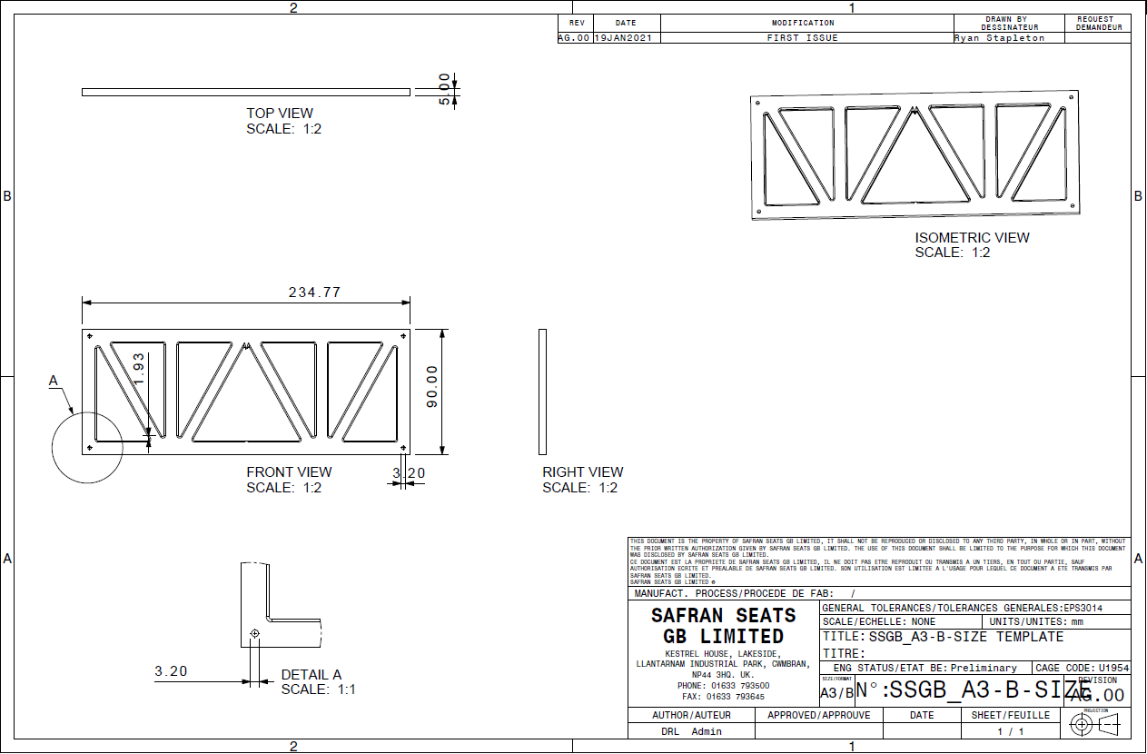

Robot Front Support Drawing
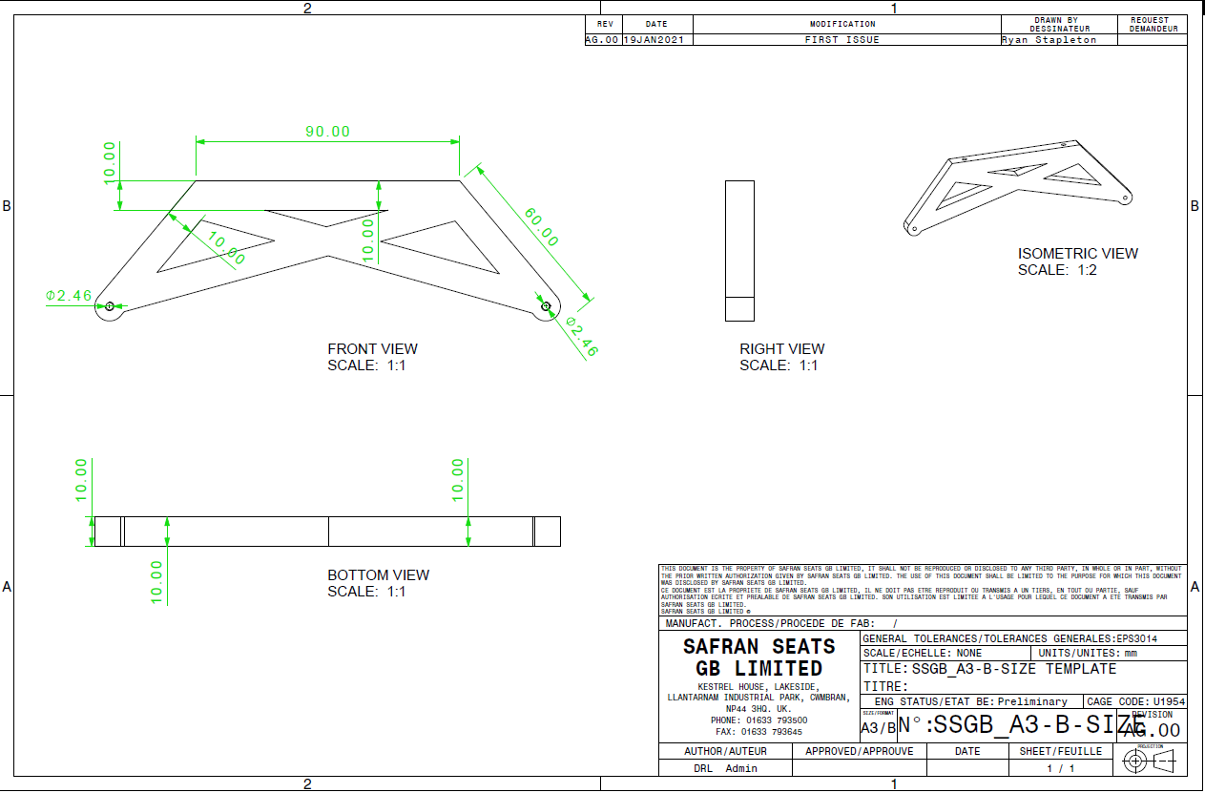

Robot Final Assembly Drawing
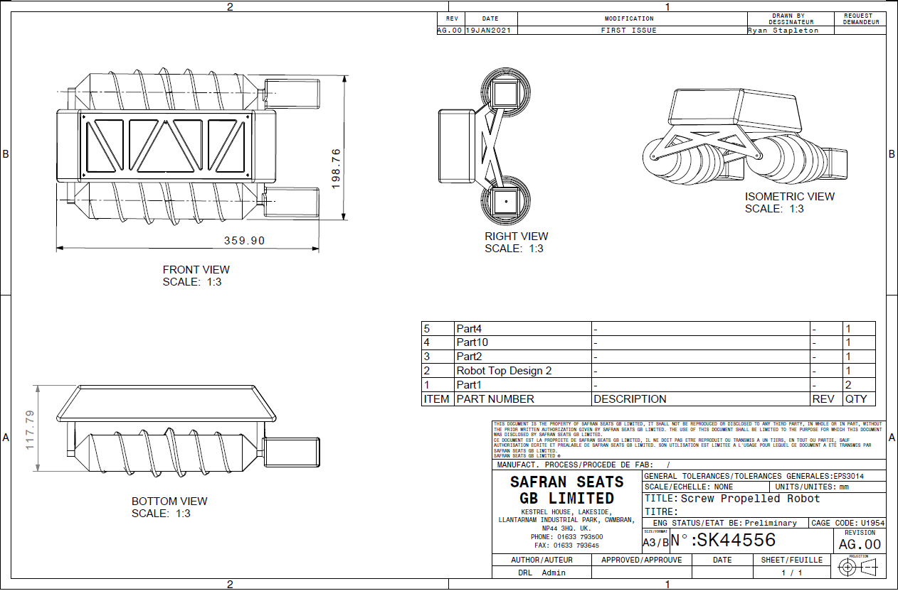

Proteus Schematics
The image below shows the schematic for the robot, and the connections of each component.
The circuit is comprised of two circuit. The left side is showcasing the motor drive/control circuit. This circuit is made up of a L298N motor drive chip, which will deliver speed and direction to the motors as commanded by the PIC. There is also a 7805 voltage regulator in place to prevent any voltage over 5V from damaging the L298N. This schematic has a few errors present. One being the motors being connected in a way that will allow them to rotate in one direction. The motor should be connected on the negative pin also to allow bi-directional rotation.

The right side of the circuit is showcasing the connection for the sensors. There is an error on this side of the circuit also. There is no requirement for the over voltage protection and signal smoothing. This is due to the sensors voltage being supplied from the PIC so it cannot exceed 5V, and the signal is a direct command to the PIC which doesn’t require any smoothing.
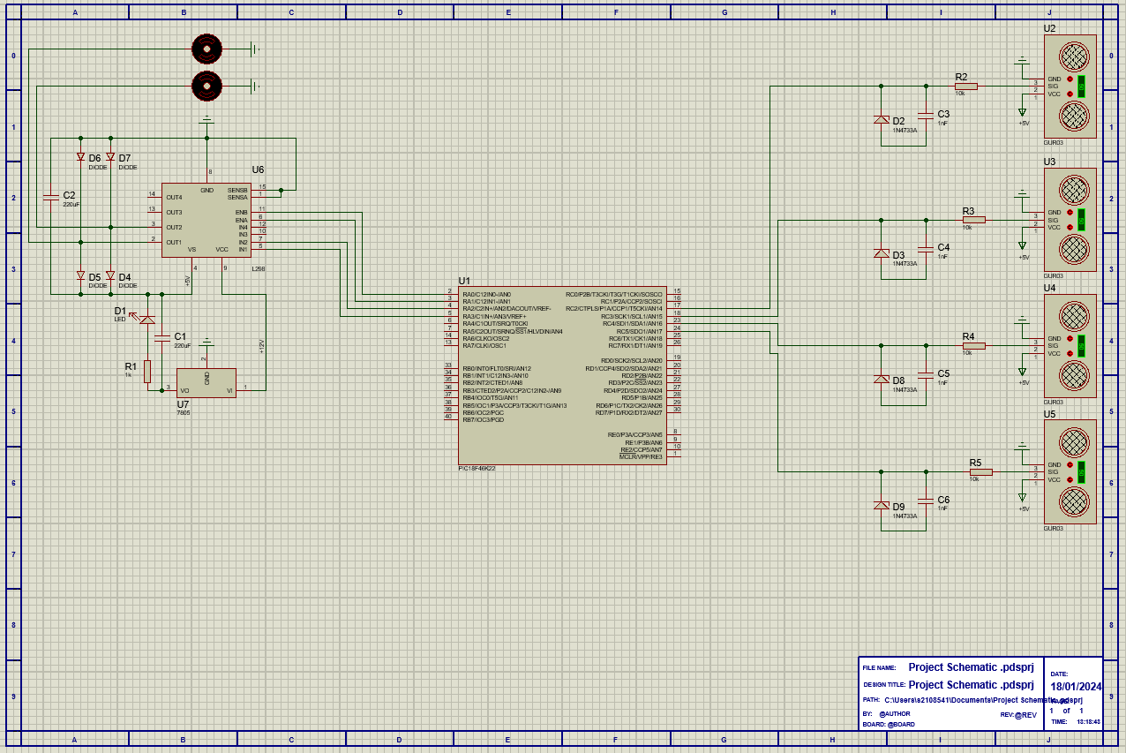
Figure 4- Proteus Schematic

Easy PC Schematics
The circuit below is the same circuit as above, but instead designed using Easy PC. This was completed with the intention designing the PCB board on this software for it to be sent off to be manufactured.
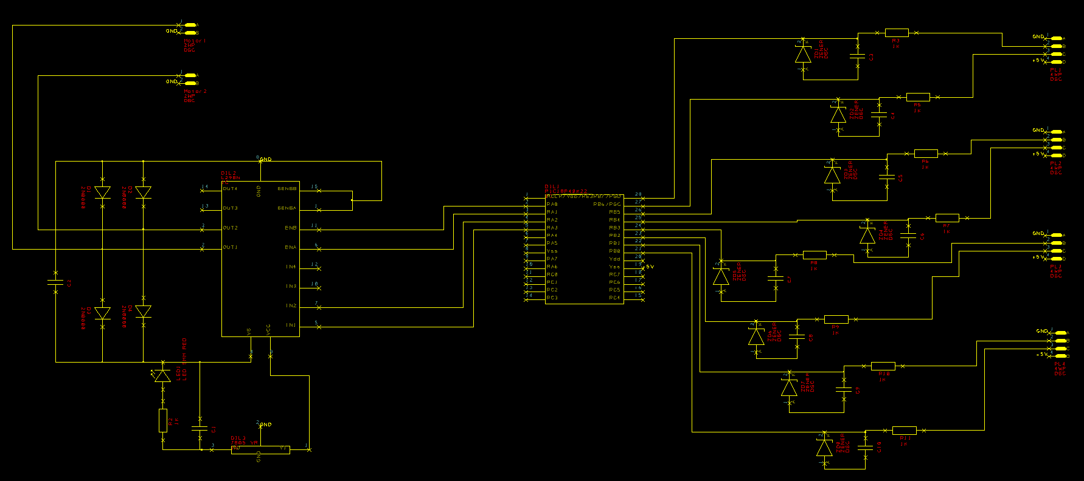
Figure 5- Easy PC Schematic

PCB Board Design
The image below shows the initial concept design for the PCB board to be manufactured. However, the design has some standout errors in the design preventing it to be manufactured. The design has crossing tracks, due to the two circuits being implemented onto one board. Upon reflection, the PCB should have been designed into two boards, one for the motor drive circuit, and the other for the sensors connections. This would’ve prevented the crossing tracks, but would’ve increased manufacturing cost.
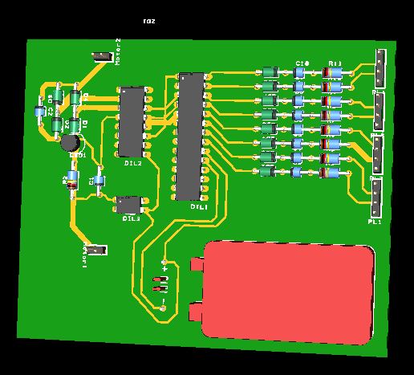
Figure 6- Easy PC PCB Board Design

Implementation
The image below showcases the central hub for the PCB board. This comprises of the microcontroller, voltage regulator and some connectors for the sensors and batteries to connect to.
All components were manually soldered to the PCB board, with jumper cables to their respective destinations.

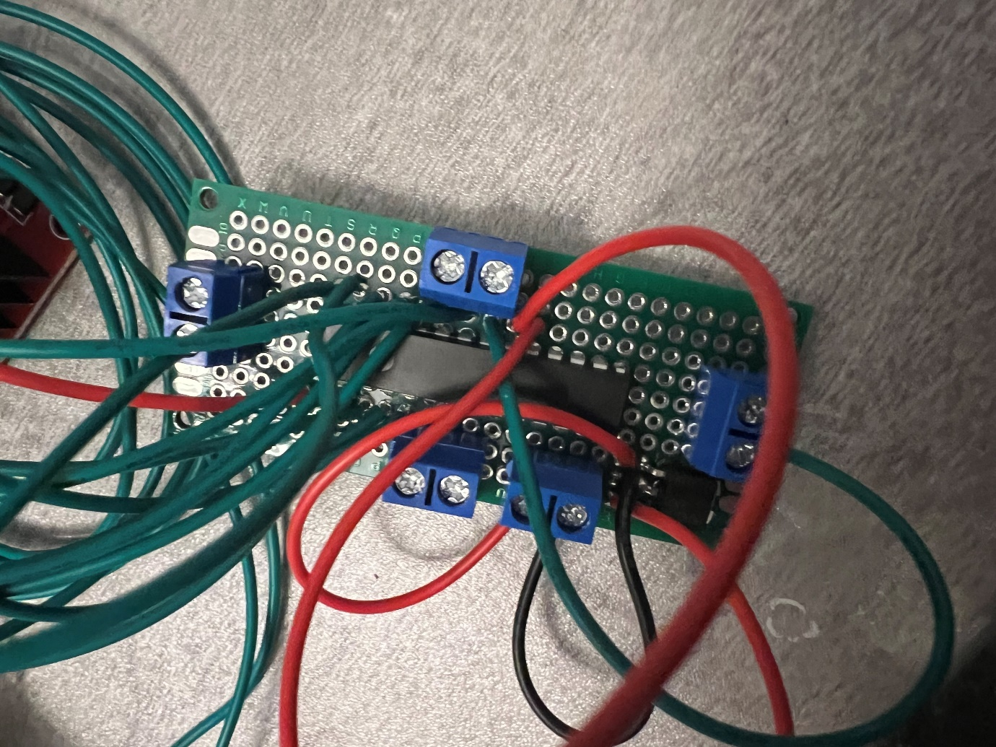
Figure 7- PIC PCB Board

The image below showcases the motor drive circuit. This circuit comprises of the L298N motor drive chip, an L805 voltage regulator with a heat sink to improve heat dissipation when operating. This circuit controls the motors connected, which is commanded through the PIC. The operations controlled by the circuit are motor speed and direction.
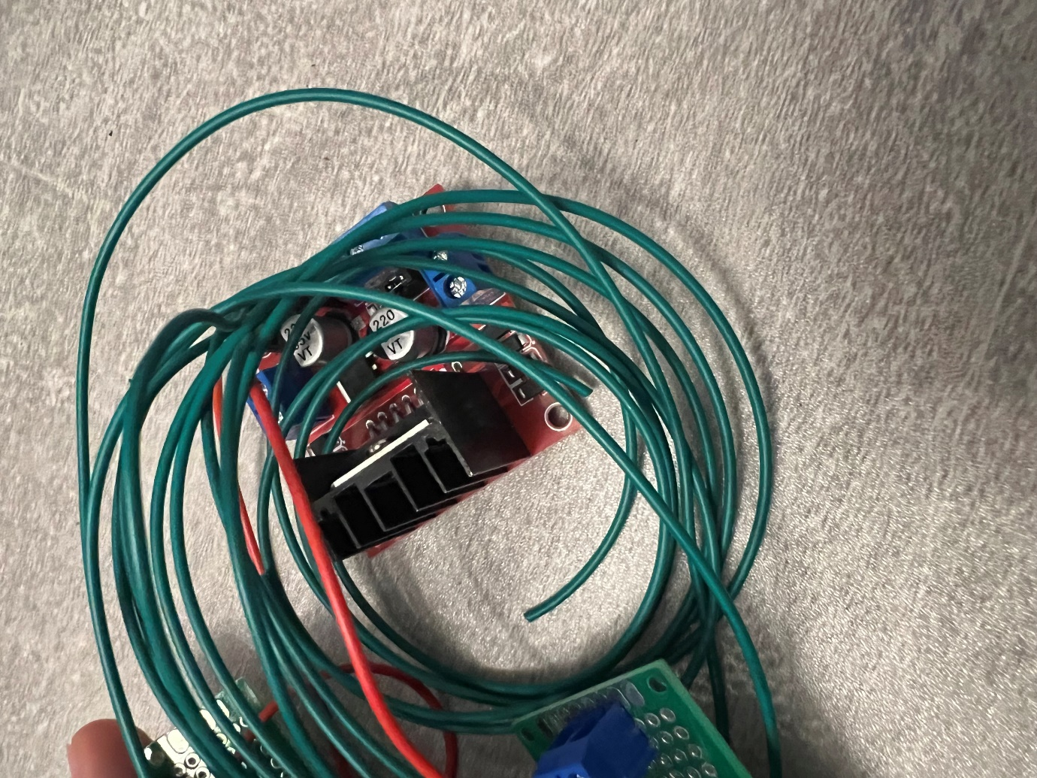
Figure 8- Motor Drive PCB Board

The image below showcases the circuit required for programming the microcontroller. This comprises of the central hub PCB board, with the required pins for the programming soldered board with a connector for the PicKit3. This is where the problems arose for the project, which is discussed later in this document under 7.0 Reflection.
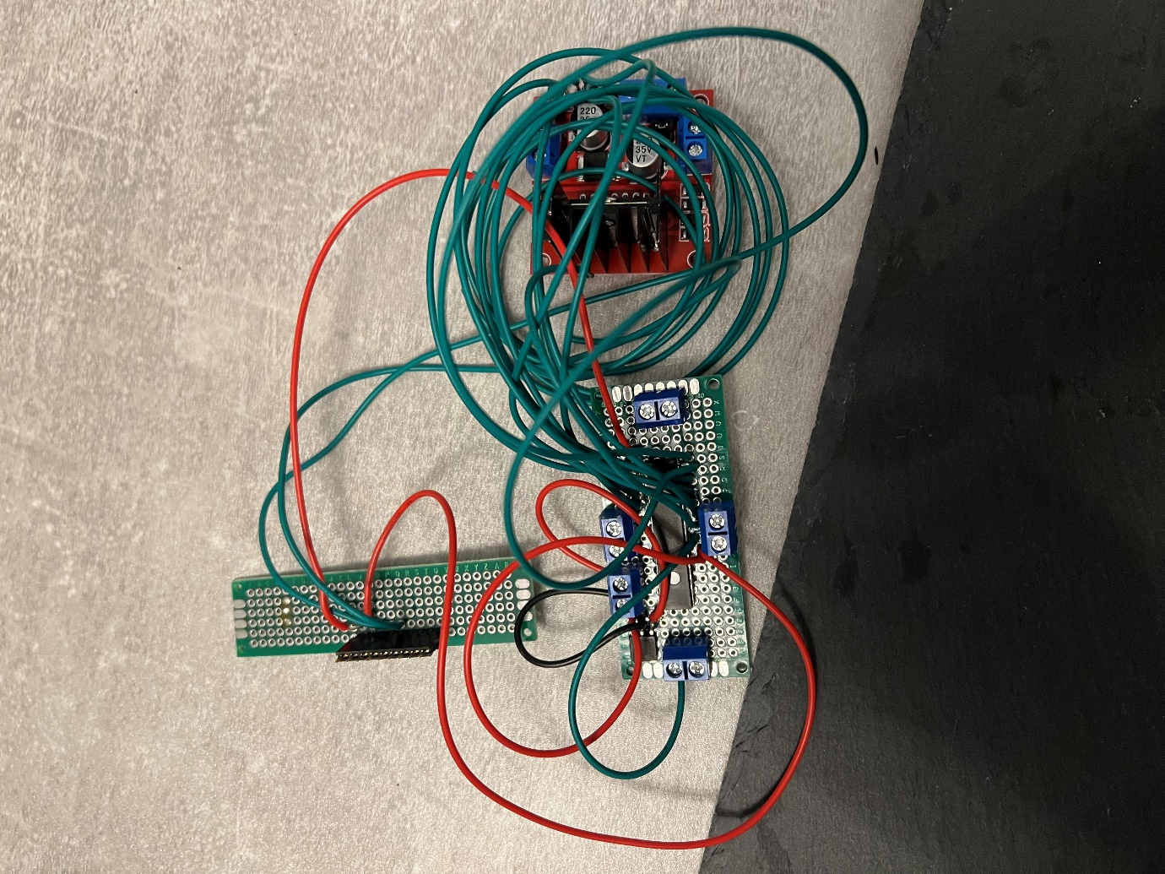
Figure 9- Programming PCB Board

The image below shows the final assembly of the robot. The robot was manufactured using a 3D printer, which was later bonded and screwed together for structural integrity.
The material used to 3D print is PLA which is a biodegradable plastic. This material has strong properties to reduce cracking under strain, whilst maintaining lightweight properties allowing for easy transportation.
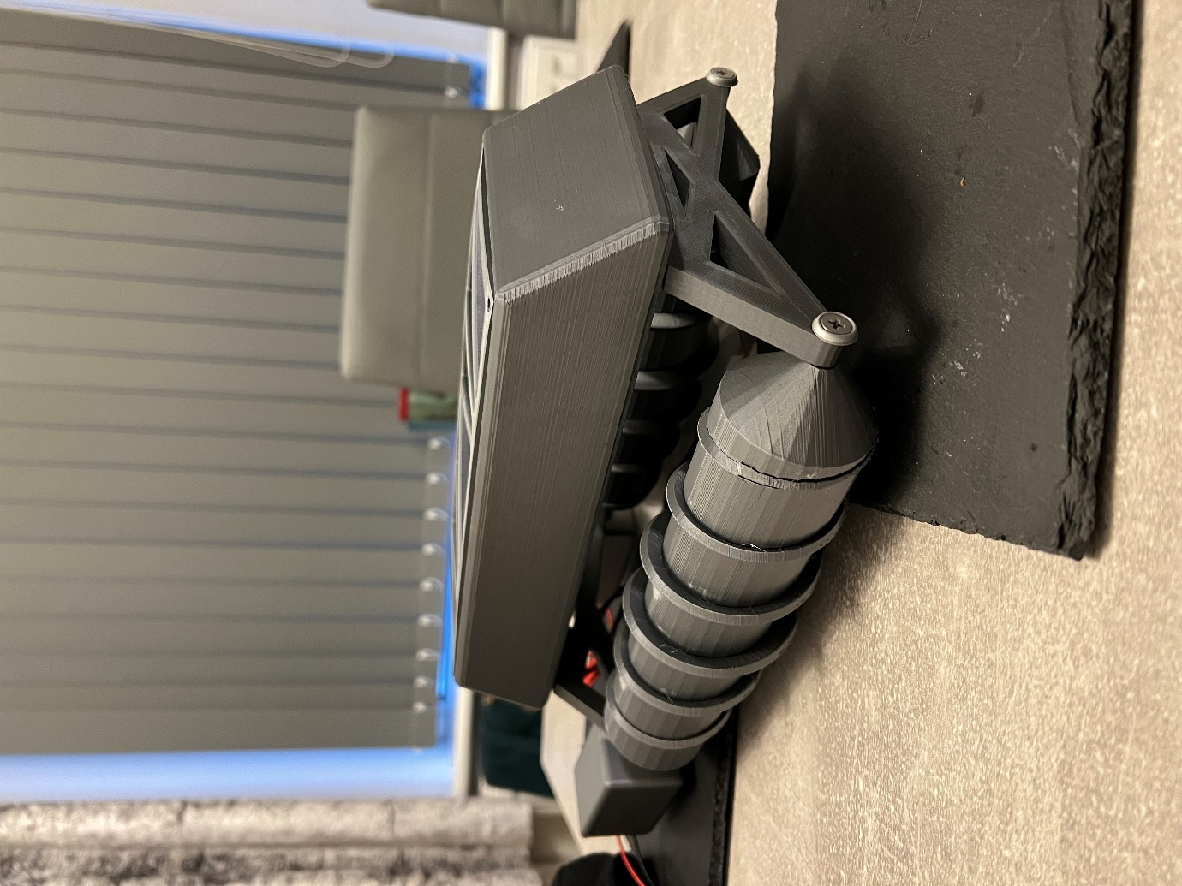
Figure 10- Final Assembly Isometric View

The image below showcases the 3D printer used to print the parts for the robot. This 3D printer is mid-range printer that is capable of printing with an accuracy of 0.15mm. This version of printer is setup to print in PLA material, which is a biodegradable plastic. Other versions of this printer allow for printing in metal and carbon fibre. This was necessary for the purpose of this project.
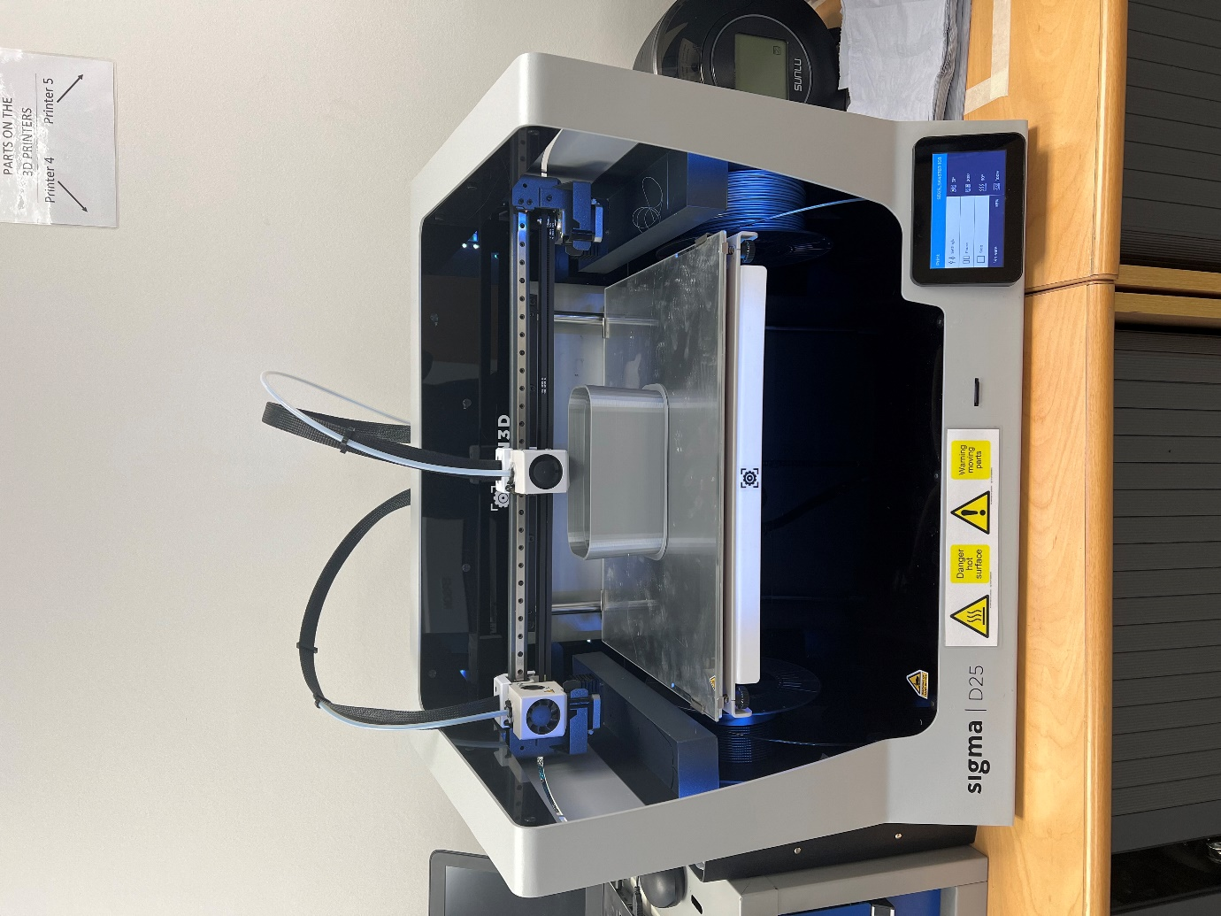
Figure 11- Sigma D25 3D Printer

The image below shows the rear of the robot, and the housing for the motors. The motors are bonded in place to prevent them from dislodging when travelling over rough terrain. The motors are then bonded to the screw via the shaft, which will supply the rotation for the screw to allow the robot to travel.
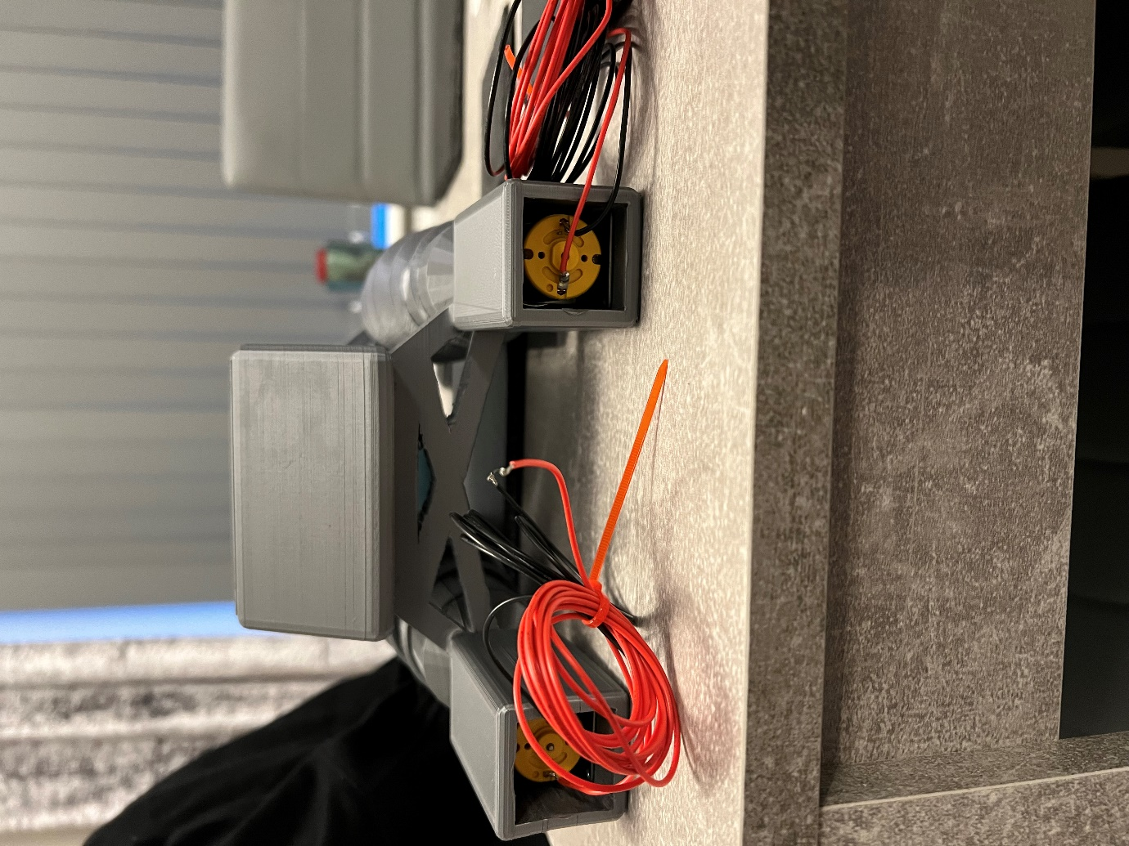
Figure 12- Final Assembly Rear View

The image below showcases the top view of the robot, and the housing for the electronics. The lid of the robot has cut outs to aid with heat dissipation and to reduce the weight and print time of this part. However, the poses an issue as this design is set to mimic an all-terrain vehicle to be used in all weathers. With these cut outs, water and moisture can easily enter the internals of the robot, posing a risk of damaging components.
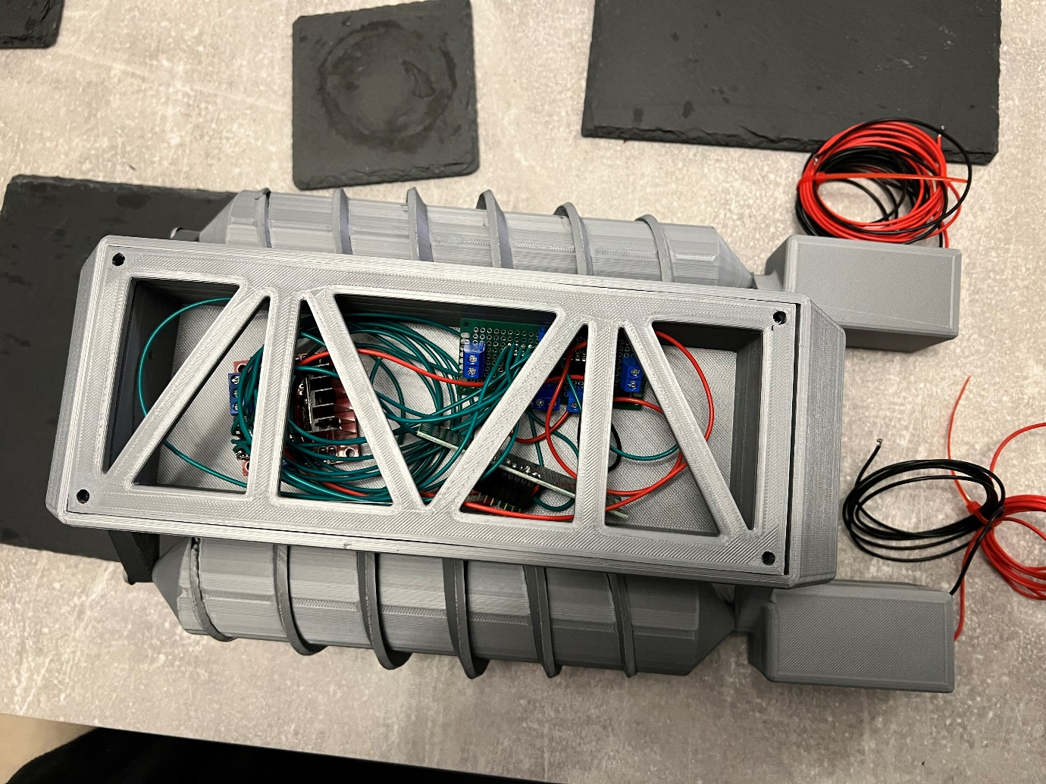
Figure 13- Final Assembly Top View

Microcontroller Code

#include <xc.h>
void main(void) {
return;
}
#include <xc.h>
#include <stdint.h>
// Define GPIO pins for ultrasonic sensor
#define TRIGGER_PIN RB6 // Change RB0 to the appropriate pin
#define ECHO_PIN RB7 // Change RB1 to the appropriate pin
#define TRIGGER_PIN RB4 // Change RB0 to the appropriate pin
#define ECHO_PIN RB5 // Change RB1 to the appropriate pin
#define TRIGGER_PIN RB2 // Change RB0 to the appropriate pin
#define ECHO_PIN RB3 // Change RB1 to the appropriate pin
#define TRIGGER_PIN RB1 // Change RB0 to the appropriate pin
#define ECHO_PIN RB0 // Change RB1 to the appropriate pin
// Define motor control pins
#define MOTOR_PIN_A RA0 // Change RA0 to the appropriate pin
#define MOTOR_PIN_B RA1 // Change RA1 to the appropriate pin
#define MOTOR_PIN_C RA2 // Change RA2 to the appropriate pin
#define MOTOR_PIN_D RA3 // Change RA3 to the appropriate pin
// Define delay for changing direction (in milliseconds)
#define CHANGE_DIRECTION_DELAY 1000 // Adjust as needed
// Function prototypes
void ultrasonic_setup();
void ultrasonic_trigger();
uint16_t ultrasonic_measure();
void motor_forward();
void motor_backward();
void motor_left();
void motor_right();
void motor_stop();
void main() {
// Initialize ultrasonic sensor and motor
ultrasonic_setup();
while(1) {
// Trigger ultrasonic sensor
ultrasonic_trigger();
// Measure distance
uint16_t distance = ultrasonic_measure();
// Check if an obstacle is detected within a certain range
if(distance < 50) { // Adjust this threshold as needed
// If obstacle detected, change direction
motor_left();
__delay_ms(CHANGE_DIRECTION_DELAY);
motor_right();
__delay_ms(CHANGE_DIRECTION_DELAY);
motor_stop();
} else {
// Otherwise, keep moving forward
motor_forward();
}
}
}
void ultrasonic_setup() {
// Configure TRIGGER_PIN as output
TRISB &= ~(1 << TRIGGER_PIN);
// Configure ECHO_PIN as input
TRISB |= (1 << ECHO_PIN);
}
void ultrasonic_trigger() {
// Send a trigger pulse
PORTB |= (1 << TRIGGER_PIN);
__delay_us(10); // Wait for 10 microseconds
PORTB &= ~(1 << TRIGGER_PIN);
}
uint16_t ultrasonic_measure() {
// Measure the pulse width on ECHO_PIN
while(!(PORTB & (1 << ECHO_PIN))); // Wait for the echo to start
TMR1 = 0; // Reset Timer1
T1CONbits.TMR1ON = 1; // Start Timer1
while(PORTB & (1 << ECHO_PIN)); // Wait for the echo to end
T1CONbits.TMR1ON = 0; // Stop Timer1
return (uint16_t)((TMR1 * 0.0343) / 2); // Convert pulse width to distance in cm
}
void motor_forward() {
// Drive motors forward by setting appropriate motor control pins
PORTA |= (1 << MOTOR_PIN_A);
PORTA &= ~(1 << MOTOR_PIN_B);
PORTA |= (1 << MOTOR_PIN_C);
PORTA &= ~(1 << MOTOR_PIN_D);
}
void motor_backward() {
// Drive motors backward by setting appropriate motor control pins
PORTA &= ~(1 << MOTOR_PIN_A);
PORTA |= (1 << MOTOR_PIN_B);
PORTA &= ~(1 << MOTOR_PIN_C);
PORTA |= (1 << MOTOR_PIN_D);
}
void motor_left() {
// Turn left by setting appropriate motor control pins
PORTA &= ~(1 << MOTOR_PIN_A);
PORTA |= (1 << MOTOR_PIN_B);
PORTA |= (1 << MOTOR_PIN_C);
PORTA &= ~(1 << MOTOR_PIN_D);
}
void motor_right() {
// Turn right by setting appropriate motor control pins
PORTA |= (1 << MOTOR_PIN_A);
PORTA &= ~(1 << MOTOR_PIN_B);
PORTA &= ~(1 << MOTOR_PIN_C);
PORTA |= (1 << MOTOR_PIN_D);
}
void motor_stop() {
// Stop the motors by turning off motor control pins
PORTA &= ~(1 << MOTOR_PIN_A);
PORTA &= ~(1 << MOTOR_PIN_B);
PORTA &= ~(1 << MOTOR_PIN_C);
PORTA &= ~(1 << MOTOR_PIN_D);
}

Cost
Component Name | Quantity | Cost
PLA 3D Print Material | 1 x 1Kg | £20
Pi Hut L298N | 1 | £6.49
Miuzei 75PCS PCB Boards | 1 | £9.99
HALJIA 5PCS 2x12V Battery Holder | 1 | £8.99
10 Pack A23 12V Batteries | 1 | £5.99
XINWANG PVC Electrical Wire Kit | 1 | £15.89
24V DC Geared Motors | 2 | £23.70
HC-SR04 Ultrasonic Sensor | 4 | £8.40
PIC18F26K22 | 1 | £3.08
L7805 Voltage Regulator | 1 | £0.41
 | Total Cost | £102.94

This shows the cost of the components required to develop and build this project. This total cost does not reflect the cost of time of myself or other individuals that assisted with the project.

Reflection
Upon reflection on the completion of the robot, it is evident that numerous improvements could be made to the robot to better aid functionality and aesthetics.

Firstly, weatherproofing the robot would be a major improvement to aid both functionality and aesthetics of the robot. The robot is designed to mimic that of an all-terrain vehicle, capable of withstanding harsh environments. However, this prototype design has exposed vents for the electronics, preventing this robot from being used in harsh conditions such as sand and mud for example. To achieve a more realistic resemblance to the machinery being mimicked, weatherproofing is an essential upgrade.

Secondly, another essential upgrade to aid functionality would be the motors used. Although the current motors do provide enough torque to make the robot manoeuvrable, the motors struggle even when being supplied with the maximum amount of input voltage. For this design to be feasible for use in all terrain, the motors would require more torque to be used in rocky environments.

Another improvement to the design would be the housing of the ultrasonic sensors. The initial idea for this prototype was to use a hole saw to cut out the area required to house the sensors in place. This was a mistake, as drilling through an angle piece of material was quite a challenge and an unnecessary one at that. To improve this, the housing for the sensors would be integrated into the model of the robot, allowing the sensors to placed and bonded into position. This in turn would improve the aesthetics and assembly of the final product.

To better aid functionality, there are a few hardware upgrades that are needed to allow the robot to be functional in accordance with the design brief. The current revision of the robot doesn’t function, which is largely down to the failure of programming the microcontroller used. To prevent this from happening again, there a few areas in both the design and personal improvements that can be made.

Instead of ordering all components and manually soldering to a PCB board, more effort should have been made using the PCB board design software, and getting the PCB board manufactured. This would have resulted in a professional board that was clean, and reduce the chance of microcontroller functioning incorrectly. By soldering components manually, there is an increased risk and damaging components, having poor joints resulting in poor conductivity and makes the board ‘untidy’ making it more difficult to house the PCB board inside the robot. This would also minimise the chance of the inability of programming the PIC, which was one issue faced when developing the project.

As a personal improvement when undertaking a task like this again, more time and care should be taken when reading the specifications of the microcontroller selected. The PIC18F26K22 selected has two VSS pins on either side of the PIC. Rather than reading the specifications of the internals of the PIC, assumptions were made that this was to accommodate accessibility rather than aid functionality of the PIC. In reality, both VSS pins are required to supply power to both sides of the PIC. This is the reason that the PIC could not be programmed, as the pins required for programming are accessed on either side of the PIC.

Conclusion

In conclusion, the endeavour to develop a screw-propelled robot has been met with challenges and setbacks, leading to an ultimately unsuccessful outcome. Despite best efforts and meticulous planning, the complexities involved in designing and engineering such a specialized robot presented formidable obstacles that proved difficult to overcome.
Through this project, invaluable insights into the intricacies of robotics design, propulsion mechanisms, and problem-solving methodologies have been gained. There were problems encountered that provided numerous technical hurdles, such as control system complexities, which highlighted the need for interdisciplinary collaboration and innovative thinking in tackling complex engineering problems.
While the outcome may not have met initial expectations, the journey itself has been a valuable learning experience. Areas have been identified for improvement, including the need for more robust testing protocols, enhanced modelling and simulation techniques, and a deeper understanding of the dynamic interactions between the robot and its environment.
In closing, while this particular project may not have achieved its intended goals, the knowledge gained and the skills developed are invaluable assets that will undoubtedly inform and inspire future endeavours in robotics research and development.

References

[1] | “Shop4Fasteners,” [Online]. Available: https://shop4fasteners.co.uk/blog/difference-single-twin-thread-screws/. [Accessed 18 April 2024].
[2] | “Elcee,” [Online]. Available: https://elcee.com/se/blog/2021/10/20/the-difference-between-multi-single-start-threads/. [Accessed 18 April 2024].
[3] | E. Weisstein, “Math World,” [Online]. Available: https://mathworld.wolfram.com/Helicoid.html. [Accessed 21 April 2024].
[4] | “Parvalux,” [Online]. Available: https://www.parvalux.com/advantages-of-dc-motors/. [Accessed 15 March 2024].
[5] | “SemiconductorForU,” [Online]. Available: https://www.semiconductorforu.com/advantages-disadvantages-of-dc-motors/. [Accessed 18 March 2024].
[6] | “Renown Electric,” [Online]. Available: https://renown-electric.com/blog/ac-vs-dc-motors-whats-the-difference/. [Accessed 18 March 2024].
[7] | “Lanen Electric Technology,” [Online]. Available: https://www.lanenelectric.com/news/ac-vs-dc-motors-advantages-vs-disadvantages-51791879.html. [Accessed 20 March 2024].
[8] | “POV Butterfly Valve,” [Online]. Available: https://www.povbutterflyvalve.com/advantages-and-disadvantages-of-hydraulic-system/. [Accessed 19 March 2024].
[9] | “El-Pro-Cus,” [Online]. Available: https://www.elprocus.com/rotary-actuator/. [Accessed 20 March 2024].
[10] | “J H Foster,” [Online]. Available: https://jhfoster.com/automation-blogs/what-are-the-advantages-and-disadvantages-of-using-electric-actuators/. [Accessed 20 March 2024].
[11] | “Eurobat,” [Online]. Available: https://www.eurobat.org/about-secondary-batteries/batteries-101/benefits-of-batteries/. [Accessed 20 March 2024].
[12] | “Electricity-Magnetism,” [Online]. Available: https://www.electricity-magnetism.org/electric-battery/advantages-and-disadvantages-of-primary-batteries/. [Accessed 20 March 2024].
[13] | “Studocu,” [Online]. Available: https://www.studocu.com/row/document/esoft-metro-campus/higher-national-diploma/advantages-and-disadvantages-of-power-supply/35768644. [Accessed 21 March 2024].
[14] | “Enel Green Power,” [Online]. Available: https://www.enelgreenpower.com/learning-hub/renewable-energies/solar-energy/advantages-solar-energy. [Accessed 21 March 2024].
[15] | “Constellation,” [Online]. Available: https://www.constellation.com/energy-101/energy-innovation/solar-energy-pros-and-cons.html. [Accessed 21 March 2024].
[16] | “Electronics Hub,” [Online]. Available: https://www.electronicshub.org/pic-microcontroller-architecture/. [Accessed 21 March 2024].
[17] | “Geeks for Geeks,” [Online]. Available: https://www.geeksforgeeks.org/advantages-and-disadvantages-of-microcontroller/. [Accessed 21 March 2024].
[18] | G. Organtini, “SCISpace,” [Online]. Available: https://typeset.io/papers/arduino-as-a-tool-for-physics-experiments-5bw6kbgneb. [Accessed 22 March 2024].
[19] | “Hills Electrical Group,” [Online]. Available: https://hillselectricalltd.co.uk/the-advantages-and-disadvantages-of-plc-control-systems/. [Accessed 22 March 2024].
[20] | “Automation Community,” [Online]. Available: https://automationcommunity.com/advantages-and-disadvantages-of-plc/. [Accessed 22 March 2024].
[21] | “Microchip,” [Online]. Available: https://www.microchip.com/en-us/product/PIC18F26K22. [Accessed 19 March 2024].
[22] | “Microchip,” [Online]. Available: https://www.microchip.com/en-us/product/pic18f26q10. [Accessed 19 March 2024].
[23] | “Microchip,” [Online]. Available: https://www.microchip.com/en-us/product/PIC18F44K22. [Accessed 19 March 2024].
[24] | R. Pro, “RS Components,” [Online]. Available: https://uk.rs-online.com/web/p/bbc-micro-bit-add-ons/2153181?gb=s. [Accessed 19 March 2024].
[25] | “Elec Freak,” [Online]. Available: https://cdn.sparkfun.com/datasheets/Sensors/Proximity/HCSR04.pdf. [Accessed 22 March 2024].
[26] | “RS Components,” [Online]. Available: https://uk.rs-online.com/web/p/sensor-development-tools/1845081?gb=s. [Accessed 19 March 2024].
[27] | “RS Components,” [Online]. Available: https://uk.rs-online.com/web/p/proximity-sensors/7033739?gb=s. [Accessed 19 March 2024].
[28] | “RS Pro,” [Online]. Available: https://docs.rs-online.com/5f97/A700000007670016.pdf. [Accessed 19 March 2024].
[29] | Mellor, “RS Pro,” [Online]. Available: https://docs.rs-online.com/0826/0900766b81650237.pdf. [Accessed 19 March 2024].
[30] | Doga, “RS Pro,” [Online]. Available: https://docs.rs-online.com/a7d9/0900766b800932a5.pdf. [Accessed 19 March 2024].
[31] | D. Systemes, “3DS,” [Online]. Available: https://www.3ds.com/products/catia/catia-v5. [Accessed 19 March 2024].
[32] | “Profile Tree,” [Online]. Available: https://profiletree.com/catia-advantages/. [Accessed 23 March 2024].
[33] | “BCN3D,” [Online]. Available: https://www.bcn3d.com/wp-content/uploads/2022/01/BCN3D-Datasheet-Sigma-D25-EN-v1.8.pdf. [Accessed 19 March 2024].
[34] | “BCN3D,” [Online]. Available: https://www.bcn3d.com/sigma-d25-vs-sigmax-r19-improvements-implemented-on-desktop-series/. [Accessed 22 March 2024].
[35] | “Ray PCB,” [Online]. Available: https://www.raypcb.com/proteus-pcb/. [Accessed 22 March 2024].
[36] | “Mirobo,” [Online]. Available: https://mirobo.tech/mplab-x. [Accessed 22 March 2024].
[37] | S. Electronics, “Shopify,” [Online]. Available: https://cdn.shopify.com/s/files/1/0176/3274/files/L298_DS.pdf?v=1590528634. [Accessed 19 March 2024].
[38] | K.Smith, “Robotics Institute,” March 2024. [Online]. Available: https://www.roboticsinstitute.com/reports/RRI-2024-001.. [Accessed 15 April 2024].
[39] | A.Johnson, “Advancements in Screw-Propelled Robotic Systems,” Journal of Robotics and Automation, vol. 12, no. 3, pp. 123-136, 2023.
[40] | B.Williams, Screw Propulsion: Principles and Applications, New York: Springer , 2022.
[41] | C.Lee, “Design and Performance Evaluation of a Screw-Propelled Robot,” in IEEE International Conference, Paris, 2024.
[42] | S. Kabai, “Wolfram Demonstrations,” 8 April 2008. [Online]. Available: https://demonstrations.wolfram.com/DoubleHelix/. [Accessed 21 April 2024].
[43] | O'Neill, in Elementary Differential Geometry, 1961, p. 72.
[44] | “Faradyi,” [Online]. Available: https://faradyi.com/7-key-advantages-of-dc-motors-over-ac-motors/. [Accessed 15 March 2024].
[45] | S. Herman, “Industrial Motor Control,” Delmar , Cengage Learning, 2010, p. 251.
[46] | R. K. Rajput, Basic Electrical and Electronics Engineering, Laxmi Publications , 2024.
[47] | “Microchip,” 2019. [Online]. Available: https://ww1.microchip.com/downloads/en/DeviceDoc/50002027E.pdf. [Accessed 22 March 2024].

