DISSERTATION PROPOSAL

Eyes on the road: A critical review of the contributory factors associated with Road Traffic Collisions in the United Kingdom
Introduction – Research Background
Every 22 minutes an individual is killed or seriously injured on the roads in the United Kingdom. Fatalities and serious injuries occurring to the presence of a Road Traffic Collision (RTC) are a preventable tragedy (Brake, 2020).
The severity of injuries caused by an RTC are sub-divided in to Fatal, Serious and Slight. The Department for Transport (DfT) outline that for a serious injury to occur the persons level of injury must equate to fractures, internal injuries, severe burns, severe cuts and/or shock requiring medical treatment. A slight injury differs as the injuries sustained do not require any form of medical treatment. (Department for Transport, 2013).
When a road user reports a collision, it is stored on the STATS19 system which is accessible by Police. STATS19 is a database which stores all reportable collisions and divides the data into different groups i.e., collisions by age, road user. The contributory factors associated with RTCs are recorded by the attending Police Constable. At one time, a Police Constable can record up to 6 contributory factors owing to the presence of that collision.
Several factors exist which contribute towards the occurrence of an RTC. The most common causes are known as ‘The Fatal 5’ outlined by Road Safety Wales (2020):
- Drink and/or drug driving
- Travelling at excessive speeds
- Careless and/or Inconsiderate driving
- Failing to wear a seatbelt
- Using a mobile phone whilst driving
In 2020, the main contributory factor of a RTC was driver error and/or reaction on all types of roads, those roads being a motorway and A and B roads. A staggering 38,745 RTC’s out of 59,980 were because of this contributory factor (DfT, 2020).
Since 2010 the number of Road Traffic Collision (RTC) casualties have significantly decreased. The year of 2010 saw 208,648 casualties in comparison to 115,584 in 2020, a detrimental 45% decrease (Dft, 2020). Although casualty rates are declining a critical review into contributory factors will highlight recommendations to prevent such tragedies.

Literature Review
Statistics published by the UK Government in June 2021 summarise the impact the COVID-19 lockdown had on reported Road Traffic Collisions. Fig 1 displays the fatalities by road user type in 2019 and 2020. The key months concerning lockdown are April to June 2020.
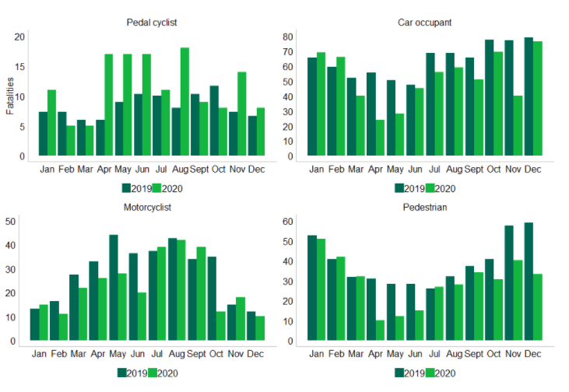

Fig 1., The Impact of Lockdown on reported road casualties, Great Britain (DfT, 2021).

The graph data reveals an evident decline in pedestrian, motorcyclist, and car occupant fatalities but a significant increase in pedal cyclist fatalities. The month of April alone saw a 183% increase in pedal cyclist fatalities from the year of 2019 (DfT, 2021). If fatalities involving car occupants, motorcyclists and pedestrians declined why have pedal cyclist fatalities surged? A review compiled by Yasin J. Yasin (2020) details the global impact of COVID-19 on RTC’s. Yasin’s review outlines that lockdown restrictions attributed to lower volumes of traffic, thus meaning roads are emptier. The DfT (2020) state that volumes of car traffic declined by 24.7% from 2019 and pedal cycle traffic increased by 45.7% from 2019. Figure 2 reveals the spike of pedal cyclist traffic on the UK roads at the start of the COVID-19 lockdown. 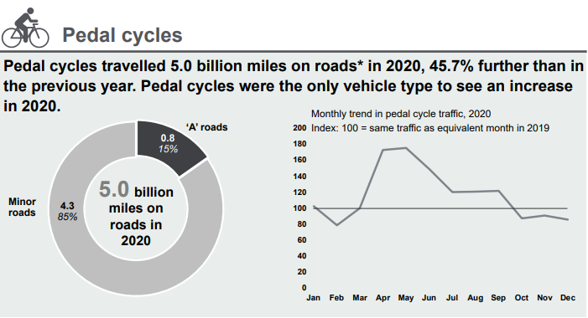Fig 2., Road Traffic Estimates 2020., (DfT, 2021)
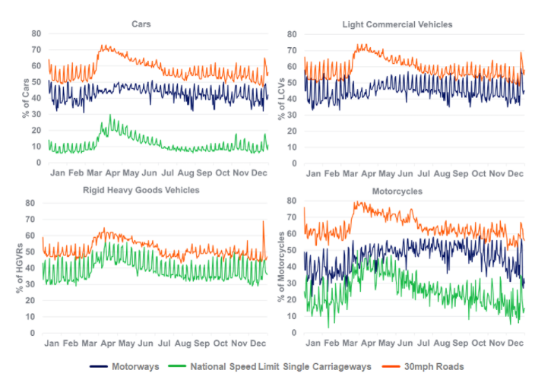
Could the possibility of emptier roads and an increase in pedal cycle traffic be a contributing factor associated with the increase of pedal cyclist fatalities? Yasin’s review reveals a report released by the National Safety Council, USA that emptier roads during the lockdown period prompted road users to excessively speed. It is already known that motor vehicle traffic reduced during the lockdown period, the DfT speed compliance figures of 2020 shown in fig3 reveal a spike in the percentage of vehicles exceeding the speed limit in lockdown
Fig 3., Speed Compliance Figures 2020 (DfT,2021).
Yasin’s review and statistics provided by The DfT are only a snippet into the contributing factors of serious and fatal RTC’s and raise questions which need to be answered. Those questions being:
What causes serious and fatal road traffic collisions?
How can serious and fatal collisions be prevented?
An extensive review of contributing factors using statistics and literature will allow a successful review into the answers required to achieve the aims and objects set out.
Research Methodology
The term ‘Methodology’ refers to the methods adopted concerning collecting data and researching it on the lines of a founded discipline (Creswell, 2003). The research methods proposed must be prudent and be formed with the aims and objectives of the review in mind:
Aim
‘A critical review of the contributory factors associated with Road Traffic Collisions’
Objectives
- Investigate the contributory factors associated with Road Traffic Collisions over a 5-year period (2017-2021).
- Analyse the data collected to identify any trends and/or patterns and investigate the causes for such change.
- Identify what factors have been implemented to reduce road user risk and Road Traffic Collisions to devise and promote new recommendations.
There are several research methods presented, notably Qualitive, Quantitative, Primary, and Secondary research. To critically review the subject matter in depth, this piece of work will rely on qualitive and quantitative research. Johnson (2004) suggested “by utilising quantitative and qualitative methods within the same framework, mixed methods research can incorporate the strengths of both methodologies.” A combination of both research methods will be appropriate for this critical review. Although statistical analysis will form the foreground of the subject matter, reviewing of literature, case studies and survey results will form partitions of the review concerning individual’s understanding and perception of road safety. This form of methodological research is known as Triangulation. The Triangulation diagram is clearly outlined in Fig 4. Triangulation refers to the use of multiple methods or data sources in qualitative research to develop a comprehensive understanding (Patton, 1999).
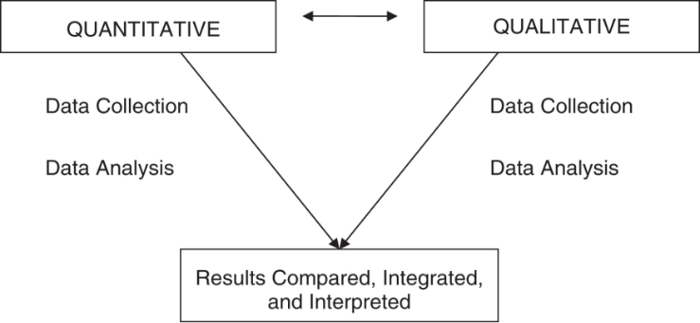
Fig 4., Triangulation Methodology (Bramble et al, 2008)
The Qualitative research method will be carried out through dissemination of a survey to road users with the view of ascertaining their understanding and knowledge of the Highway Code and The Fatal 5. Obtaining information using a survey is a fantastic method of obtaining data which is relevant to the review and in-depth. However, answers provided on the survey sheet may consist of personal or opiniated replies. It is vital that the survey is completed to a standard whereby the questions are not leading or open for interpretation and that they are tailored to provide an accurate response to the topic being asked. It is proposed that the surveys will be sent to road users through the use of e-mail as the manner of which is manageable in terms of keeping a track of respondents. It is believed the results from the following survey will provide primary data. The primary data collated will provide information concerning road users’ understanding of the Highway Code and the main causes of RTCs (Fatal 5) which in turn will assist the review with providing recommendations to reduce road user risk and prevent RTCs.
A large quantity of the review will consist of Quantitative data which Muijis (2004) defines as the collecting of numerical data which is then analysed. Quantitative data will be attained from secondary data sources. Secondary data will be obtained through extensive research and analysis of current statistics, literature and historical data concerning the factors contributing to RTCs and current trends and/or patterns causing collisions. Consideration will be given to obtaining data through the Freedom of Information Act if required. There are numerous Road Safety charities in operation who promote Road Safety campaigns with the view of educating road users, namely GoSafe, BRAKE, THINK, Project Edward, and Road Safety Trust. The collection of data using the triangulation method will enable this piece of work to provide a fair and accurate review of the main factors contributing to serious and fatal RTCs and how such incidents can be reduced or prevented.
Time management
It is critical to keep track of progress and create a timetable detailing each step of the review to ensure that it is completed by the specified date. Creation of a timeframe will enhance time management skills. Compiling the review will be difficult due to creating a work, family, and university balance therefore the following table has been devised to assist with completion and provide guidance when required. (Fig 5).
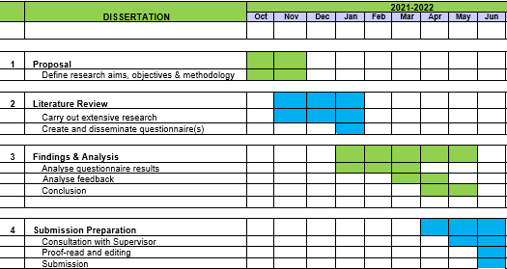
Fig 5., Time Management Table

BRAKE, 2021. UK road death and casualty statistics. [online] Brake. Available at: <https://www.brake.org.uk/get-involved/take-action/mybrake/knowledge-centre/uk-road-safety> [Accessed 10 November 2021].
Bramble, J.D, Siracuse, M.V., Galt, K.A., Rule, A.M., Clark, B.E., and Paschal, K. A., (2008) "Examining barriers to health information technology adoption", Emerald Vol. Iss: 7, pp.191 – 209
Creswell, J., 2003. Research design. 1st ed. Thousand Oaks, Calif.: Sage Publ.
Daniel Muijs 2004. Doing Quantitative Research in Education with SPSS. London: SAGE Publications, Ltd. Available at: <http://www.doi.org/10.4135/9781849209014> [Accessed 10 Nov 2021].
Department for Transport, 2021. Vehicle speed compliance statistics for Great Britain: 2020. 1. [online] UK Government. Available at: <https://www.gov.uk/government/statistics/vehicle-speed-compliance-statistics-for-great-britain-2020/vehicle-speed-compliance-statistics-for-great-britain-2020> [Accessed 10 November 2021].
Department for Transport., (2012). Reported Road Casualties in Great Britain: guide to the statistics and data sources. 1. [online] UK Government. Available at: <https://assets.publishing.service.gov.uk/government/uploads/system/uploads/attachment_data/file/259012/rrcgb-quality-statement.pdf> [Accessed 10 November 2021].
Department for Transport., (2021). Road Traffic Estimates: Great Britain 2020. [online] London: Department for Transport. Available at: <https://assets.publishing.service.gov.uk/government/uploads/system/uploads/attachment_data/file/1028165/road-traffic-estimates-in-great-britain-2020.pdf> [Accessed 10 November 2021].
Johnson, R. B. (2004) ‘Mixed Methods Research: A Research Paradigm Whose Time Has Come’, Educational Researcher, 33(7), pp. 14–26.
Patton, M.Q. (1999). Enhancing the quality and credibility of qualitative analysis. Health Sciences Research, 34, 1189–1208.
Road Safety Wales., (2020). Stay Alive, Get To Know The Fatal 5 | Road Safety Wales. [online] Available at: <https://www.roadsafetywales.org.uk/news/posts/2018/august/stay-alive-get-to-know-the-fatal-5/?Language=undefined> [Accessed 10 November 2021].

