

ASSIGNMENT TITLE: WORKPLACE CULTURE AND ITS IMPACT ON ORGANISATIONAL EFFICIENCY
Student Name: Domnica Iacoban
Student ID: 1813025
EXECUTIVE SUMMARY
In general, for an organisation to compete and survive successfully in a competitive market, it should consider some most powerful issues as its core responsibility such as ethics, values and its culture. Generally, micro and macro environment impacts the policies and business of an organization; therefore, assessing all the external factors in formulating a company’s policy is the key to uphold its success in an intense competitive market. Within an organisation, relationship between employees has resulted in formal and informal communication. However, an organisation has many barriers in effective functioning and there are also ways to overcome them. Most of the problems in an organisation arise due to ineffective communication. Therefore, a proper channel is needed within an organisation to link the employees and other governing bodies with each other. Overcoming this issue can create a better environment in an organisation and can promote a better culture, value and ethics of an organisation.

TABLE OF CONTENTS
Introduction 1
Brief Overview of Organisation 2
Effects of External Factors on the Organisation 2
SWOT analysis of Buffalo 7 3
Strengths 4
Weaknesses 4
Opportunities 5
Threats 5
PESTLE Analysis of Buffalo 7 6
Political 6
Economic 7
Social 8
Technological 8
Legal 9
Environmental 9
Formal and Informal Relationship between Department and People 10
Association of Organisational Efficiency between Formal and Informal Relationship 11
Organisational Culture, Ethos and Values. 11
Organisational Culture of Buffalo 7 12
Ethos of Buffalo 7 14
Values of Buffalo 7 14
Building sustainability of a culture within the workplace 16
Corporate Social and Environmental Responsibility of Buffalo 7 17
Personal Ethical Standards, Values, and Beliefs 18
Sharing Information via Communication Channels for Establishing Relationships 20
Restrictions to Effective Functioning in the Organisation and Remedies to Overcome Them 21
Fair Based Culture: 22
Status Based Culture: 22
Employee Dependency Awareness: 22
Time: 23
Flexibility: 23
References 25

Introduction
The study is based on one of the presentation agencies of London, United Kingdom (UK) named as Buffalo 7. The study has primary focus on comprehending the organisational culture of Buffalo 7. Furthermore, the study also discusses the impact of culture within the organisation, the effect of external forces towards organisation culture, relationship efficiency between department and people, ethos and values, sustainability of culture in a workplace, personal ethics, beliefs, and channel to communicate information in efficient manner that leads in building relationship, and the restrictions that limit the proper functioning of an organisation. The culture plays a prominent role in every organisation. It is made by the people of the organisation and can be adopted due to external factors. If the small and medium-sized enterprises (SMEs) are taken into consideration, the organisation builds the culture in the beginning to attract the workforce that may contribute in the growth of the organisation. New organisations have to create market for their product or services, in order to do that, it requires the competent workforce that contributes in fulfilling the objective who can work efficiently if they are offered a culture that is appropriate for them. It had been stated by Alvesson (2012) that the culture did not come from inside the heads of people, but it lies in between the thoughts of people or group where it is described in public through meanings and symbols.

Figure 1 Buffalo 7 (Buffalo7.co.uk, 2019).

Brief Overview of Organisation
Buffalo 7 came into being in 2009 by Richard Barnes who had 10 years’ experience of working in big media agencies. Buffalo 7 had expertise in designing of multiple disciplines. The specific area where the company is good is PowerPoint presentation design. In 2010, the director with well reputation in the design of PowerPoint had the organisation won best pitches alongside Microsoft and UEFA Champions Leagues against huge agencies located in London named: Saatchi and Ogilvy (Buffalo7.co.uk, 2019). Since then, the company had expanded and opened another studio in Manchester in 2013. Buffalo 7 had an increase turnover of around 600% in 2015 (Buffalo7.co.uk, 2019). In 2018, company was awarded Creative Industries Business of the Year at the Growing Business Awards of Amazon. Company now has less than 100 employees working in Manchester and London and considered as one of best preference for presentation designing.

Effects of External Factors on the Organisation

SWOT analysis of Buffalo 7
It had been referred that the strategic planning process is a vital element in order to understand the environment of the business. The SWOT analysis had been regarded as prominent tool that supports such understanding (Hill and Westbrook, 1997; Ying, 2010). The four elements of SWOT, Strength, Weaknesses, Opportunities and Threats are examined to position the resources of the organisation. The SWOT assists an organisation in evaluating the internal and external factors of business environment in developing plans and decisions for strategy (Phadermrod, Crowder and Wills, 2019).
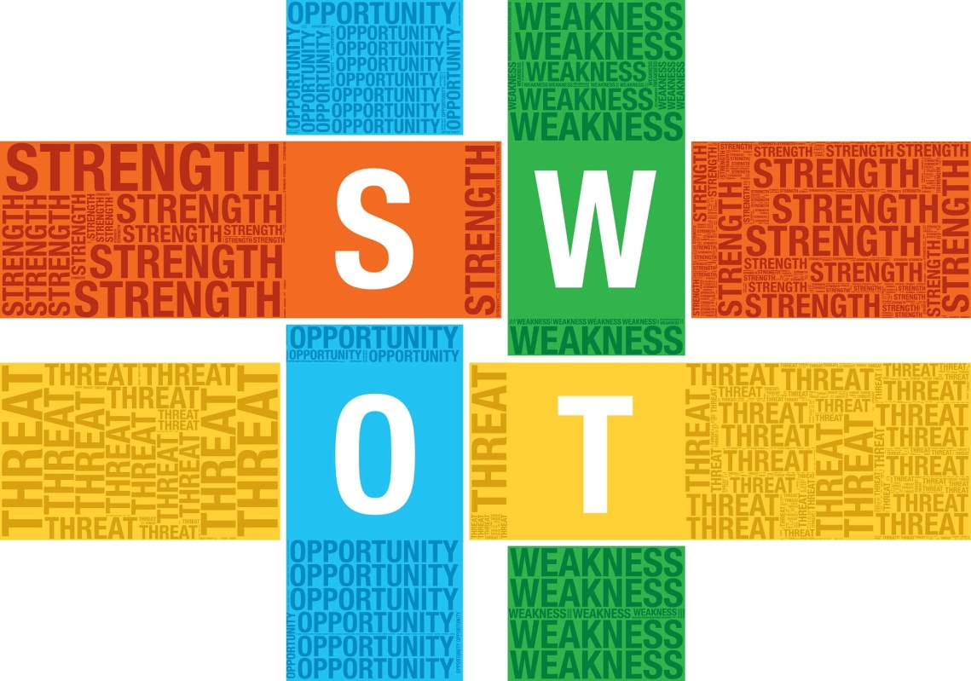
Figure 2: SWOT Analysis (Frue, 2017)

Strengths
The strength of Buffalo 7 lies in their field, the presentation designing, the PowerPoint design, storytelling, motion design, training and workshops, and e-learning (Buffalo7.co.uk, 2019). These fields require the team of creative people hence the quality can only be delivered when you have employees full of creative talents that can clearly understand any requirement of their clients and apply their creativity in the work. Another key strength for any organisation is the ability to develop an experienced resource. According to Deacon (2019) an experienced workforce can enable an organisation to cater to the requirements of their client’s in a more efficient manner. Similarly, Buffalo 7 boosts a workforce that has a vastly experienced work force (Buffalo7.co.uk, 2019). Moreover, in the present day and age, the concept of bespoke services has taken centre stage. As inculcated by Shih and Agrafiotis (2016), bespoke services are those whereby the retailer tailors the products and services to the client’s specific requirements. Therefore, another important strength for Buffalo 7 is their provision of bespoke services (Buffalo7.co.uk, 2019).

Weaknesses
The organisation began with a single man and now it has around 50 employees in 10 years (Buffalo7.co.uk, 2019). It had grown so fast but still the employee count seems low. There are many organisations in the world which grew much faster in 10 years than Buffalo 7 did. Similarly, another weakness pertinent to the services provided by Buffalo 7 is the fact that they do not offer facilities in a broader perspective. Therefore their target market is very small which creates hurdle in its growth. Additionally, another imminent weakness for the organisation is the competitive pricing that is followed by their competitors. Since, the primary service for Buffalo 7 is the provision of a high quality presentation; the level of expertise required can be emulated easily thereby making their services redundant easily. Thus, Buffalo 7 will always face problem of being unable to charge premium prices for their services.

Opportunities
Presentation is an activity that takes place in every organisation. Buffalo 7 has positioned itself in a way that it is highly regarded by their clients (Buffalo7.co.uk, 2019). The opportunity for them would be expanding their services in the same field like: using artificial intelligence to prepare a presentation according to clients need as Artificial Intelligence (AI) is the technology for future which will run the industry. Therefore, AI would play a prominent role in future for this organisation in delivering much better and reliable service. Another key opportunity that Buffalo 7 can utilise upon is the fact that they can target potential and future entrepreneurs in UK. Since, entrepreneurship is increasing in UK therefore, they can Buffalo 7 can provide services to target entrepreneurs and offer them a slightly lower priced services so they can diversify their services portfolio.

Threats
One of the threats that Buffalo 7 have is the big competitors in the market such as Ogilvy and Saatchi with same kind of services that can bring more innovative service which can reduce the market share for Buffalo 7 (Buffalo7.co.uk, 2019). Another threat that Buffalo7 have to come across is the Google. Google is offering Google Slides services to user all across the globe to switch them free of cost and it is much easier for the user to understand and create their own presentations (Buffalo7.co.uk, 2019). Another big threat for Buffalo 7 is Keynote which looks a lot professional and provides neat interface and is becoming a threat by offering a refreshing alternative to PowerPoint (Buffalo7.co.uk, 2019). Moreover, Buffalo 7 may encounter the threat with respect to advance technological features in making the design for presentation that may outrun the traditional methods of designing presentations.

PESTLE Analysis of Buffalo 7
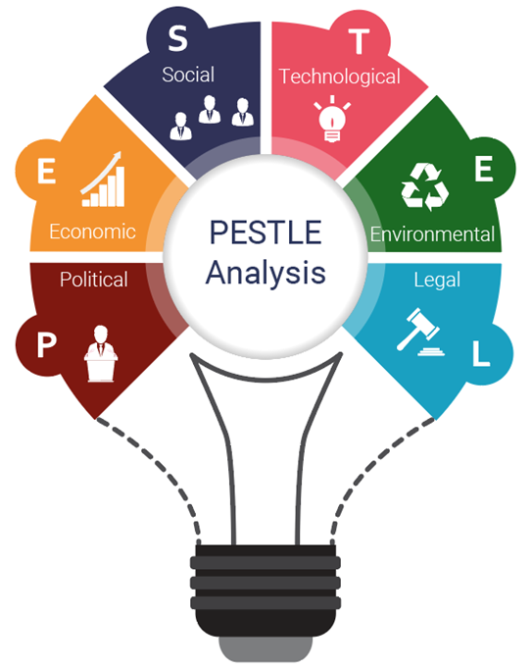
Figure 3: PESTLE Analysis (Green, 2018)

Political
Political stability is UK’s great strength; unfortunately Brexit has created political uncertainties and debates. According some analysts, Brexit will make unimaginable chaotic conditions; on the other hand some believe that doors will be open for the opportunities in the country (Dhingra, Machin and Overman, 2017). Across UK, one out of four SMEs experience political uncertainty resulting in as their main obstacle affecting their business. About 33% SMEs face political uncertainty in their business and this is highest concern amongst the smaller firms in London (ukfinance.org.uk, 2019). Moreover, as per the analysis provided by Telegraph Financial Solutions (2019) UK’s decision to leave the UK’s has had an adverse impact on the valuation of Pound. This will impact the profit margins for Buffalo 7 as their profit margins with international clients would be negatively impacted.

Economic
With the passage of time, companies have reduced their investment in UK. The chart below shows that after the referendum had taken place in UK, business investment has been disappointing, with the number of new buildings, machinery and plants barely grown and progressed in UK (Financial Times, 2019).
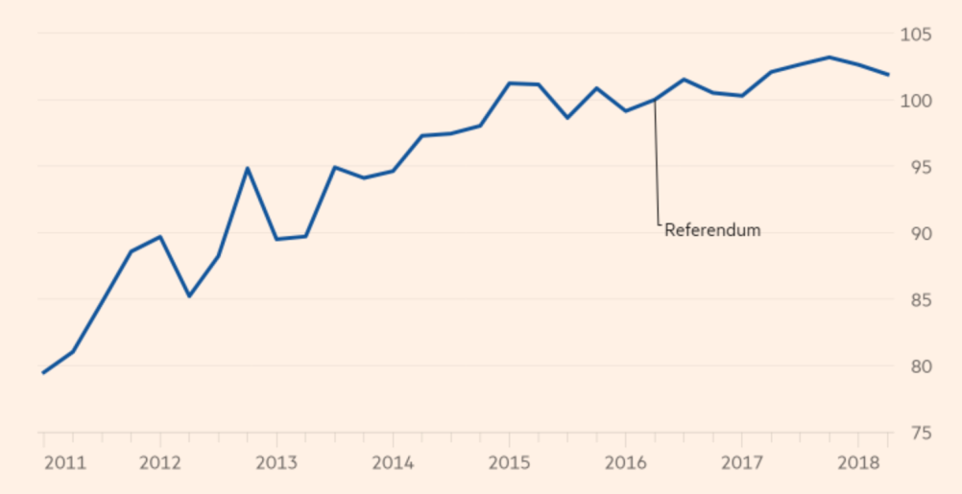
Figure 4: business investment has barely grown since the referendum
Source: Financial Times (2019)
Before the referendum, the business investment was expected to have grown above 13% from 2016 to over the period of 2 years. However the recent data picture shows a downbeat, with only 2% investment higher than the time of Brexit vote and then 0.2% lower an year ago (Financial Times, 2019).

Social
The most recent social trends that have been observed in UK are that the society, including both general consumers and businesses alike, has accepted the phenomenon of digitalisation (Ismail, 2018). This can be considered as a promising prospect for organisations like Buffalo 7 that rely on their clients to require a higher level of customisation with regards to digitalisation. Moreover, Ismail (2018) additionally documented that The UK’s digital and tech sector has shown accelerated and incremental growth as compared to the rest of the economy. It was reported that the turnover registered by the digital tech companies propagated by 4.5% in the period of 2016 to 17 as compared to UK’s GDP which simultaneously only grew by 1.7% over the same period. This reflects a good proposition for Buffalo 7 who can diversify their services to cater to the growing tech based companies in UK.

Technological
Buffalo 7 is a design agency which is specialist in PowerPoint presentation designs. Over the years, Buffalo 7 have refined their crafts and founded their niche in designs of presentation. They don’t just limit themselves to designs, in addition to this, they tell stories, tap into content, improvement and motion graphics to deliver the stories of the client in the most memorable and engaging ways. However, due to their employee’s vast experience, they create presentation that is mould to fit the needs of the client (Buffalo7.co.uk, 2019). Introduction of AI based presentation design might be threat for Buffalo 7 as their current service would then be considered outdated and brands would inclined towards them.

Legal
The UK’s employment act 1996 protects and provides all legal rights of the employees. These rights include holiday pays, sick pays, minimum wages, maternity and paternity leave and some more other rights that have been legally protected. In the similar way, the Equality Act 2010 protects and stops people from any sort of discrimination (Gov. UK, 2013). If Buffalo 7 attempts to enter another market, other than UK then there is considerable chance that the laws and other factors might be impacting the operations of Buffalo 7 like: the confidentiality agreement, the fear of client to provide personal information to Buffalo 7.

Environmental
Environment is impacted by economic activities and UK had been successful in reducing such negative impacts with substantial improvements. The authorities such as the government, newspapers, charity, local councils and others concerned bodies have come up with variety of initiatives to aware about the environmental factors and reduce the negative effect on the growth of environment. Another important environmental factor that UK faces is their challenging conditions of weather which still plays vital role in tourism. During summer, millions of people around the world visit UK for tourism.

Formal and Informal Relationship between Department and People
The Buffalo 7 is based on an idea that delivers creativity to the clients. The respect is one the important values of Buffalo 7. The organisation follows both formal and informal relationship. As the below picture shows the staff of the organisation which seems friendly and showcases the relationship among employees. The dressing and other flexibility led us believe that the organisation promotes and teamwork and caring attitude in terms of relationship.

Figure 5: Staff of Buffalo 7 (Buffalo7.co.uk, 2019).
The staff of Buffalo 7 had been increasing with the passage of time and communications is becoming more informal as they bond with one other as this kind of work highly involves collaboration and creativity that are brought by interacting and making connection. As far as, formal relationship is concerned the organisation does have structured and programmed relationship that takes place when an employee make interpersonal relationship with CEO or director.

Association of Organisational Efficiency between Formal and Informal Relationship
The workplace had been regarded as a place where the ideas, attitudes, behaviours and meanings are shared – these all would indicated the environment of the workplace and the connection between formal and informal association that referred the latter (Matthews, 1999). It had been associated that the informal learning takes places in the workplace by working in teams, solving problems, and interacting socially with the clients and colleagues (Felstead & Jewson, 2000; Felstead et al., 2005a). As Buffalo 7 is highly based on interaction, collaboration and teamwork, it is highly regarded that the informal relationships would help the organisation in working efficiently. The formal relationship would only work in reporting to manager, CEO or any other higher authority considering the working environment of Buffalo 7. Furthermore, the company is considered SME, than it is highly regarded that the small teams would prefer informal relationship in workplace and referring to one of the values of Buffalo7 which is ‘Family’, there is very low formal relationship among family members.

Organisational Culture, Ethos and Values.
Organisational Culture is defined as a system that involves values, beliefs, assumptions which sets the standards for people behaviour in an organisation. These values strongly influence the ethics of people in organisation by guiding them to act, dress, and perform their job (Ndalamba, 2018). Organisational ethos is based on compliance of code of ethics governing the behaviours. The policy makes sure that the environment is fair amongst the stakeholders including employees, customer’s management and competitors (Limwichitr, Broady-Preston and Ellis, 2015). Organisational values are described as the core ethics and principles which the company will follow regardless of any matter. Strong and clearly stated values reflects a true reflection of organisation objectives for a better behaviour in a workplace and plays a vital role in building a culture of positivity in the working premises competitors (Limwichitr, Broady-Preston and Ellis, 2015). In general, it can be said that the level of efficiency in the organisation can be evaluated with the organisational culture, values and ethos. There are in-depth perceptions regarding the values, ethos and culture of the organisation. The elaborations below comprehend the ethos, values, and culture of organisation.

Organisational Culture of Buffalo 7
It had been regarded that the organisational culture can be defined as a group of values and beliefs shared by people at workplace that comprehend the functioning of an organisation and guide them to behave in a certain way in the organisation (Deshpandé and Webster, 1989). The organisational culture can also be determined by the infrastructure of the organisation. If the employees are provided with good infrastructure, their efficiency level may be better irrespective of other external factors. Buffalo 7 as a creative organisation had built their offices with beautiful infrastructure that attracts the employees as well as their clients.

Figure 6: Buffalo 7 Office (Workspace, 2018)


Figure 7: Buffalo 7 Manchester Office (Workspace, 2018)

Ethos of Buffalo 7
Ethos provides the whole picture for an existence of organisation. The ethos basically elaborate the conduct of an organisation that are defined by the principles which guides employees and management to behave in a certain way. The way employees are involved and treated, the clients are dealt, the diversity is valued and culture is exchanged illustrates how the ethos of organisation are.
Buffalo 7 would not have gotten this far without its employees, it had been observed that the employees are considered an asset for an organisation and their creativity is valued in every aspect. High involvement and teamwork gives them competitive advantage in capturing the value from the clients. The services of Buffalo 7 are very qualitative as stated by various clients of them, employees are considered family and more than satisfied with the working environment and culture (Buffalo7.co.uk, 2019).

Values of Buffalo 7
Organisational values can be defined as foundation on which the organisation is formed, values of every organisation vary with their function. The thoughts and actions determine the values of an organisation. The values of Buffalo 7 are elaborated below:

Figure 8: Organisational Values (Speer, 2019)
The values of Buffalo 7 are: Pride, Exploration, Positivity, Grit, Clarity, Respect, and Family (Buffalo7.co.uk, 2019). The pride is one of the areas of focus for the organisation due to the fact that the employees have a behaviour to stand out for their work and be proud of what they are doing because when they would be proud of their work then their client would be as well. With one of their values of exploration in practice, the company had been awarded Creative Industries Business of the Year because this value aims to make PowerPoint creative and remove the boring resemblance of it. The positivity value of Buffalo 7 aims to look ahead and consider the upcoming opportunities to grow the business. Grit value emphasises on strength of the organisation in their work, the Buffalo 7 can go to any extend to deliver the best possible work whatever it takes. The clarity value discusses the communication aspect of the organisation as the presentation is all about communicating the point but with clarity. Respect is one of the values at Buffalo 7 as the newly emerged organisation should have respect in their value as it is one of the element of good culture. Buffalo 7 considers their team as family that works together and takes care of themselves and their clients (Buffalo7.co.uk, 2019).

Building sustainability of a culture within the workplace
It has been observed that a sustainable organisational culture of all the companies have proved to be their most essential assets for their success, as it directly relates to their performances, competitive advantage and long lasting effectiveness. Terblanche and Martins in 2003 concluded that culture of an organisation is the most important aspect for its excellence and also seems to be a primary cause resulting in the implementation of change programs in an organisation. It has also been witnessed today that the culture of an organisation impacts its performance and is playing an important role in progress and growth of the organisation (Eskebaek, and Languilaire, 2013).
According to a fact, people usually spend maximum time at their work. In fact, it would not be wrong to say that people spend maximum time in a day at work than at home. Therefore, considering the need of providing sustainable culture and healthy environment within a workplace can turn a working day into an enjoyable one for the employees. Hence, a sustainable and healthy environment is associated to happier and motivated employee which results in increasing productivity. This can turn out to be a reason for higher profits (Jurik, and Cavender, 2016).
The leaders of any organisation needs to set a behavioral standard for the employees and expect them to inherit. It is a core responsibility of an organisation to provide the resources to the employees with proper unrestricted powers. To create sustainability in a work culture, Buffalo 7 promotes a culture of ‘can do’ which is a must implemented one to perform a client work. Buffalo 7 also promotes an environment for their employees in which they are not afraid to of any challenges and they stand firm in any situation. Buffalo 7 provides a culture in which they inspire the employees to be experts with functionality of software and develop a skill that makes their work awesome.
A senior developer of Buffalo 7, Jasmine Isherwood says that they are a family. They not only enjoy coming to workplace but also enjoy looking forward to working in teams with each other on different projects. She also added that because of the diversity of the projects, they all tackle together which keeps them interesting and motivated (Buffalo7.co.uk, 2019).
The creative director Buffalo 7, Michelle Sussams says that the fact he like about Buffalo 7 is that the creatives directly get the opportunity to interact with the clients. He says that he enjoys interaction with new people and engaging with them as a team to produce a functional and attractive solution for our valued clients. He further added that every day they engage with variety of clients and their every day is different from the previous one, which is motivating, enjoyable and rewarding (Buffalo7.co.uk, 2019).
Client service director Gary Corrin says about the culture of the company that they sincerely believe in what they do and this gives them power and passion about work. Witnessing the work of the studio and to convey a solution to encounter what they have to see how it deliver in accordance to their objective is highly rewarding (Buffalo7.co.uk, 2019).

Corporate Social and Environmental Responsibility of Buffalo 7
Corporate social and environmental responsibility is an approach an organisation adopts to incorporate social, economic and environmental concerns into their operations, strategy, values, culture and decision making in a responsible and transparent manner and thus establishing a better practice environment within the corporation can benefit society and generate wealth. CSR is described by The World Business Council for sustainable development as the contribution of business to a sustainable development of economy (JAIN, 2013).
Corporate social and environmental responsibility appears in many forms. Not only big companies but even the small companies may have a large impact on social and environmental change by giving a simple humble donation to a local food or charity bank. CSR activities of Buffalo 7 is concerned with contributing to the society as well as its environment in which Buffalo 7 operates. The activities of CSR that buffalo 7 contributes, includes free training programs and campaigns for the employees, clients as well as those keen learners who can’t afford such programs, can get awareness about the latest updates and provide them free of cost workshops and seminars to make them learn and guide about PowerPoint and how to make an attractive presentations. Buffalo 7 can also make complimentary presentations for the customers free of cost to build a healthy and loyal relation with the customers. Buffalo 7 have a corporate policy for environmental benefit and should run advertisements on their websites regarding environmental safety and can give awareness about it in their seminars and workshops. Buffalo 7 further should take necessary steps for improving employee’s policy time to time to keep them motivated and work as a family. In addition to this, charitable activities and volunteering in the society. Besides this buffalo 7 should take part in Fairtrade to build trust relation which will be beneficial in a long term success.

Personal Ethical Standards, Values, and Beliefs
Ethics generally refers to behavioural rule and moral principles which implicates the adoption of doing what is right in the rightful manner. Ethics refers to a branch of philosophy that distinguish moral from immoral, good from bad, fair from unfair and right from wrong behaviour and actions through adopting reasonable, rational and theoretical thinking (Turyakira, 2018). The personal ethical standards are very important for any organisation and so is for Buffalo 7. Buffalo 7 creates an environment for their employees and clients in accordance to their ethical standards policies, which needs to be inherited by every individual within the premises.
Personal values have been differently defined by different authors. According to Schwartz, values have key importance in explaining personal organisation and social change (Fatoki, 2015.). Buffalo 7 is highly determined to uphold its personal values. The personality of the managers and leaders of Buffalo 7 specifically their personal values has a great influence on the growth of the company.
Beliefs are the thought that we assume to be true. When using beliefs to make any decision, we refer to the decisions and assume the casual affairs from the past, which eventually led us belief that it can also be applied in future. Beliefs essentially shape the personal thoughts which reflects nature of an individual work standard.
However, personal ethical standards, values and beliefs are interrelated within a company which results in effective and efficient goal achievement. Buffalo 7 has maintained a standard of ‘Can Do’ which is an essential culture that creates an effective environment for the employees to motivate them for client works. The employee work as a family and support the right thing. Satisfaction of client is the most important value, ethics and belief of the firm and same belief is built in the employees.

Sharing Information via Communication Channels for Establishing Relationships
Communication by all means is the key factor maintains a productive, healthy and strong professional and personal relationship. Choosing a suitable tool for communication require ‘3 W’s’ to be answered which are WHO referring to the AUDIENCE, WHAT referring to the MESSAGES and WHY referring to the GOALS. The answers will finally lead an important HOW which refers to the communication channel appropriate for the achievement of business goals (Respaut, 2018).
Below are 8 key channels of communication that Buffalo 7 adopts establishing relationship.
- Intranet Software: It is a channel that is tremendously valuable for the company. It can serve as a platform to provide a specific space for the employees, where all the information of the corporate, for instance, announcements, news and policies are located centrally and can be accessed anytime (Respaut, 2018).
- Infographics, Internal Blogs and Vlogs: It facilitates the employees to keep themselves engaged by boosting alliances, promote sharing and publishing of knowledgeable content and encouraging discussion openly.
- Private Messaging: Private messaging takes out daily communication occurring between members from the inbox and on a collective platform. This helps in creating a certain space for ongoing discussion within the team.
- Internal Discussion Forum: It is a forum that provides the employees with an evolving treasury of information that can be utilized to tackle difficulties, share information and bring in the knowledge of management regarding any issue.
- Project Management: It is tool to facilitate and promote team work, planning and tracking project and task management.
- Meeting Management: The software of meeting management provides 3 steps of meeting in an organisation such as pre planning, meeting and post meeting action. For pre planning meeting, the software provides scheduling, setting and distribution of agenda and pre meeting task assigning. Then during meeting, attendance taking, recording of meeting and ensure multimedia functionality. Finally post meeting minutes and recordings may be distributed, task assignment and meeting follow-up schedule.
- Issue Tracking Software: This software makes sure the recording of every query, prioritize it and convey it to the concerned department.
- Social Media, Email Marketing and Donation Platform: Social media plays a vital role in promoting dialogue between the audience and the company and also analyse the effect and impact of campaigns on social media. Whereas email marketing tools creates emails, list of subscribers, autoresponder setup and analytics monitoring.
Hence, focusing on the above channel and using any of the suggested tools to observe how effective and compelling your communication can become.

Restrictions to Effective Functioning in the Organisation and Remedies to Overcome Them
There are certain factors that restrict the effective functioning in an organisation and creates hurdles in the progress and growth. However, every restriction comes with its remedy.
Below are some restrictions and their remedies for effective functioning of an organisation.

Fair Based Culture:
An employee who seems to be afraid of appearing weak or consider incapable are less likely to engage with other employee or authority for help and hence, such employee don’t find their ways to grow and innovate.
To overcome this barrier, the leadership of the company must set an example of asking their assistants or juniors for help. Creating an impression of rewarding employees who indulge themselves for help and creating a culture of innovation to empower employee for better productivity (Auschra, 2018).

Status Based Culture:
Despite of making the employees comfortable to reach out for help, there might another hurdle that none of the employees want to share their insight. After all, power lies in knowledge.
To overcome this, recognition and appreciation for those who share their valuable insight through a recognition and rewarding scheme for employees. This should also be add in the objective of line manager.

Employee Dependency Awareness:
When new employees join a company, they usually have no idea where to go and have difficulties in adjusting in the environment, however, they become dependent of their colleagues for help.
To overcome this, the number of interdependent workers should be increased and try to organize some training programs for new employees to motivate them to socialize more.

Time:
Employee have created a concept in their mind that it will take a lot of time to engage with the right person, therefore, the employees are going to rethink over the situation and will try to mix the product or services.
To overcome this, necessary steps must be taken as quick as possible to make it easy to find the right person to engage with, but you also need to keep consideration the time of innovating services.

Flexibility:
We come to office for work and collaborate with people and get to know what they do and what are they good at. But flexibility comes into play and the office is changed, people work remotely in flexible hours. Now some employees start struggling and limit their connectivity and productivity.
To overcome this, the employee must flexibly collaborate and connect on any platform, whether day or night, wherever in the world and anyone within the premises of company.
Conclusion
Buffalo 7 is a UK based specialist agency started in 2009 that offers designs of PowerPoint presentations. Buffalo 7 inherits the expertise of well-designed presentations of PowerPoint. It was started by the efforts and vision of a single man whose hard work lead them to achieve a milestone in 2010 by winning Microsoft and UEFA pitches in competition with some big agencies of London. In 2013 the company decide to expand and grow the team, so they opened a studio in Manchester. By 2015 Buffalo 7 started enjoying increase of 600% turnover annually. Then in 2007, the company decided further growth, for which they needed to switch their Manchester head office to bigger venue, i.e. our famous Treehouse Suit. Despite of single man’s effort the company grew and in 2018 it went on to winning the Amazon Growing Business Awards in 2018 for the Creative Industries Business of the Year. Hence, the company strive to become the leaders in transforming businesses and strengthen the relationship with the stakeholders. The reason behind so much success of this medium size firm is the environment they provide within the premises that motivates the employees to work and help each other as a family.

References
Alvesson, M., 2012, Understanding organisational change. London: Sage Publications.
Auschra, C., 2018. Barriers to the integration of care in inter-organisational settings: a literature review. International journal of integrated care, 18(1).
Buffalo 7 2019, Buffalo 7 Website, viewed 27 November 2019, < https://buffalo7.co.uk/>
Deacon, J., 2019. Managing an age-diverse workforce. Strategic HR Review.
Deshpandé, R., and F. E. Webster, Jr. 1989. “Organisational Culture and Marketing: Defining the Research Agenda,” Journal of Marketing 53(1), 3–15.
Dhingra, S., Machin, S. and Overman, H., 2017. Local economic effects of Brexit. National Institute Economic Review, 242(1), pp.R24-R36.
Eskebaek, S. and Languilaire, J.C.E., 2013. Creating Sustainable Culture for Sustainability. In Conference Proceedings: 22d Nordic Academy of Management Conference;
Fatoki, O., 2015. An investigation into the personal values of small business owners in South Africa. Corporate Ownership & Control, p.618.
Felstead, A. and Jewson, N. (2000), In Work, At Home: Towards an Understanding of Homeworking (London: Routledge).
Felstead, A., Fuller, A., Unwin, L., Ashton, D., Butler, P. and Lee, T. 2005b, ‘Surveying the scene: learning metaphors, survey design and the workplace context’, Journal of Education and Work, 18, 4, 359–83.
Fozer, D., Sziraky, F.Z., Racz, L., Nagy, T., Tarjani, A.J., Toth, A.J., Haaz, E., Benko, T. and Mizsey, P., 2017. Life cycle, PESTLE and multi-criteria decision analysis of CCS process alternatives. Journal of cleaner production, 147, pp.75-85.
Frue, K. 2017. How to Do SWOT Analysis of a Company. Viewed on 27 November 2019 < https://pestleanalysis.com/how-to-do-swot-analysis-of-a-company/>
Gov. UK., 2013. Equality Act 2010: guidance. Online available at <https://www.gov.uk/guidance/equality-act-2010-guidance> [Accessed on 30th November 2019]
Green, A. 2018. How to Use IBISWorld Research in a PESTLE Analysis. Viewed on 27 November 2019 <https://www.ibisworld.com/industry-insider/how-to-use-industry-research/how-to-use-ibisworld-research-in-a-pestle-analysis/>
Hill, T., and Westbrook, R. 1997. SWOT analysis: It’s time for a product recall. Long Range Planning, 30, pp.46–52.
Ismail, N., 2018. Tech Nation 2018 report: UK tech expanding faster than the rest of the economy. Online available at < https://www.information-age.com/tech-nation-2018-report-uk-tech-faster-economy-123471982/> [Accessed on 30th November 2019].
JAIN, L., 2013. Corporate social responsibility.
Jurik, N.C. and Cavender, G., 2016. Sustainable workplaces as innovation. Journal of Applied Management and Entrepreneurship, 21(1), p.53.
Limwichitr, S., Broady-Preston, J. and Ellis, D., 2015. A discussion of problems in implementing organisational cultural change: Developing a learning organisation in university libraries. Library Review, 64(6/7), pp.480-488.
Matthews, P. 1999, ‘Workplace learning: developing a holistic approach’, The Learning Organisation, 6, 1, 18–29.
Ndalamba, K., 2018. Leadership ethos: a framework for value creation in organisation management. Journal of Business and Management, 20(6), pp.44-49.
Phadermrod, B., Crowder, R.M. and Wills, G.B., 2019. Importance-performance analysis based SWOT analysis. International Journal of Information Management, 44, pp.194-203.
Respaut, E. 2018. 8 Key Communication Channels for Your Organisation. [Online]. Available from: https://medium.com/@AmDee_Elyssa/8-key-communication-channels-for-your-organisation-568194a5916c/ Accessed on [28 November 19]
Shih, W.C. and Agrafiotis, K., 2016. The sustainable luxury craft of bespoke tailoring and its’ enduring competitive advantage. In Handbook of sustainable luxury textiles and fashion (pp. 137-161). Springer, Singapore.
Speer, J. 2019. Organizational Values: From Platitudes To Attitudes. Viewed on 27 November 2019 < http://delta-associates.com/organizational-values-from-platitudes-to-attitudes/>
Telegraph Financial Solutions. 2019. What will happen to the pound after Brexit? Online available at <https://www.telegraph.co.uk/financial-services/currency-exchange/international-money-transfers/pound-forecast-post-brexit/> [Accessed on 30th November 2019].
Turyakira, P.K., 2018. Ethical practices of small and medium-sized enterprises in developing countries: Literature analysis. South African Journal of Economic and Management Sciences, 21(1), pp.1-7.
Workspace, 2018. Buffalo 7. Viewed on 27 November 2019 <https://www.workspacedesign.co.uk/case-studies/buffalo-7-2/>

