Table of Contents
Element 1: Brand Extension Poster Presentation 4
2.1 Introduction to the Brand Extension 4
2.2 Market Rationale and Emerging Trends 4
2.3 Sustainability Alignment 4
Element 2: Segmentation, Targeting, Differentiation and Positioning (STDP) Analysis 4
3.1 Segmentation 4
3.1.1 Geographic Segmentation 4
3.1.2 Demographic Segmentation 5
3.1.3 Psychographic Segmentation 5
3.1.4 Behavioural Segmentation 5
3.2 Targeting Strategy 5
3.2.1 Target Market Selection 5
3.2.2 Targeting Approach 6
3.3 Differentiation Strategy 6
3.4 Positioning Strategy 6
3.4.1 Value Proposition 6
3.4.2 Positioning Map Explanation 6
3.4.3 Positioning Statement 6
Element 3: Marketing Mix (7Ps) 7
4.1 Product 7
4.2 Price 7
4.3 Place 7
4.4 Promotion 8
4.5 People 8
4.6 Process 8
4.7 Physical Evidence 9
Element 4: Reflection 9
5.1 Reflection on Brand Development Process 9
5.2 Reflection on Poster Presentation Experience 10
5.3 Skills and Knowledge Gained 10
5.4 Future Improvement Areas 10
References 11
Appendix: Poster 13

Element 1: Brand Extension Poster Presentation

2.1 Introduction to the Brand Extension
Apple Inc. is known all over the world for its innovative ecosystem and its brand strategy (Levy and Montevirgen, 2026). Apple EcoHome Energy System is a brand extension that is a smart home energy management system for renewable energy use. This product will be designed to connect with Apple devices and will allow users to track and optimise their energy usage using AI technology.

2.2 Market Rationale and Emerging Trends
The extension is reflective of several key global trends that have taken place, such as an increase in the number of smart homes, rising energy prices, and increased consumer consciousness about the environment. Modern consumers, especially Millennials and Generation Z homeowners, are conscious of sustainable living and technology (Kota, Debs and Davis, 2022). The trend towards renewable energy sources and artificial intelligence automation offers Apple an excellent chance to venture into home energy systems.

2.3 Sustainability Alignment
In line with Apple's pledge to attain carbon neutrality throughout its operations and supply chains by 2030, EcoHome complements this goal by facilitating the uptake of renewable energy sources, decreasing household emissions of carbon dioxide, and advocating sustainable energy use. Through the adoption of sustainable products and the application of optimisation technologies in an energy-efficient manner, this extension bolsters Apple's environmental position (Mathrani, 2023).

Element 2: Segmentation, Targeting, Differentiation and Positioning (STDP) Analysis

3.1 Segmentation
Segmentation assists Apple Inc. in identifying the desired target markets for the Apple EcoHome Energy System (Pope, 2023). Apple utilises multiple criteria to segment customers, and the criteria used include geographics, demographics, psychographics, and behavioural segments.

3.1.1 Geographic Segmentation
The major geographic regions being considered include the advanced countries like the USA, UK, Canada, Germany, and Australia (Hjeij et al., 2023). These regions have very advanced smart homes and renewable energy resources. Features such as high connectivity to the internet, supportive governmental policies towards sustainable technologies, and affordability are some of the factors that distinguish these geographic regions. Urban and suburban residences have been identified as our target market for the product.

3.1.2 Demographic Segmentation
As per demographics, the target market consists of individuals who belong to the age bracket of 28 to 50 years, working or having a double income, with a medium to high disposable income. The members of this demographic own property and have the financial ability to invest in home technologies that will give them results after a while (Ngoc, Tien and Hieu, 2023). In terms of education, the members of this demographic are highly educated and environmentally conscious.

3.1.3 Psychographic Segmentation
In relation to the psychographic profile of the target market, it includes individuals who are innovative and sustainable, focusing on efficiency, aesthetics, and prestige. As a result, the individuals adopt technology quickly, and their lifestyle is eco-friendly. In this respect, the target market seeks goods that reflect its characteristics, such as being environmentally sustainable and technologically savvy (Udodiugwu et al., 2025). Therefore, the personality of Apple, which entails innovativeness and prestige, is highly suitable for this target audience.

3.1.4 Behavioural Segmentation
From a behavioural perspective, the target segment comprises loyal customers who own products of the Apple family of products, such as iPhones, iPads, MacBooks, and the Apple Watch (Yusuff, 2022). The loyalty level of these customers is quite high, and the likelihood of switching is also very low. Such customers are always updated about any new innovation by the firm, besides being interested in energy conservation technology.

3.2 Targeting Strategy

3.2.1 Target Market Selection
The initial customer segment consists of well-heeled, environmentally aware Apple customers with property assets and in need of smart home improvements (Doll-Steinberg and Leaf, 2023). These customers have the means, the desire, and the aptitude to make such purchases. A second customer segment might include people who have adopted smart home technology but are not fully entrenched in the Apple environment.

3.2.2 Targeting Approach
A strategy based on differentiation is selected for targeting, since the focus will be on a niche and premium market rather than the mass consumer market. Based on the strategic targeting approaches put forward by Kotler, when targetinga clearly defined market segment, it is possible for companies to position themselves effectively to enjoy significant brand equity (Mallik and Aithal, 2024). In the case of Apple, it will need to maintain a premium positioning to venture into the energy management industry.

3.3 Differentiation Strategy
The key factors that set Apple EcoHome apart from other solutions include ecosystem integration, artificial intelligence optimisation, design, and data privacy assurances. In contrast to traditional energy management solutions, Apple EcoHome integrates easily with other products by Apple through the Apple Home application, allowing consumers to manage and analyse their energy use effectively (Mathrani, 2023). The AI system learns about the energy usage patterns in the house and optimises the process. Moreover, another feature that sets Apple apart from its competitors is data privacy, which is gaining increasing importance in smart homes due to rising concerns about security. Lastly, the company's reputation for great designs means that its products look sleek and elegant, contributing to differentiation from competitors' products.

3.4 Positioning Strategy

3.4.1 Value Proposition
EcoHome by Apple is energy management for your home that is intelligent, easy to use, and eco-friendly (Silver, 2024). It seamlessly blends into your Apple world while minimising its ecological footprint.

3.4.2 Positioning Map Explanation
EcoHome is positioned within the quadrants that are high in technology and high in price. Other competing energy sources could be cheap, but do not offer ecosystem connections, while traditional solar management solutions may be functional but cannot match the advanced AI optimisation capabilities and design expertise of EcoHome.

3.4.3 Positioning Statement
Apple EcoHome is the perfect smart energy system for environmentally conscious homeowners who are part of the Apple environment; Apple EcoHome ensures efficiency, sustainability, and design excellence through integration and optimisation made possible by Artificial Intelligence.

Element 3: Marketing Mix (7Ps)
Apple EcoHome Energy System’s marketing mix is carefully formulated to emphasise its superior positioning, alignment with sustainability principles, and compatibility within the Apple Inc. ecosystem (Amiri et al., 2025). Every aspect serves the purpose of brand extension through sustainable and innovative growth.

4.1 Product
EcoHome from Apple is categorised under the technology-based high involvement product category. The core product features of Apple’s EcoHome include energy efficiency, cost savings, and environmental sustainability. The tangible product includes software that utilises AI for energy optimisation, compatible solar panels, smart energy storage, and real-time energy monitoring using Apple’s Home app (Kolawole and Ayodele 2024). Augmented products will include professional installation services, AppleCare, updates to software and hardware components, and integration with various devices such as iPhones, iPads, MacBooks, and Apple Watches. In terms of innovation strategies, EcoHome falls under the incremental innovation strategy used by Apple with respect to expansion into new ecosystems. EcoHome incorporates sustainability principles through the use of energy-efficient hardware and recyclable materials. By expanding into the home energy market, Apple further cements its ecosystem lock-in strategy and design minimalism and simplicity principles.

4.2 Price
The premium value-based pricing approach has been taken into consideration, which is according to the pricing approach of Apple. As compared to being competitive on cost, EcoHome will be priced according to its value, technological advancement, and advantages of the system (Celestin et al., 2022). In terms of the entry into the market, EcoHome might use the skimming pricing approach to cater to customers who would like to be among the first users of the technology at any cost. While it is true that the initial cost is high, the benefits of energy efficiency in the long run support the price structure. Payment plans and AI analysis services based on subscriptions will provide flexibility and premium pricing.

4.3 Place
The eco-home of Apple will adopt a selective distribution channel. The idea is that the company will seek to retain exclusivity and quality in the provision of services by distributing its products through selected channels (Rasulov, 2024). For example, the products will only be available through the Apple website, the Apple stores, and the installation partners. The use of this channel will enhance convenience and enable better control over the customer experience (Ghosh, Ness and Salunkhe, 2024). In addition, the direct sales channel will strengthen the company’s ecosystem strategy. Apple stores will include demonstration zones for live energy monitoring.

4.4 Promotion
This would entail a combination of innovation and sustainability through the adoption of an integrated marketing communications strategy. Promotion shall involve extensive use of the digital medium, Apple keynotes, storytelling about sustainability, and experiential marketing (Quesenberry and Coolsen, 2023). The launch communication might take place at a worldwide Apple keynote event for maximum exposure and authority of the product brand. Digital promotions will be used to promote energy savings, minimising impacts on the environment and ease of integration into the ecosystem. Branding using influencers from both sustainable development and smart home communities may also be considered to boost credibility (Babu et al., 2024). Interactive content promoting the ability of the product to save money in energy costs will also form part of the content marketing efforts. This will help to build both rational and emotional motivation behind the purchasing decision.

4.5 People
Being an innovative combination of technology and service, people become an integral component in value creation. The company employs installation specialists and technical support staff trained by Apple who provide consistent high levels of service. Being connected with the Genius Bar, customers may get help on an ongoing basis. In accordance with the SERVQUAL theory, reliability, assurance, responsiveness, and empathy remain key to providing service (Li et al., 2024). Specialists should possess not only professional knowledge but also be able to communicate effectively in accordance with the brand values. The high-quality customer service creates an atmosphere of trust for such an expensive type of product.

4.6 Process
The process of purchasing and installing the product must remain true to the simplicity characteristic of all products developed by Apple. This means that users will be able to schedule consultations, get their energy evaluations done, and even set up appointments for installation via one single portal. AI technology will help ensure that the system gets accustomed to the pattern of energy usage in no time (Hamdan et al., 2024). Automation helps to cut down on complexity while at the same time increasing user control. The importance of communication at every step of the process cannot be overlooked. It is important to make customers feel satisfied and secure, and word-of-mouth promotion can also prove helpful.

4.7 Physical Evidence
The physical presence of the value of technology-service offerings is evidenced through tangible aspects such as design. The design of the EcoHome hardware will be simple and made of minimal aluminium finishes that are synonymous with Apple products. The packaging used to package the products will be environmentally friendly since it is recyclable (Guo et al., 2022). Live dashboards highlighting the benefits of using the service on the environment will be showcased in the stores. Labels certifying the sustainability of the offering and statistics regarding the reduction in carbon emissions will prove the sustainability aspect physically. Design of the digital interface itself is another form of physical evidence. Having an intuitively designed dashboard boosts the user’s confidence and highlights the quality design of Apple.

Element 4: Reflection

5.1 Reflection on Brand Development Process
Development of the Apple EcoHome Energy System as an extension of the Apple Inc. brand was an extremely interesting and instructive project, giving me an understanding of the complexity of the brand development (Amiri et al., 2025). At first, I thought that the idea of brand extension is relatively simple, but upon further consideration, I realised that innovation should go hand-in-hand with brand values and brand equity. In addition, segmentation and positioning concepts gave me a better picture of how marketing theories can be applied in practice. For example, I now understand the importance of a logical connection between the brand extension and the parent company and consumer expectations. In addition, the inclusion of sustainability principles in the marketing plan helped me understand that being environmentally friendly is not just a moral obligation anymore, but rather an advantage. Finally, the process of development of the new Apple product taught me how important it is to take financial feasibility, operational scalability, risk management, and many other aspects into account while developing a new business venture (Lewrick, 2022). In particular, evaluation of potential partners, pricing policy and other aspects of marketing strategy improved my commercial vision significantly.

5.2 Reflection on Poster Presentation Experience
Creating and presenting the poster presentation is very helpful for acquiring concise communication skills. Compressing a highly elaborate and extensive 2,500-word strategy into a 3–5-minute presentation entailed focusing on visual appeal and clarity of thought (Musiol, 2024). I learned how the success of marketing communication is achieved not only by the quality of the content but also through visual composition and audience interaction. I struggled to communicate to an audience the strengths of our business in terms of what we can offer to investors and what we have to offer to customers.

5.3 Skills and Knowledge Gained
As a result of this project, I have gained valuable experience in strategic planning, analysis, and evaluation of the market. My knowledge about the techniques of brand extension, ecosystem marketing, and sustainability was expanded through practical work with these concepts. The use of the STDP model and the 7Ps approach allowed me to develop a logical structuring of marketing decisions (Pathak, 2025). Moreover, the current project increased my competence in conducting research, specifically in critically evaluating the trends of developments in the smart home technology market and the renewable energy market.

5.4 Future Improvement Areas
For any subsequent projects that I undertake, there are additional strategies that I would employ to ensure a better approach, such as the use of more quantitative forecasting and competitor benchmarking to bolster financial rationale. Additionally, building up my ability to create better visuals when preparing a presentation will serve to increase effectiveness. For any subsequent projects that I undertake, there are additional strategies that I would employ to ensure a better approach, such as the use of more quantitative forecasting and competitor benchmarking to bolster financial rationale.

References
Amiri, S.M.H., Goswami, P., Barmmon, C.K., Islam, M.M., Hossen, M.S., Hasan, S.M. and Amiri, N.A., 2025. The Green Tech Revolution: Balancing Innovation and Environmental Protection.
Babu, E., Priya, P.S., Binti, A.V., Farzana, O.I. and Remya, P.D., 2024. Influencing responsibly: Harnessing the power of social media influencers to promote responsible tourism. International Journal of Communication Networks and Information Security, 16(3), pp.91-102.
Celestin, M., Vasuki, M., Kumar, A.D. and Boakye, M.M., 2022. Future-Driven Procurement.
Doll-Steinberg, D. and Leaf, S., 2023. Unsupervised: Navigating and Influencing a World Controlled by Powerful New Technologies. John Wiley&Sons.
Ghosh, S., Ness, S. and Salunkhe, S., 2024. The role of AI enabled chatbots in omnichannel customer service. Journal of Engineering Research and Reports, 26(6), pp.327-345.
Guo, X., Yao, S., Wang, Q., Zhao, H., Zhao, Y., Zeng, F., Huo, L., Xing, H., Jiang, Y. and Lv, Y., 2022. The impact of packaging recyclable ability on environment: Case and scenario analysis of polypropylene express boxes and corrugated cartons. Science of the Total Environment, 822, p.153650.
Hamdan, A., Ibekwe, K.I., Ilojianya, V.I., Sonko, S. and Etukudoh, E.A., 2024. AI in renewable energy: A review of predictive maintenance and energy optimization. International journal of science and research archive, 11(1), pp.718-729.
Hjeij, D., Bicer, Y., bin Saleh Al-Sada, M., & Koç, M. (2023). Hydrogen export competitiveness index for a sustainable hydrogen economy. Energy Reports, 9, 5843-5856.
Kolawole, M.I. and Ayodele, B.L., 2024. Smart electronics in solar-powered grid systems for enhanced renewable energy efficiency and reliability. International Journal of Science and Research Archive, 13(2), pp.2910-2930.
Kota, B.R., Debs, L. and Davis, T., 2022. Exploring Generation Z’s perceptions of green homes. Sustainability, 14(16), p.10148.
Levy, S. and Montevirgen, K., 2026. Apple Inc. [Online]. Available at: https://www.britannica.com/money/Apple-Inc [Accessed on: 4th April 2026]
Lewrick, M., 2022. Design thinking for business growth: how to design and scale business models and business ecosystems. John Wiley&Sons.
Li, J., Chiu, D.K., Ho, K.K. and So, S., 2024. The use of social media in sustainable green lifestyle adoption: Social media influencers and value co-creation. Sustainability, 16(3), p.1133.
Mallik, A. and Aithal, P.S., 2024. Uplifting Brand Equity to Unprecedented levels by Introducing Purpose as the New 8th’P'in the Marketing Mix. International Journal of Case Studies in Business IT and Education.
Mathrani, R., 2023. Challenges and Innovations in Achieving Sustainable Computing: A Comprehensive Analysis. energy, 20305, p.6.
Musiol, M., 2024. Generative AI: Navigating the course to the artificial general intelligence future. John Wiley&Sons.
Ngoc, N.M., Tien, N.H. and Hieu, V.M., 2023. The relevance of factors affecting real estate investment decisions for post pandemic time. International journal of business and globalisation, 1(1), pp.1-15.
Pathak, R., 2025. Marketing Management. INDO-CONTINENTAL ACADEMIC PUBLISHERS.
Pope, L.C., 2023. Board Games as a Teaching Tool for Sustainability. Prescott College.
Quesenberry, K.A. and Coolsen, M.K., 2023. Brand storytelling: Integrated marketing communications for the digital media landscape. Bloomsbury Publishing PLC.
Rasulov, R., 2024. Optimization of direct supply chains in the restaurant industry: Addressing key challenges through technological innovation. Economics of Development, 23(3), pp.93-103.
Silver, A., 2024. Virtual Assistants for Eco-Friendly Consumer Choices.
Udodiugwu, M.I., Obiakor, U.J., Eneremadu, K.E., Onwuegbuchulem, N.C. and Anyaegbunam, C.E., 2025. Promoting environmental sustainability through eco-friendly products: A critical review for sustainable development. Annals of Management and Organization Research, 6(3), pp.247-252.
Yusuff, M. (2022). An In-Depth Study of Consumer Perception, Brand Loyalty, and Purchasing Behavior Towards Apple Products: A Case Study of Tiruchirappalli District with Insights into Regional Market Dynamics and Competitive Analysis.

Appendix: Poster
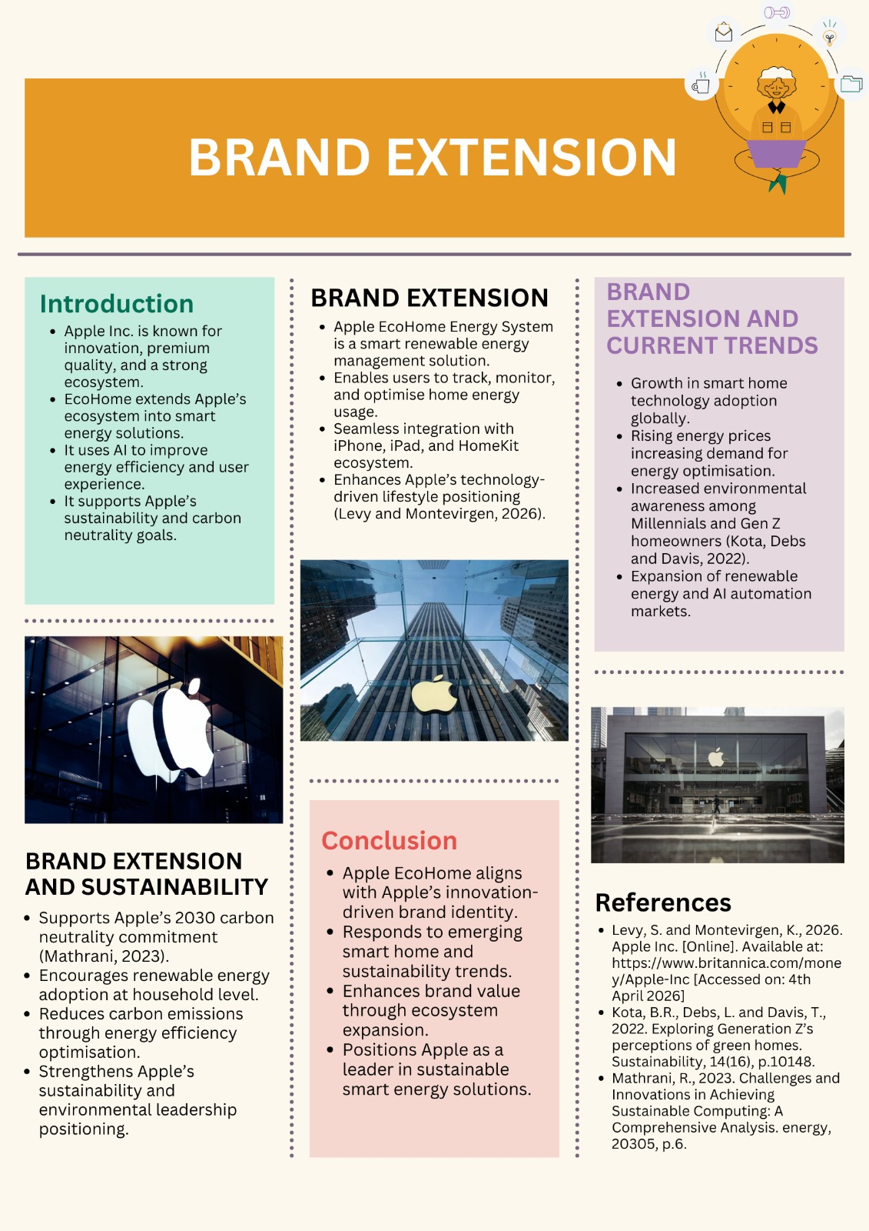


MODULE NAME: MARKETING MANAGEMENT

MODULE CODE: LCMB7024

MODULE LEADER: LAILA MAAZOUZ AND DIAN MAYASARI

ASSIGNMENT TYPE: ASSESSMENT COMPONENT 2: MARKETING STRATEGIES PORTFOLIO

STUDENT NAME: Rachitkumar Kalpeshbhai Barot
STUDENT ID: 2531441

