

The Role of Non-Banking Financial Companies (NBFCs/NBFIs) in Promoting SME BUSINESS Growth: A Systematic Literature Review

Name: Devarshsinh Manharsinh Solanki
Student Number: 2428526
Professor Name: Shengfeng Mei

Table of Contents
1. Introduction 3
1.1 Background 3
1.2 Aim 4
1.3 Research question 4
1.4 Research objectives 4
1.5 Significance 4
2. Literature review 5
2.1 The contribution of NBFCs/NBFIs in funding SME businesses 5
2.2 Comparison between NBFC lending practice and traditional banking practice 5
2.3 Issues, risks, and regulatory loopholes to the work of NBFCs 5
2.4 The effect of NBFC support on performance indicators of SMEs. 6
2.5 Literature Gap 6
3. Methodology 6
4. Expected findings 8
5. Limitations 10
6. Timeframe 10
7. Conclusion 11
8. References 12
2

1. Introduction

1.1 Background
SMEs contribute significantly to economic development since they are the source of employment opportunities and local chain supply, as well as assisting nations in developing robust markets (Omowole et al. 2024). SMEs constitute the bulk of business in most developing economies, and they are still not finding it easy to access regular bank finance. Conventional banks will require bulky documents, time-consuming procedures, and collateral, sometimes of which most small enterprises are unable to fulfil. Due to this difference, Non-Banking Financial Companies (NBFCs/NBFIs) have gradually emerged as a significant alternative source of credit (Bukhtiarova et al. 2022). They can provide quicker approvals, more flexible loan arrangements and an appreciation of the needs of small businesses. The information provided in the attached chart clearly indicates the improvement in NBFC credit in sectors since 2016 up to 2020. The lending to the MSMEs, transport operators, consumers, and other industries was growing steadily, which is evidence to show that NBFCs are opening up (Agarwal, 2023). This increase is an indication that NBFCs are taking the place of banks and are contributing to the business in other sectors of the economy. In the case of SMEs, this assistance is important since access to finance can stabilise them, grow and become increasingly competitive.

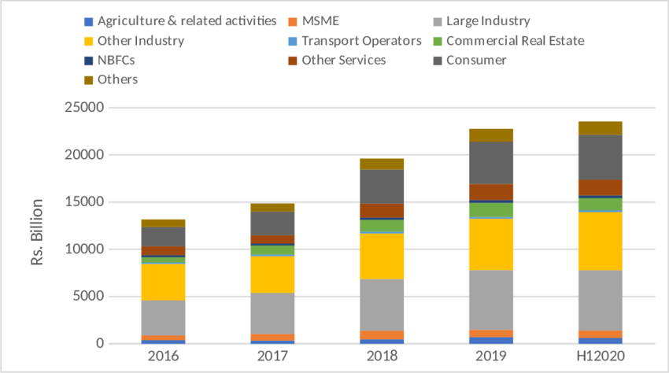
Figure 1: Sectoral Deployment of NBFC Credit in India (2016–H1 2020)
(Source: Sengupta, Son and Vardhan, 2022)

1.2 Aim
The purpose of this study is to examine the literature available to have an idea of the role that NBFCs/NBFIs play in the development of SMEs, the services they have to offer, as well as their effectiveness as compared to traditional bank lending.

1.3 Research question
Core research question
“How do NBFCs/NBFIs contribute to SME business growth, based on existing empirical and theoretical literature?”
Sub-questions
- What are the financial and non-financial services that NBFCs offer to SMEs?
- Which lending models are more effective than traditional banks when it comes to NBFC lenders?
- What are the challenges and risks involved in providing support to SMEs by NBFCs?
- What are the effects of NBFC interventions on SMEs' performance, survival and growth?

1.4 Research objectives
- To analyse the contribution of NBFCs/NBFIs in funding SME business.
- To make a comparison between NBFC lending practice and traditional banking practice.
- To examine issues, risks, and regulatory loopholes in the work of NBFCs.
- To analyse the effect of NBFC support on performance indicators of SMEs.

1.5 Significance
The study is important since the financial accessibility of SMEs is a crucial factor, and many of them tend to be denied when seeking traditional banks. The study aids in elucidating the actual contribution that NBFCs/NBFIs make to the economy and the void they fill in the credit market by examining their role in the development of SMEs. Awareness of such trends will help policymakers, lenders and owners of SMEs make improved financial choices. The results can also be useful to future measures of enhancing loan access, formulating enabling regulations, and promoting innovation in alternative lending models, which will help SMEs in the long term.

2. Literature review

2.1 The contribution of NBFCs/NBFIs in funding SME businesses
The NBFCs and NBFIs are very important in bridging the SME credit gap as they provide quick, flexible, and collateral-light finance. Lokesh and Lalitha (2025) demonstrate that the good financial performance of NBFCs, like Muthoot Finance, can help them offer credit facilities to smaller businesses more broadly. According to Sawitri (2023), SMEs depend largely on alternative lenders since, in most instances, the applications may be rejected by traditional banks due to the stringent conditions. These findings directly refer to the aim of this study of learning how NBFC services assist SMEs in getting the necessary funds to grow and become stable, and expand their businesses.

2.2 Comparison between NBFC lending practice and traditional banking practice
The NBFC lending models are contrasted with the traditional banks primarily on their speedy approvals, less strict documentation and technology-based assessment. Jha (2025) demonstrates that NBFC-P2P platforms provide faster and data-driven credit is beneficial to the small borrowers who are locked out by banks. According to Praneeth and Srisailam (2025), banks have strict collateral and high compliance, which slows down the processing of SME loans. NBFCs, on the other hand, are more customer-focused in their approach to credit management; thus, finance is closer to the people. The results are consistent with the goals of the study, which was to compare the effectiveness of NBFC lending with the practice of banks to know which model is more effective in supporting the SMEs' financing requirements.

2.3 Issues, risks, and regulatory loopholes to the work of NBFCs
NBFCs are exposed to a number of risks that affect their ability to finance SMEs. Jain (2025) underscores the fact that the weaknesses in governance, low quality of assets and being exposed to risky borrowers contribute to financial instability, leading to greater RBI measures. As revealed by Bhatnagar and Singh (2024), regulatory failures like those experienced in the case of IIFL Finance have the capacity to induce turmoil in the market and harm the credibility of the lenders. These problems demonstrate the necessity of stricter control to make NBFCs a dependable SME finance source.

2.4 The effect of NBFC support on performance indicators of SMEs.
The support of NBFC has a positive impact on the key indicators of SME performance by enhancing its liquidity, allowing its expansion, and stabilising its cash flows. Chaudhury and Sana (2024) demonstrate that NBFCs with financial strength are better placed to make regular credit that assists the SME in operating and expanding. In the same vein, AM et al. (2025) mention that effective NBFCs lead to improved borrower performance by accelerating the disbursements and offering adaptable products. These investments directly benefit the productivity of the SMEs, their sales and the sustainability of their businesses in the long term.

2.5 Literature Gap
Despite the current research pointing out the role of NBFCs, the benefits of lending, and the regulatory policies, the direct impact of NBFC support on the growth of SMEs is not substantiated in the literature. There are not many papers that provide a comparison of NBFCs with banks in detail, not to mention systematic reviews. This brings a definite gap to be filled by this study.

3. Methodology
This paper uses a research design known as Systematic Literature Review (SLR) that focuses on investigating the role of Non-Banking Financial Companies (NBFCs/NBFIs) as investors in the development of SME businesses. This study is appropriate to be conducted using a systematic review since it offers a structured, transparent, and replicable means of locating, appraising and synthesising already available evidence (Shaheen et al., 2023). The review is conducted in the PRISMA 2020 format in order to enhance the methodological rigour, minimise the selection bias, and increase the credibility of the results. The search strategy is designed with the predetermined keywords and Boolean operators and implemented in the various academic databases, such as Scopus, Web of Science, EconLit, ProQuest ABI/INFORM, JSTOR and Google Scholar.
The selection of the studies is guided by clear inclusion and exclusion criteria. Articles included not only require discussing NBFCs/NBFIs as financial intermediaries; they must also investigate the outcome of SMEs or small businesses, and provide evidence or theoretical results. These articles must be published between 2021-2025; however, they should be in English. Surveys will not be considered in terms of studies that focus on commercial banks or microfinance institutions and study the finances of households, rather than SME finance or in non-academic commentary or opinion papers. It will settle on 10 final articles after carrying out these criteria and performing full-text reviews.
Inclusion | Exclusion
NBFC/NBFI focus | Bank-only studies
SME outcomes | unrelated household finance
empirical/theoretical | non-scholarly work
English | Language Other than English
2021–2025 | Before 2021
Boolean Keywords are:
- ("NBFC" OR "Non-Banking Financial Company" OR "NBFI" OR "Non-bank Financial Institution") AND ("SME" OR "small and medium enterprises" OR "small business") AND ("finance" OR "credit access")
- ("Non-Banking Financial Institution" OR "NBFC" OR "shadow banking") AND ("SME growth" OR "business growth" OR "enterprise development")
- ("alternative finance" OR "non-bank lending" OR "NBFI") AND ("SME" OR "small enterprise") AND ("performance" OR "growth" OR "investment")
- ("fintech" OR "digital lending" OR "online NBFCs") AND ("SME" OR "small business") AND ("credit" OR "working capital")
Identification (database search results), Screening (title and abstract), Eligibility (full-text assessment), and Inclusion (final 10 studies) will compose the PRISMA process. The filtering process and the rationale of eliminating at each point will be documented in a PRISMA flow diagram.
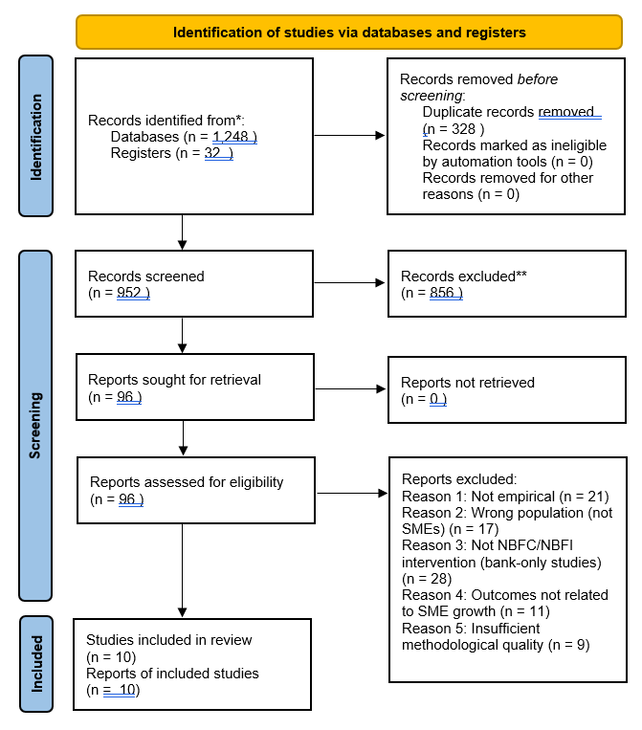
Figure: PRISMA.
(Source: Self-Created)
A structured matrix will be used to extract data, with variables being author, year, country, method, mechanisms of NBFC, SME performance, and key results. Synthesis will be directed by a thematic analysis approach, which will allow the uncovering of patterns and mental relationships present in all 10 studies. There will be a narration synthesis of quantitative results because designs and measures are expected to vary. The approach will make the final review give out a clear and coherent evidence-based insight into how NBFCs affect SME development and the gaps that can be addressed in research in the future.

4. Expected findings
It is presumed that the findings will reveal that, due to the current trends in scholarly literature and the orientation of the current review, the NBFCs/ NBFIs will play an important and growing role in filling the long-term gaps in Financing experienced by the SMEs. It is anticipated that, in its review, it will be demonstrated that through their various lending models and relaxed documentation procedures, and tolerance to risk, NBFCs can serve segments of the SME population that have been overlooked by traditional commercial banks (Sriyono, Biduri and Proyogi, 2021). It is likely that many of the chosen studies will inform about faster loaning of NBFCs, tailor-made financial offers and relationship-based lending, all of which will increase the access to working capital, expansion credit, and asset lending by the SMEs.
One of the recurring trends that is anticipated throughout the literature is that NBFI financing is positively associated with growth performance of SMEs, such as growth in revenue, productivity, cash flow, as well as, in other instances, employment creation (Nguyen and Canh, 2020). The importance of NBFCs in facilitating business continuity, particularly among micro and small businesses that work within an informal or semi-formal sector, is also expected to be one of the key findings.
These NBFCs enabled by fintech are probably marked as especially influential ones, and digital assessment tools, alternative credit scoring, and automated processes are expected to enhance access to credit and the performance of loans regarding SMEs (Murinde, Rizopoulos and Zachariadis, 2022). This is likely to draw a picture of how NBFCs, through technology, contribute to reducing information asymmetry, having a lower cost of transaction, as well as lucrative financial involvement.
Challenges and risks will also be presented in the predicted findings. Some of the studies will create question issues associated with the excessive interest rates, overdependence on short time capital, unregulated gaps and the potential liquidity issues in NBFCs. Such shortcomings in structure can affect SME finance reliability and sustainability. The review will expose the differences between the countries/regions and will demonstrate that regulatory frameworks and macroeconomic environment have a big influence on the effectiveness of NBFCs in stimulating the development of SMEs.
The anticipated results will show that, although NBFCs have a key role in closing the credit gap in SMEs as well as fuelling enterprise growth, their effect becomes apparent depending on sound regulation and the remaining innovative use of technology. The findings will also point to the gaps in the research about the SME long-term performance and the cross-country comparative evidence.

5. Limitations
This research suffers from a number of limitations that can affect the richness and breadth of the research findings. As the study is based solely on a Systematic Literature Review, the analysis will be based on the quality and accessibility of published research. Most papers on NBFC- and SME-related subjects are in emerging markets, and the data is often skewed, differing in data quality, sample, and rigour of methods used. This can pose a problem in the comparison of results in other countries or other regulatory settings. The other weakness is that there will be limited access to some paid academic journals, which could lead to the rejection of potentially valuable research studies. Variations in terminology NBFCs, NBFIs, shadow banks and alternative lenders, may also cause discrepancies in the search and screening process.
Another limitation is the dynamism of the regulatory environment. Policies that are impacting the operations of NBFCs change regularly, and some of the literature reviewed may not be up to date with the latest changes or risks. Moreover, there are studies that place significant emphasis on the financial performance of NBFCs over the SMEs, and therefore, it is challenging to estimate the precise contribution of NBFC support towards the indicators of SME growth. Irrespective of these shortcomings, the review shall be conducted in a transparent and systematic manner to ensure credibility. Through rigorous inclusion and searching a number of databases, and considering the themes thoroughly, the study is expected to offer a balanced and significant insight into the role of NBFCs in the development of SME.

6. Timeframe
The project will be depicted in a schedule of 1-2 weeks. The first two weeks will be devoted to the Introduction preparation and background and rationale finalisation. Week 3-4 will be devoted to the completion of the Literature Review and will be assisted by searches in databases. Week 5 will entail Data Collection, which will entail the identification and collection of 10 selected articles. Week 6 will be spent completely on the completion of the Methodology part. Data Analysis will take place in Week 7-8 and involve thematic coding, quality appraisal, and synthesis. Week 9-10 will be dedicated to the Discussion section, which will be connected with the findings and literature. Lastly, the Conclusion will be done during Week 11-12, and the final parts of the dissertation will be done.
Activities | W1 | W2 | W3 | W4 | W5 | W6 | W7 | W8 | W9 | W10 | W11 | W12
Introduction
Literature Review
Data Collection
Methodology
Data Analysis
Discussion
Conclusion

7. Conclusion
The current research proposal is given based on a systematic and intensive plan to explore the role of Non-Banking Financial Companies (NBFCs/NBFIs) in helping SME business expansion based on a Systematic Literature Review. SMEs still continue to play a central role in economic development, but they still have significant financing constraints. This review will offer a full picture of how NBFCs can effectively fill these gaps by flexing their lending model, relationship-oriented financing and technology-based evaluation tools as ten academic studies will be synthesised to give their readings.

8. References
Agarwal, R. (2023). ‘The past & future of Indian finance’. M-RCBG Associate Working Paper Series. Available at: https://www.hks.harvard.edu/sites/default/files/centers/mrcbg/212_AWP_final.pdf [Accessed: 18 November 2025].
AM, S., Kulandai Joel M, A. and Arul Dominic, N., (2025). ‘Financial Performance of Select Non-Banking Finance Companies in India’. Nishanth and S, Prasanna Kumar. Available at: https://papers.ssrn.com/sol3/Delivery.cfm?abstractid=5276663 [Accessed: 18 November 2025].
Bhatnagar, S. and Singh, M., (2024). ‘RBI's Crackdown on IIFL Finance: Unpacking Governance Issues, Market Turmoil, and Legal Paths. Market Turmoil, and Legal Paths’ (December 26, 2024). Available at: https://papers.ssrn.com/sol3/Delivery.cfm?abstractid=5206564 [Accessed: 18 November 2025].
Bukhtiarova, A.H., Semenoh, A.Y., Mordan, Y.Y., Kremen, V.M. and Balatskyi, Y.O., (2022). ‘Modeling the dynamic patterns of banking and non-banking financial intermediaries’ performance’. Available at: https://essuir.sumdu.edu.ua/bitstream/123456789/87905/1/BBS_2022_01_Bukhtiarova.pdf [Accessed: 18 November 2025].
Chaudhury, P. and Sana, A.K., (2024). ‘Measuring Financial Performance of Non-Banking Financial Companies (NBFCs): Evidence from Select BSE-Listed NBFCs In India’. Advancement in Management and Technology (AMT), 5(1), pp.42-54. Available at: https://ejournal.lincolnrpl.org/index.php/ajmt/article/download/176/183 [Accessed: 18 November 2025].
Jain, A., (2025). ‘NBFC ON THE EDGE: RBI'S CRACKDOWN AND ITS RIPPLE EFFECTS ON INDIA'S FINANCIAL PULSE’. Available at SSRN 5328928. Available at: https://papers.ssrn.com/sol3/Delivery.cfm?abstractid=5328928 [Accessed: 18 November 2025].
Jha, A.K., (2025). ‘Scrutinising the Effectiveness of the NBFC-P2P (Peer-To-Peer) Lending System in India’. Cuestiones de Fisioterapia, 54(1), pp.338-344. Available at: https://cuestionesdefisioterapia.com/index.php/es/article/download/1015/810 [Accessed: 18 November 2025].
LOKESH, S. and Lalitha, K., (2025). ‘Financial Performance of Non-Banking Finance Companies (NBFCs): Muthoot Finance’. International Journal of HRM and Organizational Behavior, 13(2), pp.914-928. Available at: https://ijhrmob.org/index.php/ijhrmob/article/download/378/350 [Accessed: 18 November 2025].
Murinde, V., Rizopoulos, E. and Zachariadis, M. (2022). ‘The Impact of the FinTech Revolution on the Future of banking: Opportunities and Risks’. International Review of Financial Analysis, [online] 81(102103), p.102103. Available at: https://doi.org/10.1016/j.irfa.2022.102103. [Accessed: 18 November 2025]
Nguyen, B. and Canh, N.P. (2020). ‘Formal and informal financing decisions of small businesses’. Small Business Economics, [online] 57(3). Available at: https://doi.org/10.1007/s11187-020-00361-9. [Accessed: 18 November 2025]
Omowole, B.M., Olufemi-Phillips, A.Q., Ofodile, O.C., Eyo-Udo, N.L. and Ewim, S.E., (2024). ‘The role of SMEs in promoting urban economic development: A review of emerging economy strategies’. Journal Name Unspecified. Available at: https://www.researchgate.net/profile/Bamidele-Omowole/publication/387029364_The_Role_of_SMEs_in_Promoting_Urban_Economic_Development_A_Review_of_Emerging_Economy_Strategies/links/675cfa5bebc8f979702e9437/The-Role-of-SMEs-in-Promoting-Urban-Economic-Development-A-Review-of-Emerging-Economy-Strategies.pdf [Accessed: 18 November 2025].
PRANEETH, D. and Srisailam, D., (2025). ‘A study of Credit Management of Banking and Non-Banking Finance companies in India’. International Journal of HRM and Organizational Behavior, 13(2), pp.701-716. Available at: https://ijhrmob.org/index.php/ijhrmob/article/download/363/338 [Accessed: 18 November 2025].
Sawitri, N.N., (2023). ‘Financial Funding for Small and Medium-sized Enterprises (SMEs)’. East Asian Journal of Multidisciplinary Research, 2(11), pp.4605-4614. Available at: https://repository.ubharajaya.ac.id/27819/1/GAB%20PAPER%20LOA%20DAN%20BUKTI%20INDEX%20Financial%20Funding%20for%20Small%20and%20Medium.pdf [Accessed: 18 November 2025].
Sengupta, R., Son, L.L. and Vardhan, H., (2022). ‘A study of the non-banking finance companies in India (pp. 1-22)’. Indira Gandhi Institute of Development Research. Available at: http://www.igidr.ac.in/pdf/publication/WP-2022-009.pdf [Accessed: 18 November 2025].
Shaheen, N., Shaheen, A., Ramadan, A., Hefnawy, M.T., Ramadan, A., Ibrahim, I., Hassanein, M., Ashour, M.E. and Flouty, O. (2023). ‘Appraising Systematic reviews: a Comprehensive Guide to Ensuring Validity and Reliability’. Frontiers in Research Metrics and Analytics, 8(8). Available at: https://doi.org/10.3389/frma.2023.1268045. [Accessed: 18 November 2025]
Sriyono, Biduri, S. and Proyogi, B. (2021). ‘Acceleration of performance recovery and competitiveness through non-banking financing in SMEs based on green economy: impact of Covid-19 pandemic’. Journal of Innovation and Entrepreneurship, 10(1). Available at: https://doi.org/10.1186/s13731-021-00166-4. [Accessed: 18 November 2025]

