Database Coursework Submission Template
1. Student Details
- Name: Mouhamad Wade
- Student ID: 2510886
- Module:
- Lecturer:
2. Table of Contents
(Use automatic table of contents in Word)
3. Introduction
Databases play an important role in today's businesses as it organizes information storage, retrieval and management. Database systems help to improve information handling compared to paper based information management systems by increasing accuracy, reducing duplications and making accessing information much easier. A good database design improves organization efficiency and allows to make better decisions.
This report discusses AutoPark Management System design and implementation in Microsoft Access. AutoPark is currently managing a number of parking sites in the city. Information about clients, cars, parking slots and payments is kept in manual databases that cause problems with information management, increasing risks of mistakes, lost information and inefficient management of the available parking slots.
The aim of the new database system is to collect all of the parking information in one relational database. This system will store the information about customers, their cars, parking sites, parking slots, reservations and payments. Staff will be able to check the parking slots availability, to enter cars to the system, keep the booking schedule and other tasks related to business operation.
This report discusses a complete development process of the database. The description of the scenario analysis, Entity Relationship Diagram (ERD), data structure design, normalization to Third Normal Form (3NF), sample data, queries and tests are provided. The developed database solves the parking management problem efficiently.
4. Scenario Analysis
The AutoPark Management System database has been normalised to Third Normal Form (3NF) to decrease data redundancy and enhance data integrity. The normalisation has been performed in such a way that each table only contains the relevant data and relationships among tables have been established through the use of primary and foreign keys.

The database fulfills the criteria of First Normal Form (1NF) as all the tables in the database contain unique records that have been assigned a primary key and each attribute has been assigned a single atomic value. The database has no repeating groups and attributes having multiple values have not been combined into a single attribute.

The database fulfills the criteria of Second Normal Form (2NF) as all the non-key attributes are completely dependent on the primary key of their respective tables. All the tables in the database have only one entity type in them for example Client, Vehicle, ParkingLot, ParkingSlot, Booking or Payment.

Lastly, the database is normalised up to Third Normal Form (3NF) as all the non-key attributes are completely dependent on the primary key of their respective tables and not any of the other non-key attributes.
5. Entity Relationship Diagram (ERD)
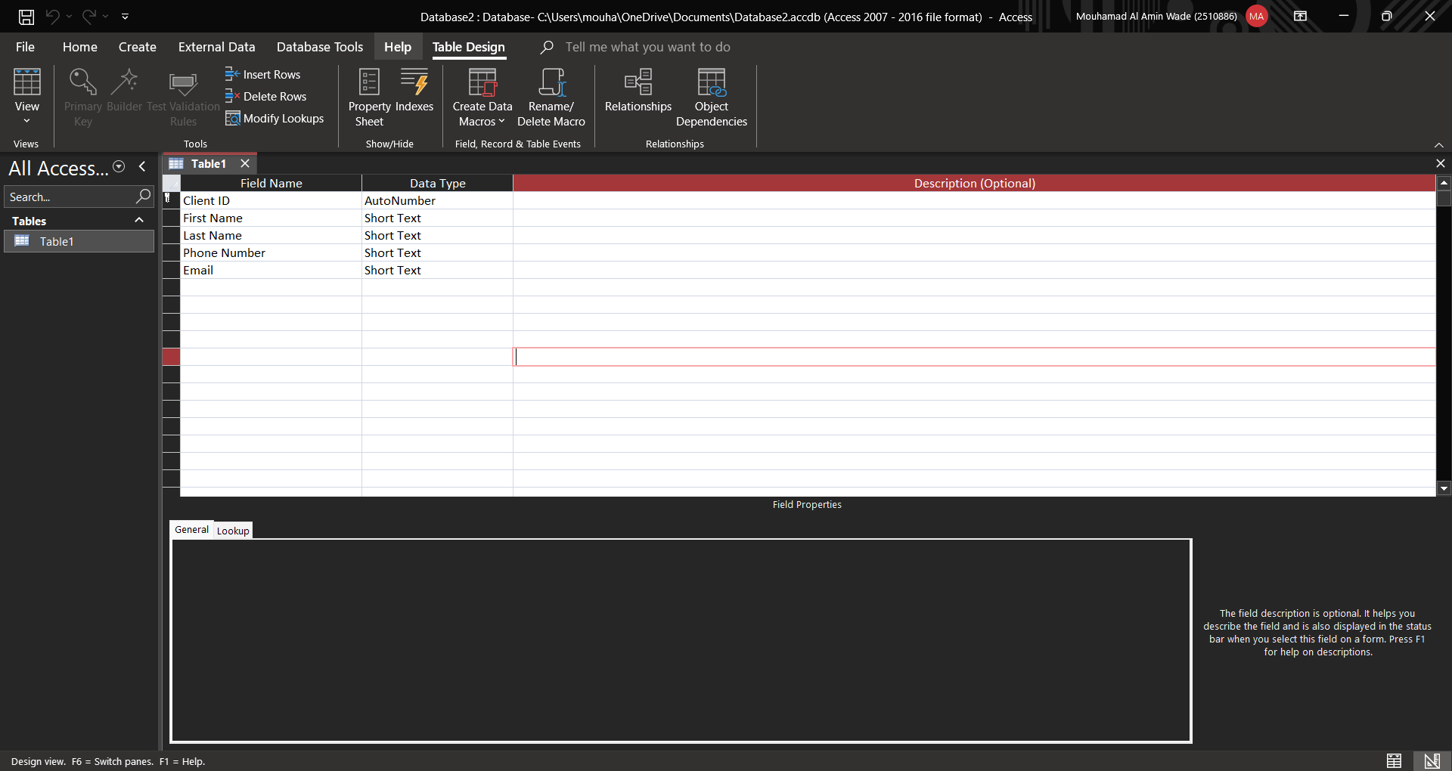
The database was populated with sample data to test the functionality of the AutoPark Management System. Five records were entered into each table to represent realistic parking operations.
The Client table contains information about five customers, including their names, phone numbers and email addresses. The Vehicle table stores the vehicles registered to each customer, including registration number, vehicle type and colour.
The Parking Lot table contains details of five parking locations, while the ParkingSlot table records the parking slots and their current status (Available or Occupied).
The Booking table records customer parking bookings, including the booking date, entry time and exit time. Finally, the Payment table stores payment information such as the payment amount, payment method, payment date and payment status.
The sample data was entered successfully into all tables and was used to test relationships between entities and verify that the database functions correctly before creating queries, forms and reports.

6. Data Structure Design
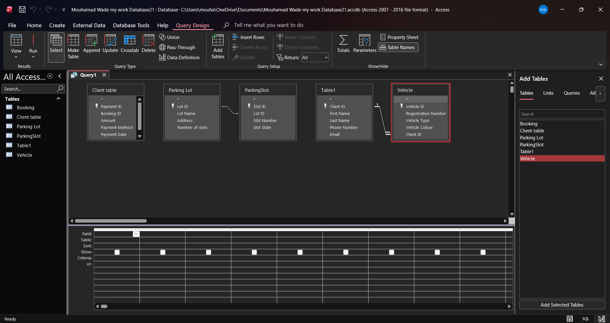
Queries were created in Microsoft Access to retrieve and organise information stored in the AutoPark Management System database. These queries were designed to demonstrate that the database can search, filter and display data efficiently for different parking management tasks. The queries included displaying all client records, showing clients together with their registered vehicles, identifying occupied parking slots, listing all booking records, and displaying payment information. Creating these queries demonstrates that the database is functioning correctly and can provide useful information to support the daily management of parking operations. The screenshot below shows the query design process in Microsoft Access.
7. Normalisation (Up to 3NF)
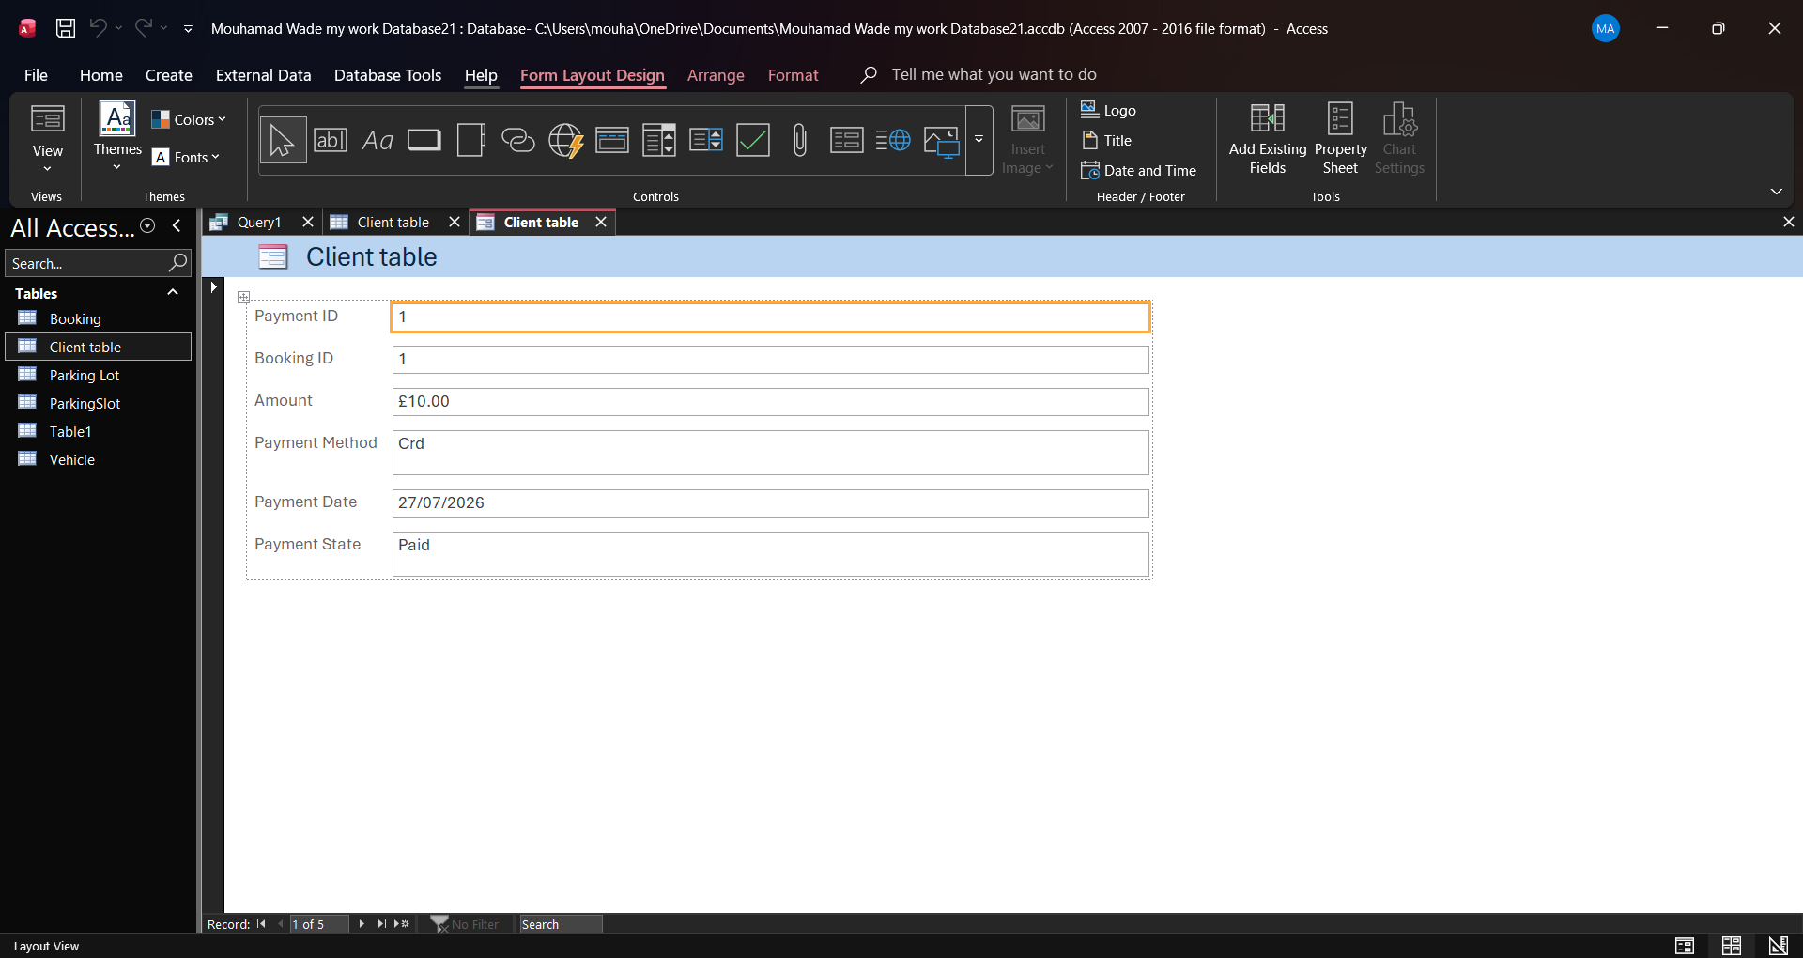
A form was created in Microsoft Access to provide a simple and user-friendly way of viewing and entering data into the AutoPark Management System. The form displays information from the database in an organised layout, making it easier for users to manage records without directly editing the tables. Forms help improve accuracy, reduce data entry errors and make the system easier to use. The screenshot below shows an example of the form created for the database.
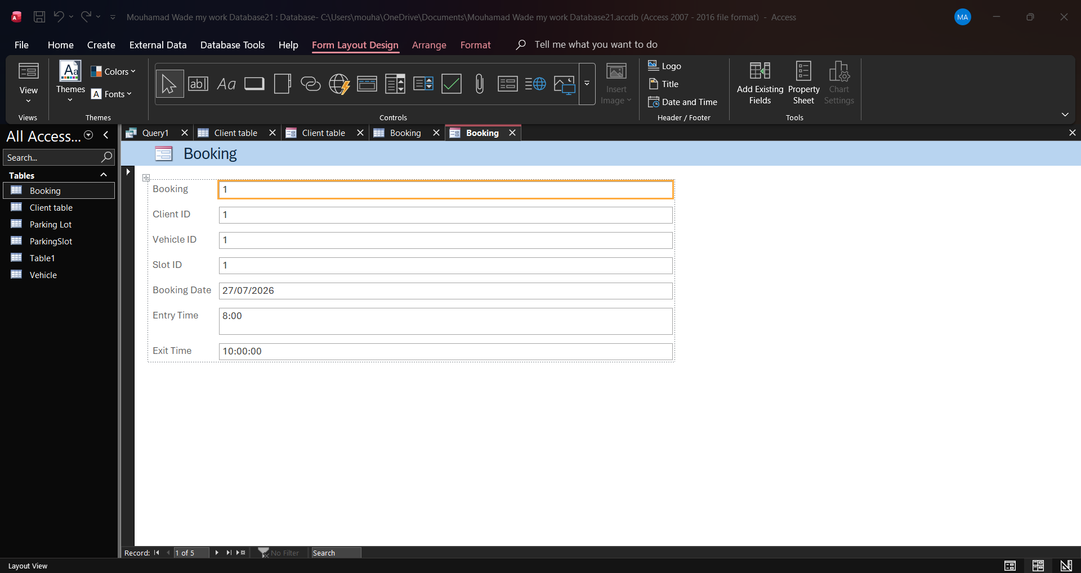
A second form was created for the Booking table. This form allows booking information such as the booking date, entry time, exit time and parking slot to be viewed and managed in a user-friendly format. Using forms makes it easier to enter and update records while reducing the risk of data entry errors.
8. Sample Data
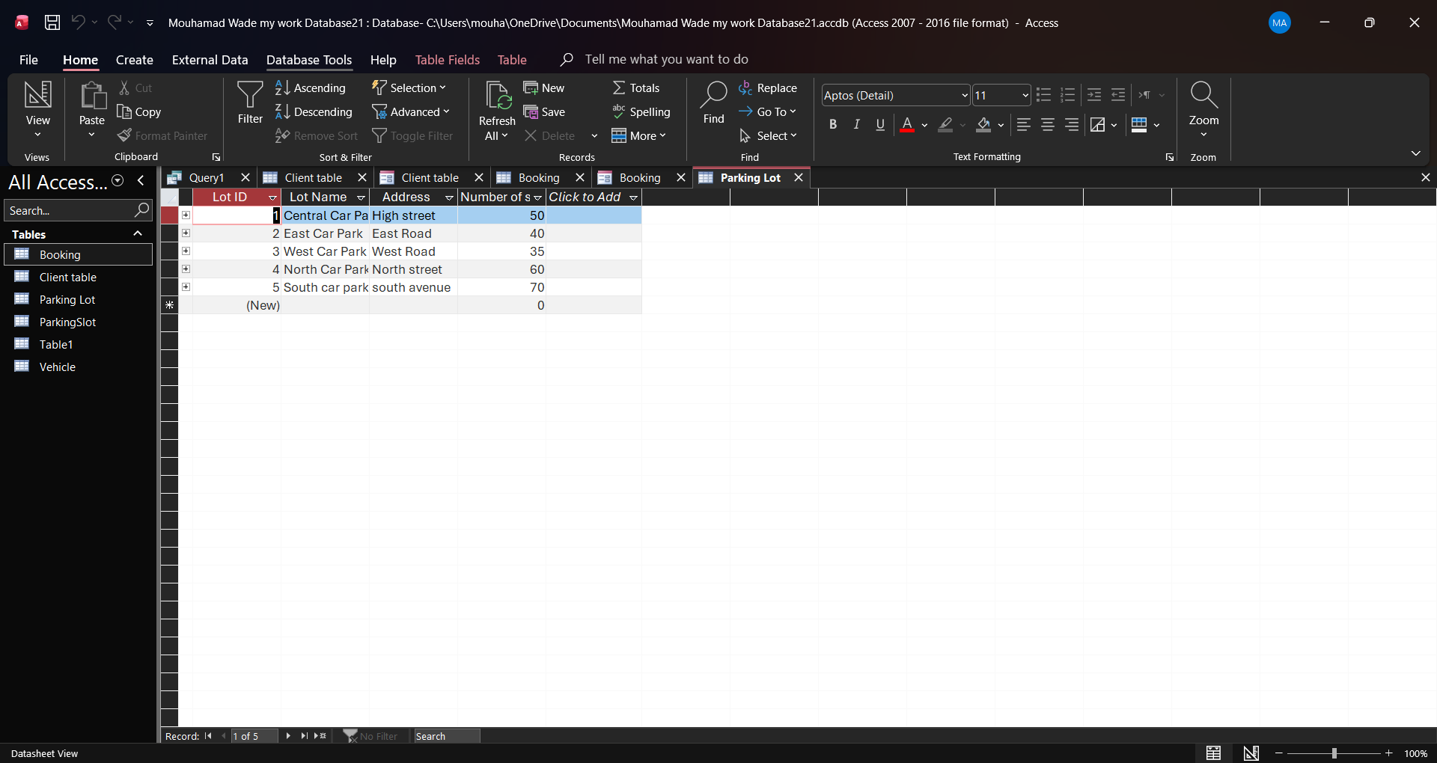
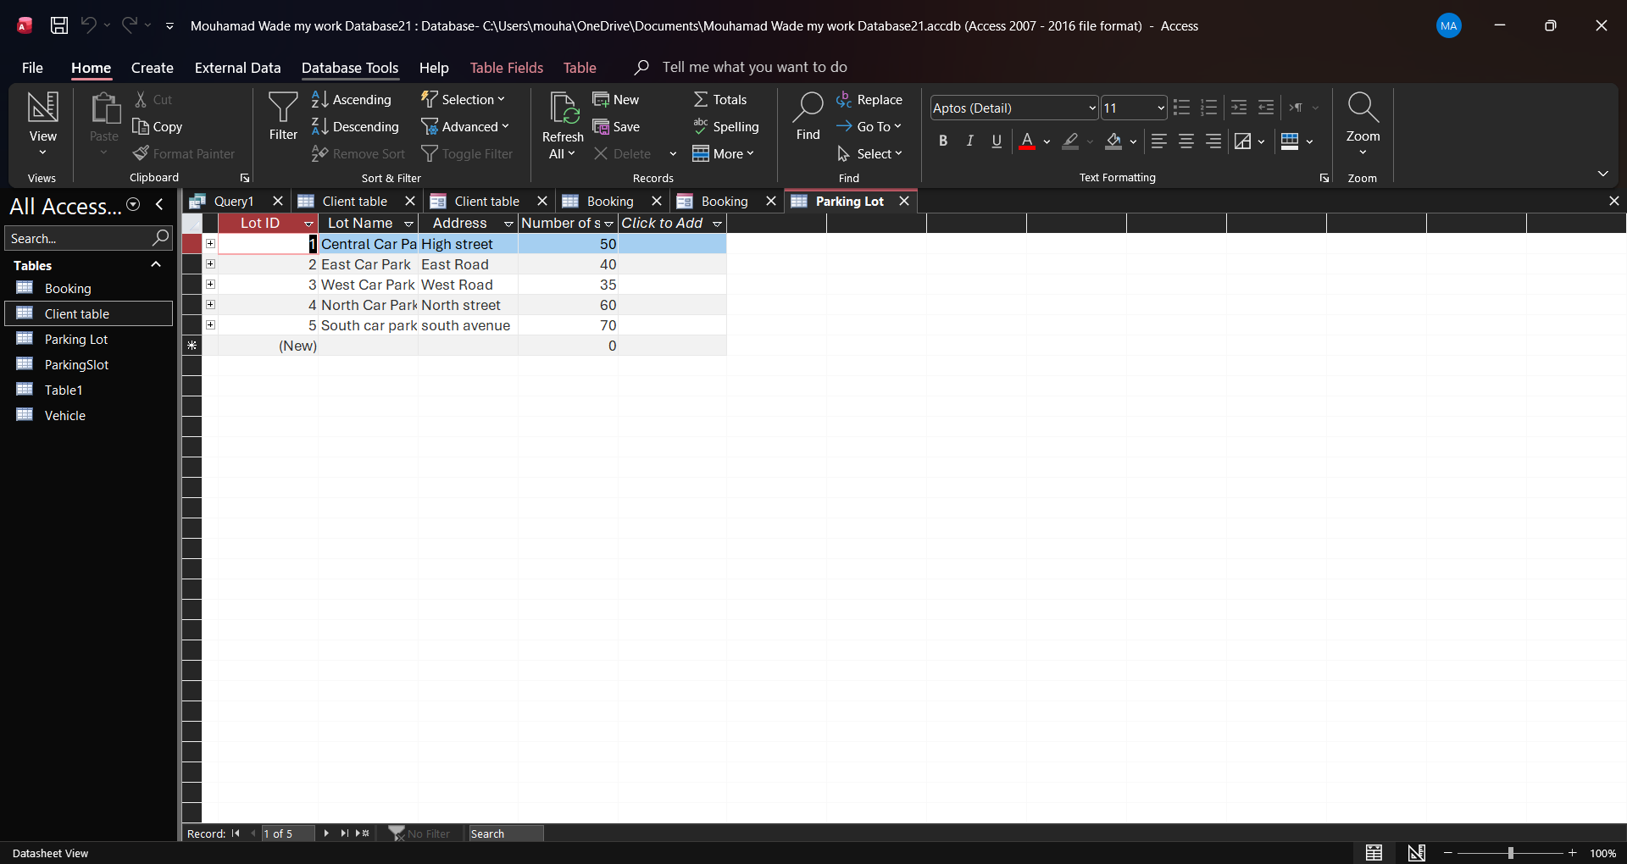
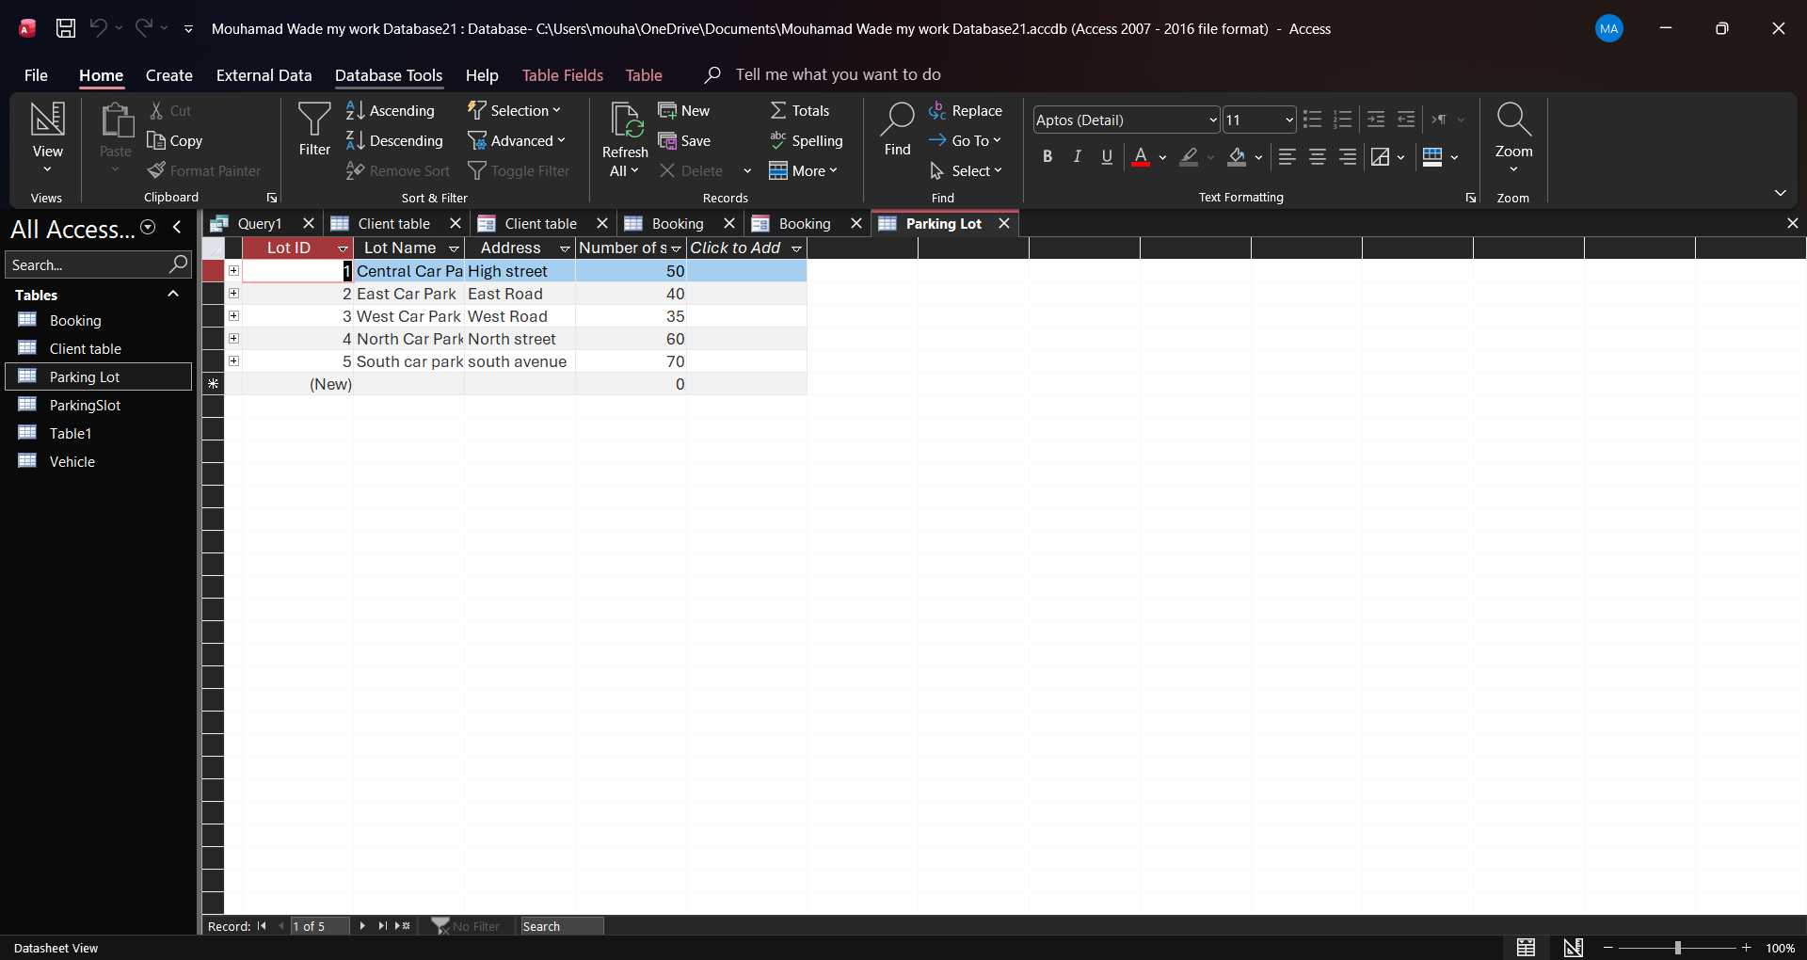
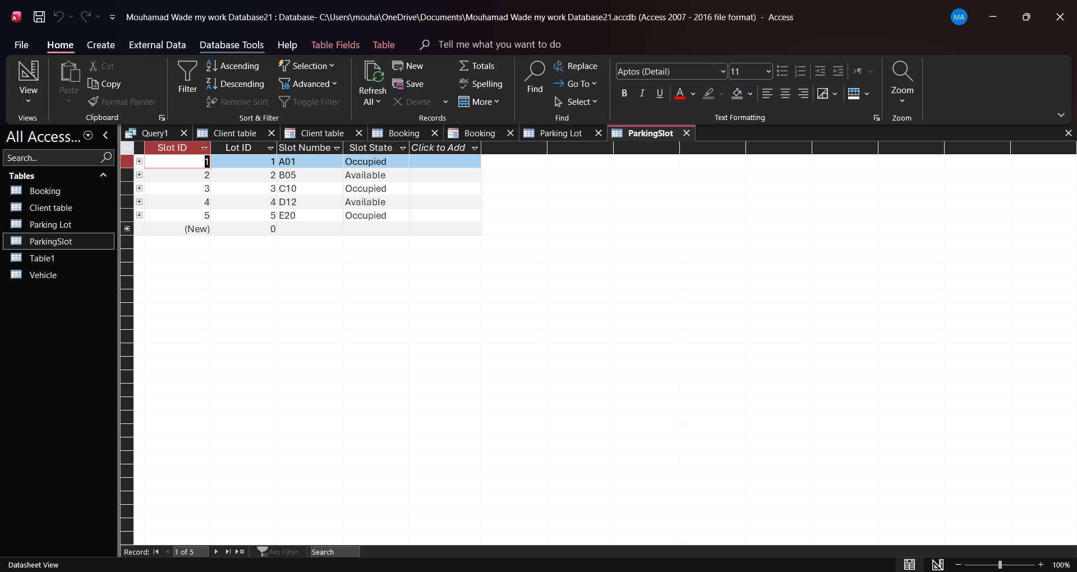
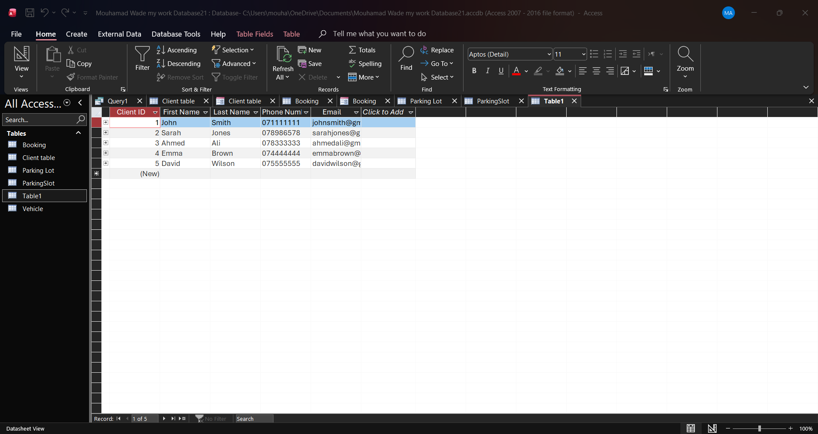
The AutoPark Management System database was populated with sample data to test its functionality. A minimum of five records were entered into each table, including the Client, Vehicle, Parking Lot, Parking Slot, Booking and Payment tables. The sample data represents realistic parking management scenarios and was used to verify that the relationships between the tables were working correctly. Entering the sample records also allowed the queries, forms and reports to be tested successfully. The screenshots below show the sample data entered into the database.
9. Queries
The following queries were created in Microsoft Access to retrieve and organise information from the AutoPark Management System database.
Query 1 – All Clients: This query displays all customer records stored in the Client table. It allows users to view customer details such as names, contact numbers and email addresses.
Query 2 – Client Vehicles: This query displays customers together with their registered vehicles. It helps identify which vehicle belongs to each customer.
Query 3 – Occupied Parking Slots: This query displays only the parking slots that are currently occupied. It helps staff quickly identify which parking spaces are in use.
Query 4 – All Bookings: This query displays all booking records, including the booking date, entry time and exit time. It provides a complete overview of parking activity.
Query 5 – Payment Records: This query displays payment information, including the payment amount, payment method and payment status. It helps monitor customer payments and financial records.
10. Forms and Reports
Forms and reports were created in Microsoft Access to improve the usability of the AutoPark Management System. The forms provide a user-friendly interface for entering, viewing and updating records without directly editing the database tables. This makes the system easier to use and helps reduce data entry errors.
The reports were created to present the stored information in a clear and organised format. They allow important data, such as customer details, bookings and payments, to be viewed, printed and shared when required. Reports make it easier to analyse information and support decision-making within the parking management system.

11. Validation and Testing
Testing Methodology

Testing was done by inserting test data in every table to ensure that the data was stored properly. Testing was further done for the relationships among the tables to ascertain whether customers, vehicles, bookings and payments were related properly. Queries, forms and reports were tested to check if information could be extracted, viewed and presented properly from the database.

Results

The results of the tests were successful in establishing that the database was working as expected. Test records were inserted into the database, relationships among the tables were functioning properly and queries provided the expected results. Forms and reports showed the information in a proper and organized manner.

Issues Identified and Resolutions

During the process of developing the database, some problems emerged, especially on issues of table names and the configuration of relationships among the tables. Such issues were resolved by correcting the database and ensuring that all tables were properly linked. This saw the database work successfully to meet the requirements of the AutoPark Management System.
12. Reflection
This project has assisted me to gain more knowledge on database design and use of Microsoft Access. I have learned how to design tables, set up primary keys and foreign keys, establish relationships among tables, as well as organize data through normalisation. I have also had the opportunity to input sample data, design queries, design forms, and generate reports.

I faced some difficulties in establishing the relationships as well as setting up the queries while developing the database. But by testing the database and rectifying the errors, I could overcome those problems. This project has helped me understand the practical use of database systems for information management.

On the whole, this project has increased my confidence level of using Microsoft Access.
13. Conclusion
In conclusion, the AutoPark Management System has been successfully designed and implemented using Microsoft Access. Database was designed to help improve the management of the parking operations through the elimination of manual record keeping and creation of a well-structured database system. The design of the database has made it possible to store and manage information about customers, vehicles, parking lots, parking slots, booking and payment.

Throughout this project, various concepts of database design have been effectively used in coming up with the appropriate design. Relationship between tables was achieved through the use of primary key and foreign keys. Also, the database has been normalized to Third Normal Form (3NF). Sample data was provided to test the performance of the database while queries, forms and reports were provided to show how the information in the database is effectively searched and displayed.

Tests performed showed that the database fulfils the major objectives of the project. Data storage and retrieval capabilities, maintenance of relationship between records and provision of useful information through queries and reports are some of the capabilities that make the database easy to use and make better decisions on matters of parking management.

From this project, I have gained knowledge on designing a database, normalization process and implementation of a database using Microsoft Access. This project has helped me improve on my skill in analyzing problems of business organizations and provide a database solution.
14. References
- Use IEEE format
[1] Microsoft, Microsoft Access Documentation. [Online]. Available: https://support.microsoft.com/access. [Accessed: Jul. 27, 2026].
[2] Oracle, Database Design Basics. [Online]. Available: https://docs.oracle.com. [Accessed: Jul. 27, 2026].
[3] M. Hernandez, Database Design for Mere Mortals: A Hands-On Guide to Relational Database Design, 3rd ed. Boston, MA, USA: Addison-Wesley, 2013.
[4] T. Connolly and C. Begg, Database Systems: A Practical Approach to Design, Implementation, and Management, 6th ed. Harlow, U.K.: Pearson Education, 2015.
[5] Microsoft, Introduction to Database Design. [Online]. Available: https://support.microsoft.com/office/introduction-to-database-design-9f8d3c9a-4d58-4d3f-bc1d-5b1f8d3b3a0d. [Accessed: Jul. 27, 2026].

15. Appendices
- Additional screenshots
- Additional queries if needed

