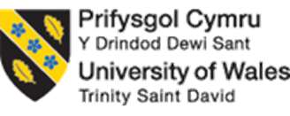

UWTSD MBA HKBM7009
(UWMBA-30013-2022-1-SS)
HKBM7009 Global Business Challenges

An Analytical Study on Exploring Investment Opportunities in a Global Financial Market: Germany

An Analytical Report Submitted in Contribution to 100% Module Assessment

Student Name | ： | CHAN Gi Wing, Constance
Student ID Number | ： | 2133979
Date of Submission | ： | 27 February 2023
Lecturer | ： | Dr. Che Cheong Poon

UWTSD MBA (May/Nov 2022 intakes)
BMMB7009 Global Business Challenges

Assignment Title:
An Analytical Study on Exploring Investment Opportunities in a Global Financial Market: Germany

“I, CHAN Gi Wing Constance (Student ID: 2133979), certify this work is the result of my own investigations, except where otherwise stated. All references have been duly cited.”

Signed: Constance Chan__________________

Date: 27 February 2023

Synopsis

In this study, the Germany stock market has been analyzed to see if it is suitable for the company to invest in after the COVID-19. Comparing both HSI and DAX indices, they have high correlation coefficient in general, but a huge different during and after COVID-19. To prove that Germany stock market didn’t get much impacted from the pandemic, one stock was chosen to be an example for analysis. With the strong and stable performance in the past record, Germany stock market has shown it is reliable to be invested in.

Table of Contents

 |  |  |  |  |  |  |  | Page
1 | Introduction |  |  |  |  |  |  | 1
 | 1.1 | Research motivation, aim, and objectives
 | 1.2 | Research framework
2 | Company Background |  |  |  |  |  |  | 4
 | 2.1 |  | Company profile
 | 2.2 |  | Current investment portfolio and investment performance
 | 2.3 |  | The global business challenges and the rationale for exploring investment opportunities in some global financial markets
3 | Characteristics of Germany stock market |  |  |  |  |  |  | 8
 | 3.1 |  | A comparison of the stock price index movement between Germany and Hong Kong
 | 3.2 |  | The Germany stock market profile
 | 3.3 |  | The Germany economic prospect
4 | Analysis and discussion |  |  |  |  |  |  | 14
 | 4.1 |  |  |  | Investment return
 |  |  |  |  | 4.1.1 |  | Capital return
 |  |  |  |  | 4.1.2 |  | Income return
 |  |  |  |  | 4.1.3 |  | Equity premium
 | 4.2 |  |  |  | Investment risk
 |  |  |  |  | 4.2.1 | Stock price volatility
 |  |  |  |  | 4.2.2 | Market risk
 |  |  |  |  | 4.2.3 | Exchange rate risk
5 | Conclusion and recommendations |  |  |  |  |  |  | 19
 | 5.1 |  |  | Conclusion
 | 5.2 |  |  | Recommendations
References |  |  |  |  |  |  |  | 20

1 Introduction

This study argues if AAA Company should invest in Germany stock market in order to diversify the increasing market risk impacted by the COVID-19 crisis. In this session, the research motivation, aim, and objectives also the framework of this research will be described in detail, to have a brief understanding about the whole study at the beginning.

1.1 Research motivation, aim, and objectives

As the leader of the industry, AAA Company should act faster and be the first mover in the field to enhance its own competitivity, exploring the opportunity and probability of success from investing in other stock market would be a first step to do so.
The motivation of this research is to enhance the competitivity of AAA Company and stabilize their position in the industry. And the aim, would be to find out Germany stock market is a suitable choice for AAA Company to invest in.
The objectives of this study will be:
- Analysis the current investment portfolio of AAA Company
- Comparing Hong Kong’s and Germany’s economy appearance
- Germany stock market analysis
- Calculating the estimate return from investments in Germany stock market
As the correlation coefficient of both stock indices is very high (will be explained in detail in section three of this study), Germany might not be the best choice for AAA Company to invest the stocks over there if they aimed for gaining as much assets as they could while Hong Kong’s economy went down. However, by the past appearance of DAX indices, especially during the pandemic period that caused by COVID-19, it was just a slightly drop comparing to HSI. Therefore, Germany stock market might be a great choice if AAA Company would like to keep a certain amount of their investment at a safe place/market during an unstable situation of the economy in Hong Kong and Asia market.

1.2 Research framework

In this session, the framework of this study will be described with stating all the variables which will be used in analysis.
To analysis the investment portfolio of AAA Company, the percentages of the company currently investing in different aspect will be listed out in table.
To comparing Hong Kong’s and Germany’s economy, the HIS and DAX indices, historical inflation rate and GDP growth rate of both regions will be compared. Referring these factors in the past few years, Germany’s economy will be overviewed generally in this study. By comparing the historical records of DAX indices with HSI indices, how each market acted in the past during the same period would be easier to predict if any similar economy storm ever happened again, would Germany stock market be suitable and secure to be invested in.
Analyzing Germany stock market would be great to have an example, therefore one of the medical devices manufacturer stock price changes will be used as reference in this study. With the price changing, the estimated return could be calculated and determine if Germany stock market is suitable for AAA Company to invest in.

2 Company background

AAA Company is one of the largest non-hospital medical service providers in Hong Kong. Start with providing service in aesthetic medicine aspect, to owning more than 40 brands in different professional medical aspect, such as dental care, ophthalmology center, health management center and veterinary hospital within 15 years (AAA Company, 2023).

2.1 Company profile

In the past three years, COVID-19 has influenced the public views on health care, they would like to have a proper body check to diagnose the disease earlier and prevent it from getting worse in a concise amount of time. More Hong Kong people would review or purchase new medical insurance which would cover new diseases as well.
AAA Company has cooperated with a famous insurance company in Hong Kong to run a health management center. With their sensitive market sense and excellent marketing skills, AAA Company has grown so fast, compared to the other competitor in Hong Kong, they have succeeded to build up a new ecosystem of health care and become an influencer in different medical specialties throughout a few years.
Moreover, not only in domestic region, they also provide service in Mainland China and Macau with their strong customers bases in these regions, which is about 10% of their total revenue. Although they do not have invested in the market, they are trying to promote their service in Mainland China and Macau to convince them to have the health manage every time they visit Hong Kong with different levels of promotions (AAA Company, 2022b). This would also help improving local tourism and retail sales industries with their promotions, more other companies from these industries would like to cooperate with AAA Company as combined promotions.
According to their financial forecast, the total revenue will increase about 30% in 2023 (AAA Company, 2022a). It is a great opportunity for AAA Company to expand their market and investigate the stock markets of other regions for further investments.
AAA Company, as a medical service provider, they have a very strict quality requirements on their medical devices. They would look for those devices have more functions to provide services to clients, and with safety approval of regulations from other countries. The main reason is Hong Kong government does not have their own regulations on medical devices, they would refer to FDA approval and CE mark to ensure the quality and safety of the devices. Therefore, AAA Company as a private medical center, they would follow the regulation from European countries and purchased most of their medical devices from European brands with CE mark, and Germany is one of the most manufacturing medical devices region in Europe. Of course, AAA Company would purchase this kind of devices and has connection with their manufacturers for after service for the devices, such as maintenance and annually checking services. Since then, they would have their basic network in there to get to know more about the market over there, it should be easy for them to collect information and suggestions from local organizations.

2.2 Current investment portfolio and investment performance

As mentioned, AAA company has a steady revenue and sales record during the COVID-19 period in the past three year, comparing to other competitors or industries, their stock has a better performance and “survived” under the pandemic situation. With such brilliant outcome, the internal analysis will be included in this study, and of course the other environment factors of AAA company, including Hong Kong society culture, will be referenced to analysis and predict AAA company’s performance in the upcoming three years.

Investment portfolio usually contain the collection of the company’s stock, bonds, real estate, private investment etc. (Tardi, 2022), which is a useful tool for the managers to evaluate current investment plan is suitable to continue or need to be adjusted to reach company’s target.
At the beginning of 2020, COVID-19 has impacted Hong Kong and the patients number increased rapidly. Hong Kong government had announced different social distancing measures as a quick react, to try slow down or stop the spread of COVID-19. However, the pandemic still affected the economy very badly during 2020 to 2021. However, to AAA Company, it was a great opportunity for them to promote their business and branding during pandemic period. Since Hong Kong public have concerned and care more about health care, most of them are very greedy on getting information related to medical and health checking services in private clinical centers since government hospitals have long queuing time as always. Those people who have stable financial background wouldn’t mind to pay more for getting a full body check service were increased, which matched with AAA Company’s target customers group.
By observing the public’s need, AAA Company has plans to acquire more medical centers to try to expand their customers group, from office workers to pet owners, from aesthetic medicine to veterinary, AAA Company has been developed to a fully taking care of publics and their families’ health center.
Return of equity (ROE) reflects how the company would generate revenue from their total equity, since a number of inventories decreased would not affect the equity directly (Klingenberg et al, 2013).
ROE = Net Income / Average Shareholder’s Equity
According to AAA Company annual report for their last financial year, their ROE was 11.5% in 2022 (AAA Company, 2022a), comparing with their past five years ROE, which are decreasing year by year. A low ROE may not represent a bad thing (Macrotrends, 2020), since the main reason of that is AAA company has continually acquired different organizations in the past few years, and the numbers of organizations increased year by year, it actually normal that ROE would drop even their revenue was increased comparing to previous year.
On the other hand, AAA Company also started investing on properties since last year and planned to have a building for their own health care centers and office. This project is ongoing and targeted to be completed by 2027.
Overall, AAA Company’s current investments are focusing on acquiring other organizations, to expand their own services and completing their aim, as to build up a new ecosystem of health care industry in Hong Kong.
Since COVID-19 has impacted the local economy for about three years, most of the companies from different industries had to close their businesses. During the pandemic, Hong Kong government has released social distancing measurement in different levels time by time. In the beginning of 2022, people are highly recommended to stay at home, only leaving house for necessary needs, government also started “Work from Home” policy in different departments, to encourage private companies to follow. However, these are not suitable for all industries and jobs, especially for those people who are at lower socioeconomic positions, their jobs are not allowed to work from home (Burki, 2022). COVID-19 has infected Hong Kong public so suddenly with different variants, once government needs to react fast by releasing policies to solve public concerns, usually the plans could only slow down the problems get worse in social and gain more time for the government to plan for further strategy. But this time, COVID-19 lasted too long, especially longer than SARS which was in 2003, those aftereffects of the temporary policies appeared in the society, which makes Hong Kong's economy suffer over the past three years.
Surprisingly, AAA Company, leader of private medical service provider in Hong Kong, didn’t closed any of their center, but even continually acquires different organizations and open their new flagship center in 2022 (AAA Company, 2022b).
As a company with such high potential to expand their markets and with much assets to invest into other regions for further development, and with clear mapping of investing in Macau and Mainland China as they already have strong customer base over there. It may be a good opportunity to analysis if AAA Company should invest into European countries’ stock market for earning more resources if possible.

2.3 Global business challenges and the rationale for exploring investment opportunities in Germany stock markets

As a local medical service provider with its business focused exclusively on the local market since its inception, AAA Company has many factors need to be considered before opening its global financial investment business in other countries.
There are several general global business challenges, for example culture differences, currency and inflation rate, which are very common and the first few issues that every business would face when they enter an international market.
First of all, culture differences may need time to understand deeper to conduct business successfully (Cote, 2020). Luckily, the working cultures of Hong Kong and Germany are very similar to each other, normally five working days per week from 8-9 am to 5-6pm. Also for the stock market, would be Monday to Friday from 8am to 10pm, with seven hours difference between two regions, Hong Kong investors would have enough time to monitor and study the stock price every day. Since AAA Company has their own investment management team, they do have enough resources and knowledge to manage their investment in Germany stock market.
Second, the inflation rate and currency are also the main factor that investors should consider before making decision of investment in other countries. Especially after COVID-19, the inflation rate of most of the countries had increased rapidly and continually, which this trend would continue in 2023 (Marr, 2022). With the unstable global economy in the near future, it might be better that AAA Company should wait for one to two years to observe the trends of both markets, or invest a lower amount in Germany stock market if they insist to invest in European countries, as it is the most powerful economy country of Europe.
As AAA Company started investing properties and fixed assets in Hong Kong in the past few years, they may consider to do the same in other countries. Germany is one of the most stable markets in Europe, was ranked as third out of twenty sevens Member States of the European Union of having the most assets under management with €2,385 billion at the end of 2021 (Eberlein, Ernst & Kampen, 2022).
On the other hands, as the industrial production industry gets the most share of Germany stock market (Kuepper, 2021), AAA company may invest an amount of their stock, for example the stock of their medical devices supplier or related organizations if they would like to take an easy step as investigating Germany market is suitable for further investment in their planning.

3 Characteristics of Germany stock market

In this section, different aspects of the Germany market have been analyzed, including DAX index, general stock market profile and economic prospect. This information is used to comparing with Hong Kong market, to observe how Germany market would act when Hong Kong economy was under unstable conditions in the past.

3.1 A comparison of the stock price index movement between Germany and Hong Kong

The historical price of DAX (Germany stock market) and HSI (Hong Kong stock market) will be plotted in below graph for analyzing the patterns in typical time.
Figure 1 Time plot of stock price index movements in HSI and DAX
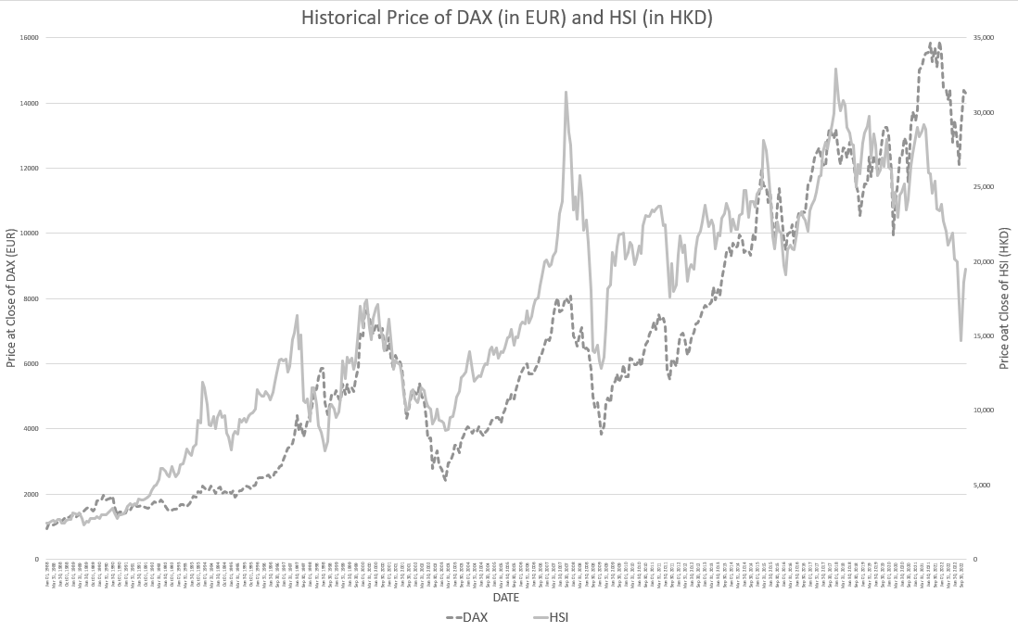
Sources: Yahoo! Finance
Figure 1 shows that two indices have very similar pattern. Whenever one goes up, the other would go up as well. However, there is a cross change in Jan 2020, which could show how COVID-19 impacted two markets differently. According to the timing that COVID-19 affected Hong Kong, which is at the beginning of 2020, the HSI index stopped increasing and started dropping rapidly. On the later time, around March to May 2022, COVID-19 spread out globally and of course impacted Germany as well, DAX index also dropped by then, but didn’t drop as much as HSI index did. And by the end of 2022, both indices turned the trend back to increasing, so both markets were assumed would back to normal since 2023, also assuming that the impacts caused by pandemic finally ended.

Table 1 Correlation coefficients of DAX and HSI for selected time periods
Selected time period | The Pearson correlation coefficient (r)
1988 - 2022 | 0.886
1988 - 1999 | 0.731
2000 - 2009 | 0.785
2010 - 2019 | 0.795
2020 - 2022 | 0.224

From Table 1, it shows the correlation rate of DAX and HSI indices, to analysis the relationship and understand the pattern time by time easily, the historical price of each index has been divided into four periods.
The reason of calculating the correlation rate of local stock index and the target market stock index is to reduce the risk of investment (Flavin, Hurley & Rousseau, 2002). Usually, company would not choose those market which has high correlation rate to invest, it’s because this act could not reduce the risk of a portfolio (Edwards, 2022).
Overall, DAX and HSI have a very high correlation value as 0.886. Starting from 1988 to 2019, it remains above 0.7. However, in the period of 2020-2022, the correlation rate has dropped to around 0.2. According to the historical price record, the huge difference was started from Jan 2020. COVID-19 had impacted Hong Kong's economy since that time, but not yet infected to European countries, which shows the HSI index dropped while DAX index remains normal slightly growth.
Assuming everything will back to normal since 2023, COVID-19 / pandemic won't further impact world's economy, the correlation rate of HSI and DAX will increase back to 0.7 - 0.8 in the near future, approximately by 2025.

3.2 The Germany stock market profile

Germany is the largest economy in Europe, which driven by industrial products, and has a great number of exports, even more than China and USA (Kuepper, 2021).
To understand if the economy of Germany is stable and safe to invest, the past GDP growth and inflation rate were should be studied before decide investment.
GDP is often used to evaluate if the economy is healthy or not, which is also widely used to indicate the economic performance. So, for investors, GDP could be a heads up for them to see if the trend of the stock price might be dropping and lower their earning in the near future (Kramer, 2022).
Figure 2 GDP growth rate of Germany and Hong Kong in the past 25 years
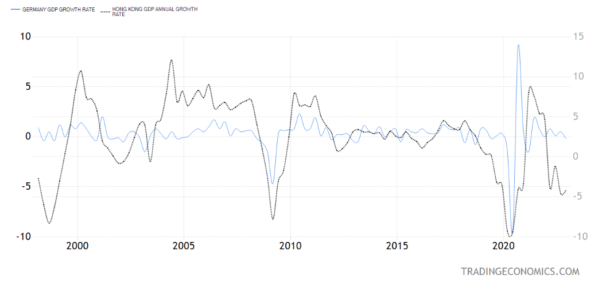
Sources: tradingeconomics.com
From Figure 2, the GDP annual growth rates of Germany and Hong Kong had been plotted on the same graph for comparison. Except the huge drop in 2020 and rise in 2021 due to COVID-19, the GDP annual growth rate of Germany has been stabled overall in the past, remaining at around 2-3% every year. During the Great Recession in 2008, the GDP growth rate of both regions had been dropped, Hong Kong dropped further than Germany. Since Germany’s economy is one of the leaders in eurozone, the GDP growth rate changes would be influenced by different factors or issues that happening in Europe.
Generally speaking, when GDP rising up, it usually represents the economy of that region is being well, and when real GDP grows strongly, may cause by employment rate increase which means people had earned more than last year (Callen, 2021).
Other than GDP, inflation rate of a country/region is also a great reference for investor to determine if the economy is stable or not to invest.

Inflation rate is often used to measure the price changes of the goods in the country, which would directly impact the purchasing power of their people and their cost of living (Fernando, 2023). Moreover, inflation rate would also affect the interest rate and currency as well, which are the main indices that investors would observe before making investment decisions. As the role of central banks is to control the keep control the inflation, usually would keep it low at around 2% to 3%, then the banks could keep the interest rate lower to enable people to afford paying for services and purchasing goods (Lowry, 2022). Since inflation rate increased, which means the same amount of money could not buy as much goods or products as before. This would also reflect in currency changes, the currency’s buying power would be decreased when inflation rate was increased, which means the currency conversion rate also dropped (Lowry, 2022).
Figure 3 Inflation rate of Germany and Hong Kong in the past 25 years
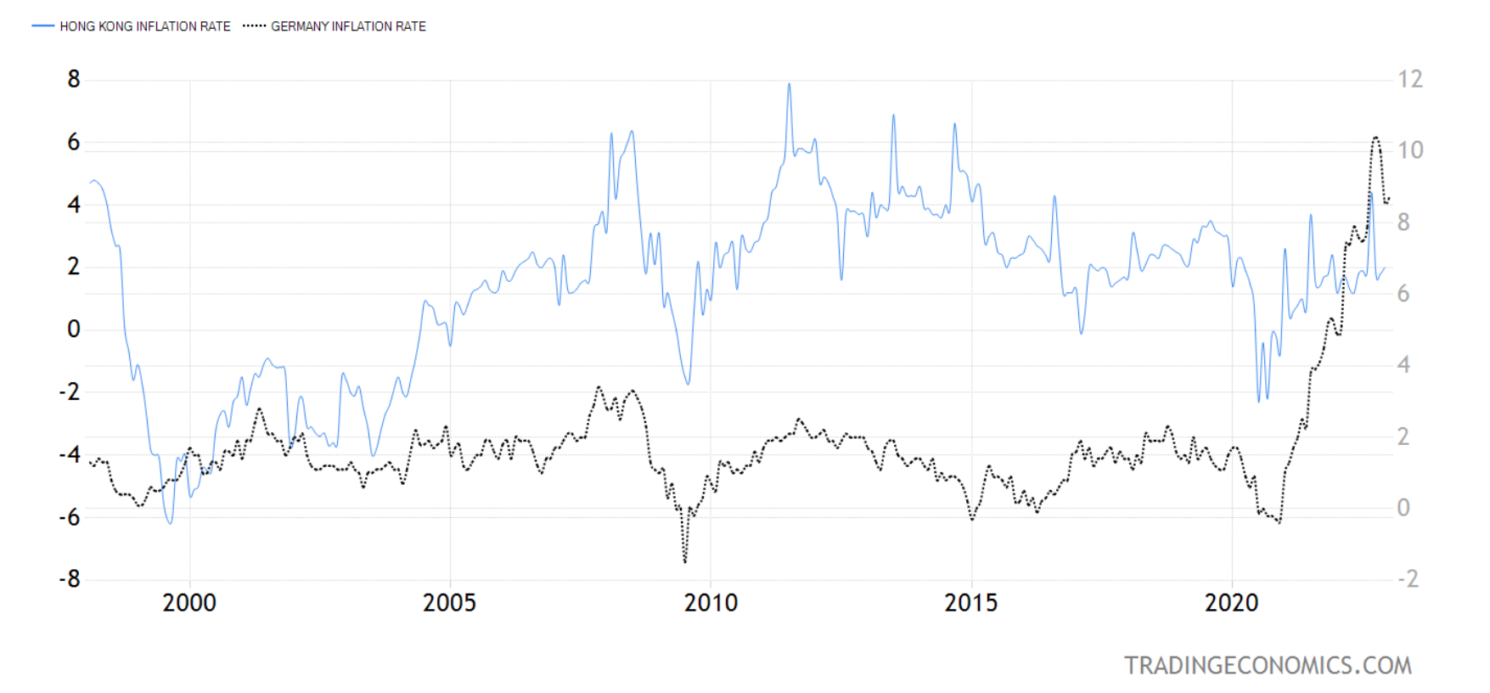
Sources: tradingeconomics.com
From Figure 3, both inflation rates were plotted and easier to compare the trends. Germany increased inflation rate continually after COVID-19, and Hong Kong remained around 2% since 2021.
According to these numbers, the living cost in Germany was assumed to be increased rapidly after 2020, but the employment rate didn’t have a huge growth, so the purchasing power of their people should have reduced. In short term, investors should keep on observe Germany’s economy changes if it would be getting better after 2023 before making a move.

3.3 The Germany economic prospect

After the pandemic, assuming the status of global economy would back to normal in 2023, there are few challenges that Germany needs to face for making their economy stable.
Firstly, low wage growth and inflation rate, as mentioned above, the unemployment rate is still high, and may higher than the other areas, it may help to boost up Germany’s economy if the workers would receive wage increases and able to spend more (Edwards, 2021). By 2026, the real total GDP in Germany is expected to grow by 4.00%, so the employment rate is assumed to be increased by 2026 (Statista, 2022).
Secondly, an aging society, Germany government had saved up and placing more budgets on aging population's pensions and healthcare (Edwards, 2021). However, there are still other essential initiatives that need budget for enhance people living quality, such as road construction, child care and after school program. To solve this problem, Germany would need an economy growth with exporting products to other countries, especially Asia areas. Therefore, Germany may invest more in R&D in the near future.
Thirdly, balanced savings and investments, most of the workers in Germany would like to save money more than spending, which would slow down the economy growth of Germany (Edwards, 2021). To encourage them to spend money on buying goods and products, Germany government would need policies to reduce the needs of saving pressures for retirement of the workers, which would affect the prospect of Germany economy in the upcoming few years.
By 2025, Germany is forecast to grow their GNI (Gross National Income) to about USD 5.25 trillion and total investment amount to USD 1.13 trillion (Statista, 2022). Hopefully with the end of impacts caused by COVID-19, Germany will rebuild or maybe boost up their economy in a steady pace in the next three years.

4 Analysis and discussion

In this section, the risk and return of investing Germany stock will be analyzed and discussed. Assuming AAA Company would like to invest in a stock, Siemens Healthineers AG, which is a medical devices company in Germany, to earn more resource for further development or earn more money as back up assets to prevent a total lost when Hong Kong economy drop if any other pandemic happens again.
Brief introduction of Siemens Healthineers, they are founded in 2017 and fully owned by Siemens in Germany. They went public on the Frankfurt Stock Exchange in 2018 and were promoted to the DAX in 2021 (Siemens Healthineers, 2023).
Therefore, AAA Company, as a medical service provider, could be the user of those medical devices by Siemens Healthineers. With the confidence in quality of their products, AAA Company would discover the potential of Siemens Healthineers and consider buying their stock as an overseas investment.
Figure 4 Historical stock price of SHL (Siemens Healthineers AG)
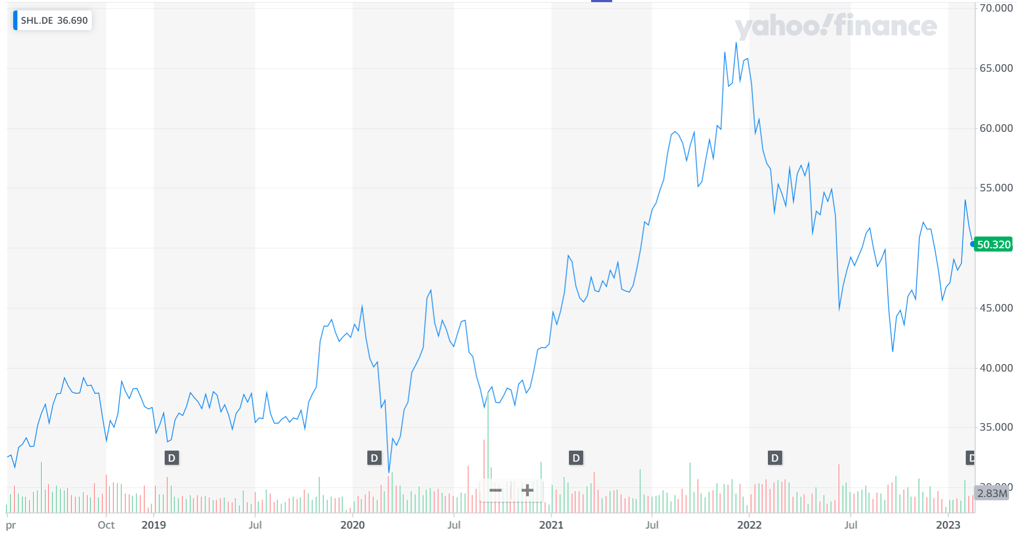
Sources: Yahoo! Finance
From Figure 4, the trend of SHL is clearly shows that it is going upwards. Although there was a drop in the first half of 2022, may related to lack of semi-conductor supply which affected many devices manufacturers in several countries, especially Europe and Asia, the stock price went back upward later by the end of 2022.

4.1 Investment return

The total return of an investment usually involves two elements: the capital return and the income return (Bassanese, 2022). However, only viewing the figures from the return rate is not enough and may not able to define if the investment is good or bad, therefore the environment factors of the stock market should also be consider as well.
As the largest and the top economy in European country, there benefits of investing Germany stock markets. One of them was the strong economy, it is the healthiest economy in the world, Germany’s GDP has reached USD 3.84 trillion in 2020. The other benefits or advantages would be European Union (EU) membership and workforces. Germany has become more competitive to against other industrialized countries, and with their highly educated workforces (Kuepper, 2021), investors would have confidence to invest their money to Germany market.

4.1.1 Capital return

For sure, every investor expecting to receive the returns from their investments as much as possible. Before calculating the capital return that AAA Company may able to gain, let’s take a look of the definition of capital return.
Capital return, as known as capital gain, are the returns earned when an investment is sold for more than its purchase price (Investopia, 2022).
Assuming AAA Company is going to purchase 1,000 shares of stock in SHL at EUR 50:
Capital expenditure = EUR 50 X 1,000 = EUR 50,000
Then assuming SHL stock price increased to EUR 60, which happened at least twice in 2021, and if AAA Company decides to sell the share at this price, the total income will be:
EUR 60 X 1,000 = EUR 60,000
The capital return on this investment will be:
Total income – initial capital = EUR 60,000 – EUR 50,000 = EUR 10,000
Capital return rate = EUR 10,000 / EUR 50,000 = 20%

4.1.2 Income return

Income return is an additional income from the company paying out the dividend per share of stock (Investopedia, 2021). In AAA Company case, assuming that Siemens Healthineers decided to pay EUR 1 per share of each 100 shares that investors purchased, and assuming AAA Company still owning their shares. The investment will generate income return:
EUR 1 X 1,000 = EUR 1,000
Income return rate = EUR 1,000 / EUR 50,000 = 2%

Since Total Return equals to the sum of Capital Return and Income Return, the Total Return rate of this investment would be 22%.

4.1.3 Equity premium

As calculated the total return rate as 22%, it could be used to calculate the equity premium of this investment.
Equity premium is the difference between the expected return on the market portfolio of common stock (total return rate) and the treasury bill rate (Fama and French, 2002). Treasury bill rate is the sum of inflation rate and the real rate, which are 8.7% and 3.0% in Germany by February 2023.
Calculation of equity premium is:
Equity Premium = Total Return – Treasury Bill Rate
= [20% + 2%] - [8.7% + 3.0%]
= 22% - 11.7% = 10.3%

Therefore, the equity premium of AAA Company’s investment of purchasing 1,000 shares of SHL stock would be 10.3%.

4.2 Investment risk

After all, every investment would contain some risks, not only the performance of the company would affect the stock prices, also the other environment factors of the stock market might cause the risks to investors. For Germany market, there are few things that may affect investors’ confident to invest in their stock market, such as the debt issue as Germany is a member of EU, the aging society and the development economy in a slower speed (Kuepper, 2021).

4.2.1 Stock price volatility

Stock price volatility is the standard deviation of the price of a stock has been changing, increase or decrease, over a certain amount of time (Fidelity, 2023).
The reasons of causing stock price volatility are politic and economic factors, industry and sector factors and company performance.
For example, when there is an election period, stock prices usually got influenced by the reaction among the investors (Fidelity, 2023).
Studying the stock price volatility would allow investors to determine if expecting the return from this stock is a short term or long term. As volatility representing the changes of stock price, it is not always a bad thing. Stock price would temporarily drop over a period, if the investors believe that this company would perform better later so they may purchase more shares of stock at a lower price.

4.2.2 Market risk

The expected market risk premium is used to calculate out the minimum rate that investors could receive on the investment by finding the difference between expected return on a market portfolio and the risk-free rate, which usually refer to treasury bill rate (Chen, 2022).
For AAA Company investment on SHL, the expected market risk premium will be:
20% - 11.7% = 8.3%

4.2.3 Exchange rate risk

Based on the previous section, showing that GDP and inflation rate of Germany would become stable in 2023, just the inflation rate was so much higher than the past few years right after COVID-19.
Inflation rate would direct influence the exchange rate risk, since it may huge different from other countries, this risk is couldn’t be prevented and controlled, so foreign investors usually would consider and study this measurement before investing overseas market.

5 Conclusion and recommendations

With all the analysis and discussions on above factors, including AAA Company’s internal factors and Germany’s economy, which are helpful for finding the answers for the questions that brought up in the introduction of this study, we could come up a conclusion on if AAA Company should invest in Germany stock market and would this act safe for them if Hong Kong economy went down again.

5.1 Conclusion

Since AAA Company has their huge amount of revenue and expecting their business will continually growing in the next few years, they do have potential to start investing in foreign market. Germany is the strongest economy in Europe, also having steady GDP growth rate, it is always a great choice for foreign investors to consider investing in their stock market. Considering the connection of AAA Company would build with their supplier, it would be better for them to invest in the related industry with a positive historical stock price. Although the inflation rate of Germany is still remained high in 2023, the pressure of Germens on living cost will continue and last for at least two more years, Germany government would have policies on boosting up their economy back to normal growth by 2026. Therefore, AAA Company should invest in Germany stock market, since DAX has more stable performance in the past comparing to HSI, this act would be safe for AAA Company if Hong Kong economy got influenced again in the future.

5.2 Recommendations

Even though it is safe for AAA Company to invest in Germany stock market, but as mentioned in above sections, global economy is still no back to normal until the second half of 2023. So, AAA Company should wait and observe the market trend until July 2023 to make further decision on foreign investment.
On the other hand, AAA Company should see the investment on SHL as a short-term return, to minimize the risks in the investment which contain uncontrollable factors.
References
AAA Company (2023). About Us. [Accessed 29 January 2023].

AAA Company (2022a), FY21/22 annual report. [Accessed 29 January 2023].

AAA Company (2022b). FY22/23 Interim results investors presentation. [Accessed 29 January 2023].

Abiad A., Arao R. M. & Dagli S. (2020). The economic impact of the COVID-19 outbreak on developing Asia. [Accessed 31 January 2023].

Bassanese D. (2022). Income return vs capital return: correctly assess fund performance. [Accessed 15 February 2023].

Burki T. (2022). Hong Kong's fifth COVID-19 wave—the worst yet. Available at: https://www.thelancet.com/journals/laninf/article/PIIS1473-3099(22)00167-0/fulltext [Accessed on 1 February 2023]

Callen T. (2021). Gross Domestic Product: An Economy's All. Available at: https://www.imf.org/en/Publications/fandd/issues/Series/Back-to-Basics/gross-domestic-product-GDP. [Accessed on 10 Feb 2023]

Chen J. (2022). What Is Market Risk Premium? Explanation and Use in Investing. [Accessed 15 February 2023].

Cote C. (2020). 5 Common Challenges of International Business You Should Consider. Available at: https://online.hbs.edu/blog/post/challenges-of-international-business [Accessed on 3 February 2023]

Edwards J. (2021). 3 Economic Challenges Facing Germany in the 2020s. [Accessed on 3 February 2023]

Edwards J. (2022). Why Market Correlation Matters. [Accessed on 1 February 2023]

Fama E. F. & French K. R. (2002). The equity premium. The Journal of Finance, 57(2), 637-659. [Accessed 18 February 2023].

Fernando J. (2023). What you need to know about the purchasing power of money and how it changes. Available at: https://www.investopedia.com/terms/i/inflation.asp [Accessed on 4 February 2023]

Fidelity (2023). Understanding stock market volatility and how it could help you. Available at: https://www.fidelity.com.hk/en/start-investing/learn-about-investing/your-guide-to-stock-investing/understanding-stock-market-volatility-and-how-it-could-help-you [Accessed on 11 February 2023]

Flavin T. J., Hurley M. J., & Rousseau F. (2002). Explaining stock market correlation: A gravity model approach. The Manchester School, 70(S1), 87-106. [Accessed on 4 February 2023]

Investopia (2022). Capital Gains vs. Investment Income: What's the Difference?. Available at: https://www.investopedia.com/ask/answers/032715/what-difference-between-capital-gains-and-investment-income.asp [Accessed on 17 February 2023]

Klingenberg, B. et al. (2013). The relationship of operational innovation and financial performance - A critical perspective. International journal of production evonomics, 142(2), 317-323. [Accessed on 12 February 2023]

Kramer L. (2022). What Is GDP and Why Is It So Important to Economists and Investors? Available at: https://www.investopedia.com/ask/answers/what-is-gdp-why-its-important-to-economists-investors/ [Accessed on 13 February 2023]

Kuepper J. (2021). Investing in Germany. Available at: https://www.thebalancemoney.com/the-definitive-guide-to-investing-in-germany-1979023 [Accessed on 10 February 2023]

Lowry C. (2022). How Inflation Affects Currency and Interest Rates. Available at: https://www.westernunion.com/blog/en/us/how-inflation-affects-currency-and-interest-rates/ [Accessed on 4 February 2023]

Macrotrends (2020). Return on Equity (ROE). Available at: https://macrotrends.net/definitions/terms/return-on-equity-roe/ [Accessed on 10 February 2023]

Marr B. (2022). The 7 Biggest Business Challenges Every Company Is Facing In 2023. Available at: https://www.forbes.com/sites/bernardmarr/2022/11/15/the-7-biggest-business-challenges-every-company-is-facing-in-2023/?sh=79dfb64e5688 [Accessed on 3 February 2023]

Siemens Healthineers (2023). Our management. Available at: https://www.siemens-healthineers.com/company/ [Accessed on 15 February 2023]

Statista (2022). Economy - Germany. Available at: https://www.statista.com/outlook/co/economy/germany [Accessed on 13 February 2023]

Tardi C. (2022). Financial Portfolio: What it is, and How to Create and Manage One. Available at: https://www.investopedia.com/terms/p/portfolio.asp [Accessed on 1 February 2023]

