Student Name: Valentino Fernando
Student ID: 2532545
Module Code: LCHS4008
Date of Submission: August 18,2026
Module Leader: Dr.Patronella Ganza

Table of Contents
Analysis of Type 1 Diabetes 3
Introduction 3
Measuring, Monitoring, and Controlling of Disease 5
Consequences of Type 1 Diabetes and the Role of Health and Social Support Services 7
Conclusion 8
References 9

Analysis of Type 1 Diabetes

Introduction
NHS (2019) has defined type 1 diabetes as a condition where the body fails to produce adequate insulin, resulting in excessive production levels of sugar. International evidence shows 9.5 million people suffering from type 1 diabetes in 2025 (Ogle et al., 2025). This has strong relevance to the UK, where people belonging to poor socioeconomic backgrounds are more prone to developing type 1 diabetes. This is justified by statistics: 15.2% prevalence of type 1 diabetes for South Asian and black ethnic deprived UK communities, as seen in Figure 1 (Public Health England, 2016). According to NICE (2026), 5.8 million people in the UK are diagnosed with diabetes, of whom 464,000 people experience type 1 diabetes. What’s more concerning is that the UK is experiencing a rapid increase in diabetes’ prevalence. This is supported by the NHS (2023), which reported an incident rate of 8640 in 2018-2019, which has increased to 9275 in 2021-2022, as seen in Figure 2.
Collectively, such statistics reveal that the UK is currently experiencing a high prevalence of type 1 diabetes, which addresses the need for identifying measures to control it, followed by the help of social care support services. NHS (2024) shows that the signs of type 1 diabetes can span from excessive peeing, abnormal weight loss, infections, and wounds that do not show speedy recovery. However, the impact of type 1 diabetes is not merely constrained to small factors, but instead it can extend to death. This is justified by Diabetes UK (2022), who proposed that type 1 diabetes can lead to the pathogenesis of Diabetes Keto Acidosis (DKA), which is a life-threatening disease. Therefore, this report aims to identify multiple approaches for controlling and measuring it, as an attempt to promote diabetes awareness and reduce its prevalence in the UK.
Figure 1: Public Health England (2016)
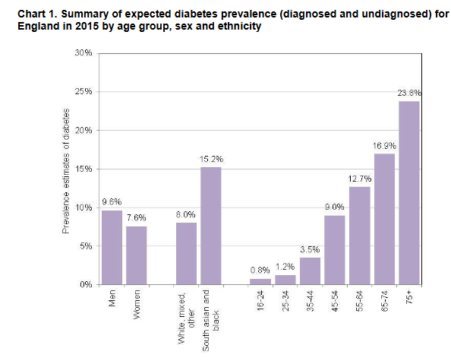
Figure 2: NHS (2023)
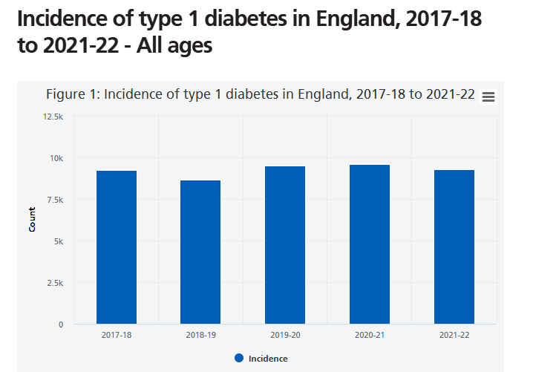

Measuring, Monitoring, and Controlling of Disease
Since type 1 diabetes is a condition in which the body begins to attack itself, healthcare professionals initially suggest measurement of type 1 diabetes through autoantibody testing. Identification and measurement of type 1 diabetes is recommended through autoantibody screening because it detects immune markers that negatively affect pancreatic beta cells (CDC, 2024). In this regard, the body begins to show markers of GADA, IA-2A, and ZnT8A, which can be detected in autoantibody testing (Ilonen et al., 2017). The number of autoantibodies determines the risk of developing type 1 diabetes. Its application could be seen in a study that used a sample size of 100,000 children and found excessive autoantibodies, which confirmed type 1 diabetes through capillary blood collection (Raab et al., 2016).
In addition, a fasting blood glucose test also serves as a vital measurement tool for the identification of type 1 diabetes (Mathew and Zubair, 2026). Since it requires people not to eat for a minimum of 7-8 hours, it accurately identifies variances in body’s sugar levels without any food intake activity. Studies highlight that a blood glucose concentration of more than 7.0 mmol/L (126 mg/dL) is a significant predictor of type 1 diabetes (DiMeglio, Evans-Molina and Oram, 2019).
WHO (2011) has recommended the haemoglobin A1c (HbA1c) test for identification of diabetes. It identifies the amount of glucose sugar stuck to haemoglobin that is not fully processed by the body. An HbA1c level of 6.5% is a strong predictor for identifying type 1 diabetes (WHO, 2011). Collectively, the findings have highlighted that autoantibody screening, fasting blood glucose test, and HbA1c are internationally recognised and credible tests for type 1 diabetes measurement.
Apart from screening, it is equally essential to continuously monitor glucose levels after type 1 diabetes diagnosis has been confirmed. In this regard, research has highlighted the importance of flash glucose monitoring because it not only reduces DKA admissions but also improves HbA1c (Tyndall et al., 2019). However, critics argue that real-time continuous glucose monitoring is comparatively better than flash glucose monitoring in terms of improving hypoglycemia (Hásková et al., 2020). These findings are consistent with a study that supported the role of continuous glucose monitoring because it effectively measures glucose in accordance with time ranges and glycaemic variability (Carr et al., 2026). Other studies have supported the effectiveness of wearable glucose monitoring sensors because of their diverse glucose-oxidase characteristics that quickly provide measurements within a time frame of 5 minutes (Cappon et al., 2017).
A hybrid model consisting of integration of biomedical, psychological, education, support, and patient collaboration is recommended for controlling and preventing further development of type 1 diabetes. In this regard, the treatment of type 1 diabetes consists of insulin therapy, oral medications, dietary changes, and lifestyle modifications. Additionally, the American Diabetes Association (ADA) has recommended Glucagon-like peptide 1receptor agonists (GLP1-RAs) and sodium-glucose cotransporter 2 inhibitors (SGLT2is) for preventing diabetes because such medications significantly prevent cardiovascular diseases, which are likely to coexist with diabetes (Wisniewski et al., 2024). Another study highlighted the importance of metformin for diabetes prevention (Foretz, Guigas, and 2023). While biomedical interventions may control sugar levels to a significant extent, it is equally important to improve lifestyle practices. In this regard, Mediterranean diet plan and lifestyle modification practices are recommended for controlling glucose levels in diabetes. Literature shows that legumes, nuts, and fish are fundamental components of the Mediterranean diet plan that are central for diabetes prevention (Calabrese, Valentini and Calabrese, 2021). Evidence shows that the Mediterranean diet leads to diabetic prevention for both children and adolescents (Güneş Kaya et al., 2024).
Collectively, these findings suggest that an effective nutrition plan followed with exercises and lifestyle modification practices is essential for controlling type 1 diabetes.
However, critics argue that diabetic patients tend to get exhausted because of complex medications and pressure to adopt lifestyle modification practices (Nyirongo, 2017). Under such circumstances, literature emphasises providing recommendations that are aligned with the tolerance level of diabetic patients (Anais et al., 2025). This is aligned with the theoretical model of Reason’s Swiss Cheese theory, who proposed that patients experience difficulties due to systematic weaknesses and simultaneous failure of multiple layers of defense (Anais et al., 2025). This implies that while healthcare professionals may prescribe Metformin, salmon, and aerobics to patients, they often neglect patients’ tolerance levels and individual circumstances, which is a significant systematic vulnerability.
Under such circumstances, it is essential to provide medications and recommendations based on patients’ tolerance levels. This can be best done through maintaining effective bonds with patients, educating them, and encouraging them towards self-care. This is aligned with literature that emphasises healthcare professionals teaching insulin administration, glucose monitoring, and healthy lifestyle practices for improving glycemic control in diabetic patients (Arias, Santacruz, and Torales, 2021). Other studies have highlighted the importance of maintaining effective patient communication and promoting personalised education (Mora, 2025). Collectively, these findings reveal that type 1 diabetes cannot be controlled by using medications as a stand-alone measure; rather, it is best controlled through effective integration of medications, lifestyle modification practices, a Mediterranean diet plan, and education.

Consequences of Type 1 Diabetes and the Role of Health and Social Support Services
Generally, genes, stress, poor socio-economic background, and deprivation are some of the factors that negatively affect diabetic outcomes. Diabetes UK (2023) shows that the likelihood of diabetes progression increases for a child when one or both parents are diagnosed with type 1 diabetes. Furthermore, the consequences of type 1 diabetes can adversely impact patients in all dimensions. This is supported by the NHS (2024a), which found that type 1 diabetic patients can experience coronary heart disease, stroke, damaged nerves, and constrained blood supply. Similarly, Diabetes UK (2025) proposed that type 1 diabetes can cause retinopathy problems where diabetic patients may experience blurred vision to a significant extent. However, the consequences of type 1 diabetes are not merely constrained to negative physical changes, but instead it extends to social life. For instance, diabetic patients require continuous glucose monitoring, social support, and money for regular check-ups. This poses a financial strain on families where they are expected to provide both financial and emotional assistance, which is not always realistic during times of hyperinflation. This is supported by a study that found families of diabetic patients experiencing negative emotions.
Collectively, these findings support the notion that the consequences of type 1 diabetes span from physical abnormalities to financial strain, emotional overlap, and constrained social life. However, there are multiple social care support services available in the UK for supporting diabetic patients. In this regard, Diabetes UK is the most dominant institution that not only provides financial incentives but also has its workforce always available on the helpline (Diabetes UK, 2019). Such an approach reflects its commitment to supporting diabetic patients because its helpline service is effective for assisting diabetic patients who may prefer to remain anonymous. What truly makes Diabetes UK stand out from other services is that it also provides guidance to families of diabetic patients (Diabetes UK, 2019a). This reveals that it recognises the social and physical burden of diabetes on families. Similarly, the NHS provides medical guidance while the UK government offers financial assistance to support diabetic patients. This reveals the government’s effective approach for recognising its community’s diabetic issues.

Conclusion
In conclusion, the UK is experiencing a high prevalence rate of type 1 diabetes, while findings have revealed that its incidence rate is likely to increase in the future. Since the consequences of type 1 diabetes range from excessive peeing to DKA, diabetic patients must follow medications, a Mediterranean diet plan, lifestyle modification practices, and self-care. Ultimately, the findings have addressed the need for reducing type 1 diabetes by seeking Diabetes UK’s help.

References
Anais, K., Soria, I., Obdulia, E., Loja, A. and Mercedes, J. (2025). Nursing strategies to improve treatment adherence in patients with type 2 diabetes. Community and Interculturality in Dialogue, 5, pp.156–156. https://doi.org/10.56294/cid2025156.
Arias, J.V., Santacruz, J.A. and Torales, J. (2021). Comprendiendo la conducta del paciente con diabetes: estrategias para mejorar la adherencia terapéutica. Medicina clínica y social, 5(2), pp.90-99. https://doi.org/10.52379/mcs.v5i2.187.
Calabrese, C.M., Valentini, A. and Calabrese, G. (2021). Gut Microbiota and Type 1 Diabetes Mellitus: The Effect of Mediterranean Diet. Frontiers in Nutrition, 7. doi:10.3389/fnut.2020.612773.
Cappon, G., Acciaroli, G., Vettoretti, M., Facchinetti, A. and Sparacino, G. (2017). Wearable Continuous Glucose Monitoring Sensors: A Revolution in Diabetes Treatment. Electronics, [online] 6(3), p.65. doi:10.3390/electronics6030065.
Carr, A.L.J., Sutton, H., Agesen, R.M., Bonifacio, E., Bosi, E., Gillard, P., Swaby, R., Vercauteren, J. and Besser, R.E.J. (2026). Continuous glucose monitoring as a tool in early-stage type 1 diabetes. Diabetologia, [online] pp.10.1007/s00125–026–06707–4. doi:10.1007/s00125-026-06707-4.
CDC (2024). Testing for Diabetes. [online] Diabetes. Available at: https://www.cdc.gov/diabetes/diabetes-testing/index.html [Accessed 23 July 2026].
Diabetes UK (2019). Support for You. [online] Diabetes UK. Available at: https://www.diabetes.org.uk/support-for-you [Accessed 23 July 2026].
Diabetes UK (2019a). Care and support. [online] Diabetes UK. Available at: https://www.diabetes.org.uk/about_us/what-we-do/care-and-support [Accessed 23 July 2026].
Diabetes UK (2022). Type 1 diabetes symptoms. [online] Diabetes UK. Available at: https://www.diabetes.org.uk/about-diabetes/type-1-diabetes/symptoms [Accessed 23 July 2026].
Diabetes UK (2023). Type 1 diabetes. [online] Diabetes UK. Available at: https://www.diabetes.org.uk/about-diabetes/type-1-diabetes [Accessed 23 July 2026].
Diabetes UK (2025). Complications of diabetes. [online] Diabetes UK. Available at: https://www.diabetes.org.uk/about-diabetes/looking-after-diabetes/complications [Accessed 23 July 2026].
DiMeglio, L.A., Evans-Molina, C. and Oram, R.A. (2019). Type 1 Diabetes. The Lancet, [online] 391(10138), pp.2449–2462. doi:10.1016/s0140-6736(18)31320-5.
Foretz, M., Guigas, B., and Viollet, B. (2023). Metformin: update on mechanisms of action and repurposing potential. Nature Reviews. Endocrinology, 1 - 17. https://doi.org/10.1038/s41574-023-00833-4.
Güneş Kaya, D., Arslan, N., Ayyıldız, F., Bayramoğlu, E., Turan, H. and Ercan, O. (2024). The potential of the Mediterranean diet to improve metabolic control and body composition in youths with Type 1 Diabetes Mellitus. BMC Endocrine Disorders, 24(1), p.63.
Hásková, A., Radovnická, L., Petruželková, L., Parkin, C.G., Grunberger, G., Horová, E., Navrátilová, V., Kádě, O., Matoulek, M., Prázný, M. and Šoupal, J. (2020). Real-time CGM Is Superior to Flash Glucose Monitoring for Glucose Control in Type 1 Diabetes: The CORRIDA Randomized Controlled Trial. Diabetes Care, [online] 43(11), pp.2744–2750. doi:10.2337/dc20-0112.
Ilonen, J., Lempainen, J., Hammais, A., Laine, A.-P., Härkönen, T., Toppari, J., Veijola, R. and Knip, M. (2017). Primary islet autoantibody at initial seroconversion and autoantibodies at diagnosis of type 1 diabetes as markers of disease heterogeneity. Pediatric Diabetes, 19(2), pp.284–292. doi:10.1111/pedi.12545.
Mathew, T.K. and Zubair, M. (2026). Blood glucose monitoring. In StatPearls [Internet]. StatPearls Publishing.
Mora, C.J. (2025). El rol de la enfermería en la gestión de la adherencia al tratamiento farmacológico en pacientes con enfermedades crónicas. Reincisol., 4(7), pp.1759–1786. https://doi.org/10.59282/reincisol.v4(7)1759-1786.
NHS (2019). Type 1 diabetes. [online] NHS. Available at: https://www.nhs.uk/conditions/type-1-diabetes/ [Accessed 23 July 2026].
NHS (2023). Incidence and prevalence of diabetes, 2017-18 to 2021-22. [online] NHS Digital. Available at: https://digital.nhs.uk/data-and-information/publications/statistical/national-diabetes-audit/report-1-care-processes-and-treatment-targets-2021-22-full-report/section-1---incidence-and-prevalence-17-18---21-22-copy [Accessed 23 July 2026].
NHS (2024). Symptoms of type 1 diabetes and how it’s diagnosed. [online] nhs.uk. Available at: https://www.nhs.uk/conditions/type-1-diabetes/symptoms/ [Accessed 23 July 2026].
NHS (2024a). Complications of type 1 diabetes. [online] nhs.uk. Available at: https://www.nhs.uk/conditions/type-1-diabetes/complications/ [Accessed 23 July 2026].
NICE. (2026). Background Information. [online] NICE. Available at https://cks.nice.org.uk/topics/diabetes-type-1/background-information/prevalence/ [Accessed 23 July 2026].
Nyirongo, S. (2017). Adherence to treatment by patients with type 2 diabetes mellitus at Monze Mission Hospital, Monze, Zambia (Doctoral dissertation, The University of Zambia).
Ogle, G. D, Wang, F., Haynes, A., Gregory, G.A., King, T.W., Deng, K., Dabelea, D., James, S., Jenkins, A.J., Li, X., Ma, R.C.W., Maahs, D.M., Oram, R.A., Pihoker, C., Svensson, J., Zhou, Z., Magliano, D.J. and Jayanthi Maniam (2025). Global type 1 diabetes prevalence, incidence, and mortality estimates 2025: Results from the International diabetes Federation Atlas, 11th Edition, and the T1D Index Version 3.0. Diabetes Research and Clinical Practice, 225(112277), pp.112277–112277. doi:10.1016/j.diabres.2025.112277.
Public Health England. (2016). Diabetes Prevalence Model. [online] Public Health England. Available at https://assets.publishing.service.gov.uk/media/5a82c07340f0b6230269c82d/Diabetesprevalencemodelbriefing.pdf [Accessed 23rd July 2026].
Raab, J., Haupt, F., Scholz, M., Matzke, C., Warncke, K., Lange, K., Assfalg, R., Weininger, K., Wittich, S., Löbner, S., Beyerlein, A., Nennstiel-Ratzel, U., Lang, M., Laub, O., Dunstheimer, D., Bonifacio, E., Achenbach, P., Winkler, C. and Ziegler, A.-G. (2016). Capillary blood islet autoantibody screening for identifying pre-type 1 diabetes in the general population: design and initial results of the Fr1da study. BMJ Open, [online] 6(5), p.e011144. doi:10.1136/bmjopen-2016-011144.
Tyndall, V., Stimson, R.H., Zammitt, N.N., Ritchie, S.A., McKnight, J.A., Dover, A.R. and Gibb, F.W. (2019). Marked improvement in HbA1c following commencement of flash glucose monitoring in people with type 1 diabetes. Diabetologia, [online] 62(8), pp.1349–1356. doi:10.1007/s00125-019-4894-1.
WHO (2011). Use of glycated haemoglobin (‎HbA1c)‎ in diagnosis of diabetes mellitus. [online] www.who.int. Available at: https://www.who.int/publications/i/item/use-of-glycated-haemoglobin-(-hba1c)-in-diagnosis-of-diabetes-mellitus [Accessed 23 July 2026].
Wisniewski, B., Smith, E., Kaur, J., Sherling, C., Vanapalli, S. and Lussier, M. (2024). Medicare formulary restrictions for glucagon-like peptide 1 receptor agonists and sodium glucose cotransporter 2 inhibitors used in type 2 diabetes mellitus: 2019-2023. Journal of Managed Care & Specialty Pharmacy, [online] 30(1), pp.34–42. https://doi.org/10.18553/jmcp.2024.30.1.34.

