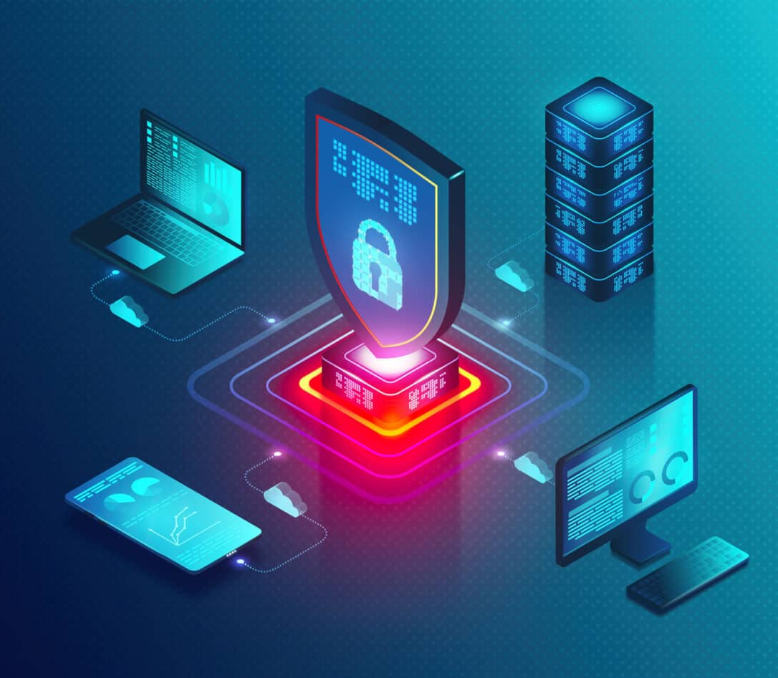
Student NO | 2440118
Student name: | Mohamad A Idris
Programme: | CertHE Computing Skills for Workplace
Module: | Networks and Cyber Security Essentials
Module code: | ACCA4024
Lecturer: | Muhammad Azeem Abbas

Contents
Introduction 2
Comprehensive Data Security and Governance Framework 5
The framework is built upon five pillars: 6
5.0 Mitigation Measures Specific technical and organisational controls to counter identified threats. Unauthorized Cloud Access, 8
Conclusion 11
Cyber Threat Table: Analyze and Protect Tools 12
Samples of Cybersecurity Accident:1 14
References 18

Introduction
Building a secure network for is like constructing a fortress: we need to lay a solid physical foundation and then establish multiple layers of defence to protect what's inside. here is a comprehensive breakdown of what we need, covering both the physical setup and the cybersecurity measures.
We can approach this as a project with two main phases:
- Building the Network Infrastructure and then.
- Securing It Cybersecurity.
Phase 1: Building the Physical Network
Before we secure anything, we need a reliable and well-planned network. This involves choosing the right type of network and gathering the essential hardware.
1. Choose Network Type:
· Wired Network: Ideal for desktop computers, servers, and printers that don't move. It offers the fastest and most secure connection.
· Wireless Network: Essential for mobile devices like laptops, tablets, and phones. It provides flexibility but needs strong security measures.
· Hybrid Network: The most common and recommended choice for businesses. It combines the speed and security of wired connections for static devices with the convenience of Wi-Fi for mobile ones.
2. Gather Essential Hardware
Here is a checklist of the physical components you will need:
Hardware component function, why it's Important for router connects your business to your Internet Service Provider (ISP). This is your gateway to the internet. Usually provided by your ISP.
Router Directs traffic between your local network and the internet. Choose a business-grade router for better performance, security features, like firewall and VPN support, and the ability to handle more connected devices.
Network Switch Connects all your wired devices, computers, printers, servers, to the network. A managed switch is highly recommended as it allows you to monitor traffic, prioritize data quality of service, and configure secure virtual Local Area Networks (VLANs).
Wireless Access Point (WAP): Broadcasts the Wi-Fi signal throughout your office. For reliable coverage, use multiple WAPs instead of relying on a consumer-grade router's built-in Wi-Fi. This eliminates dead zones.
Ethernet Cables the physical cables that connect wired devices to the switch. Use cables for reliable gigabit speeds and to reduce interference.
Patch panel a central panel where all the Ethernet cables from wall outlets terminate. Keeps your wiring organized, tidy, and easy to troubleshoot. It connects to your switch via short cables.
Server and network attached storage NAS: Optional but recommended, centralizes file storage, backups, and application hosting. Makes data management, sharing, and backup easier and more secure.
Uninterruptible Power Supply UPS: Provides temporary battery power during an outage. Protects your critical equipment like router, switch, server from power surges and allows for safe shutdown, preventing data loss.
Pro-Tip for Setup: Plan your network by mapping out where devices will go. Run cables to desks for static devices, like desktops, to free up Wi-Fi bandwidth for mobile devices, improving performance for everyone.
Phase 2: Implementing Cybersecurity Layers
Once your network is physically set up, the next step is to build your defences. This is your cybersecurity layer, designed to protect your data and devices from threats. A multi-layered approach is key.
1. Secure the Perimeter (Network Security)
· Hardware Firewall: Don't just rely on a basic router. Consider a dedicated hardware firewall or a Unified Threat Management (UTM) appliance placed between your modem and your network. This device inspects all traffic coming in and out. Ensure its firmware is always updated.
· Network Segmentation (VLANs): Use your managed switch to create separate virtual networks. For example, create a Guest Wi-Fi network completely isolated from your Internal Business Network (where sensitive data lives) and another for Security Cameras. This prevents a compromised guest device from accessing your company files.
2. Protect Your Devices (Endpoint Security)
· Endpoint Detection and Response (EDR): Move beyond basic antivirus. EDR software on all laptops, desktops, and servers provides advanced threat detection, monitoring for suspicious behaviours and automatically responding to incidents.
· Patch Management: Enable automatic updates for operating systems (Windows, macOS) and all software (Zoom, Adobe, Chrome). Outdated software is a top reason for breaches.
3. Control Access (Identity Management)
· Multi-Factor Authentication (MFA): This is non-negotiable. Require MFA for every single account, especially email, banking, and remote access. It ensures that a stolen password is not enough to log in.
· Least Privilege Access: Give employees access only to the files and systems they absolutely need to do their jobs. A junior staff member shouldn't have access to HR payroll folders.
· Strong Password Policy: Use a password manager to enforce long, unique passwords for every service.
4. Secure Your Data (Data Protection)
· Encryption: Encrypt all sensitive data. This includes data on devices (full-disk encryption) and data sent over the network (using encrypted protocols and ensuring your website uses HTTPS) .
· Regular Backups: Follow the 3-2-1 Backup Rule: Keep at least 3 copies of your data, on 2 different types of media (e.g., an external drive and the cloud), with 1 copy stored off-site. Crucially, test restoring from your backups regularly to ensure they work.
5. Strengthen Your Human Firewall (Policies & Training)
· Security Awareness Training: Regularly train employees to spot phishing emails, avoid suspicious links, and understand safe internet practices. Since human error causes a huge percentage of breaches, this training is your most important investment.
· Incident Response Plan: Have a simple, written plan for what to do if a breach happens. Who do you call? How do you isolate an infected computer? How do you restore from backups? Practice this plan.
6. Monitor and maintain
· Logging and Monitoring: Set up your firewall and systems to create logs. Reviewing these logs (or using a service that does) can help you spot unusual activity, like a strange device trying to connect, before it becomes a major issue.
Building a secure network is not a one-time task but an ongoing process. Start with the physical setup using quality hardware, then methodically work through these security layers.

Comprehensive Data Security and Governance Framework
Role: IT Security Manager
Organisation: UK Healthcare Technology Company
Scope: Protection of sensitive patient data, compliance with UK GDPR and NHS Digital Security Standards
The healthcare sector is a high-value target for cybercriminals due to the sensitivity and financial value of patient data. As a UK-based healthcare technology provider processing large volumes of sensitive health records, our organisation faces heightened risk from cyberattacks, insider threats, regulatory non-compliance, and operational disruption.
Recent incidents including unauthorised cloud data access and a ransomware attack demonstrate vulnerabilities in access control, monitoring, and resilience planning. This report presents a comprehensive data security and governance framework designed to:
Strengthen confidentiality, integrity, and availability (CIA) of data
Ensure compliance with UK GDPR and NHS Digital Security Standards
Mitigate internal and external cyber threats
Establish proactive monitoring and incident response capabilities
Foster a culture of security awareness
The framework aligns with recognised standards such as ISO/IEC 27001 and the NCSC Cyber Assessment Framework and adopts a Zero Trust security approach.
This report outlines a comprehensive data security and governance framework for HPA, a healthcare technology company processing sensitive UK patient data. In response to recent data protection incidents, this framework is designed to systematically strengthen defences, ensure compliance with the UK GDPR and NHS Digital Security Standards, and cultivate a robust security culture.

The framework is built upon five pillars:
- Identification of threats, security policies, mitigation measures, monitoring and response, and Training and awareness. Implementation of this integrated plan will significantly reduce risk, protect patient information, and restore stakeholder trust, securing HPA’s position as a reliable partner in the UK healthcare sector.
2.0 Introduction & Scope HPA operates in a high-risk, high-trust environment. The sensitive nature of patient data, stringent regulatory landscape UK GDPR, and NHS data security and protection toolkit, and evolving cyber-threat landscape require experience, proactive security status. Recent incidents involving unauthorised cloud access and ransomware highlight critical vulnerabilities. This framework provides a strategic roadmap to transition from a reactive to a proactive and resilient security model, embedding data protection into the fabric of the organisation’s operations.
Identification of threats is a clear understanding of threats is fundamental. Threats are categorised as Internal and External.
3.1 Internal Threats Insider threats malicious:
- Neglected employees or contractors with privileged access intentionally exfiltrating data, sabotaging systems, or facilitating external attacks.
- Insider Threats: Well-meaning staff who cause breaches through human error, such as misconfiguring cloud storage, falling for phishing attacks, losing devices, or emailing data to incorrect recipients.
- Inadequate access controls: Overly permissive user privileges, dormant accounts of former employees, and lack of role-based access control leading to unnecessary data exposure.
-Weak development practices: Vulnerabilities in HPA’s proprietary software or analytics platforms due to insecure coding practices, lack of penetration testing, and insufficient software development life cycle security integration.
3.2 External threats ransomware and malware:
- Targeted attacks, like the one experienced, that encrypt data on analytics servers, demanding payment for restoration. This leads to operational disruption and potential data theft.
- Phishing and social engineering: False communications designed to steal credentials or deliver malware, often the initial vector for larger breaches.
- Cloud configuration exploitation: Automated scans and targeted attacks seeking misconfigured cloud services storage, databases to gain unauthorized access.
-Advanced continued threats: Sophisticated, state-sponsored or criminal groups conducting prolonged, stealthy campaigns to exfiltrate sensitive health data for espionage or fraud.
-Third-party and supply chain risk: Vulnerabilities in vendors, partners, or open-source software components integrated into HPA’s environment.
-DDoS attacks: Attempts to overwhelm network resources, causing service disruption for client hospitals and clinics.
4.0 Security Policies provide the formal rules and standards governing HPA’s security posture. All policies shall be reviewed annually and aligned with ISO 27001, NIST CSF, UK GDPR, and NHS standards.
-1. Data classification and handling policy: Mandates classification of all data, NHS confidential, patient Identifiable. Defines strict handling rules for storage, transmission, and destruction per classification level.
-2. Access control policy: Enforces the principles of requires robust authentication MFA for all access, timely user supplying and un supplying, and regular access reviews.
-3. Cloud security policy: Establishes mandatory security configurations for all cloud services, including encryption at rest and in transit, logging enabled, and formal change management for configuration.
-4. Network security policy: Defines segmentation strategies, isolating analytics servers from general corporate networks, firewall rules, and secure remote access protocols VPN with MFA.
-5. Incident response and breach notification policy: Formalises roles, responsibilities, and procedures for detecting, reporting, responding to, and recovering from incidents. Includes strict timelines for internal escalation and regulatory reporting per UK GDPR less than72-hour mandate.
-6. Acceptable use policy clearly outlines acceptable and forbidden use of company IT assets, including email, internet, and software.
-7. Password authentication policy: Requires strong, unique passwords and mandates multi-factor Authentication MFA for all systems accessing sensitive data or administrative functions.
-8. Software development security policy: Integrates security into the software security, requiring threat modelling, static and dynamic code analysis, and penetration testing before deployment.

5.0 Mitigation Measures Specific technical and organisational controls to counter identified threats. Unauthorized Cloud Access,
1.Cloud security posture management and configuration hardening. Deploy a tool with firm’s like, Wiz, Prisma Cloud, to continuously scan environments for mis configurations against NHS benchmarks. Automate where possible. Implement Infrastructure templates with security baked in.
2. Enhanced data encryption and access logging. Enforce mandatory encryption for all data using customer-managed keys where feasible. Enable detailed access logging for all cloud storage and database. Logs must be stored in a secure security information and event management.
Ransomware & malware:
3.Network segmentation & endpoint protection. Implement strict network segmentation micro-segmentation ideally to isolate analytics servers, development environments, and corporate networks. Deploy next-generation antivirus and firewall and endpoint detection and response solutions on all endpoints and servers, with 24/7 managed threat hunting.
4. Robust, Immutable Backups. Implement the 3-2-1 backup rule, 3 copies, on 2 different media, with 1 copy offline. Regularly test backup restoration processes. Air-gapped or cloud backups are critical for analytics server data.
Insider threats & errors
- Privileged access management and user behaviour analytics, solution to vault, monitor, and session-record all privileged access, admin accounts. Implement a solution to baseline normal user behaviour and flag anomalies, bulk downloads, access at unusual hours.
- Data loss prevention. Deploy a network and endpoint DLP solution to monitor and block unauthorized attempts to exfiltrate sensitive patient data via email, web uploads, or USB devices, based on the Data Classification policy.
- Phishing and credential theft. Advanced email security and mandatory. Implement an advanced email gateway with URL rewriting, attachment sandboxing, and impersonation protection. using phishing-resistant methods security keys for administrative accounts. Regulatory non-compliance
- Automated compliance monitoring and data protection impact assessment integration. Utilise the cloud security posture management tool and security information and event management tools to generate automated compliance reports against UK GDPR and NHS requirements. Integrate Data Protection Impact Assessments into all project lifecycles for new data processing activities.
6.0 Monitoring and Response Plan A proactive, cyclical approach is required prepare, identify, contain, eradicate, recover, and learn.
6.1 Continuous Monitoring Architecture Centralised SIEM:
Aggregate logs from all critical systems cloud, network, endpoints, applications into a central security information and event management system. Security operations centre: Establish a dedicated internal team or contract a managed security service provider for round-the-clock monitoring, alert triage, and initial response.
Threat Intelligence Feeds: Integrate industry-specific healthcare threat intelligence to tailor detection rules to relevant threats.
Key Stages: Preparation: Maintain the IR plan, contact lists, and communication templates.
Identification & Triage: SOC analyses SIEM alerts. A pre-defined severity matrix triggers appropriate response levels.
Containment: Immediate isolation of affected systems, network quarantine followed by longer-term containment, credential resets.
Eradication & Recovery: Identify root cause, remove malware, patch vulnerabilities. restore systems from clean, validated backups. Post-Incident activity lessons learned, mandatory review within 2 weeks. Document findings, update policies controls, and refine detection rules. This feedback loop is critical for maturity.
7.0 Training and Awareness Program Technology alone is insufficient. Employees are the first and last line of defence.
Program Goal: To create a sustainable human firewall by fostering a culture of shared responsibility for data security.
Core principles continuous, not annual move beyond annual checkbox training to ongoing engagement.
Role-Based: Tailor content for developers, data analysts, HR, and executives. Engaging & Relevant: Use healthcare-specific scenarios, gamification, and phishing simulations.
Measured: Track metrics beyond completion rates, phishing click rates, reported incidents.

Program Components:
- Foundation Training Mandatory, on hire & annually:
1.Core modules: data protection UK GDPR, acceptable use, password hygiene, phishing awareness, physical security, and Incident reporting procedures.
Format: Interactive e-learning with short knowledge checks.
- Phishing simulation campaigns: Run controlled, internal phishing tests with increasing sophistication. Those who fail are automatically enrolled in a short, remedial training module. Celebrate and reward employees who consistently report simulations.
- Role-specific deep dives:
- Developers: Secure coding, policy, data analysts cloud engineers, secure data handling, cloud configuration best practices.
- Leadership Board: Cyber risk governance, regulatory responsibilities, crisis communication.
- Continuous Engagement:
- Security champions network: Recruit volunteers from each department to disseminate messages and provide feedback. Monthly security bulletins short emails or intranet posts on topical threats, policy reminders, and positive security stories. Promote and simplify the reporting process for suspicious emails or activity, ensuring free culture for good-faith reports.
8- Metrics & Reporting:
Track: Training completion, phishing simulation click report rates, number of internal security incidents reported, time to report. Report metrics quarterly to the Board to demonstrate cultural progress.

Conclusion
This framework provides HPA with a holistic, actionable plan to secure sensitive patient data, achieve compliance, and rebuild trust. The interconnected nature of the five pillars ensures defences are layered and resilient.
Recommended Immediate Next Steps:
- Board Approval & Funding: Secure commitment and resources for implementation.
- Project Initiation: Form a dedicated programme team with cross-functional representation IT, Security, Legal, HR, Operations.
- Policy Finalisation & Communication: Finalise and formally communicate the new Security Policies.
- Technology collecting & deployment: Begin collecting for critical tools identified like cloud security poster management, endpoint detection and response, security information and event engagement, privileged access management, data loss prevention.
- Launch Phase 1 Training: Roll out the foundation training and first phishing simulation to all staff within 90 days. By adopting this proactive and comprehensive framework, HPA will not only protect the patients it serves but also secure its own future as a trusted leader in healthcare technology.

Threat Category | Primary Target (Entry/Goal | Attack Method | Primary Defense Mechanism
Ransomware (Double Extortion) | User Devices & Servers | Encrypting local data followed by data exfiltration for blackmail purposes. | Immutable Backup & XDR: Storage that is isolated and cannot be removed by attackers.
Supply Chain Attack | Third-Party Software Updates | Introducing malicious code into legitimate software provided by trusted vendors. | Software Bill of Materials (SBOM): Thorough evaluation of third-party dependencies and code signing.
Advanced Persistent Threat (APT | Network Infrastructure | Covert, long-term infiltration to extract data or monitor communications. | Network Micro-segmentation: Splitting the network into smaller segments to hinder lateral movement.
Business Email Compromise | Communication Platforms (Email/Teams | Employing social engineering or deepfakes to impersonate executives for financial gain. | DMARC & MFA: Enforcement of strict email authentication standards and hardware-based solutions.
Zero-Day Exploit | Application Layer (Software) | Taking advantage of unpatched vulnerabilities in software that are not yet known | WAF & Virtual Patching: Utilizing Web Application Firewalls to block suspicious traffic patterns.
DDoS (Distributed Denial of Service) | External Network Perimeter | Overloading servers with excessive junk traffic to disrupt services. | Cloud Centers  Employing traffic filtering services that manage and cleanse incoming data.
Insider Threat Internal Databases | HR Systems Harmful or careless actions by authorized staff or contractors. | User Behaviors Analytics | Monitoring data access or downloads, along with prohibiting USB usage.
Phishing Credential Harvesting | the Human ElementMisleading websites or messages aimed at capturing login credentials. | Zero Trust Identity | Confirming identity based on device integrity, user location, and behavioral patterns.

Cyber Threat Table: Analyze and Protect Tools

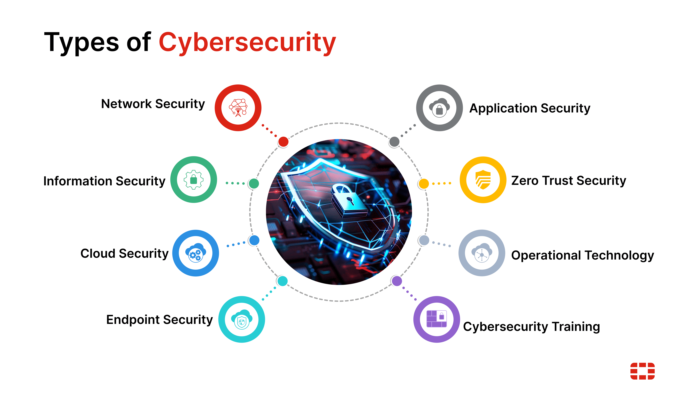
Governance, Risk Management, and Compliance (GRC)

Feature | ISO/IEC 27001 | NIST Cybersecurity Framework (CSF)
Origin | International Organization for Standardization (ISO) | U.S. National Institute of Standards and Technology (NIST)
Structure | Prescriptive; requires implementation of specific controls (Annex A) within an ISMS. | Framework-based; organised around 5 core functions: Identify, Protect, Detect, Respond, Recover.
Focus | Process and certification. Demonstrates a formal, audited ISMS. | Risk management and outcomes. Provides a common language for cybersecurity risk.
Typical Use | Formal certification, regulatory compliance, structured ISMS implementation. | Strategic planning, maturity assessment, and cross-functional risk communication.
Flexibility | Lower; controls are explicitly defined but can be tailored. | Higher; acts as a flexible framework adaptable to any organisation's specific risks.

Samples of Cybersecurity Accident:1

Criminals hijack thousands of devices to create never-before-seen cyber weapon
Victims of the KadNap botnet are spread throughout the world
Anthony Cuthbertson
Monday 16 March 2026 14:13 GMT

Criminals have secretly hijacked more than 14,000 devices worldwide in order to carry out attacks that are almost impossible to protect against, security researchers have warned.
The majority of devices infected by the sophisticated new malware, dubbed ‘KadNap’, are Asus routers, which are being used to route malicious traffic to carry out large-scale cyberattacks.
Details of the KadNap botnet were shared by the cybersecurity firm Lumen in a new report, which revealed that it is using a decentralised peer-to-peer system to avoid network detection.
A botnet is created by compromising the security of internet-connected devices, which can range from routers to smart

Accedent2
A test from the UWTSD support Team to Jeck our Security knowledge, first the e-mail I received and the second and the third e-mails. The training I had to avoid such security issues.
Account verification
Summarise
Teams support<teamsnoreply@templateau.com>
​Mohamad Idris (2440118)​

Dear Mohamad,

We're committed to maintaining the security of your account. As part of our ongoing efforts to ensure the safety of your data, we're requesting a quick verification. Please click on the following link to verify your Microsoft Teams account:

Click Here

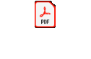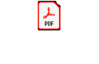

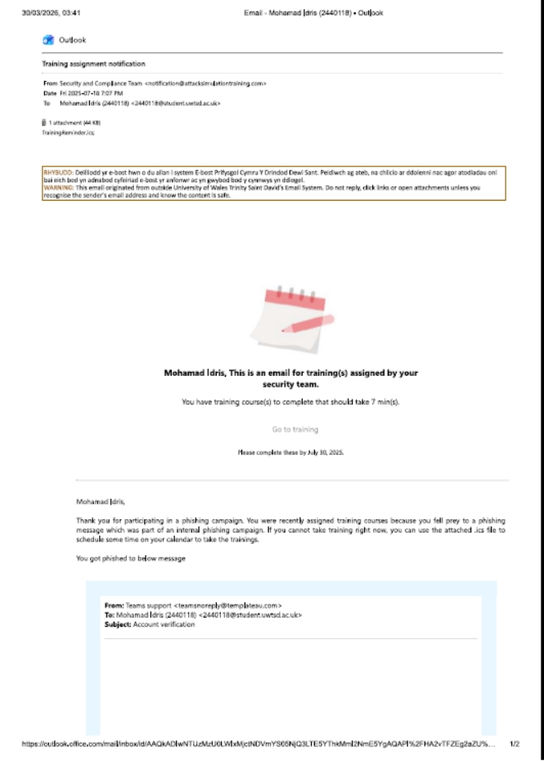

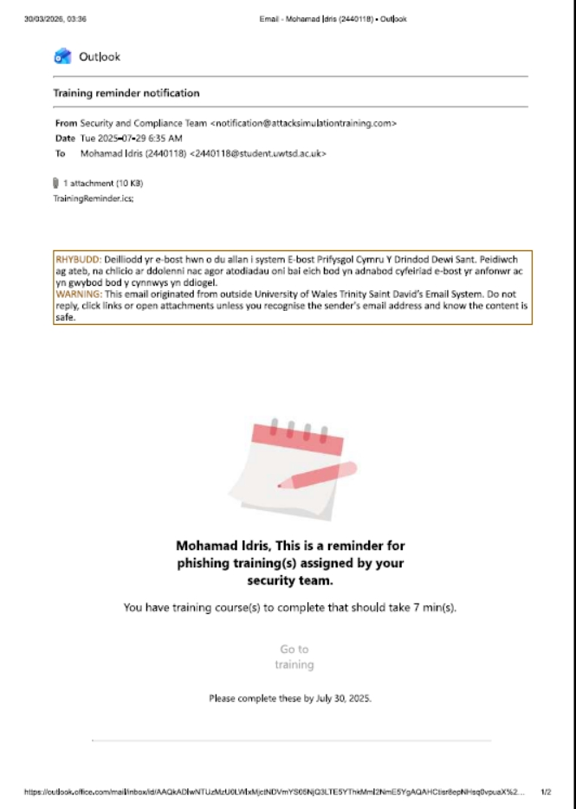

References
[1] A. Cuthbertson, “Criminals hijack thousands of devices to create never-before-seen cyber weapon,” The Independent, Mar. 16, 2026. https://www.independent.co.uk/tech/security/cyber-weapon-kadnap-botnet-hijack-malware-b2937703.html (accessed Mar. 30, 2026).
‌[2] Anderson, R. (2020). Security Engineering: A Guide to Building Dependable Distributed Systems (3rd ed.). John Wiley & Sons.
[3] CrowdStrike. (2021). Global Threat Report 2021. CrowdStrike Holdings, Inc.
[4] FireEye. (2020). *M-Trends 2020: Annual Threat Report*. FireEye, Inc.
[5] NIST. (2020). Zero Trust Architecture (NIST Special Publication 800-207). National Institute of Standards and Technology. https://doi.org/10.6028/NIST.SP.800-207
[6] SANS Institute. (2021). The SolarWinds Hack: Lessons Learned. SANS Institute Information Security Reading Room.
[7] Sophos. (2023). The State of Ransomware 2023. Sophos Group PLC.
[8] Stallings, W., & Brown, L. (2018). Computer Security: Principles and Practice (4th ed.). Pearson Education.
[9] “Data Security and Protection Toolkit - NHS Standards Directory,” Standards.nhs.uk, 2023. https://standards.nhs.uk/published-standards/data-security-and-protection-toolkit.
‌

