PROFESSIONAL CAREER DEVELOPMENT

Lavinia Neda 2312753

Table of Contents
Introduction 3
Component 1 3
Component 2 11
Conclusion 14
Reference list 15

Introduction
Professional development goals are segmented into two parts such as gaing theoretical knowledge and understanding the process of making the practical application (Vangrieken et al., 2017). In consideration of that situation, the purpose of the study is to evaluate the areas of strength and weakness with Kolb’s reflective model.

Component 1
Fulfilling the goals of professional development is based upon an evaluation of strengths, and weaknesses and adopting practical initiatives to bring change. The below-mentioned Kolb’s reflective cycle shows multiple areas of strength and weakness of students associated with business management study.
Reflection using Kolb’s Model
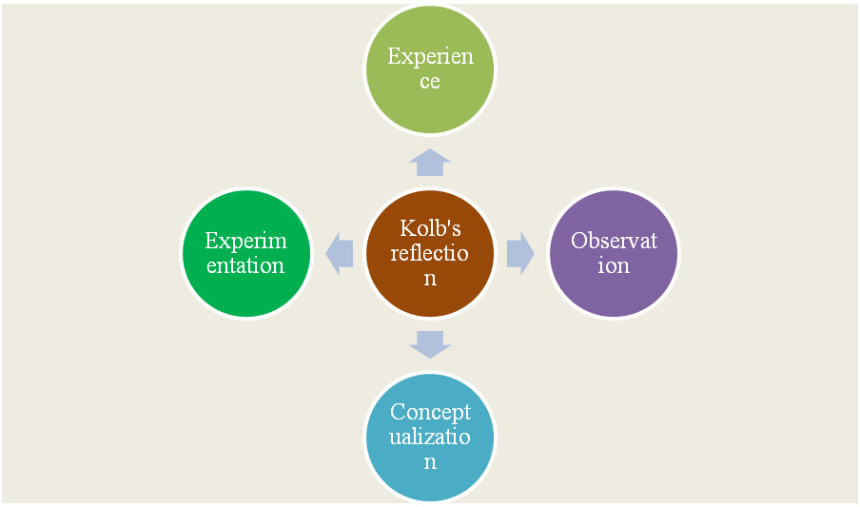
Figure: Stages of reflection
Source: ( Made by the learner)
Concrete experience
A professional career development plan helps to get insight regarding the practical implementation of knowledge I have gathered from management study. Planning, organising, directing and controlling are four major areas in which I have gained experience while participating in teamwork. Due to the immersive experiences, I have gathered from the module I got clarity regarding the practical application.
Reflective observation
Getting the opportunity to reflect upon the journey helps to create self-awareness regarding strengths, weaknesses, opportunities and threats. Reflection and self-awareness to work on the areas of weakness.
SWOT
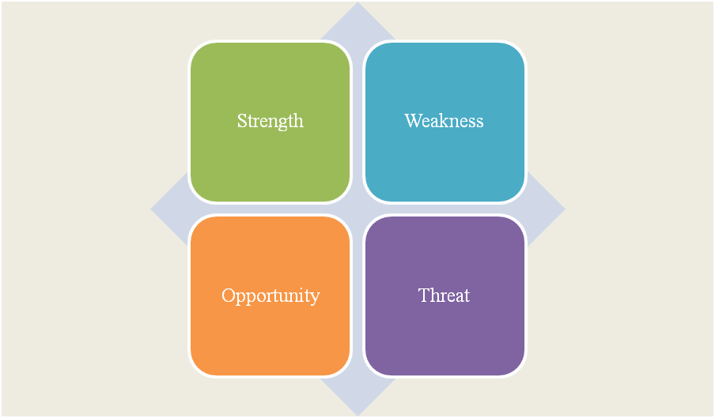
Figure: SWOT analysis
Source: ( Made by the learner)
Strength  - Honesty, and integrity while performing different tasks.  - Knowledge regarding the ongoing trend of global business management process. | Weakness  - The tendency towards missing deadlines to focus on minute details of the project.  - Lack of capability in collaborative communication with the team.
Opportunity  - Opportunity for practical skill development with the guidance of trainers.  - Understanding the improvement in leadership capability. | Threat  - A high level of market competition creates a risk for survival.  - Dynamic career fields sometimes require complete diversification of the practical understanding.
Table: SWOT analysis
Source: (Made by the learner)
From the above-mentioned analysis, it can be stated that working on areas of weakness can improve opportunities for career growth. The purpose is to work on the areas of gap and incraese accuracy in the pattern of work.
Abstract conceptualization
On the evaluation of theoretical knowledge gained and the process of practical implementation, I have developed an understanding of the process of working upon weaknesses. The below-mentioned SMART objectives show how the improvement can be accomplished in this segment.
SMART
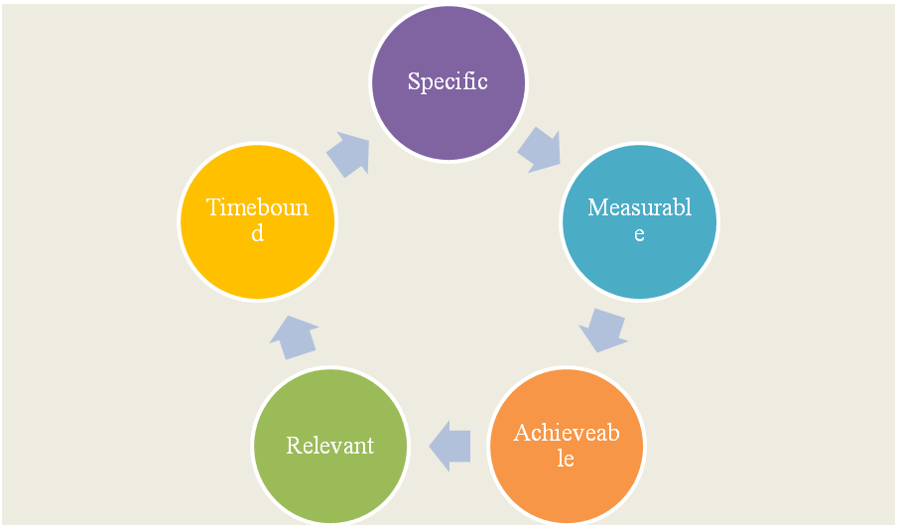
Figure: SMART objectives
Source: ( Made by the learner)
Objectives | Specific | Measurable | Achievable | Relevant | Time-bound
To bring improvement in the quality of work | To explore the understanding of the process of implementing knowledge associated with business studies in practical application and improve work quality | It can be measured with the help of expansion in the business network and lead conversion rate. | It can be achieved by following module learning and guidelines associated with business management principles. | It helps to develop guidelines about the implementation of knowledge gathered from the management study. | 3 months
To develop knowledge in the implementation of business principles. | Develop planning to implement an understanding of the process of business management. | It can be observed in terms of the skill development of team members and the potential for career growth in the team. | By launching a collaborative training programme and gaing support from team members equally. | It increases the opportunity to develop success in career goals and work on areas of weakness. | 4 months
To increase administration efficiency with data-driven decision-making making practice. | Adopt the process of data-driven decisions to improve administrative efficiency. | The rate of employee retention is another important factor in defining the scope of progress. | It can be achieved with the incraese of collaboration and communication among fellow members of the team. | It helps to increase the accuracy of business processes. | 6 months
Table: SMART objectives
Source: ( Made by the learner)
From the above-mentioned objectives, it can be analysed that by working on the goal of skill development an individual can reach targeted objectives. In this manner reducing challenges and accomplishing growth can become easier.
Active experimentation
This segment in Kolb’s Model focuses on developing deep insight into the process of implementing theoretical knowledge in terms of practical application. I have decided to identify areas of weakness and strength. Then the PDP plan is designed to work on the areas of gap.
Johari Window
Open area  Self-awareness, and adaptability help to develop a structured learning approach. This aspect has provided me with the opportunity to get acknowledgement in teamwork. | Hidden area  Certain aspects of my personality such as health issues, family problems and stress factors cause challenges for me many times. These aspects are completely hidden from fellow members of the team.
Unknown area  There are a few aspects of my personality traits which are undiscovered by others as well. | Blind area  A few areas of my skill need special focus such as communication, shyness and patterns when working with other team members.
Table: Johari window
Source: ( Made by the learner)
PDP
The below-mentioned PDP plan shows how the areas of weaknesses can be addressed by following effective strategies. The purpose is to achieve long-term career growth by working on weaknesses. It helps to develop skills and thus understanding the areas of skill gap becomes easier.
Skills to be developed | Process to improve | Resources required | Timeline
Communication skills | The practice of collaborative communication and improved command over languages. | Learning module of language skill development, online communication skill development programme. | 3 months
Time management skill | Setting deadlines, breaking the entire task into small segments. |  | 3-month
Leadership and Administration | Focusing upon the practice of active listening and working on conflict management strategy. | Reading modules on leadership strategy. | 3-month
Table: PDP
Source: ( Made by the learner)
Learning style
In the case of business studies, the style of learning plays an important role in increasing accuracy and level of knowledge. The below-mentioned table below shows different learning styles to get the scope of knowledge development. The purpose of learning style is to increase the scope of long-term success.
Learning-style | Analysis
Visual | With the use of images, graphics, and mind maps communicating a concept becomes easier. Thus learners can use this learning style to improve their knowledge level in business studies.
Auditory | It is a learning pattern with the help of active listening and the mind has a good capacity to retain concepts by listening (Van Zanten and Van Tulder 2018). Auditory learners depend upon podcasts, lecture notes, speeches and audio. In business studies, it provides an opportunity to retain information.
Tactile | This type of learner adopts the process of touching to get an understanding of a particular topic (Annan-Diab and Molinari 2017). In the case of business studies increasing the accuracy of the learning module is based upon the adoption of this process.
Kinaesthetic | It tends to retain information by doing practical application rather than listening (Li and Krasny 2019). In the case of the study of business management, it helps to retain information in the long run.
Table: Learning style
Source: ( Made by the learner)
From the above-mentioned evaluation, I can state that I would like to adopt two learning styles such as visual and auditory. In case of the business studies adoption of these two styles provides me with the opportunity to develop an understanding of different segments of learning associated with business studies.

Component 2
Part 1
a) The role
As a student who studies business management, I am equipped with a versatile skill set that opens the door to a variety of job opportunities across different industries. Business management is a field that focuses on planning, the organization as well, as overseeing the activities of an organization to achieve its goals and objectives. Here I will discuss my role as a “Business Development Manager” (Sakaue et al., 2019). A business development manager is an important player within an organization who is responsible for driving growth, expansion as well as profitability, their main role is to recognize as well as create opportunities for the company to increase its revenue as well as market share. Some of their responsibilities include Market research and analytics where the business development manager takes on in-depth research in order to recognize trends, and customer requirements as well as the competitive landscape They mainly analyze such information in order to develop strategies for the purpose of business growth (Hassa Nien and Dale et al., 2019), They mainly create as well as implement strategic plans that aligns with the objectives of the company This involves setting clear goal as well as developing action plan in order to achieve them. Building and remaining mindful of relationships with clients and strategic partners is basic. Business Development Managers routinely participate in talks, contract conversations, and partnership blueprints. They might be responsible for deals activities, including pitching products or services to potential clients and guaranteeing that revenue targets are met.: Collaborating with product or organization teams, Business Development Managers help refine and loosen up responsibilities to satisfy market needs. They survey the financial viability of business initiatives, considering costs, revenue potential, and return on speculation. Therefore, Business Development Managers lead teams of professionals, delegate errands, and give direction.
They evaluate potential dangers and develop mitigation strategies to minimize negative impacts on business development attempts. Consistently, they give reports and snippets of data to senior management, following progress, and embracing acclimations to strategies.
Attending industry events and building a professional network is essential for extraordinarily updated on industry trends and significant entrances (Ahmad et al., 2019). Therefore, business management graduates should possess strong leadership, communication, and analytical limits. They need to adjust to dynamic financial conditions and demonstrate a critical understanding of their organization's industry. Additionally, Business Development Managers should be inventive, lively, and objective coordinated to truly drive business development.
b) A background to the company
Background - Walmart is one of the world's largest and most renowned retail corporations ix the company which the Business Development Manager has applied to work for. It was established in1962 by Sam Wilton, Walmart has properly grown to become a huge retail l giant with a significant presence in the United Kindom as well as several other countries
Staff Numbers: Walmart employs over 2.3 million associates worldwide, making it one of the largest private employers universally. The company's workforce is diverse, comprising employees from various establishments and ranges of abilities (Sjödin et al., 2020).
Organizational Structure: Walmart operates under a hierarchical organizational structure, with a clear hierarchy of leadership. The company is divided into divisions, each responsible for specific aspects of the business, like Walmart U.S., Walmart International, and Sam's Club. This structure takes into consideration efficient management and oversight of its tremendous operations.
Values: Walmart's core values include respect for individuals, service to customers, striving for excellence, and acting with integrity. These values guide the company's actions and decision-making processes and are a fundamental piece of its corporate culture.
Statement of purpose: Walmart's central objective is to "save people money so they can live better." The company is committed to equipping customers with access to quality items at affordable prices, chipping away at personal fulfillment for individuals and communities (Belalet al., 2020).
Locations: Walmart has an immense worldwide presence, with thousands of stores and distribution centers across the United States and in 27 other countries. The company's stores include Walmart Supercenters, deal shops, warehouse clubs (Sam's Club), and e-commerce stages.
Services: Walmart offers a wide range of services beyond traditional retail. This includes grocery shopping, pharmacy services, monetary services like Walmart Money Center, and an expanding e-commerce stage, which has become increasingly huge in the advanced age. Walmart additionally actively participates in charitable efforts and feasibility initiatives.
As a Business Development Manager at Walmart, the applicant would assume an essential part in fostering the company's growth and expansion. They would work inside an established and extensive organizational structure, collaborating with various departments to identify opportunities for revenue generation and strategic partnerships (Clifton. and Harter, 2019). The company's values of respect, service, excellence, and integrity would guide their decision-making and actions, ensuring alignment with Walmart's culture.
2. Challenges observed in the role and process to overcome it.
On completion of the course, I would like to join as a business management professional and as per my understanding it is going to be full of many challenges. For instance, communication barriers, confrontation with performance problems, adopting the right hiring decision, managing conflict in the team, and retaining employees in a competitive business environment. Reporting necessary data to the higher authority becomes challenging in a few cases due to the presence of diverse team members.
Upon completion of the course in business studies I would like to work in the administrative department. In that context, the most notable challenge I am going to face is regarding the balance among team members because the working process of every individual differs. On the other hand global business dynamics are changing at a high speed. It causes difficulty in case of the timely completion of the project goal (Wu et al., 2018). On the other hand, a dynamic and fast-changing global business environment requires adequate planning to deal with the need for transformation. Thus it is not always possible to bring fast transformation in the strategy concerned. It helps to increase accuracy in the process of working and thus dealing with challenges becomes easier.
To achieve long-term success in professional development goals the need is to work on the strategies adopted to implement the knowledge. To reduce the communication gap it needs to adopt the process of collaborative communication and data-driven decision-making practice. It helps to analyse both the short and long-term implications of an initiative adopted and thus getting the scope of career growth becomes easier. To reduce the complexity among team members the need to incraese the frequency of taking feedback to address their issues and concerns. Team management and the use of the complete potential of team members to achieve business objectives are the two most crucial areas of focus in the study of business management. In consideration of that situation, the need is to work on the administrative structure and use the complete potential of team members to accomplish long-term success in professional goals.
4. Motivation behind applying for the role.
Motivation is the most crucial component to assist an individual to perform better. In consideration of that situation, it is the responsibility of the management to motivate the team and help them to accomplish long-term success. In the case of flexible global business dynamics, the need is to access the proper process of motivation.
In the case of the role of a business administrator, the need is to understand business needs and implement strategies accordingly. Understanding that motivation can provide the opportunity for an individual to work on weaknesses. On the other hand, working on weaknesses and using the complete potential to accomplish business objectives are two important factors. Higher authority can adopt it as the most effective strategy to achieve long-term success in business ventures. It will increase accuracy in the pattern of work and improve business performance.
In the present time the global business dynamics is changing at a high speed and to manage balance with that the need is to manage coordination among team members. Understanding the multiple areas of difficulty the need is to work on collaboration among team members and reduce challenges observed in business ventures. Motivation is the most important strategy to deal with the multiple layers of difficulties observed in terms of managing business. Thus the need is to work on increasing motivation.

Conclusion
From the above discussion, it can be concluded that reaching the targeted career goal needs theoretical knowledge and strategic intervention in its practical implementation. It increases the opportunity to achieve success in the desired career goal and ensures the scope of long-term business success.

Reference list
Ahmad, A., Kura, K.M., Bibi, P., Khalid, N. and Rahman Jaaffar, A., 2019. Effect of compensation, training and development and manager support on employee commitment: the moderating effect of co-worker support. Journal on Innovation and Sustainability RISUS, 10(2), pp.39-55.
Annan-Diab, F. and Molinari, C., 2017. Interdisciplinarity: Practical approach to advancing education for sustainability and the Sustainable Development Goals. The International Journal of Management Education, 15(2), pp.73-83.
Belal, A.E., Predictors of Managers' Career Success: The case of the Egyptian Service Sector. Predictors of Managers' Career Success: The case of the Egyptian Service Sector, p.2.
Clifton, J. and Harter, J.K., 2019. It's the Manager: Gallup finds the quality of managers and team leaders is the single biggest factor in your organization's long-term success. Washington, DC, USA: Gallup Press.
Hassa Nien, A. and Dale, C., 2019. Hospitality business development. Routledge.
Li, Y. and Krasny, M.E., 2019. Practice change in environmental education: lessons from professional development. Environmental Education Research, 25(7), pp.1119-1136.
Sakaue, T., Chomei, Y. and Nanseki, T., 2019. Business and Manager Development in Agricultural Corporations: A Case Study from Japan. Entrepreneurship and Innovation in Japanese Agriculture, pp.31-50.
Sjödin, D., Parida, V., Jovanovic, M. and Visnjic, I., 2020. Value creation and value capture alignment in business model innovation: A process view on outcome‐based business models. Journal of Product Innovation Management, 37(2), pp.158-183.\
Van Zanten, J.A. and Van Tulder, R., 2018. Multinational enterprises and the Sustainable Development Goals: An institutional approach to corporate engagement. Journal of International Business Policy, 1, pp.208-233.
Vangrieken, K., Meredith, C., Packer, T. and Kyndt, E., 2017. Teacher communities as a context for professional development: A systematic review. Teaching and teacher education, 61, pp.47-59.
Wu, J., Guo, S., Huang, H., Liu, W. and Xiang, Y., 2018. Information and communications technologies for sustainable development goals: state-of-the-art, needs and perspectives. IEEE Communications Surveys & Tutorials, 20(3), pp.2389-2406.

