MOUEL TITLE: Developing Workplace Critical Thinking
MODULE CODE: BMSK5001

STUDENT ID: 1605672
STUDENT NAME: Mohammed Miah
MODULE TUTOR: J Molly

Table of Contents
Introduction: 1
1. Identification of a management theory relevant to my role and critical assessment of its impact on my own beliefs, attitudes and values: 2
1.1 Beliefs, Attitude and Values; A Theory of Organization and Change by Milton Rokeach: 2
1.2 Theory X and Theory Y of McGregor’s: 5
1.3 A Closer Look at Maslow's Hierarchy of Needs: 6
1.4 System Theory of Management: 8
2. Critical assessment of the impact of beliefs, attitudes and values on own workplace behaviour: 9
2.1 The Hawthorne Studies: 9
2.2 Herzberg’s Motivation-Hygiene Theory: 11
2.3 Contingency Theory: 12
2.4 Frederick Taylor's scientific management theory: 13
Conclusion: 15
References: 16

Introduction:
Organizations nowadays are no longer simple business which is run only for profits. Organizations have become much more complex in recent environments. Organizations today are more strong in competing rivals and different types of philosophy are constituted throughout the business environment. Business organizations are now more dependent on different perspectives of employees. Different beliefs, attitudes and values are making business organizations much more complex than it used to be previously. There are different types of management theory regarding beliefs, attitudes and values of employees. By achieving different beliefs, attitudes and values business organizations are flourishing very fast in terms of globalization (Andriof et al., 2016). An individual can put together a belief with respect to certainties, probabilities or matters of confidence. A belief can emerge out of various sources, including an individual's own experiences or examinations, the acknowledgement of cultural and societal standards and what another individuals state. A potential belief sits with the individual until the point that they acknowledge it as truth, and embrace it as a component of their individual belief framework. Every individual assesses and looks for sound reasons or proof for these potential beliefs in their own particular manner. A belief can emerge out of anything additionally numerical evidence, social effect, guarantee association and so on. In any case, the values are the dependable version of the beliefs on which a man develops all his/her decisions. Values are steady dependable beliefs about what is vital to an individual. They move toward becoming models by which individuals arrange their lives and settle on their decisions. A belief will form into a value when the individual's responsibility to it develops and they consider it to be being critical. The attitude is the wisdom an individual hold to any passionate ideas or target matters or even people. For showing the exercises of beliefs, attitudes and values there was needed to select a company and it was Tesco Plc which is one of the biggest retailers in the world. It was founded in 1919 and today it has 6,553 shops across the world with a number of employees of 476,000 approximately (Tesco Plc, 2018). I have been basically appointed as a sales manager in Tesco and have the opportunity to work with the management as well as workers of Tesco.

1. Identification of a management theory relevant to my role and critical assessment of its impact on my own beliefs, attitudes and values:
There are different theoretical models which can absolutely relate the relationship between beliefs, attitudes and values for the employees of an organization. Beliefs are mainly based on different variables of experiences of one’s life and help to create an attitude of a person which finally organize the values of a character (Bresciani, 2014). As I have been appointed as a sales manager of Tesco, I would like to share how these management theories affect my role of sales manager with the factors of beliefs, attitudes and values.

1.1 Beliefs, Attitude and Values; A Theory of Organization and Change by Milton Rokeach:
This examination investigates the Beliefs, Attitudes and Values theory that was created, broadly inquired about and distributed by Milton Rokeach in 1968. The theory demonstrates that a man's beliefs, attitudes, and values must be an incongruity with each other and are interconnected with each other, and further elucidates the significance of every perspective in the speciality of influence. The theory is additionally imperative since it proposed an answer for the attitude-behavior discrepancy issue. To close, a viable methodology of the Beliefs, Attitudes and Values theory in a particular correspondence situation is inspected underneath:
Belief:
Beliefs, to say it just, are discernments that something exists or is valid (Adi, 2018). As people, we have the abilities to have a huge number of be1iefs. Beliefs are by and large ordered into two general classes – focal beliefs, which are harder to change since they are integral to the person's presence and are of more significance to him or her, and fringe beliefs, which are less demanding to change since they are of lesser significance to the subject included. For example, to give the malfunctioned product to the customer in Tesco is no right. It means I have a belief in my own which separates me to do any unethical deeds in Tesco.

Attitude:
Attitudes are the constructive or contrary emotions we have towards individuals, thoughts or things. An essential inquiry to consider is whether attitudes anticipate conduct, on the grounds that while a definitive objective of influence is to, truth be told, impact and change behaviour, look into on the connection somewhere in the range of attitudes and behaviour has reliably brought about the end that attitudes are poor indicators of behaviour (Brookfield, 2010). This is known as the attitude-behaviour discrepancy and has been shown on various events in an extensive variety of research. For example, I have an attitude of cost savings, this will help me to save extra costs of Tesco in managing the sales.
Value:
Values are beliefs that are critical to a man that assistance control their lives and are the most imperative variable in this hypothesis which is against one individual having a great many be1iefs or attitudes, a man more often than not has moderately few values in correlation. Values come in two principal types – instrumental values, which are the methods by which a man deliberately chooses to experience their lives – for instance, being straightforward, upright and equitable, and terminal values, which are beliefs that are held dear to a man that is like the finishes and ultimate results that the individual plans to accomplish – for instance, getting a degree from USC could be viewed as a terminal value that a man really accepts is critical. Values are the most critical variable in this hypothesis in light of the fact that by influencing a man's values, genuine influence happens on the grounds that these are beliefs that a man means to live by (Caroselli, 2010). For example, I talk quite straightforward, this will not be seen with a good eye for every customer of Tesco. But some customer like to speak with them straight. This value will affect Tesco plc both positively and negatively.
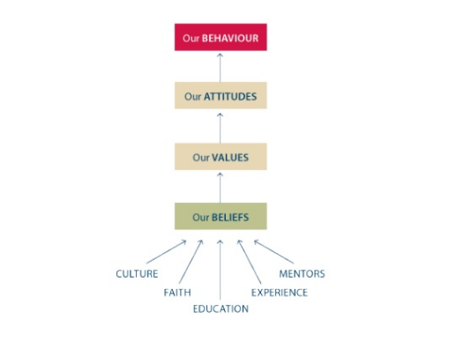
Figure 1: Relationship of Beliefs, Values and Attitudes
Source: (Adi, 2018)
The primary contention of Rokeach's theory is that social analysts should move their accentuation from attitudes to values, on the grounds that values are more vital to consider in light of influence. With the three primary factors of Rokeach's theory being beliefs, attitudes and values, all ostensibly mental attributes that affect the conduct of a person. The Beliefs, Attitudes and Values theory is likewise moderately testable in light of the fact that while the hypothesis encourages us to comprehend that to really induce an individual, he or she should be persuaded that the value is important to the manner in which this individual might want to see themselves (Costa, 2011). Rokeach's Beliefs, Attitudes and Values theory is helpful as it gives us significant knowledge into the speciality of influence and abandons us better prepared to comprehend the subtleties of instigation. The one issue the hypothesis does not plainly address is the way that it isn't really profoundly testable or remotely legitimate – every circumstance and the conditions inside every circumstance is extraordinary and applying a similar standard of influencing the esteem arrangement of the person to cause genuine influence may not really work.

1.2 Theory X and Theory Y of McGregor’s:
It is difficult to trust that employees get extraordinary fulfilment from their work and take pride in doing the most ideal activity or they consider it to be a weight and just work for the cash. These presumptions about my team members can impact how I oversee them in Tesco. During the 1960s, social psychologist Douglas McGregor created two differentiating theories named Theory X and Theory Y. For explaining how I control workers under me in Tesco this theory is very important.

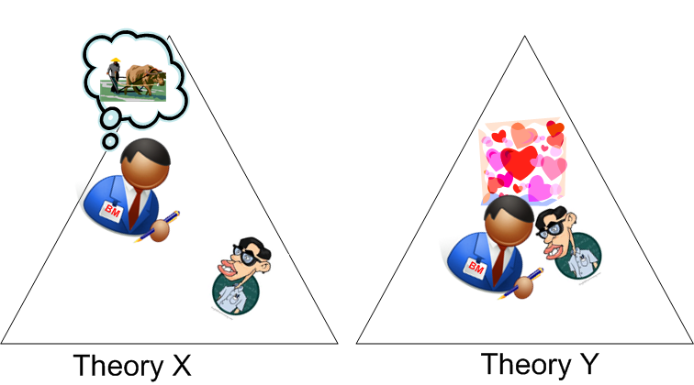
Figure 2: McGregor’s Theory X and Theory Y
Source: (Mindtools.com, 2018)
Management that puts stock in Theory X, makes stick-and-carrot approach-based firms with prohibitive order and inescapable controls (Eliot, 2016). In this way, they trust that partners ought to be incited, remunerated or repelled dependably to guarantee that they complete their endeavours. Work in affiliations that are supervised like this can be repetitive, and people are every now and again induced with a "carrot and stick" approach. Performance appraisals and compensation are typically founded on substantial outcomes, for example, in Tesco I suggest my workers deal figures or item yield and utilize to control staff and "keep tabs" on them. This helps me to cooperate with a range of employees because in some cases, workers need some urgent directions to accomplish their task and Theory X helps me to suggest my employees specifically and directly. Theory X approach will, in general, have a few levels of managers and supervisors to supervise and direct workers.
Theory Y demonstrates the backing of an increasingly synergistic, trust-based association among managers and their team individuals. People have a progressively imperative obligation, and managers ask them to develop their capacities and propose upgrades (Elliot and Turnbull, 2017). In this approach, managers have a confident, valuable finish of their family, and they use a decentralized, participative management style. Examinations are common in any case, not in any manner like in Theory X affiliations, they are used to help open correspondence rather than control staff. Theory Y affiliations furthermore give specialists visit open entryways for headway. When I need to take any decision of the sales process in Tesco which might need a lot of external knowledge and experiences of people, I usually discuss with the employees within a team by following Theory Y. This helps me to understand a lot of perspective of different people inside my organizations and helps to take a precise decision. Workers also feel very much proud by participating in management decision. Hypothesis Y has ended up being all the more outstanding among affiliations. This mirrors experts' extending need for progressively noteworthy employments that outfit them with an option that is other than money. It's moreover observed by McGregor as superior to Theory X, which, he says, decreases workers to "gear-teeth in a machine," and likely demotivates people over the long haul (Elliot and Turnbull, 2017).

1.3 A Closer Look at Maslow's Hierarchy of Needs:
Maslow initially displayed his concept of a hierarchy of needs in his 1943 paper "A Theory of Human Motivation" and his subsequent book Motivation and Personality. This hierarchy prescribes that people are impelled to fulfil essential needs before continuing forward to other, further created needs. It is an absolute necessity to be extremely reasonable about my attitude as a sales manager in Tesco toward my associations with the employees and my attitudes, beliefs and values and which can identify with Maslow's hierarchy of needs.
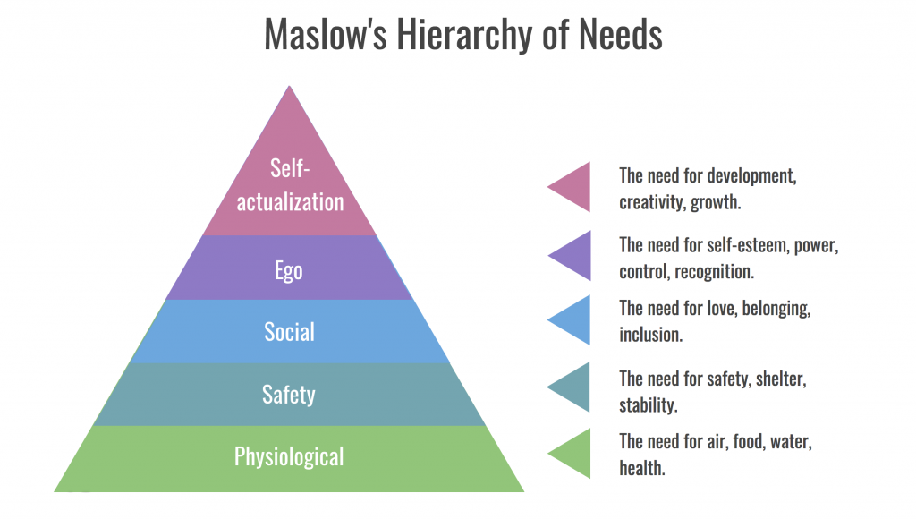
Figure 3: Maslow’s Hierarchy of Needs
Source: (Verywell Mind, 2018)
As a sales manager, it's my duty to ensure the physiological needs of the employees under me with food, shelter, clothing and so forth. When these lower-level needs have been met, people can continue ahead to the accompanying dimension of needs, which are for Safety and Security needs. At this dimension, the prerequisites for security and safety which ended up being fundamental. Minimal dimensions of the pyramid are contained the most essential needs, while most incredible needs are at the most noteworthy purpose of the pyramid. Needs at the base of the pyramid are basic Physical necessities including the prerequisite for food, water, sleep, and warmth. The essential physiological needs are in all likelihood really obvious, these fuse the things which are pivotal to our survival, notwithstanding the fundamental prerequisites of sustenance, air and temperature heading, the physiological needs similarly consolidate such things as asylum and dress (Illeris, 2012). People require control and demand in their lives, so this necessity for safety and security adds, all things considered, to rehearses at this level. As a sales manager, I need to ensure a part of the major security and safety needs for the representative of Tesco including financial security, health and wellness safety against mishaps and harm. The social needs in Maslow's hierarchy join such things as love, acceptance and having a place (McWhorter, 2016). At this level, the necessity for enthusiastic associations drives human direct. As a manager, I have to create some responsible group among the employees of Tesco beneath me so that they feel superior of having such group which can make them proud in the society.

1.4 System Theory of Management:
Systems theory approach refers to the perspective of associations which must connect with the surroundings along with the long term and short term goal. Retailer organizations like Tesco rely upon their surroundings for a few fundamental assets: customers or consumers who buy the end product or services, suppliers or specific providers who give raw and medium level materials, representatives who work for the company or management.
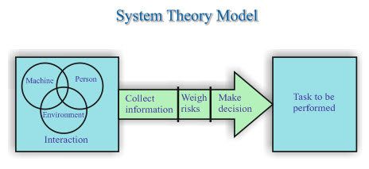
Figure 4: System Theory Model
Source: (Saylordotorg.github.io, 2018)
As a sales manager, I have to evaluate system management carefully for the employees. I ensure the system at that point looks for input to decide whether the output was viable in reestablishing harmony. As can be seen, the systems approach centres around the methods used to keep up hierarchical survival and underscore long-term goals as opposed to the short-term goals of the goal-attainment approach. Tesco as indicated by systems theory, adjust to their surroundings. Environments territory from "static" on one outrageous to "dynamic" on the other. Static environments are moderately steady or unsurprising and don't have an incredible variety, while dynamic environments are in a consistent condition of motion (Andriof et al., 2016). As per it is known, environments can’t be run totally in a one-way direction or in a static form or especially in a dynamic form and these are showing the sign of changes over the times which influences Tesco to have a dynamic and a static environment in regard of different situations.

2. Critical assessment of the impact of beliefs, attitudes and values on own workplace behaviour:
Beliefs, attitudes and values are the main three components of a person which characterize himself or herself. Belief describes some evidence of subconscious trust which is developed from the inception of one’s life and it dictates the attitude of one person (Bresciani, 2014). Bunch of beliefs can produce an attitude of a person. Values are the combinations of several perceptions and judgements which are derived by beliefs and attitudes. The relationship between these three components is reflected in every sector of life as well as the workplace. So, beliefs, attitudes and values must be evaluated before recruiting someone in an organization. The relationship between these three factors can be shown through different theories such as Hawthorne Studies, Hygiene theory, Contingency theory and Scientific management theory. Those are given below with example on the context of Tesco:

2.1 The Hawthorne Studies:
The Hawthorne studies were led on specialists at the Hawthorne plant of the Western Electric Company by Elton Mayo and Fritz Roethlisberger during the 1920s. The outcomes of the studies were amazing: Mayo and Roethlisberger found that workers were increasingly receptive to social factors, for example, the general population they worked with on a group and the measure of intrigue their manager had in their work than the elements the scientists had gone in to investigate. The studies initially investigated whether specialists were progressively responsive and worked all the more proficiently under certain and specific environmental conditions which provide prerogatives for the employees, for example, enhanced lighting inside the workplace environment (Brookfield, 2010). The Hawthorne studies were a piece of attention on managerial strategy and activity fusing the socio-psychological parts of human conduct in associations. The Hawthorne studies found that specialists were exceedingly receptive to extra consideration from their managers and higher authorities and the inclination that their managers really thought about, and were keen on, their work.
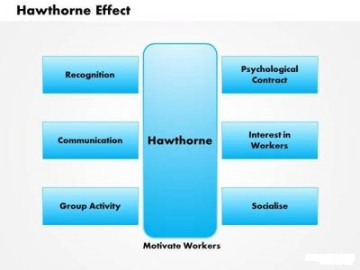
Figure 5: The Hawthorne Effect
Source: (Courses.lumenlearning.com, 2018)
Financial motives and social issues are equally important factors in the workplace environment as well as productivity which were found simultaneously by the Hawthorne Effect. Worker productivity dictates how effectively employees are working for the organizations (Caroselli, 2010). This research mainly was developed to find out the way of the different working environment according to adverse and relevant circumstances in organizations. Some working people were replaced by their condition, they were kept in the lighting room instead of having natural lighting. But there was no change in the productivity of the workers. This implies that there is nothing to change by the environmental issues of the organization. Later, this study showed that there were significant effects of social factors on productivity rather than the changed environment. Yet at the same time, the performance of the employees got expanded by a major edge in view of the consideration they were given, a better stream of correspondence and clearly the social factors, for example, beliefs, values and attitudes.
The impact of the beliefs, values and attitudes of different perspectives can be shown in light of the performance of Tesco. Tesco has given me the opportunity to show my potentials in different sectors. In my early ages, I was quite frightened of taking any decision in my life. When I came into Tesco, I had to take a lot of instant decision for sales activity. This gives me more potential and beliefs in my own decision-making process which changes my values in a vast way. Tesco gave me the power of mid-top management through which I run my own employees. It gives me more confidence to make good productivity around the company, thus my values, beliefs and attitudes towards different things have been changing day by day and ultimately this is bringing the productivity of Tesco.
Dealing with the employees is an overwhelming task to me since they have originated from various social foundations and all of them has diverse beliefs, values and attitudes (Costa, 2011). Hawthorne Effect encourages me a great deal comprehend diverse individuals' values, beliefs and attitudes to overseeing them too. I offered them different open doors past their activity obligations, for example, cash counter analysis, decision making analysis for clients. Therefore, the attitudes and values of those representatives who got these sorts of chances changed and the efficiency level and workplace behaviour got improved too.

2.2 Herzberg’s Motivation-Hygiene Theory:
Fredrick Herzberg and his partners interpreted The Herzberg's Motivation-Hygiene Theory which contemplated the criteria seen to be attractive to acquire goals and the undesirable conditions. They set out to decide the impact of attitude on motivation, by requesting that individuals portray situations where they felt great, and downright terrible, about their jobs. What he found was that individuals who liked their jobs gave altogether different reactions from the general population who felt awful. Job conditions have been considered as the maintenance or hygiene factor, wherein the equivalent job conditions give a similar level of disappointment, in the event that the conditions are missing, nonetheless, their quality does not motivate emphatically (Eliot, 2016). The next arrangement of workplace environment is alluded to as different motivational factors, which essentially work to construct solid will to work and a higher level of job satisfaction. Mainly job satisfaction is totally dependent on personal factors of employees and these factors consist of beliefs, values and attitudes of each of the employees.
People who are engaged with the hard task and the creative task they seek personal recognition and self-esteem. As a manager of Tesco, I usually try to give space and recognition to the employees who are attached with tough tasks. It gives them more productivity than any other things. On the other hand, Herzberg argued that these things are regarded as hygiene factors and these factors don’t work as a satisfaction factor rather these factors only limit the dissatisfaction level of people.
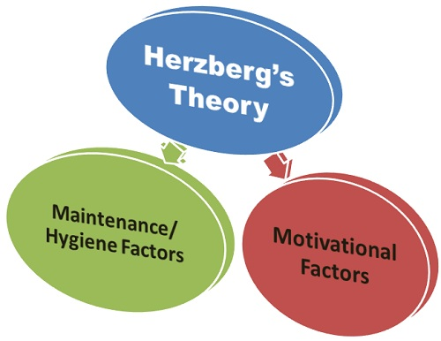
Figure 6: The Herzberg's Motivation-Hygiene Theory
Source: (Business Jargons, 2018)
On the other hand, motivator factors are such things which work as a satisfactory function of the organization. Employee’s values, beliefs and attitudes are also related to this motivator factors. I mainly try to follow the motivator factor of Herzberg in my organization for the employees. Motivator factors make them more alive and increase their productivity at an outstanding level. Motivator factors change the values, attitudes and beliefs of the employees (Elliot and Turnbull, 2017). Employee love to have recognition beyond their job, they want the achievement, success celebration, social status etc. I usually try to give much of the motivator factors for the employees of Tesco beneath me, this also helps me understand their beliefs, attitudes and values, as well as my own values, beliefs and attitudes, are developed through this factor.

2.3 Contingency Theory:
Contingency theory mainly deals with the idea where nothing is the most ideal system or approach to direct and lead an organization. There are a lot of external and internal constraints which clarify the most appropriate and legal approach to lead an organization in a specific circumstance. For example, everything depends on the recent and ongoing circumstance concerning what may be considered the best strategy. There are a lot of situations in any organization which may arise suddenly and can create a lot of effects in profit-making and company organizing (Illeris, 2012). These situations are unwanted and sometimes can be acute. Contingency theory implies how to deal with these sudden changes or situations. In Tesco, there were a lot of sudden changes happened across the financial year. I try to solve all the problems very prudently by applying the contingency theory. I try to understand the problem and how they are related to the values, attitudes and beliefs of the employees. After that I start working on that particular factor of the employees thus it doesn’t happen in the next time. Contingency theory has a great effect on the business environment as well as employee’s values, beliefs and attitudes.
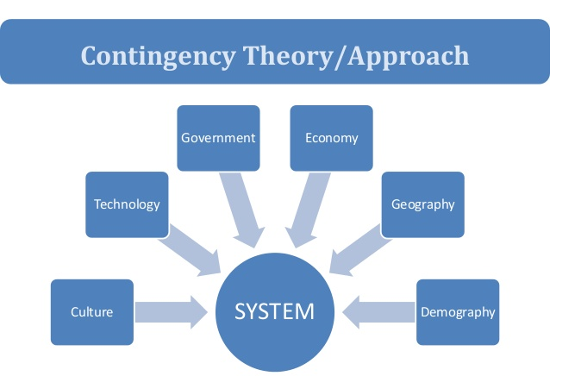
Figure 7: Contingency Theory
Source: (business.com, 2018)
I have been observing in Tesco that, there are numerous internal and external factors that can impact the ideal organizational structure and values and attitudes of the employees.

2.4 Frederick Taylor's scientific management theory:
Frederick Taylor's scientific management theory additionally called the classical management theory, accentuates efficiency, much as Weber Max. Be that as it may, as indicated by Taylor, as opposed to reprimanding employees for each minor misstep, employers should remunerate workers for increased productivity. The vital question of management ought to be to anchor the prosperity context for the business (McWhorter, 2016). Workers values, attitudes and beliefs mainly work as fundamental things in this context.

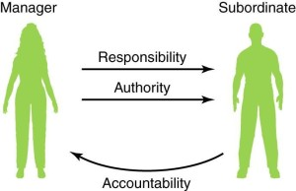
Figure 8: Taylor’s Scientific Management Theory
Source: (business.com, 2018)
When I work with my employees, it’s quite pragmatic that they make mistakes. It doesn’t mean that every time they make the mistake I have to scold him/her for his/her task. Rather I choose other ways, I console them and remunerate them with satisfaction that it will not happen again etc. I noticed that it brought a lot of productivity among the employees and develop the values, beliefs and attitudes of the employees which they hold. In Tesco, a salesman once made a mistake by providing and exchanging a product with another customer. It brought customer complaints from both of the sides. The salesman didn’t make the mistake intentionally rather it was a mistake. I understood the salesman with motivation and make him believe that he made a mistake. It brought him a lot of success in the days ahead. He hasn’t made a single mistake after that day. It implies that what I told that salesman that day, that changes the beliefs of the employees and creates values of his/her own through which his attitudes changes over the time to his/her job and that bring success and more productivity for the organization.

Conclusion:
Different management theories are the most fundamental of work environments which enable organizations to run successfully. A lot of management theories have been connected in this report and the role of a manager has additionally been decided for continuing evaluations basically on some major parts of human instincts like beliefs, attitudes and values. The theoretical model of beliefs, attitudes and values will help with separating and examining the distinction these viewpoints inside the setting of an association which has been talked about here. System Management Theory is also discussed which is relevant to the employee’s attitudes, beliefs and values of an organization for being productive. Any person can try to make an evaluation and appraisal of possessing beliefs, values and attitudes and furthermore their instant effects on different workplace behaviour and culture, for example, how they will conduct and interpret their attitudes in specific incidents or how those values and attitudes can be developed and the theory of McGregor relates to clarifying a person's job. I have shown my own beliefs, values and attitudes applicable to my job in Tesco which has likewise been talked about dependent on the hierarchy theory. How these can affect my conduct in the workplace is additionally clarified with precedents. Clear recognizable proof to my job in the workplace has been depicted through Hertzberg's theory, Hawthorne Studies, Contingency theory, Scientific Management Theory and so forth. These speculations incorporate different conduct position of management which have been utilizing in numerous associations to deal with the associations in a proficient and powerful way. In this manner, administrators should put more accentuation on the beliefs, value and attitudes of the workers for better accomplishment of goals and targets.

References:
Andriof, J., Waddock, S., Husted, B. and Rahman, S. (2016). Unfolding Stakeholder Thinking.
Bresciani, M. (2014). The neuroscience of learning and development.
Brookfield, S. (2010). Developing critical thinkers. Baltimore, MD: Laureate Education, Inc.
Caroselli, M. (2010). 50 Activities for Developing Critical Thinking Skills. Amherst: HRD Press.
Costa, A. (2011). Developing minds. Alexandria, VA: Association for Supervision and Curriculum Development.
Eliot, G. (2016). The mill on the Floss. New York: Open Road Integrated Media.
Elliott, C. and Turnbull, S. (2017). Critical thinking in human resource development. London: Routledge.
Illeris, K. (2012). International perspectives on competence development. London: Taylor and Francis.
McWhorter, K. (2016). Study and critical thinking skills in college. New York: Pearson/Longman.
Referenceforbusiness.com. (2018). Tesco PLC - Company Profile, Information, Business Description, History, Background Information on Tesco PLC. [online] Available at: https://www.referenceforbusiness.com/history2/11/Tesco-PLC.html [Accessed 12 Nov. 2018].
Tesco plc. (2018). Key facts. [online] Available at: https://www.tescoplc.com/about-us/key-facts/ [Accessed 12 Nov. 2018].
Mindtools.com. (2018). Theory X and Theory YUnderstanding People's Motivations. [online] Available at: https://www.mindtools.com/pages/article/newLDR_74.htm [Accessed 12 Nov. 2018].
Verywell Mind. (2018). The 5 Levels of Maslow's Hierarchy of Needs. [online] Available at: https://www.verywellmind.com/what-is-maslows-hierarchy-of-needs-4136760 [Accessed 12 Nov. 2018].
Business.com. (2018). The Management Theory of Frederick Taylor. [online] Available at: https://www.business.com/articles/management-theory-of-frederick-taylor/ [Accessed 12 Nov. 2018].

