Student Name: Nisipeanu Denisa Elena  Student ID: 2234127  Module Title: Foreign Languages & Cultural Awareness  Module Code: BMIH5003  Lecturer: Lisa Bassler  Date: 9th February 2024 | 
ASSIGNMENT 1: PORTFOLIO
(4 Components)

Component 1: Professional Reflection (500 words +/- 10%)

Weighting: 25%
Scenario: I ran into a Japanese visitor at the hotel dining throughout a busy dinner service. In my rushi to serve the guest promptly, I did not present the dish according to traditional Japanese dining etiquette. The guest felt humiliated, and I was left feeling confused and embarrassed due to this lack of cultural sensitivity.
Understanding Cultural Misunderstandings: Such cultural misconceptions are frequently the result of ignorance of various cultural norms and behaviours. In the hospitality industry, where customer satisfaction is crucial such disparities can have a significant impact on the guest experience. Liu et al. (2022) draw attention to the significance of cultural awareness in cross-cultural communication and explain how ignorance of cultural differences can lead to misunderstandings. In a similar vein, Manoharan et al. (2021) explore how strategic diversity management affects innovation and performance in the hospitality industry and contend that improved guest interactions can result from a greater awareness of cultural variety. Additionally, Thoungphut and Kaur (2023) emphasise the importance of linguistic variety in the travel industry, emphasising that language proficiency is a critical component in avoiding miscommunication.
Personal Reflection and Skill Development: As I think back on this situation, I see how important it is to be considerate of visitors' varied origins and cultural awareness. I need to gain a deeper awareness of cultural customs, especially about eating etiquette, to avoid miscommunications in the future. It is imperative to participate in training for cultural sensitivity and ongoing learning. I want to get better at speaking, especially in the languages that our visitors speak. Through the integration of scholarly materials and real-world experiences, my goal is to advance personally as well as professionally.
Conclusion: This event has been a crucial teaching moment that highlights how important cultural awareness is in the hospitality sector. I want to serve every guest with outstanding service, no matter what their cultural background is, and I'm committed to improving my communication and cultural awareness. In addition to being a professional duty, acquiring cultural competency is an individual dedication to creating a welcoming and courteous work environment in the lodging sector.
References:
Liu, Y., Liu, J. and King, B., 2022. Intercultural communicative competence: Hospitality industry and education perspectives. Journal of Hospitality, Leisure, Sport & Tourism Education, 30, p.100371. https://doi.org/10.1016/j.jhlste.2022.100371
Manoharan, A., Madera, J.M. and Singal, M., 2021. Walking the talk in diversity management: Exploring links between strategic statements, management practices, and external recognition. International Journal of Hospitality Management, 94, p.102864. https://doi.org/10.1016/j.ijhm.2021.102864
Thongphut, A. and Kaur, J., 2023. “Doing Explicit” in hospitality and tourism service encounters in English as a lingua franca. English for Specific Purposes, 70, pp.224-236. https://doi.org/10.1016/j.esp.2023.01.003

Component 2: Training Plan (500 words +/- 10%)

Weighting: 25%

Identified cultural misunderstanding (in a few words):
The goal of the training is to help hotel employees become more culturally sensitive and proficient communicators. A look back on a recent miscommunication involving a Japanese client will emphasise the difficulties and subtleties of servicing a diverse clientele.
Training plan (Why/What//Who/Where/When):
- Cultural Sensitivity Workshops:
  - These sessions, which are based on research by Lam et al. (2021), will emphasise the development of cultural intelligence and an understanding of various cultures.
  - Practice and promote learning through interactive sessions that use role-playing scenarios.
- Language and Communication Training:
  - The training will involve language courses concentrating on the fundamentals of the languages most frequently spoken by our guests, based on the findings of Harju-Autti et al. (2020).
  - Effective nonverbal communication and recognising cultural subtleties in various circumstances will be emphasised.
- Diversity Management in Hospitality:
  - These workshops, which are based on Omotayo et al. (2017), will address diversity management techniques and train employees on how to use cultural diversity to improve customer happiness and service quality.
Implementation Strategy: The six-month training programme will be implemented in stages. Experts in language instruction and intercultural communication will lead each module. Assessments conducted after training, such as written exams and role-playing scenarios, will gauge how well staff members have understood and used the new abilities.
Monitoring and Evaluation: Staff performance reviews and questionnaires asking for guest input will be used to track how well the training is working. We'll hold follow-up meetings regularly to discuss any new issues and reinforce what we learned.
Conclusion: Staff performance reviews and guest feedback surveys will be used to track how effective the training was. To reinforce knowledge and handle any new issues, additional meetings will be held regularly.

References:
- Lam, R., Cheung, C. and Lugosi, P., 2022. The impacts of cultural intelligence and emotional labor on the job satisfaction of luxury hotel employees. International Journal of Hospitality Management, 100, p.103084. https://doi.org/10.1016/j.ijhm.2021.103084
- Harju-Autti, R., Mäkinen, M. and Rättyä, K., 2022. ‘Things should be explained so that the students understand them’: adolescent immigrant students’ perspectives on learning the language of schooling in Finland. International Journal of Bilingual Education and Bilingualism, 25(8), pp.2949-2961. https://doi.org/10.1080/13670050.2021.1995696
- Omotayo, O., Anthonia, A., Hezekiah, F., Odunayo, S., Opeyemi, O. and Odion, E.I., 2020. Diversity management and organisational performance in deposit money banks in Nigeria. Cogent Business & Management, 7(1), p.1836751. https://doi.org/10.1080/23311975.2020.1836751

Component 3: Student Self-Reflection (500 words +/- 10%)

Weighting: 25%
Description: My grasp of cultural sensitivity in the hospitality sector started very limited, mainly concentrating on linguistic variations. One of my most important experiences was seeing a cultural misunderstanding engage a Japanese guest during my Level 4 placement. Even though it was embarrassing at first, this episode sparked a deeper investigation into the subtleties of cultural differences in hospitality.
Feelings: In addition to making me feel inadequate professionally, the experience piqued my interest in ethnic diversity. I felt a range of feelings, including shame and a strong desire to be better. It was an eye-opening and humble encounter that caused me to reevaluate how I greet and interact with visitors from other ethnic backgrounds.
Evaluation: After reflecting on the event, I concluded that actual cultural awareness goes beyond simple linguistic translation. It includes having a thorough awareness of various traditions, customs, and visitor expectations. My initial lack of cultural competency was evident in my reactive instead of proactive response to the issue.
Analysis: I consulted academic literature such as Beaulieu and Jimenez-Gomez's (2022) work on the intelligence of culture to analyse this shift in understanding. The research reviewed here emphasised how crucial a thorough awareness of culture is to efficient service delivery and communication. Li and Shang (2020) also emphasised the important role diversity management has in raising service quality. My perspective was further expanded by Doiz and Lasagabaster's (2020) findings regarding the significance of linguistic tactics in multicultural contexts, which emphasised the necessity of a systematic approach to linguistic and cultural competency in hospitality.
Conclusion: Through this process of contemplation, I have come to realise how crucial cultural awareness is to the hospitality sector. Avoiding misunderstandings is only one aspect of it; another is improving the visitor experience by engaging in sincere cultural appreciation and conversation. I discovered that developing cultural awareness is a lifelong process that calls for constant learning and tolerance. My career path and attitude to providing exceptional service in a global sector have been greatly influenced by this journey.
Action Plan: I promised myself to continue my education in language proficiency and cultural sensitivity to increase my level of cultural competency. I intend to actively look for official and informal chances for cultural learning and exchange. My action plan will include self-directed cross-cultural learning as well as frequent attendance at seminars and classes on cultural intelligence.
In summary, this contemplation has greatly advanced my knowledge of the vital role cultural sensitivity plays in the tourism industry and has been a major contributor to my professional development. It emphasises how important it is to continuously learn new things and adjust to a world with a diverse population.
References:
- Beaulieu, L. and Jimenez‐Gomez, C., 2022. Cultural responsiveness in applied behavior analysis: Self‐assessment. Journal of Applied Behavior Analysis, 55(2), pp.337-356. https://doi.org/10.1002/jaba.907
- Li, Y. and Shang, H., 2020. Service quality, perceived value, and citizens’ continuous-use intention regarding e-government: Empirical evidence from China. Information & Management, 57(3), p.103197. https://doi.org/10.1016/j.im.2019.103197
- Doiz, A. and Lasagabaster, D., 2020. Dealing with language issues in English-medium instruction at university: A comprehensive approach. International Journal of Bilingual Education and Bilingualism, 23(3), pp.257-262.
Component 4: Training Presentation (6 Slides)

Weighting: 25%
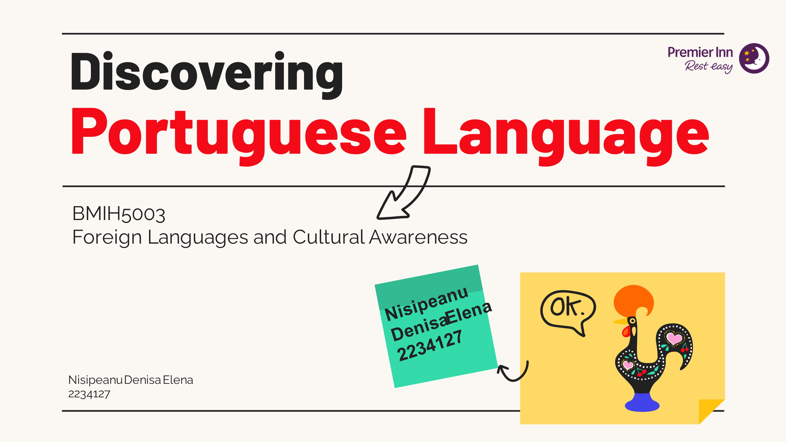
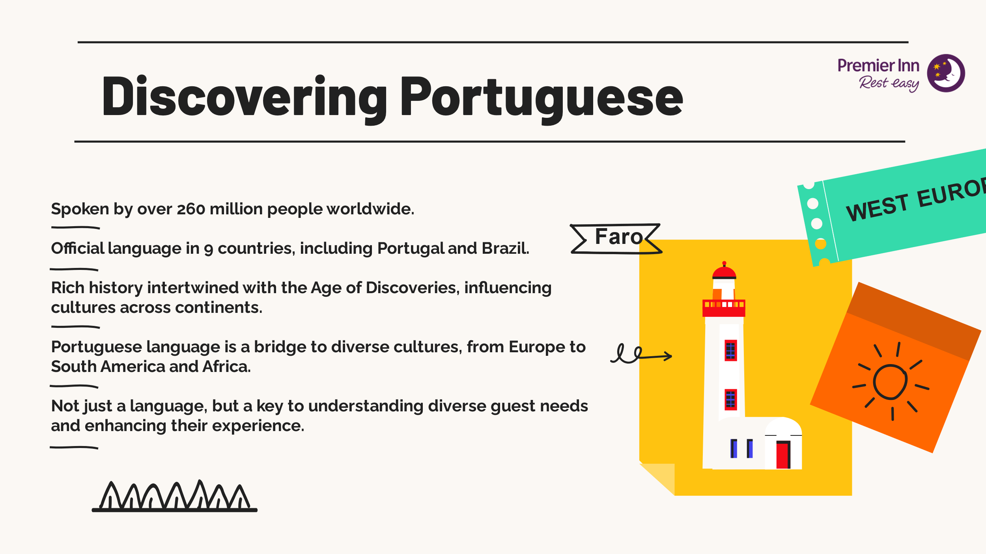
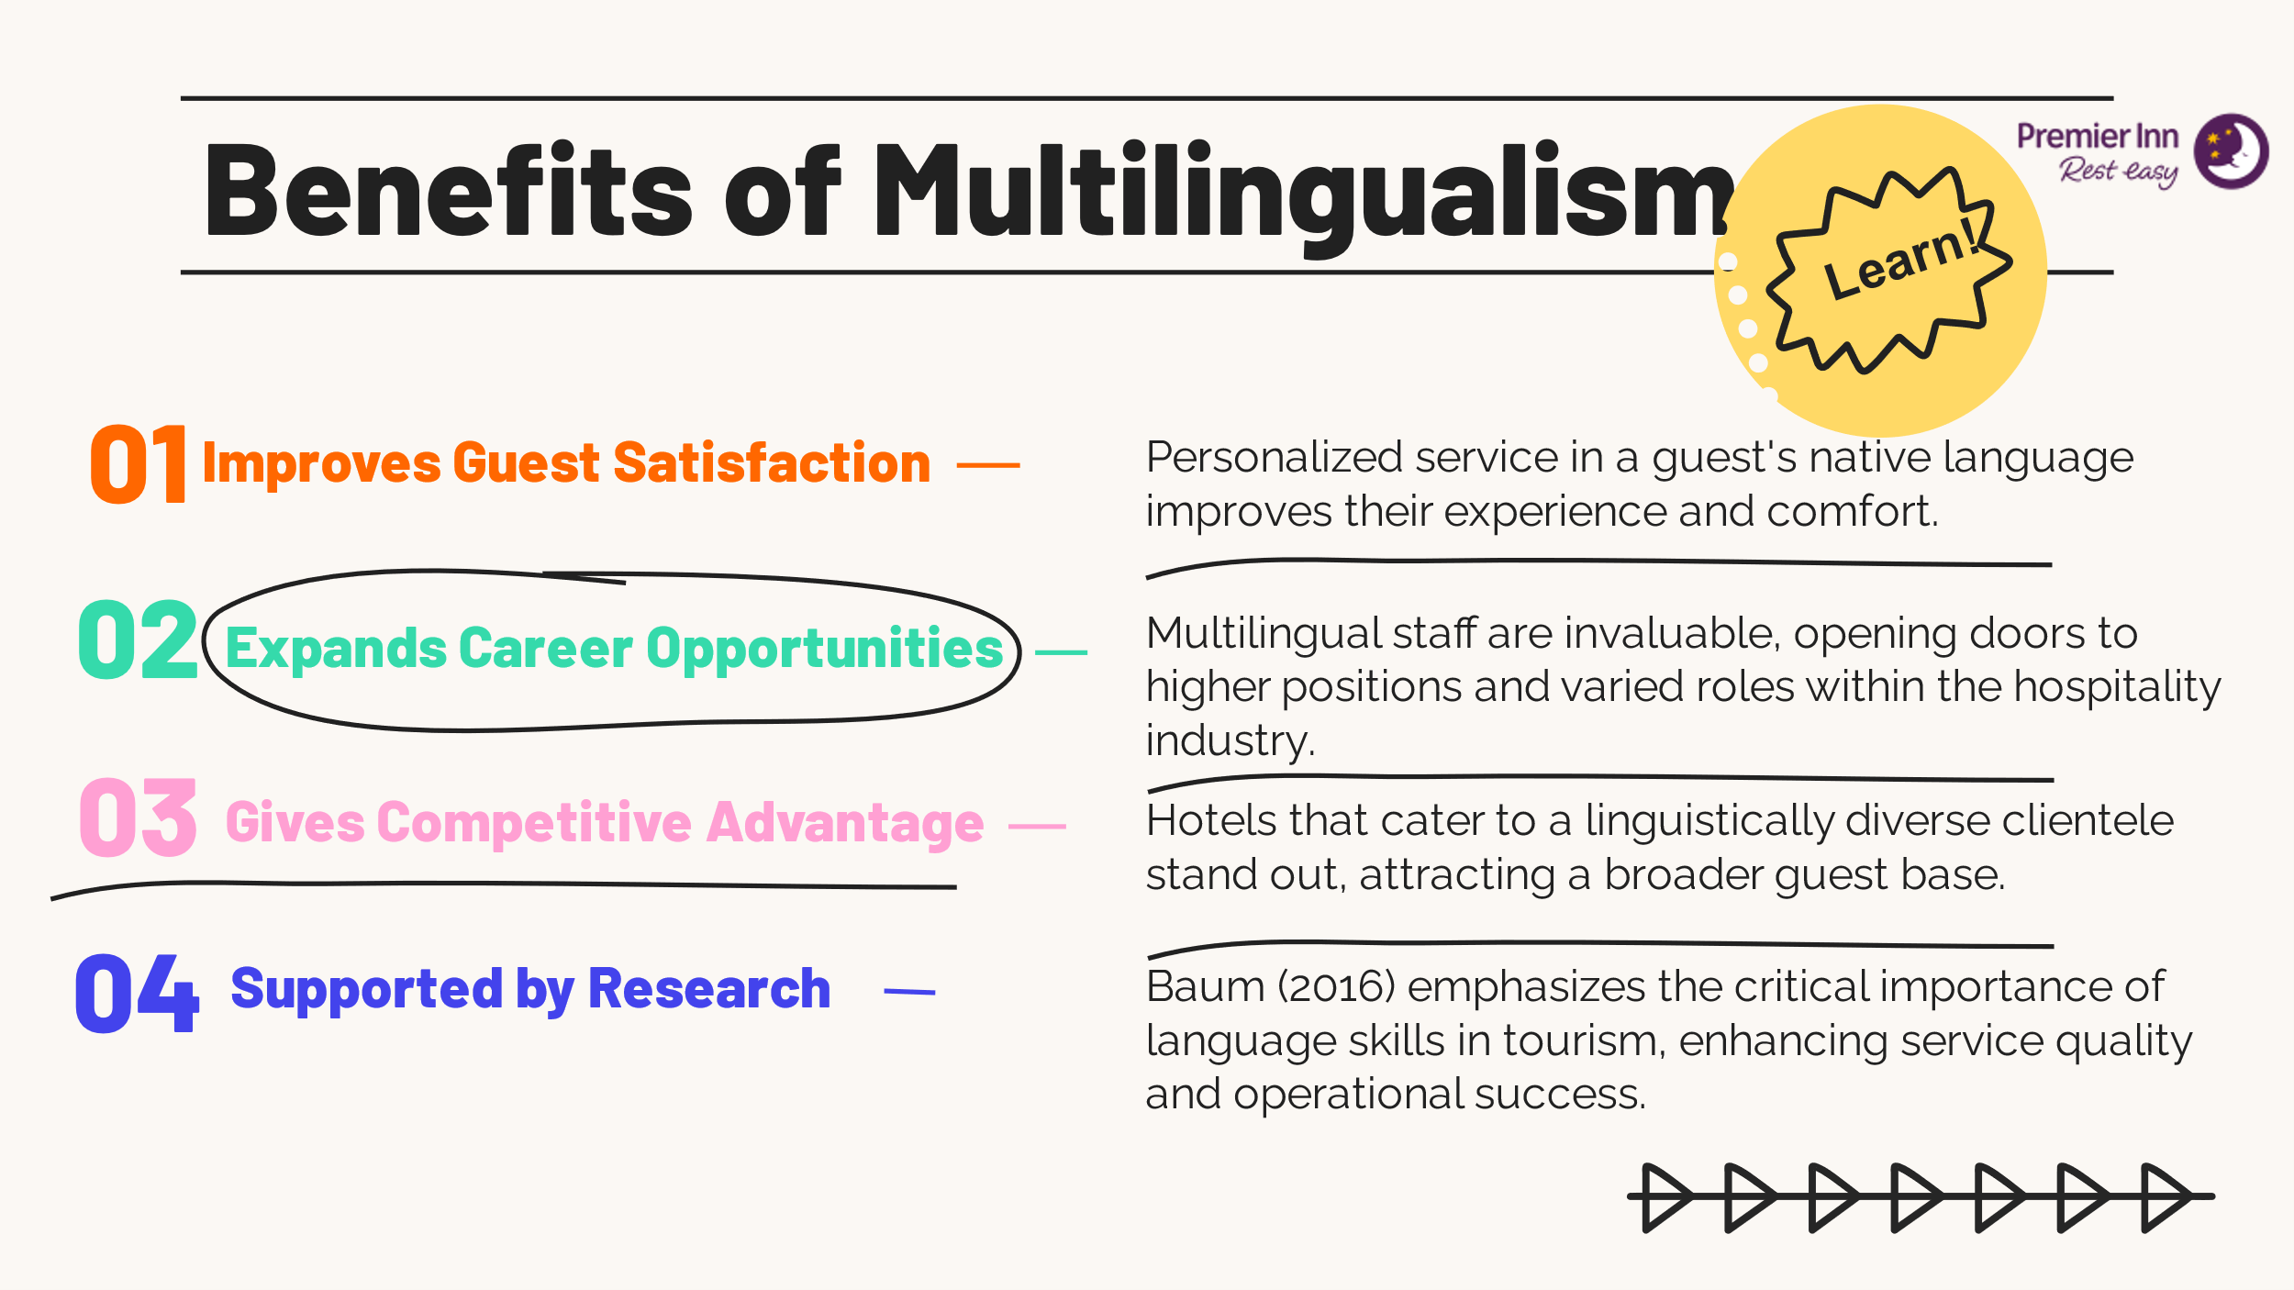
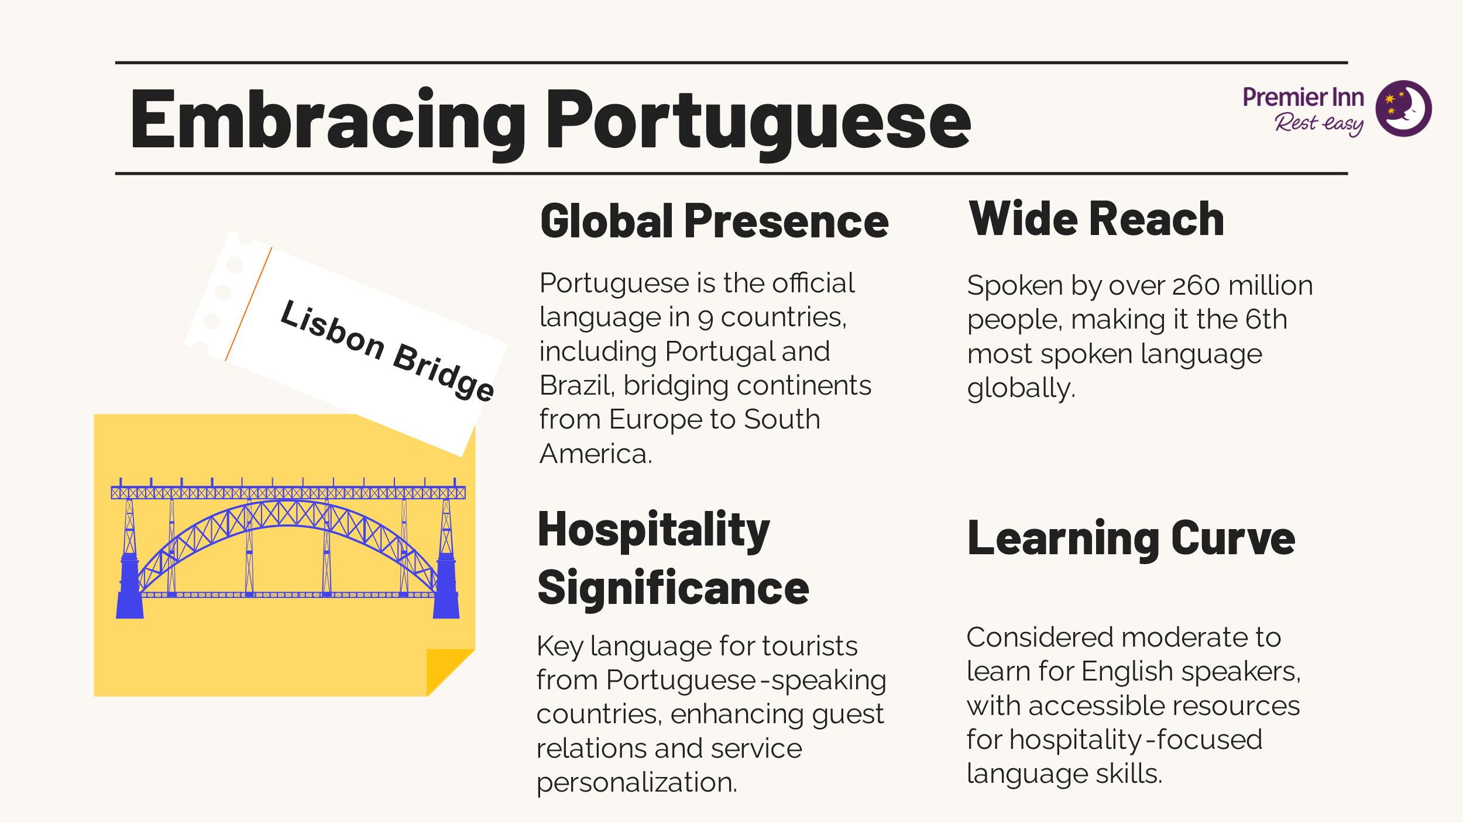
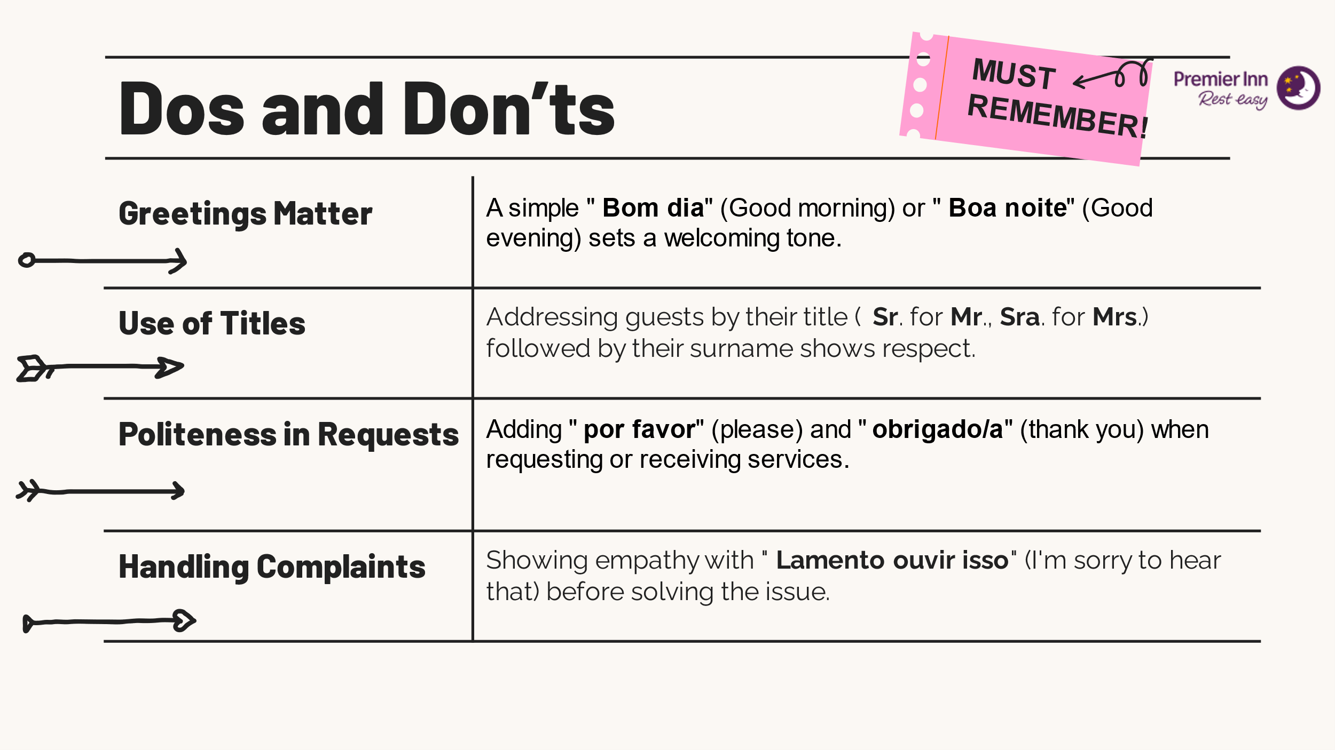
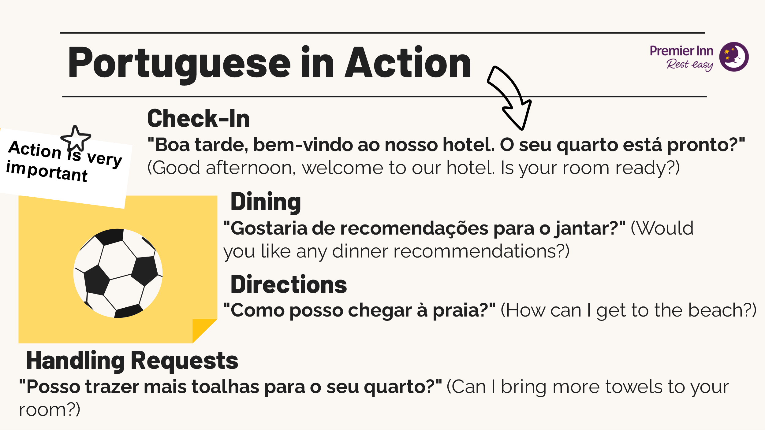
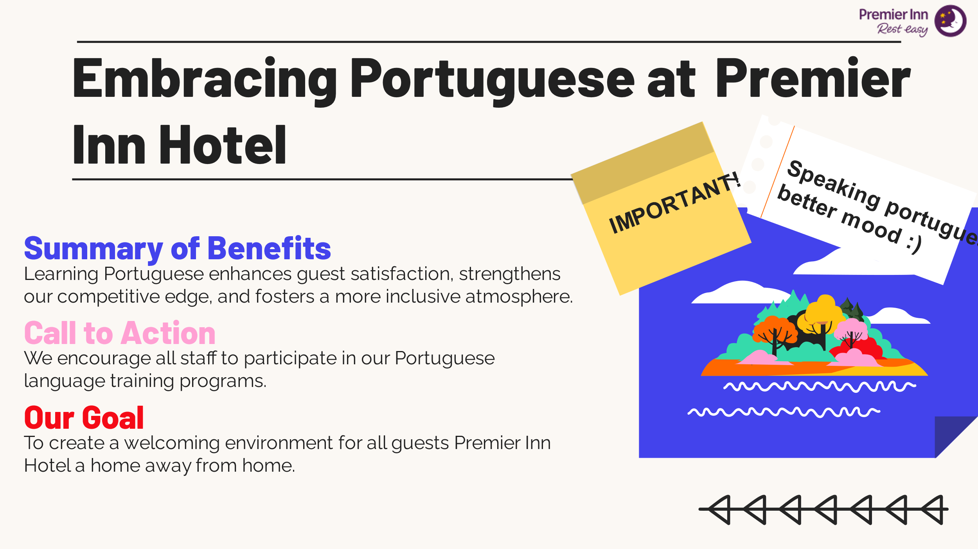

References
- EFSTATHIOS, D.V. and OLGA, K., THE HUMAN FACTOR AS CRITERIA OF QUALITY IN HOTELS. MEASUREMENTS IN THE GREEK HOSPITALITY. June 13th to the 15th of 2008 Athens, Greece, p.170. http://www.teiath.gr/userfiles/laloumis/1st_icthm.pdf#page=171
- Ho, Y.Y.C., 2020. Communicative language teaching and English as a foreign language undergraduates’ communicative competence in Tourism English. Journal of Hospitality, Leisure, Sport & Tourism Education, 27, p.100271. https://doi.org/10.1016/j.jhlste.2020.100271
- Mariani, M.M., Borghi, M. and Kazakov, S., 2019. The role of language in the online evaluation of hospitality service encounters: An empirical study. International Journal of Hospitality Management, 78, pp.50-58. https://centaur.reading.ac.uk/81129/3/Manuscript_Revised_Centaur.pdf
- Meliou, E. and Maroudas, L., 2011. Career development in the hospitality industry in Greece: Implications for human resource practices. Journal of Human Resources in Hospitality & Tourism, 10(2), pp.218-233. https://doi.org/10.1080/15332845.2010.536503
- Schouten, B.C., Manthey, L. and Scarvaglieri, C., 2023. Teaching intercultural communication skills in healthcare to improve care for culturally and linguistically diverse patients. Patient Education and Counseling, 115, p.107890. https://doi.org/10.1016/j.pec.2023.107890
- Sekerka, L.E. and Yacobian, M.M., 2016. Encouraging informed balance in management education: An ethical path to understanding Middle Eastern culturalism. The International Journal of Management Education, 14(2), pp.102-115. https://doi.org/10.1016/j.ijme.2016.03.003
- Smith, W. and Lewis, M., 2022. Both/and thinking: Embracing creative tensions to solve your toughest problems. Harvard Business Press. https://www.researchgate.net/profile/Russ-Vince/publication/367399542_Bothand_thinking_embracing_creative_tensions_to_solve_your_toughest_problems_by_Wendy_K_Smith_and_Marianne_W_Lewis_Boston_MA_Harvard_Business_Review_Press_2022_336_pages_22_hardback_829_Kindle_LCCN_20/links/659158760bb2c7472b21fe96/Both-and-thinking-embracing-creative-tensions-to-solve-your-toughest-problems-by-Wendy-K-Smith-and-Marianne-W-Lewis-Boston-MA-Harvard-Business-Review-Press-2022-336-pages-22-hardback-829-Kindle.pdf

