AI Acknowledgement - I used Microsoft Copilot to help me structure my presentation, and that no AI was used for the writing of this assignment.

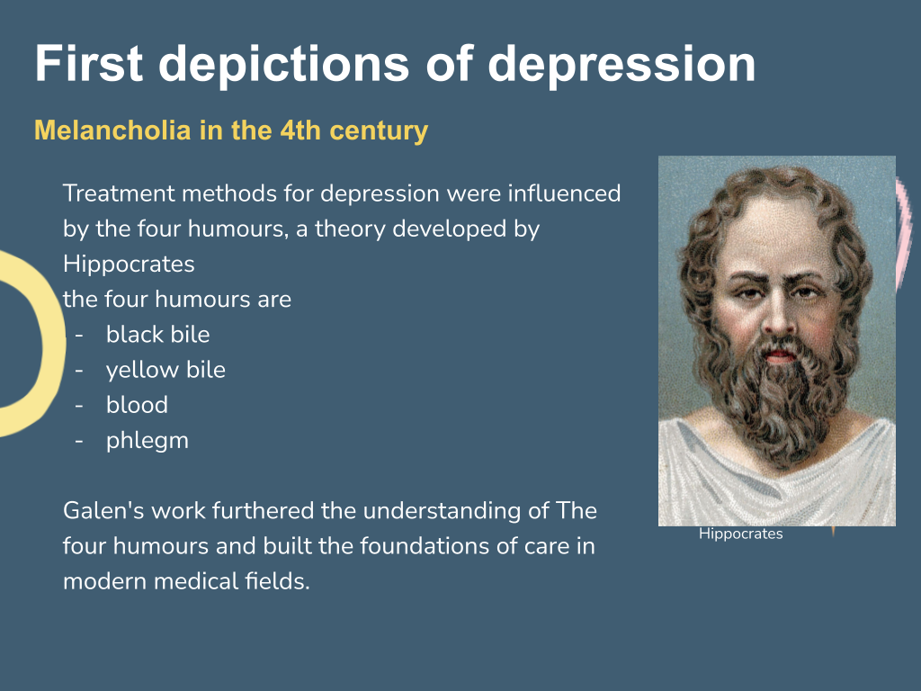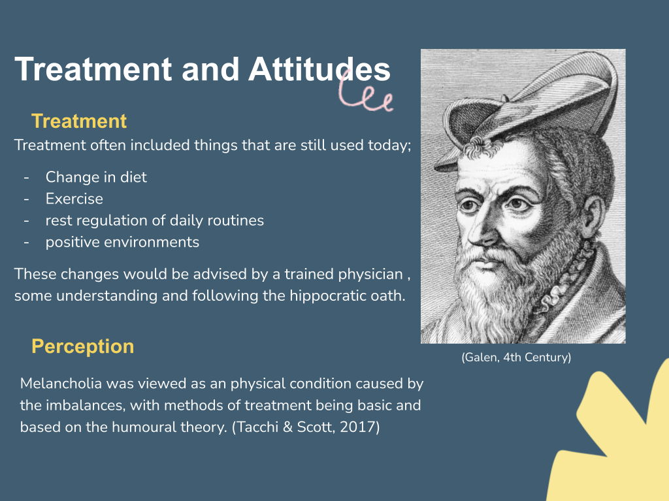
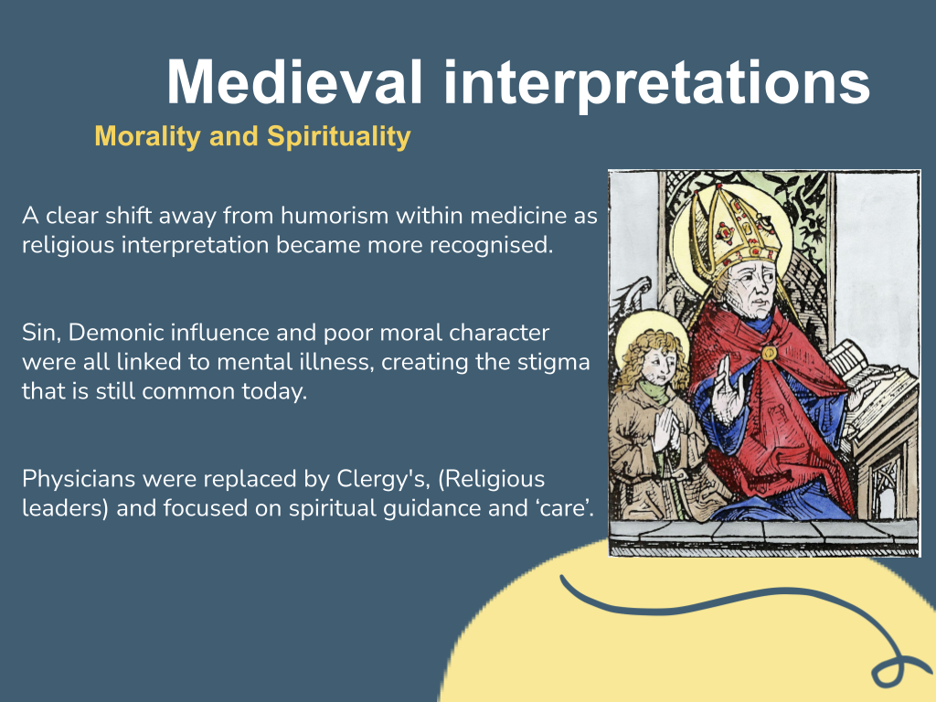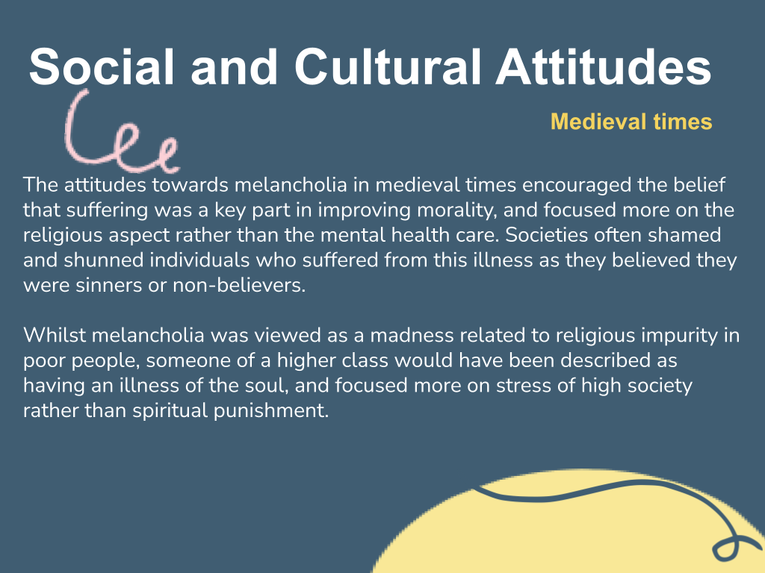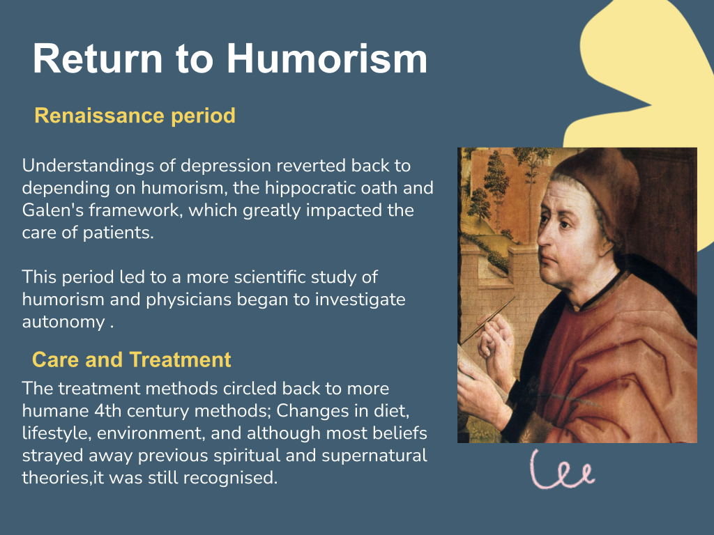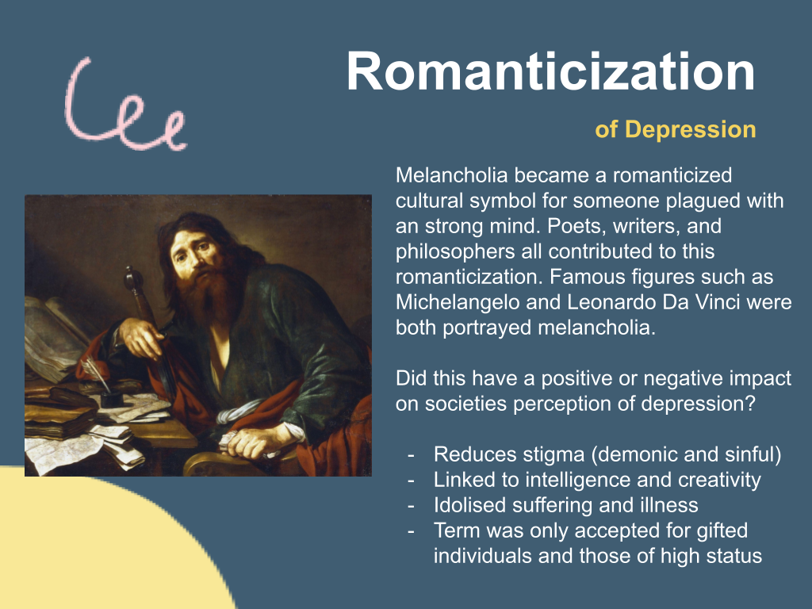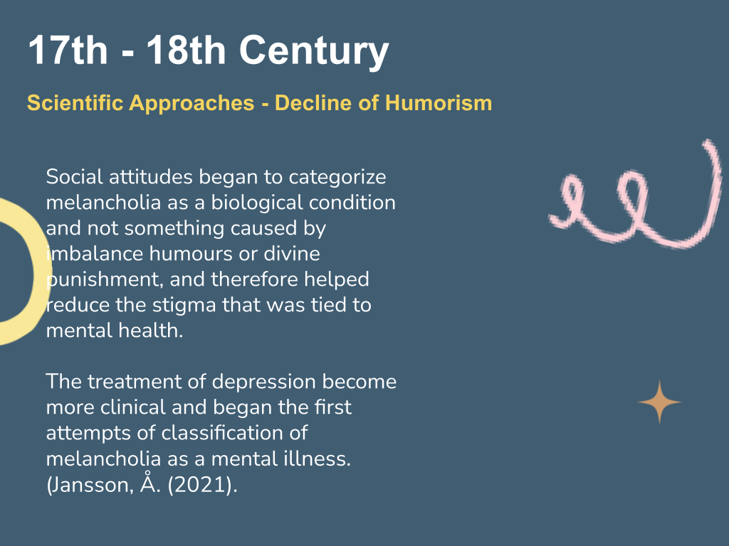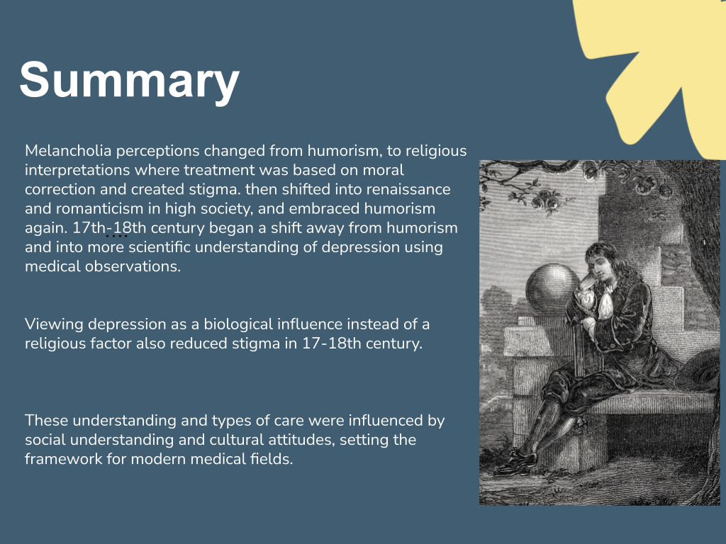

LINK TO POWERPOINT
https://docs.google.com/presentation/d/1bqSWhNekmGMlRyItxRRBzmCqS56XUgs0/edit?usp=sharing&ouid=112287189676877257520&rtpof=true&sd=true

All images were taken from ‘Stock Images’

REFERENCES FOR POWERPOINT AND SPEECH|

Jansson, A. (2021). From melancholia to depression: Disordered mood in nineteenth‑century psychiatry (pp. 63–88).Springer.

Klibansky, R., Panofsky, E., & Saxl, F. (1964). Saturn and melancholy: Studies in the history of natural philosophy, religion and art (pp. 112–113). Thomas Nelson & Sons.

Kroll, J., & Bachrach, B. (1984). Sin and mental illness in the Middle Ages. Psychological Medicine, 14(3), 507–514. doi:10.1017/S0033291700015105

Porter, R. (2002). Madness: A brief history. Oxford University Press.

Tacchi, M. J., & Scott, J. (2017). Depression: A very short introduction. Oxford University Press.

