Assessment 1 – Reading Assessment
Mustaqeem Hussain
2610559
LCLM4001

Assessment 1 – Reading Assessment
PART 1
Mind Map
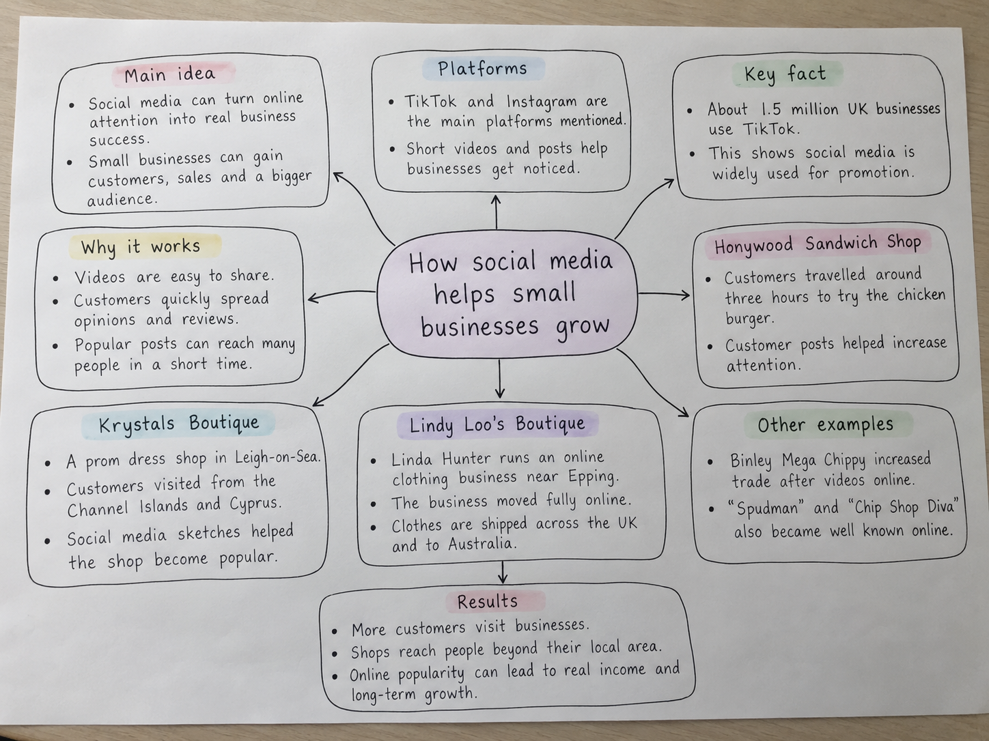

PART 2

A. What is the main idea of the whole text?
The main idea of the text is that social media helps small businesses grow by making them more visible to the public. Online posts can turn attention into extra customers, more sales and a wider audience.
B. What is one key point that supports the main idea, and which specific example from the text shows this?
One key point is that social media can persuade people to visit a business after seeing content online. For example, the article says some people travelled around three hours to Honywood Sandwich Shop to try its chicken burger.
C. What is a different key point that supports the main idea, and which specific example from the text shows this?
A different key point is that social media allows businesses to reach people outside their own town or local area. One example is Lindy Loo's Boutique, which now ships clothes across the UK and even to Australia.
D. Which part of the text do you think is most important, and why?
I think the most important part is the evidence showing that online attention can lead to real business success. This is important because the text includes both examples and facts, such as about 1.5 million UK businesses using TikTok, which shows the impact is widespread.
Reflection
E. What did you find difficult in this Assessment (including in-class components), and why was it difficult?
I found it difficult to choose the strongest supporting details because the article included several different businesses and examples. It was also challenging to keep my answers short while still including clear evidence from the text.
F. What helped you with this difficulty, and how did it help you?
The mind map helped me organise the information into sections such as key facts, examples and results. This made it easier to understand the article clearly and then write the answers in my own words.

