Developing an artefact in the shape of an information booklet for Encouraging Adult Involvement in Singing Activities and addressing why there is a reluctance to participate
Introduction
When I began to research possible subject matters for this module I immediately became aware that there are a multitude of notable gaps in the available research specifically addressing adult participants in this field (Dingle, et al, 2019). This opened up a wealth of possible topics; however, I was acutely conscious of the time constraint of this module. Therefore, I aimed to identify a specific gap that I could begin to address with this project. One specific area that I became increasingly interested in, as it aligns with my own experiences as a singing for health practitioner, was the hesitance from potential participants. There is a particularly growing need for research regarding non professional singers and the older generation, given that most existing studies emphasise trained or professional singers and often concentrate on younger voices. However, it is increasingly difficult to conduct these studies without participants which leads me to the decision that a practical starting point would be to explore ways to encourage more adults to participate in singing studies and activities. This is echoed in my own experience as much of my ongoing work is helping students to overcome their fears and feel comfortable enough to participate. Historical studies and research analysis have shown the benefit of bitesize information in order to wet the appetite of students, this involves the development of an artefact in the form of an information booklet aimed at encouraging adult involvement in singing activities and addressing the reasons behind the reluctance to participate. Singing is an innate ability that is accessible to nearly everyone, deeply rooted in our primal history, and serves as a powerful means of fostering connections both with others and within ourselves (Rao, 2005). Despite its universal nature, many individuals harbour apprehensions about exploring this talent, often due to misconceptions or societal pressures. This artefact in the shape of an information booklet aims to serve as a foundational resource that addresses and dispels common myths surrounding singing, thereby supporting and alleviating the anxieties that prospective learners may experience. By providing a welcoming and informative introduction to the art of singing, it seeks to encourage individuals to embrace their vocal potential and engage with this enriching form of expression.
Planned Program of Study
Throughout my teaching journey and research studies, I have observed that there are preconceived notions that singing is exclusively reserved for the young and gifted. This misconception arises from various societal misunderstandings and cultural influences that frequently assume that in order to be able to be a good singer you must possess a natural talent (Knight,2011); however, in my experience, there has always been an undercurrent awareness that suggests there is far more to singing, and it is not just for a select group of individuals but can be extremely beneficial for everyone no matter their ability or skill set, this knowledge has become more scientifically researched and accepted in recent years. Given my experience in teaching, I have witnessed first-hand how beneficial singing is and how it can provide and possess a practical understanding whereby this reluctance to engage frequently arises from elements such as social anxiety or a lack of adequate information. This is the primary motivation behind the development of this artefact which will take the shape of an information booklet or leaflet. Though I am aware that this artefact won’t necessarily be a ground-breaking piece of research, I am hoping that it will help enhance the current literature available. I intend to create an information booklet that will act as an introduction to research that addresses misconceptions regarding singing, offering a redefinition of what singing is making this knowledge more easily accessible. Consequently, I will concentrate on strategies that could in theory render singing classes more inviting for potential participants. Specifically, the older generation, as my teaching practice is primarily working with adult singers. When studying the literature, I observed a distinct necessity for further exploration into studies concerning the older generation, this is continually crucial as we are an ageing population (World Health Organization, 2024,Age UK, 2024), creating an increasing call for research focused on the benefits of adult singing and the development of the adult voice (Skingley, Martin and Clift, 2016). A significant barrier contributing to the scarcity of research in this area is the insufficient number of willing adult participants(Dingle, et al, 2019) this realisation has prompted me to delve deeper into underlying theories explaining this deficiency gaining understanding as to why there is this hesitance to participate ultimately using this to create an information booklet that will demystify singing to newcomers. A significant portion of the concept lies in unpicking previous experiences and preconceived knowledge contributors have and finding a way to reframe such comprehension in a welcoming, non-challenging way (Knight, 2011). Because of this my primary emphasis is on qualitative data collection to better understand the personal experiences of potential participants. This involves identifying existing barriers and exploring ways to mitigate any anxieties they may experience. Creation of this information booklet artefact will potentially augment my own practice as an introduction to classes.
My primary objective is to develop a comprehensive booklet aimed at enhancing the existing body of knowledge while simultaneously motivating prospective students to engage in the subject matter. To achieve this, the first step involves conducting a thorough literature review to identify significant barriers that may hinder participation, also examining current gaps in relevant literature concerning adult singers, as understanding these deficiencies is crucial to address factors that may influence potential participation in singing activities. Following this, the second objective is to amalgamate current available evidence regarding the benefits of singing, which will provide a solid foundation and boost content of the booklet.
My anticipated learning outcomes include gaining a deeper insight into methods that effectively facilitate the involvement of older adults in singing classes, ultimately clarifying and simplifying the process for them. This endeavour requires the development of a foundational framework that bridges existing gaps between older individuals and opportunities available in musical engagement. By understanding the unique challenges and barriers faced by this demographic, I aim to create an inclusive environment that encourages participation fostering a sense of community. This approach not only has the potential to enhance experiences for older adults within singing classes but also focuses on promoting overall well-being and social interaction, thereby enriching lives through the joy of music. I will subsequently conduct a critical evaluation of my artefact, assessing whether it fulfils my aims and objectives by examining its effectiveness as a valuable piece of information that could contribute positively to the program of study.
Methodology.
When contemplating the methodologies that I endeavour to employ for this research, I aim to review and compare different opinions of what singing is. To achieve this, it is important to create a balance between academic and accessible communication. Ox.ac.uk (2021) suggests that balancing academic research with effective communication requires a comprehensive strategy that emphasises inclusive language, varied methodologies, and adherence to universal design principles. I will endeavor to promote inclusive and accessible research interactions by using language shaped by advocacy (Seomavericks, 2024).
By way of a thorough review of existing literature, I aim to gain insights that will broaden my understanding, enhancing the overall quality of my teaching practice which will enable me to identify necessary evidence distinguishing between credible and non-credible sources for my information booklet.
I will achieve this by using specific search terms.
Why do we sing?
Adult singing
Why don’t more people sing?
What are the benefits of singing?
What causes a lack of confidence?
What causes performance anxiety?
How to get more people into singing?
Singing, where to start?
How to create an information booklet?
An extensive part of this is determining the search terms I will be using as Aromataris and Riitano (2014) describe how effective search strategies should combine both keywords or free-text terms with index terms used by major bibliographic databases. These index terms form a controlled vocabulary that categorises published articles, employing standardised terminology that can differ between databases. This approach enables a more accurate classification based on the specific subject matter of articles. This process will enable me to filter out invalid sources and synthesise practical studies into key findings. Ultimately, I aimed to create a literature review that is both comprehensive and critically analysed, thereby establishing a robust foundation for my own research. (Gaw, 2025)
Simultaneously, engaging in reflective practice allows me to critically assess my experiences and decisions, fostering a deeper awareness of my methodologies and their effectiveness. The process of gathering informal reflections from my own practice can be approached through several methodologies recognising the inherent subjectivity and biases that I, as the researcher, may have and are vital components of the research endeavour. Campbell and Ceau (2023) observe how this allows for a personal exploration of thoughts and feelings related to the research experience; initiating informal conversations, which facilitate the exchange of ideas and perspectives between peers and mentors; and positionality statements, which articulate the researcher’s social and cultural context, thereby clarifying how these factors influence the research process. Each of these methods contributes to a deeper understanding of the researcher's role and complexities of the research landscape, ultimately enriching the overall inquiry.
To gather necessary information for my research, I opted to utilise voice notes, which I plan to transcribe into written text for further analysis. This method potentially allows me to capture my thoughts and experiences in a natural and fluid manner, facilitating a more authentic reflection on the patterns that emerge from my personal journey. By examining these patterns, I aim to identify correlations and discrepancies between my findings and existing literature in the field. This comparative analysis will not only enhance my understanding of the subject but also contribute to broader discourse by situating my experiences within the context of established research.
Williams, Woolliams, and Spiro (2017, pp. 1–75) pose a thought-provoking inquiry: Is reflection not an inherent part of our daily lives? They suggest that reflection is not merely a casual activity but rather a crucial element of scientific reasoning, experimentation, and the advancement of knowledge. The transition from informal personal notes to formal reports is a familiar process for many, highlighting the importance of reflective practice in shaping our understanding and communication of scientific concepts. This process underscores how reflection serves as a bridge between personal insights and structured presentations of ideas, ultimately contributing to the collective progress in various fields of study. This dual approach not only offers to enhance my analysis but also provides a comprehensive framework for continuous improvement throughout this module.
Project Report
Introduction
When I started this project, I wanted to consider what gaps there are in current research regarding singing adults and singing for health. There was an abundance; the overarching one was the lack of longevity with an ageing population. There is a need to gain a better understanding of the adult voice. In my research on adult singing, I have identified several critical gaps that require further investigation. These areas of inadequacy highlight the need for a more comprehensive understanding of the complexities involved in adult vocal performance. These include neurocognitive effects of singing throughout different stages of life, the need to understand diversity and accessibility challenges faced by amateur singing groups, and physiological changes that ageing brings to professional and amateur vocalists. Additionally, there is a pressing requirement for studies that adhere to higher methodological standards to enhance overall qualities of findings in this field. Much literature available is either specific to professional or classically trained voices, and often to a young demographic. Because of this, though literature that does pinpoint these issues is more recent, it is also brief and provides only fleeting insights into the voice and experiences of the adult singer. To acquire a more profound understanding, it is essential to undertake additional research, and to facilitate such research, there is a need to encourage more people to participate in singing activities, which is what brought me to the creation of this artefact in the form of an information booklet.

Know That
Upon initiating my examination of the existing literature and the necessity for additional research regarding methods to encourage greater participation in singing, I noted this recommendation frequently appeared in the conclusions of various studies, presented as a thought-provoking suggestion for possible future studies. Whilst looking into this further, I observed how there is a cultural misunderstanding that nothing is to be gained by training the adult voice, with opinions like ‘the damage has already been done.’ Or the familiar phrase ‘you can’t teach an old dog new tricks’ to the older generation learning new skills(Callaghan et al., 1993). This stems from the idea that the voice is something you obtain in your youth and must hold on to, because once it’s gone, it's gone, but through research, we know this simply isn’t true; the voice is far more complicated(Lamont, 2011; Ruddock, 2010). Our voice has many varied elements and can be used for so many different things; the key is to think of the voice as an ever-changing resource we can tap into and learning how it works, what its strengths and weaknesses are opposed to trying to force it to do what we think it should be able to do(McPherson and Welch, 2018). I also recognised the importance of gaining a deeper understanding of what is known in academic literature regarding the reasons behind why singers, specifically adult singers, are reluctant to actively engage with singing activities. Upon investigation, I identified several recurring themes that illuminate why many individuals exhibit hesitance towards actively participating in singing and singing classes. This prompted me to investigate the question, ‘Why don’t more people sing?’ Although I noted a scarcity of research concerning inexperienced adult vocalists, a consistent theme throughout this investigation was that a lack of self-confidence was a primary contributor to what is known as performance anxiety. A lack of confidence is a barrier that, no matter the skill set, every singer faces at some point; it is a universal feeling, and because of that, there is a wealth of knowledge available from all walks of life to be universally transposed and utilised. Hutchison and Beynon (2014), for example, observed the effects of a lack of confidence in one of their few studies available that addresses the older generation, which involved the collection of narrative data, revealing that seniors often grapple with feelings of diminished self-assurance. This insecurity is compounded by concerns regarding perception by younger generations, particularly children and suggests fear of judgment as the most prominent cause of performance anxiety creating hesitation when it comes to singing. However, the assertion that this fear of judgment is exclusive to the judgment of younger generations overlooks other possible influences, as this fear impacts everyone and can stem from peers, authority figures, audiences, or a combination of these sources.(Ruddock, 2010, Knight 2011) The elements that lead to diminished self-confidence and fear of judgment vary and relate uniquely for every individual. These contributing factors can be a combination of genetic predispositions, cultural heritage, formative experiences, and various life situations (Markway 2018). Schei and Schei (2017) refer to this as voice shame, which is the distressing sensation of being viewed as absurd or inadequate, which may occur when a performer recognises the scrutiny of an audience and assumes the assessment is unfavourable. This awareness prompts a heightened vigilance regarding the singer's vocal delivery and how they are perceived by others. The phenomenon of voice shame can profoundly affect both amateur and professional voice users, leading them to implement self-preservation techniques to evade feelings of embarrassment. This study highlights internalised standards and notions of excellence, influenced by social exchanges and cultural norms. This lack of confidence and fear of judgment causes performance anxiety and is felt by beginners, novices and those who have access to singing training, this is prominent in the research as there are many studies into the effects of performance anxiety on professional singers. However, according to Driskill (2012) experts affiliated with opera companies have often remarked on the overall deficiency in skill and self-assurance that singers exhibit upon finishing their formal education. While this is not the sole contributing factor, confidence or lack of it is noted to be a primary factor that contributes to music performance anxiety, suggesting this is a concern that is not well researched in academic settings. However this study took place in 2012, and since then, there have been more studies on links between performance anxiety and confidence; nonetheless, there is still much more to learn on this subject. My next focal point of research was the origins of confidence deficiency. I discerned it might arise from a lack of information, which can prevent people feeling able to engage. Providing insights into the facts surrounding singing can significantly contribute to helping individuals to feel better equipped and demystifying the process(Fletcher, Najarro and Yelland, 2023).
A significant aspect of reshaping the perception of singing involves examining its perceived primary functions. Predominantly in Western culture, singing is regarded merely as a form of artistic entertainment, with little additional significance. However, a deeper exploration reveals a more complex history, and notes the earliest recognised musical instruments globally, consisting of flutes crafted from bones and mammoth ivory, are believed to be over 40,000 years old. Nevertheless, there is the possibility that instruments and melodies are even more ancient (Prasad, 2024). The main source for this information was an article titled "When Did Humans First Make Music?" published in BBC Science Focus which provides a concise overview of the evolution of music and singing. Authored by Dr Aarathi Prasad, a writer, broadcaster, and researcher specialising in science and history, while her work is not primarily focused on music, Dr Aarathi Prasad occasionally incorporates musical elements within her historical investigations. This article serves as an introductory resource on the history of music and directs readers to the works of Charles Darwin, who is a key reference in my research concerning the historical development of music. Charles Darwin is widely recognised as the pioneer of the theory of evolution through natural selection. His groundbreaking publication, On the Origin of Species, released in 1859, presented a perspective on the evolution of life on Earth that significantly influenced nearly all biological theories and many subsequent philosophical ideas (Pence, 2025). He is regarded as one of the most impactful individuals in both the scientific realm and public perception although his primary focus does not centre on music, he serves as a profound and credible source; Charles Darwin's theory concerning singing and music continues to hold relevance in contemporary discussions, as it provides insights into the evolution of human musical abilities and their significance within social and emotional contexts( Darwin, 1871) . This perspective aligns with current theories on the evolution of music, which regard it as a technology that leverages pre-existing skills and carries essential implications for both our culture and biology (Townsend, 2020). Furthermore, the relevance of Darwin's theory extends to understanding music's role in promoting social cohesion, fostering group identity, and enhancing verbal and social competencies in children. It also plays a part in discussions surrounding the therapeutic effects of music and the importance of sound in healthcare settings. In summary, Darwin's theory of singing and music continues to serve as a crucial framework for understanding the evolution of human musical abilities and their impact on society today (Hamilton 2025).
"A Brief History of Singing" is an online article written by John Koopman, who is a music educator and a faculty member at Lawrence University. His contributions are regarded as a reliable educational resource within the realms of music history and pedagogy.
His research has been referenced in various academic settings, particularly in relation to the validity and educational value of community music practices. This indicates that his contributions are acknowledged within the wider domain of music education scholarship. Koopman (2019) notes how ‘Singing, the vocal production of musical tones, is so basic to man, its origins are long lost in antiquity and predate the development of spoken language.’ Offering this reframing of singing as a form of communication as opposed to a talent-based skill can help to remove the pressure and stigma regarding participants’ ability to sing.
Expanding on this, the subsequent research direction was to outline the advantages that can be derived beyond merely producing an appealing sound. My research highlighted that there has been an understanding of the benefits of music and singing since at least 1588. One leading source of this information is William Byrd who was an English composer and organist from the Shakespearean era, renowned primarily for his contributions to the English madrigal. Byrd (1920) discusses the benefits of singing and expresses the opinion that if more men took more interest in singing, they would feel the benefits of it (Neighbour, 2006b). When considering the benefits of singing, we can categorize them into physical, emotional, psychological, and social aspects, and how these can collectively influence overall well-being. There are many pockets of information regards the benefits of singing for adults including how it effectively reduces stress and anxiety by decreasing cortisol levels encouraging the release of endorphins, which helps alleviate feelings of depression and loneliness this is highlighted by Goldenberg (2018).Rachel Goldenberg is a speech-language pathologist, a specialist in singing voice, and a clinical voice therapist. She is a top expert in singing and lung diseases along with Moisseinen et al., (2025) Livesey, et al, (2012) and Beck, et al, (2000). These sources provide trustworthy and dependable information, as they are all esteemed scholars in their respective disciplines.

Know How
From my personal teaching experience, the main drawback many have struggled to overcome is lack of confidence, fuelled by preconceived ideas about abilities or lack thereof. The predominant statement encountered when engaging in conversations about singing with individuals interested in enrolling in my classes is, ‘I can’t sing.’ This expression invariably perplexes me. Bodkin-Allen, Swain, and West, (2019) noted this same phenomenon of self-derogating, documenting how numerous individuals openly discuss lack of ability and confidence. Richards and Durrant (2003) observe how it is "culturally acceptable and even cool to claim singing disability". These observations align with my own findings working with students, particularly in group settings, they feel comfortable being with others who have the same skill set or preconceived absence of singing ability. Singing is frequently perceived as a static quality: something you can either accomplish or not. This perception is linked to the ‘talent’ myth prevalent in Western societies: musical proficiency, which includes the ability to sing, is viewed as a characteristic possessed by a select few who are deemed talented (Lamont, 2011; Ruddock, 2010). Understanding this core belief and where it comes from can be incredibly useful in unpicking its roots, reframing what singing is and what abilities they have, instilling a belief that they can improve. My typical response is that anyone has the capacity to sing; however, this can be seen as combative, a singing teacher who is confident in their own ability is bound to have this opinion which can create a disconnect due to bias. During my teaching journey, I have documented in my reflective notes the need for a better, more empathetic approach to this and have used my collected data to help develop a more informed understanding of what my students respond most positively to and how I can connect with them. I have done this through literacy research, open dialogue with students and potential students, throughout this process I discovered often the key lies in sharing factual data largely focusing on the anatomy of the voice. One example is explaining how we create sound through the use of different muscles and how they can be trained with correct techniques just like any other muscle group (Sataloff,1992, Holland, 2022). When recapping my own notes, I found this to be a most useful tactic as I have used my collected data to create dialogue helping demystify how the voice works creating interest in learning more. I often use my analogy of how I couldn’t run a marathon tomorrow, but if I trained over time, I could, though I may not be the fastest out there, I would participate at a competent level. Expanding further, it is thoughtful to help them recognise the fact that the voice is complex and unique with many essential aspects encompassing a variety of elements, including vocal range, weight, tessitura, timbre, and the transition points that occur within the vocal production, such as breaks and lifts. (Meizel, 2011, Miller, 2020, Singh, and Raj, 2025). Offering the premise that the key lies in discovering your own voice, along with its strengths and weaknesses, identifying styles most suitable for you. Many people often become preoccupied with the pursuit of perfection or with specific qualities of a voice they wish to emulate. To help them shift away from this narrow focus, I aim to redirect attention from merely their vocal talents to intricate anatomy and mechanics that underpin voice production. By engaging with these elements through proper technique, individuals can effectively rebuild vocal capabilities, enhance their sound and develop comprehensive understanding of how voice production operates from the ground up. It is crucial to deliver lessons that are informative not overwhelming, which I achieve by distilling complex concepts into more digestible insights. This approach allows me to convey essential information about the voice's functionality and underlying principles, thereby fostering a solid foundation of knowledge supporting vocal development.
There is no simple solution; rather, a lengthy journey focused on establishing trust—not only between myself and students but also within a group context, where fostering a welcoming atmosphere with mutual trust among them is crucial (Jason, Stevens, and Light, 2016) . I strive to create a soothing environment. This process of building trust contributes significantly to fostering a sense of belonging. Engaging in singing, an activity that has been shown to enhance social connections (Clements-Cortés 2015) plays a vital role in this. Analysis of my voice notes reveals a significant sense of social connection within classroom dynamics. This connection is evident within interactions among students, characterised by collaboration and mutual support. Classmates engage actively in group discussions and informal conversations, demonstrating a collective commitment creating positive learning environments. The encouragement and camaraderie observed through singing activities further strengthen this sense of belonging (Joseph, 2017). Such interactions not only enrich individual learning experiences but also foster cohesive classroom atmospheres, where students feel appreciated and connected. This intricate network of relationships highlights critical roles of social dynamics in educational contexts, emphasising influences on both academic success and personal growth (Osher, et al 2020). I have observed my students forging strong relationships, resulting in a supportive community looking out for one another sharing a passion for music. This is an element I actively promote and seek to nurture. This social connection appears to be particularly beneficial with older age groups.
My primary practice caters to adult novice singers wherein I have gained valuable insights into challenges they face building the confidence necessary to engage in singing classes. This practical experience illuminates various obstacles that many individuals encounter, allowing me to develop strategies to help alleviate concerns. Interestingly, I have observed singers feeling they have lost some or all of their vocal abilities experiencing heightened anxiety compared to those who have never sung before. In contrast, individuals without prior singing experience tend to approach the activity with fewer preconceived notions, often leading to a more enthusiastic willingness to participate. This understanding is crucial for my research, as it highlights the uniqueness of each singer, shaped by their personal experiences and belief systems significantly influencing their individual journeys in the realm of singing. A deficiency in self-assurance may stem from external influences, as noted by Markway (2018). "The elements that lead to diminished self-confidence amalgamate and interact uniquely for each individual. Factors such as genetics, cultural heritage, early life experiences, and various life situations all contribute to this phenomenon." I believe that it is important to first examine early life experiences, which may include a scarcity of resources and information to better know how to support my students. This could involve educators who themselves lack the confidence to engage in singing, as highlighted by Swain and Bodkin-Allen (2017).
‘Early childhood educators are typically generalist instructors with minimal training in music, creating a unique intersection: a scenario where young children are arguably at their most musical, juxtaposed with teachers who frequently possess little or no specialised musical training.’
Their research elucidates that when instructors lack the knowledge, skills, and/or confidence in a discipline such as singing, they may struggle to support others effectively. Nevertheless, the presence of a teacher who is self-assured within the field is not the sole determinant that may impede skill acquisition. A deficiency in resources or financial support can also serve as a significant barrier, as numerous educational environments do not consistently regard the arts as a priority. However, this misconception that the arts do not hold deeper benefits outside of being a form of entertainment requires reshaping, as Sousa (2018) articulates,
‘The arts are not merely expressive and emotional; they are profoundly cognitive. They cultivate vital cognitive tools.’
The arts contribute to the enhancement of cognitive abilities such as problem-solving and analytical reasoning, and they are instrumental in fostering social skills and building confidence. In the absence of access to the arts, individuals may easily become estranged from disciplines like music. As time progresses, this disconnection can evolve into a lack of self-confidence regarding their capabilities, a concern identified by Hutchison and Beynon (2014) during their work with older adults.
This recontextualization of the advantages of the arts, particularly singing, is an approach I incorporate into my teaching practice to mitigate anxieties that students and prospective students might experience.
I am confident the foundational knowledge cultivated in this area equips me well to convert this understanding into an informational booklet for this artefact.
In contemplating the title of my information, I deemed it most effective to remain concise and adopt the name of my class, which was originally designated by the organisers at Age UK as Singing 4 Health. The inclusion of the number 4 was necessitated by the existence of other groups sharing the same name, and I believe it accurately reflects the essence of the initiative. 'Why Do We Sing?' was the subheading adopted in an effort to encourage readers to delve inside for the answer. I opted for a blue colour scheme as blue is frequently associated with medical information booklets, and websites most notably by the NHS (2025), thereby establishing a precursor to the notion that this booklet pertains to health and wellness rather than merely serving as a recreational activity.
Know What
I chose the medium of an information booklet because if I were to use this in my own practice, it is easy to distribute(French,2013), particularly with my demographic, as many of the older generation do not find it easy to use technology or simply don’t have access to it (Reneland-Forsman, 2018). I would have the ability to bring it along and distribute it as a means of enhancing discussions with prospective students, providing them with something to take home and review at their convenience.
While conducting academic research, Once gaining a clearer understanding of why people may be reluctant to take part in singing, it was helpful to create a knowledgeable place to start from, feeling that sharing knowledge, demystifying what singing is and reframing how singing is thought of could be extremely helpful. The key was putting this into a user-friendly format that is both educational and welcoming.
When creating this booklet, I knew it was essential to employ language that is both inviting and informative, avoiding any sense of alienation. I strived for a conversational tone while maintaining brevity, thus providing the chance for further exploration of the topic (Seely, 2013).
As the body of research continues to grow, it becomes increasingly clear that singing is not merely a form of entertainment but a potent tool for promoting health and wellness, warranting further investigation into its multifaceted impacts on individuals and communities alike. With this artefact, I am striving to highlight premises that engaging in singing is a holistic practice which can profoundly enrich one’s overall well-being, influencing a wide range of dimensions, including physical health, neurological function, psychological resilience, emotional stability, and social interactions. Therefore when embarking on creating this artefact, I noted it was beneficial to examine literature that is readily available to the public. I commenced my investigation using genetic search engines, posing broad questions such as "Can anyone sing?" and "What are the benefits of singing?" as well as inquiries related to singing for beginners to better comprehend what my target audience would be accessing. This exploration revealed an abundance of information; however, much of it constitutes grey literature in a multitude of different formats. The internet's capacity for rapid content generation complicates the process of quantifying and peer-reviewing sources. While this proliferation of knowledge can be beneficial, it could also lead to confusion, potentially overwhelming individuals who are unsure where to begin, increasing the risk of following incorrect or potentially harmful advice. Therefore, I focused on using trusted academic sources to create this information booklet.
I split the information booklet into four topics which where;
- The History of singing
- Why do we sing?
- What are the benefits of singing?
- Where to start.

The History of Singing.
For discussing the history of singing I primarily used research from Charles Darwin proved incredibly useful especially due to universal familiarity with his name. When studying his discussions on the role of music and singing as a means of communication among animals alongside investigations into the beginnings of human communication indicate that music may have existed before language. Darwin also proposed that music functioned as a means of communication and a way to express emotions. I used this premise in my booklet as the main focus when discussing the history of music and singing, offering a scientific outlook of the history of singing (Darwin 1871).

I intended to present a comprehensive overview of the history of singing, as I have noted that grasping the historical context of an activity can be tremendously advantageous in understanding motivations for engaging in such practices.

Why do we sing?
Though singing is widely valued for its entertainment qualities, I endeavoured to use this booklet to reframe how people perceived singing help them develop a working knowledge also valuable in different aspects of life, therefore I highlighted how singing is used in all regimes such as rituals, both cultural and religious, social and community bonding, communication, spiritual healing, and storytelling (Ludolph, 2021). Participating in song with others, whether in a choir or during events such as weddings and sports gatherings, fosters a profound sense of belonging, unity, and comprehension. (Kreutz, 2014).
Discussing how singing is a powerful form of Self-Expression, expanding to suggest that singing acts as a powerful and therapeutic outlet for conveying a wide range of emotions—from joy to grief—that mere words might not adequately express. (Coutinho, et al, 2014) This also connects back to the history of singing and how singing is a form of emotional communication. Another arguably obvious reason to sing is to improve our mood as even in a small setting, singing can boost self-esteem and courage, generating a beneficial ripple effect across various facets of life. (Wu, 2024) from humming along to the radio to singing in the shower, singing even in a small personal way can have great benefits without us even realising. Music and singing have been a universal tool throughout the world and history, the primary focus of its value has shifted somewhat in more recent years, focusing on the financial benefits and quality of singing as opposed to emotional, social and health benefits of singing. Due to this, many people find the prospect of singing, especially in front of others, intimidating. The fear of judgement and ridicule causes them to shy away from singing and benefits that it could have for them. With these factors in mind, it is easier to gain an understanding as to why those who do not have an overarching good experience with singing, especially those who are in later adulthood may find it difficult to step away from those preconceived philosophies. Consequently, it is crucial to identify a method that facilitates the dismantling of these concepts without being overly confrontational regarding their core beliefs.
The benefits of singing.
In order to try to remedy this, I pondered how I could reframe the way singing is perceived, shifting focus from vocal performance to how singing benefits individuals. Through recent years academic communities have begun to understand the arts are more than just a means of entertainment and this movement is beginning to gain momentum, aiming to rectify the historical misconceptions associated with the benefits of singing by conducting thorough research in this area overturning the current prevailing notion that music lacks the seriousness required for clinical investigation. For centuries, individuals have recounted personal anecdotes highlighting the positive effects of singing on mental and emotional health; however, it is only in recent years that systematic studies have emerged, providing substantial empirical support for these claims. This shift in perspective marks a significant advancement in the field, as researchers are uncovering various physical and psychological health benefits linked to singing. These advantages encompass enhanced emotional well-being, strengthened social connections, and even potential improvements in cognitive function recognizing that without engaged participants, the research loses its relevance and impact (Goldenberg 2018, Moisseinen, et al, 2025). Nevertheless, I frequently discovered I was diverting my attention to other subjects during my research journey, and I often struggled to refocus myself. I struggled with this loss of direction throughout this module. Another concern I discovered is that due to near hyperfocus, I would lose track of time, causing other elements to feel rushed without balance.
The most challenging aspect of this entire project was identifying an effective method for distributing information in a manner that avoids overwhelming the audience, fostering a combative atmosphere, or coming across as condescending. The goal was to create a communication style that not only enlightens but also invites engagement and participation from the audience. Striking this balance required careful consideration of language, tone, and presentation, ensuring that information shared was accessible and encouraging, rather than intimidating or dismissive. This approach aimed to cultivate an artefact that encouraged individuals to feel valued and motivated to explore subject matter further, ultimately enhancing their understanding and appreciation of the content presented. I feel for the most part I achieved this, though it is not a perfect artefact, it delivers on offering a starting point to build from. If I were to undertake this project once more, I would continue to prioritize development of an information booklet. I consider this to be the most intuitive method for my teaching practice, as it offers a relaxed means of communication (Seely, 2013). This format allows me to present information to potential participants without the pressure of a face-to-face interaction, which some individuals find daunting. The booklet can be read at the reader's convenience, free from time constraints or expectations regarding their decision to join a class. My primary objective was to develop a user-friendly resource that provides pertinent information without overwhelming the reader. I do feel that I managed to offer a somewhat comprehensive overview of different perspectives of singing creating a balance between academic and accessible communication. There is a lot more work needed in this field but I feel this project has created a starting point for me to build on. One aspect of this module I found most beneficial is that it has helped me to gain a clearer idea of what my strengths and weaknesses are.
When deciding how to communicate these facts, I soon realised that an over abundance of information might alienate readers, possibly deterring them from delving deeper into the subject. To mitigate this risk, I decided to adopt a more concise, bullet-point style of presentation (Elmira 2025). . This approach allows me to convey essential insights in a straightforward manner, ensuring content remains accessible and engaging. By keeping information brief yet informative, I hope to encourage readers to pursue additional research or engage in discussions about the subject, rather than feeling inundated by an overload of details. This strategy not only enhances readability but also fosters a more inviting atmosphere for exploration and inquiry into the myriad benefits associated with singing. I believe that utilising bullet points would be the most effective format, as it highlights crucial information, facilitating the scanning of documents for key details enhancing communication with the audience.
Where to start
In this section I considered this booklet as the starting point for readers to start their own research journey giving them a template to follow whilst offering further sources the reader can explore on their own in order to gain more information. Some examples of top sources I have come across include a podcast on the BBC website called ‘Sing’ Just One Thing – with Michael Mosley (Mosley , M. 2021, BBC 2021). This podcast resonates strongly with my own ideas of singing. Dr. Michael Mosley was a well-known British journalist, producer, and author, recognised for his contributions to health and diet. I used this as a resource that people reading my booklet could explore and expand their knowledge base another source was Cheryl Porter who is a renowned American vocal coach, singer, and motivational educator she has gained international recognition, earning the title of "World's #1 Vocal Coach." With millions of followers on social media platforms like TikTok and YouTube (Porter, 2025) she champions inclusivity in the realm of singing. Through her content, she strives to make knowledge about the benefits of singing, as well as warm-ups and techniques, more accessible to everyone. The challenge of relying on a physical reference, such as a book, lies in the rapid expansion of knowledge in this field. I worry that readers may purchase a single book adhering strictly to its teachings, viewing it as a safe choice, rather than exploring further. It is essential to seek out various literature discovering what resonates with them, as every voice is distinct. Not every teaching style or exercise will be suitable for each student, making it crucial to experiment identifying what works best for themselves.
I provided search engine prompts designed to assist in conducting further research. My intention is to inspire students to take on the role of researchers themselves. These were‘The anatomy of the voice, why do we sing, is singing for everyone?, and singing classes near me’ I provided search engine prompts designed to assist them in conducting further research. Many of these prompts were ones utilized in my own research, upon reviewing the existing literature, I noted the singing for health movement is establishing a more robust knowledge base focused on accurate information. Consequently, these search queries are directing them towards information that I consider to be the most promising and relatively reliable as a foundation for their own research. I also included a disclaimer suggesting it would be prudent to seek a singing group or vocal coach for training assistance.
Should I utilise this artefact beyond the confines of this module, I would additionally provide my class details, allowing individuals opportunities to either join or reach out to me for further information if necessary. For the purposes of this module, information I provided is fictitious, solely for data protection reasons and to present a clear illustration of potential usage.
Conclusion
Throughout this module, I have identified deficiencies in existing literature and research that require additional investigation, especially regarding the adult singer. This artefact serves as a valuable resource for developing further research, yet it has merely touched upon the surface of the topic. This study has enhanced my own understanding and provided me with specific areas for future research. The most significant limitation I encountered was the insufficient time available to perform a more comprehensive analysis of this subject.Over the course of this module, I have highlighted the gaps in current literature research and studies that are in need of further exploration, particularly the need for further studies into the adult singer. This artefact is a useful tool to use as a building block to create further research, but has only scratched the surface. This study has helped me enrich my own knowledge base and given me focal points that I can research in the future. The largest limitation I found was the lack of time to conduct a more in-depth review of this topic.
Critical Evaluation
As I embarked on this project, I invested a significant amount of time on the initial phases, meticulously defining my area of focus within this academic discipline. The escalating need for research in this domain is largely attributed to the notable gaps that have emerged with regards to singing for health, especially considering the increasing number of elderly individuals in our society. Initially, the wide range of opportunities appeared to be quite encouraging; however, this soon evolved into an overwhelming selection of choices. The abundance of options often complicates the decision-making process, as I struggled to hone in on a particular direction. As a result, I frequently found myself enmeshed in a multitude of possibilities, which proved time-consuming, detracting from my overall progress. A thorough review of existing literature on singing for health and adult singing classes revealed a notable gap in research specifically addressing adult participants in the field. This realisation prompted me to delve deeper into underlying theories explaining this deficiency; after refining my choices further, I identified a logical starting point centred on facilitating participation in classes. Given the demographic shift towards an ageing population, there is an increasing necessity for research focused on adult singing and the adult voice. Such studies would significantly enhance my own practice. To avoid becoming overwhelmed by extensive research avenues available and to address the immediate need for adult engagement in singing, I decided that a practical starting point would be to explore ways to encourage more adults to participate in research and what I need to work on for future projects.

Appendix

-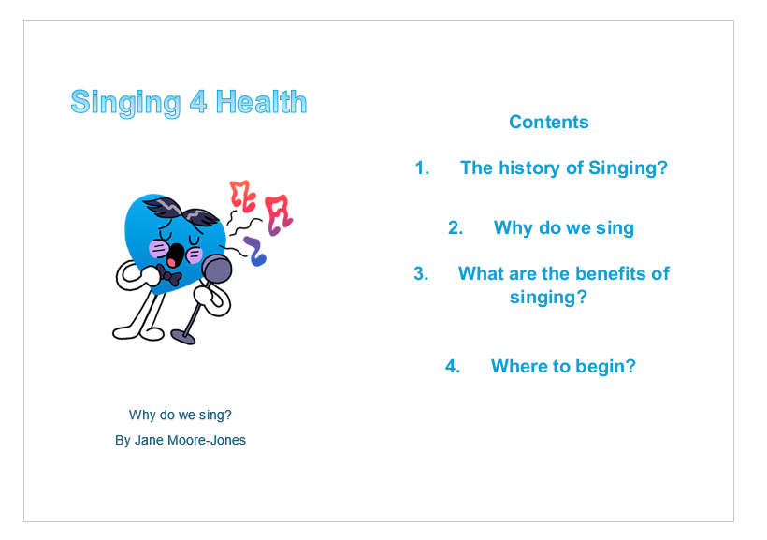

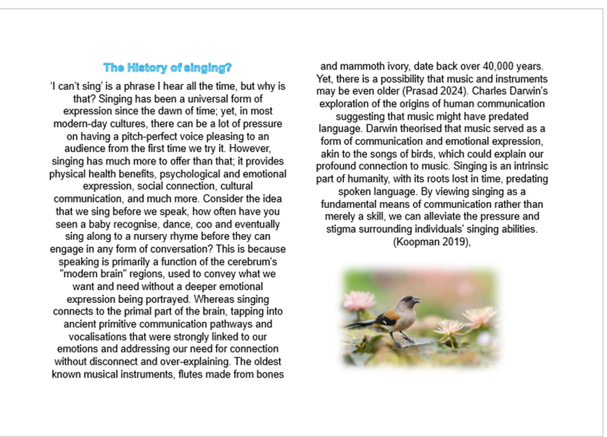

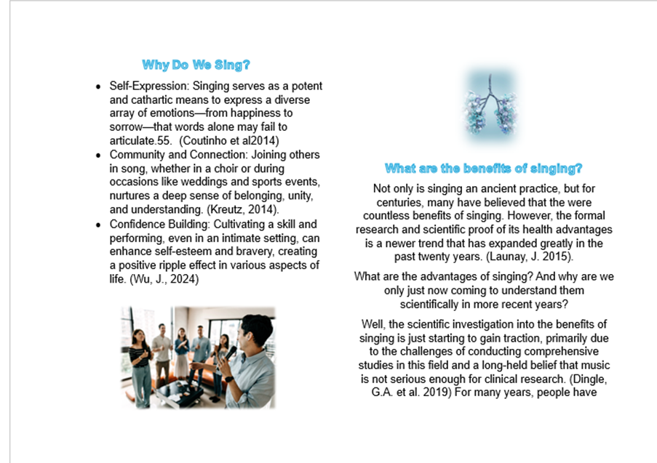
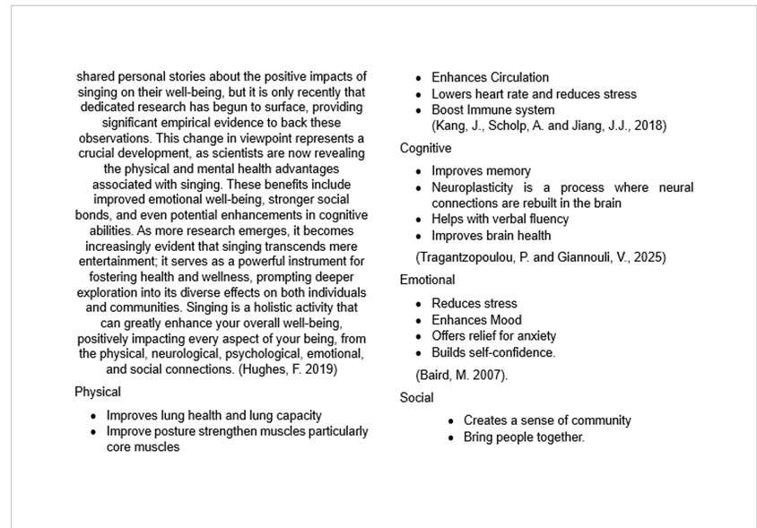
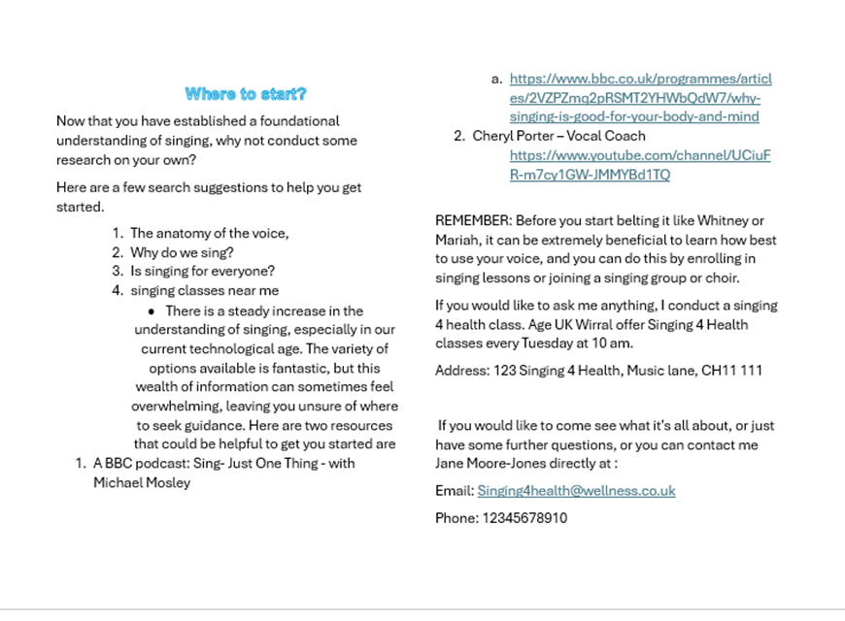

Reference Page
- Age UK (2024). State of Health and Care of Older People in England 2024. [online] Age UK. Available at: https://www.ageuk.org.uk/discover/2024/september/state-of-health-and-care-of-older-people-in-england-2024/.
- Aromataris, E. and Riitano, D. (2014). Constructing a Search Strategy and Searching for Evidence. American Journal of Nursing, 114(5), pp.49–56. doi:https://doi.org/10.1097/01.NAJ.0000446779.99522.f6.
- Baird, M. (2007). PERCEIVED BENEFITS OF CHORAL SINGING: SOCIAL, INTELLECTUAL, AND EMOTIONAL ASPECTS OF GROUP SINGING. [online] Available at: https://www.collectionscanada.gc.ca/obj/thesescanada/vol2/002/MR51363.PDF?oclc_number=723408871.
- BBC (2021) Just One Thing - with Michael Mosley - Why singing is good for your body and mind. https://www.bbc.co.uk/programmes/articles/2VZPZmq2pRSMT2YHWbQdW7/why-singing-is-good-for-your-body-and-mind.
- Beck, R.J. et al. (2000) 'Choral singing, performance perception, and immune system changes in salivary immunoglobulin A and cortisol,' Music Perception an Interdisciplinary Journal, 18(1), pp. 87–106. https://doi.org/10.2307/40285902.
- Bodkin-Allen, S., Swain, N. and West, S., 2019. 'It's not that bad singing with other people': The effect of a single outreach on singing attitudes and confidence in adults. Australian Journal of Music Education, 52(2), pp.22-32.
- Byrd, W. (1920). Psalms, Sonnets, and Songs of Sadness and Piety to Five Parts.
- Callaghan, L., Chu, M., Cumings, A., Faratro, R., Houghton, B., Lau, K. and Kelman, B. (1993). ‘You can’t teach an old dog new tricks’. pp.317–321. doi:https://doi.org/10.1007/978-94-011-1822-4_34.
- Campbell, C. and Ceau, M. (2023). Leading Reflective Practice -Reviewing the Evidence. [online] Available at: https://www.ewc.wales/site/index.php/en/documents-eng/policy-and-research/1207-leading-reflective-practice-reviewing-the-evidence/file.
- Clements-Cortés, A., (2015). Singing for health, connection and care. Music and Medicine, 7(4), pp.13-23.
- Coutinho, E., Scherer, K.R. and Dibben, N., 2014. Singing and emotion. The Oxford handbook of singing, pp.297-314.
- Darwin, C. (1871) The descent of man, and selection in relation to sex, J. Murray eBooks. https://doi.org/10.5962/bhl.title.2092.
- Dingle, G.A. et al. (2019) 'An agenda for best practice research on Group Singing, Health, and Well-Being,' Music & Science, 2. https://doi.org/10.1177/2059204319861719.
- Driskill, K. (2012). Symptoms, Causes, and Coping Strategies for Performance Anxiety in Singers: A Synthesis of Research. doi:https://doi.org/10.33915/etd.3585.
- Elmira (2025). Bulleted Lists 101: When, Why, and How to Use Them. [online] ClickHelp. Available at: https://clickhelp.com/clickhelp-technical-writing-blog/bulleted-lists-when-why-and-how-to-use-them/.
- Fletcher, J., Najarro, A. and Yelland, H. (2023). Fostering Habits of Mind in Today’s Students. Taylor & Francis.
- French, C., (2013). How to write a successful how-to booklet. The Endless Bookcase Ltd.
- Gaw, A. (2025) Writing an Effective Literature Review: A Study guide, A Study Guide. https://www.docs.hss.ed.ac.uk/iad/Postgraduate/PhD_researchers/Study_Guide_How_to_Write_an_Effective_Literature_Review_v2.0_.pdf.
- Goldenberg, R.B., (2018). Singing lessons for respiratory health: a literature review. Journal of Voice, 32(1), pp.85-94.
- Hamilton, A. (2025). The Evolution of Music: Human and Non-Human. Music & Letters, 00. doi:https://doi.org/10.1093/ml/gcaf028.
- Holland, T. (2022) Heavy Lifting! The Muscles that Control the Vocal Cords — Caveness Voice. https://www.cavenessvoice.com/blog/heavy-lifting-the-muscles-that-control-the-vocal-cords#:~:text=And%20that%20piece%20is%20the,Muscles%2C%20and%20the%20Arytenoid%20Muscles.
- Hughes, F. (2019) 'Book review: Music, Health and Wellbeing (Raymond MacDonald, Gunter Kreutz & Laura Mitchell, Eds.),' DOAJ (DOAJ: Directory of Open Access Journals) [Preprint]. https://doaj.org/article/6f1896a5237545cf98adbd3fb507c24f.
- Hutchison, J. and Beynon, C. (2014). ‘It’s All about Confidence and How You Perceive Yourself’: Musical Perceptions of Older Adults Involved in an Intergenerational Singing Program. Literacy Information and Computer Education Journal, 5(2), pp.1556–1565. doi:https://doi.org/10.20533/licej.2040.2589.2014.0207.
- ITV (2025) A journey from 7 to 63 years old | 63 up | Full episode. https://www.youtube.com/watch?v=CESol35myZQ
- Jason, L.A., Stevens, E. and Light, J.M., (2016). The relationship of sense of community and trust to hope. Journal of community psychology, 44(3), pp.334-341.
- Joseph, D., (2017). Fostering a sense of belonging and identity through sound and spirituality. In Re-Enchanting Education and Spiritual Wellbeing (pp. 189-200). Routledge.
- Kang, J., Scholp, A. and Jiang, J.J., (2018). A review of the physiological effects and mechanisms of singing. Journal of Voice, 32(4), pp.390-395.
- Keeler, J.R. et al. (2015) 'The neurochemistry and social flow of singing: bonding and oxytocin,' Frontiers in Human Neuroscience, 9, p. 518. https://doi.org/10.3389/fnhum.2015.00518.
- Koopman, J. (2019). A Brief History of Singing. [online] Lawrence.edu. Available at: https://www2.lawrence.edu/fast/KOOPMAJO/antiquity.html
- Kreutz, G., (2014). Does singing facilitate social bonding?. Music and Medicine, 6(2), pp.51-60.
- Launay, J. (2015). Choir singing improves health, happiness – and is the perfect icebreaker | university of oxford. [online] University of Oxford. Available at: https://www.ox.ac.uk/research/choir-singing-improves-health-happiness-%E2%80%93-and-perfect-icebreaker.
- Lewis, A. et al. (2016) 'Singing for Lung Health—a systematic review of the literature and consensus statement,' Npj Primary Care Respiratory Medicine, 26(1), p. 16080. https://doi.org/10.1038/npjpcrm.2016.80.
- Livesey, L. et al. (2012) 'Benefits of choral singing for social and mental wellbeing: qualitative findings from a cross‐national survey of choir members,' Journal of Public Mental Health, 11(1), pp. 10–26. https://doi.org/10.1108/17465721211207275.
- Ludolph, D.L., 2021. Singing Difference Amid Relational Connectedness: A Narrative Study of How Singing Together Shapes Worldview.
- McPherson, G. and Welch, G. (2018). Vocal, Instrumental, and Ensemble Learning and Teaching. Oxford University Press.
- Meizel, K., (2011). A powerful voice: Investigating vocality and identity. Voice and Speech Review, 7(1), pp.267-274.
- Miller, F.E., (2020). The voice. BoD–Books on Demand.
- Moisseinen, N. et al. (2025) 'Neurocognitive and emotional benefits of choir singing and their mediating factors across adulthood,' Aging Clinical and Experimental Research, 37(1), p. 272. https://doi.org/10.1007/s40520-025-03187-1.
- Mosley , M. (2021). BBC Radio 4 - Just One Thing - with Michael Mosley - Why singing is good for your body and mind. bbc.co.uk. Available at: https://www.bbc.co.uk/programmes/articles/2VZPZmq2pRSMT2YHWbQdW7/why-singing-is-good-for-your-body-and-mind.
- Neighbour, O. (2006b) 'Psalmes, Sonets and Songs (1588),' Music and Letters, 87(3), pp. 488–491. https://doi.org/10.1093/ml/gci228.
- NHS (2025). NHS. [online] NHS. Available at: https://www.nhs.uk/.
- Osher, D, et al (2020). Drivers of human development: How relationships and context shape learning and development1. Applied developmental science, 24(1), pp.6-36.
- Ox.ac.uk. (2021). Section 6: Facilitating inclusive interactions | University of Oxford. [online] Available at: https://www.ox.ac.uk/research/using-research-engage/public-engagement/participatory-research/researcher-insights/Facilitating-inclusive-interactions [Accessed 24 Nov. 2025].
- Pence, C.H. (2025). Darwin, Charles | Internet Encyclopedia of Philosophy. [online] Internet Encyclopedia of Philosophy. Available at: https://iep.utm.edu/darwin/ [Accessed 2025].
- Porter , C. (2025). Cheryl Porter Vocal Coach - YouTube. [online] www.youtube.com. Available at: https://www.youtube.com/channel/UCiuFR-m7cy1GW-JMMYBd1TQ.
- Prasad, A. (2024). When did humans first make music? [online] www.sciencefocus.com. Available at: https://www.sciencefocus.com/the-human-body/when-did-humans-first-make-music.
- Rao, D., (2005). Singing in the twenty-first century... singing a better world. The Phenomenon of Singing, 5, pp.248-256.
- Reneland-Forsman, L., 2018. ‘Borrowed access’–the struggle of older persons for digital participation. International Journal of Lifelong Education, 37(3), pp.333-344.
- Ruddock, E. (2010) Societal judgment silences singers, UNESCO OBSERVATORY, FACULTY OF ARCHITECTURE, BUILDING AND PLANNING, THE UNIVERSITY OF MELBOURNE REFEREED E-JOURNAL. https://d1wqtxts1xzle7.cloudfront.net/33025788/Ruddock_formatted_20101029-libre.pdf?1393941179=&response-content-disposition=inline%3B+filename%3DSocietal_judgment_silences_singers.pdf&Expires=1764589999&Signature=IMEPdkWX9G5rEoPnNByxH-Yc13b-ianuA2yrLrkbHtuiYvy2Whix-WuK3NeGzmpyVDkhHiSPmqc0PmY8o~iklGrkr7Dlt~kWiU0qiflQxV0cpsrrNUGsoNA148QqNtK-ETFEveeYGrRRQh5a0tZtHpFfV5MQ0LMMXIdjM7uB8VSewFYfrBPi9Bb494dqVPSBO6rpKfRBN9coF-X7jHnrFM7WXStvcgX7v--tqgrDgs9DV1aguzD3hQhOWrfHj~y63PkZlFHfrXlxwfFE0oSoWu0~LA1y1C8kTGZLBKCtkAKtt25wBtThnum9ifyENddXD-2msnmvmYH-dTSfUSqORQ__&Key-Pair-Id=APKAJLOHF5GGSLRBV4ZA.
- Sataloff, R.T., (1992). The human voice. Scientific American, 267(6), pp.108-115.
- Schei, T.B. and Schei, E., (2017). Voice shame: Self-censorship in vocal performance. The Singing Network, 1.
- Seely, J., (2013). Oxford guide to effective writing and speaking: How to communicate clearly. OUP Oxford.
- Seomavericks (2024). The Role of Language in Mental Health Advocacy. [online] Southcoastcounselorsandphysicians.com. Available at: https://southcoastcounselorsandphysicians.com/the-role-of-language-in-mental-health-advocacy/ [Accessed 1 Dec. 2025].
- Singh, R. and Raj, B., (2025). Human Voice is Unique. arXiv preprint arXiv:2506.18182.
- Skingley, A., Martin, A. and Clift, S. (2016). The Contribution of Community Singing Groups to the Well-Being of Older People. Journal of Applied Gerontology, 35(12), pp.1302–1324. doi:https://doi.org/10.1177/0733464815577141.
- Stephens, E.G. (2012). Formation and Prediction of the Singing Perceptions of Self-Labeled Singers and Non- Singers.
- Townsend, P.D. (2020). The evolution of music through culture and science. Oxford, United Kingdom: Oxford University Press.
- Tragantzopoulou, P. and Giannouli, V., (2025). A Song for the Mind: A Literature Review on Singing and Cognitive Health in Aging Populations. Brain Sciences, 15(3), p.227.
- Williams, K., Woolliams, M. and Spiro, J. (2017). Reflective writing. 2nd ed. London: Macmillan Education, pp.1–75.
- World Health Organization (2024). Ageing and health. [online] World Health Organization. Available at: https://www.who.int/news-room/fact-sheets/detail/ageing-and-health.
- (Wu,, 2024). The Importance of Building Students' Good Singing Psychology. International Journal of New Developments in Education, 6(10).

