University of Wales Trinity Saint David


Wales Institute of Science and Art

Engineering Skills Technical Report
Engineering Skills (ACHA4022A)

Liam Evans
2408460
(12/2025)

2066 Words

Contents
1. Introduction: 1
2. Health And Safety with Risk Assessment: 2
2.1 Health and Safety Within The Workshop: 2
2.2 Risk Assessment Table: 3
3. Security Risk Matrix: 4
3.1 Potential Risks: 4
3.1.1 Electric Car Battery Igniting: 4
3.1.2 Signal Manipulation: 5
3.1.3 Cyber Attacks: 5
3.1.4 Self-driving Systems Failing: 5
3.2 Security Risk Matrix: 7
3.3 Engineering Response to A Cyber Attack: 7
4. Engineers Role In Society: 7
4.1 Code of Conduct: 8
4.1.2 Institution of Engineering and Technology (IET): 8
4.1.3 Mercedes: 8
5. Problem Solving: 10
5.1 Problem Solving Techniques: 10
6. Team Structure: 12
6.1 Team Structures and Personal Reflection: 12
6.2 More efficient team structures: 13
7. Conclusion: 14
8. Reference List: 15
References 15
9. List Of Figures 18
10. List of Tables 18

Introduction:

This report will aim to discuss the many types of health and safety risks associated with working in a workshop and what PPE is required to prevent any accidents. It will display a security matrix with many possible threats rated with a likelihood and severity. The report will also discuss team structures, and which structures have worked better in the past. A problem solving techniques will be discussed and analysed.

Health And Safety with Risk Assessment:

2.1 Health and Safety Within The Workshop:
Health and safety is a key factor to every workplace to ensure there is little risk to individuals performing tasks where there is potential to cause injury. There are many tasks and machines that follow the multiple legislations within the health and safety laws that students have access too. For example, tasks like as the milling drill exercise require different pieces of PPE. These include steel toe cap shoes, eye protection, long sleeved top and a hair tie (long hair only).
While on the milling drill, the machine will not start unless the guard passes the safety switch. This ensures that the individual will be protected from hot swarf while the milling drill is active. This is to protect the face as the swarf can cause burns if it lands on the skin due to its extreme temperatures. This is why it is essential to also wear a long-sleeved top like a sweater or the provided blue lab coat to prevent potential burns to the forearm.
Eye protection is vital when using any of the drills as debris can leave the piece at high speeds and temperatures. This could very easily hit someone on the eye, potentially causing vison problems.
There is also the danger of people getting their hair tangled in the drill. To prevent this, people with longer hair are required to tie it up.
These are all forms of PPE which falls under the Personal Protective Equipment at Work (PPE) Regulations 1992. This act meant that PPE had to be provided for workers, PPE would be regularly maintained to ensure there was always high protection and PPE would be assessed to maintain its safety level. (Legislation.gov, 1992).
This act is relevant as it ensures that all PPE had to be worn and checked for any wear and tear. In 2022, the legislation was also changed so that responsibility was on both employee and employer that PPE was being used correctly and that it was being worn when necessary (legislation.gov, 2022). This legislation is relevant as it provides a level of understanding for employees and employers on what PPE is required. Additionally, the Health and Safety act of 1974 set the groundworks for the development of future legislations as it covers such a wide range of health and safety rules and covers both employee and employers’ responsibilities (Bitesize, n.d.).

2.2 Risk Assessment Table:

Figure 1 - A table with a risk assessment for using the milling drill

Security Risk Matrix:

As vehicles become more autonomous with the likes of Tesla’s semi-automatic self-driving system, they become increasingly more likely to become victims of cyber-attacks and security threats. Many companies will use a risk matrix to identify the specific threats and rate them on a low risk scenario and a potentially high risk scenario.

Potential Risks:

As cars become more advanced due to the development of new technology, there are more threats that could damage the industry.

3.1.1 Electric Car Battery Igniting:

There are many possible reasons that a car battery could ignite and potentially explode, from overcharging to a car accident. A battery catching fire is especially dangerous as using water on an electrical fire can create an even bigger flame. When the batteries do catch fire, it can do irreversible damage to the environment as it releases toxic gasses that can be harmful to breathe in (Taotianchen Wan, 2022). An example of a tesla battery igniting happened in 2023 where a ‘tesla car battery spontaneously burst into flames’ (Wile, 2023) This then took over 6,000 gallons of water to extinguish. This is a threat to modern day vehicles as we are slowly moving towards the banning of manufacturing new combustion engines in 2030, as Britain is aiming to hit a net zero carbon emissions by 2035, meaning that only electric vehicles will be manufactured.

3.1.2 Signal Manipulation:

Signal manipulation means that criminals can manipulate signals sent between the vehicles fob key and its central locking system (DIA, 2025). This means that people attempting to steal the vehicle can take it silently and without touching the vehicle. The BBC reported that 40% of all vehicle thefts in England and Wales in 2022/23 were done using signal manipulation (Rossiter, 2025).

3.1.3 Cyber Attacks:

A cyber attack occurs when a group of hackers or an individual gets into the database at a specific company to steal private data or to disrupt the companies operations. In 2025 Jaguar Land Rover was hit with one of the worst attacks in history. This was estimated to cost the UK economy over £1.9 Billion (Bridie Adams, 2025). Cyber attacks can also occur in modern day vehicles as they become more technology dependent. For example, voice control systems are easily targeted by cyber attacks as hackers can encode malicious voice commands into the system possibly causing crashes (Shah Khalid Khan, 2020). Often, these hackers can spend weeks within the database and go unnoticed. This did a lot of damage to automotive engineering as Jaguar Land Rover is one of the largest automotive engineering companies in the world and had to shut down for 5 weeks.

3.1.4 Self-driving Systems Failing:

An auto-driving system is a system where the computer will drive the car for you. This is a highly regulated system and many vehicles require you to have your hands on the wheel while it is active. The dangers of this failing are that it can cause major accidents if it makes an error. The biggest example of a self driving system is Tesla. Tesla’s biggest issue is misidentifying situations and phantom breaking. There are reports of Tesla’s breaking when its unnecessary due to flashing lights that are misinterpreted (Anne Linja, 2022). In 2025, 500,000 Tesla’s were recalled due to a critical software glitch with the auto driving feature (Review, 2025). Tesla has the most advanced self-driving features, and it raised big concern when they had to be called back.

3.2 Security Risk Matrix:
Likelihood | Impact | 1 | 2 | 3 | 4 | 5
1
2 |  |  |  | EV Battery Igniting
3 |  | Signal Manipulation |  |  | Self Driving System Failures
4 |  |  |  |  |  | Cyber Attacks
5

Table 1 - A security risk matrix designed for this report - Evans L

3.3 Engineering Response to A Cyber Attack:

In the event of a cyber-attack, it is important to ensure that the hackers haven’t done anything that could cause injury or death like manipulating a self-driving system. It is crucial to preserve any evidence for the police. To prevent future attacks, have a constant cyber security monitoring the system for any breaches and patch up any vulnerabilities within. If there is a breach, the team will be able to stop the threat from causing any damage. This will also prevent any future attacks on the company.

Engineers Role In Society:

4.1 Code of Conduct:

An engineer code of conduct means that chartered engineers are held to a high professional standard. This includes meeting ethical values, sustainability and honesty. If an engineer doesn’t meet or breaches a code of conduct, they could face disciplinary action.

4.1.2 Institution of Engineering and Technology (IET):

IET has 36 rules of conduct rules that were made effective from 29th of July 2024. Rule 15 states that members of IET should take all responsible steps to avoid wasting natural resources and damage to the environment (IET, 2024). This is relevant in the motorsport world as one of the main points driven is environmental protection. Formula 1 has cut its carbon emissions by 26% and plans to be at Net Zero by 2024 (Barretto, 2025). Motorsport is in a constant battle with meeting the net zero target as it produces lots of carbon emissions because most motorsports still use the combustion engine.

4.1.3 Mercedes:

Mercedes’ code of conduct aims to act with integrity. They strive to make the right decisions based on 5 key rules. These rules are sustainable values, respect the rules, address issues openly, fairness and respect and diversity (Mercedes, n.d.). Mercedes has a massive grip within motorsport and has done for over a decade. They compete in many different styles of motorsport from Formula 1 to sim racing. This means that all 5 of these rules are relevant in motorsport and used actively every day. Their sustainability rule also means that they comply to the best of their ability to the F1 rules on environmental protection and meeting the net zero target.

Problem Solving:

5.1 Problem Solving Techniques:

Problem solving is one of the most important skills for an engineer to develop and use while working within the industry, as they could face a new problem everyday that has never been faced before. This is due to the constant development of technology. There are many different problem solving techniques that can be applied in an engineering workplace. If, while developing a new product, they ran into an issue and they weren’t sure of what the root cause could be, they could use a method known as FMEA. Failure mode and effects analysis (FMEA). There are 4 core types of FMEAs, these are system, design, process and service. This helps prove why FMEAs are one of the best problem solving techniques due to how in depth they go (W C Ng, 2017). FMEA involves using different steps to find the root of the problem (Croft, 2025). These steps are:
- Identifying the steps of the process
- Assemble a team that is ale to brainstorm potential failure areas
- Identify the effects of the failures
- Consider the severity of each failure
- Identify exactly what is causing the issues
- Consider an occurrence rate
- List current controls that can prevent the failure
- Then create a detection rate
- Set up a table to show all of the possible issues and outcomes
- Priorities the issues with the highest RPN score (Detection rate x Severity x Occurrence)

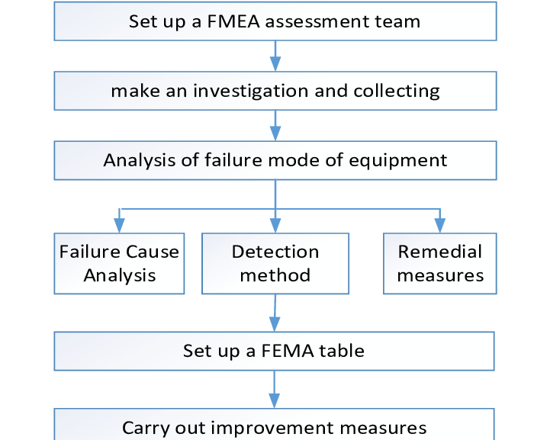
Figure 2 - A flow diagram based around the FMEA problem solving technique - Hou -H.H

This process is very efficient and leaves little room for error, therefore, engineers use it daily. On the other hand, it takes a long time to fully complete because there are so many steps.

Team Structure:

6.1 Team Structures and Personal Reflection:

I have worked within a team many different times with multiple different structures. When I work in McDonalds it is mainly a cross-functional team. This is because when we are initially trained, we are trained on every possible station meaning we are versatile and can be used wherever needed. The main team structure I would like to focus on is when I did the group project during my foundation year. Very early on in the project, the team collectively agreed that a self-managed team structure would work best. We decided on this as we were all new to each other and didn’t know each other’s strengths.
In hindsight, this structure didn’t work as well as we thought it would as without an overarching leader, work was completed at different speeds. This meant during our weekly meeting we would be at different levels of the project due to different members of the group struggling with time management. This structure was also very disorganised as we didn’t organise the report until we had all finished and by that time there wasn’t long until it had to be submitted. However, there were many positives to this team structure. For example, we were able to go into the role we were most comfortable with. This also helped to break down the workload as we were given a specific task to achieve before each meeting.

I believe overall I worked well in the team as I always had my part of the work ready in time for each meeting and did my best to communicate with the team and help those struggling. This was then reflected in my final mark where I scored 67% overall.

6.2 More efficient team structures:

I think for the group project there were many different team structures which would have benefitted the team more than the self-managed structure. For example, I believe that a flat structure would have been more suitable as it would have provided a much needed backbone. This would have ensured that work was completed on time, and nobody worked at too slow of a speed. A flat team structure allows students to contribute to the team leader while growing their own leadership skills (Alejandra Nitsch, 2020).

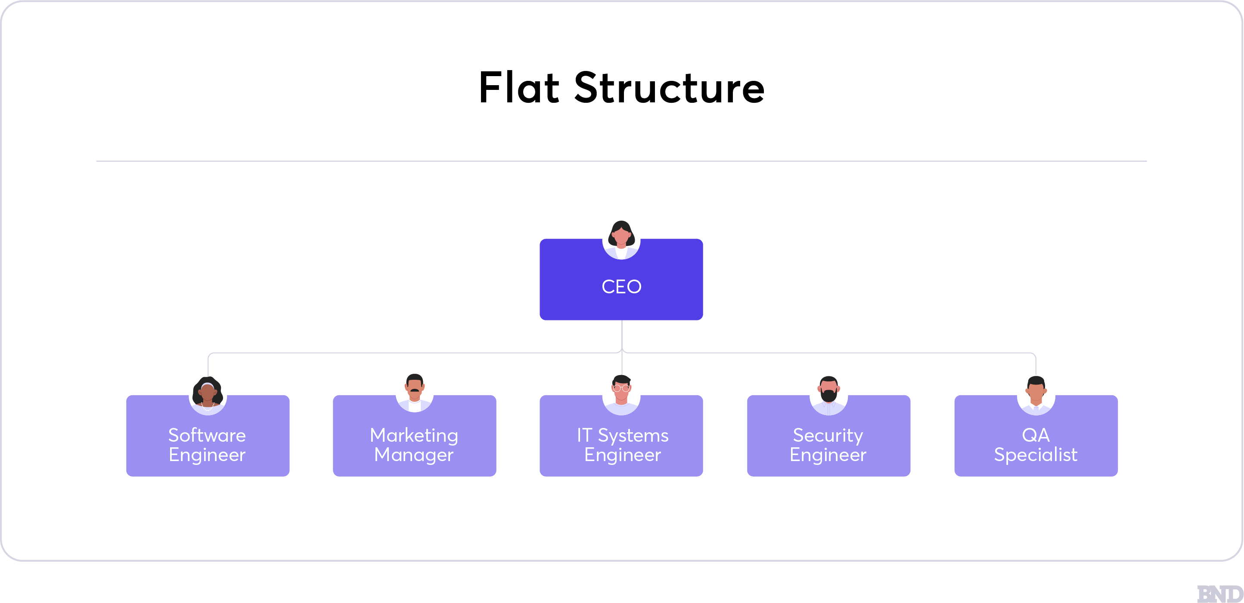
Figure 3- an example of a flat structure - CustomMapPoster

Conclusion:

To conclude, the report covered all the aims set out in the introduction. Many health and safety risks were identified and so were the multiple ways to prevent an accident. A security matrix was created with relevant problems facing modern day automotive engineering. It discussed problem solving techniques like FMEAs and the structure behind them. It also explored the different team structures like the flat structure and the self-managed team structure.
Maintaining the continuous development and health and safety is essential in engineering as there are new technologies being developed every day, along with that comes many risks which can be avoided by strong teamwork and great problem solving skills.

Reference List:

References
Alejandra Nitsch, M.N.S.K.N.O. (2020) 'A Flat Organizational Structure for an Inclusive, Interdisciplinary, International, and Undergraduate-Led Team', Frontiers, 5.
Anne Linja, T.I.M.S.T.M. (2022) 'When Self-Driving Fails: Evaluating Social Media Posts Regarding Problems and Misconceptions about Tesla's FSD Mode', Multimodal technologies and interaction, 6, p.86.
Barretto, L. (2025) EXPLAINED: How Formula 1 has cut its carbon footprint by 26%. Available at: https://www.formula1.com/en/latest/article/explained-how-formula-1-has-cut-its-carbon-footprint-by-26.4hWrySuBvCXVfGah6hIMRL (Accessed: 11 November 2025).
Bitesize, B. (n.d.) BBC Bitesize. Available at: https://www.bbc.co.uk/bitesize/guides/zcs4ng8/revision/4 (Accessed: 11 November 2025).
Bridie Adams, P.U.a.S.J. (2025) JLR cyber attack impact 'may last for six months'. Available at: https://www.bbc.co.uk/news/articles/c0qpl0v3gnzo (Accessed: 11 November 2025).
Croft, D. (2025) How To Do An FMEA (Failure Modes Effect Analysis). Available at: https://www.learnleansigma.com/continuous-improvement/how-to-do-an-fmea-failure-modes-effect-analysis/ (Accessed: 11 November 2025).
DIA (2025) www.driving.org. Available at: https://www.driving.org/alarming-rise-in-vehicle-thefts-using-signal-manipulation/#:~:text=Signal%20manipulation%20involves%20intercepting%2C%20copying%2C%20amplifying%2C%20or%20replaying,devices%20to%20either%20boost%20or%20mimic%20the%20signal. (Accessed: 11 November 2025).
IET (2024) Rules Of Conduct. Available at: https://www.theiet.org/about/governance/rules-of-conduct (Accessed: 11 November 2025).
Legislation.gov (1992) The Personal Protective Equipment at Work Regulations 1992. Available at: https://www.legislation.gov.uk/uksi/1992/2966/contents (Accessed: 11 November 2025).
Legislation.gov (2022) legislation.gov. Available at: https://www.legislation.gov.uk/uksi/1992/2966/regulation/10/2022-04-06.
legislation.gov (2022) The Personal Protective Equipment at Work Regulations 1992 - 2022 Adjustment. Available at: https://www.legislation.gov.uk/uksi/1992/2966/regulation/10/2022-04-06 (Accessed: 11 November 2025).
Mercedes (n.d.) Our Integrity Code. Available at: https://group.mercedes-benz.com/sustainability/society-governance/compliance-integrity/integrity-code.html (Accessed: 11 November 2025).
Review, T.S. (2025) The Silicon Review. Available at: https://thesiliconreview.com/2025/03/tesla-autonomous-driving-recall (Accessed: 11 November 2025).
Rossiter, S.J.&.E. (2025) Electronic devices used for car thefts set to be banned. Available at: https://www.bbc.co.uk/news/articles/c2046qlwzz3o (Accessed: 11 November 2025).
Shah Khalid Khan, N.S.P.S.Y.C. (2020) 'Cyber-attacks in next-generation cars, mitigation techniques, anticipated readiness and future directions.', Accident Analysis & Prevention, 148, p.105837.
Taotianchen Wan, Y.W. (2022) ' The Hazards of Electric Car Batteries and Their Recycling', OP conference series. Earth and environmental science, 1011, p.12026.
W C Ng, S.Y.T.H.C.L.P.C.T. (2017) 'The integration of FMEA with other problem solving tools: A review of enhancement opportunities', Journal of Physics, 890, p.12139.
Wile, R. (2023) NBC News. Available at: https://www.nbcnews.com/business/business-news/tesla-car-battery-fire-needed-6000-gallons-water-to-extinguish-rcna68153 (Accessed: 11 November 2025).

List Of Figures

Figure 1 - A table with a risk assessment for using the milling drill 3
Figure 2 - A flow diagram based around the FMEA problem solving technique - Hou -H.H 11
Figure 3- an example of a flat structure - CustomMapPoster 13
Figure 2 - https://www.researchgate.net/profile/Hui-Hou/publication/330489285/figure/fig2/AS:874660568764417@1585546738985/The-flow-chart-of-FMEA.png
Figure 3 - What Organizational Structure Is Right for Your SMB? - businessnewsdaily.com (2025)

List of Tables

Table 1 - A security risk matrix designed for this report - Evans L 7

