

BMSW4003

Digital skills and Research Methods
Individual Report

Biser Emilov Kolev
Student number: 2022842
Lecturer’s name: Koushik Modak

Table of Contents
1.0 Introduction 3
2.0 Background 3
2.1 Concept and significance of VLE 3
2.2 Benefits obtained by students while using VLE 4
2.3 Challenges or issues faced by students and professors while accessing VLE 5
3.0 Aims and Objective 6
4.0 Method 6
5.0 Analysis 6
6.0 Discussion 9
7.0 Conclusion 10
References 11

1.0 Introduction
The students at the University of Wales Trinity Saint David London Campus have changed their methods of learning due to the sudden lockdown. The use of the college online platform has been considered in deciding whether they are a useful source for providing valid information or not. The research is done based on the interview of three students, student 1, student 2, and student 3, and 17 students were involved in the process of giving their valuable opinions on the impact of Virtual Learning Environment (VLE).
The primary data of the seventeen students were collected in the research project and from which the three students were selected to make the research valid. The research initiates a survey in which the general learning experience of the students has been collected. The analysis and the discussions were made based on the research work. The open and closed-end questionnaire is analysed and with it, the comparison is made. The aims and objectives of the VLE are also stated as it helps in the proper functioning of the classes through the online medium. The factors which affected the students and the professors as they cannot adapt to the sudden changes were also considered.

2.0 Background

2.1 Concept and significance of VLE
Virtual learning environment helps in the enhancement of the educational practices and tends to educate the students by giving them the online way of communicating and learning with it. The enhancement in the use of online learning as the most important platform during the growing times of the Covid-19 and a sudden lockdown followed by it. Students can access the materials and assignments very easily and it can be done from anywhere and anytime. The students are now able to interact with the teachers and they can be guided by the tutors anytime.

Figure: 1: Learners impacted by the school closures all over the world.
(Source: Li and Lalani, 2020)
The figure shows the impacts which the pandemic brought on the students as they had to stay at home as the schools were closed and with this, the face-to-face education was affected. The innovative and easily accessible method of teaching is cost-effective, flexible, and is a very high-performing system from where the education can be valuably given to the students by the teachers.

2.2 Benefits obtained by students while using VLE
As stated by Smart and Conrad (2017), the students connect based on increased inclusivity as all the students get engaged in the process and it is quite easy for all the students. The improved accessibility helps in the access of the virtual method of teaching and leading all the learners to access with mobility. The community and relationship building states that students get to develop a bond and work collaboratively on the projects and learning. The comfort and flexibility of the virtual learning environment show that the learners can easily access the teaching and connect with the teachers from the comforts of home and the virtual conversations can also be recorded and studies in the future. Feedback and screen sharing is important for the students to learn from their mistakes and to access the details at any point in time. This immediate feedback from the teachers helps a student to completely understand the topic and their ways of communicating with the teachers become easier.
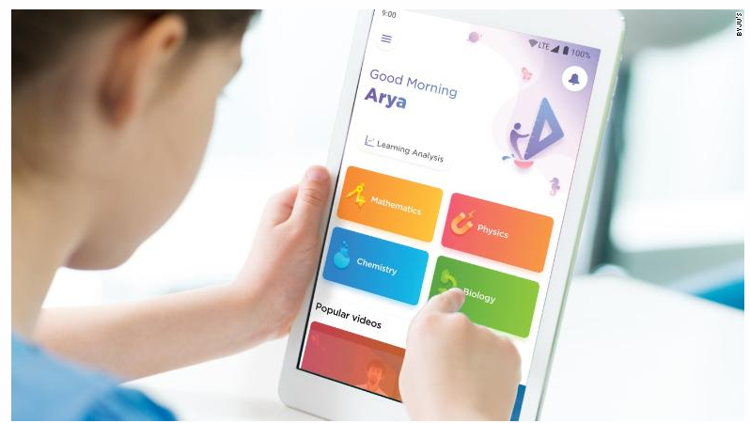
Figure: 2: Learning through the online media.
(Source: LEWIS, 2020)
The figure states that the online methods of learning progressed due to the sudden lockdown and the virtual media helped the students to stay connected with the teachers and the progression in studies.

2.3 Challenges or issues faced by students and professors while accessing VLE
According to V (2021), the students face the problem with adaptability as the students are new to this method of learning through virtual media, they tend to face the challenge of how to optimize the ways of learning. The technical glitches of the network slow down the learning process through online media and in this way the morale of the students goes down as they lose track of the live sessions. The virtual medium of learning has a problem with time management as the students and the teachers lose track of time due to multitasking and distractions in the work. The learning style is not like the physical classroom and with this, the students face the problem of difficulty in creating projects and assignments using the technology which is very new for students to adapt.
Heckel (2021) stated that virtual engagement is difficult for the students as they feel the struggle in understanding the concepts of the study which can be done easily through the physical classroom. The sudden change from the physical medium to the online medium of learning affected the professors too as in the short span of time they are not able to change and adapt the method of online teaching.

3.0 Aims and Objective
This research aims “to identify the benefits and loopholes of VLE or Virtual Learning Environment- Moodle on the experiences gained by the students currently studying in UWTDLC.
The objectives of the research are as follows-
- To know the concept of the Virtual Learning Environment concept.
- To state the benefit of the VLE and its impact on the learning experience of the students.
- To find out the limitation that can be found in and its impact on the learning experience of the students.
- To take strategies so that the enhancement of the VLE can be positively made to improve the quality of the online learning process.

4.0 Method
This part highlights the methodological side of this study where the researcher studied the topic in detail and found the design of the research and research approach. After the aims and objective is set the research was conducted primary data collection methods. The aim of the study was to find out the impact of VLE on students of the UWTSD. Both the qualitative and quantitative methods were used as the use of Moodle was stressed with online learning in this study. For the survey, a group of students was chosen to state their opinion. 17 students participated in this survey when for interview purposes 3 students were chosen among them to place their opinion regarding online learning at UWTSD.
The survey was in London as the University is in London. The advertisement regarding the research was posted on social media platforms. The students who used Moodle practically were preferred more for this research. The survey questions were 4 and the interview questions were 4 all total there were 8 questions. Both open-ended and close-ended questionnaires were prepared. The survey was done online the questionnaires were forwarded to the participants through emails. This system was followed to maintain social distancing during covid 19 situations.

5.0 Analysis
Q1. What type of learning do you prefer?
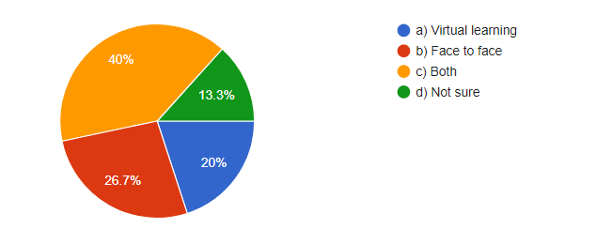
Figure 3: Type of learning preferred.
Analysis: Here in this survey the majority said they prefer both the form of learning around 40% of the student said this. 20% voted for virtual learning and 26.7% went for face-to-face learning and 16% are still confused with the whole thing.
Q2. How happy are you to become a student at UWTSD?
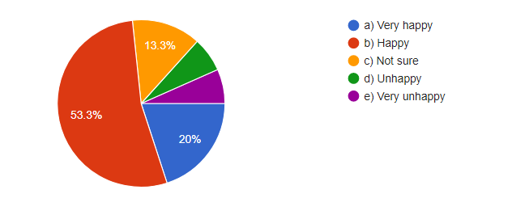
Figure 4: Satisfaction in becoming a student of UWTSD.
Analysis: Nearly 53.3% are happy to be a part of UWTSD. They are satisfied to be the students at this university. Very less percentage of people are not satisfied with the performance of the university.

Q3. Moodle is helpful with my online learning.
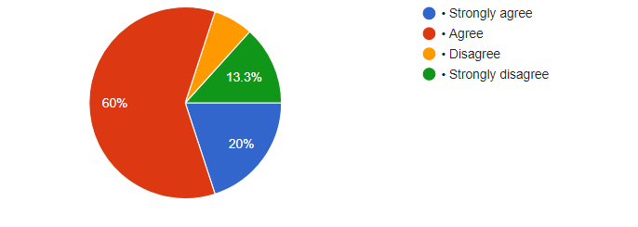
Figure 5: Usefulness of Moodle in online learning.
Analysis: Moodle is quite very useful in online learning as 60% of students strongly agreed with this and very less that is around 13.3% strongly disagreed with the statement.
Q4. How far satisfied are you with virtual learning at UWTSD?

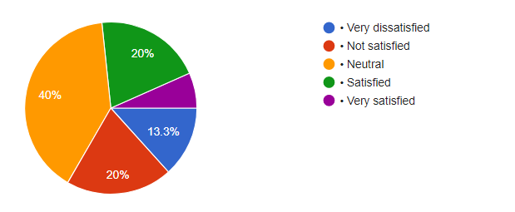
Figure 6: Satisfaction with virtual learning at UWTSD
Analysis: Virtual learning is a very new method of learning thus it needs some time to replace the traditional method of learning. About 40% of the students gave a neutral reaction to this context.
Q5. How did you feel about the studying methods during online classes?
As per the statement of student 1 and student 2 the online classes are average according to them as they do not get that environment which they used to get in a face-to-face learning environment. On the other hand, student 3 said he is enjoying this mode of learning as it is saving traveling time.
Q6. How would you describe your experience with virtual learning?
In this question, almost the same kind of answer has been noticed according to the three students the virtual learning method has a very usual problem of connectivity which disrupts the classes in between.
Q7. Are you happy with online learning in UWTSD?
Like the first question the three students replied accordingly. The first 2 students are not happy much but the third one is quite very satisfied.
Q8. Would you recommend your university?
Yes, three of them recommended their university they said it is one of the best universities in the country and the students experience a very bright future.

6.0 Discussion
The responses of the research are representing that the students have mixed reviews regarding the online learning process. Many students are still not familiar with the concept of Virtual Learning Environment (VLE) and Moodle as they did not use it practically thus, they are not much aware of its effects. The first question has a very neutral response around 40% responded neutrally. Still maximum prefers face-to-face learning mode till date. Many have doubts regarding this online mode of learning (Kelly and Rebman, 2014). The observation is saying that the perception of the VLE is still not clear to the students, and that’s why conflicting views are being noticed.
60% of the students agreed that Moodle is the best online learning platform. It has opened a new way for online learning and has enhanced a lot (headspace, 2021). Similarly, as per the statement of Smart and Conrad (2017) the students connect to it and engage themselves easily with it. The group of 17 students said they are happy to be a part of UWTSD as they are enjoying the VLE of the university. 20% are satisfied and 20% are dissatisfied this question got 40% neutral responses. For the qualitative method three students were chosen among the 17 students they were interviewed regarding the learning experience in Moodle and at the UWTSD. 2 students said that according to them the online learning procedure is not up to the mark as this does not give that feeling of learning which they used to get in offline mode of learning. Face-to-face learning is much more effective than virtual one (staffordglobal, 2020). The other student that is the student number 3 said that he enjoys the online mode very much as he stays a bit far from the university thus, for him this mode of learning saves a lot of time, energy, and money. He wants this way to be continued permanently.
The experiences that they shared regarding virtual learning were almost the same. They shared a quite common issue they said the connectivity breaks the rhythm of the classes this issue affects a lot and disturbs the moods to an extreme level. According to V (2021), he also stated something like this, the technical glitches slower down the learning process through social media and thus, morale goes down. Apart from this part, the online learning method is not that bad. The last question was regarding the University how far the students recommend others to take admission in this university. In reply to this question, the students said that they recommend all to join this university as this is the best university as per them in this country. The students who passed out from this university have prospered a lot in their fields. Thus, all the three stated the same answer in this regard.

7.0 Conclusion
From the above discussion and analysis, it can be found that the overall view of the three students was neutral in stating the usefulness of the Virtual Learning Environment. So, the VLE being a useful part of modern times can have various advantages and disadvantages too. The advantage is its cost-effective method of accessing education in times of crisis and lockdown. Whereas the disadvantage is that it cannot be easily accessed as they involve the virtual medium in the process.

References
embibe.com. 2021. 10 Online Learning Challenges & How to Overcome These Problems. [online] Embibe Exams. Available at: <https://www.embibe.com/exams/online-learning-challenges-and-solutions/> [Accessed 5 April 2021].
headspace.org.au.,2021. Face To Face Vs. Online Learning Options | headspace. [Online] Available at: <https://headspace.org.au/young-people/face-to-face-vs-online-learning/> [Accessed 5 April 202].
Heckel, J. 2021. News Bureau | ILLINOIS, News.illinois.edu. Available at: <https://news.illinois.edu/view/6367/807512> [Accessed: 5 April 2021].
Kelly, D. and Rebman Jr, C.M., 2014. Perception and Acceptance of Online Education: Do Online Courses Pass the Muster?. Issues in Information Systems, 15(2).
LEWIS, N., 2020. Coronavirus lockdown could give online education a lasting boost in India. Published: April 8, p.2020.
Li, C. and Lalani, F., 2020, April. The COVID-19 pandemic has changed education forever. This is how. In World economic forum (Vol. 29).
Smart, P. and Conrad, L.Y., 2017. Diversity, inclusivity, and accessibility. Learned Publishing, 30(3), pp.183-184.
staffordglobal.org.,2020. Online Learning vs Classroom Learning. Read 5 differences. [Online] Available at: <https://www.staffordglobal.org/articles-and-blogs/general-articles-and-blogs/5-differences-between-online-learning-vs-classroom-learning/> [Accessed 5 April 2021].

