Student Name: Joel Martin Goldring
P Number: 1902827
Programme of Study: Advertising & Brand Design
Module: M4X01560

Tasks in the order I received them:
Task One: Julia Lockheart – Manifesto Writing: “What do I believe in?” = 499 words
Task Two: Ryan Moule – Observational Writing: Identify an image and write a Semiotic Analysis = 491 words
Task Three. Jon Pugh – Reflective Writing: Do you know what you think? = 501 words

Task One: Manifesto (Julia’s Task)

- Art can be expressed in any way the artist sees fit.
- Always be present. It is better to regret being in the moment than to wish you were there when you weren’t.
- Expression has no barriers, no matter how hard society tries to restrict it.
- The only thing more powerful than knowledge, is belief.
- Creativity comes from experience, so allow yourself the opportunity to experience new things.
- Failure is inevitable, learn from it and grow.
- Actions create reactions. Consider, calculate and remain composed.
- Follow your heart, it will lead you to where you want to be.

Keywords and Images

Expression


A mural of US President Donald Trump kissing Vladimir Putin

- Expression has no barriers, no matter how hard society tries to restrict it.

The extent to which a person can express themselves has changed drastically over the last century as people are becoming more and more accepting of others who are different or come from different backgrounds. This change in mentality comes from people fighting back against the societal norms although we are still a long way off of being where we aim to. Sharing your opinion or your thoughts with others is an effective way of expressing yourself, even if it does not align with the majority. People should strive to have that confidence in themselves, to be okay with somebody not agreeing them. As mentioned in Sarah Knight’s the Life-Changing Magic of Not Giving a Fuck, “for those wishing to free themselves from the shackles of fuck-giving in pursuit of healthier, happier lives”, it does not matter if society agrees with you. We as a society, have an obsession with wanting to know what others think of us. In order to be able to grow, we must stop caring so much and just live our best lives, expressing ourselves in whatever way we want. The barriers that were put over people in the past must serve as an example of why we need to work on being more accepting of people who express themselves in different ways.

Belief
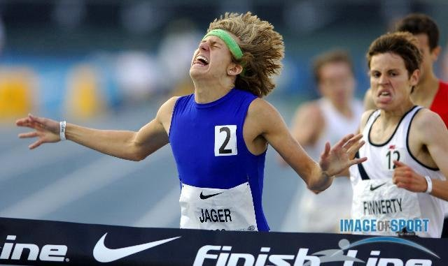

A picture of a runner winning a race

- The only thing more powerful than knowledge, is belief.

As said by Gary John Bishop in Unf*ck Yourself, “The way we talk doesn’t only affect us in the moment. It can seep into our subconscious and become internalized, changing our thoughts and behaviour in the long term”. Having belief in yourself can carry you through many situations, even if when you don’t know what’s going on. Sometimes it is more valuable to having a strong belief in yourself than it is to know every trick in the book. It’s like a runner knowing all the best techniques but not being able to beat the opponent who just had more belief in themselves and their abilities. It can be hard to take but that’s the magic of having true determination and will power. Knowledge is power but so is the right kind of belief, especially when paired with someone who is a naturally determined person.

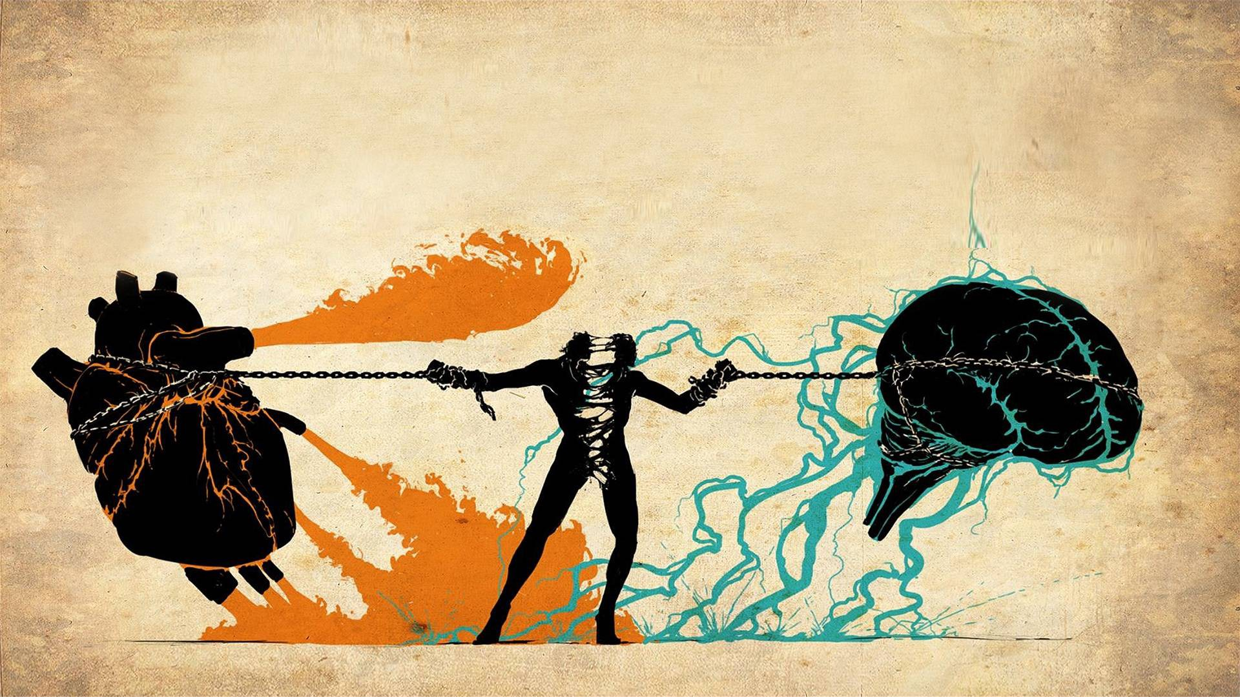

The battle between the mind and heart

- Follow your heart, it will lead you where you want to be.

Sometimes the heart wants what the heart wants, even if you know better. What that does tell you is that as long as you follow your heart, you will always be where you truly want to be. As said by Andrew Mathews in Follow Your Heart, “Whatever thoughts are causing you pain, they are only thoughts. You can change a thought.” You can change your mind, but you cannot change your heart so do not be scared to follow it. Obviously, there are times where thinking with your heart and not your head can be inappropriate, such as cheating on a significant other for example. Even if your heart may have turned, it would be better to think with your head in that kind of situation but still you cannot deny yourself happiness by not following your heart.

Bibliography
- Putin, Trump image: news.artnet.com/art-world/trump-putin-kiss-lithuania-mural
- Man winning race image: www.reddit.com/r/photoshopbattles/comments/196246/runner_winning_a_race/
- Fight between mind and brain image: https://livelikepros.com/hrv-resist-temptations/
- UnF*uck Yourself by Gary John Bishop
- Andrew Mathews Follow Your Heart
- Sarah Knight the life-changing magic of not giving a Fuck

Task Two: Semiotic Analysis (Ryan task)

What do everyday objects mean to us? Why is a toothbrush no more than just a toothbrush or why is a traffic light no more than a traffic light? In order to truly understand the value of everyday objects, we need to look beyond the surface level. As said by Roger Zelazny in Lord of Light, “No word matters. But man forgets reality and remembers words.” Although words do not feel as valuable as physical objects, knowing how to truly understand something and appreciate it, can be one of the valuable skills you can take through life.

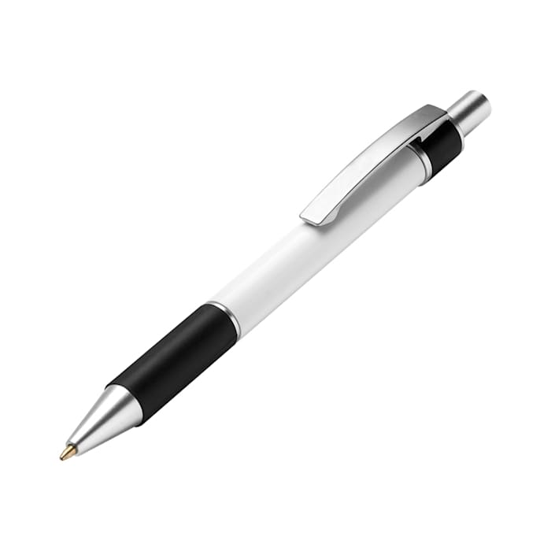
The object I have decided to analyse is a pen. I will research into why this pen is much more than what it seems. All it takes is a bit of effort and consideration to see the true value of this object. What most people look at as an average everyday item, I can reveal it’s true value by looking a little bit deeper than the surface. By the end of my piece, I am confident I will have made a convincing argument as to why this pen is undervalued.

The pen that I am analysing is my sign. The signifier is the actual physical object. So, we can see that the pen is long, silver, cold, hard, rubbery and so on. By looking at the sign and analysing what we can see, we can get a solid idea of the signifier. The signifier can help you associate the sign with things such as paper, ink, books, library and so on.

“Beneath the rule of men entirely great, the pen is mightier than the sword” famously said by Edward George Bulwer-Lytton. The pen is a symbol of keeping record, writing, keeping track of history. Looking at the pen, you can think about how this tool is the reason we know so much about our past and ancestors. This simple little tool is one of the most important factors to our development as a modern society.
The pen has captured thousands of years of history and will capture thousands more to come. “My heart overflows with a good theme; I address my verses to the King; My tongue is the pen of a ready writer” - Psalm 45:1. This pen is a symbol of words spoken by man thousands of years in the past. You can also see this object as something that is negative by associating it with unfavourable experiences such being in school or work. In order to understand the sign, you must look unto the signified and analyse it.

“That they were graven with an iron pen and lead in the rock for ever!” Job 19:24. This image of a pen represents history and the future. This is how much value you can take from something that most people wouldn’t have thought twice about. Taking an extra minute and analysing something can give it far more significance to you and to others.

Bibliography
- Roger Zelazny, Lord of Light
- Edward George Bulwer-Lytton
- The Bible Psalm 45:1
- Biblehub.com
- The Bible Job 19:24.

Task Three. (Jon’s Task)

I have decided to reflect the Kevin Carter’s Pulitzer prize winning photograph, ‘The vulture and the little girl’.

As of January 1993, many men, women and children were dying of starvation in Ayod, Sudan. In order to try and help the people of Ayod, Operation Lifeline Sudan reached out to journalists to try and get them to raise awareness of the reality of what was happening. Journalists were being offered 24-hour visas to come see the country and meet the people. This is how Kevin Carter would end up in Ayod at that time. As said by John Green in Will Grayson, Will Grayson, “It's hard to believe in coincidence, but it's even harder to believe in anything else.” This coincidence that led Kevin Carter to Ayod resulted in one of the most powerful photographs ever being taken.

The image that Kevin Carter captured depicted a small child, visibly starving to death, curled over on the floor with a vulture standing yards behind. The reason this was so powerful is because it depicted the harsh reality of the situation in Ayod at this time. Seeing an innocent, defenceless child dying of starvation whilst a vulture silently and patiently waits in the background has a breath-taking impact. As said by Philip K. Dick in I hope I Shall Arrive Soon, “Reality is that which, when you stop believing in it, doesn't go away.” Just simply wishing this little child wasn’t in that situation helps nobody. That was the aim of the Government in Sudan at the time, to try and show people the harsh reality so that simply wishing it away wouldn’t be enough.

The vulture in the background acts as a symbol of everyone around the world doing nothing but watching whilst the child dies of starvation. It makes you re-evaluate your own point of view as you realise you are no different to the vulture. Simply forgetting after seeing the image almost feels just as bad as being there in person and doing nothing. It makes you want to act, to make a difference. This also called into question why Kevin Carter did not help the child instead of taking advantage of the situation. This photograph would go down as one of the most powerful images ever taken and yet the child still gets nothing. Whilst Kevin Carter and all the other Journalists were looking for their money shots and winning awards, thousands of children would still remain in the same situation with no help. “They say, timing is everything. But then they say, there is never a perfect time for anything”- Anthony Liccione. Although Kevin Probably could have helped that individual child, his image would go on to help thousands of other children as people became inspired by the work. As said by Aleksandr Solzhenitsyn in The Gulag Archipeago, “Thus it is that no cruelty whatsoever passes by without impact.” Kevin Carter committed suicide on July 27,1997 at age 23 just four months after being awarded the Pulitzer Prize.

Bibliography

- Thehindubusinessline.com
- Wikipedia.org
- John Green, Will Grayson, Will Grayson
- Philip K. Dick, I Hope I Shall Arrive Soon
- www.goodreads.com/quotes/tag/do-nothing
- Aleksandr Solzhenitsyn, The Gulag Archipelago 1918–1956

