A report on-
Managing Enterprise in the 21st Century
Module Code: BMSK4006
Student’s Name: Sekimwanyi Abdallah
Student’s No: 1806580
28/04/2019

Lecturer’s Name: Rexon Nting

Executive Summary
The report deals with the business plan understanding based on the team work where different models like Tuckman team work theory and Belbin team roles have been applied to coordinate the group activities to make an effective business plan on a restaurant. Furthermore, here the Gibbs ‘Reflection Cycle has been used to analyze the knowledge based analysis.

Index
Background of the report 1
Gibbs reflection cycle 2
Description 3
Feelings 5
Evaluation 6
Analysis 7
Conclusion 8
Action plan 9
Conclusion 10
References 11

Background of the report
Business plans are the prerequisite for a start-up and in this report the understanding of the start-up plan of a restaurant performed by my team covering the Tuchman team model theory to generate higher team value has been reflected. However, the following steps have been considered based on the skill achievement demonstrating the activities as well as the pros and cons of the restaurant business plan. To be more specific, the Gibbs’ Reflection cycle has been used to analyze methods, understandings and the action with synopsis of the plan. Furthermore, the skill gaps has been analyzed along with the implication of the ins and outs of the business plan components.

Gibbs reflection cycle
Gibbs reflection cycle is the most effective psychological implication of an analyst of his or her own performance (Fernandes, 2017). The cycle consists of six steps where each of the steps has some unique considerations for the analysis (Fernandes, 2017). The first steps are description that determines the activities performed, feelings that reflects the inner sense and thought process of the performer(s), evaluation that evaluates the activities based on the learning process, more specifically the theories and models relation with the work, analysis that evaluates the performed activities with any standards and points out the merits and demerits and the place of improvements, conclusion where the analyst comes to a firm conclusion to perform the reformed activities that are required to be done with diligence and the last step is the action plan that includes the recommended activities to be performed relating the models, improving the problematic issues and so on .

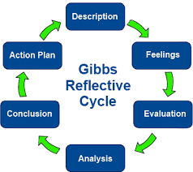
Figure: Gibbs reflection cycle

Description
In the class, along with my team, I made a restaurant business plan analyzing the economic factors, industrial factors and the restaurant business factors in UK. Before coming to the business plan, we discussed on what we knew about the business plan and the points came out that a business plan is the initiative of an entrepreneur to take risk for higher return and make an employment opportunity for himself as well as for other unemployed people. However, we also did not know about the economic analysis and the industry analysis approach and with the group discussion and with the help of the books and different journals on economic analysis and the industry analysis, we came to know about the PESTEL analysis (Keegan, 2014) and the Porter’s five forces (Michaux, Cadiat and Probert, 2015) with which we analyzed the restaurant industry. Furthermore, we also came to know the components of the business plan and synthesized a possible components for our restaurant business.
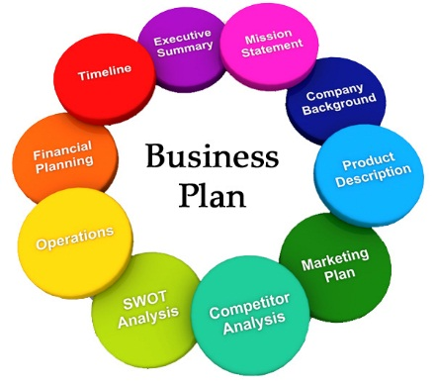
Figure: Components of the restaurant business plan
Here, we considered the problem finding at first where we found that in UK there are hardly any restaurants that are giving the utmost service to the customers to be satisfied and therefore, most of the restaurants are lacing the profitable margin over the years. In the following diagram, we analyzed that the sales change of the restaurant business has declined severely and so we considered to take the opportunity of the market and started designing our business plan covering the opportunities. We set mission and vision for our business and analyzed the market with the statistical tools as well as market survey approached like questionnaire and interviewing the customers of different restaurants in London. At the same time, we analyzed the competitors in the restaurant market so that we can have the vibe of the market leaders and follow the positive signs and be concern of the shortfalls.
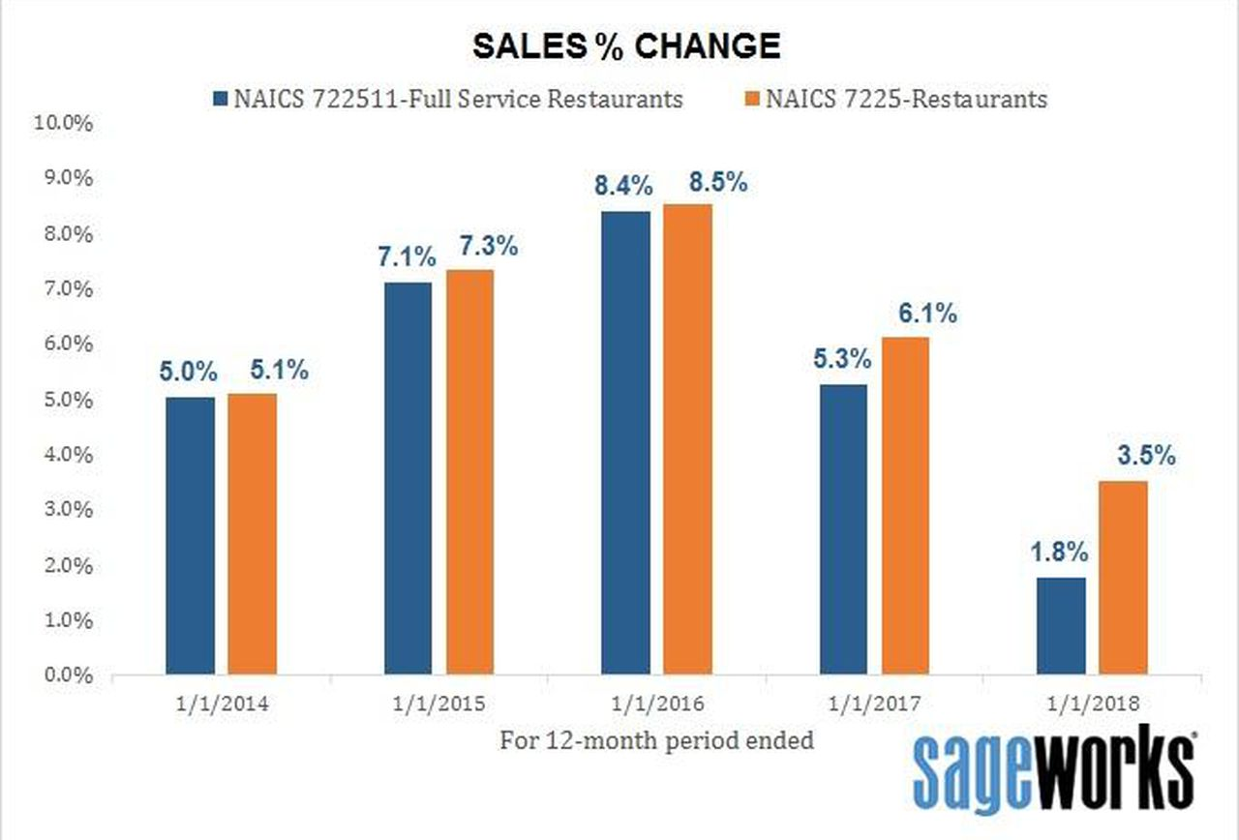
Figure: UK restaurant industry sales trend (Google.com, 2019)
We also made an operation plan with a management team hierarchy so that the power and task distribution can be done accordingly. However, we included a draft financial plan for the business and included possible financing opportunities with cost effective view. In the overall business plan, we, however, got an understanding that we were following the Tuchman’s team role subconsciously where the steps are as follows:
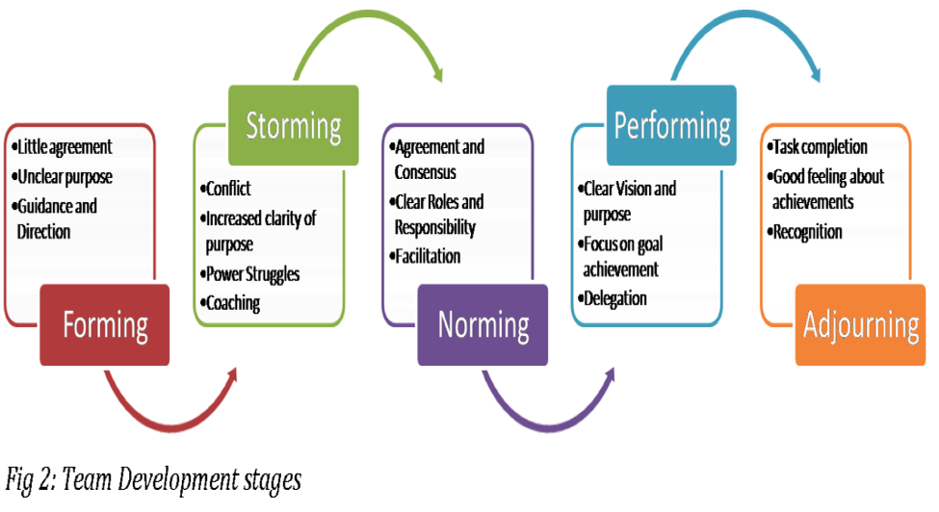
Figure: Tuckman’s team role theory
We formed a group, stormed the activities reducing the conflicts among us agreed to work together and prepared a hierarchy of the power and task flow and finally performed the planning based on the goals and objectives. In fact, we adjourned the plan after the finishing touch.

Feelings
After doing the business plan, we in the group following the Tuckman’s team role theory, felt that we are being bonded to our activities and we have become different parts of a same body. Our thought process became similar as we approached to analyze the restaurant business with a coordinated plan and felt that we could achieve any difficult activity in a group task. As we approached through the team activities we formed our mission and reduced a conflict that occurred during our planning process. While planning, one of the team mate argued that we should think only of the local restaurants and make our plan with less effort as we will not make the business in a real sense. So, his thought process became different form the other team members and then we made him understand that we were a team and whether we would make the business in a real sense or not, we should do our duty in an appropriate manner as within some months or years, we will move to job sector or career building approach and so, we should be concerned.

Evaluation
In the business plan making time, I evaluated some skills of mine which were latent to me previously. I found that I could manage my time and in the team, I could respond instantly. In fact, I became accustomed to working in the group and also led the group to analyze the business plan components like financial plan and operation plan. On the other hand, I found that I was not adept in the communication skill rather I was prone to give instructions and did not bother to tale the feedback form the team mates. In addition, I also felt that I lacked the softcore skills like impersonal skills. Apart from my own evaluation, I also evaluated the business components for the restaurant business and found that the group wanted to focus on the solution at first that we had to make restaurant business plan whereas the problem identification should have been the first concern of the business plan for the restaurant. However, this weakness in the group led to some issues of weak operational plan and poor financial plan also. For this reason, we, as a team, along with the Tuckman’s team role theory, used the Belbin’s team role theory that is more extensive for the team activities (Belbin.com, 2019) and made our task more specific aligning with the goal of the business plan.
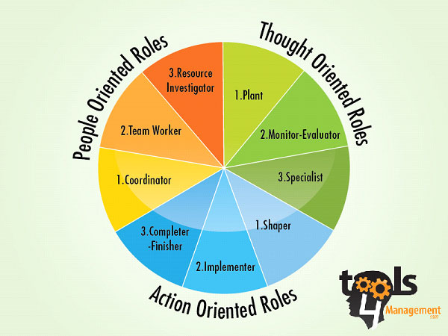
Figure: Belbin’s team role theory (Belbin.com, 2019)

Analysis
Using the Belbin’s team role theory, we analyzed the thought oriented roles, people or group oriented roles and action oriented roles. We analyzed the importance of the thinking process before approaching to the business plan and found out the individual weakness and strengths with SWOT analysis and skill audits. Surprisingly, most of us lacked the communication skill and we worked on it to make ourselves clear to each other and worked as a team as well as coordinator of the tasks. However, we also analyzed a more feasible use of the team work in planning and focus on the SCOC analysis instead of the SWOT analysis.
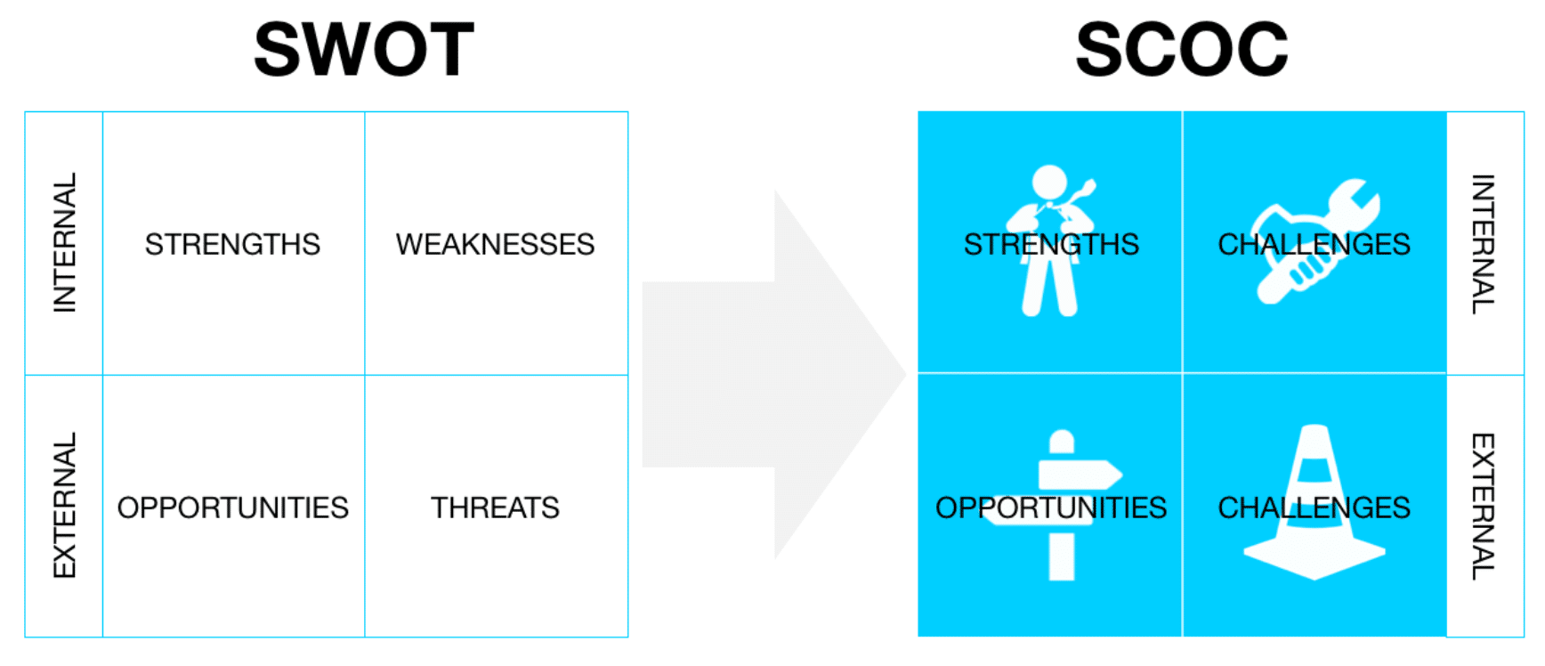
Figure: SWOT to SCOC analysis
We focused on the team roles and the challenges as well as the opportunities of the restaurant business and with the in-depth analysis using accounting tools and tax accounting methods, we found that if we can initiate a well-organized restaurant, we can get tax benefits from the generated income as there are some investment tax credits available for the restaurant business investment and by attaching the compliance forecast of the regulation of the business in the operation plan, we decided to take the advantage of tax credit and our feasibility test showed us that if we could really implement this restaurant business in the opportunistic market where the customers are demanding customer oriented service, we can, with our full strength and skill development on time management, leadership, as well as impersonal skills can take the business to a profitable level.

Conclusion
Based on the analysis and evaluation as well as the performed activities, I can make a firm conclusion that if we can reduce the skill gaps and develop our business plan aligning with the market analysis and SCOC analysis, we can generate higher value for the restaurant business. As a result, after we complete our graduation, we can, as a team, develop an effective restaurant business with extensive knowledge and review of the improved skills. With the passage of time, it highly recommended that we develop our time management skills and impersonal skills as well as the understanding of the critical thinking ability and analytical ability to be up to date with the changing world.

Action plan
At this stage, I require to improve my skills like time management as I often get idle to do my due tasks on time and feel that I will finish it latter and thus I can’t make the work in time. So, I prefer to follow the below steps in my action plan in developing the restaurant business plan with my team. At first, I have already identified my lacing in the skill audit including the communication skill, critical thinking skill and the impersonal or softcore skills. I need to be open minded to improve such skills and implement the acquired knowledge in the business. I have to study the team building models of Tuckman and Belbin so that I can not only just understand the importance of the team work but also implement it in my daily activities in the restaurant business planning process with the other team mates. Moreover, I should take communication courses and evaluate my task and result.
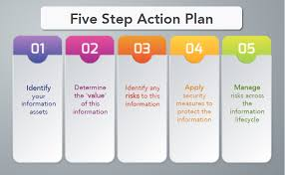
Figure: Action plan (Ctb.ku.edu, 2019)
However, the action plan can be finalized by implementing the business plan into action and I hope that with this extensive and realistic analysis of the business plan, I can along with the team mates start-up a restaurant business in London to garb the opportunities and enlighten the future with proper self-employment rather working for others.

Conclusion
The business plan is not just a plan for the course it made me understand the importance of team work (Gregory, 2013) and I prefer to initiate the restaurant after my graduation and improve my skills to be more competent that the counterparts so that one day I may not go for work, rather people will come for work to me and my feasibility of the plan of the restaurant business can make this happen in my later life.

References
Maksimović, M. (2018). Muzika u team building-u. Humanistika, 2(4), pp.87-92.
Gregory, H. (2013). Teamwork. 5th ed. North Mankato, Minn.: Capstone Press.
Fernandes, M. (2017). A Critical Reflection on Real Business Cycle Models. SSRN Electronic Journal. 5(2), pp. 25-30.
Belbin.com. (2019). Belbin and Tuckman: Supporting your team at every stage. [online] Available at: https://www.belbin.com/resources/blogs/belbin-and-tuckman/
Belbin.com. (2019). Home. [online] Available at: https://www.belbin.com/
Keegan, W. (2014). Marketing. 4th ed. Scarborough, Ont.: Prentice Hall Canada.
Michaux, S., Cadiat, A. and Probert, C. (2015). Porter's five forces. 7th ed. [Place of publication not identified]: 50Minutes.
Ctb.ku.edu. (2019). Chapter 8. Developing a Strategic Plan | Section 5. Developing an Action Plan | Main Section | Community Tool Box. [online] Available at: https://ctb.ku.edu/en/table-of-contents/structure/strategic-planning/develop-action-plans/main
Google.com. (2019). restaurant industry sales 2018 - Google Search. [online] Available at: https://www.google.com/search?sa=G&hl=en-BD&q=restaurant+industry+sales+2018&tbm=isch&tbs=simg:CAQSkwEJLfgCdBbrVyIahwELEKjU2AQaAAwLELCMpwgaYgpgCAMSKI0IigitE64T9wKyE6EHmxSvE7MT7z_1XP_1A_1oz6lK-4_17T-JK6oo1j8aMCPnf6Rs_1KDw0w2n_1a50FzUDqKPnCA5GodN4mdzd0D-0ty1LLIdF-sma7ExAszhVLyAEDAsQjq7-CBoKCggIARIEsypHRww&ved=0ahUKEwjX7Y_zot7hAhWIu48KHd80CLAQwg4IKSgA&biw=1366&bih=619#imgrc=LfgCdBbrVyJvRM:

