University of Wales Trinity Saint David

Wales Institute of Science & Art

Material Selection Report

Workshop and Practice (ACHA4001)

Jacob Ling
220427
April 2024
Contents
1 Introduction 2
2 Component Design Specification 3
3 Material Selection 4
3.1 Cast Iron 4
3.2 Aluminium Alloy 5
3.3 Forged steel 6
3.4 Property Table 7
4 Manufacturing Process Selection 8
5 Conclusion 9
6 Reference List 10

Introduction

In this report I will be evaluating the most suitable manufacturing process and materials for an engine or suspension component of my choice. For this assignment I have decided to use a crankshaft from a 2.0 TDI engine as these are very common engines and widely manufactured and used across multiple brands.
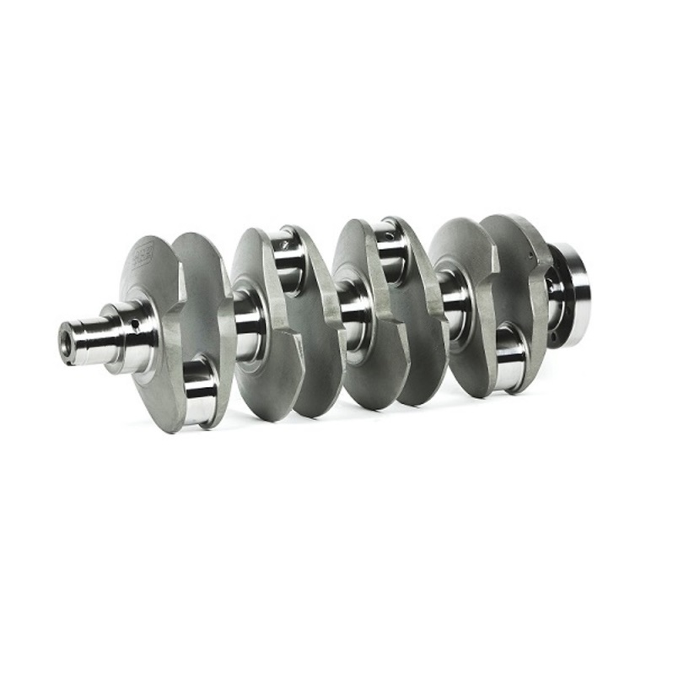
Figure 1

Component Design Specification

Performance Requirements | Design Requirements | Design Specification
Cost | Must be cost effective to prevent passing the cost onto the consumer | Should not cost more than £400
Corrosion | Materials used must be non-corrosive | Use materials known to be long lasting and not corrosive
Durability | Must be able to tolerate daily use | Use materials that are high strength and unlikely to brake
Environmental Impact | Production must be environmentally sustainable | Use materials that are produced and manufactured in the most environmental possible way

Material Selection
Material selection is a vital part of designing and creating components of a vehicle as there is many variables to consider. When deciding on a material you must consider cost, density, strength / durability, environmental impact.
Crankshafts are typically made from cast iron, forged steel, or Aluminium alloy.

Cast Iron
Pros of Cast Iron Crankshafts:
Affordability: Cast crankshafts are generally much more affordable to produce due to the simplicity of the casting process. The raw material costs and tooling expenses are also significantly lower.
Widespread Use: Cast crankshafts are commonly found in stock or budget-friendly engines, including many original equipment manufacturer (OEM) applications.
Simplicity: The casting process is straightforward, involving pouring molten material (typically cast iron) into a mold to create a raw casting.

Cons of Cast Iron Crankshafts:
Weight: Cast crankshafts tend to be heavier compared to their forged counterparts. The additional weight can affect engine performance, especially in high-performance applications.
Grain Structure: Cast iron crankshafts have a less precise grain structure compared to forged cranks. This can impact strength and durability.
Brittleness: Basic cast iron used for crankshaft production is rather brittle. Meaning it is not suitable for operating under high amounts of stress for long periods.
Corrosion: Cast iron is prone to corrosion if not properly protected, especially in environments with high humidity or exposure to corrosive substances. This can lead to premature degradation of the crankshaft and reduce its lifespan if not adequately maintained.

Aluminium Alloy
Pros of Aluminium Alloy crankshaft:
Lightweight: Aluminium alloys are significantly lighter than cast iron or forged steel. A lighter crankshaft reduces the overall weight of the engine. This can improve fuel efficiency, reduce emissions, and enhance vehicle performance.
High Strength-to-Weight Ratio: Despite being lightweight, aluminium alloys can offer high strength-to-weight ratios, providing adequate strength for engine operation while keeping weight to a minimum.
Corrosion Resistance: Aluminium alloys typically have good corrosion resistance, especially when properly treated or coated. This helps extend the lifespan of the crankshaft, particularly in environments with high humidity or exposure to corrosive substances.
Improved Engine Dynamics: The lighter weight of an aluminium alloy crankshaft can result in reduced rotating mass, which can lead to improved engine response, faster revving, and better throttle response.

Cons of Aluminium Alloy crankshaft:
Lower Fatigue Strength: Compared to materials like forged steel, aluminium alloys have lower fatigue strength, which may make them more susceptible to fatigue failure, especially under high-stress conditions or in applications with frequent load cycling.
Limited Durability: While aluminium alloys can be engineered to provide adequate strength for crankshaft applications, they may not offer the same level of durability as materials like forged steel or cast iron. This can be a concern in high-performance or heavy-duty applications where durability is critical.
Cost: Aluminium alloys are generally much more expensive to produce than materials such as cast iron. This results in higher manufacturing costs for aluminium alloy crankshafts, making them less economical for mass-produced engines.
Machinability: Aluminium alloys are more challenging to machine compared to materials like cast iron or steel. This can increase manufacturing costs and complexity, especially for precision machining processes required for crankshaft manufacturing.
Reduced Damping: Aluminium alloys have lower damping characteristics compared to materials like cast iron. This may result in increased engine noise and vibration, potentially leading to decreased comfort and NVH (Noise, Vibration, and Harshness) levels.

Forged steel

Pros of Forged steel:
High Strength: Forged steel crankshafts are known for their exceptional strength and resistance to bending and twisting forces. This makes them suitable for high-performance engines and applications where durability is critical.
Fatigue Resistance: The forging process aligns the grain structure of the steel, resulting in improved fatigue resistance compared to cast components. This ensures the crankshaft can withstand repeated stress cycles without failure, making it ideal for high-RPM and high-torque applications.
Precision Machining: Forged steel crankshafts can be machined to very precise tolerances, allowing for tight bearing clearances and optimal balancing. This precision contributes to smoother engine operation, reduced vibration, and improved reliability.
Versatility: Forged steel crankshafts can be tailored to meet specific performance requirements by adjusting the alloy composition and heat treatment process. This versatility allows manufacturers to optimize the crankshaft for different engine designs and operating conditions.

Cons of Forged steel:
Cost: The manufacturing process for forged steel crankshafts involves multiple steps, including forging, heat treatment, and machining, which can be expensive. As a result, forged steel crankshafts tend to be more costly than cast iron or aluminium alternatives.
Weight: While forged steel crankshafts are stronger than cast alternatives, they are typically heavier. This added weight can increase the overall mass of the engine, impacting vehicle performance and fuel efficiency, particularly in weight-sensitive applications.
Complexity: The production of forged steel crankshafts requires specialized equipment and expertise, adding complexity to the manufacturing process. This can lead to longer lead times and higher production costs compared to simpler manufacturing methods.
Brittleness: While forged steel crankshafts exhibit excellent strength and fatigue resistance, they can be more prone to brittleness compared to cast iron or aluminium alloys. Extreme operating conditions or impact loading may increase the risk of sudden failure or crack propagation.

Property Table

Material | Yield Strength MPa | Tensile Strength  MPa | Elastic Modulas | Relative Cost per Kg | Hardness value
Cast Iron | 248 - 655 MPa | 65.5 - 1450 MPa | 62.1 - 250 GPa | £0.18 | 120 - 550
Aluminium Alloy | 124 MPa | 164 MPa | 70 GPa | £0.70 | 12 - 230
Forged Steel | 350 MPa | 420 MPa | 190 – 215 GPa | £0.61 | 170 - 210

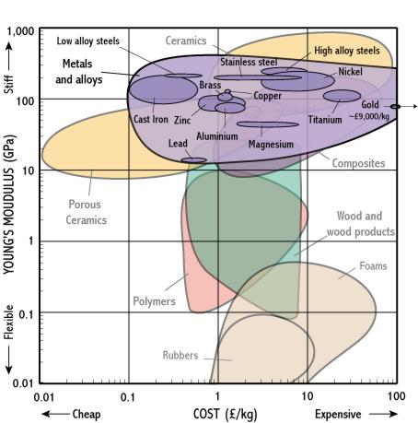
Figure 3
Figure 2
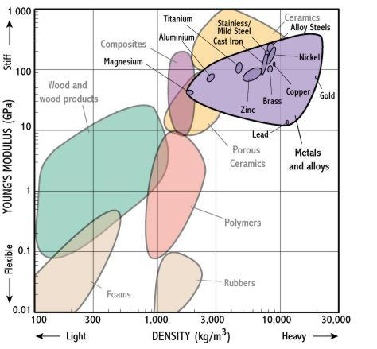

Manufacturing Process Selection

Forging:
Forging is one of the most common methods for manufacturing crankshafts. In this process, the chosen material is heated then placed into a die and shaped using compressive force. Forging aligns the grain structure of the metal, resulting in improved strength and fatigue resistance.

Machining from Bar Stock:
This method involves machining the crankshaft directly from a solid bar of the chosen material. Computer Numerical Control (CNC) machines are used to cut and shape the crankshaft to its final dimensions. While machining from bar stock allows for precise customization and tight tolerances, it can be more time-consuming and costly compared to other methods.

Casting:
Casting involves pouring molten metal into a mold to form the shape of the crankshaft. Cast iron is commonly used for casting crankshafts due to its excellent damping properties and cost-effectiveness. However, cast crankshafts may have limitations in terms of strength and performance compared to forged or machined alternatives.

Hybrid Methods:
Hybrid manufacturing methods combine multiple techniques to produce crankshafts with optimized properties. For example, a crankshaft may be forged to shape and then undergo additional machining operations to achieve precise dimensions and surface finish. Hybrid methods allow manufacturers to optimise the best parts about different types of manufacturing.

Conclusion

For the component I have chosen, forged steel is the best material as it combines good strength with a lighter weight than cast iron and much cheaper than aluminium alloy. It is also not corrosive meaning its long lasting therefore has less of a environmental impact as it doesn’t have to be replaced as often. It is also easy to mass produce as the material is easy to get access to. The most suitable method for manufacturing this product would be forging as it increases the strength of the material and provides more accuracy than method such as casting whilst remaining fairly cheap unlike machining.
The actual crankshaft consists of forged steel, although it is not the cheapest material to use it offers many benefits over other alternatives. Forged steel offers high strength and excellent fatigue properties which is due to the process of production. “Steel is typically used for crankshafts because of its high strength and hardness. Compared to other materials of the same price, steel has a very high fatigue strength.” (Iyas, 2021).

Reference List

TSR-Performance Ltd. (2024). ZRP Audi / VW 2.0L TFSI (Belt Driven) EA113 / 1.8T 20v (06A) Stroker Billet Crankshaft. [online] Available at: https://tsr-performance.com/zrp-audi-vw-2-0l-tfsi-belt-driven-ea113-1-8t-20v-06a-stroker-billet-crankshaft/
MotorReviewer - In-Depth Engine Reviews. (n.d.). 2.0 TDI CR EA189 Engine - In-Depth Look at Design and Reliability. [online] Available at: https://www.motorreviewer.com/engine.php?engine_id=43
MAVRIGIAN, M. (2020). Forged Crankshaft Tech. [online] Engine Professional. Available at: https://engineprofessional.com/magazine/articles/forged-crankshaft-tech/
Iyas, M.D. (2021). Crankshaft: Parts, Function, Types, Diagram & More [PDF]. [online] The Engineers Post. Available at: https://www.theengineerspost.com/crankshaft-parts-and-function/?utm_content=cmp-true
www.matweb.com. (n.d.). Overview of materials for Cast Iron. [online] Available at: https://www.matweb.com/search/datasheet_print.aspx?matguid=6291a24572754cae94ff365ed99b96f9
www-materials.eng.cam.ac.uk. (n.d.). Young’s Modulus - Cost. [online] Available at: http://www-materials.eng.cam.ac.uk/mpsite/interactive_charts/stiffness-cost/basic.html

