Name of Student: Carly Jay Thomas : 0700100

CIPD Membership Number: 49486486

Report Title: Employee Engagement and the link to Wellbeing

Tutor Name: Jayne Woodman

Word Count: 4948 (Excluding Executive Summary)
5215 (Including Executive Summary)

Contents
EXECUTIVE SUMMARY 4
1.0 INTRODUCTION 6
1.1 Background to Organisation 6
1.2 Operating Environment 6
1.3 The link between Engagement and Wellbeing 7
Figure 1 – Wellbeing and Engagement Source: (MacLeod & Clarke, 2009) 8
Figure 2 – CIPD Employee Wellbeing Pyramid 2016 9
1.4 Sickness History within SS 9
1.4 Aim of Report 10
1.5 Objectives of Report 11

2.0 LITERATURE REVIEW 12
2.1 Employee Relations 12
2.1.1 Theoretical Understanding and Perspectives 12
2.2 Conceptual Factors affecting Employee Relations 13
2.2.1 External Factors affecting Employee Relations 13
2.2.2 Internal factors affecting Employee Relations 14
2.3 Employment Relations – Engagement 14
2.3.1 What is Engagement? 14
2.3.1 Engagement Enablers 15
Figure 3 – Four Enablers of Employee Engagement 16
2.4 Benefits of Engagement: How to identify if the workforce is engaged 16
Table 1 – Examples research linking employee engagement to organisational benefits 17
2.5 The link between Engagement and Wellbeing 18
2.5.1 Current Position on Wellbeing in the Education Sector 19
Figure 4 – Level of Stress Chart, Source: (Education Support Partnership, 2018) 20
Figure 5 – Symptoms experienced by Education Professionals, Source: (Education Support Partnership, 2018) 21
Figure 6 – Examples of Mental Health Conditions and Diagnosis Figures 22
2.5.2 The Impact of Employee Wellbeing 22
2.5.3 Wellbeing within S 23
Figure 7 - No. FTE Days Lost for Employes with 3 instances of absence……………………………………….23
Figure 8 – No. FTE Days Lost for Employees with Long Term Absence 24
Source: (Moore, 2018) NPT Sickness Data Q3 24
Figure 9 – No. FTE Days Lost and Reasons for Absence 24
Source: (Moore, 2018) NPT Sickness Data Q3 24
CONCLUSION 26
RECOMMENDATIONS 28
Figure 10above – Available Support Source: (Education Support Partnership, 2018) 29
Figure 11 – How Employee’s alleviated Mental Health concerns, Source: (Education Support Partnership, 2018) 29
Figure 12 – How Employers could improve symptoms Source: (Education Support Partnership, 2018) 30
Recommendation 1 – Mental Health First Aid Training 30
Recommendation 2 – Designated S Mental Health Nurse/Educational Psychologist 31
Table 2 – OHU referral statistics 31
Table 3 – OHU Statistics for Counselling 32
Recommendation 3 – More L&D opportunities 32
Emotional Intelligence Training 32
Leadership Development Training 32
Recommendation 4 – Recreational Activity Opportunities 33
Recommendation 5 – Regular employee satisfaction surveys to be sent out 33
REFERENCE LIST 34
References 34
APPENDICES 39
Appendix 1 – PESTLE Analysis on factors affecting Employee Relations MER 39
Appendix 2 – Action Plan 42

EXECUTIVE SUMMARY
This report discusses an employment relations issue within the Schools section of the Education Directorate of Neath Port Talbot County Borough Council.
Initially the report sets out the approach taken in S when dealing with employee relations, the report goes on to elaborate on what is meant by employee relations while higlighting conceptual factors that affect such management.
For the purposes of this report, the employee relations issue being discussed is that of Engagement. This is done by critical analysis of what ‘Engagement’ generally means from an employment perspective with reference to more recent opinion linking Engagement to Wellbeing.
Findings from secondary research found in the majority that engagement from employees has many organisational and indvidual advantages but is not sustainable in the long term unless employee wellbeing is captured within it. With research demonstrating that disengagement results in higher absence levels, and with S experiencing high teacher absence levels relating to stress and mental health concerns, this is the focus of the report.
The report discusses current and historic literature showing that stress and mental health concerns are and always have been a cause for concern within the Education profession. Synthesising sources, linking absence levels to wellbeing and wellbeing to engagement the report confirms the position that S is experiencing employee engagement issues which are evidenced through stress/mental health related absence levels.
With consideration given to the barriers to engagement, established through PESTLE analysis and Dundon’s Conceptual factors, this report aims to provide viable recommendations to improve employee engagement through implementation of meaningful wellbeing measures with the aim of reducing stress/mental health related absences.

1.0 INTRODUCTION

1.1 Background to Organisation
Neath Port Talbot County Borough Council (NPTCBC) is a Local Authority situated in South Wales employing approximately 5,700 individuals providing a vast range of public services. NPTCBC is made up of five directorates, these being; Chief Executives, Education, Finance and Corporate Services, Environment, and Social Services and Housing.
Given the wide range of professions and departments across NPTCBC and with consideration given to time restrictions and word count, this report does not allow for consideration of the Authority as a whole. The focus of this report will be the Education directorate of NPTCBC. The report will not focus on the Education directorate as a single service provider as services within central education are also too vast. This report focuses on the schools section of the Education Directorate, referred to as ‘S’, which comprises 41% of NPTCBC’s workforce, 23% of the total workforce are teaching staff.

1.2 Operating Environment
NPTCBC has a long-standing history of Labour party dominance and is still currently led by a Labour cabinet. Historically the Council have operated in a ‘placid’ environment (Kew & Stredwick, 2008) with the assumption that the future will reflect the past, characterised by rigidity (Clegg, et al., 2008).

Changes in the external environment (Appendix 1) such as technological advancements, social attitudes, new behaviours and political leadership created times of austerity, and have shaped a business environment of Volatility, Uncertainty, Complexity and Ambiguity (VUCA) (Bennett & G. James Lemoine, 2014). Reflection on custom and practice actions to inform future decision making is no longer enough to survive – let alone thrive – in today’s modern world (Stacey, 2004).
As a result of these changes, the UK Government have continuously made cuts to public spending, NPTCBC has seen a significant reduction of £77 million to their budget since 2010 (Neath Port Talbot County Borough Council , 2017), this reduction is also mirrored within the Welsh Government’s Education budget.

The Association of School and College Leaders (ASCL) comments that schools in Wales are ‘struggling to make ends meet’ with budgets being ‘stretched to breaking point’ ASCL have calculated that the Welsh Government Education budget shows an overall reduction of £35million , leaving just £170million between 1547 schools (Wightwick, 2017 ). Tim Pratt, ASCL Cymru Director advises that this could potentially allocate £32,000 to each school, depending on funding formula, which he describes as being a ‘drop in the ocean’.

When looking at the expenditure of a school the majority think of general maintenance, education and improvement costs, however these are not the only financial aspect that a school has to consider. A major concern within S is the cost of sickness absence - sickness absence costs alone reached a staggering £1million in 2016 (Wales Online, 2018). Although certain elements of this cost are covered by insurance, these are costs that S simply cannot afford.

1.3 The link between Engagement and Wellbeing
A comprehensive amount of research evidences that employee engagement is critical to sustainable organisational performance which in turn is linked to increased performance and productivity (Baldoni, 2013) (Dukes, 2018) (Sorenson, 2013) (CIPD, 2017) (CIPD, 2012) (CIPD, 2018). With a mounting body of evidence strongly linking wellbeing to engagement (MacLeod & Clarke, 2009) (Gray, 2014) it only follows that research is indicating a growing recognition of a positive link between employee well-being and long term organisational health (CIPD, 2016). Figure 1 below illustrates the link between employee wellbeing and engagement.

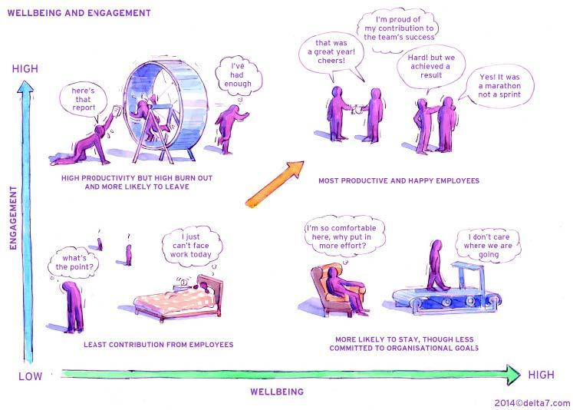

Figure 1 – Wellbeing and Engagement Source: (MacLeod & Clarke, 2009)
Further evidence can be found in the recent CIPD report (CIPD, 2018), along with the creation of the Wellbeing Pyramid which the CIPD believe reflects the current position (Figure 2 below).
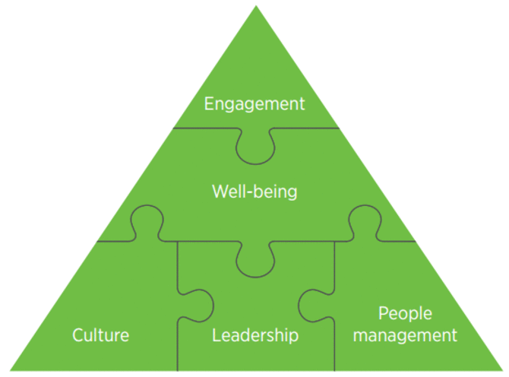

Figure 2 – CIPD Employee Wellbeing Pyramid 2016

1.4 Sickness History within SS
As highlighted. in the past sickness absence levels within S and associated costs have been causing concern -it was estimated that over £1million was spent on school sickness absence costs in financial year 16/17 (Wales Online, 2018).
Stress and mental health conditions have accounted for the highest reasons given for sickness absence in NPTCBC since 2016 (Neath Port Talbot County Borough Council , 2017) (Moore, 2018) with 66% of all sickness absence relating to long term absence from work (absence longer than 28 continuous days) (Neath Port Talbot County Borough Council , 2017).

Due to the high levels of sickness absence within S and associated costs, a sickness taskforce was set up in 2016 with a dedicated HR Officer focusing on long term sickness absence, briefing managers within S on long term absence management with early intervention being vital. Since the introduction of this taskforce, long term sickness absence costs within primary schools has reduced by £200,000 in 2017/2018 financial year, with secondary schools spending approximately £80,000 less on long term and short-term absences (Wales Online, 2018). Education Director, Aled Evans, comments that although this decrease is positive, there is ‘more work to be done’ (Wales Online, 2018).

Some of the most common reported reasons for absence in NPTCBC are stress and mental health. Tom Owen, HR Manager for Education at NPTCBC was spoken to for the purposes of this report and confirmed that a Mental Health Strategy team had been set up with a view to ‘combating the cause of such absence along with developing a culture for employee’s to feel able to speak openly about mental health and equipping our managers to manage situations competently and effectively’.
Figure 9 at point 2.5.1 in the main body of this report reflects the current position in relation to absence reasons within NPTCBC and supports the statement that stress remains the highest reported reason for absence, this is also true for the position within S.
Among the highest reported reasons for absence lie other mental health related absences such as depression, bereavement, work-related stress etc. These statistics show that it is crucial that consideration is given to employee wellbeing in an attempt to reduce these absence levels and increase the engagement of the workforce.

1.4 Aim of Report
This report aims to critically analyse engagement levels of the teaching staff within S. Engagement levels will be considered and determined through analysis of teacher stress/mental health related absence levels. The report will make partial reference to resource and talent management topics resulting from engagement issues (such as exit rates/retention) and will aim to provide viable recommendations to improve engagement through implementation of meaningful wellbeing measures with the aim of reducing stress/mental health related absence levels within S.

1.5 Objectives of Report
The objectives of this report are to:
- Provide an overview of the importance of Engagement within an Organisation
- Discuss the current position in relation to Employee Engagement and Employee Wellbeing while analysing whether there is a Wellbeing issue within S
- Make viable recommendations to increase employee engagement by implementing positive wellbeing measures to reduce stress/mental health related absence levels.

2.0 LITERATURE REVIEW

2.1 Employee Relations
Replacing the term ‘industrial relations’, employee relations relates to individual and collective workplace relationships. The interpretation is now much wider, reflecting the introduction of various individual workplace rights, together with the decrease in trade union impact (CIPD, 2018). The employment relationship is about more than ‘work for pay’. Employee Engagement has become a key part of the employment relationship and with research indicating that the UK on the whole has an employee engagement deficit, being ranked 9th amongst the world’s twelfth largest economies as ranked by GDP (Business Wire, 2012), it is essential that employers understand their approach to engagement, what engagement is and what the benefits are.

2.1.1 Theoretical Understanding and Perspectives
When considering perspectives on employee relations there are three general terms of reference that can be considered, specifically, Pluralist, Radical and Unitary. NPTCBC and S adopt a Pluralist approach to managing employment relations through partnership working and agreed policies/procedures. Pluralists see the employment relationship as the coalition of different players – there is understanding and acknowledgment of conflict in the face of different interests, favouring implementation of policies and practices to avoid such conflict (Bres & Raufflet, 2013). Any conflict is to be managed through discussion and partnership working by way of recognised Trade Union Institutions. Henry Ford once commented ‘Coming together is a beginning, keeping together is progress and working together is success’ (Anderson, 2013), this nicely summarises the Pluralist approach and NPTCBC’s position in relation to MER.

Historically within S, traditional hierarchical structures have been favoured with a command and control type of leadership, running risk of a Unitary approach to MER, this approach does not acknowledge employee voice and runs on the basis of shared values and common objectives stemmed from the employer. It is argued that this approach is outdated and better suited to 19th Century organisations (Gennard, et al., 2016). Given the strong presence of Trade Unions within S, current employee voice mechanisms and collaboration being a key leadership attribute for the future world of work, it could be deemed that the Pluralist approach is the correct approach for S.

2.2 Conceptual Factors affecting Employee Relations

2.2.1 External Factors affecting Employee Relations
Based on Appendix 1, as outlined in the introduction, significant changes in Political Leadership, Technological advancements, Legislation, Economic Climate, Social Attitudes and Corporate Social Responsibility have reformed the way employment relations are dealt with in the UK.
The State has major influence in shaping the way employment relations are conducted, firstly through a legislative framework providing rights to both employer and employee, and secondly through the running of enforcement channels of such rights (Gennard, et al., 2016, p. 15). As a result, decisions made by the Government will filter down to local level and impact the way S manages employment relations.
Since the Thatcher Government and introduction of various employment legislations it could be argued that the balance of power has shifted to the employer through a neo-liberal approach based on denationalisation and marketisation (Gennard, et al., 2016), essentially limiting Trade Union influence, and demonstrated through various instances, one being the Miners Strike of 1984-85.

Economic changes in the aftermath of the global financial crisis (The Economist, 2018) resulted in the aforementioned budgetary cuts (point 1.2), impacting S as the workforce was reduced and redundancies were made, effectively increasing the workload, adding to teacher pressures-resulting in stress. In addition to this, changes in social attitudes have impacted engagement within S, as society’s behaviours have changed, public expectations have increased – despite a decreasing budget, a smaller workforce and a higher workload, teachers are expected to deliver the same, if not higher results.

2.2.2 Internal factors affecting Employee Relations
Due to the external factors mentioned above, NPTCBC have had to consider measures for implementation in order to survive times of austerity, these measures have filtered to S. Restrictions have been made on the ability to externally advertise and grant voluntary redundancies, with an active focus on redeployment through the signing up of a Safeguarding Pledge as well as introduction of sickness taskforce teams to drive down absence costs.

2.3 Employment Relations – Engagement

2.3.1 What is Engagement?
There are numerous definitions of employee engagement (Kahn, Utrecht, Kruse etc) - What is agreed is that employee engagement is not about using a mechanistic approach to extract discretionary effort from employees by manipulating emotions and commitment (MacLeod & Clarke, 2009). Engagement is the emotional commitment an employee has to an organisation and its goals (Kruse, 2012). Kahn believes it is about how people interact with their work roles and ‘express themselves physically, cognitively and emotionally’ (CIPD, 2018).

The concept of engagement builds upon motivational theories as well as other concepts such as job satisfaction, shared purpose and Katz’s organisational citizenship behaviour (CIPD, 2018). There has been criticism with this concept of employee engagement with critics’ focus on its separability from previously studied concepts (Rayton, 2012).

While the majority of research highlights the positive impact engagement can have for an organisation, it is important to note that there are opposing views to engagement. References to ‘the dark side’ of engagement have increased as technology has advanced in the workplace. Research has shown that being too engaged leaves employees with little to no opportunity to ‘switch off’ from work, resulting in higher stress levels (Harvard Business Review, 2016) (Forbes, 2014) (CMI, 2016), the same argument has been put forward for teachers (Education Support Partnership, 2018). Due to restrictions on time and word count, this report does not allow for further discussion on this.

2.3.1 Engagement Enablers
Due to various factors -such as generational differences and organisational culture, there is no ‘one size fits all’ approach for engagement. Four common themes were found following extensive government research- Referred to as the ‘four enablers’ they capture many of the key elements believed to be crucial for the presence of employee engagement (MacLeod & Clarke, 2009) (Figure3).
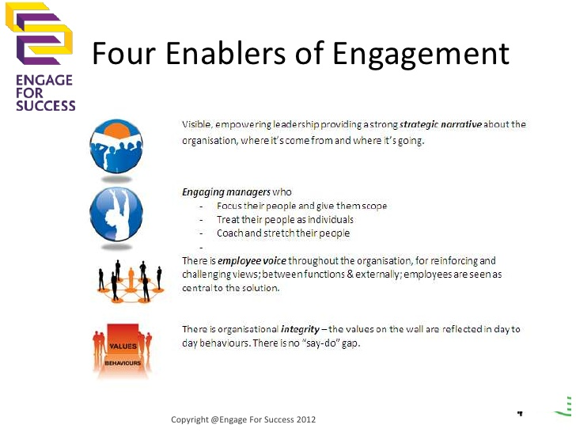

Figure 3 – Four Enablers of Employee Engagement

2.4 Benefits of Engagement: How to identify if the workforce is engaged
Critics of employee engagement have argued that there are successful traditional 19th century organisations operating on a command and control basis (MacLeod & Clarke, 2009, p. 34). While this is true, it could be argued that this is due to a loose labour market with low competition/high supply and demand cultures for a particular product. Telefoncia O2 argues that an organisation that does not pay focus on employee engagement is not maximising its long-term value.

Extensive amounts of research have shown that organisations with high levels of employee engagement have higher operating income, productivity, profitability and safety standards (CIPD, 2012, p. 2)(Baldoni, 2013) (Dukes, 2018) (Sorenson, 2013) (CIPD, 2017) (CIPD, 2012) (CIPD, 2018). At an individual level, research shows that engaged employees are less likely to leave the organisation, have lower absence rates and higher job (and life) satisfaction (CIPD, 2012). It is important to note that the sheer volume of research and evidence for the above correlations is so large that this report does not allow for detailed discussion, please see Table 1 below for further sources.
Study | Finding
The Corporate Leadership Council (Coporate Exexcutive Board , 2008) | Reported that engaged organisations grew profits three times faster than their competitors. Arguing that highly engaged organisations were able to reduce staff turnover by 87% and improve performance by 20%.
Chartered Management Institute  ‘Quality of Working Life’  (Worrall & Cooper, 2007) | Found a significant association between employee engagement and innovation.
Gallup (Harter, et al., 2006) | Found that engagement levels can be predictors of sickness absence, with more highly engaged employees taking an average of 2.7 days per year, compared with disengaged employees taking an average of 6.2 days per year

Table 1 – Examples research linking employee engagement to organisational benefits

From the above research it follows that an organisation should be able to identify if their workforce is engaged through careful analysis of the organisation’s performance, productivity, innovation and absence levels. As outlined in the introduction, when considering engagement levels within S, the focus of the report will be on stress/mental health related absence levels from teaching staff.

The next section of the report will provide an overview on the link between employee engagement and wellbeing, which in turn impacts absence levels.

2.5 The link between Engagement and Wellbeing
Academic research supports the links between employee engagement and wellbeing, absence and resilience (Gray, 2014) (MacLeod & Clarke, 2014). Work is the primary activity carried out by individuals during their waking hours (MacLeod & Clarke, 2014), comprising over one third of total awake time (ONS, 2011), taking this into consideration, it is not surprising to see a correlation between engagement, wellbeing and absence levels (Rayton, 2012).

As noted, employee engagement has been associated with higher levels of psychological wellbeing (Dulagil, 2012) (Wright, et al., 2007) While some argue that work engagement is negatively correlated with burnout (Schaufeli, et al., 2002) (Forbes, 2014) (Harvard Business Review, 2016) others have found that “meaningful work leads to lower levels of absence because people are engaged with their work” and that “the association between meaningfulness and engagement is strengthened by wellbeing” (Soane, et al., 2013).

Referring back to the various definitions of employee engagement, the definitions generally focus on employee commitment and organisational goals, however more attention is being given to employee wellbeing playing an integral part in employee engagement as it is argued that engagement created without the consideration of employee wellbeing will not be sustainable in the long term (CIPD, 2012) (MacLeod & Clarke, 2014) (CIPD, 2018) (Rayton, 2012). Below notes an updated definition of Engagement encompassing employee wellbeing.

“A workplace approach designed to ensure that employees are committed to their organisation’s goals and values, motivated to contribute to organisational success, and are able at the same time able to enhance their own sense of wellbeing’ (MacLeod & Clarke, 2014).
As previously highlighted (Figures 3,4, and 5), S experiences high absence levels from the teaching staff, indicating an engagement issue within S. Should this be the case, research would argue that S will experience higher absence levels, lower innovation, lower performance/productivity and higher turnover.

2.5.1 Current Position on Wellbeing in the Education Sector
Stress within the teaching profession has been a topical subject for years, current thinking of the National Foundation for Educational Research states that teachers endure greater work-related stress than other professions, arguing 1 in 5 teachers feeling tense about their job most or all of the time, compared to just 13% in similar occupations (Busby, 2019).

The Education Support Partnership conducted extensive research which found that 76% of surveyed teachers experienced work related behavioural, psychological or physical symptoms due to stress with 57% considering leaving the profession. It has been said that there is a ‘stress epidemic’ with increases in mental health issues being seen across the entire UK Education sector (Education Support Partnership, 2018).

Claimed to be the most comprehensive report into the wellbeing of educational professionals, the findings of the report highlight the crisis being faced within today’s education sector.
- 65% did not feel confident to disclose a mental health concern
- 47% were off with a mental health issue for a month or more over the academic year
- 31% report an experience with a mental health issue over the last year
- 36% feel there is no mental health support
- 74% advising they could not switch off from work, work load being a major contributing factor in a negative work life balance. According to the National Education Union’s joint general secretary Dr Mary Bousted, it is believed that teachers often work in excess of 50 hours per week, with primary teachers new to the profession working nearly 19 hours per week outside of normal school hours (Webber, 2019).
Detailed below are some statistics taken from (Education Support Partnership, 2018) illustrating the extent of the issue across the Education sector.
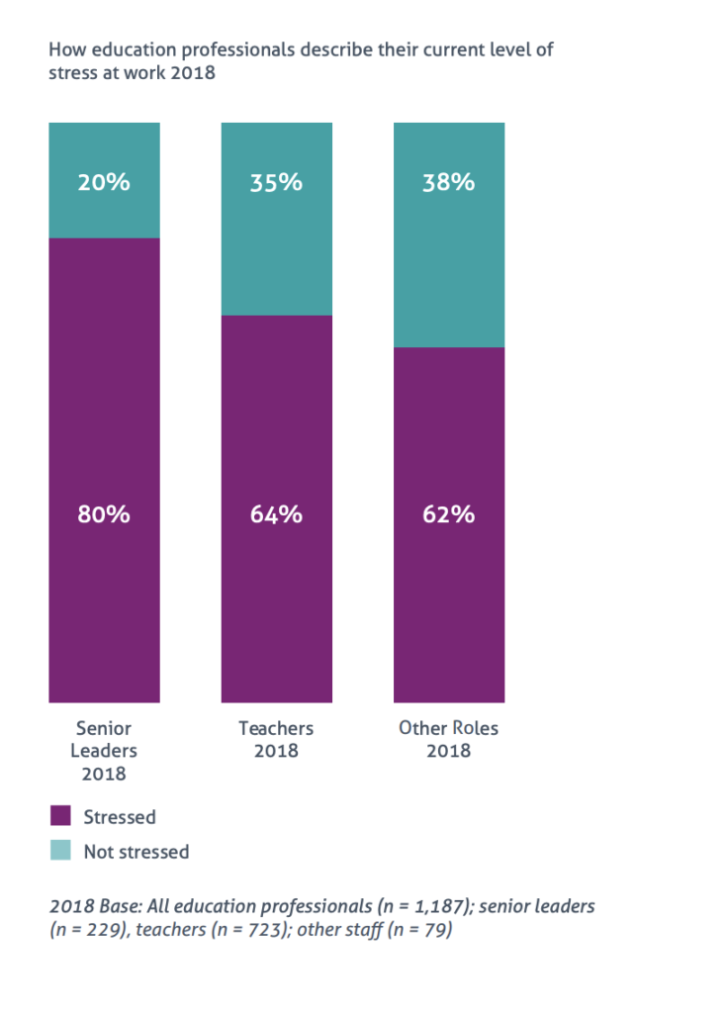

Figure 4 – Level of Stress Chart, Source: (Education Support Partnership, 2018)

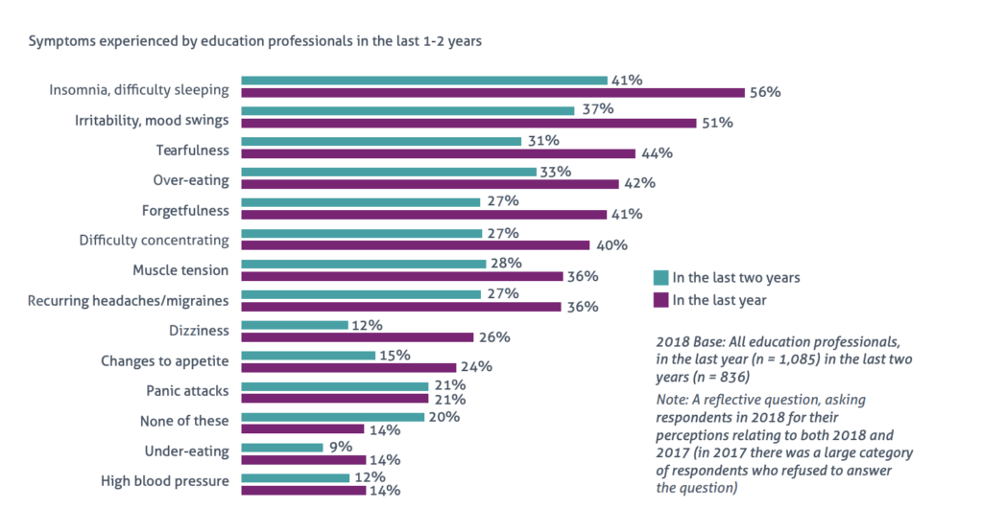

Figure 5 – Symptoms experienced by Education Professionals, Source: (Education Support Partnership, 2018)

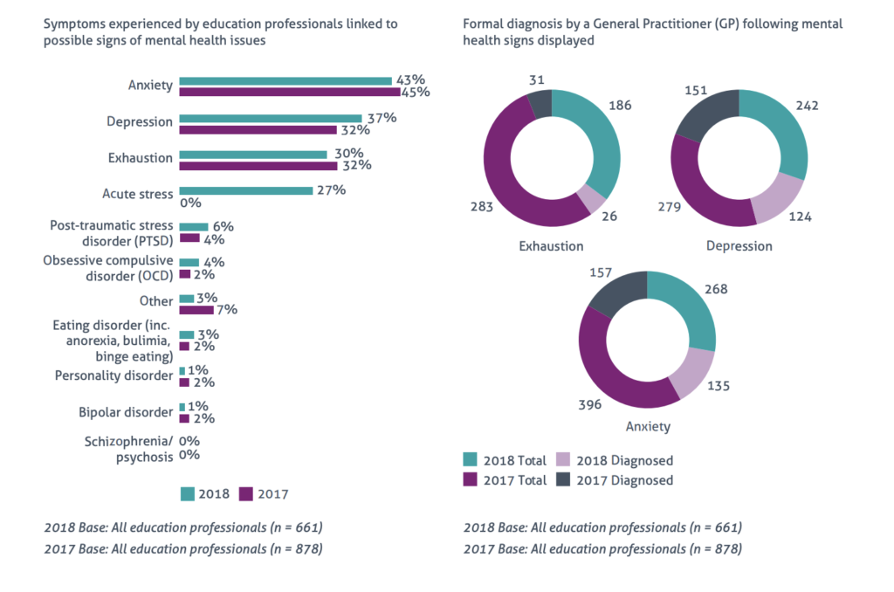

Figure 6 – Examples of Mental Health Conditions and Diagnosis Figures

2.5.2 The Impact of Employee Wellbeing
Stress from workload is not just impacting teacher absence levels- Recent research from the University College London found that 40-50% of teachers had already left, or were considering leaving the profession within the first 10 years of starting their teacher training (Brown, 2019). Although poor retention rates are further evidence of disengagement, due to report restrictions the focus will solely be on stress/mental health related absence levels.

The modern-day teacher must work within a target-driven culture, delivering results capable of satisfying changing social attitudes and increased expectations. Running in tandem to these pressures are financial pressures and budget cuts, decreasing staff numbers, changes to the teacher role as they are expected to do more, increasing class sizes with increasing reports of pupil behaviour becoming worse over the last decade as social climates change (Roberts, 2018) (Evans, 2014) (BBC News, 2010). With these factors it is no surprise that teacher absence due to stress/mental health is on the rise.

An annual survey of teaching days shows that the number of days lost to stress in 2016 has remained at around 50,000 since 2012 costing around £8m a year, according to the National Education Union Cymru (NEU) (Evans, 2014)(Sheldrick, 2015)(Wightwick, 2018). With only 6 Welsh Council’s losing less than 1,000 teacher days due to stress (Evans, 2016) and with the longest individual teacher absence in 2016 being 683 days (Wightwick, 2018), it is clear work needs to be done around wellbeing in an attempt to improve absence rates and employee engagement.

2.5.3 Wellbeing within S
Figure 7 below evidences the absence issues within S, showing that S has the highest number of FTE days lost for employees with 3 or more instances of sickness, with long term absences (over 28 days) being one of the highest across NPTCBC (Figure 8).

It can be seen that the ‘stress epidemic’ and rise in mental health related absences is not contained to education. Stress also accounts for the number one reason for absence across NPTCBC. Figure 9 attempts to categorise different mental health concerns and tries to separate personal stress from work related stress. As can be seen by the chart, the figures representing generalised stress and work-related stress vary enormously.

Unfortunately it cannot be said that this is a true representation of absences arising from work related stress. This could potentially be due to incorrect/insufficient information taken at the time of reporting the absence, a fear of the employee to provide specifics or complete omission on the part of the recorder to ask any queries in relation to the source of stress altogether.
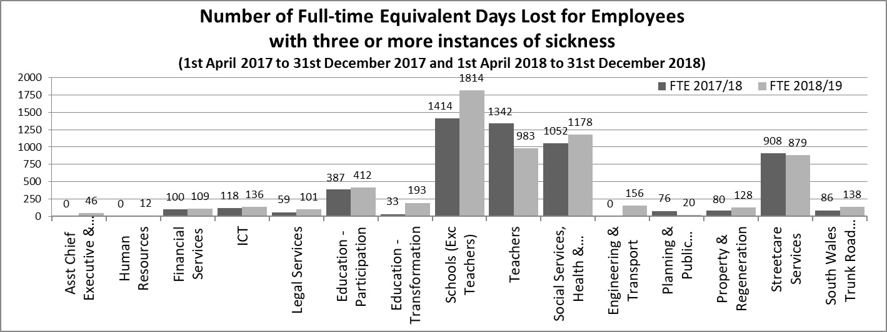Figure 7 – No. of FTE Days Lost for Employees with 3 or more instances Source: (Moore, 2018) NPT Sickness Data Q3

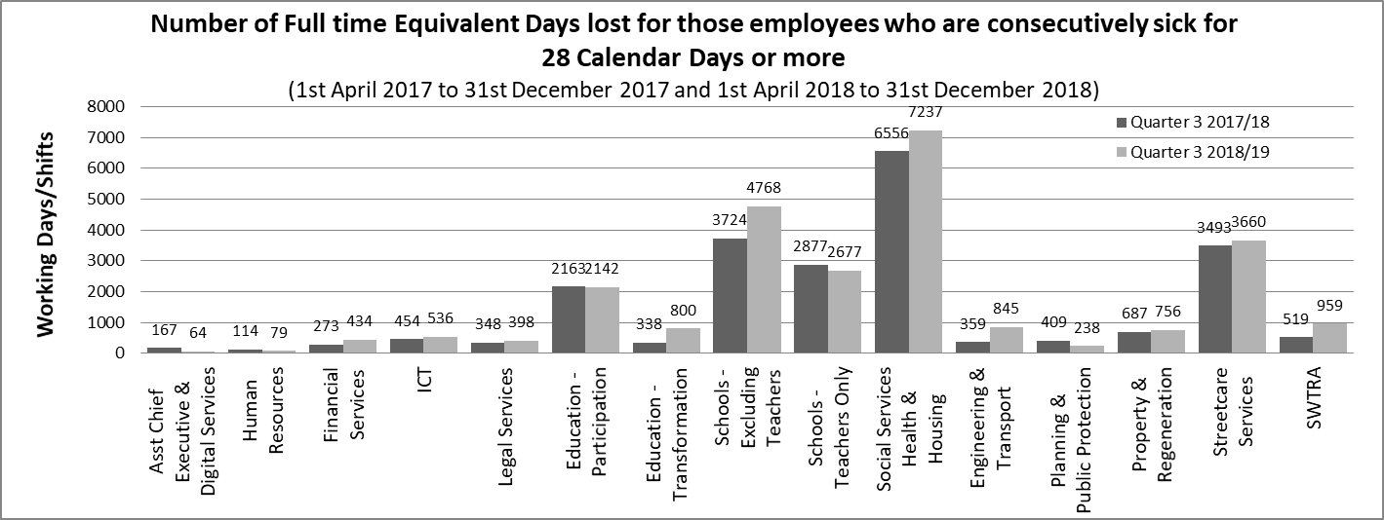

Figure 8 – No. FTE Days Lost for Employees with Long Term Absence

Source: (Moore, 2018) NPT Sickness Data Q3

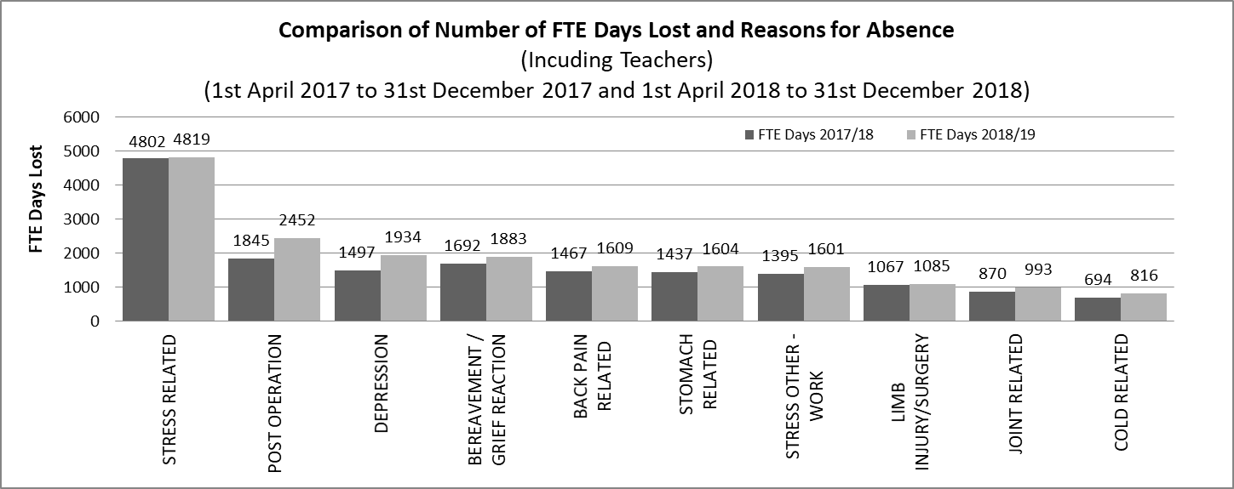

Figure 9 – No. FTE Days Lost and Reasons for Absence

Source: (Moore, 2018) NPT Sickness Data Q3

In 2017, the government estimated the school population would increase 19 per cent over the next decade, meaning around half a million more students in secondary school by 2026 (BBC News, 2017). Combine this with the current teacher shortages, increasing workload and increase in social expectations and it could be argued that the teaching profession is in crisis, following from this, it may be argued that it is highly likely that teacher absence levels linked to stress and mental health will continue to rise.

CONCLUSION
While literature provides strong arguments in support of investment into employee engagement, it is evident that various factors can affect an organisations ability to actively engage their employees to extract discretionary effort to help the business reach its goal. Factors such as motivation (generational differences, application of motivational theories Maslow v Pink), leadership styles (Trait v Collective leadership) and L&D methods (Adult Learning Theory/Constructivist v classroom based) will have a significant impact on engagement (MacLeod & Clarke, 2009) but due to restrictions on time and word count this report has not allowed for discussion on these topics. What is also evident is the fact that mere engagement from an operational and targets driven perspective is not likely to be sustainable in the long term. This is where employee wellbeing intrinsically links in with employee engagement. The National Education Union believe that there are overarching principles to consider when looking at employee mental health:

- A Safe Workplace – including the necessary risk assessments
- Support from Colleagues, including management
- Fair and Equal Treatment
- Clear Procedures, Policies, Roles and Responsibilities
- Sufficient Personal and Social Time

In order to reap the benefits of employee engagement in the long run, organisations must ensure that employee’s wellbeing is as fundamental as the day to day operations of the business, this initial investment should make engagement sustainable in the long term. In turn, absence rates should decrease, recruitment and training costs should decrease, and productivity/performance should increase. In addition to this, organisations should see an increase in innovation which, on another note, will be crucial for the future world of work.

For the purposes of this report, what is questionable is how NPTCBC will target wellbeing to combat the high teacher stress absence levels with the view of increasing employee engagement. NPTCBC will have to consider the current workload, class sizes, available support and service delivery impact when considering any potential wellbeing measures.

RECOMMENDATIONS
When deliberating on potential recommendations consideration has been given to the (Education Support Partnership, 2018) survey which highlights the different types of support available to Education Professionals (Figure 10), ways individuals can improve their symptoms (Figure 11) and how employers can assist (Figure 12) . As S are able to offer some of this support the recommendations will fall out of the remainder.
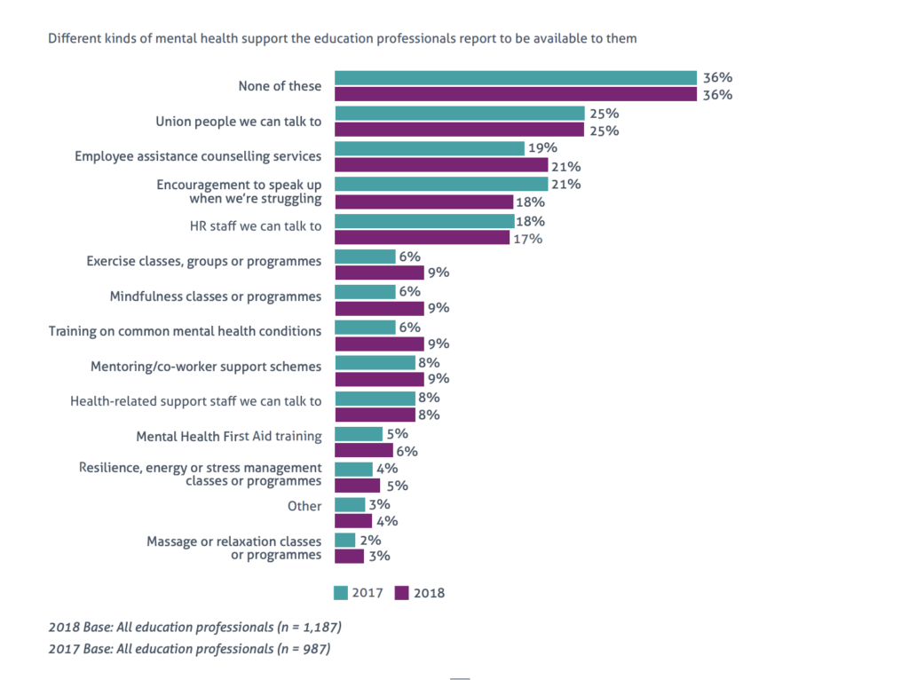

Figure 10above – Available Support Source: (Education Support Partnership, 2018)
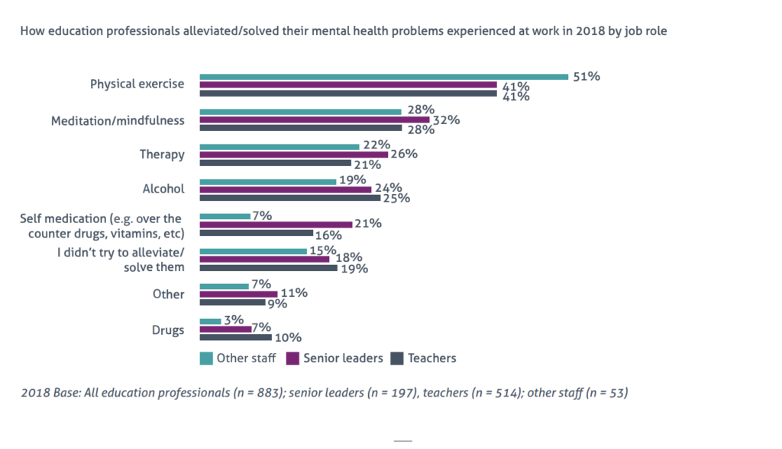

Figure 11 – How Employee’s alleviated Mental Health concerns, Source: (Education Support Partnership, 2018)
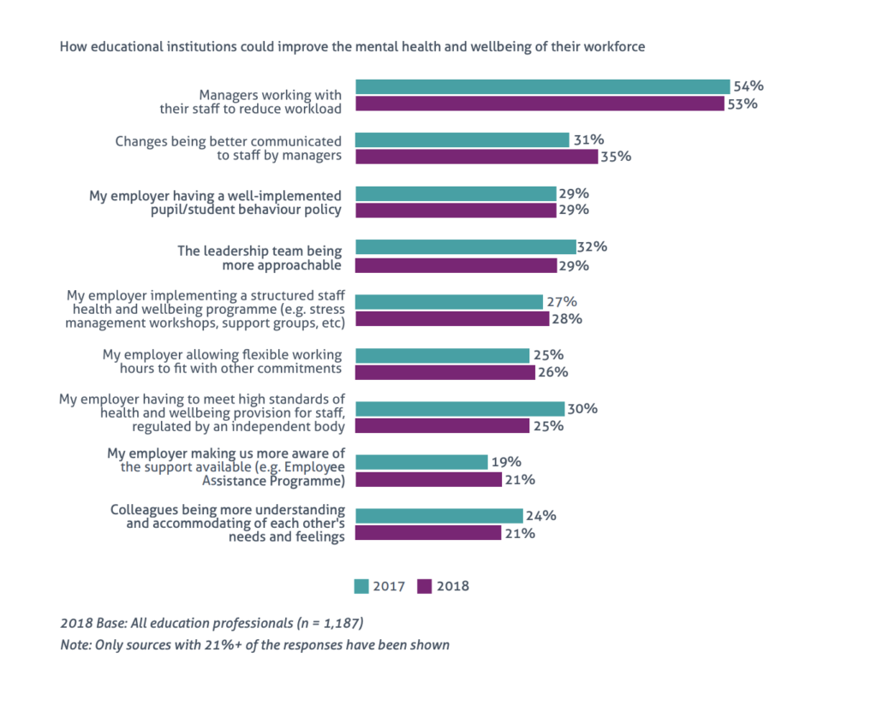

Figure 12 – How Employers could improve symptoms Source: (Education Support Partnership, 2018)

Recommendation 1 – Mental Health First Aid Training
Similar to the concept of a conflict resolution officer, it is recommended that S choose a well-respected individual to undertake a Mental Health First Aid Training Course. This individual would then act as the first point of contact for those experiencing Mental Health symptoms. Given the vast range of symptoms being experienced (Figure5 above), this course will aim to provide the first aider with the required tools to deal with different symptoms. In addition to this, it is recommended that the Headteacher/someone within a leadership position also attends to improve the potential of identifying symptoms as early intervention is key in most cases (Mental Health Foundation, 2016). Another aspect of this recommendation could be to draw up a prevention plan with individual’s known to suffer with symptoms. This plan will outline common symptoms for the individual, detail supportive measures such as temporary adjustments and what is to be done in extreme circumstances.
The training would be provided through ‘Training in Mind’ located in Blaenavon, at a cost of £120 per participant. There is potential for Instructor Trainer to be undertaken at a cost of £500 which would allow the participant to become a recognised trainer of the programme. However due tight delegated budgets and the ability of the first aider to run sessions based on their learning and experience, the instructor training session is not recommended. Another aspect of this recommendation would be to promote ‘Stress/Mental Health Awareness Months’.

Recommendation 2 – Designated S Mental Health Nurse/Educational Psychologist
It is recommended that Employment of a Mental Health Nurse for 1 day per week or alternatively, agreement with NPTCBC to arrange facility time for one of the professionals from the Occupational Health Department is considered. This arrangement would allow those with symptoms the opportunity to have 1:2:1 time with a healthcare professional, whether to discuss coping strategies, counselling, or other issues. This could potentially alleviate their symptoms, avoid absence and improve engagement.
Detailed investigation into productivity, absence costs and engagement would need to be carried out prior to implementation of this recommendation as it is a substantial investment with the salary of a 1 day per week mental health nurse being approximately £6,250. There is scope for negotiation regarding the OHU professional.
Tables2&3 below shows the statistics from the OHU department in NPTCBC, this includes the teaching staff in S. There was no time for a detailed breakdown of these figures to reflect the number of staff within S attending OHU, however as noted from the outset, S accounts for 53% of NPTCBC’s workforce.

Financial Year | Total Number of Referrals | Of Which number referred for Stress/ Mental Health | And number referred for Work Related Stress
2014/15 | 740 | 49 | 51
2015/16 | 698 | 123 | 64
2016/17 | 668 | 133 | 48
2017/18 | 683 | 151 | 35
2018/19 | 611 | 131 | 31

Table 2 – OHU referral statistics

Financial Year | Number of Employees Referred for Counselling | Annual Cost of External Counselling
2014/15 | 51 | £11815.00
2015/16 | 20 | £7180.00
2016/17 | 29 | £11852.50
2017/18 | 24 | £10945.00
2018/19 | 39 | £13995.00

Table 3 – OHU Statistics for Counselling

Recommendation 3 – More L&D opportunities

Emotional Intelligence Training
Different generations are motivated and engaged by different things, wellbeing may be improved by a greater awareness of emotional intelligence. Allowing for increased L&D opportunities such as coaching or mentoring may increase wellbeing and result in higher engagement.

Leadership Development Training
Although not specifically linked to a wellbeing measure, leadership development training could help to ensure that S’s leaders are equipped to deal with a multi-generational workforce who are engaged and motivated by different things (Forbes, 2017).
Collaboration, change management and building relationships are key leadership attributes (Centre of Creative Leadership, 2007, p. 13). As leadership and engaging managers are noted to be 2/4 enablers of engagement, which could indirectly improve employee wellbeing.
Thorough investigation into S’s needs and resources would need to be done before this could be considered, due to restrictions, it is not possible to discuss this.

Recommendation 4 – Recreational Activity Opportunities
In line with current thinking from medical practitioners, it is recommended that S arrange mindfulness and exercise classes for staff to take advantage of. Due to service delivery demands, these classes could be arranged to take place following the school day and could be run weekly. The classes could improve morale, boost wellbeing and subsequently improve engagement. It is recommended that staff are consulted to establish preference on class type and days. The cost of such class would be contained to the time of using school premises and facilities as well as the cost of the session which is estimated to be in the region of £60 per week.

Recommendation 5 – Regular employee satisfaction surveys to be sent out
It is recommended that engagement surveys are sent out on a regular basis to allow S the opportunity to capture relevant information on engagement and target area’s that need improvement.

REFERENCE LIST

References
Anderson, E., 2013. 21 Quotes From Henry Ford On Business, Leadership And Life. Forbes, 21 May .
Baldoni, J., 2013. Employee Engagement Does More than Boost Productivity. Harvard Business Review, 4 July.
BBC News, 2010. Violence is getting worse in primary schools. [Online]
Available at: http://news.bbc.co.uk/1/hi/education/8592578.stm
[Accessed 15 April 2019].
BBC News, 2017. Secondary School Pupil Numbers set to 19% rise by 2026. [Online]
Available at: https://www.bbc.co.uk/news/education-40608795?platform=hootsuite
[Accessed 15 April 2019].
Bennett, N. & G. James Lemoine, 2014. What VUCA Really Means for You. Harvard Business Review, Jan.
Bres, L. P. & Raufflet, E., 2013. Pluralistic Organizations in Management: One Phenomenon and Multiple Theoretical Developments. Academy of Management Annual Meeting Proceedings, 2013(1), pp. 1-40.
Brown, L., 2019. ‘Crippling’ workloads leading swathes of teachers to quit, research finds. People Management, 2 April.
Busby, M., 2019. Teachers experience more stress than other workers, study shows. The Guardian, 25 February.
Business Wire, 2012. CEOs from across the Nation Call on UK to Deliver £26bn GDP Growth by Better Engaging Employees at Work, Says Engage for Success. [Online]
Available at: https://www.businesswire.com/news/home/20121111005021/en/CEOs-Nation-Call-UK-Deliver-£26bn-GDP
[Accessed 15 April 2019].
Centre for Creative Leadership, 2007. The Changing Nature of Leadership, s.l.: Centre for Creative Leadership.
Centre of Creative Leadership, 2007. The Changing Nature of Leadership, Brussels: CCL.
CIPD, 2012. Managing for Sustainable Employee Engagement, London: CIPD.
CIPD, 2016. Growing the Health and Wellbeing Agenda: From First Steps to Full Potential, London: CIPD.
CIPD, 2017. Employee Outlook Survey, London: CIPD.
CIPD, 2018. Employee Engagement and Motivation, London: CIPD.
CIPD, 2018. Employee Relations: An Introduction, London: CIPD.
Clegg, S. R., Kornberger, M. & Pitsis, T., 2008. Managing and Organisations: An Introduction to Theory and Practice. London: SAGE.
CMI, 2016. Stressed and overworked: Managers struggle in ‘always on’ work culture, London: Chartered Management Institute.
Coporate Exexcutive Board , 2008. Improving Employee Performance in the Economic Downturn, London: Corporate Leadership Council.
Dukes, E., 2018. Employee Engagement And Employee Productivity Aren't The Same Thing -- Here's How To Boost Both. Forbes, 12 January .
Dulagil, A., 2012. The relationship of employee engagement and. Wollongong, Austrailia, SBS HDR Student Conference.
Education Support Partnership, 2018. Teacher Wellbeing Index , London: Education Support Partnership.
Evans, G., 2014. Decline in pupil behaviour is an increasing problem for teachers. Wales Online, 13 February.
Evans, G., 2014. Teacher stress costs Wales 50,000 days off school a year. Wales Online, 13 March.
Evans, G., 2016. Concerns for teacher welfare as 52,000 days lost to stress. Wales Online, 24 July.
Forbes, 2014. Motivating People: The Dark Side of High Employee Engagement. Forbes, 20 May .
Forbes, 2017. How To Reach And Engage Millennial Audiences. Forbes, 4 July.
Gennard, J., Judge, G., Bennett, T. & Saundry, R., 2016. Managing Employment Relations. 6th ed. London: CIPD.
Gray, R., 2014. Employee Engagement Closely tied to Health and Wellbeing. HR Magazine, 16 April.
Harter, J., Schmidt, F. L., Kilham, E. A. & Asplund, J. W., 2006. Q12 Meta-Analysis,The Gallup Organisation, Washington: Gallup Organisation.
Harvard Business Review, 2016. Motivating People: The Dark Side of High Employee Engagement. Harvard Business Review, 16 August .
Kew, J. & Stredwick, J., 2008. Business Environment: Managing in a Strategic Context. London: CIPD.
Kruse, K., 2012. What is Employee Engagement. [Online]
Available at: https://www.forbes.com/sites/kevinkruse/2012/06/22/employee-engagement-what-and-why/#763785457f37
[Accessed 12 April 2019].
MacLeod, D. & Clarke, N., 2009. Engaging for Success, UK : BIS.
MacLeod, D. & Clarke, N., 2014. The Evidence: Wellbeing and Employee Engagement, London: Engage for Success.
Mental Health Foundation, 2016. Mental health statistics: prevention and early intervention. [Online]
Available at: https://www.mentalhealth.org.uk/statistics/mental-health-statistics-prevention-and-early-intervention
[Accessed 16 April 2019].
Moore, J., 2018. Sickness Management Data Report Q3, Port Talbot: NPTCBC.
Neath Port Talbot County Borough Council , 2017. The Workforce Plan, Port Talbot: NPTCBC.
ONS, 2011. Hours Worked in the Labour Market, London: ONS.
Rayton, B., 2012. The Evidence: Employee Engagement Taskforce 'Nailing the Evidence' workgroup, London: Engage for Success.
Roberts, J., 2018. Pupil behaviour getting worse, say most teachers. [Online]
Available at: https://www.tes.com/news/exclusive-pupil-behaviour-getting-worse-say-most-teachers
[Accessed 15 April 2019].
Schaufeli, W. B., Salanova, M., González-romá, V. & Bakker, A. B., 2002. The Measurement of Engagement and Burnout: A Two Sample Confirmatory Factor Analytic Approach. Journal of Happiness Studies, 3(1), pp. 71-92.
Sheldrick, T., 2015. 50,000 teaching days lost each year in Wales due to stress-related illness. [Online]
Available at: https://www.itv.com/news/wales/2015-05-22/exclusive-50-000-teaching-days-lost-each-year-due-to-stress-related-illness/
[Accessed 15 April 2019].
Soane, E. et al., 2013. The association of meaningfulness, well-being, and engagement with absenteeism: A moderated mediation model. Human Resource Management, 52(3), pp. 441-456.
Sorenson, S., 2013. How Employee Engagement Drives Growth. [Online]
Available at: https://www.gallup.com/workplace/236927/employee-engagement-drives-growth.aspx
[Accessed 16 April 2019].
Stacey, R. D., 2004. Strategic Management and Organisational Dynamics: The Challenge of Complexity. 4 ed. Harlow: Pearsons Education Limited.
The Economist, 2018. The catastrophe if another global financial crisis strikes. [Online]
Available at: https://www.economist.com/open-future/2018/09/12/the-catastrophe-if-another-global-financial-crisis-strikes
[Accessed 16 April 2019].
Wales Online, 2018. Staff Sickness at Neath Port Talbot Schools cost taxpayers more than £1 million. Wales Online, 4 May.
Webber, A., 2019. One in five teachers stressed most of the time. Personnel Today, 25 Feb .
Wightwick, A., 2017 . Most Schools in Wales are Struggling to Make Ends Meet. Wales Online, 2 Nov.
Wightwick, A., 2018. Some teachers in Wales have been off work for years with stress. Wales Online, 2 April.
Worrall, L. & Cooper, C., 2007. The Quality of Working Life: Managers' Health, Motivation and Productivity, London: Chartered Management Institute.
Wright, T. A., Cropanzano, R. & Bonnet, D., 2007. The Moderating Role of Employee Positive Wellbeing on the Relation between Job Satisfaction and Job Performance. Journal of Occupational Health Psychology, 12(2), pp. 93-104.

APPENDICES

Appendix 1 – PESTLE Analysis on factors affecting Employee Relations MER
Area | Factors | How it affects MER
Political | Privatisation, requiring schools to be self-financing and self-managing | Both positive and negative results in terms of MER as it could allow greater autonomy with budget allocation however could increase costs general operating costs restricting school activities/resources.
Economic | Government or Authority decisions affecting the budget  Restrictions on salary / protected salaries under teachers terms and conditions  Valued and experienced staff moving to up and coming schools | Delegated budget where amount is influenced by factors such as pupil numbers (based on age), the number of statutory staff (with support staff generally not being funded). Could result in redundancies affecting relations within the school.  Reducing the budget of the school restricting activities potentially affecting engagement  Losing knowledge and experience, potentially impacting the performance, quality and capability of the workforce
Social | Population changes  Inability to attract the correct staff  Increase in Parental power  Pupil Behaviour | This could have an either way effect on pupil numbers and budgets, potentially affecting staff numbers  Reducing the knowledge and experience within the workforce, potentially reducing the quality and capability of the workforce  Adding pressure to the staff potentially affecting engagement.  Making it difficult to retain staff - Losing knowledge and experience, potentially impacting the performance, quality and capability of the workforce
Technological | Changes to the standard / equipment required  Out of date computer software | No control over the size of the budget therefore little scope to invest in new equipment, potentially adding to stress if creating further difficulty in carrying out tasks/designing lessons  Potentially affecting the quality and standard of the ICT systems and teaching standards
Legislation | New legislation such as:  Health and Safety  Child Protection  Changes to Welsh Government (WG) Guidance | Potentially resulting in further administrative burdens, increasing costs and extra responsibility for staff  Further costs for P, for example, WG pulled the funding for independent investigation into Child Protection cases, this results in the schools having to use the budget to cover these costs
Environmental | Deprived area’s | May result in increase of children with behavioural issues, adding to stress, potentially reducing engagement.

Appendix 2 – Action Plan
Action | How will this be done? What will be the outcome? | How will we demonstrate progress?
Action | How will this be done? What will be the outcome? | How will we demonstrate progress? | Cost | 18/19 | 19/20 | 20/21 | 21/22
To liaise with NPTCBC regarding the potential of adopting their Employee Engagement Strategy | To implement and measure actions to improve employee engagement across services – starting with wellbeing measures listed below. | Delivery of an Employee Engagement Strategy | To be developed in 2019/2020  Cost unknown
To promote well-being through the workplace through appointment of mental health first aiders | Appointed first point of contacts to support employees suffering with mental health symptoms. | Delivery of a Mental Health First Aider | To be implemented by December 2019  Cost £120 per participant  Session time during working hours – to be calculated
Employment of a Mental Health Nurse for 1 day per week | First detailed analysis needs to be done.  Appointment will be to assist staff in time of need and to provide support and signposting to third party organisations. | Appointment of Mental Health Nurse or agreement for designated facility time of an occupational health professional. | September 2020  Cost - £6250 per year for Mental Health Nurse 1 day per week
To arrange recreational wellbeing sessions to take place after school, | Headteacher to contact various providers to enquire about costs.  Survey to be sent out to staff to enquire about availability and preferences. |  | September 2019 – start of the new academic year  Cost – to be confirmed, estimated £60 + resources
Emotional Intelligence awareness sessions | Headteacher to contact various providers to enquire about costs.  Staff to gain a greater understanding of emotional intelligence with the view to increasing their wellbeing. | Sessions being run and absence levels reducing. | June 2020  Cost to be confirmed following enquiries  Facility time – training to be run on inset days to save costs.
Raise awareness about the Menopause – this could assist with wellbeing as there are arguments that | Employees will have greater awareness of how women in the workplace may be affected by the Menopause and know how to refer people to support services. | Baseline and measures will be developed in 18/19. | January 2020  Session costs – to be confirmed

