Software Solutions for Business
Name: Marcus Gilkes
Student ID: 2529012
Lecturer: Osman Elgawi
Module: ACCA4026
University of Wales Trinity Saint David
Submitted: 25/03/2026

  - Assignment

Contents
E-Commerce Website builders/software solutions 1
Microsoft Sway 1
Shopify. 2
3
Fig2. Shopify e-commerce. 3
Wix 3
Mind-map of contemporary software application 4
Fig.4. mind map example 4
5
Microsoft Word 5
MS PowerPoint 6
MS Excel 6
MS Access 7
IF Function 7
VLOOKUP 8
Communication and Collaboration applications 8
References 13

E-Commerce Website builders/software solutions
Task1. E-commerce website builders/software solutions.

Microsoft Sway

Microsoft Sway is an e-portfolio building and hosting tool within the Microsoft 365 suite, designed to create interactive presentations, newsletters, and web-based content in a visually engaging format. First introduced in beta in August 2014 and fully released in 2015, Sway has become a user-friendly solution for individuals and businesses who require professional digital content without advanced design skills. One of its key strengths is its simplified interface, which allows users to easily drag and drop content from multiple sources such as YouTube, OneDrive, and social media platforms. This enables businesses to integrate various forms of media, such as product videos, advertisements, and reports, into a single, cohesive presentation or webpage. Additionally, Sway differs from older tools like Microsoft FrontPage by allowing users to create and host web-based content more efficiently. The main benefits of Sway include ease of use, accessibility, and the ability to produce professional-looking outputs quickly. However, its limitations include reduced customisation compared to more advanced design or web development tools, and fewer features than specialised platforms such as Canva or Mailchimp, which offer more control over design and marketing functionality [1].

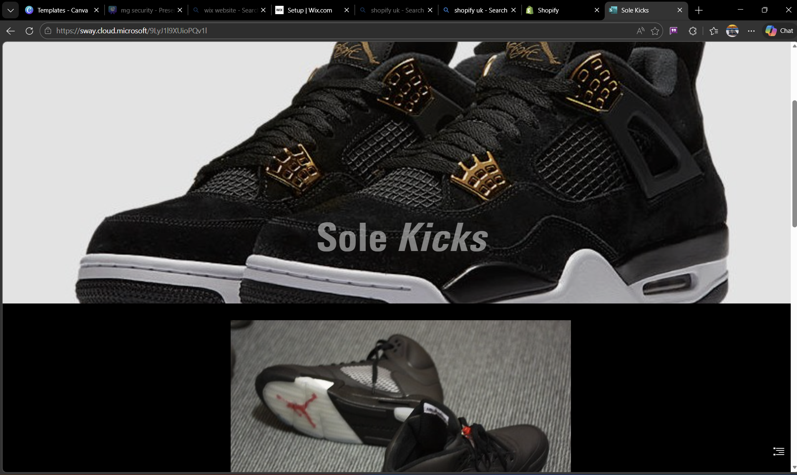
Fig1. Microsoft Sway website builder.

Shopify.

Shopify is a widely used e-commerce platform founded in 2006 in Canada, designed to enable businesses to create and manage online stores. It provides a complete solution for selling products online by offering a digital storefront alongside integrated tools for inventory management, payment processing, and tax compliance. Shopify supports a wide range of users, from small startups and sole traders to large multinational companies, making it a scalable platform for different business sizes. One of its key advantages is its cost-effective subscription model, which is particularly beneficial for small and medium-sized enterprises that may not have the resources to develop a custom website or payment infrastructure. Additionally, Shopify has grown significantly in popularity since 2020 due to its integration with social media platforms such as TikTok and X, allowing businesses to promote and sell products directly through these channels. However, despite its strengths, Shopify has limitations, including ongoing subscription fees, transaction costs, and reduced customisation compared to fully bespoke e-commerce websites [2].

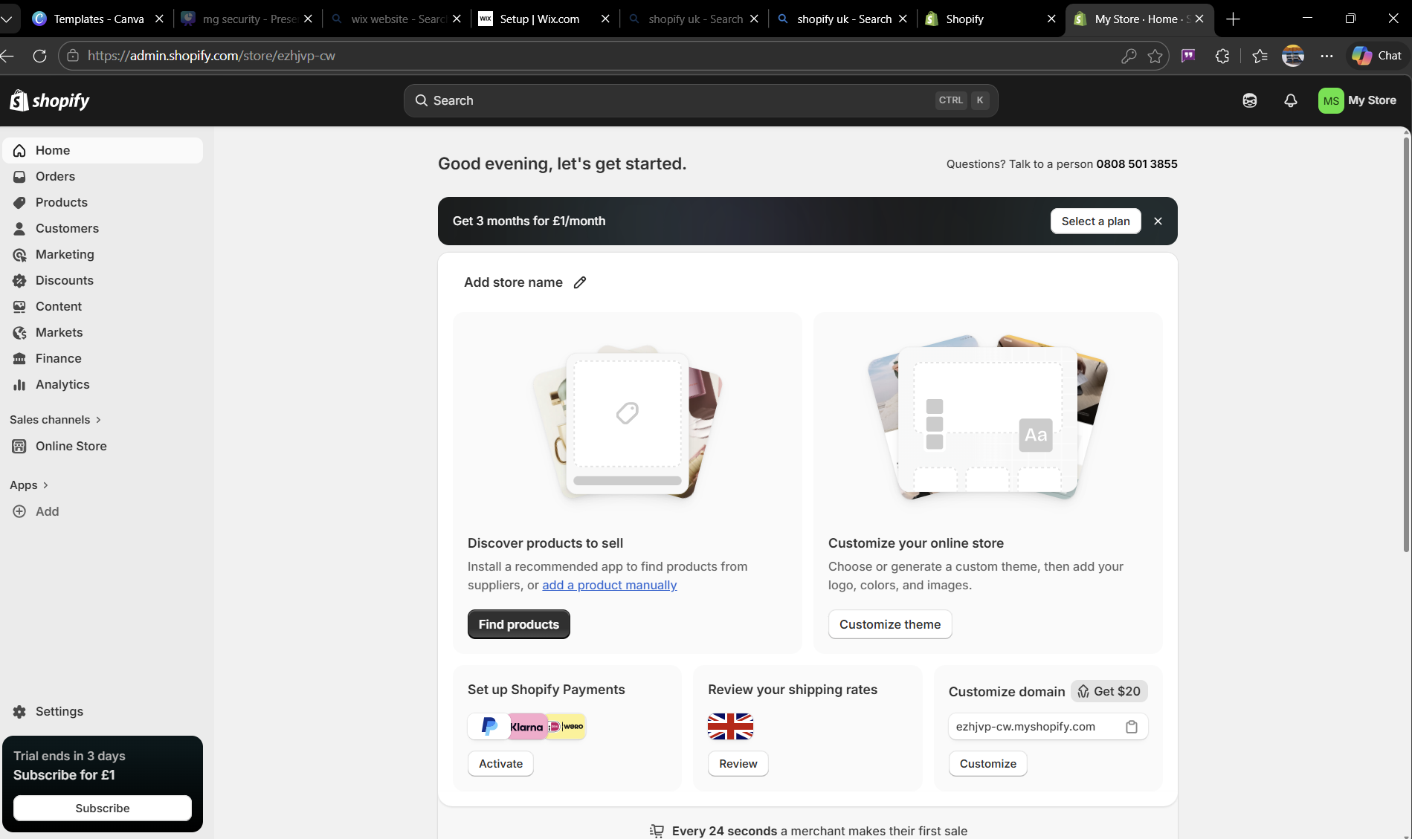

Fig2. Shopify e-commerce.

Wix

Wix is a cloud-based website and e-commerce platform, also founded in 2006, that focuses on providing flexible website-building tools for small businesses. It is particularly known for its drag-and-drop editor, which allows users to easily design and customise websites without requiring advanced technical skills. Wix offers a wide range of templates and the option to build a site from scratch, enabling businesses to create websites tailored to their specific needs. In terms of e-commerce functionality, Wix provides tools for processing payments, managing products, and tracking sales, similar to platforms like Shopify. However, Wix extends beyond basic e-commerce by offering additional features such as booking systems and customer lead management, making it suitable for service-based businesses as well as product-based ones. The main benefits of Wix include its ease of use, design flexibility, and all-in-one functionality. However, its limitations include less scalability compared to more specialised platforms like Shopify and potential restrictions when customising more advanced features [3]

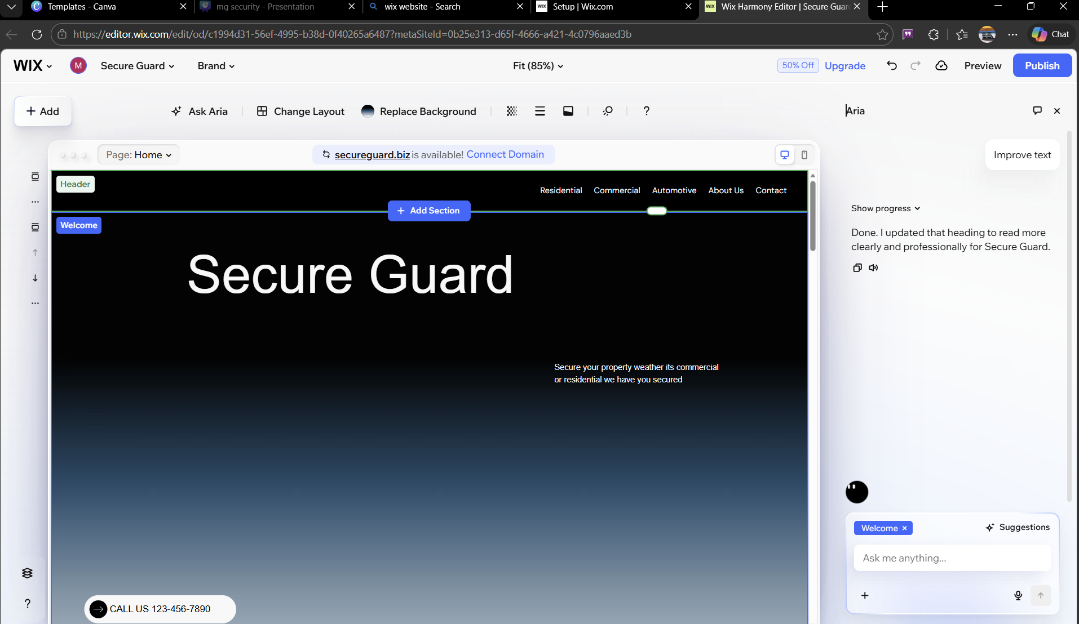Fig3. Wix website builder.

Task 2. Mind-map of contemporary software application
such as project plans and roadmaps. A multitude of businesses use mind-mapping techniques and software, from small startups to global conglomerates. At its core, mind mapping is a visual technique used to organise information, usually stemming outwards from a central concept or issue [4]. For example, a marketing team may have a mind map around advertising, and from that consider ideas around paid advertising, print advertising, radio and TV advertising and others for marketing a new product. From these branches, they would be able to expand further into what type of print advertising, such as newspapers vs magazines, or what sort of radio station listeners would be most receptive. These mind maps usually complement brainstorming sessions, which can often start off as an informal exercise in the initial stages of whatever the business is trying to achieve [4]. Beyond this, they can also be used for more formal purposes. They’re often used to break down large tasks and projects to make them easier to understand and delegate tasks to team members.
One of the biggest benefits of mind mapping lies within the visual element. They were created to mimic the concept of the brain and the way the brain’s neural network processes information, and so businesses use this tool to help unlock different ways of looking at products, projects, and ideas that would not normally occur if they were simply reading through a document [4]. In this way, they’re often noted for increasing creativity and encouraging new ways of thinking during brainstorming sessions. Another benefit is the order it brings to ideas. The visual structure of having one central component with branches leading from it creates a natural hierarchy of information, helping users understand complex topics more easily. This also helps break down large or complicated ideas into smaller, more manageable parts.
Another benefit is the group collaboration element. Businesses value this as it brings together team members who may normally work in silos, encouraging communication and shared understanding. It helps not only to get ideas onto a page or board but also creates open and clear communication between team members. One of the biggest advantages is how widely mind maps can be used. They are suitable for a wide range of business tasks, from brainstorming ideas and strategies to identifying problems and challenges within an organisation. The information produced can also be easily transferred into other business documentation [4].

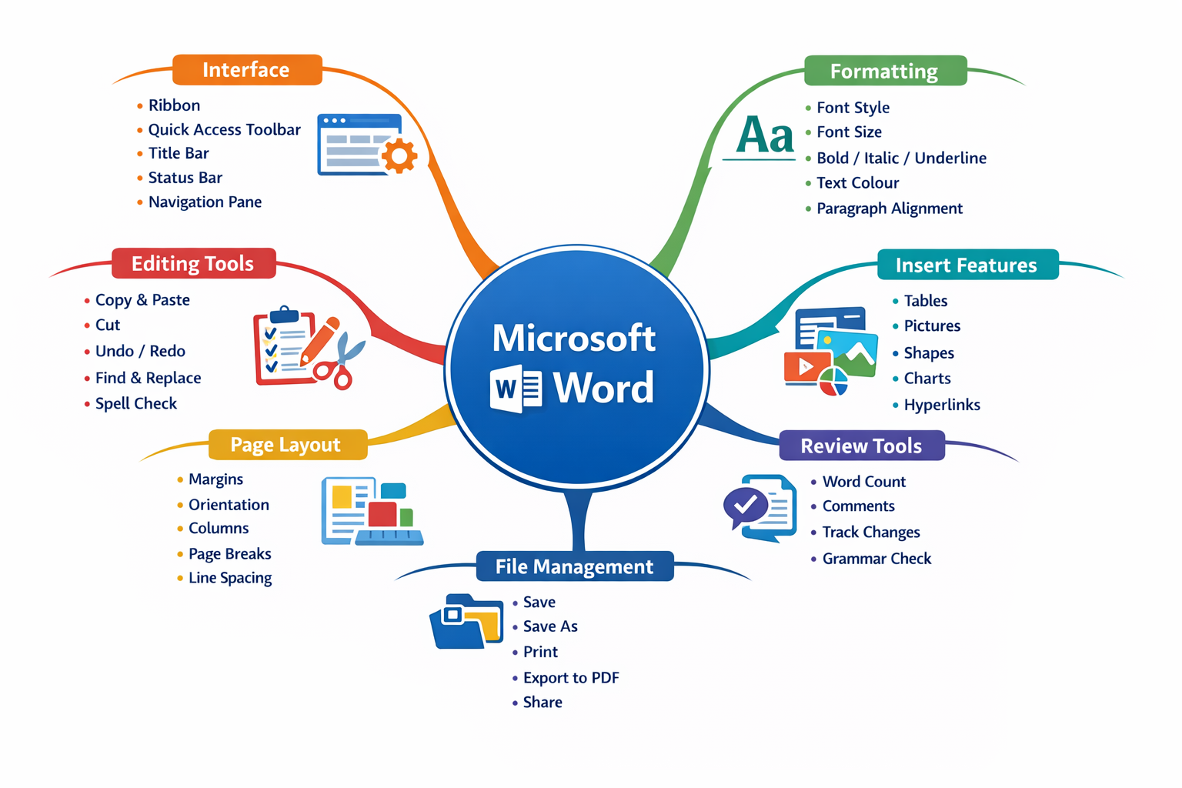 Fig.4. mind map example

This mind map shows how different software applications are used in a security company.
Each tool supports daily operations, such as managing staff, storing data, communicating, and protecting information.
This helps the business run efficiently and securely.

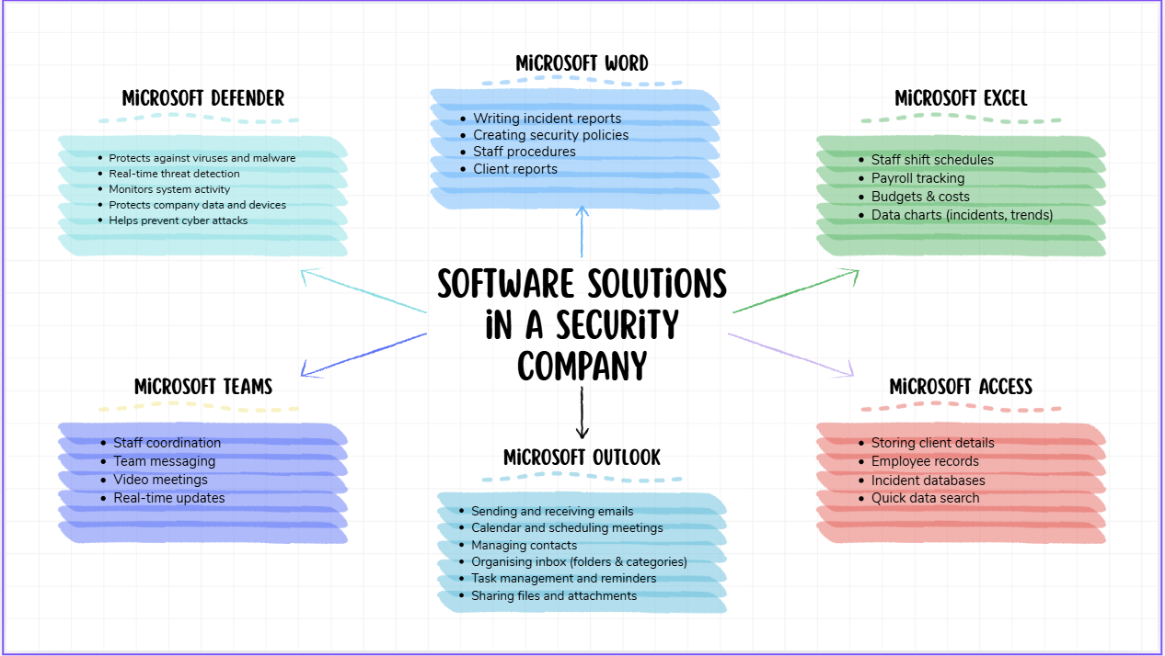fig.5.Screenshot of mind map in a security company.

Task 3. Office applications

Office Applications for creating, storing, presenting, and analysing information/data

Microsoft Word
Microsoft Word is a word processing software widely used in business operations to create and format documents such as reports, letters, and proposals. It includes key features like text formatting tools, templates, spell check, and collaboration options such as comments and track changes. These features allow users to produce professional and well-structured documents efficiently. The main benefits of Microsoft Word are its ease of use, wide availability, and ability to support teamwork. However, it has limitations, as it is not designed for data analysis or handling large datasets, and performance may decrease with very large documents [5].
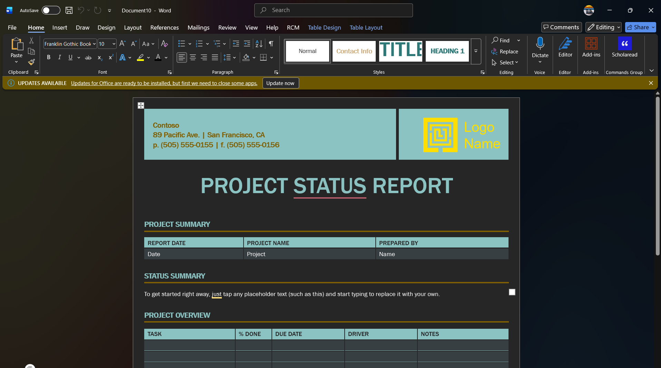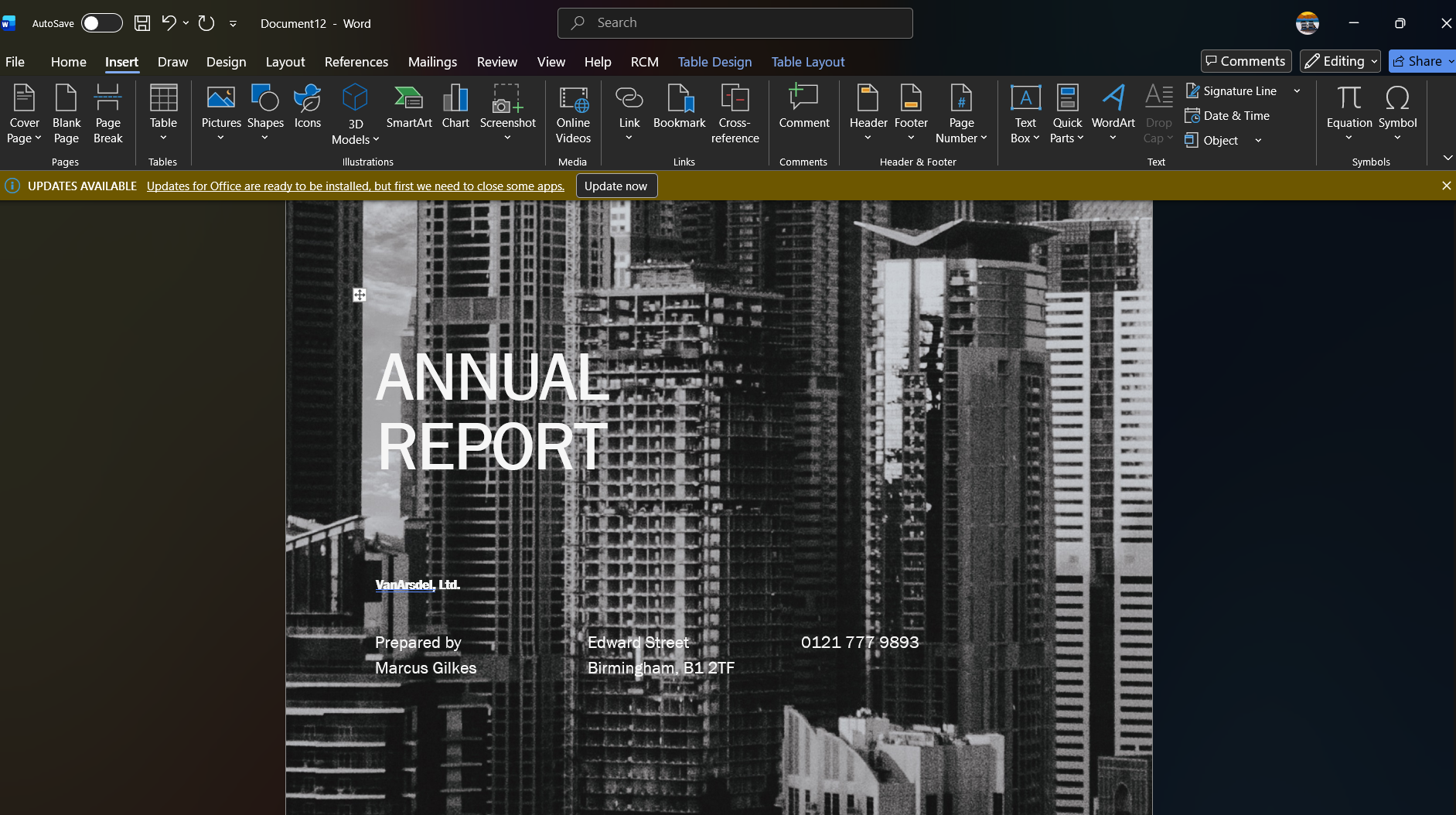
Fig.6: Screenshot of a Microsoft Word Document

MS PowerPoint
Microsoft PowerPoint is a presentation software used to communicate information visually through slides. It allows users to combine text, images, videos, and animations to create engaging presentations for meetings, training sessions, or business pitches. Key features include slide design templates, transitions, animations, and presenter tools such as speaker notes. The main benefit of PowerPoint is its ability to enhance audience engagement and simplify complex information. However, it has limitations, including over-reliance on visuals which can reduce clarity if poorly designed, and it is not suitable for detailed data analysis [6].
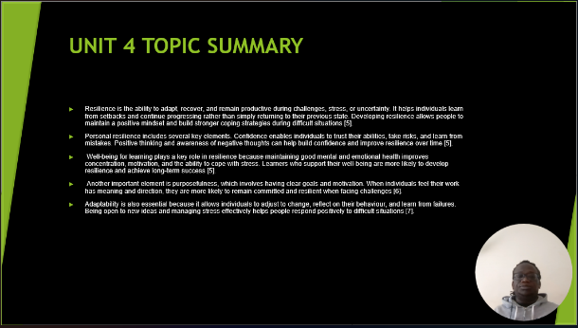
Fig.7. Screenshot of PowerPoint

MS Excel

Microsoft Excel is a spreadsheet application used for organising, analysing, and calculating data. It includes powerful features such as formulas, functions, charts, pivot tables, and data filtering tools. These features make it highly effective for financial analysis, budgeting, and decision-making in business. The main benefits of Excel are its flexibility, accuracy in calculations, and ability to identify trends and patterns in data. However, Excel can be complex for beginners, and errors in formulas can lead to incorrect results. It is also less suitable for managing very large or relational databases [7]
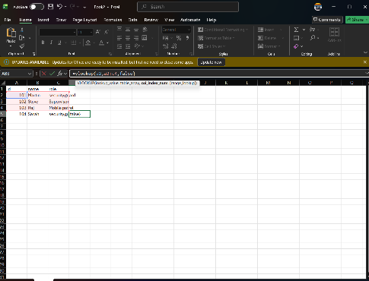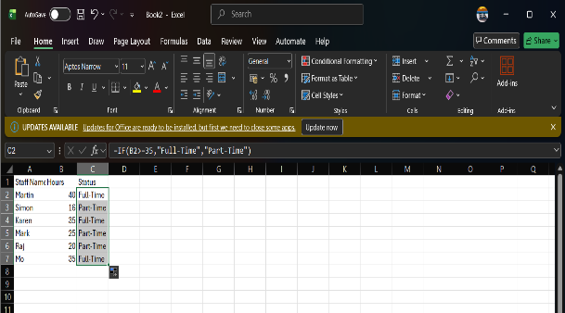
Fig.8. Screenshot of Excel Document

MS Access
Microsoft Access is a database management system used to store, manage, and retrieve structured data efficiently. It allows users to create tables, queries, forms, and reports, making it useful for managing large amounts of information such as customer records or inventory. The key benefit of Access is its ability to organise data systematically and reduce duplication. However, it is more complex than other Microsoft Office applications and requires a higher level of technical knowledge. Additionally, it may not be suitable for very large-scale enterprise systems compared to more advanced database solutions [8].
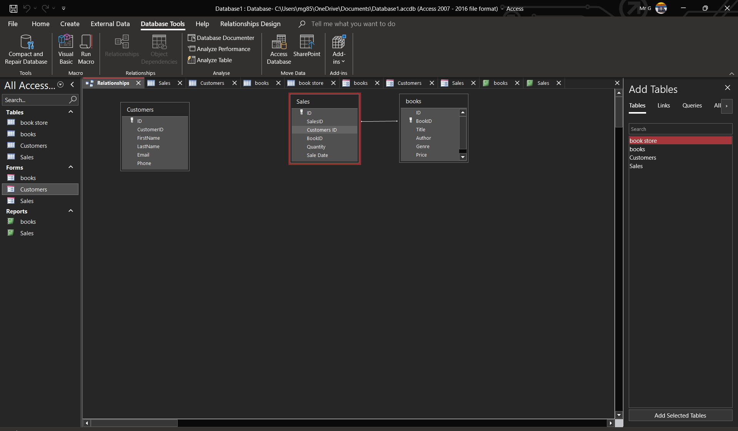
Fig.9. Screenshot of Access document

IF Function

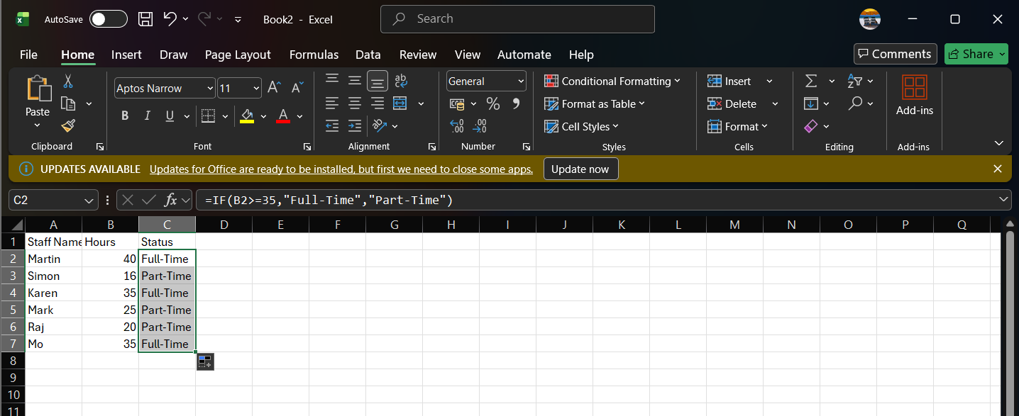
The IF function is used to test a condition and return different results. In this example, it identifies whether staff are full-time or part-time based on their working hours. This helps a security company manage staff efficiently.

VLOOKUP
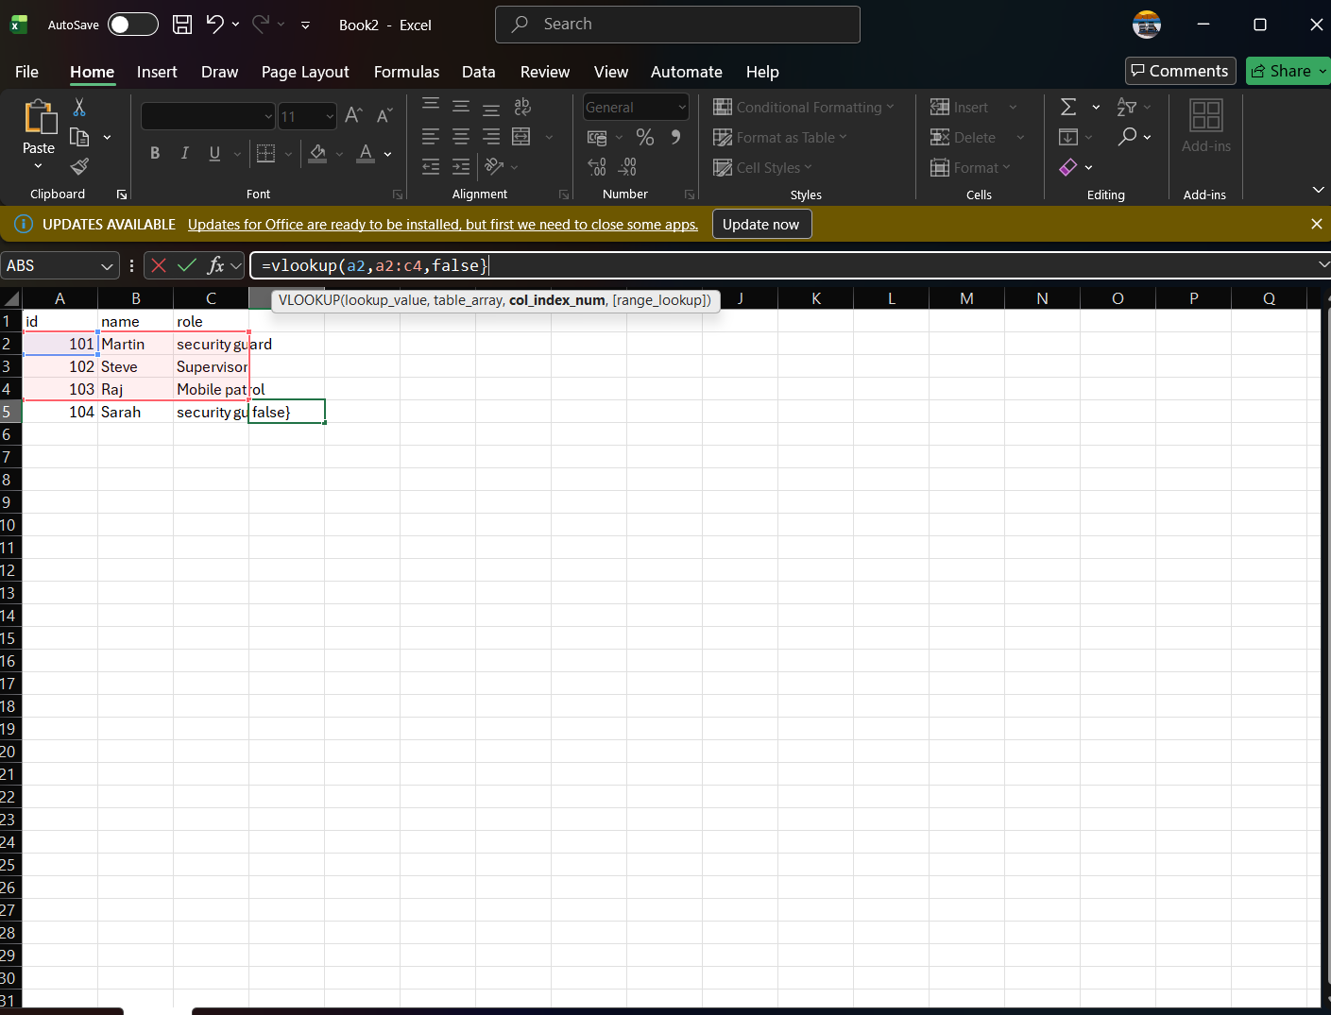
This screenshot shows the VLOOKUP function in Microsoft Excel.
It is used to search for data in a table and return a matching result.
In this example, entering an ID retrieves the staff member’s name.
In a security company, this can be used to quickly find employee details or client information

Task 4. Communication and Collaboration applications
Outlook - Communication
Microsoft Outlook is one of the most widely used email applications for businesses across the world, and it is used daily in all types of enterprises ranging from small startups and family run businesses to global conglomerates. The main function of Outlook is email communication, however, it also has several functions built into it too, such as time management, collaboration with colleagues and organising tasks. Communication is crucial in any workplace, from sending documents and other assorted files to organising meetings and cross-collaboration with various stakeholders [9].
Another key feature and advantage for organisations using Microsoft Outlook is the embedded security available on the software. Most modern organisations have some level of security against outside threats, such as malware and hacking threats, and usually employ the use of cybersecurity tools and protocols should they come under attack. To this end, cyber criminals usually use emails to hack into organisations, as they will often send a ‘phishing’ email where the recipient clicks a link and this allows the hacker to gain access to the employee's account, and therefore access to the wider IT network the organisation uses. Microsoft Outlook has a high security standard developed by the parent company, Microsoft, over many decades. Microsoft Outlook offers users the ability to automatically filter out suspicious looking emails and can block access to documents and attachments. Employees are usually trained to be vigilant when opening emails, however, this automatic screening adds another layer of security.
Beyond sending, scheduling and receiving emails, Outlook also has another important feature, the ability to view your diary, and schedule appointments/meetings with others. Microsoft Outlook is also embedded with Microsoft Teams, so when scheduling a meeting via Outlook, the system automatically adds it as a virtual teams meeting, unless it specifically states it will be an in-person meeting. This is beneficial as it makes the meeting creation process simpler, instead of having to use Microsoft Outlook to schedule availability then another platform to set the actual virtual meeting up.
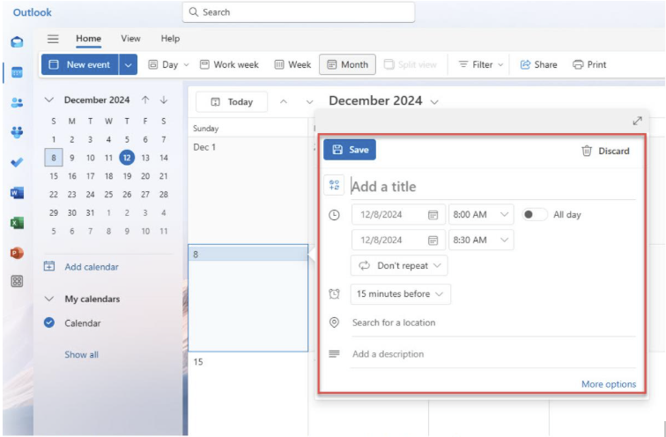
Fig4. Creation of an event/meeting via Microsoft Outlook [10].
Overall, Microsoft Outlook, and emails in general, are a critical way for businesses to communicate both internally and externally. They can be used for an almost infinite number of reasons, from carrying important information and sending documents and attachments to scheduling meetings and keeping employees and stakeholders up to date. Emails are not only used in a corporate setting but also in personal lives too as people rely on them as a primary form of communication.
Microsoft Teams – Collaboration

Businesses are increasingly moving towards using digital tools for collaboration, and Microsoft Teams is at the forefront of this digital transformation. Launched in 2017, Teams is now part of the Microsoft 365 suite and is closely integrated with other applications in the suite such as Microsoft Outlook. By using Microsoft Teams, businesses can combine communication, sharing files, project management work in a single application.
Microsoft Teams has a wide variety of features designed for communication in the modern business. The main feature of this is the chat channels, where users can speak with one another like an instant messaging service, they can also create group chats between colleagues and channels for larger groups to not only speak but post updates. These chat channels not only let users instantly message each other, but also share documents, audio files and collaborate on projects. This collaboration extends to Microsoft Team’s integration with other applications in the Microsoft 365 suite – including Microsoft Word, Excel, SharePoint and OneNote. In a modern business, users can collaborate on documents via other applications but remain in Microsoft Teams.
For example, employees can create a shared report on Microsoft Word, via Microsoft Teams, that allows them to draft and edit it without leaving the Microsoft Teams application.
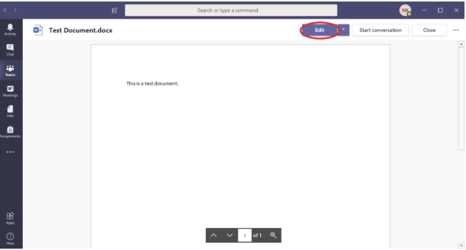
Fig5. Editing a shared document in Microsoft Teams.[11]
Additionally, this integration extends beyond the Microsoft 365 suite. Microsoft Teams can also seamlessly integrate with third-party collaboration apps, such as Trello and Asana, which are usually used in a collaborative project management setting. This means Microsoft Teams can act as a central ‘hub’ for several different collaborative business processes, from editing excel reports with employees to tracking project milestones via Asana.
Overall, Teams plays a fundamental role in collaboration for modern businesses. This is even more critical due to the Covid-19 pandemic, where businesses had to find digital-first ways for employees to collaborate virtually without the need to communicate in-person due to office restrictions. Uptake of Microsoft Teams had been slowly increasing since being founded in 2017; however, downloads surged from 32 million daily users in March 2020 to 145 million by April 2021. Additionally, this growth not only corresponds with working from home, but with the new hybrid working model where some employees work from home and some from the office, through Teams they are still able to collaborate on documents and via video conferencing. Many modern businesses are also geographically dispersed throughout the UK and globally, and so Microsoft Teams allows colleagues to collaborate and communicate across different geographical offices and even time zones. Another final key feature for modern businesses is Microsoft Team’s inbuilt cybersecurity features. The application offers security controls, data encryption and multi-factor authentication. This is extremely important as sensitive information, and documents are often shared on the platform by organisations in regulated industries such as government, healthcare and finance [12].
4b – Collaboration and Communication tool demonstration
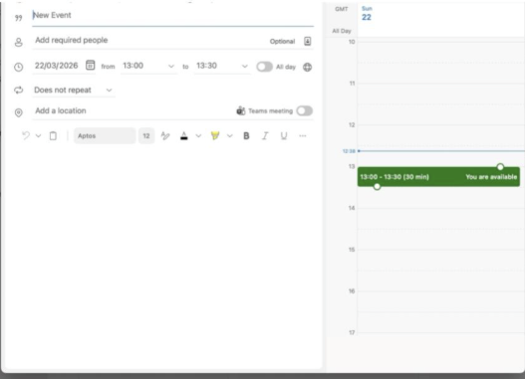
Fig.6. Creating a meeting in Outlook
Creating a meeting in Outlook allows me to create a title and put text in the body of the meeting, which those invited can see, for example, the agenda of the meeting could go in that section.
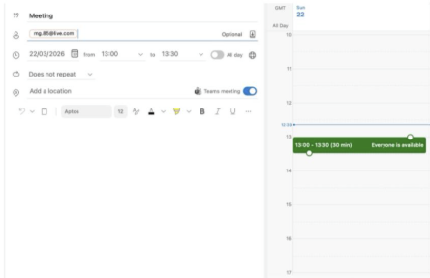
Fig. 7. Inviting someone to a meeting. I have used my personal Live.com account for this example.
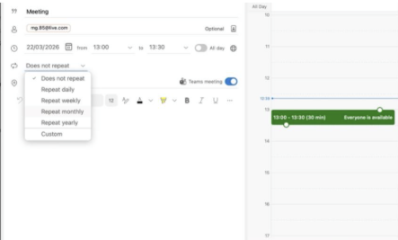
Fig. 8. Making the meeting recurring over a set frequency I have set this to occur at the same time every Month.
Microsoft Teams demonstration – Using Microsoft Planner in Microsoft Teams
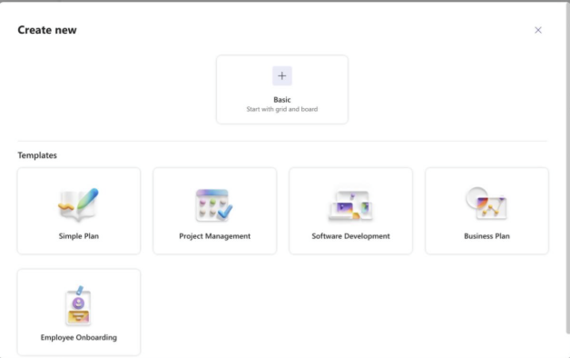
Fig.9. Creating a new plan on Microsoft Planner (within Microsoft Teams)
Description – Microsoft Teams has a built in ‘Planner’ App that allows users to create and monitor tasks, and users can also ‘tag’ others into tasks for enhanced collaboration.
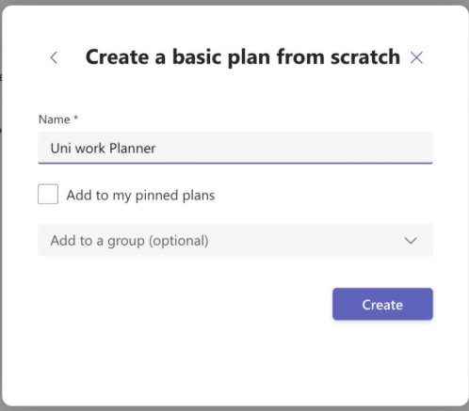
Fig.10. Creating a new ‘Plan’ for my university studies. This also allows me to invite people to communicate and collaborate via this plan.
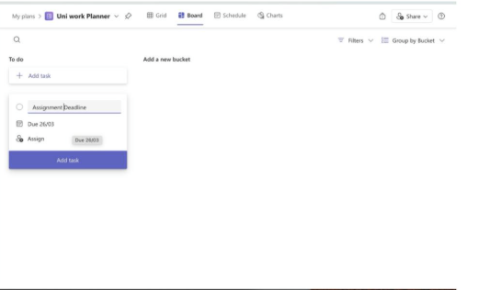
Fig.8. The front page of my Uni Work plan this allows me to create tasks and reminders and share the plan with others to add tasks.

References
Re
[1] Microsoft, “Sway help & learning,” Microsoft Support. [Online]. Available: https://support.microsoft.com/sway. Accessed: Mar. 17, 2026.
[2] Shopify, “Shopify Help Centre,” Shopify. [Online]. Available: https://help.shopify.com. Accessed: Mar. 17, 2026.
[3] Wix, “Wix Support Centre,” Wix. [Online]. Available: https://support.wix.com. Accessed: Mar. 17, 2026.
[4] T. Buzan and B. Buzan, The Mind Map Book. London, U.K.: BBC Active, 2006.
[5] Microsoft, “Microsoft Word,” Microsoft. [Online]. Available: https://www.microsoft.com/word. Accessed: Mar. 17, 2026.
[6] Microsoft, “Microsoft PowerPoint,” Microsoft. [Online]. Available: https://www.microsoft.com/powerpoint. Accessed: Mar. 17, 2026.
[7] Microsoft, “Microsoft Excel,” Microsoft. [Online]. Available: https://www.microsoft.com/excel. Accessed: Mar. 17, 2026.
[8] Microsoft, “Microsoft Access,” Microsoft. [Online]. Available: https://www.microsoft.com/access. Accessed: Mar. 17, 2026.
[9] Tech-Wales, “Why your organisation should use MS Outlook,” Tech-Wales. [Online]. Available: https://www.tech-wales.co.uk/news/why-your-organisation-should-use-ms-outlook/. Accessed: Mar. 22, 2026.
[10] CiraSync, “Microsoft Outlook,” CiraSync. [Online]. Available: https://cirasync.com/blog-articles/microsoft-outlook/. Accessed: Mar. 22, 2026.
[11] UNC School of Government – ITD, “Using Teams collaborative editing,” UNC ITD. [Online]. Available: https://itd.sog.unc.edu/knowledge-base/article/using-teams-collaborative-editing. Accessed: Mar. 22, 2026.
[12] Berkshire Community College, “Schedule a meeting in Teams,” Berkshire CC. [Online]. Available: https://www.berkshirecc.edu/knowledge/microsoft-office/schedule-a-meeting-in-teams.php. Accessed: Mar. 22, 2026.

