Yr Wyddor Gymraeg The Welsh Alphabet

There are 29 letters in the Welsh alphabet.

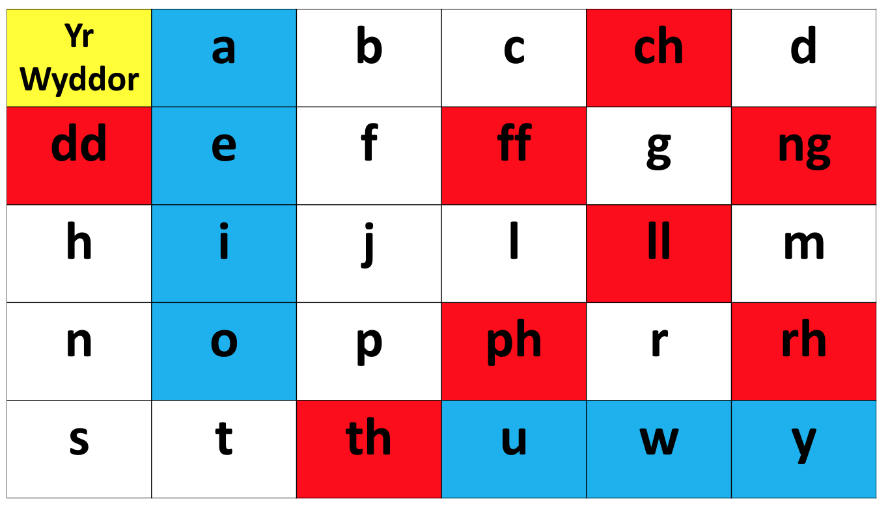

Allwedd
Key Llafariaid/Vowels

Llythrennau dwbl
Double letters

a ah - as in ambulance, man, bath or in America
b b - as in boy, book, burn or bag
c k - as in kite, bacon, cat or car
ch ch - as in loch or bach, the sound is made at the back of the throat. It is never pronounced as in church or chapel
d d – as in dog, adder or donkey
dd th - as in the, other, breathe, them or heather
e eh - as in then, bet, hen or end
f v - as in very, even, value, over or of
ff f - as in France, foot, off or different
ph ph – as in hyphen
g g – as in go, ago, garden or gone, (never as in George
or general)
ng ng – as in ring, finger, song or long
h h / aha as in hat, house or hut
i ee – as in seen, queen or meek
y – as in yes and youth
j j - as in jam, just or ajar
tsi / tsh as in ch in church

l l - as in lamp, lily or lost
ll ll – place your tongue on the roof of your mouth and blow noiselessly as if to say 'l' and hissing out of one side of the mouth
m m - as in mummy, man or mouse
n n - as in nine, nanny, name or number
o oh - as in door, boat, orange or more
o – as in hot and pot
p p as in pen, open, pyjamas or prize
ph ph – as in physics or graph
This letter only appears as a mutated form of p
r rr – as in rat, rip, rose or run
This letter is trilled and is rolled much more than in English
rh rrh – add a ‘h’ after a trill or the rolling r
s s - as in hiss, sun or sit
si is pronounced as the English sh, siop = shop, or sham, mesh
When si appears on its own it is the same sound as the
English sea

t t - as in top, pity, tyre or target
th th - as in thin, theatre or thankful ( never as in that, the or them)
u ee – as in tree, feel or in
w oo - as in wool, look or fool
w – as in went
y i short: as in sinner, bin, sit or tin
uh short: as in gun, but or up
ee long: as in seen

Nodiadau Notes:
- The double letters, ch, dd, ff, ng, ll, ph, rh, and th are one letter in Welsh and are one letters when completing a crossword, e.g. ffôn (=phone) is a three letter word.
- There are seven vowels in the Welsh language, a, e, i, o, u, w, y.
- Two consonants, 'n' and 'r', are sometimes doubled in written Welsh, e.g. carreg (stone), torri (to cut), honno (that one), trannoeth (next day).
- When the letter f occurs at the end of words it is frequent silent, e.g. araf is often pronounced ara’, dref is often pronounced dre’.
- A vowel is sometimes introduced between pairs of consonants at the end of words, e.g., llyfyr for llyfr, pobol for pobl and cefen for cefn.
- Sometimes the long vowel is marked by a circumflex known in Welsh as to bach (little roof), e.g., tân (fire), cân (song) or pêl (ball).
- The accent is usually on the last syllable but one.
cymylog eliffantod dibynnu mabolgampau
llygoden teledu cwningen ysgwyddau
- The diaeresis is sometimes used to indicate that a vowel must be sounded separately, e.g., llungopïo, gweddïo.
The Diphthongs
Diphthongs are combinations of two vowels which are pronounced together:
ae is pronounced as English eye
ai, au are pronounced as ai in Shanghai
aw is pronounced as ow as in cow
eu, ei are pronounced the same way as the English ay in pray
ew is similar to eh-oo or perhaps as in the mount or yew tree
i'w, yw are pronounced as ee-you or ee-oo, similar to yew or you
oe is similar to the English oy or oi as in oily or oyster
ow is pronounced ho-oo, ow as in the English bowling, tow or low
wy is pronounced as in the English wi in with, win or oo-ee or wee
yw is pronounced as in the west Wales clothing company, Howies or
as in bowling or slow

