Electronic Circuits Testing and Applications
Electrical Control Systems (ACHA4010)

Jay Wexler
2305581
Lecturer: Ryan James

University of Wales Trinity Saint David
School of Engineering
Motorcycle Engineering BEng

24/03/2024

Contents
Table of Figures 2
Task 2 3
Scope Time Division Calculations (4) 3
Function Generator output sine wave (3) 4
Unsmoothed Rectifier Wave (3) 4
Smoothed Rectifier Wave with capacitor (3) 5
Drop in Voltage Question (4) 5
Different Voltage Readings Question (5) 5
Rectifiers use in Automotive applications Question. (4) 6
Probing Question (4) 6
Task 3 7
Scope Time Division Calculations (4) 7
Function Generator output square wave (3) 7
Capacitor charge and discharge wave marked at correct points. (3) 8
Basic Capacitor Calculations (3) 8
Capacitor discharge table (4) 9
Gradient Plot and calculations (4) 9
Capacitor Uses (5) 10
Capacitors in electrical application: 10
Capacitors in automotive application: 10
Capacitors in motorcycle application 10
Inaccuracies Question (4) 10
References 11

Table of Figures
Figure 1 5
Figure 2 5
Figure 3 6
Figure 4 (Assel Zhaksylyk, 2023) 7
Figure 5 9
Figure 6 10
Figure 7 11
All used figures and tables (unless specified otherwise) were gathered through practical tasks personally completed.

Task 2

Scope Time Division Calculations (4)
$$f=10Hz$$
$$period=\frac{1}{f}$$
$$period=\frac{1}{10}$$
$$period=0.1s$$
For only one period on screen,
$$Time/DIV=\frac{0.1}{10}$$
$$Time/DIV=0.01s$$
$$Time/DIV=10ms$$

Function Generator output sine wave (3)
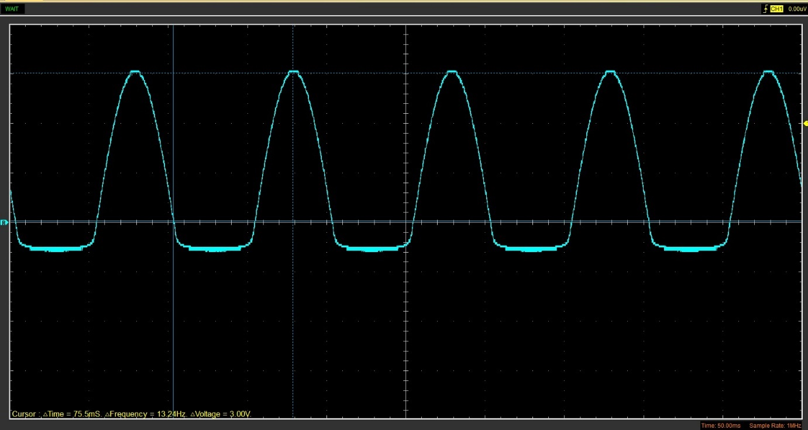
Figure 1

Unsmoothed Rectifier Wave (3)
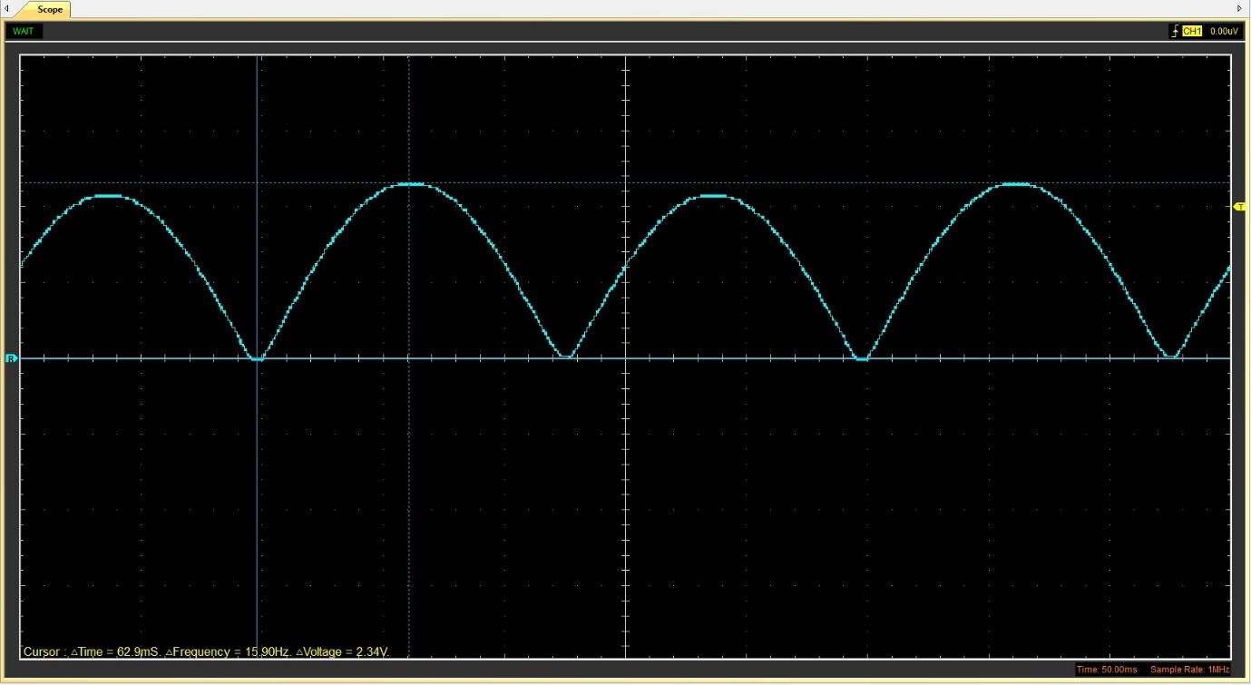
Figure 2

Smoothed Rectifier Wave with capacitor (3)
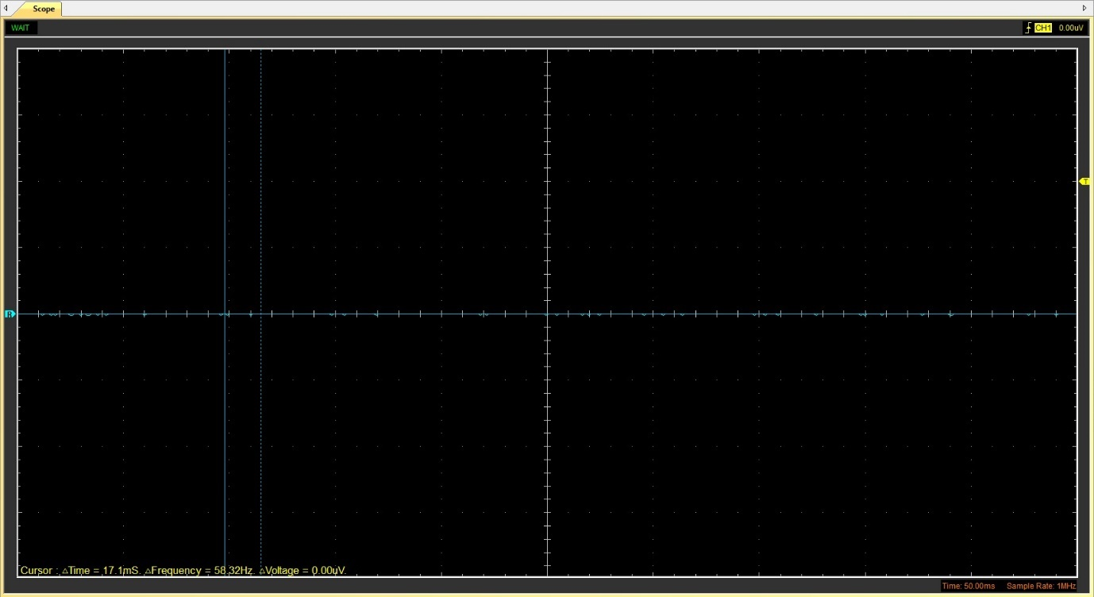
Figure 3

Drop in Voltage Question (4)
The key factor that is likely to cause a voltage drop between the 2 points is the resistivity of the wires themselves, this comes as a result of the length and the material that the wire is made of. Considering voltage ‘flows’ similarly to fluid through a pipe, consider that the resistances works as friction (Solo Nunoo, 2012) and therefore reduces the total voltage at the peak of the sinewave input.

Different Voltage Readings Question (5)
Peak positive input voltage ($V_{p}$) | Peak to peak voltage ($V_{pp}$) | Root mean square (using$V_{p}$) | Root Mean Square (using $V_{pp}$)
1.38V | 2.9V | 0.9578V | 1.0253V
Table 1
Root mean square for voltage or effective voltage, is an equivalent to the value of a dc voltage which creates equal heat energy due to resistance against the current travelling through the circuit (Rawlins, 2000). The reason for the difference between the rms’ and the other voltages is down the fact that when working with an alternative current voltage, the RMS represents a direct current voltage which would dissipate equal power as the alternative current used for the calculation (Wet, 2024).

Rectifiers use in Automotive applications Question. (4)
A common use for rectifiers within the automotive industry is in electric vehicle, specifically ‘active front-end’ (AFE) rectifiers. The role they play is one that increases the charging infrastructure greatly within high power electric vehicles with increased efficiency and reliability (Assel Zhaksylyk, 2023). The importance of the qualities of AFE rectifiers is that they are able to improve the running function of electric vehicles through while also reducing/minimising the disturbances which are generated as a result of the EV charging systems through the limitation of harmonic distortion.
Furthermore, the use of AFE rectifiers can be done in a modular application, with ‘modularity’ meaning they are capable of being separated into smaller parts. The benefits that come from this concept are the ability to individually design, modify and replace modules with others. When considered, an AFE rectifier can account for a single module with the ability to join together within a system. This application allows for the ability to individually modify the power rating of a rectifier in order to improve efficiency as shown in figure 4 (Assel Zhaksylyk, 2023).
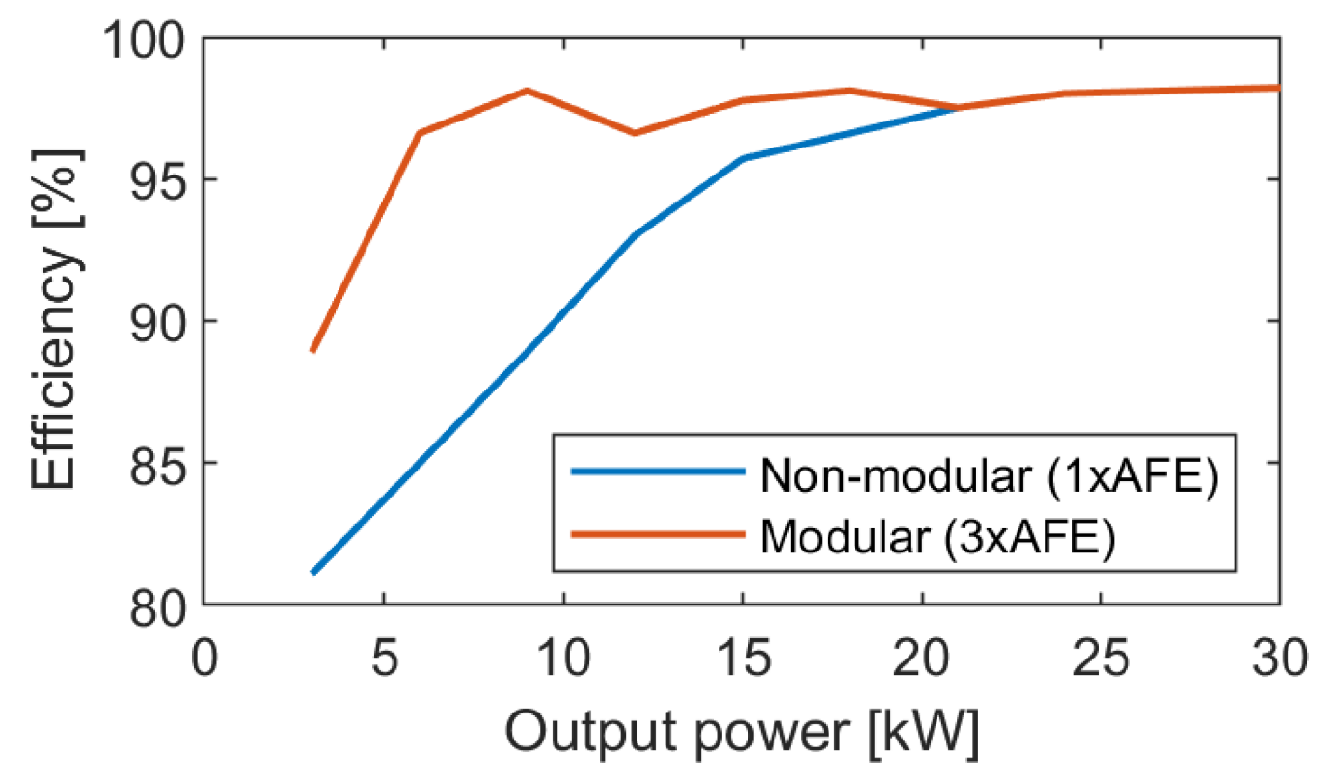
Figure 4 (Assel Zhaksylyk, 2023)

Probing Question (4)
The main reason for being unable to probe multiple areas at a single time with the provided oscilloscope is the fact that the oscilloscope only had two connection points and the function generator had its own port to connect it to a circuit for an input. A way to read both the function generators input and the rectifiers output at the same time, is to use an oscilloscope with multiple ports per channel to allow for readings at multiple points. A tool that could be used in for wider results may be an optical oscilloscope although this would require high speed connections (Rick L. Morrison, 2004).
Another variation of oscilloscope, that would make it possible would be the Hantek 1008C oscilloscope as this allows the user to use 8 probes at a single time allowing for simultaneous data across multiple channels which in turn would in theory allow for the ability to read both the input and outputs previously stated (Bhatia, 2015).

Task 3

Scope Time Division Calculations (4)
$$R=10kΩ$$
$$C=225μF$$
$$τ=RC$$
$$τ=10,000×\left(225×{10}^{-5}\right)$$
$$=22.5mS$$
$$20τ=22.5×20$$
$$=450mS$$
$$f=\frac{1}{450}$$
$$=0.00\dot{2}Hz$$
For only one period on screen,
$$Time/DIV=\frac{0.00\dot{2}}{10}$$
$$Time/DIV=0.000\dot{2}s$$
$$Time/DIV=200μS$$

Function Generator output square wave (3)
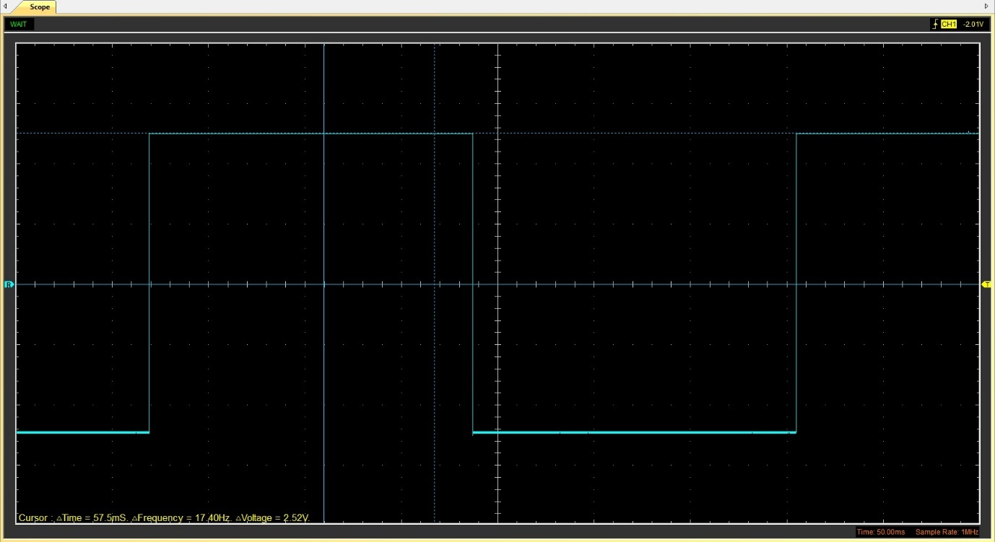
Figure 5

Capacitor charge and discharge wave marked at correct points. (3)
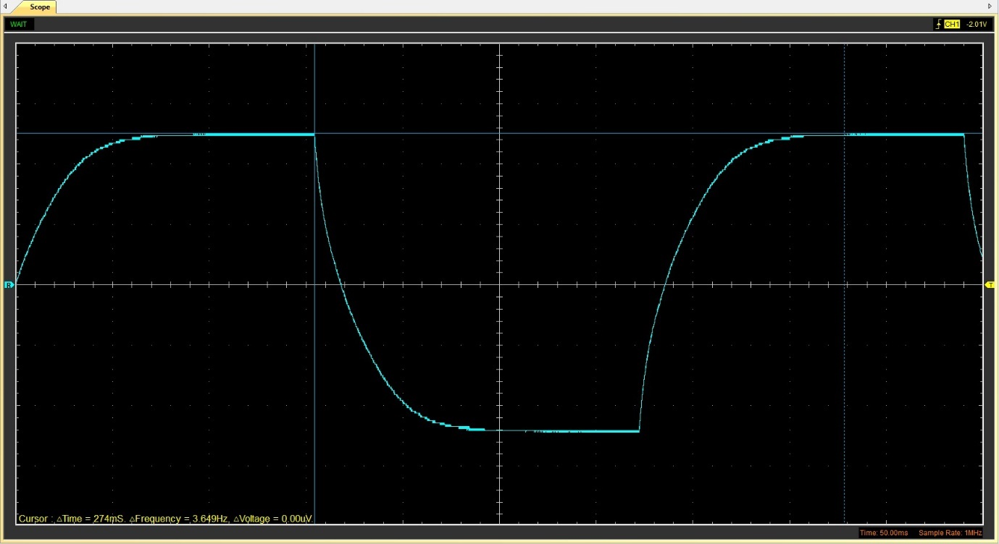
Figure 6

Basic Capacitor Calculations (3)
$$τ=\left(4.97-\left(-2.45\right)\right)*0.632+\left(-2.45\right)$$
$$=2.23944s$$

$$C=\frac{τ}{R}$$
$$C=\frac{2.23944}{10000}$$
$$=0.000223994F=223.994μF$$

Capacitor discharge table (4)
Time (s) | V | V+ | Ln(V) | dy | dx | dy/dx
0.010396 | 3.0745 | 9.0745 | 2.205468 | x | x | x
0.010752 | 1.1294 | 7.1294 | 1.964227 | -0.24124 | 0.000356 | -677.644
0.011108 | -0.0627 | 5.9373 | 1.781254 | -0.18297 | 0.000356 | -513.968
0.011464 | -1.1294 | 4.8706 | 1.583217 | -0.19804 | 0.000356 | -556.285
0.01182 | -1.8824 | 4.1176 | 1.41527 | -0.16795 | 0.000356 | -471.76
0.012176 | -2.5725 | 3.4275 | 1.231831 | -0.18344 | 0.000356 | -515.279
0.012532 | -3.2 | 2.8 | 1.029619 | -0.20221 | 0.000356 | -568.01
0.012888 | -3.702 | 2.298 | 0.832039 | -0.19758 | 0.000356 | -555.001
0.013244 | -4.0784 | 1.9216 | 0.653158 | -0.17888 | 0.000356 | -502.475
0.0136 | -4.2667 | 1.7333 | 0.550027 | -0.10313 | 0.000356 | -289.694
Table 2

Gradient Plot and calculations (4)

Figure 7
$$Gradient=-522.08$$
$$τ=\frac{-1}{y}$$
$$τ=\frac{-1}{-522.08}$$
$$=0.019154s$$
$$C=\frac{τ}{R}$$
$$C=\frac{0.019154}{10000}$$
$$=0.0000019154F=1.9154μF$$

Capacitor Uses (5)

Capacitors in electrical application:
- Energy storage,
- Power conditioning,
- Signal processing.
- Remote sensing

Capacitors in automotive application:
- Engine control units (ECU’s) for battery controls,
- Onboard chargers for electric vehicles,
- Electric motors for fuel pumps and fans.

Capacitors in motorcycle application
- Conventional ignitions systems,
- Capacitor discharge ignition (CDI) systems,
- CDI ignition systems with AC and DC currents.

Inaccuracies Question (4)
A potential reason for the major difference in the calculated results with and without using the gradient shown in figure 7 is the point at which the reading is taken, since the points take for the graph may be on a point of the wave after the capacitor has discharged significantly more than the point where the voltage for the other calculation is taken since it uses the peak value from the wave while the graph shows a portion of the wave after it begins to drop off. Additionally, measured results can vary drastically with different method of measurement (Jorge Golowasch, 2009).

References
Assel Zhaksylyk, H. R. (2023, February 27). Review of Active Front-End Rectifiers in EV DC Charging Applications. (O. Veneri, Ed.) Batteries, Modular AFE. doi:https://doi.org/10.3390/batteries9030150
Bhatia, S. (2015, Apr 22). Data Acquisition and Signal Processing for Advanced Physics Research through state of the art Oscilloscope and Digitizer Technologies. Retrieved Mar 24, 2024, from https://www.ipr.res.in/iaeatm2015/talk/Keysight%20Presentation%20-%20IPR%20Final.pdf
Jorge Golowasch, G. T. (2009). Membrane Capacitance Measurements Revisited: Dependence of Capacitance Value on Measurement Method in Nonisopotential Neurons. Journal of Neurophysiology, Results. doi:10.1152/jn.00160.2009
Rawlins, J. C. (2000). CHAPTER 2 - AC and the Sine Wave. In J. C. Rawlins, Basic AC Circuits (Second Edition) (pp. 29-63). Burlington: Newnes. Retrieved Mar 23, 2024, from https://www.sciencedirect.com/topics/engineering/root-mean-square-value
Rick L. Morrison, S. G. (2004, Jun 16). A multichannel optical oscilloscope for sampling broadband,. Naperville, Illinois, United States of America. Retrieved Mar 24, 2024, from https://math.mit.edu/~stevenj/papers/MorrisonJo96.pdf
Solo Nunoo, J. A. (2012, Jan). An Investigation into the Causes and Effects of Voltage Drops on an 11 kV Feeder. Canadian Journal on Electrical and Electronics Engineering, 3, 44. Retrieved Mar 23, 2024, from https://www.researchgate.net/publication/249649564_An_Investigation_into_the_Causes_and_Effects_of_Voltage_Drops_on_an_11_kV_Feeder
Wet, R. d. (2024). What is the RMS of a voltage? RMS Voltage Calculator. Retrieved Mar 23, 2024, from https://www.omnicalculator.com/physics/rms-voltage#what-is-the-rms-of-a-voltage

