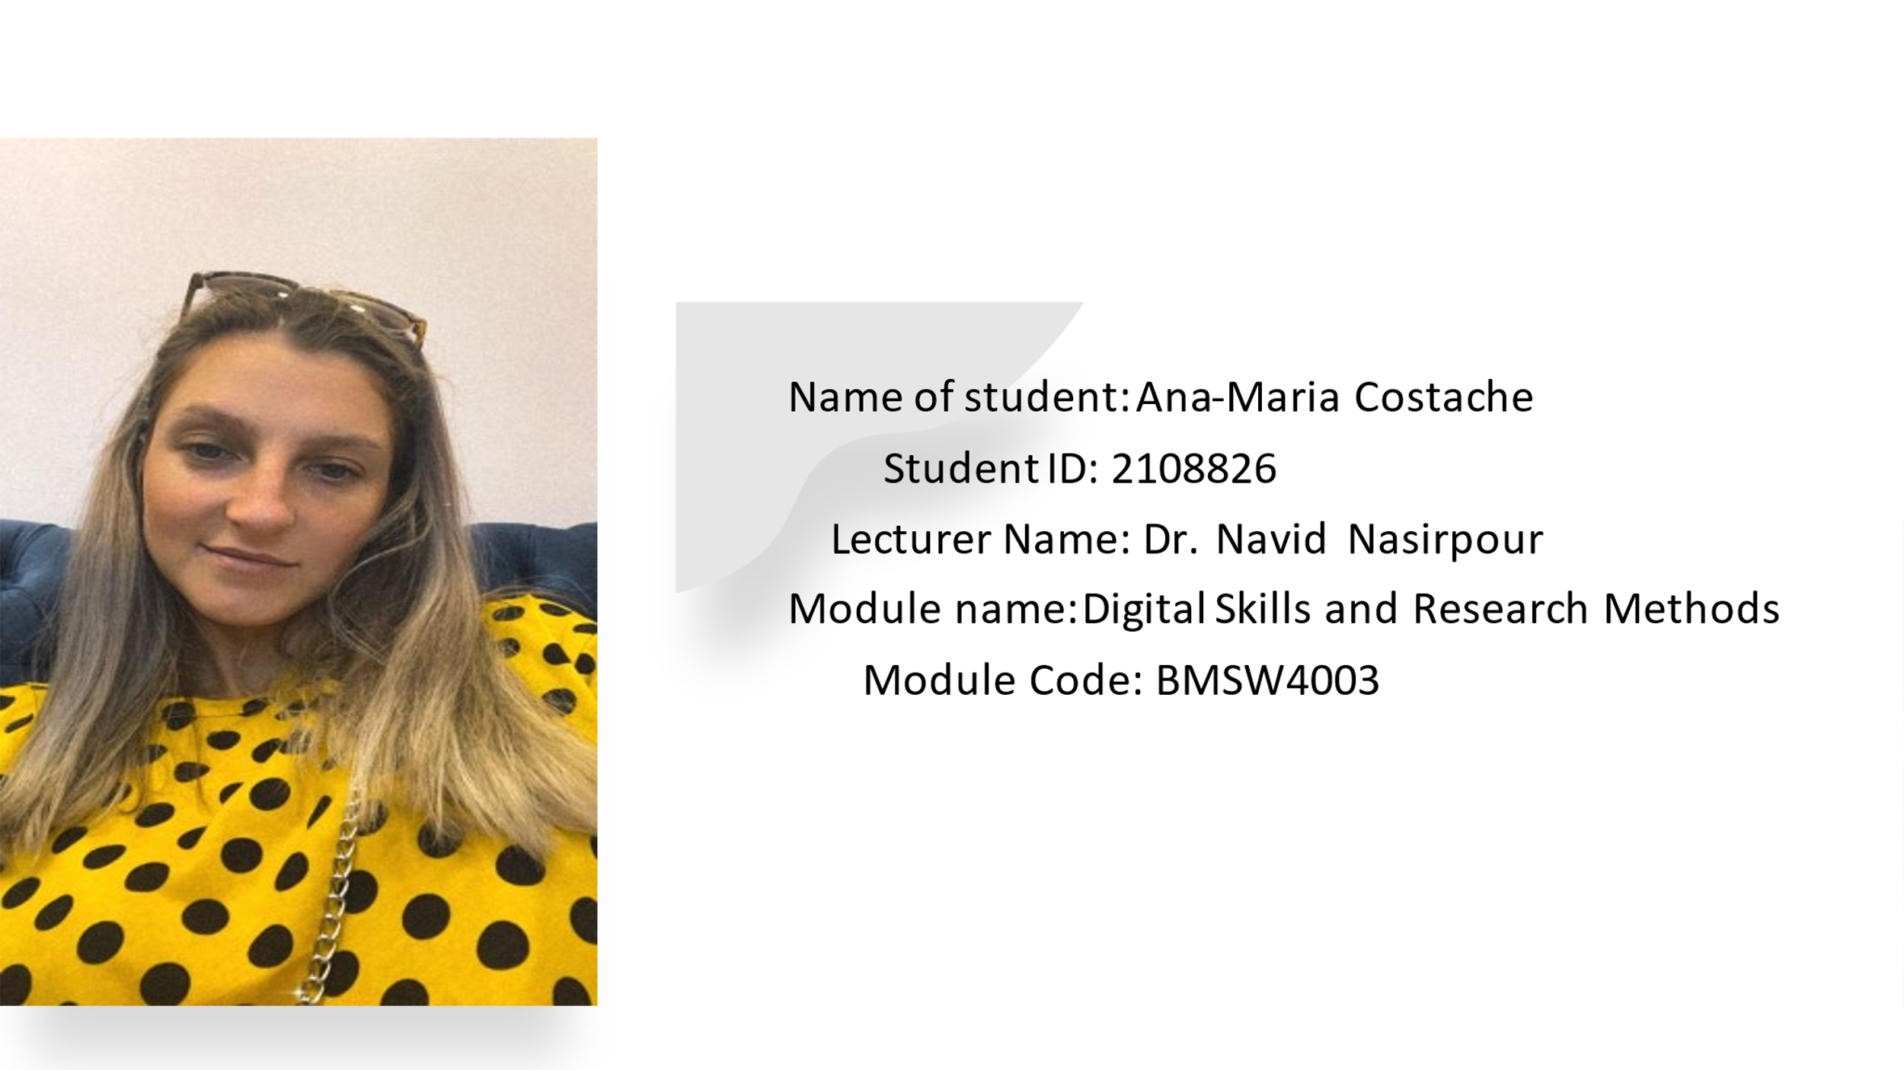

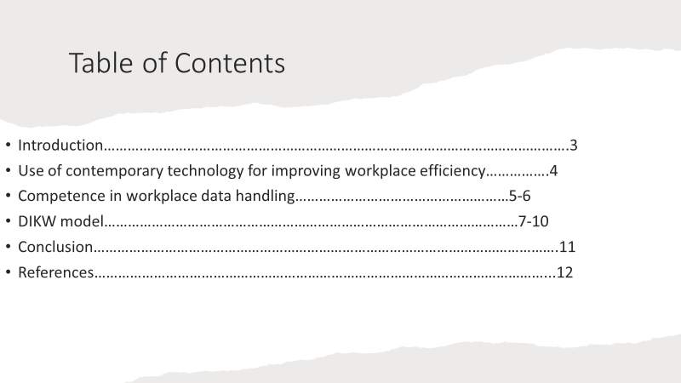

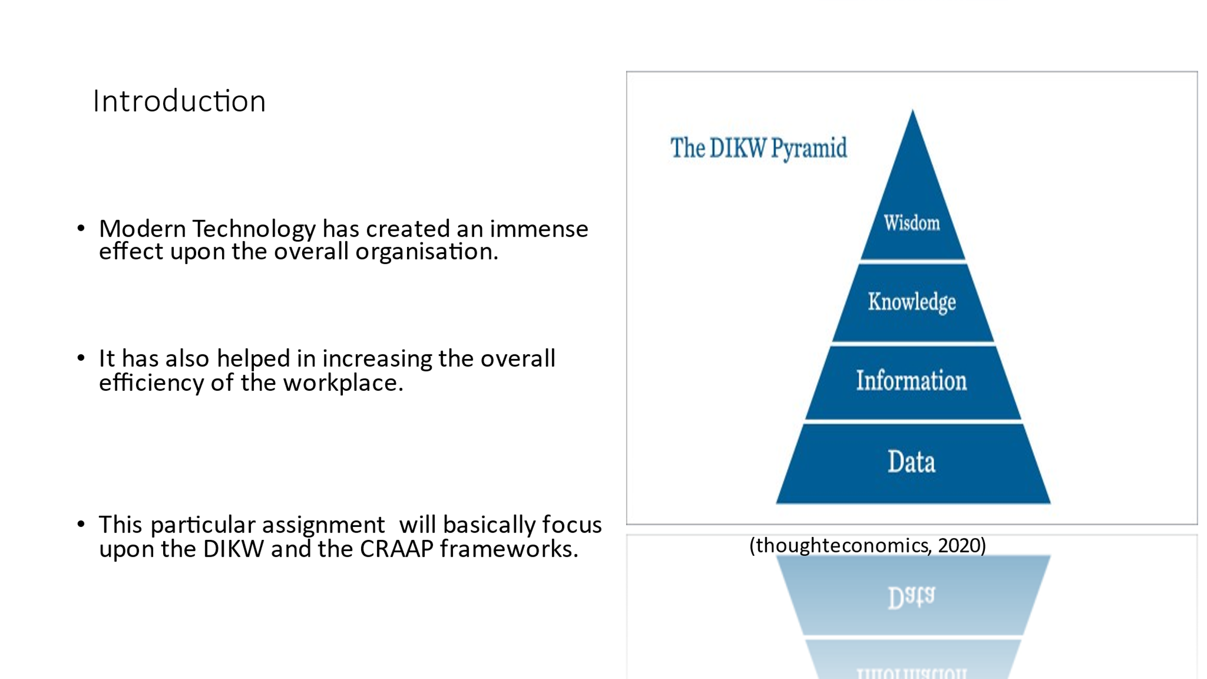
Modern Technology has created an immense effect upon the overall organisation and has also helped in increasing the overall efficiency of the workplace. Further, there are different technological advancements in the recent times which has helped in identifying the reliability of the resources. These techniques have earned a huge importance in the overall organisation and has also ensured that the organisations are able to gain the complete benefits out of this technique. The range of information sources can be validated as well with the help of different advancements in the technology. This assignment will basically focus upon the use of two different frameworks such as the DIKW and the CRAAP frameworks so that I am able to refute or confirm the work that has been produced by Angela Duckworth. Along with this, these two frameworks are most important to validate the wide range of information sources and the validity of the work can also be checked with the help of this particular tools. Further, the DIKW is the framework which analyses the relationship among the data, the information, the knowledge as well as the wisdom. This is represented in the form of a form of pyramid which adds more value to the range of information sources.

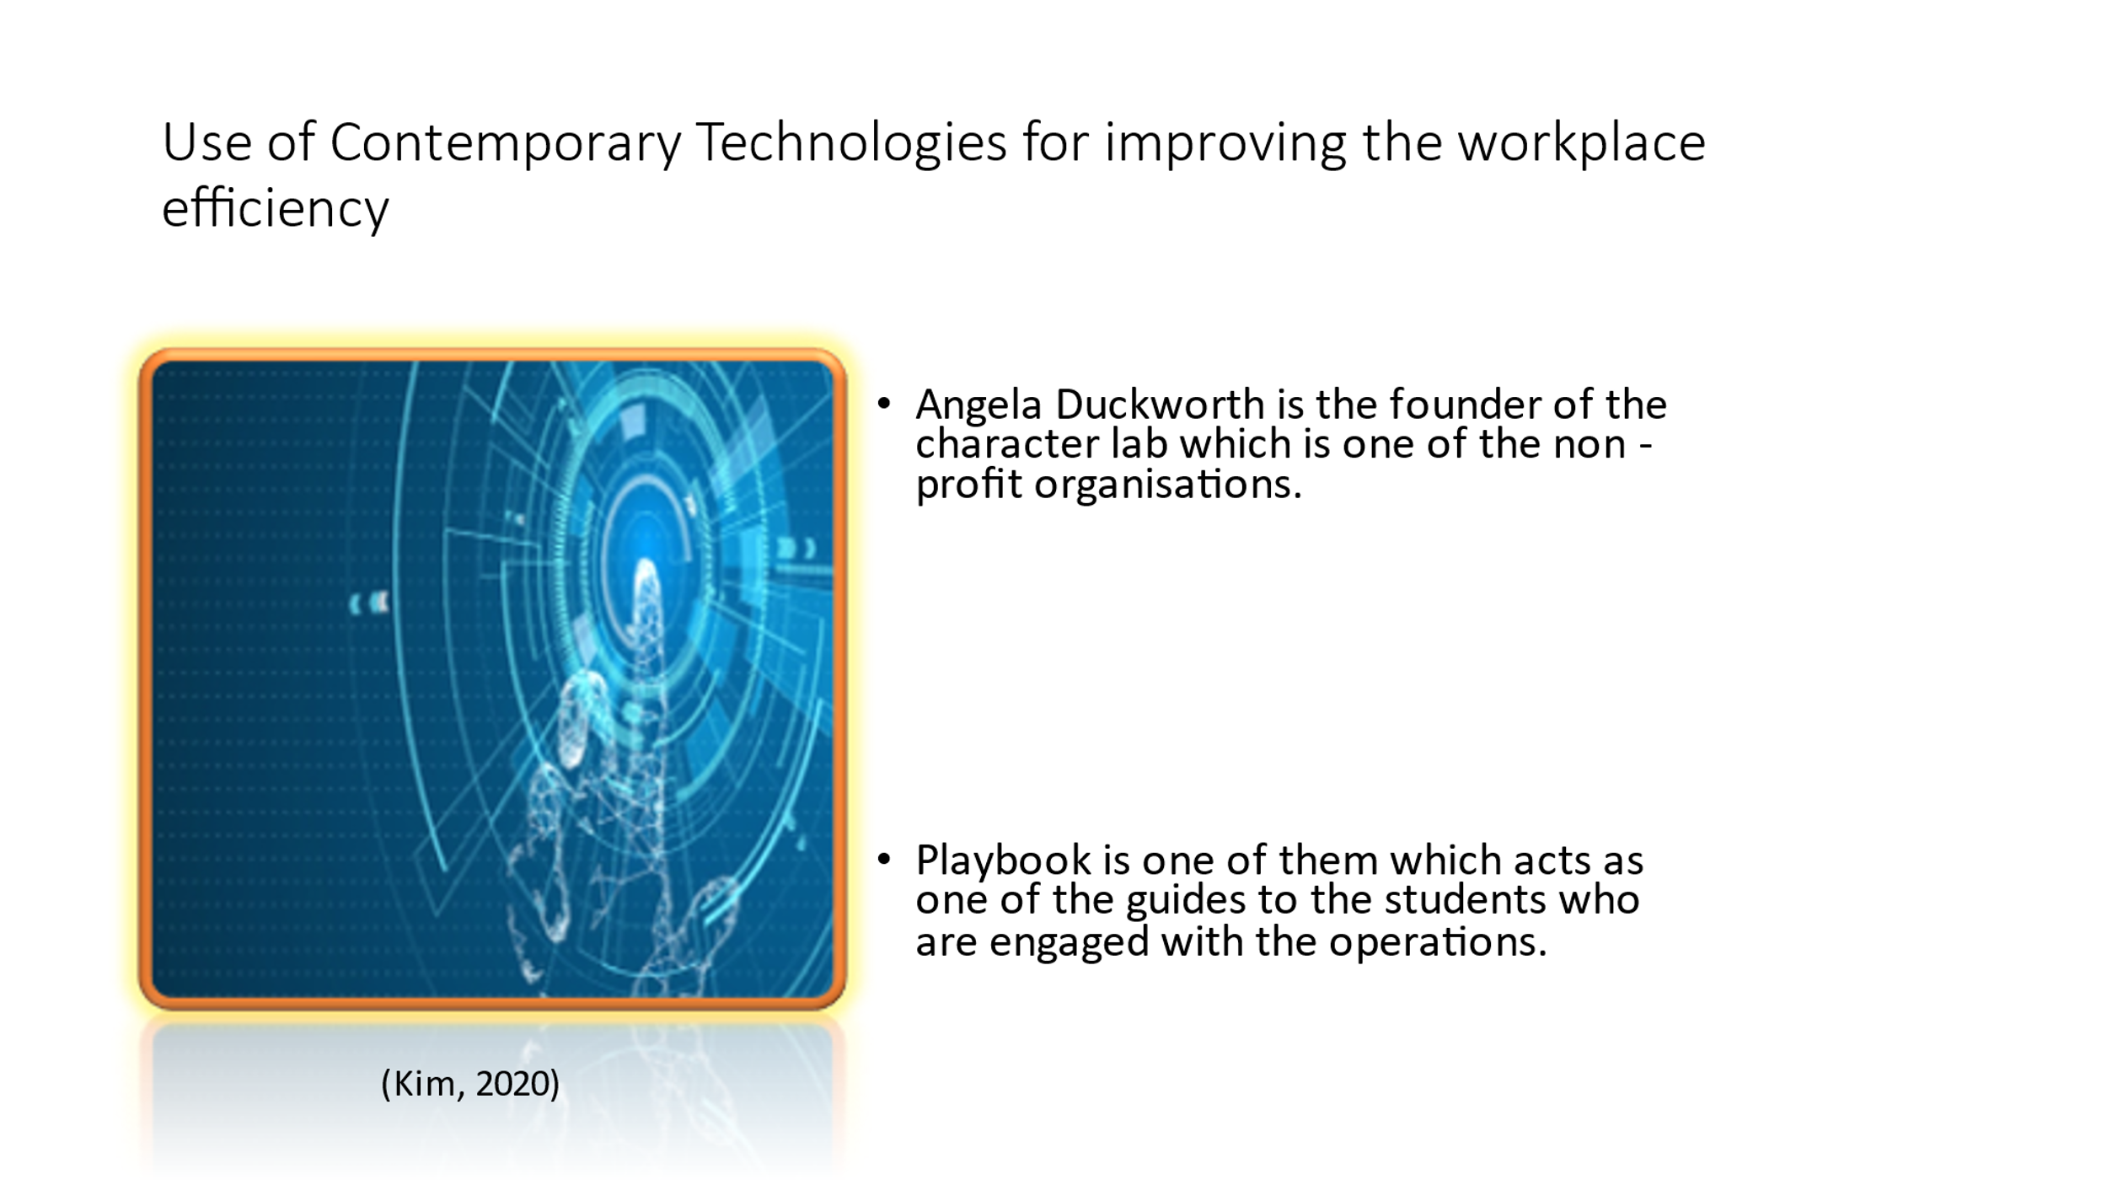
1. Use of Contemporary Technologies for improving the workplace efficiency
The advancements in the technology has helped in influencing the modern workplace and has also helped in enhancing the overall productivity of the organisation. Further, Angela Duckworth is the founder of the character lab which is one of the non-profit organisations and it aims at providing advance scientific insights to the children which will help them to thrive in the competitive environment. With the help of advanced technologies, she was able to create the character lab which is one of the non-profit organisations and it aimed at connecting the researchers with that of the educators so that greater knowledge about the conditions is created (thought economics, 2020). This also aimed at the providing different scientific insights to the young people so that they are able to contribute towards doing something good for the overall society. Different contemporary technologies are used within this character lab. Playbook is one of them which acts as one of the guides to the students who are engaged with the operations. Further, these playbooks are an example for the technological advancements which helps in enhancing the overall efficiency of the students who are engaged in the evidence-based research. These playbooks also help in testing the level of knowledge of the students so that their overall efficiency can be enhanced with the tests (Kim, 2020).

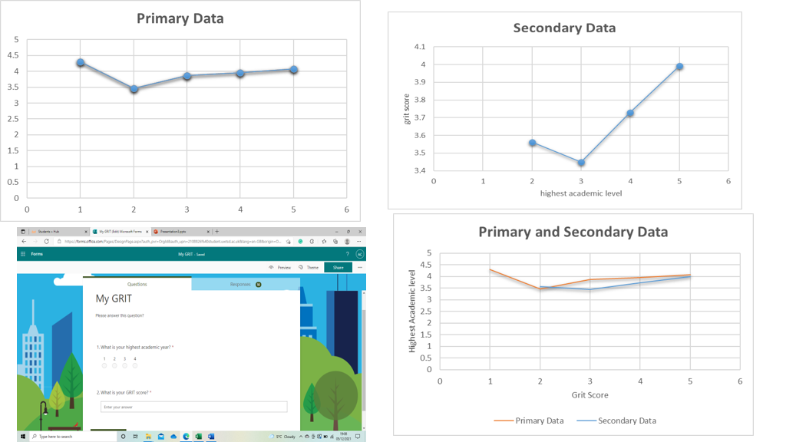
2. Competence in workplace data handling.
Data handling in workplace is usually defined as the concept that is used for storing the data regarding the research so that it cannot be misused by the other people. Further, this is one of the significant aspects which help in managing all the information sources and creating the validated data. This has also earned a significant position in the character lab as well as in the book grit. The book Grit is one of the works of Angela Duckworth which consisted of different topics regarding passion and perseverance. These data is properly analysed with the help of this particular topic. Furthermore, there are several techniques which are included in the data handling method which helps in ensuring that the data can be handled properly. This is one of the significant aspects which helps in collecting the data properly so that the data is reliable to use it for any particular work. Along with this, it is one of the several aspects which can ensure the proper utilization of the overall data. Organising all the data also becomes easier with the help of this handling process (characterlab, 2020). Hence, it can be said that the overall procedure of the data handling process makes the work easier for the management of character lab to organise the data of the students involved with the process of the evidence-based research.

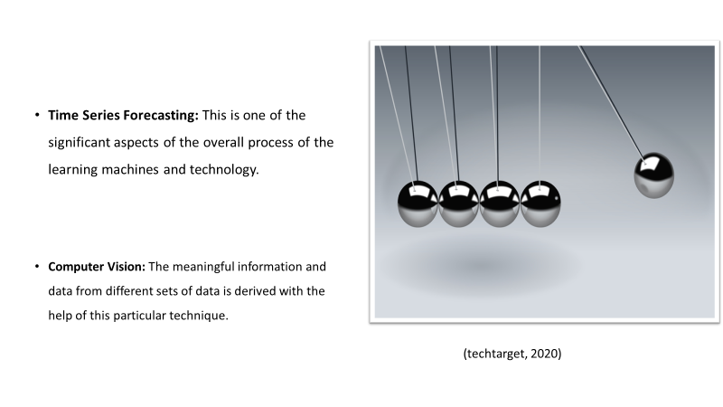

Time Series Forecasting: This is one of the significant aspects of the overall process of the learning machines and technology. The prediction of the problems is the main problems that is associated with the data handling process. There are different set of skills which are required for the process of data handling. Further, the time series forecasting is one of the different processes through which the process of predicting the problems becomes easier for the overall organisation. This is one of the techniques which ensures that the data is collected properly and also understood properly (techtarget, 2020).
Computer Vision: The meaningful information and data from different sets of data is derived with the help of this particular technique. The students of Character Lab often view different types of images. This is one of the different methods which is included in the process of AI and helps the students to derive the actual meaning of the images that they can view. The visual inputs are also properly analysed with the help of this particular technique. There are different requirements in this particular technique. The first one is the deep learning and the second one is the neural network of CNN.

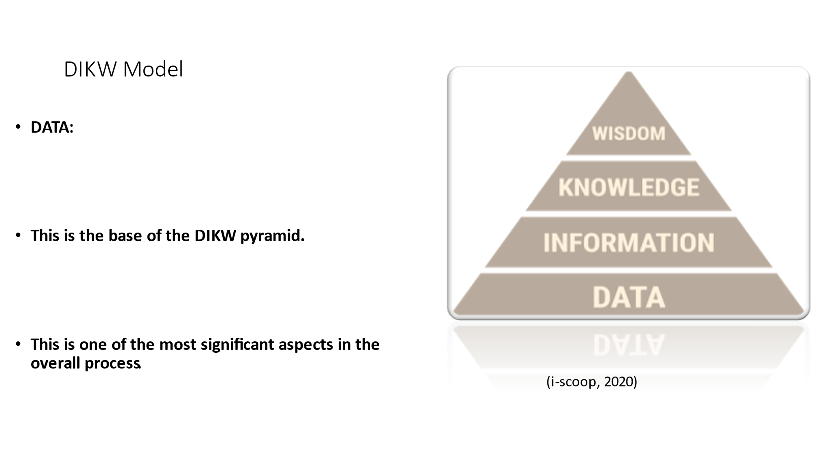

DIKW Pyramid
This is one of the frameworks that is used for representing the interrelationship between the different sets of data, knowledge, information and wisdom (Tomita, et, al., 2017, pp. 858-870). This is one of the efficient frameworks which helps in enriching the data so that it helps in taking better decisions. Further, the different steps that is included in the framework is explained below:
DATA:
This is the base of the DIKW pyramid which can be described as the collection of the information in the unorganised form so that it can be properly handled by the individuals for their own use. This is basically the starting point towards reaching a meaningful point or the useful result at its extreme end. There might be several things which can be included in the overall data which might not have any relevance with that of the actual outcome of the overall process. However, there can be certain changes in the data which then becomes useful for the individuals. Further, this is one of the most significant aspects in the overall process. This says that the building blocks of the pyramid is the data which is managed well by the different users so that the individuals are able to cope up with the requirements of the research and reach towards a reliable conclusion (i-scoop, 2020). Without the help of this particular matter, the overall process cannot be completed efficiently.

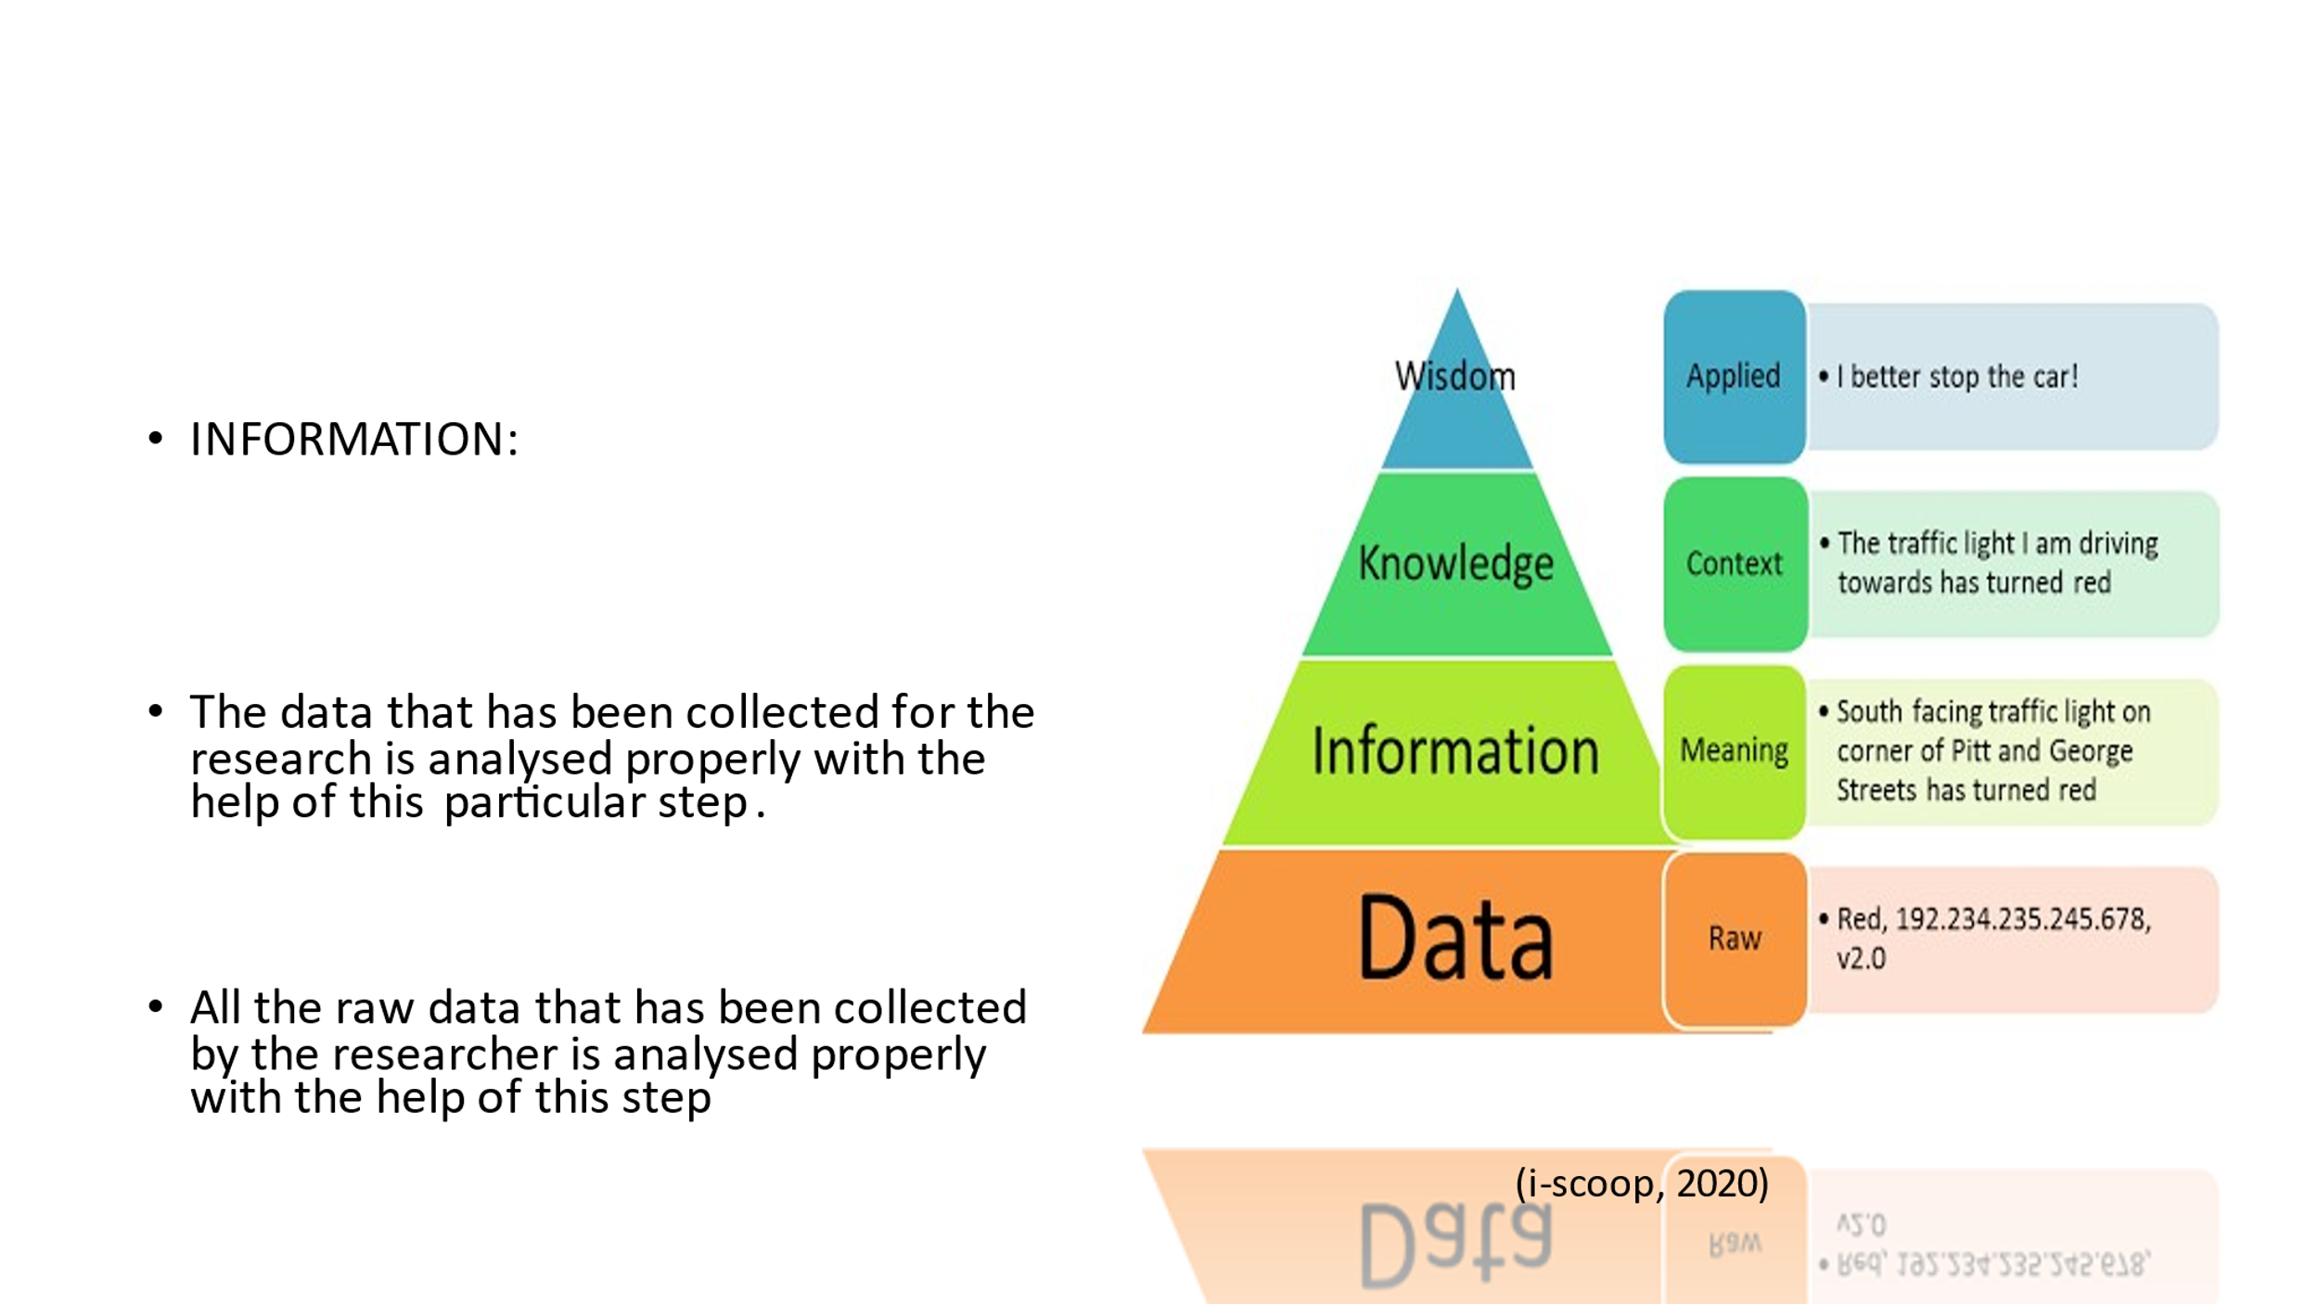

The data that has been collected for the research is analysed properly with the help of this particular step. This step helps in processing the data in an efficient way and also allows in revealing the relationship among the data in an efficient way (Merkus, et, al., 2019, pp. 143-154). Furthermore, this efficient step also allows the individuals to gain more information regarding the particular event and enhances the quality of the overall availability of the information. This step also includes analysing the data appropriately so that it can be managed efficiently by the individuals for increasing the efficiency of the information sources. Moreover, this is also one of the significant aspects which ensures that the sources of information are reliable to get used by the research for accomplishing its research. After this step, the data will be able to answer the question that are related to Who, What, When and Where (Pretorius, et, al., 2019, pp.319-326). All the raw data that has been collected by the researcher is analysed properly with the help of this step so that the useful information can be gained from this step. Furthermore, for all this reasons this particular step becomes the most important among all the other steps in the pyramid.

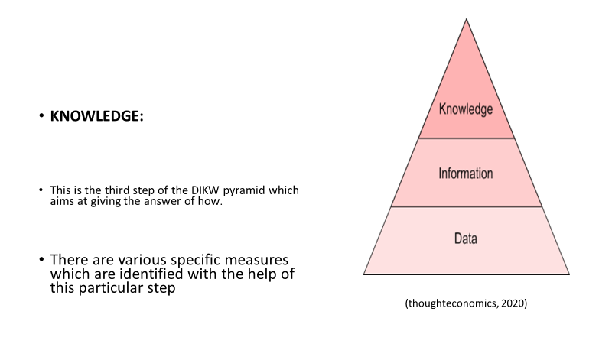

KNOWLEDGE:
This is the third step of the DIKW pyramid which aims at giving the answer of how. This means that the relevance of the data is analysed with the help of this step. This is also one of the significant steps which is included in the pyramid and helps in confirming the validity of the particular incidence. There are various specific measures which are identified with the help of this particular step (Frické, M., 2019, pp.33-46). The information that has been gained from the previous step help in giving the answer to the relevant questions that arises with the help of different techniques from the sources of information. Moreover, this is one of the most important aspects of the overall process of the DIKW analysis. This also helps in analysing the overall data and the information from the relevant data is able to convert into reliable sources towards the useful and valid information so that the researcher will be able to use it to accomplish the overall research. Moreover, this is one of the significant aspects which helps in managing the data efficiently so that the sources can be reliable and can be valid for the use in the overall research. Hence, this is one of the significant aspects of the overall research.

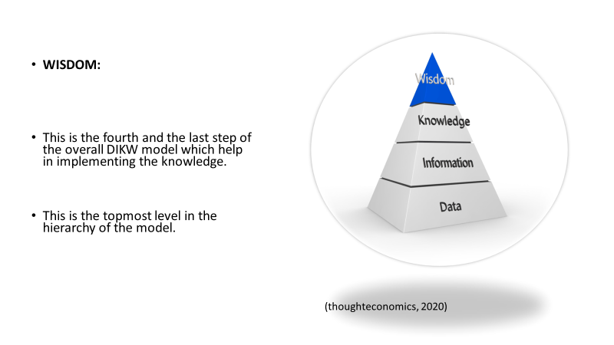

WISDOM:
This is the fourth and the last step of the overall DIKW model which help in implementing the knowledge. This is the final step of the overall model which helps the researcher to gain the appropriate knowledge for the overall research. Further, this is the topmost level in the hierarchy of the model. This step includes the way through which the knowledge that is gained from the overall process is applied by the researcher in its work. The researcher is able to gain the final results or the final information from this particular step (Duan, et, al., 2019, pp.323-335). This is basically done with the help of the calculations that has been drawn from the extrapolation of knowledge.

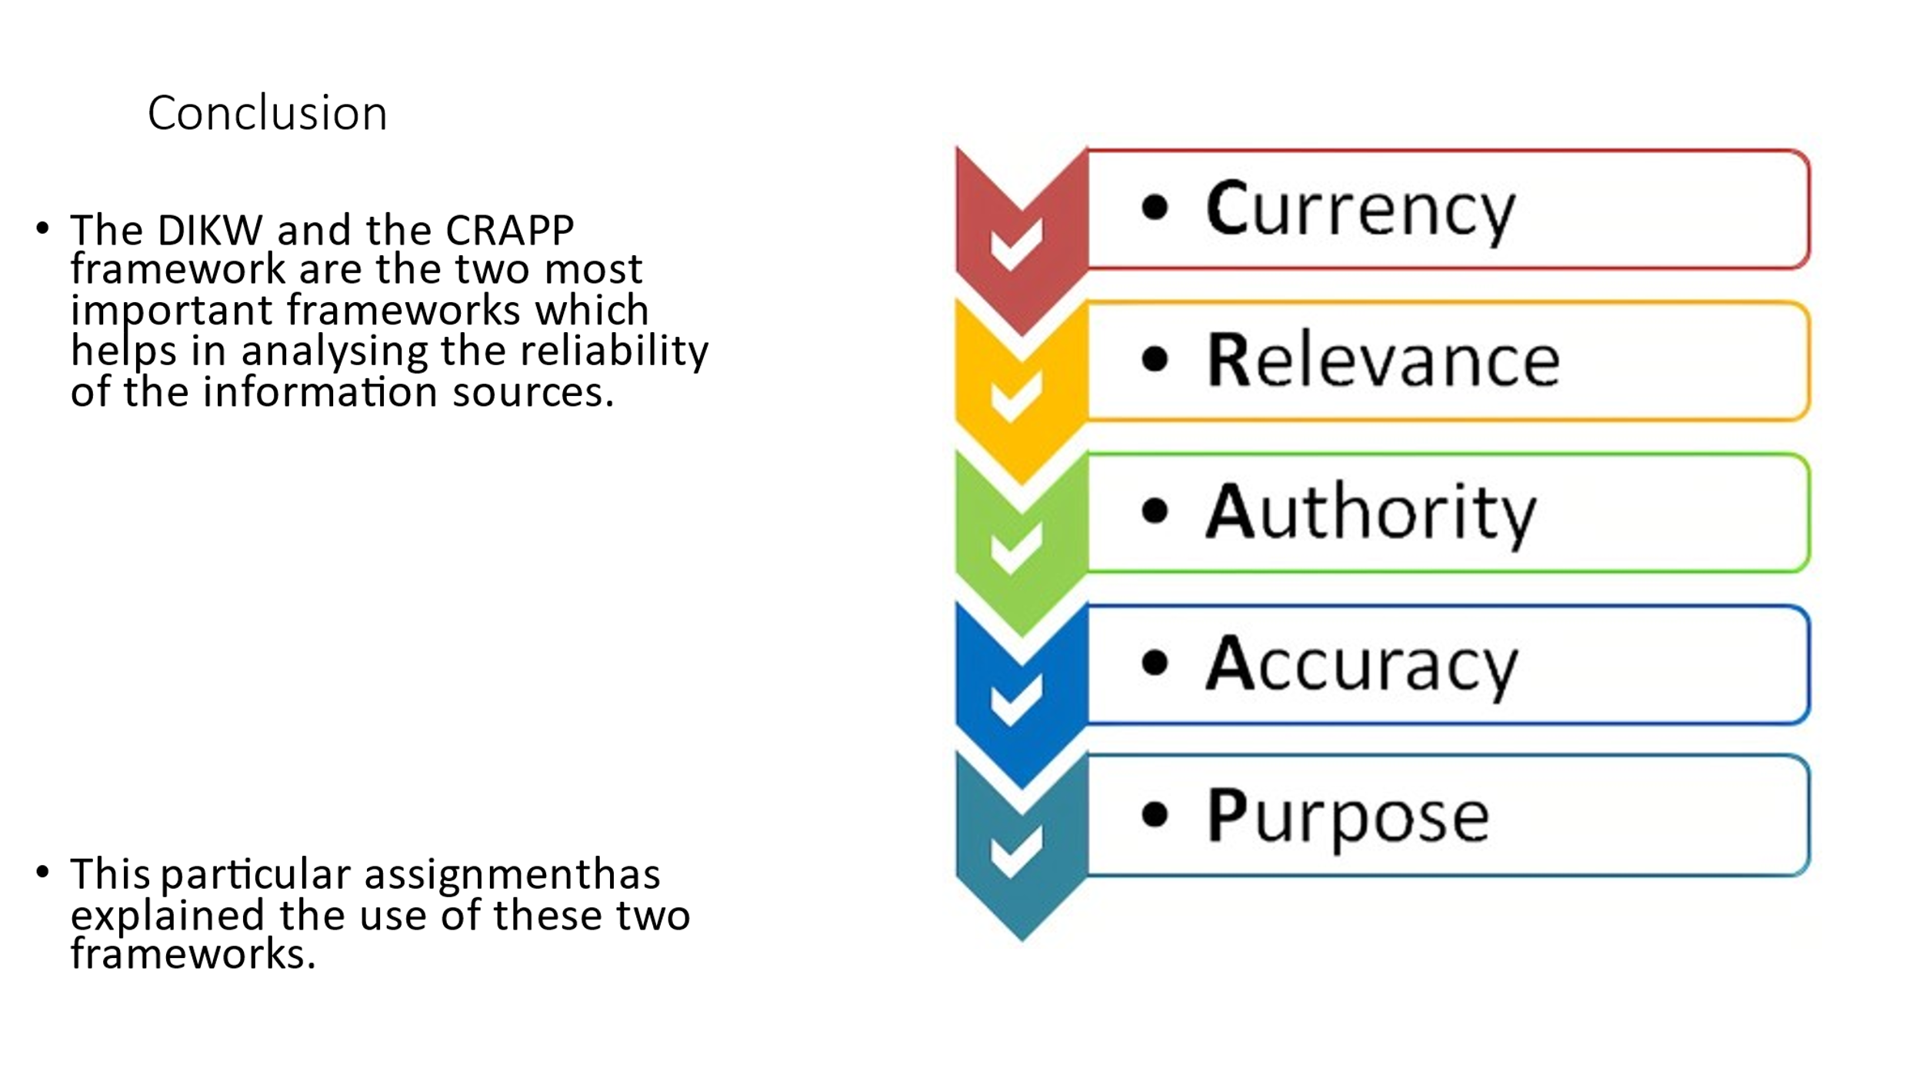

Conclusion
The DIKW and the CRAPP framework are the two most important frameworks which helps in analysing the reliability of the information sources. These two helps in analysing the relevance of the information sources. This particular assignment has explained the use of these two frameworks. Further, it has also confirmed the work of Angela Duckworth with the help of CRAPP test. Based on the works of Angela Duckworth, the assignment has also explained the use of modern technologies in the workplace which has gained immense importance in the recent times. The modern technology can be described as the most important resources which allows the organisation to gain the overall advantage in the recent times. The wide range of information that is available for the use of the researcher to accomplish the overall research. Moreover, this aspect of the technology has been utilised extensively by the business organisations as well so that all the work can be managed efficiently without much delay in it. The lesser use of manpower is also ensured by the use of technology. Hence, it can be said that the information sources can be handled and managed properly with the help of this framework.



