L5 UCM Assignment 1
TURNITIN Submission

Module: Changemakers: Creativity and Value Creation
Module code: ACCA5033
Assignment Title: Assignment 1: E-Portfolio
Student name: Aaron Bowditch
Student number: 2012801
Course title: Electrical and Electronic Engineering

Contents:
E-portfolio
Task 1 –Mind map
Task 2 – Imaged based video presentation
Task 3 – Video presentation
Task 4 – Academic poster

E-PORTFOLIO LINK;

E-Portfolio is password protected
Password:- AaronChange123

https://rhubarb-point-x7z4.squarespace.com
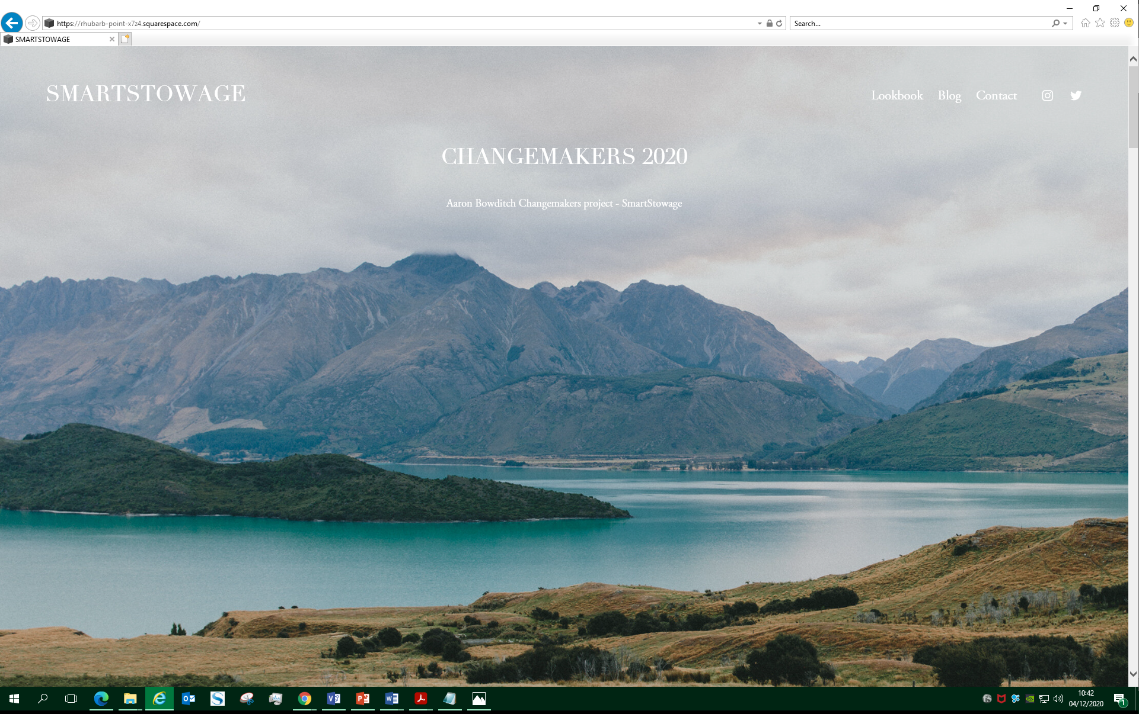

Task 1 – mind map
Link to mind map - https://www.mindmeister.com/1708560327/smart-stowage
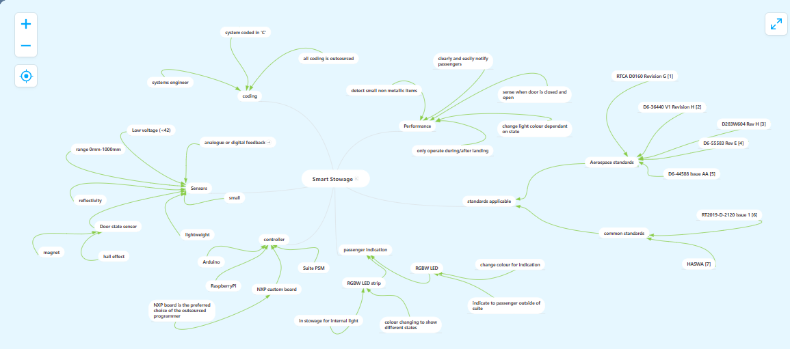

Task 2 – video presentation
Link to presentation - https://youtu.be/nBPUpYNMmlc

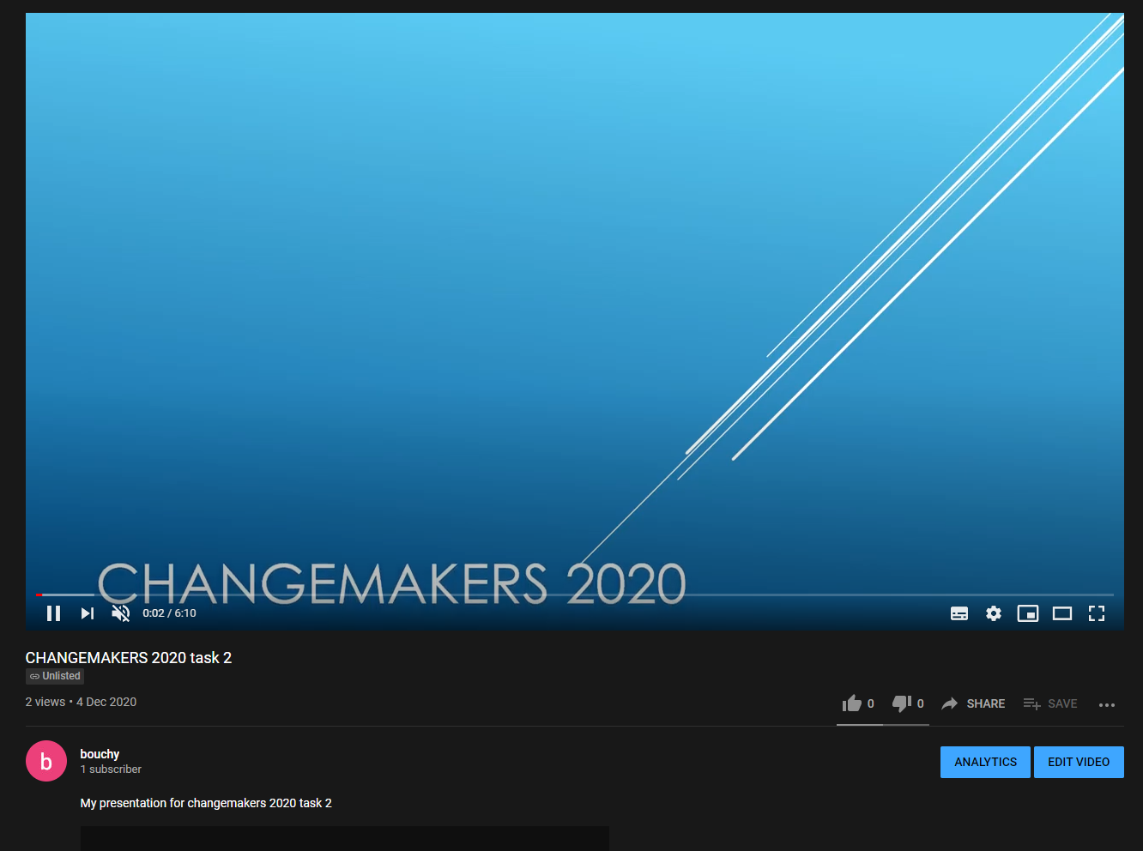

Task 3 – video presentation
Link to presentation - https://youtu.be/2SXnnNtpjJ4

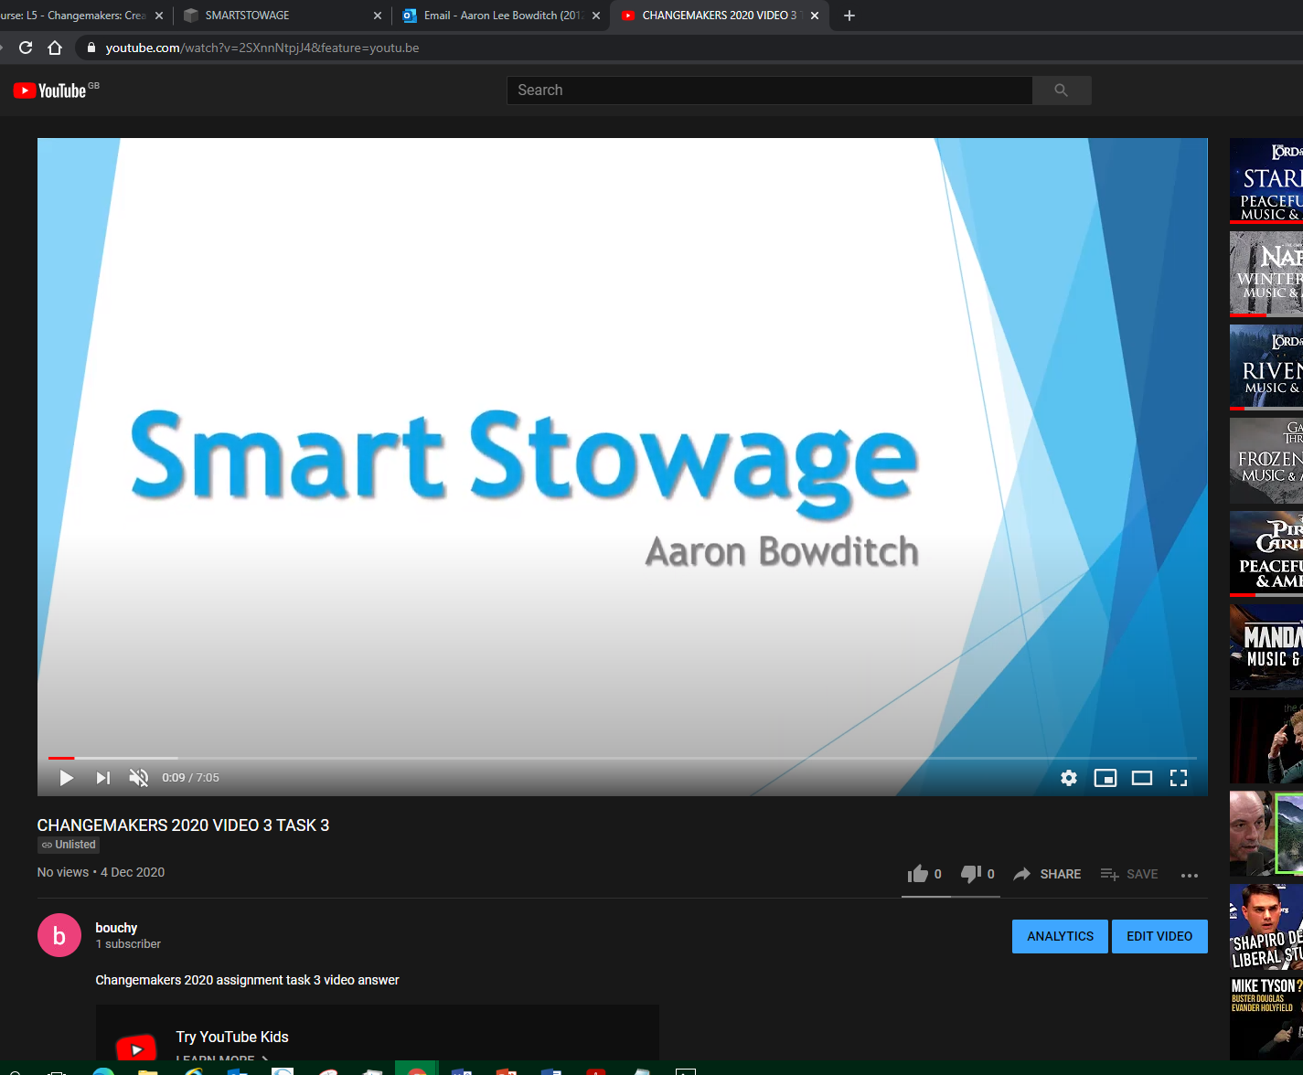

Task 4 – academic poster
Poster was created on Microsoft power point

Poster is digitally available via the e-portfolio


