Report for Academic Skills Assignment 2 2018 – Reflective Report



MARCH 2018

MODULE NAME: Academic Skills
Project Name: Ysgol Crug Glas Tuck Shop
Name: Samuel Lockley
Student Number: 1704902

Table of Contents

1. EXECUTIVE SUMMARY 2
2. Introduction 3
2.1 report remit………………………………………………………………………………………………………………………..3
2.2 background on the project………………………………………………………………………………………………….3
3. models of reflection 4-7
4. masterclass sessions 8

4.1 influence of masterclasses on project…………………………………………………………………8-9
4.2 influence of the masterclasses on personal learning & development…………………………9-10
5. CONCLUSION……………………………………………………………………………………………………………………….......11
6. References .12-14

LIST OF FIGURES

Figure 2 1 ………. Driscoll 3 factors
Figure 2-2 ………. Kolb's experiential learning theory.

eXECUTIVE sUMMARY

The purpose of the report is to consider various models of reflection that I have used to help with my self-improvement, in combination with a number of masterclass talks I have attended over the course of the year, and how they have helped me to change and improve myself both during and outside of the project I have been working on. The project has been about working with a group of school children with disabilities to bring a small tuck shop to the university campus as well as potentially other businesses in Swansea. Key points I took away from the master class talks include those on how to improve one’s confidence which I was able to apply at the project showcase event. I became more confident in talking to strangers than I have ever been before and I did not shy away from answering questions or discussing the project with them. This has also worked its way into my every day life where I am now much more confident talking to people in general. The masterclasses also taught me to seize an opportunity when it arises and so I jumped at the chance to do a sponsored walk in order to raise money and awareness for the school.
I have learnt that it is important to reflect on one’s own actions in order to better oneself, so that you are able to enjoy life to the fullest without having any regrets for not doing something you wish you had done.

Introduction

Report Remit
This report will be looking at the many experiences that various guest speakers have had, in order to achieve their goals, be it for business or personal reasons as well as how they bettered themselves because of it all. We will also look at various models of reflection that have been devised over the years to help people to improve themselves in many aspects of life. It shall also be shown how I was able to apply the knowledge to the project group and to my everyday life, and how I can change things for the future to ensure that I better myself through critical thinking. Ennis (1962) describes critical thinking as "the correct assessing of statements," as by taking time to just sit and think on something and weighing all possible pros and cons, a better understanding of an appropriate approach can be established. Santy (1997) backs up the point by acknowledging it as a legitimate way of professional development. By the end of the report I hope to explain that simply setting aside 30 minutes a day can improve one’s self-awareness and ability to take on board criticism rather than ignoring it.

Brief background on THE project
My project group was aiming to help students from a school called Ysgol Crug Glas, who suffer from various disabilities, to get an experience that they deserve by taking their small tuck shop into various businesses in Swansea. This is to help them improve various skills such as numeracy and social interaction. As the school’s website says ‘’Yes I Can: Small Steps Everyday’’ (Y.C.G 2017) showing that the children are going to be improving themselves and the way they live with small steps. showing that no matter how much of a struggle it may seem, everyone can improve themselves if they try hard enough. We also ained to raise awareness of the disabilities these children deal with as it is often a topic not keenly spoken about and deserving of having light shed on the fact that they should have as much a chance at life as everyone else.

3. Models of reflection

There are various models for reflecting on one’s self, one of which was put forward by Driscoll (1994) which consists of 3 factors; What? Where we look back at what the task was about and understanding why the task was important. Now what? What needs to be done from now on, be it a continuation or something new.

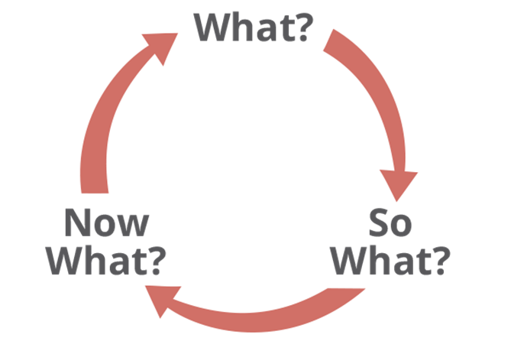
Figure 2-1 Driscoll 3 factors

What occurred was that a number of students from Ysgol Crug Glas came on to the university campus to set up their tuckshop. Under the same heading would be what I personally did, which was to help arrange a date and time for them to come down, as well as help move everything they needed down to the campus. Another aspect is my reaction, which was that I was eager to help the children be able to enjoy themselves.

With the, So what? Portion of the model I was delighted to see the children so happy to have these experiences that they would not normally have. My feelings on the matter remain the same as there can be no greater joy than making others happy, especially those who try so hard despite being hindered. I believe the effects of what was done could be that the children have managed to improve how they interact with others. What troubles me is that this is only a small step in helping the children as well as society in general, as the social stigma regarding children with disabilities still remains.

As for, Now what? if I were to help the school again I would make sure that the stall is better planned by setting more dates to get goals done and making sure plans are more coordinated as well as try and communicate better. The latter would help to improve the former if I decide to do a stall with the school. Information I would need include any issues the children may face if they are not the same ones who participated with the running of the tuckshop originally. Setting timescales to acheive certain objects as part of the process makes it possible to review progress and make sure that everything is on track to achieve the final objective.

Driscoll (2001) talks about how important reflection is as an activity, as without reflection, self-betterment is much harder to achieve as simply saying, ‘’I will do this’’ means there is very little chance of it getting done. Writing is considered one of the most effective ways of reflection be it through the use of a journal, a mind map or a diary (Health 1998, Holly 1989, Kottkamp 1990, Walker 1985) so that you can see what you have done and how you can improve yourself further by changing daily habits or improving on a skill. (Fisher 1996)

The experimental learning model put forward by Kolb (1984) is about six propositions;

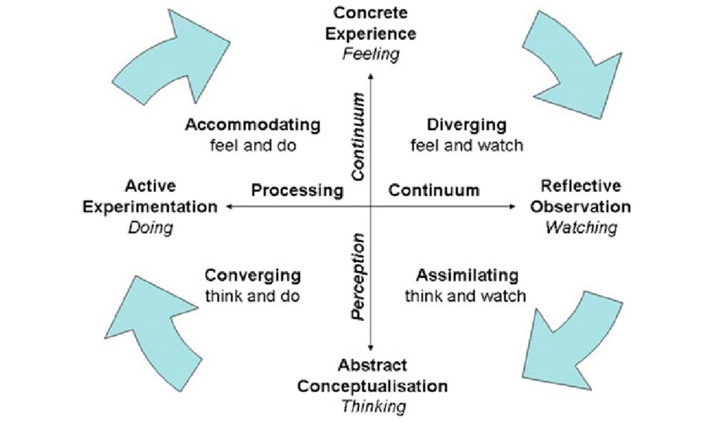
Figure 2 -2 Kolb's experiential learning theory.
- Learning is a process, not in regard to the outcome, but on how engaged the person is with the process. According to Dewey (1897) "Education must be conceived as a continuing reconstruction of experience: . . . the process and goal of education are one and the same thing’’ I learnt a lot from the project due to how engaged I became when helping the students and teachers to set up and bring the stall to the university.
- That learning works best when drawing out what the student’s beliefs are as well as their own ideas, and then combining them with more refined ideas. I brought my own ideas and beliefs were brought to the project where they were discussed and refined.
- That the learning process is driven forward by disagreements, conflict as well as differences. Within the project group there were a number of disagreements and conflict but once resolved led to a better understanding of the task and how we should tackle it.
- That learning requires an adaptive process to the world, meaning that people need to change based on global behaviour. In regard to the project we had to be sensitive with how we tackled the task as the topic of disabilities is considered a sensitive one.
- That learning can happen by ‘’assimilating new experiences into existing concepts and accommodating existing concepts to new experiences’’ (Kolb 2005) Working with these children was a whole new experience for me and has definitely made me learn more about what these children go through.
- That learning occurs when social knowledge is re created into personal knowledge, this entry is in contrast with the transmission model (Swap 1993) which is the model that is currently used for teaching. I can say this was used within the group when we pooled ideas and came to a better understanding of how we should arrange things.

Many scholars have been continually working to improve the theory and find better way for people to improve themselves such as Baxter-Magolda (1999), Boyatzis, Cowen, & Kolb (1995) Keeton, Sheckley, & Griggs (2002), King (2003), Light (2001), Mentkowski and Associates (2000) and Zull (2002) with new models for reflection being brought forward. However, the process of self-reflection is still not easy and so people often just put it off by finding other tasks to do instead. This is known as procrastination. Procrastination is the main reason why people do not change, saying that they will do something but never end up doing it. Urban (2016) describes the reason behind this as an ‘’instant gratification monkey’’ meaning the brain wants the reward of doing something fun now rather than putting it off until a task is complete, which is usually not an issue when deadlines are involved, as panic will kick in allowing normal function to take over. However, when changing something about yourself there are no deadlines, only promises to yourself, and no pressure to change by a set date. It is down to the individual to be able to find a method of coping with these urges to procrastinate on making these changes.

Masterclass Sessions

The main themes of the masterclasses which had an impact on me were the ones based around confidence and how to build it by the likes of guest speakers such as Mr Producer, who spoke about general confidence building and how he was able to get so confident in what he does. According to Manktelow (2011) there is no quick solution to improve one’s self-confidence and that there are many long term solutions such as achieving large goals. Andy Rogers spoke about how to make networking more accessible to introverts, who may find the prospect of talking to complete strangers daunting as a task. Zack (2010) discusses some small activities such as never eating alone and promoting yourself constantly, due to how small they may seem, people could potentially brush this off as insignificant to influencing daily life. This view point may see to contradict Manktelow’s (2011) point of view as these tasks seem quick and easy to accomplish in terms of improving one’s self confidence, however these tasks would need to be done over a long period of time to have a noticeable effect. Another theme that I took from the masterclasses was that of seizing opportunities and taking risks, as Kate who runs Gower Brownies thought nothing of her home-made brownies, but decided to give promoting them a try, when she got many compliments regarding them, and became a huge success. Shane (Et al, 2003) seems to compare taking such risks as a game, and that one needs to be able to evaluate such opportunities or else they pass them by, however an issue with not taking these opportunities could be due to a lack of confidence. How much these benefited me and the project was evident to see based a number of factors which will be discussed.

Influence of Masterclasses on the Project

The masterclasses did not have much of an influence on how I tackled the project itself except in the case of seizing opportunities. I seized the opportunity to take up an offer from one of the other groups to do a joint sponsored walk where I personally raised £56 for the school as well as making a huge step to the project’s overall goal of raising awareness. Corbett (2005) talks about how it is important to identify what opportunities are worth pursuing, this correlates with the opinion Shane (Et al, 2003) put forward regarding opportunities. I believe that this opportunity was one that I needed to pursue to help fulfil the project goals, Kare Anderson (2014) discusses that opportunities come more frequently to those who make more contacts, meeting new people and helping each other. I would like to believe I have managed to make a positive impact on the lives of those children. If I were to repeat the project, or do something similar, I would try to ensure everyone, especially myself, were more organised with how the project was to be tackled as there was no clear planning. Steiner (2010) discusses how planning can alleviate the issues of inefficiencies if the plan is good enough. Bower (1966) seems to suggest that there are 14 steps to an effective plan. some of which include, setting objectives, establishing goals, and developing a structure. This could also have been influenced by a lack of leadership at the beginning of the project. Next time I will ensure that there is someone in position to lead the project group or take on the role myself should the need arise. ’’Leadership is the ability to impress the will of the leader on those led and induce obedience, respect, loyalty, and cooperation.” (Moore 1927, p. 124) This seems to infer that leadership is a large motivating factor in driving teams forward. Communicating with the school could have been better and I should make sure in future to chase up anything that is needed more often to ensure everything is communicated effectively. I would do so by visiting in person rather than solely relying on email. While it is an easy form of communication, there is no guarantee of receiving a reply within a set time frame. Visiting in person also reduces the chances of a misunderstanding between the two parties. Politi and Street (2011) feel that its important to make sure that you check that there is a mutual understanding, that all issues and concerns are resolved as well as establishing an appropriate follow up plan.

Influence of the masterclasses on personal learning & development

On a personal level, I feel that the masterclasses affected me greatly. All my life I have had trouble with confidence and talking to strangers, however I feel that the advice the classes offered, from the likes of Mr Producer, gave me a push in the right direction which I would say helped improve my ability to seize opportunities, as said by Kare Anderson (2014), opportunities come to those who make contacts, which is now easier to do now thanks to the boost in confidence to talk to others. I was able to take on board what was suggested and applied it when communicating with others at the Unit 19 event, being able to talk to visitors in much greater detail rather than just clamming up. This has also done the same for my everyday interactions with others.
In order to plan for the future, it is wise to do a brief SWOT analysis (strengths, weaknesses, opportunities and threats) to effectively identify areas for improvement, what avenues there are to help improve, and anything that could potentially bar or hinder me from achieving those improvements. The concept of SWOT analysis was in part developed by Humphrey (2005) who believes that through the use of a SWOT analysis one can indicate both the short and long-term goals of an individual or business. Doing so would allow the person or business to prioritise what needs to be done more effectively and know what needs to be changed in order to do so.
I would say that my personal strengths consist of dealing with numbers, working with computers, as well as being an attentive listener.
On the other side things my weaknesses would lie in communicating with others, planning, and procrastination. Of course, these are the areas I should focus on improving but I should not neglect building on what I am already strong at.
Opportunities that are available to me could consist of continuing with education after my degree pursuing a Master’s Degree, finding a job within an industry that I would enjoy, or taking my studies abroad, where I would be able to experience new cultures and meet new people who differ from myself, thus taking me out of my comfort zone.
The threats to these opportunities could be that I fail to achieve my Bachelor of Arts degree preventing me from proceeding further. This could be rectified by retaking the necessary years, although would not be ideal. A threat to finding a job that I enjoy could be a lack of opportunities in the Swansea area however moving elsewhere could resolve that issue. Finally, a threat to being able to study abroad is if there was an issue getting my student visa or that political changes in the country prohibited me from being able enter the country to study.

Conclusion
In conclusion there are many models that aid and support with reflecting on one’s actions so that it is possible to change yourself for the better. There are also always people working to find new ways for people to improve themselves, leading to a more fulfilling lifestyle rather than continuing with your normal routine without making an effort to put in motion the changes that you wanted. I believe that because of reflecting on the past year I have been able to identify key areas where I need to improve in my everyday life, as well as areas that I have already improved on during that time, be it thanks to advice given or just generally getting more experience by actions I would not normally have taken otherwise. I can now plan exactly how I will be able to tackle these areas of improvement with the help of a SWOT analysis while still bearing in mind the fundamental aspects of various models when doing so. It is also evident that by listening to other people’s experiences it is possible to glean ways of being able to do things differently that would be better for yourself overall.

References

Anderson, K., 2014. Be an opportunity maker. [Online] Available at: https://www.ted.com/talks/kare_anderson_be_an_opportunity_maker#t-350421 [Accessed 12 03 2018].
Baxter-Magolda, M. B. 1999. Creating contexts for learning and self-authorship. Nashville, TN: Vanderbilt University Press.
Bower, M., 1966. will to manage; corporate success through programmed management.
Boyatzis, R. E., Cowen, S. S., & Kolb, D. A. 1995. Innovation in professional education: Steps on a journey from teaching to learning. San Francisco: Jossey-Bass
Corbett, A.C., 2005. Experiential learning within the process of opportunity identification and exploitation. Entrepreneurship Theory and Practice, 29(4), pp.473-491.
Dewey, J. 1897. My pedagogic creed. The school journal. LIV(3): 77-80.
Driscoll J (1994) Reflective practice for practise – a framework of structured reflection for clinical areas. Senior Nurse 14(1): 47–50
Driscoll, J. and Teh, B., 2001. The potential of reflective practice to develop individual orthopaedic nurse practitioners and their practice. Journal of Orthopaedic Nursing, 5(2), pp.95-103.
Ennis, R.H., 1962. A concept of critical thinking. Harvard educational review.
Fisher M (1996) Using reflective practice in clinical supervision. Professional Nurse 11(7): 443 – 444
Heath H (1998) Keeping a reflective practice diary: a practical guide. Nurse Education Today 18: 592–598
Holly M (1989) Writing to Grow: Keeping a Personal – Professional. Journal Heinemann, Portsmouth, New Hampshire
Humphrey, A., 2005. SWOT analysis for management consulting. SRI alumni Newsletter, 1, pp.7-8.
Keeton, M. T., Sheckley, B. G., & Griggs, J. K. 2002. Efficiency and effectiveness in higher education. Dubuque, IA: Kendall/ Hunt Publishing Company.
King, P. M. 2003. Student learning in higher education. In S. R. Komives, D. B. Woodward, Jr., and Associates (Eds.), Student services: A handbook for the profession: 234-268. San Francisco: Jossey Bass.
Kolb, A.Y. and Kolb, D.A., 2005. Learning styles and learning spaces: Enhancing experiential learning in higher education. Academy of management learning & education, 4(2), pp.193-212.
Kolb, D. A. 1984. Experiential learning: Experience as the source
of learning and development. New Jersey: Prentice-Hall
Kotthamp R (1990) Means for facilitating reflection. Education & Urban Society 22(2): 182–203
Light, R. J. 2001. Making the most of college: Students speak their minds. Cambridge, MA: Harvard University Press.
Manktelow, J. and Carlson, A., 2011. Building Self-Confidence.
Mentkowski, M., & Associates. 2000. Learning that lasts: Integrating learning, development and performance in college and beyond. San Francisco, CA: Jossey Bass.
Moore, B.V., 1927. The May conference on leadership. Personnel Journal, 6(124), pp.50-74.
Politi, M.C. and Street, R.L., 2011. The importance of communication in collaborative decision making: facilitating shared mind and the management of uncertainty. Journal of evaluation in clinical practice, 17(4), pp.579-584.
Santy J (1997) The role of reflection in the education and development of orthopaedic nurses. Journal of Orthopaedic Nursing 1: 183 –187
Shane, S., Locke, E.A. and Collins, C.J., 2003. Entrepreneurial motivation. Human resource management review, 13(2), pp.257-279.
Steiner, G.A., 2010. Strategic planning. Simon and Schuster.
Swap, S.M., 1993. Developing Home-School Partnerships: From Concepts to Practice. Teachers' College Press, Columbia University, 1234 Amsterdam Avenue, New York, NY 10027 (cloth--ISBN-0-8077-3231-1).
Tim Urban. (2016). Tim Urban: Inside the Mind of a Procrastinator. [Online Video]. 1
February 2016. Available from:
https://www.ted.com/talks/tim_urban_inside_the_mind_of_a_master_procrastinator#t-221346. [Accessed: 5 March 2018].
Walker D (1985) Chapter 3 Writing and reflecting in: Boud D, Keogh R, Walker D (eds.) Reflection: turning experience into learning. Kogan Page, London
Ysgol Crug Glas, 2017. About YCG. [Online]
Available at: https://hwbpluse.wales.gov.uk/en/6707008/Pages/about.aspx
[Accessed 26 02 2018].
Zack, D., 2010. Networking for people who hate networking: A field guide for introverts, the overwhelmed, and the under connected. Berrett-Koehler Publishers.
Zull, J. E. 2002. The art of changing the brain: Enriching teaching by exploring the biology of learning. Sterling, VA: Stylus.

