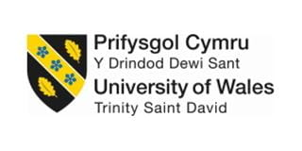

LCBB4004
Marketing fundamentals

Analysis of GARNIER L’ORÈAL

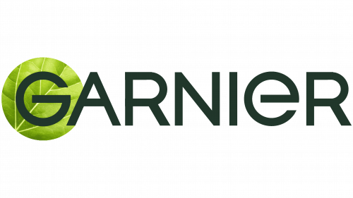

Student name: Vali Daniela Pantazi
Student number: 2212835
Words:3441

Lecturer: Efua Adams

Table of contents

1. INTRODUCTION 3
ABSTRACT 3
GARNIER L’ORÈAL PROFILE 3
DEFINITION OF MARKETING 3
THE GLOBAL BUSINESS ENVIRONMENT 4
2. ANALYSIS OF GARNIERS’ MARKETING STRATEGIES 4
Product 5
Price 6
Place 6
Promotion 7
People 7
Process 7
3. THE GLOBAL BUSINESS ENVIRONMENT 8
Political 9
Economic 9
Social 9
Technological 9
Legal 10
Environmental 10
4. GARNIER’S STAKEHOLDERS AND THEIR IMPACT ON THE BUSINESS 10
Primary stakeholders 11
Secondary stakeholders 12
5. CONCLUSIONS AND RECOMMENDATIONS 13
6. REFERENCES 14

INTRODUCTION

ABSTRACT

An organization is structured around some areas which are all working together to achieve the main goal-customers’ satisfaction.
This essay will analyse the markets that Garnier L’Oréal operates in. It will explain the role of marketing department and analyse the global environment that the organization operates in and the factors affecting the organization, using specific marketing theories.
In every business marketing is the key factor in interacting with customers, to deliver the best products and meet the set targets (Kotler and Armstrong, 2019).

GARNIER L’ORÈAL PROFILE

Garnier was founded in 1904 in France, by Alfred Amour Garnier and its first product was a plant-based hair lotion, La Lotion Garnier (Garnier,2022). It is now, a beauty brand part of L’Oréal Group. Garnier developed into a global provider of skin and hair care products, made by using plants, seeds, bulbs and flowers. Its products are tailored to suit the needs of women all around the globe, at affordable prices (Garnier, 2022).
According to Adrien Koskas, (2021), Garnier Global Brand President, their goal is “to make
green beauty accessible to everyone”.

DEFINITION OF MARKETING

Marketing can be defined in numerous ways, according to the understanding of the author, but no matter how the definition sounds, it will lead to the same idea, that marketing is an exchange process (Twin, 2022).
According to AMA (The American Marketing Association) (2004) marketing is “an organisational function and a set of process for creating, communicating, and delivering value to customers and for managing customer relationships in ways that benefit the organisation and its stakeholders” (Gundlach & Wilkie, 2009). The Chartered Institute of Marketing (2009), (CIM), defines marketing as “the management process responsible for identifying, anticipating and satisfying customer requirements profitably”. AMA stands for delivering value, while CIM promotes customers’ requirements.
The two definitions above explain that marketing leads to increased profit and meets customers’ satisfaction, also drives sales, and helps the organization achieve a competitive advantage which is vital for the business to run at maximum potential.
To achieve its goals Garnier will use the marketing mix which implies using the 4P’s model: price, promotion, product and place, model initially suggested by E. Jerome McCarthy in 1960. In 1981 Mary Bitner and Bernard Booms built a model consisting of 7P’s, adding people, to recognize de importance of human element in all the aspects of marketing. They also added processes, to explain that the services are perceived as processes when purchased, and physical evidence.

THE GLOBAL BUSINESS ENVIRONMENT

The global business environment can be defined as “the environment in different sovereign countries, with factors exogenous to the home environment of the organization, influencing decision making on resource use and capabilities” (Morrison, 2017).
For Garnier to make better decisions when expanding globally, a PESTLE analysis of the macro-environment is necessary. PESTLE stands for Political, Environmental, Social, Environmental, Technological and Legal factors that can affect the organisation and cannot be controlled by it. The framework encourages the management department to strategize and quickly respond to changes in external environment that can negatively impact the business' operations. The effectiveness of this model increases when combined with other strategic tools (Murphy, 2021).

ANALYSIS OF GARNIERS’ MARKETING STRATEGIES

Garnier appears to understand that to be better than its competitors, must continuously develop new market strategies to keep its customers and attract new ones. On the beauty market, Garnier L’Oréal has strong competition worldwide such as Unilever, Estee Lauder, Procter-Gamble, Shiseido.

Source: Self-mode
With a cosmetic and personal care products market, projected to grow by 2027, Garnier has to strive to achieve competitive advantage and remain on the market (GlobeNewswire News Room, 2022).
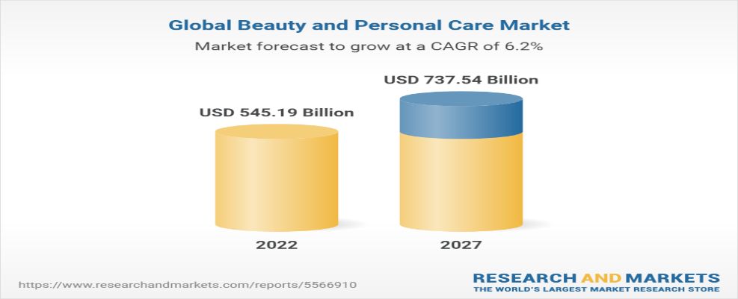Source: Research and Market

Garnier is an international brand with definite product lines and aims to offer to its customers good quality products at affordable prices. The products belong to skincare and haircare targeted for various types of skin and hair. In keeping up with the evolution of markets, Garnier developed a range of products for men and kids (Garnier,2022).
To better strategize and understand the customer needs and wants, Garnier uses the Marketing Mix model (Bhasin, 2019).

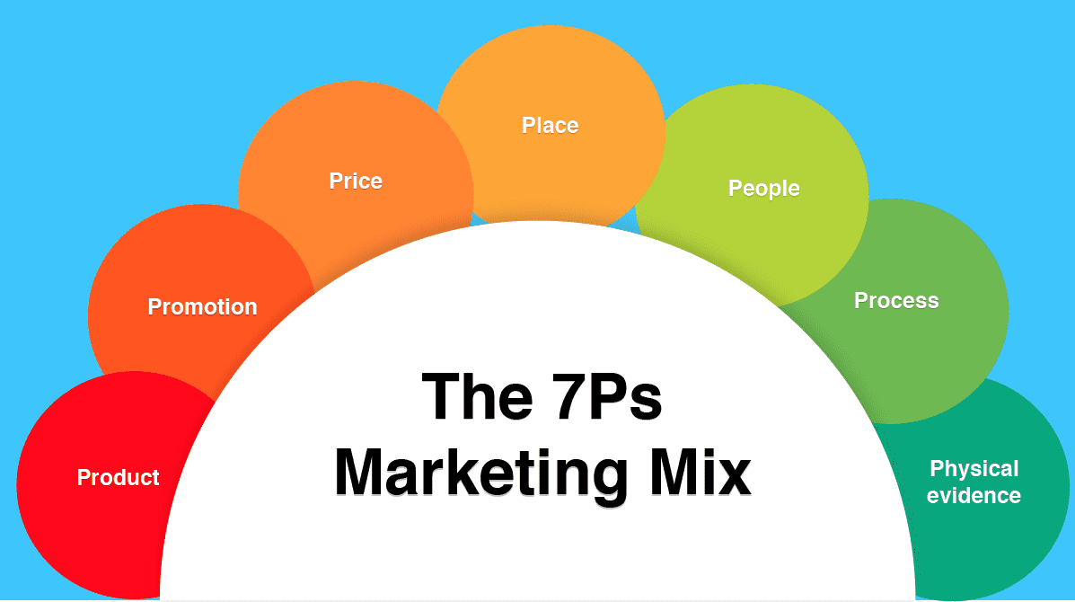
Source: Smart Insights

Product

Garnier maintains the high-quality products by procuring row materials only from trusted suppliers and these materials are processed at higher standards to maintain the consistent quality of the products. Recently Garnier transformed more of its products with formulas of more than 90% of natural ingredients, certified organic products, and vegan suitable formulas. Garnier commits to Green Beauty and all its products are now globally approved Cruelty Free International under the Leaping Bunny program (Garnier, 2022).
Garnier’s products always come with “how to use” instructions which are simple and easy to use, and they promise to the consumer security, confidence and an ego boost. When using the brands’ products, people may think to improvements in their beauty, healthier skin and hair.
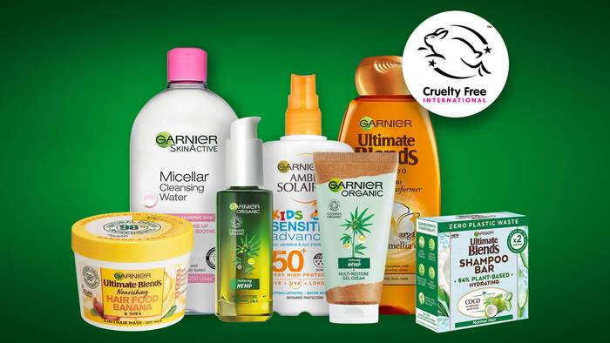
Source: Garnier.com

Price

Garnier use several pricing techniques for pricing its products, e.g., premium pricing, psychological pricing, geographical pricing, and bundle pricing (Henry, 2018).
Premium pricing stands for its high-end products targeting middle and rich class consumers such as Garnier Complete Serum Cream or Garnier Sheets Masks. With this strategy, Garnier managed to make some of its range of products exclusive by restricting production and sales, and in turn, achieved a perception of luxury in consumption of the products (Henry, 2018).
By using psychological pricing, Garnier managed to increase sales as customers purchase a higher volume of products. For example, Garnier Body Lotion is sold in Asda at the price of £ 3.99 and the customer perceives this price as £3.00 instead of the actual £4.00, treating £3.99 as a lower price than £4.00.
With the use of geographical pricing, Garnier can optimally penetrate various regional markets and maintain the growth of its revenue by altering prices in different countries based on the local currency value.
Garnier often uses bundle pricing to control prices and costs by lowering the expenses with marketing and distribution. This strategy also adds value to the brand and can experience a high return of the cost, by gaining new customers (Henry, 2018)
As relevant example, the price of the Garnier Body Lotion in Japan is ¥ 1.275 approx. £ 7.30, compared to UK price of £3.99 which shows the difference between pricing on various parts of the world.

Place

Garnier is an international brand as its products are available in various countries. The luxury brand of Garnier has a wide market especially in Asia in countries such as India, Japan, and China, but it is present on all other continents. The demand for natural cosmetics has led Garnier to have a strong presence on the emerging markets (Bhasin, 2019).
Garnier has a distinct distribution policy that helped the organisation smooth the process of product distribution. From the manufacturers, the products go to the wholesalers, and they provide to the retailers and from them, the customer can easily purchase any products. Garnier is a valuable brand that by its innovative ideas managed to keep together all its intermediaries, as it is easy to negotiate with existing distributors than with the new ones (Bhasin, 2019).
Garnier has successfully developed an online platform where customers can place and track orders, encourages sales through social media and also stocks products with online retailers as Amazon and eBay. This has boosted the sales and increased the accessibility of its products for customers (Bhasin, 2019).

Promotion

Garnier heavily invests in promoting its products. Radio promotions and television commercials are the most utilized channels, along with ads in magazines and newspapers. Garnier also uses the internet to promote its products to online customers which helps the organization directly engage with them and understand their needs and wants.
The loyalty card allows customers to earn points on each purchase and later to use them towards the cost of other products or gifts (Garnier, 2022).
For promoting its products, Garnier uses, at times, celebrities such as a Bollywoodian actress representing trendy generation, Drew Barrymore or Holly Willoughby.
The use of community influencers is another way for Garnier to promote its products. Strong and motivated individuals are selected to be brand ambassadors in their community and provides them with products to use themselves and share the benefits.

People

The marketing mix of Garnier also places a great emphasis on peoples’ development and training. Garnier’s employees are continuously trained to respect the customers, to value their opinions and consider their preferences. All departments are contributing to the success of the organization; therefore, people are being given a lot of attention (Garnier, 2022).

Process

Garnier has a series of processes in place to ensure the organization is running smoothly. To ensure that their products are always available at the retailers, Garnier installed systems to be notified when the stock is low at the stores, so it can be replaced in time. This ensures their products are always available for the customers. The online delivery process and the involvement in continuous market research make Garnier competitive on the market (Addison, 2019).
Physical evidence

Garnier’s products are placed in the stores on a special shelve, with distinct colour and design, and the products are sold in packages that can be easily identified. If you go for example to Asda, you will find all Garnier products on one separate shelve for each type of products. The online website is easy to visit, the products are accurately described, and the images are very clear (Addison, 2019).
All the strategies that Garnier L’Oréal uses to attract customers and to remain competitive, appear to be working more in some parts of the world, and less in others, as the market share graph below shows.

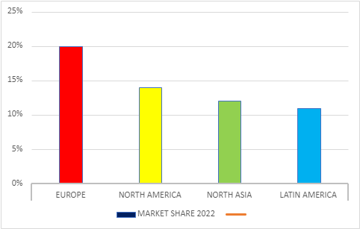
Source: Statista.com

THE GLOBAL BUSINESS ENVIRONMENT

To be able to operate worldwide, Garnier L’Oréal has chosen a unique strategy, Universalization. It means globalization that captures, respects, and understands differences in desires, needs, cultures and traditions (L'Oréal, 2020). For Garnier, globalization means having a global presence through a distinct organization. It positions itself strategically concentrated but locally decentralised, so local teams are empowered, ensuring that in each country, Garnier is relevant and close to its customers (L'Oréal, 2020).
Garnier L’Oréal developed a worldwide network of Research and Innovation, and, for each strategic market a meeting hub: the United States, Brazil, Japan, China, India, and South Africa, all to ensure that their products are perfectly adapted to the needs of their customers, wherever they live. To succeed in each country, the organization invested approximately 1.029M € in R&I departments in around 150 countries, and managed to register 517 patents (L'Oréal, 2020).
To ensure its global development, Garnier L'Oréal relies on the R&I department, which is supported by a set of corporate functions, such: Administration and Finance, Digital, HR, Communications and Corporate Responsibility (L'Oréal, 2020).
When operating globally, Garnier has to be aware of the series of factors that may affect the business and cannot be controlled by the organization. To do this, for every country, a PESTLE analysis is required to be able to solve problems that may occur.

Political

A company like Garnier L'Oréal, with a global presence, could be affected by the political environment of each country it operates in, therefore it needs to strategize accordingly. The political condition of a country and the political stability in recent years could affect the business operations. Also, the form of government and the ruling party’s interests could affect the growth of the business. Garnier being a mass French cosmetics company, the relations of other countries with France could affect operations in other nations. For example, Germany is encouraging its citizens to buy national products and abandon international brands may concern Garnier and may inquire new market strategies in order to establish itself and gain ore customers (Team, 2021). Also, competition regulations, tax policies and trade blocks could affect Garnier’s operations in different countries.

Economic

By operating in an FMCG industry, economic factors such as inflation, foreign exchange, interest rates and the attitude towards savings, can change buyers’ behaviour. For example, in UK this year, inflation was extremely high, the value of money reduced so people were able to buy less products with the money available (BBC News, 2022). In situations like this, people my prioritize to spend towards their basic needs, and the customers’ ability to spend on Grainers’ products is affected, therefore, the business is affected. Another factor that can affect the organization is the Labour market condition. If the labour is available at cheaper rates, then Garnier can make more revenue (Team, 2021). Trade relations between countries due to political stability and strength allows Garnier to maintain offshore business affiliations easily (Garnier, 2022).

Social

A nations’ culture, spending patterns and peoples’ behaviour are social factors that can impact on Garnier’s’ sales. The age group of a market and the class distribution are factors that Garnier considers when strategizing on a market. Also, the health standard and the level of education of people are considered to offer the products in the best manner. The level of acceptance of the “online shopping” of a society needs to be analysed, to be able to promote for distinct types of customers. Garnier addresses its products to various ages and all genders (247caseanalysis, 2021).

Technological

Like mentioned above, the penetration of internet in each country is a key factor in Garnier’s promotion and selling. Another crucial factor to be considered is the infrastructure, along with the use of social media and the investments in R&D, can make a market worth to be analysed by Garnier. According to Statista (2022) the higher internet penetration is in USA, United Kingdom, and Denmark with 99% and the lowest rate is in India, 47% and Kennya 42%. For example, with this statistics, Garnier’s strategies in India will not focus as much on social media as in USA.

Legal

Certain legal factors such as copyrights, data protection, intellectual property law or patents can affect the operations of a business in certain countries. Also, employee protection laws and consumer protection laws must be studied and abide by, in each case. Garnier regularly conducts workshops for its employees to make them aware of their rights and strives to improve their health and safety. Being part of the FMCG industry, Garnier must study the environmental rules and regulations when disposing waste and producing.

Environmental

Garnier is committed to improve the environmental impact of its products and empowers the customers with information to make more sustainable decisions through the clear labelling system that offers clear information about the social and environmental impact of the products (Garnier, 2022).
Different industries in various countries have different set of standards of environmental protection that need to be followed and the company should aim to abide by these standards. Taking all steps towards Environmental Protection can build a positive brand image for its consumers.
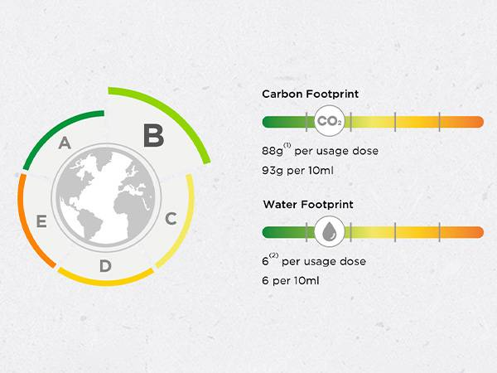
The “Overall Environmental Impact” score
Source: Garnier.com

GARNIER’S STAKEHOLDERS AND THEIR IMPACT ON THE BUSINESS

Edward Freeman (2010) first used the term “stakeholder” to define the individuals or organizations that can influence a company achieving its goals or can be influenced by the firm’s actions. Stakeholders can be divided in two categories: primary stakeholders whose participation is vital for the continuity of a business (investors, suppliers, consumers, workers, financial institutions et.al.) and secondary stakeholders, which are not essential for the continuity of the business but can influence or be affected by the activity of the organization (competitors, media, political and public institutions) (Affinita, 2017).
To remain prosperous and long lasting on the markets, Garnier must respond to the expectations and demands of its stakeholders, by building relations of mutual trust and respect.

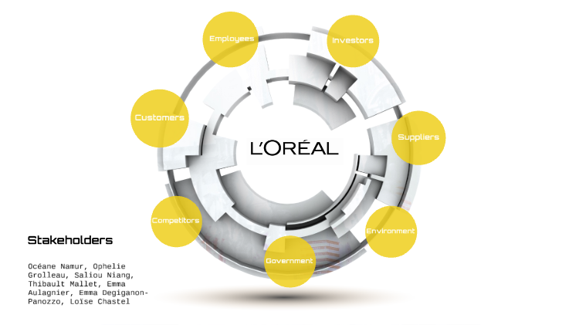
Source: Prezzi.com

Primary stakeholders

Investors can have a major impact on the business as they can provide the business with the necessary capital to develop and grow the business.

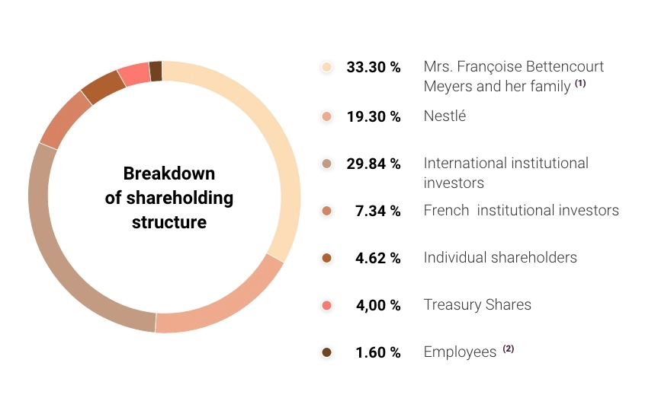
Source: L’Oréal Finance, 2021
Employees as primary stakeholders can also have an impact on the business and are particularly important. At Garnier, employees are valued, and the company ensures all the steps for individual development are taken. Garnier committed to fairness and ethics and promotes diversity and inclusion. L’Oréal launched L’Oréal for Youth to help young people start their career. The programme is supporting people with difficulties rebounding after the pandemic, particularly increasing work opportunities for young people below 30 years old in 2021 by 30% globally, compared to 2020 (L’Oréal, n.d.).
Customers depend on Garnier to supply the beauty products. In return, they support the company by buying these products. By doing so, the customers guide the company towards the direction it should follow to meet customers’ expectations and needs.
Amongst Garnier’s customers are specialized retailers, beauty professionals and grocery stores.
Suppliers are playing a significant role in the functionality of the business. Suppliers provide raw materials for Garnier’s factories around the world, also they make the products reach the final customers. According to Garnier (2022), the purchasing policy is based on meeting strict ethical, social, and environmental standards, which help ensure the quality, effectiveness, and traceability of the products. Garnier has a Buy and Care charter which connects the company with their suppliers and ensures responsible purchasing worldwide.
Suppliers can influence a business by either lowering or increasing the prices of goods, by changing credit terms or the delivery times.

Secondary stakeholders

Competitors of Garnier are many on the world’s markets, and to remain competitive, the organization needs to analyse their impact, as they can decrease the market share and shrink the customer base. Competitors can also force Garnier to lower their prices to remain competitive and by doing so, their revenue can decrease.
Garnier manages to remain competitive on the market by offering to its customers products free from animal-based ingredients and the quality of their ingredients provide nourishment to hair and skin, which make Garnier different and preferred to the chemical-based products on the market (Shastri, 2022).
Government as a stakeholder, can influence the business by different rules and regulations. As an example, in the EU, regulations change on a regular basis due to scientific progress. The health authorities of the Member States make decisions “based on proposals from the European Commission” (loreal.com, 2021). They rely on the opinion of independent European experts who gather within the European Scientific Committee for Consumer Safety (SCCS)” (loreal.com, 2021). Garnier follows the rules and regulations an see itself in the position to constantly adapt its products by eliminating certain ingredients that are not in line with the cosmetic industry regulation.
The media industry is an important stakeholder and includes organizations specialized in broadcast content and delivery, print, Internet, television, radio, and direct mail. The media helps customers shape their attitudes towards, in this case, Garnier business. Consumers and organizations can be positively or negatively affected by the media, as through this means, information is provided (Lombardo, 2022). Through media, Garnier L’Oréal managed to build its brand, and became well-known worldwide.

CONCLUSIONS AND RECOMMENDATIONS

Garnier L’Oréal aims to offer innovative natural hair and skin care beauty products to over one billion women and men all around the world, products formulated according to their diversity. This essay meant to critically analyse marketing strategies of Garnier and the environment it operates in, both locally and globally. According to the research and findings, Garnier is a brand that is worth trying, due to their natural ingredients used and the directions the company is following in protecting the environment and promoting “Green Beauty.”
Garnier is a well-known brand with a strong image worldwide and the mother company, L’Oréal has the biggest market share in the beauty and cosmetic world. L’Oréal is producing cosmetics for over a century now, innovated based products, based on research data, to meet customers’ needs and satisfaction. Their products are reasonably priced and high-quality to enhance beauty (Shastri, 2021).
As a recommendation, Garnier L’Oréal could intent to penetrate new beauty sectors, such as personal care, as people are always looking for the best products for their body. Also, Garnier may consider expanding out into developing economies and countries where the markets are not saturated, such as Indonesia or Brazil (Frue, 2018).
Another focus of the company may be to create new products for niche customers, as Garnier already concentrates on curly hair and darker skin tones, the competition is vast, due to many companies working only in these niches (Frue, 2018).
Garnier could try to develop into an eco-friendlier company, as customers seek products that are efficient for their body but 6at the same time not taxing on the environment. Other type of customers are looking for products sulphate, paraben and silicone-free. As the demand for natural and organic products is high nowadays, Garnier L’Oréal should put even more focus on this sector (Frue, 2018).

REFERENCES

247caseanalysis. (2021). PESTEL Analysis of Garnier. [online] Available at: https://www.247caseanalysis.com/essay/Garnier-13856-Pestel-Analysis [Accessed 29 Nov. 2022].
Addison, M. (2019). Marketing Mix Garnier. [online] Essay48. Available at: https://www.essay48.com/term-paper/13856-Garnier-Marketing-Mix [Accessed 28 Nov. 2022].
Annual Report – L’Oréal Finance. (2022). Cosmetics Market. [online] Available at: https://www.loreal-finance.com/en/annual-report-2021/cosmetics-market/ [Accessed 28 Nov. 2022].
Baalbaki, Y. (2015). History of Marketing Mix from the 4P’s to the 7P’s. [online] Linkedin.com. Available at: https://www.linkedin.com/pulse/history-marketing-mix-from-4ps-7ps-yousef-baalbaki [Accessed 17 Nov. 2022].
BBC News (2022). What is the UK’s inflation rate and why is the cost of living going up? BBC News. [online] 13 Apr. Available at: https://www.bbc.co.uk/news/business-12196322 [Accessed 29 Nov. 2022].
Bhasin, H. (2019). Marketing mix of Garnier - Garnier marketing mix and 4 P’s. [online] Marketing91. Available at: https://www.marketing91.com/marketing-mix-garnier/ [Accessed 23 Nov. 2022].
GlobeNewswire Newsroom. (2022). Global Beauty and Personal Care Market (2022 to 2027) - by Products, Outlook, Distribution Channel, Category and Geography. [online] Available at: https://www.globenewswire.com/en/news-release/2022/04/08/2419164/28124/en/Global-Beauty-and-Personal-Care-Market-2022-to-2027-by-Products-Outlook-Distribution-Channel-Category-and-Geography.html [Accessed 23 Nov. 2022].
Gundlach G., Wilkie W. (2009) The American Marketing Association’s New Definition of Marketing: Perspective and Commentary on the 2007 Revision. Journal of Public Policy & Marketing, 28 (2); p.259-264
Henry, Z. (2018). Marketing Mix of Garnier. [online] Case48. Available at: https://www.case48.com/term-paper/Garnier-Marketing-Mix-13856 [Accessed 23 Nov. 2022].
Kotler, P. and Armstrong, G. (2019). Principles of marketing. 18th ed. New York, Ny: Pearson Education.
L'Oréal (2020). L’Oréal Group: Strategy & Model. [online] L’Oréal. Available at: https://www.loreal.com/en/group/about-loreal/strategy-and-model/ [Accessed 29 Nov. 2022].
Morrison, J. (2017). The Global Business Environment. London Macmillan Education Uk.
Murphy, F. (2021). PESTEL Analysis Of Garnier. [online] EssayPandas. Available at: https://www.essaypandas.com/essay/Garnier-13856-Pestel-Analysis [Accessed 23 Nov. 2022].
Petruzzi, D. (2022). L’Oreal’s market share worldwide by region 2022. [online] Statista. Available at: https://www.statista.com/statistics/243955/market-share-of-loreal-by-region/ [Accessed Nov. 28AD].
R. Edward Freeman, Harrison, J.S., Wicks, A.C., Parmar, B.L. and Simone de Colle (2010). Stakeholder Theory. Cambridge University Press.
Statista. (2022). Countries with the highest internet penetration rate 2020. [online] Available at: https://www.statista.com/statistics/227082/countries-with-the-highest-internet-penetration-rate/ [Accessed 29 Nov. 2022].
Team, M.S. (2021). Garnier PESTLE Analysis. [online] MBA Skool. Available at: https://www.mbaskool.com/pestle-analysis/companies/18156-garnier.html [Accessed 29 Nov. 2022].
The Chartered Institute of Marketing (2009). Marketing and the 7Ps A brief summary of marketing and how it works. [online] Available at: https://www.thensmc.com/sites/default/files/CIM%207Ps%20Resource.PDF [Accessed 17 Nov. 2022].
Twin, A. (2021). Marketing. [online] Investopedia. Available at: https://www.investopedia.com/terms/m/marketing.asp [Accessed 17 Nov. 2022].
www.garnier.co.uk. (n.d.). About Garnier | Garnier. [online] Available at: https://www.garnier.co.uk/within-garnier/about-garnier [Accessed 17 Nov. 2022].
Affinita, F. (2017). ‘TOGETHER LET’S MAKE THE WORLD MORE BEAUTIFUL’: A CSR project by Garnier de L’Oréal. [online] Available at: http://tesi.luiss.it/21900/1/199081_AFFINITA_FRANCESCA%20ROMA_THESIS%20FINAL%20PDF.pdf [Accessed 29 Nov. 2022].
L’Oréal Finance. (2021). Share Ownership. [online] Available at: https://www.loreal-finance.com/eng/share-ownership#:~:text=(1)%20Consisting%20of%20Ms%20Fran%C3%A7oise [Accessed 29 Nov. 2022].
Shastri, A. (2022). Detailed SWOT Analysis of Garnier - 2022 Study | IIDE. [online] iide.co. Available at: https://iide.co/case-studies/swot-analysis-of-garnier/ [Accessed 28 Nov. 2022].
inside-our-products.loreal.com. (2021). Cosmetic products regulation | Inside our products - L’Oréal. [online] Available at: https://inside-our-products.loreal.com/our-approach/compliance-cosmetics-regulations [Accessed 29 Nov. 2022].
Lombardo, J. (2022). The Media Industry. [online] Study.com. Available at: https://study.com/academy/lesson/the-media-industry-roles-impact-ethics.html#:~:text=One%20of%20the%20most%20valuable [Accessed 30 Nov. 2022].
Frue, K. (2018). L’Oréal optimistic on emerging markets | WARC. [online] origin.warc.com. Available at: https://www.warc.com/newsandopinion/news/loreal-optimistic-on-emerging-markets/28930 [Accessed 30 Nov. 2022].

