8/11/2026
University of Wales Trinity Saint David

Module Name: Software Solutions for Business
Module Code: ACCA 4026

Student Name: Rajeep Maharjan
Student ID: 2538568
Group: 1

Lecturer’s Name: Rajeev Nath

Contents
Introduction 2
Task 1. e-Commerce Website builders/software solutions 2
1.1 Wix 2
1.2 Shopify 2
Conclusion 4
Task 2. Mind-map of contemporary software applications 4
2.1 Describe mind mapping and explain the benefits of using mind mapping 4
2.2 Create a mind map of contemporary software applications 5
Task 3. Office Applications 6
3.1 Four office software solutions for business operations 6
Microsoft 365 office applications remain the core productivity layer for day-to-day business operations. While newer cloud tools exist, Word, PowerPoint, Excel and Access provide an integrated framework for document creation, presentation, data analysis and structured storage [7][8]. 6
MS Word: Creating and Managing Business Documents 6
MS Excel: Analysing and Storing Data 7
MS PowerPoint: Presenting Information 8
MS Access: Structured Data Storage 9
3.2 Test any two features 11
Mail Merge 11
IF Statement 15
Task 4. Communication and Collaboration applications 19
4.1 One contemporary Communication and one Online Collaboration 19
Gmail 19
Zoom 20
4.2 Test one feature of a freely available Communication (1) and one feature of a Collaboration (1) application 21
Gmail 21
Zoom 24
Conclusion 26
References 27
Bibliography 28

Introduction

In the contemporary digital economy, software applications form the backbone of business operations, from customer-facing commerce to internal knowledge management and productivity. This report critically evaluates three interlinked domains of business software.

First, it examines two leading e-commerce website builders, Wix and Shopify, comparing their design philosophy, commerce capabilities and pricing structures to determine their suitability for different business scales.

Second, it explores mind mapping as a visual thinking technique, defining its principles, historical development by Tony Buzan, and analysing its benefits for collaboration, creativity, and simplification of complex information in project management contexts. The contemporary application landscape is then visualised through a mind map linking productivity suites, communication, e-commerce, design and data tools.

Finally, the report analyses four core Microsoft 365 office applications — Word, Excel, PowerPoint and Access — evaluating their major features, benefits and limitations for structured and unstructured business information management, supported by practical testing of Mail Merge and advanced Excel functions.

The aim is to provide a comprehensive overview of how modern software solutions can be strategically selected and applied to enhance operational efficiency, communication and business growth.

Task 1. e-Commerce Website builders/software solutions

Wix and Shopify are among the most widely used contemporary e-commerce website builders. Both platforms provide hosted, no-code solutions, although each targets distinct user groups.

Wix
Wix is a cloud-based website builder recognised for its intuitive interface and creative flexibility, which appeals particularly to small businesses and entrepreneurs [1], [2]. Since its launch in 2006, Wix has enabled millions of users to create professional websites without coding requirements [1]. The Wix eCommerce platform provides a comprehensive suite of features, including hundreds of designer-made, mobile-responsive templates and a drag-and-drop editor, which allow for complete customisation of store layouts, product pages, and navigation [1], [2].
Wix supports a broad range of payment gateways, including PayPal, Stripe, and Wix Payments, to ensure secure transactions for merchants and customers [1]. Integrated inventory management tools provide real-time stock tracking, automatic out-of-stock notifications, and centralised order management within a user-friendly dashboard [2]. Additional features such as abandoned cart recovery, discount code creation, and integrated shipping solutions further enhance sales performance [1].
A key strength of Wix is its App Market, which offers access to a wide range of third-party tools for marketing, analytics, and customer support, enabling businesses to expand their store’s functionality as they grow [1], [2]. Wix also provides built-in SEO tools and analytics, allowing users to optimise their stores for search engines and monitor visitor behaviour and sales trends [2]. For international businesses, Wix supports multiple languages and currencies, facilitating global expansion and sales [1].
Wix’s value proposition is particularly compelling for users who prioritise design flexibility, ease of use, and cost-effective entry, as its tiered pricing structure accommodates a range of business needs and sizes [2].

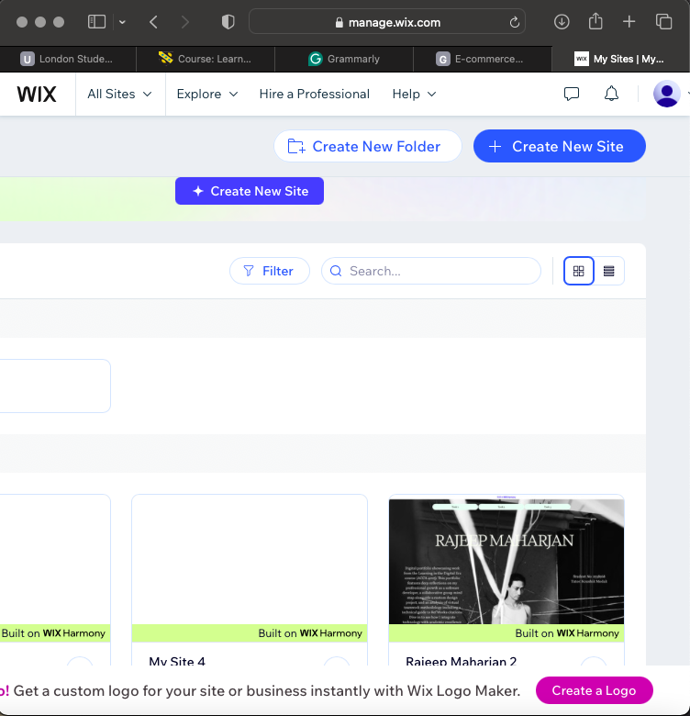

Shopify

Shopify, by contrast, is a platform designed exclusively for e-commerce and is widely recognised for its scalability and comprehensive sales features [3]. Supporting over a million businesses globally, Shopify’s infrastructure accommodates organisations ranging from small start-ups to large enterprises with extensive product catalogues and high transaction volumes [3].
Shopify offers a comprehensive management dashboard for products, inventory, orders, and customer data. Its range of professional, mobile-optimised themes ensures a consistent shopping experience across devices [3]. Shopify also provides payment flexibility by supporting numerous gateways and offering its own integrated payment processing system. The point-of-sale (POS) system enables businesses to unify online and physical store operations [3].
The Shopify App Store provides thousands of integrations for marketing automation, drop shipping, accounting, and customer engagement, enabling merchants to tailor their stores to specific business strategies [3]. Shopify is designed to manage high-volume sales and complex catalogues, supporting multi-currency transactions, multiple languages, and local payment methods [3]. Advanced analytics and reporting tools help merchants track sales, customer behaviour, and overall performance, supporting data-driven growth strategies [3].

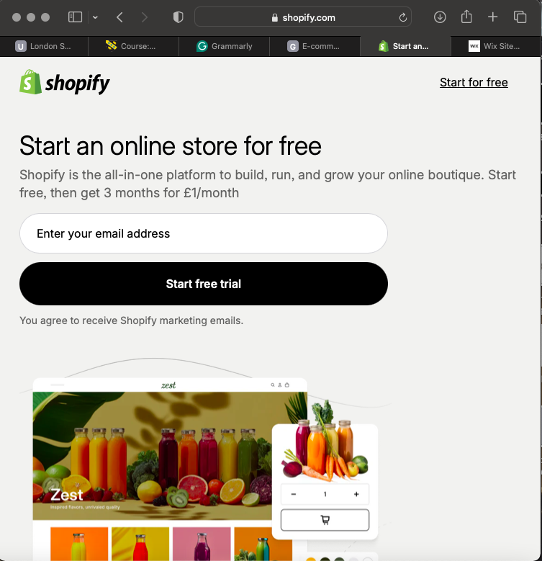

Conclusion
Both Wix and Shopify provide high-quality e-commerce website building solutions, but they serve different audiences and business objectives. Wix is most suitable for small to medium-sized businesses and creative entrepreneurs who prioritise design flexibility and ease of use [1], [2]. In contrast, Shopify is designed for businesses that require advanced e-commerce features, scalability, and infrastructure to support significant growth and complex operations [3].

Task 2. Mind-map of contemporary software applications

2.1 Describe mind mapping and explain the benefits of using mind mapping

Mind mapping is a visual thinking technique for organising information and generating ideas. It can be defined as a conceptual web showing the relationship between ideas and as a simple technique for drawing information in a creative and logical non-linear diagram built around a central concept [4],[5].
Unlike linear notes or outlines, a mind map is a visual thinking framework used to explore, organise, and develop ideas around a central topic. The structure is radial: a single central idea, theme or problem is placed in a middle of a blank canvas, and related sub-ideas branch outwards. Those branches then expand further into sub-branches with keywords, short phrases, icons, images and colour coding. The technique was popularised in the 1970s by British psychology author Tony Buzan, who argued it mirrors how the brain works associatively rather than linearly, combining words, pictures, symbols and colour to create a picture of information [4], [5].
The basic process is consistent: begin with a central node, brainstorm related themes, draw lines to represent relationships, and use formatting to visually organise information. Because there is no single way to do it, it can be done on paper or with digital tools that allow real-time editing, embedding of links and storage for later use [4].
Benefits of Mind Mapping

Mind mapping has become an essential tool for project managers and teams who want to make brainstorming and project planning more efficient. These tools provide a visual way to organize thoughts, ideas, and information, which makes complex projects easier to manage and understand [4].

Enhanced Collaboration: Mind mapping software lets team members contribute to projects in real time from anywhere, making sure that different perspectives are included. In group settings, mind mapping can encourage members to take part because they can see information visually and better understand thought processes within the group [4], [6].

Improved Productivity and Planning: Mind mapping speeds up planning and brainstorming phases. It gives a visual overview of tasks, dependencies, and progress, so managers can quickly spot bottlenecks and adjust resources, which can help reduce project timelines [4].

Increased Creativity: The visual format helps users see connections between ideas they might not have noticed before, creating an environment where creativity can grow. Instead of working step by step in a straight line, teams can jump between ideas and come up with solutions from different fields.

Simplifies Complex Ideas: Mind maps show information clearly, highlighting how topics are connected. This helps with decision-making and makes it easier to share strategies, since visual information is more engaging and easier to remember than plain text [6].

Better Information Retention and Versatility: Using colors, images, and spatial relationships helps people remember project details. Mind maps can be used in many situations, from studying and taking notes to planning projects and creating marketing strategies [4], [6].

In short, mind mapping turns scattered thoughts into structured clarity, aligning teams and accelerating execution.

2.2 Create a mind map of contemporary software applications

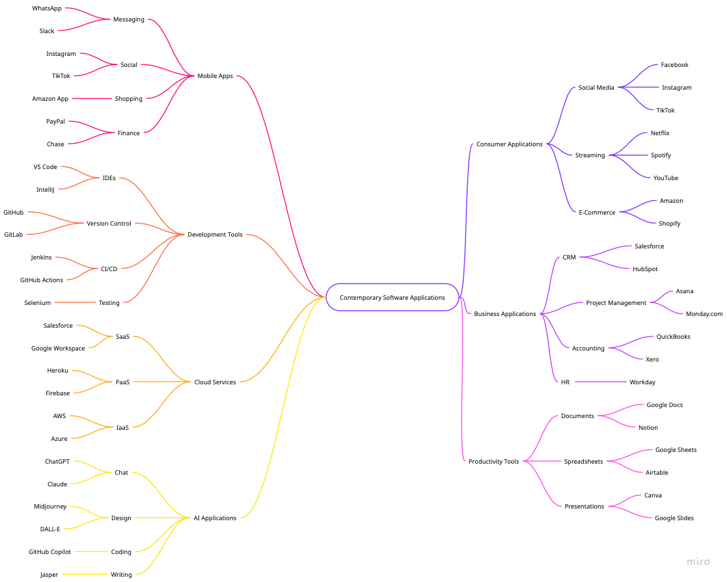
https://miro.com/app/board/uXjVHzzyaqs=/?share_link_id=48887693339

Task 3. Office Applications

3.1 Four office software solutions for business operations

MS Word: Creating and Managing Business Documents

Microsoft 365 office applications remain the core productivity layer for day-to-day business operations. While newer cloud tools exist, Word, PowerPoint, Excel and Access provide an integrated framework for document creation, presentation, data analysis and structured storage [7][8].

MS Word is the standard word processor for business reporting, policy documentation,
proposals, contracts and correspondence.

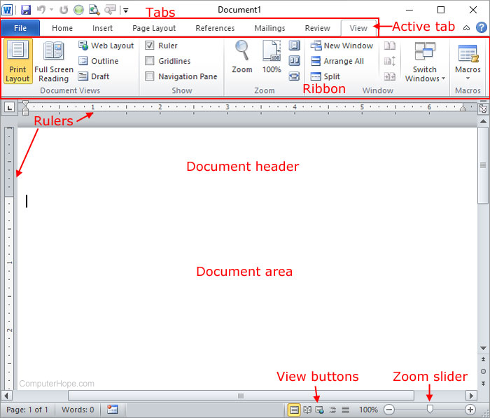
Figure 1https://miro.medium.com/1*j-ex7lzUbs0vh6cC-AM5bg.jpeg

Major Features

Word is valued for its ability to create professional, well-structured documents while remaining easy to use for both simple and complex tasks. Formatting and review features provide significant value in day-to-day work. Tools such as styles, templates, tables, comments and track changes help maintain consistency across documents while making it easier for multiple contributors to review content and provide feedback [7].

Key features include:
Formatting and Styles: Styles, themes, headers, footers, Table of Contents, footnotes, bibliography and Auto-Formatting for consistent corporate branding.

Review and Collaboration: Track Changes records all edits showing who made changes and when. Reviewers can add comments without altering original text, and real-time co-auditing via Microsoft 365. It allows multiple users to work simultaneously with version history [7].

Mail Merge: Combines a main document with a data source personalised documents such as form letters, mailing labels and envelopes. It is particularly useful in mass communication where personalised content is necessary [7].

Graphics and Automation: Drag-and-drop insertion of photos, illustrations, SmartArt, tables and charts from Excel, plus Macros and VBA for automating repetitive tasks and template management for standardising contracts and proposals.

Benefits
Familiarity is the biggest benefit. Most employees can begin using Word productively with minimal onboarding, while more advanced functionality remains available for complex documentation requirements [7].

Limitations
Maintaining consistent formatting when documents are edited by multiple contributors can be challenging, even with templates. Large documents containing tables, images and frequent revisions become more difficult to manage [7].

MS Excel: Analysing and Storing Data
Excel is the most widely used spreadsheet for budgeting, forecasting, reporting and operational tracking [9].

Major Features

It is used regularly for reporting, data analysis, budgeting, forecasting, tracking operational metrics and organising large volumes of information. Teh combination of formulas, pivot tables, charts, conditional formatting and data validation tools makes it easy to transform raw data into meaningful insights [9].
Excel provides 50+ categories of functions: Mathematical SUM, PRODUCT, Statistical AVERAGE, COUNT, Logical IF, AND, Text LEFT, CONCAT, Date TODAY, NETWORKDAYS and Lookup VLOOKUP, INDEX/MATCH [9].

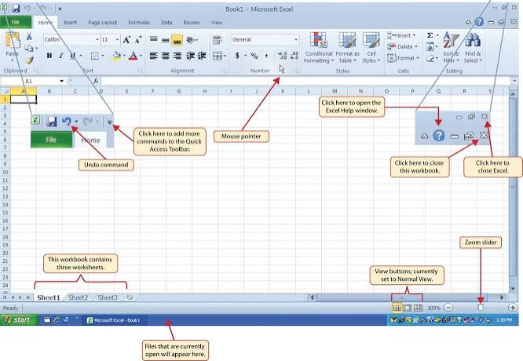
Figure 2https://openoregon.pressbooks.pub/app/uploads/sites/7/2016/09/image2.png

Benefits
Features such as pivot tables, filters and automated calculations reduce manual effort while improving accuracy and consistency, becoming essential for decision making. Its versatility makes it a must-have skill across finance, marketing and data science, and it supports real-time co-authoring, import/export from CSV and AI tools for dashboard building [9].

Limitations
Excel can slow down or lag when handling very large datasets or when a workbook relies on complex formulas. Performance declines significantly as file size enlarges, multiple users cannot simultaneously edit without risking data loss, it does not have built-in tools to maintain data integrity and offers limited defence features requiring external methods [9].

MS PowerPoint: Presenting Information
PowerPoint is the go-to tool for business presentations, training, sales pitches and product demos [8].

Major Features
Features include easy slide creation and editing, built-in templates and themes, support for images, audio and video, animation and transition effects, and chart and graph creation tools [8]. The Ribbon interface has been bundled since the early 1990s, reducing learning curve for organisations. Beyond standard tools, PowerPoint supports VBA scripting for automating repetitive tasks [8].

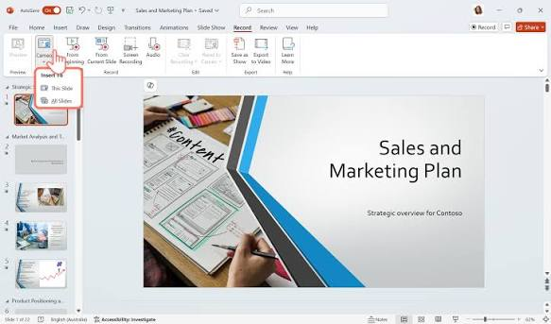
Figure3https://images.ctfassets.net/b4k16c7lw5ut/76wLjyQZzGRIPItep7sodo/6a5c93a24b90deb3c59d287aa3662e2f/How_to_video_record_yourself_presenting_a_PowerPoint_-_1.png

Benefits
Advantages include enhances visual communication, easy to learn and use, supports multimedia integration, improves audience engagement and widely supported across platforms. Its works both offline and online, files sync via OneDrive, and presenter tools such as Slide Show view, Speaker Notes and PowerPoint Live allow low-bandwidth delivery with live reactions and translation [8].

Limitations
Disadvantages include overuse of animations may distract viewers, large files may consume more storage space, and design quality depends on user skills [8].

MS Access: Structured Data Storage
Access is a desktop relational database management system combining a database engine with a visual interface [10].

Major Features
Access combines a relational database engine with an intuitive interface, enabling users to create tables, forms, queries and reports without deep programming expertise. Core objects are Tables for structured storage, Forms for data entry, Queries for retrieval, and Reports for presentation [10].
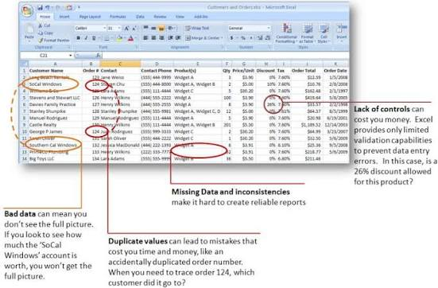
Figure 4https://encrypted-tbn2.gstatic.com/images?q=tbn:ANd9GcRAp56rCZHDb3URRi6ErX8LoJy6KYEr1aqefGk_wUvD6xjdeTpZ

Benefits
Users consistently praise the ease of use and flexibility, highlighting intuitive interface that simplifies database creation and integration with other Office tools, making it convenient for small to medium-sized projects [10].

Limitations
Access is predominantly favoured by small to medium businesses. Its suitability diminishes as organisational needs scale, especially when multiple concurrent users or high transaction volumes are involved, with performance bottlenecks and data corruption risks [10]. Technical limit is 255 concurrent users, however real-world limit is only 10 to 80, and maximum file size is 2GB [10].

Together, Word for creation, PowerPoint for presentation, Excel for analysis and Access for structured storage cover the full information lifecycle. In modern operations Word and PowerPoint handle unstructured communication, Excel bridges semi-structured analysis, and Access provides low-code relational management for departments that need more than spreadsheets but do not yet require enterprise SQL Server or Oracle.

3.2 Test any two features

Mail Merge

STEP 1: Prepare Data Source in Excel

Open Microsoft Excel and create a list with clear headers: First Name, Last Name, Email, Address, City. Enter 5-10 sample records. Save as Customer_Mailing_List.xlsx and close Excel. This file will be your data source.

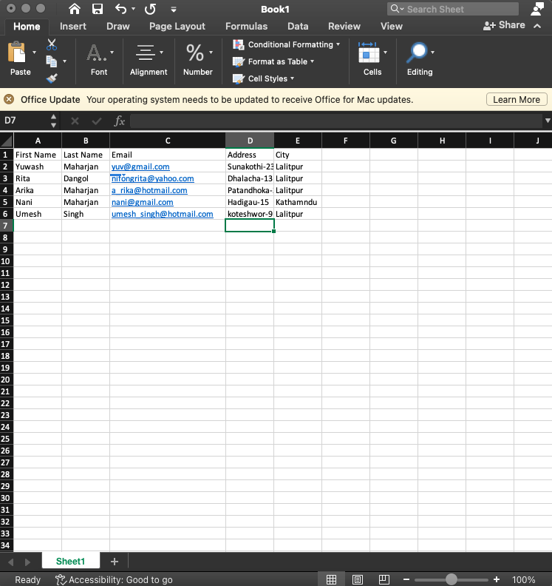

Figure 5Snapshot

STEP 2: Open Word and Go to Mailings Tab

Open Microsoft Word and create a new blank document. Type your main letter. At the top, click the Mailings tab. There, you'll find options like Start Mail Merge, Select Recipients, Insert Merge Field, Preview Results, and Finish & Merge.

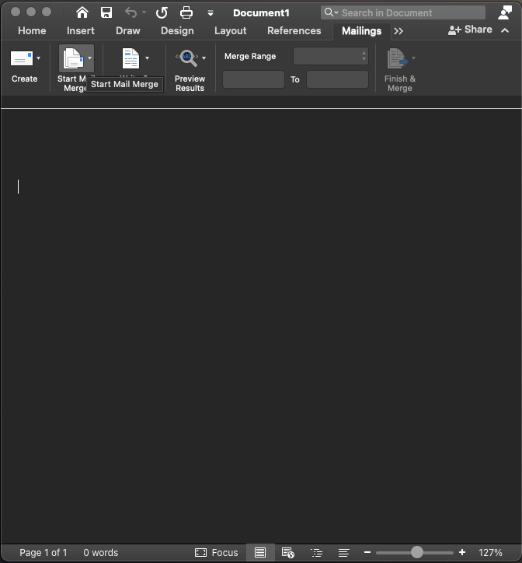
Figure 6Snapshot

STEP 3: Start Mail Merge - Select Document Type

Click Start Mail Merge and choose Letters, or use the Step-by-Step Wizard. For this example, pick Letters as the document type and click Next. This lets Word know which type of merge you want to do.

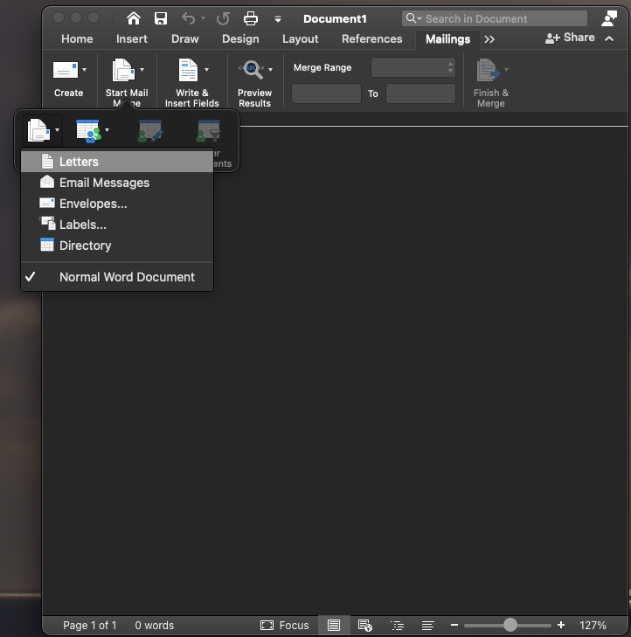
Figure 7Snapshot

STEP 4: Select Recipients - Use Existing List

Click Select Recipients, then choose Use an Existing List. When the file browser opens, go to This PC, open Documents, then Mailing Lists, and select Customer_Mailing_List.xlsx. Click Open, pick Sheet1, and make sure 'First row contains column headers' is checked. Click OK. Your Excel list is now connected to Word.

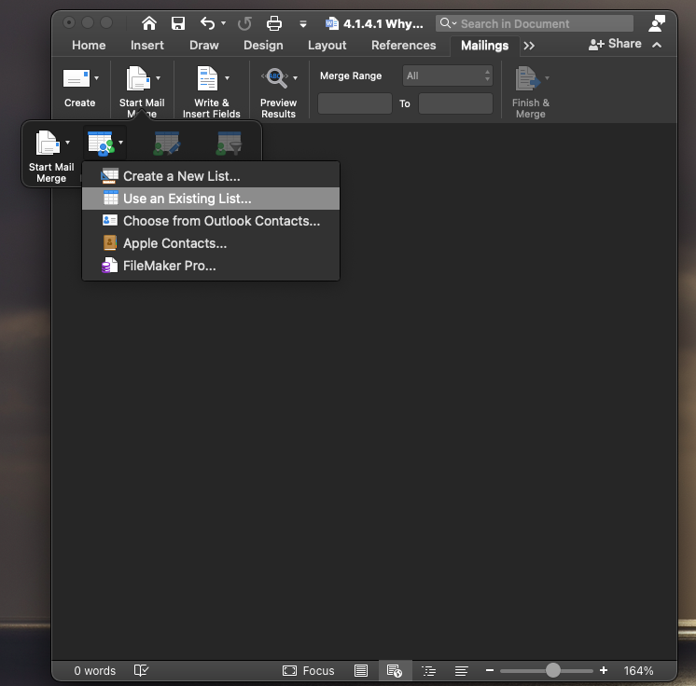
Figure 8Snapshot

STEP 5: Insert Merge Fields

Put your cursor in the letter where you want to add a personal touch, like just after 'Dear.' Click the Insert Merge Field dropdown and choose First Name. You’ll see <<First Name>> appear. Do the same for Last Name, Address, or any other fields you need. For example: Dear <<First Name>> <<Last Name>>, We will mail to <<Address>>.

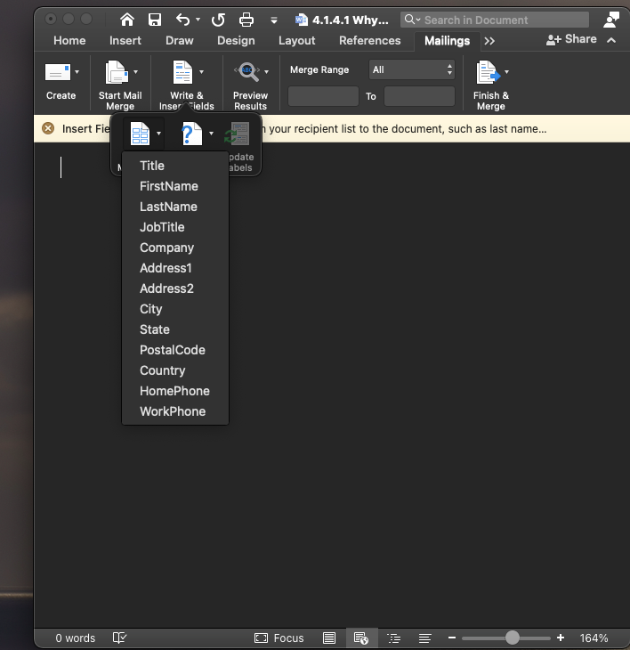
Figure 9Snapshot
STEP 6: Preview Results

Click the Preview Results button. Word will replace <<fields>> with actual data from your Excel file. Use the Next and Previous arrow buttons to review each recipient. Look for any spacing errors. Click Highlight Merge Fields to show the merged fields in grey.

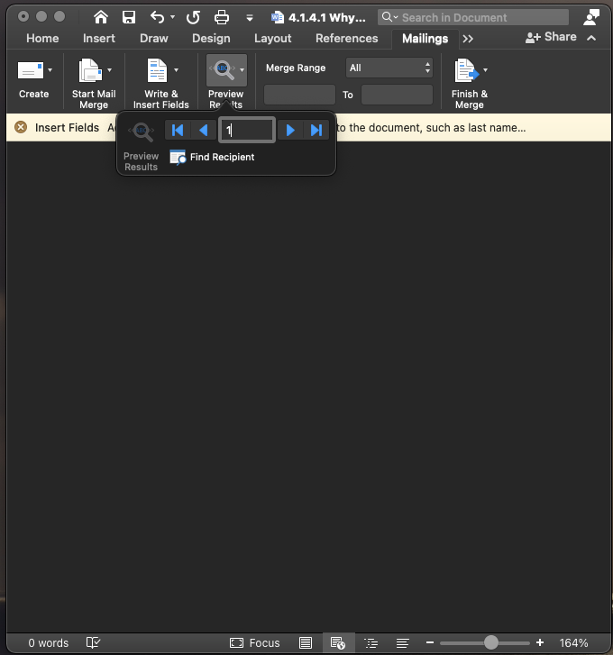
Figure 10Snapshot

STEP 7: Finish & Merge

Click Finish & Merge to complete your mail merge. You will see three options: 1) Edit Individual Documents, which makes a new Word file with all your letters; 2) Print Documents, which prints them right away; and 3) Send Email Messages, which sends personalized emails using the Email column. To finish, select Edit Individual Documents, choose All, and click OK.

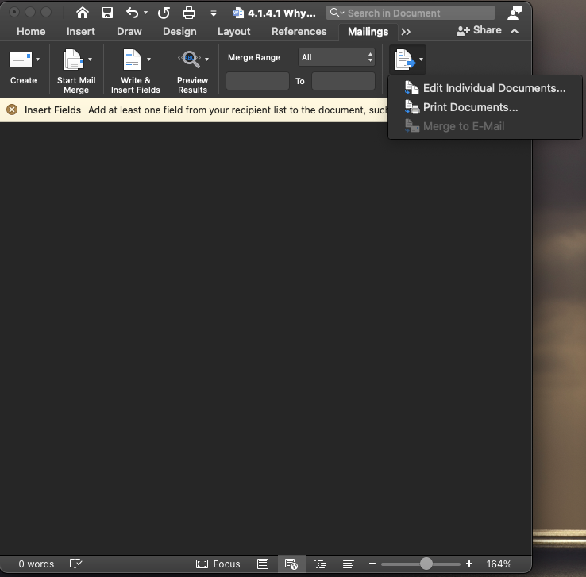
Figure 11Snapshot

Conclusion
Mail Merge helps you save time by creating personalized letters, emails, labels, and envelopes for multiple recipients using one template and data source. When you link your data source, any updates in Excel will show up in your merged documents. This tool is important for business communication, marketing, and administration.

IF Statement

Objective

This guide will show you how to use IF, Nested IF, and IF with AND/OR functions in Microsoft Excel to help make decisions. Each step includes a screenshot for reference.
STEP 1: Understand IF Function Syntax
Formula: =IF(logical_test, value_if_true, value_if_false)
The IF function is the most commonly used logical function in Excel for making decisions.

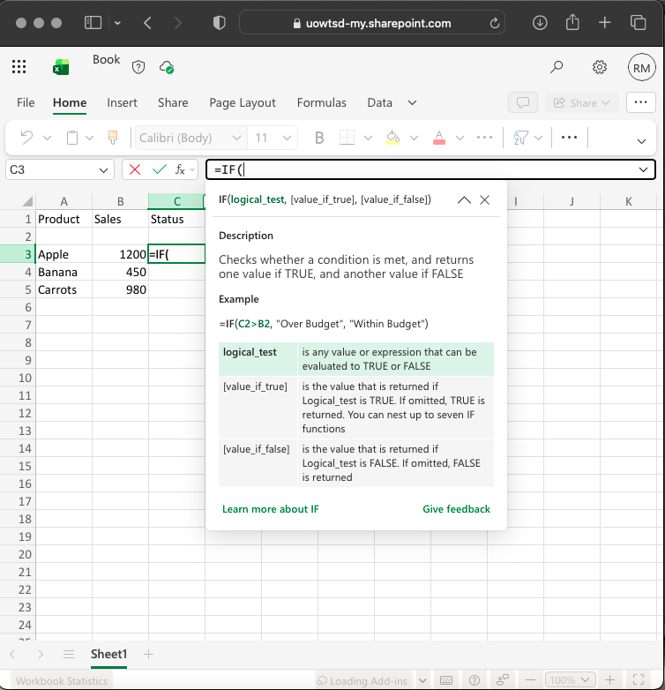
Figure 12Snapshot

STEP 2: Prepare Your Data Table

Create table in Excel:

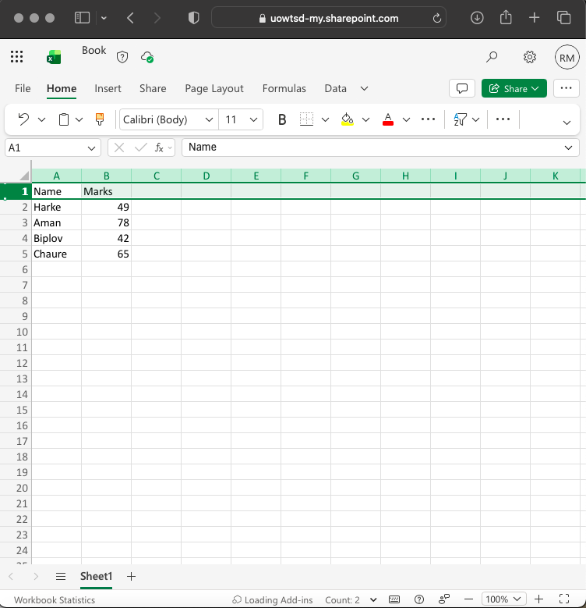
Figure 13Snapshot

STEP 3: Enter Simple IF Formula - Pass/Fail

Click in C2 and type: =IF(B2>=50,"Pass","Fail")
Press Enter. If the marks in B2 are 50 or higher, it will show Pass. Otherwise, it will show Fail. The tooltip can help you enter the arguments correctly.

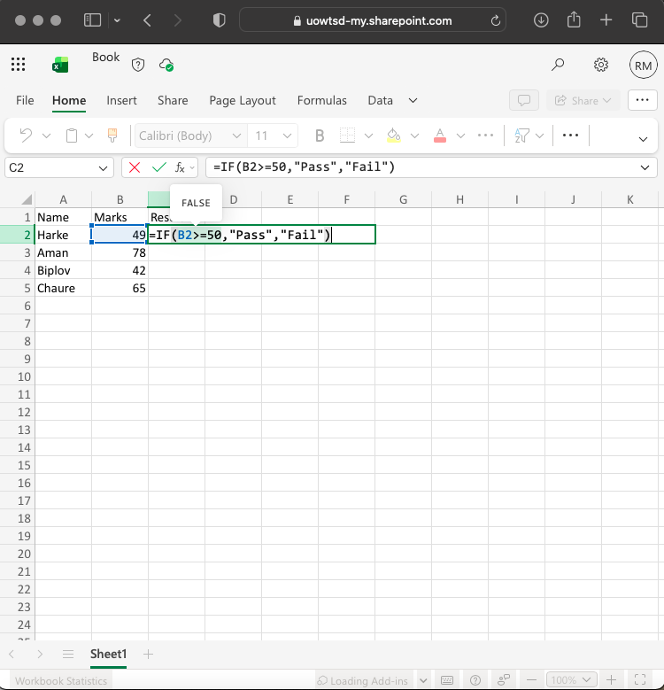
Figure 14Snapshot
STEP 4: Copy Formula Down – AutoFill

Click on cell C2, then drag the small green square in the bottom right corner down to C5. Excel will update the formula for each row, so you’ll see the Pass/Fail results for all students right away.

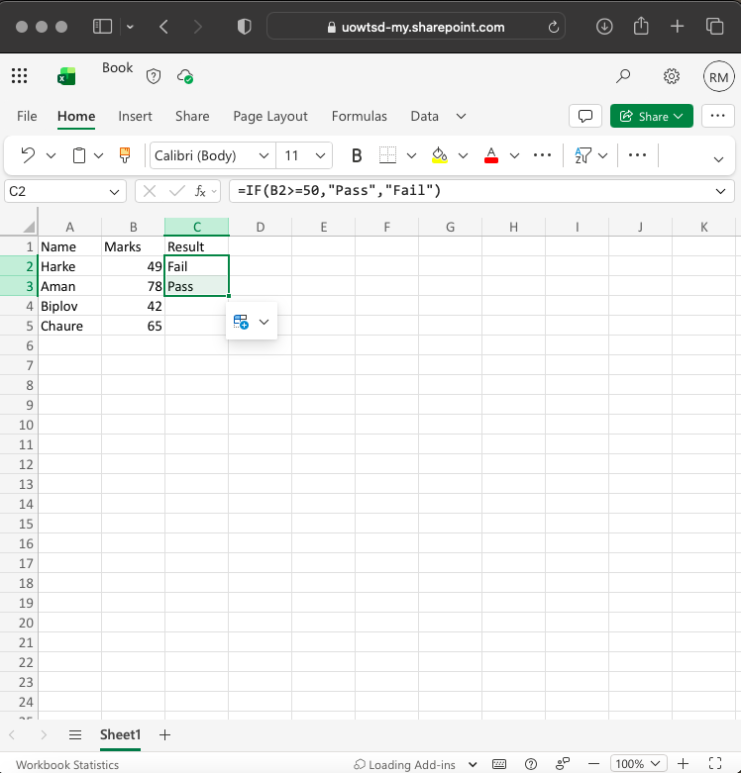
Figure 15Snapshot

STEP 5: Nested IF for Grades - Advanced Level

To handle several conditions, use a Nested IF formula.
=IF(B2>=80,"A",IF(B2>=60,"B",IF(B2>=40,"C","F")))
Here’s how it works: If the score is 80 or higher, the grade is A. If it’s 60 or higher, the grade is B. If it’s 40 or higher, the grade is C. Otherwise, the grade is F. This formula sets up a grading system. For example, in the image, Harke scored 49 and got a C, while Aman scored 78 and got a B.

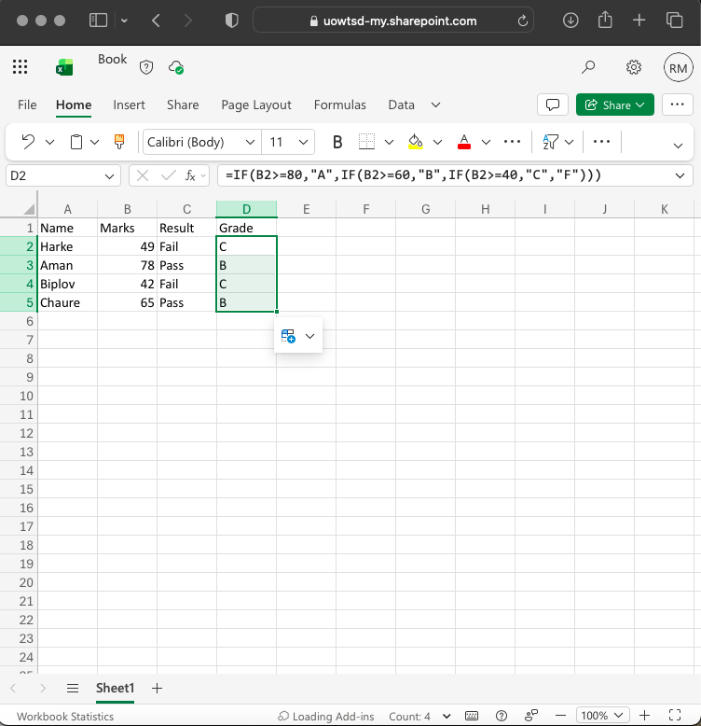
Figure 16Snapshot
STEP 6: IF with AND / OR - Two Conditions

If you want to check two conditions at the same time, use this:
=IF(AND(B2>=50, C2>=50),"Pass Both","Fail")
The AND function needs both conditions to be true. The OR function only needs one to be true. For example: =IF(OR(B2>=50, C2>=50),"Pass","Fail")

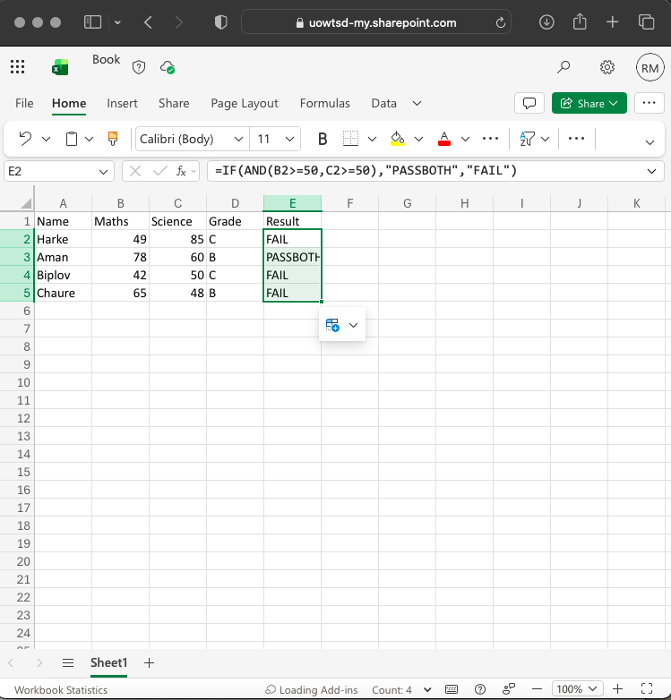
Figure 17Snapshot

Conclusion
The IF statement is a key tool for automating decisions in Excel. A simple IF checks one condition. A nested IF lets you handle several levels, like grades or discounts. IF with AND or OR helps you combine conditions

Task 4. Communication and Collaboration applications

4.1 One contemporary Communication and one Online Collaboration

In today’s business world, communication tools help people share information, while collaboration tools let teams work together on shared projects. Google and Zoom are leaders in both areas.

Gmail

Gmail is the most widely used business email, with over 1.8 billion users. For many companies, it serves as more than just email—it’s a central place for communication.
Gmail’s premium features help you look professional and build trust with a custom email address like you@your-company.com. Gemini in Gmail also lets you write, search, and organize your inbox more quickly.

Key Features:
- Professional identity and organization: Use a custom domain (like @your-company.com) to boost credibility. Gmail also offers powerful search, labels, filters, and a conversation view that keeps related emails together in threads.

- AI-powered productivity: Features like Gemini in Gmail, Smart Compose, Smart Reply, and Smart Scheduling help predict text, suggest replies, and speed up writing.

- Security and confidentiality: Gmail offers strong security features like two-factor authentication, spam filtering, and encryption. In 2025, Google added Client-Side Encryption (CSE) for Workspace enterprise users, so emails are encrypted on the sender’s device before reaching Google’s servers. Gmail also has Confidential Mode for expiring messages and revoking access.

- Integrated communication suite: Gmail works closely with Google Chat and Meet. You can chat, join video calls, and access Drive files right from the left sidebar, all without leaving Gmail.

- Collaboration: You can co-author in real time, @mention colleagues, attach Drive files with permission controls, and see comments as they happen. directly.
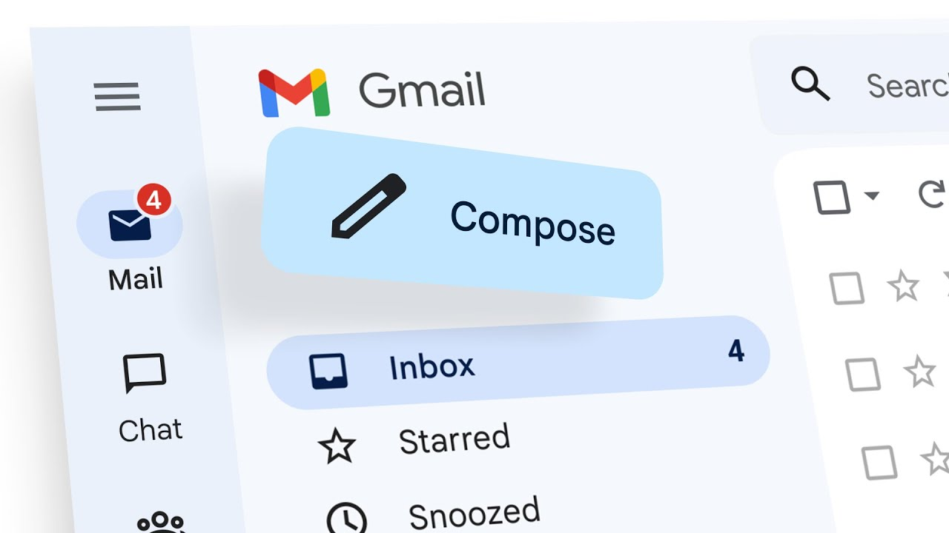
Figure 18https://i.ytimg.com/vi/AbuQ3rXgrfg/maxresdefault.jpg

Zoom

Zoom started as a meeting app but has grown into a full collaboration platform. Its goal is to help people communicate and work together easily, no matter where they are or what device they use.

Zoom Workplace offers tools for real-time communication, like Meetings for video calls, Zoom Chat for instant messaging, and Phone for online calls. For productivity, it also includes Docs for collaborative documents and a whiteboard for visual teamwork.

Key Features:

- HD meetings and scalability: Zoom’s easy-to-use interface lets anyone start or join meetings with just a few clicks. It can handle anything from one-on-one calls to webinars with up to 1,000 participants.

- Collaboration tools: You can work together on whiteboards, documents, notes, and more, both in Zoom and with third-party apps. Participants can share screens, use virtual whiteboards, and even control each other’s screens when needed.

- Unified workspace: Zoom brings together features like whiteboard, team chat, and integrated mail and calendar. It also includes Docs, Clips, and a scheduler.

- Scheduling and accessibility: You can quickly schedule and join meetings with integrated calendar tools. Zoom also supports global collaboration with multi-language captions and translations.

- AI Companion: Zoom’s AI can create meeting summaries, list next steps and action items, and make smart recordings that you can share by email or chat.
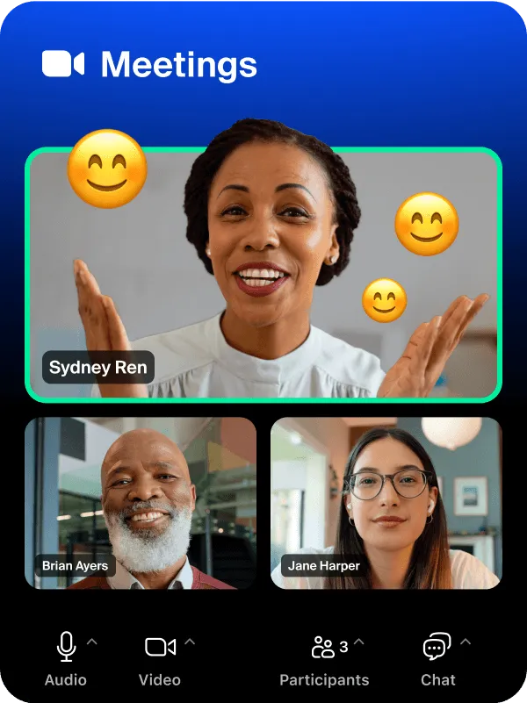
Figure 19https://st1.zoom.us/homepage/20260805-1234/primary/dist/assets/zoommedia/meetings.jpg

4.2 Test one feature of a freely available Communication (1) and one feature of a Collaboration (1) application

Gmail

Gmail – Testing Free Features: Confidential Mode and Schedule Send

A free Gmail account gives you 15GB of storage, AI-powered Smart Compose, Confidential Mode, and Schedule Send. I tried Confidential Mode for secure client emails and used Schedule Send to manage different time zones. Both features work without a paid Google Workspace plan.

GMAIL TEST – Step 1: Composing a New Email (Free Feature)

Go to gmail.com and log in with your free account. Click Compose. Enter the recipient (client@zunki3.com) and the subject. Write your message. At the bottom, click the paperclip icon to attach a file from Drive. This checks how Gmail’s free 15GB storage works with Drive.
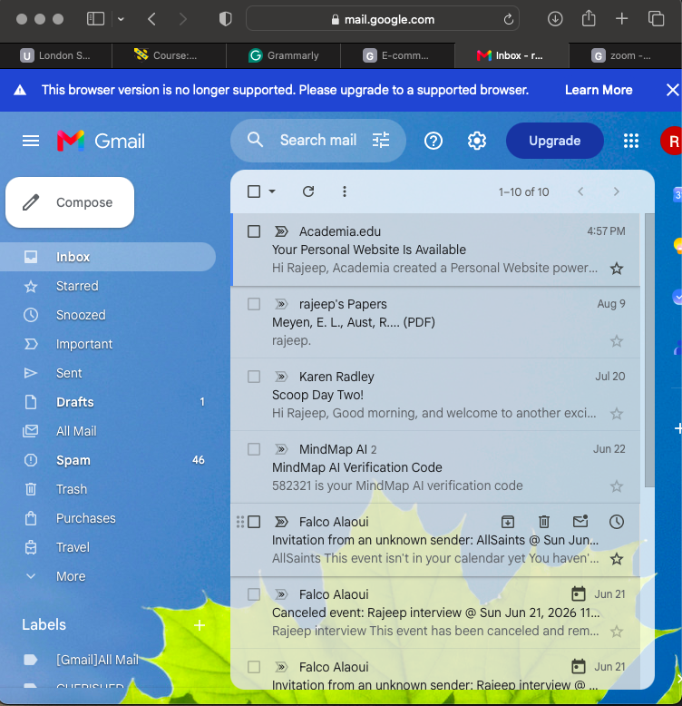
Figure 20Snapshot

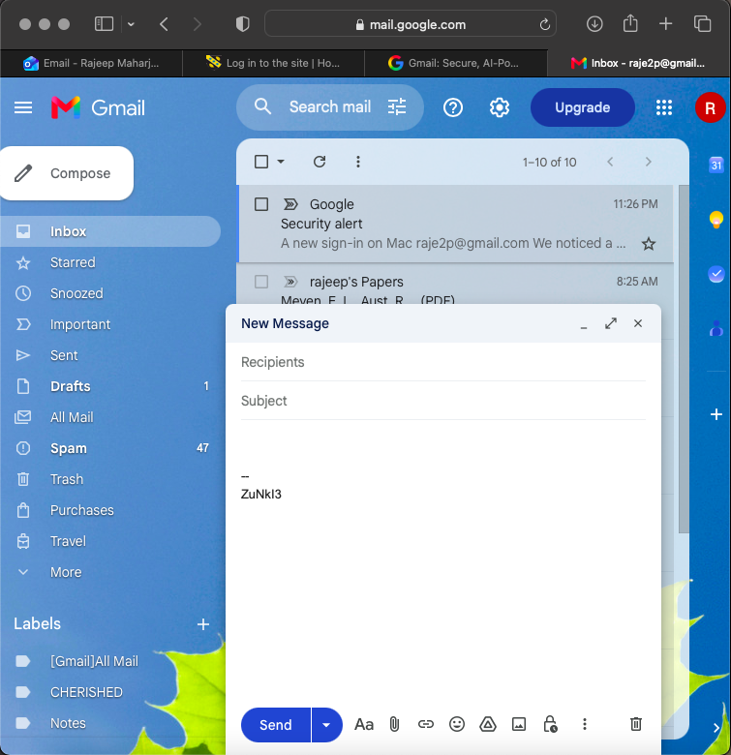
Figure 21Snapshot
GMAIL TEST - Step 2: Enable Confidential Mode (Free Security Feature)

In the compose window, click the lock and clock icon to turn on Confidential Mode. When the dialog opens, set the expiry to 1 week and choose SMS passcode for verification. Click Save. You’ll see a note at the bottom saying recipients can’t forward, copy, print, or download the email. This shows how Gmail’s free encryption helps protect sensitive business information.

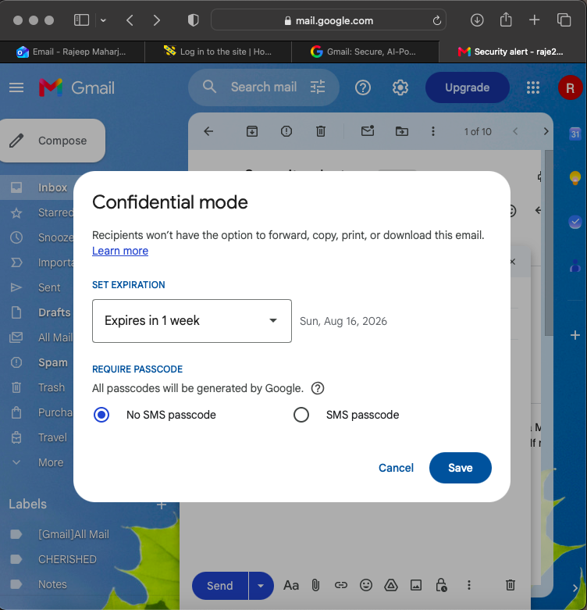
Figure 22Snapshot

GMAIL TEST - Step 3: Schedule Send (Free Productivity Feature)

To schedule an email in Gmail, click the drop-down arrow next to Send and select Schedule Send. Then, choose Tomorrow morning at 8:00 AM. Gmail will move your email to the Scheduled folder. You can check a screenshot to confirm it is scheduled. This feature is helpful for sending emails across different time zones. Free users can schedule as many emails as they want. To verify or cancel a scheduled email, go to the Scheduled folder.

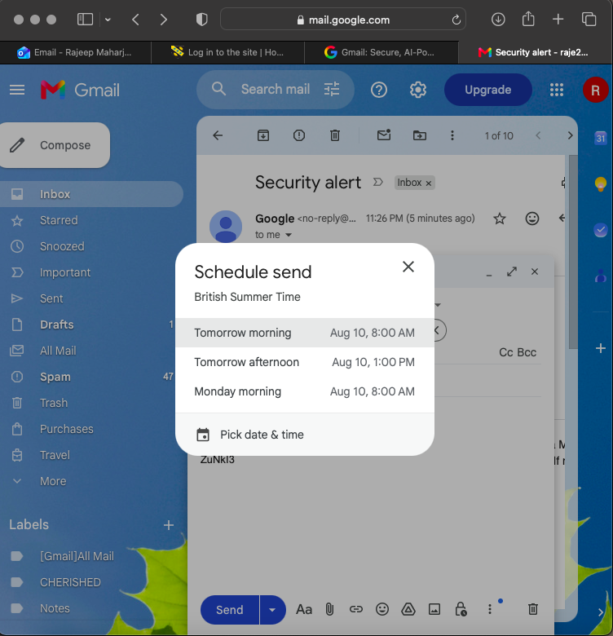
Figure 23Snapshot

Observation - Gmail Test
The email was moved to the Scheduled folder and expired after one day, as planned. The recipient needed an SMS passcode to open it. This feature worked right away on a free account, showing that Gmail’s free version offers strong security and productivity tools at no cost. This helps protect Zunki3 design files from being forwarded.

Zoom

Zoom Workplace: Testing Free Features Like Scheduling, Screen Sharing, and Whiteboard

The free Zoom plan lets you host 40-minute meetings, use HD video, share your screen, use a whiteboard, chat, and record locally. I tried out the scheduling and visual collaboration tools, which are important for working together online.

Zoom Test, Step 1: Open Zoom Workplace and Schedule a Meeting (Free Feature)

Go to zoom.us, sign up for free, and open Zoom. Click 'Schedule a Meeting' to start collaborating.

Figure: ZOOM TEST - Step 1: Open Zoom Workplace - Schedule a Meeting (Free Feature)
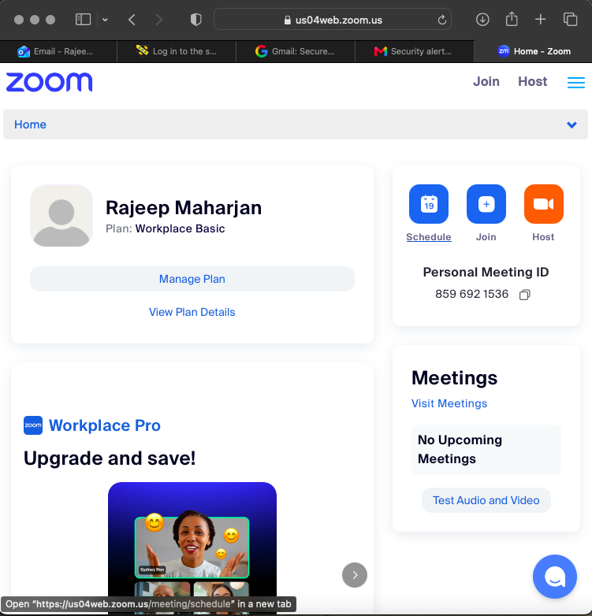
Figure 24Snapshot
ZOOM TEST - Step 2: Enter Meeting Details

Let Zoom auto-generate the Meeting ID and enable the passcode. Zoom will create the meeting link and add it to your Google Calendar with the invite.

Step 2: Fill Meeting Details

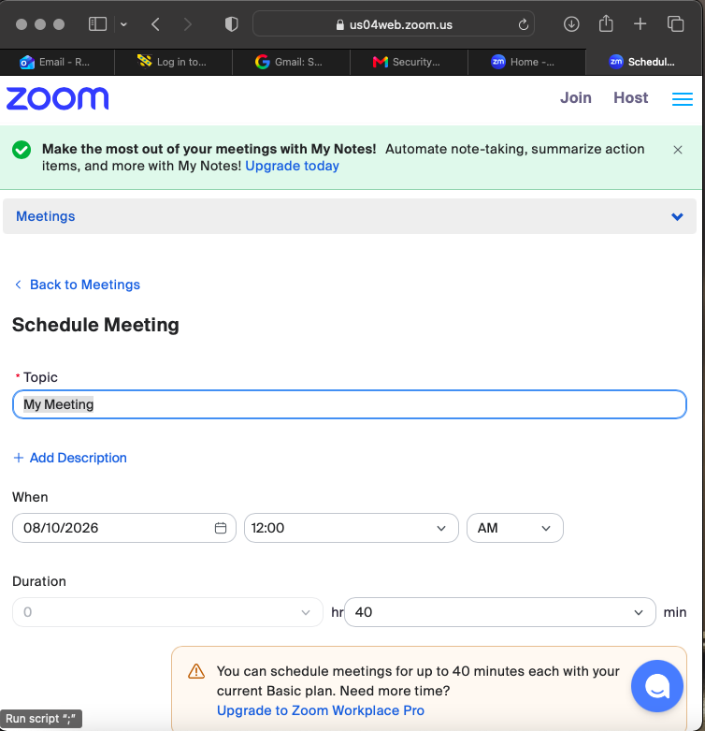
Figure 25Snapshot

ZOOM TEST - Step 3: Start Meeting & Test Screen Share + Whiteboard

Start your meeting and click Share Screen,
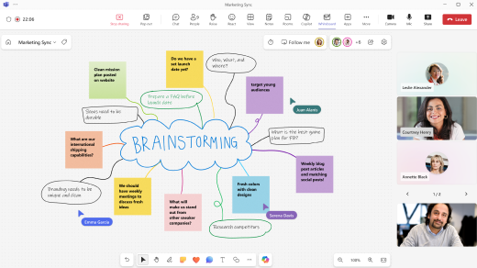
Figure 26Start Meeting & Test Screen Share + Whiteboard

Zoom Test Observations
The meeting link was created right away, and a calendar invite was sent. Screen sharing was in HD with no lag, and whiteboard updates showed up in real time for everyone.

Conclusion

This report has demonstrated that contemporary software selection must align with specific business needs rather than adopting a one-size-fits-all approach. The comparison of Wix and Shopify reveals a clear trade-off between design flexibility and e-commerce scalability: Wix offers an accessible, template-rich environment ideal for SMEs prioritising rapid deployment and visual customisation, while Shopify provides a specialised, scalable commerce infrastructure suited to growth-oriented retailers requiring extensive integrations and global payment options [1]-[3].
Secondly, mind mapping, both as a concept and through modern digital tools such as Miro and Mind Meister, proves to be more than a note-taking technique. By leveraging radial, non-linear visualisation, it enhances collaboration, accelerates planning, and improves retention of complex information, addressing key challenges in distributed project management [4]-[6].
Finally, the analysis of Microsoft 365 applications confirms their continued relevance as an integrated productivity ecosystem. Word remains indispensable for structured document creation and collaborative review, Excel provides versatile analytical power despite scalability limits, PowerPoint facilitates engaging communication, and Access offers a low-code relational solution for departments exceeding spreadsheet capabilities but not yet requiring enterprise databases [7]-[10].

Together with tested features such as Mail Merge, these tools illustrate how core office applications continue to support the full information lifecycle in modern business operations.

References

Task 1 References
[1] Wix.com, "eCommerce website builder: Build an eCommerce site," Wix.com, 2026. [Online]. Available: https://www.wix.com/ecommerce/website. [Accessed: 10-Aug-2026].

[2] S. Massey, "Best ecommerce website builder of 2026: 10+ services compared," Gizmodo, 2026. [Online]. Available: https://gizmodo.com/best-ecommerce-website-builder. [Accessed: 10-Aug-2026].

[3] PageFly, "Shopify website builder (2026): 8-step guide + pricing," PageFly.io, 2026. [Online]. Available: https://pagefly.io/blogs/shopify/shopify-website-builder. [Accessed: 10-Aug-2026].

Task 2 References
[4] The Digital Project Manager, "10 best mind mapping software for teams in 2026," thedigitalprojectmanager.com, 2026. [Online]. Available: https://thedigitalprojectmanager.com/tools/best-mind-mapping-software/. [Accessed: 10-Aug-2026].

[5] Boise State University, "What is mind mapping?," boisestate.edu, 2026. [Online]. Available: https://www.boisestate.edu/elearning/what-is-mind-mapping/. [Accessed: 10-Aug-

[6] Indeed Editorial Team, "What is a mind map? Benefits explained," Indeed Australia, 2024. [Online]. Available: https://au.indeed.com/career-advice/career-development/what-is-a-mind-map. [Accessed: 10-Aug-2026].

Task 3 References
[7] G2, "Microsoft Word pros and cons | User likes & dislikes," G2.com, 2026. [Online]. Available: https://www.g2.com/products/microsoft-word/reviews. [Accessed: 10-Aug-2026].

8] Vedantu, "PowerPoint presentation software guide," Vedantu.com, 2025. [Online]. Available: https://www.vedantu.com/coding-for-kids/python-powerpoint-presentation. [Accessed: 10-Aug-2026].

[9] G2, "Microsoft Excel pros and cons | User likes & dislikes," G2.com, 2026. [Online]. Available: https://www.g2.com/products/microsoft-excel/reviews. [Accessed: 10-Aug-2026].

[10] G2, "Microsoft Access reviews 2026: Details, pricing, & features," G2.com, 2026. [Online]. Available: https://www.g2.com/products/microsoft-access/reviews. [Accessed: 10-Aug-2026]. [2]

Bibliography

[1] | Boise State University, “What is mind mapping?,” boisestate.edu, 2026. [Online]. Available: https://www.boisestate.edu/elearning/what-is-mind-mapping. [Accessed 10 August 2026].
[2] | S. Massey, “Best ecommerce website builder of 2026: 10+ services compared,” Gizmodo, 2026. [Online]. Available: https://gizmodo.com/best-ecommerce-website-builder. [Accessed 10 August 2026].
[3] | PageFly, “Shopify website builder (2026): 8-step guide + pricing,” PageFly.io, 2026. [Online]. Available: https://pagefly.io/blog/shopify/shopify-website-builder. [Accessed 10 August 2026].
[4] | The Digital Project Manager, “10 best mind mapping software for tams in 2026,” thedigitalmanager.com, 2026. [Online]. Available: https://thedigitalprojectmanager.com/tools/best-mind-mapping-software/. [Accessed 10 August 2026].
[5] | Wix.com, “eCommerce website builder: Build an eCommerce site,” Wix.com, 2026. [Online]. Available: https://www.wix.com/ecommerce/website. [Accessed 10 August 2026].
[6] | Indeed Editorial Team, “What is a mind map? Benefits explained,” Indeed Australia, 2024. [Online]. Available: https://au.indeed.com/career-advice/career-development/what-is-a-mind-map. [Accessed 10 August 2026].
[7] | G2, “Microsoft Word pros and cons | User likes & dislikes,” G2.com, 2026. [Online]. Available: https://g2.com/products/microsoft-word/reviews. [Accessed 10 August 2026].
[8] | Vedanatu, “PowerPoint presentation software guide,” Vedantu.com, 2025. [Online]. Available: https://www.vedantu.com/coding-for-kids/python-powerpoint-presentation. [Accessed 10 August 2026].
[9] | G2, “Microsoft Excel pros and cons | User likes & dislikes,” G2.com, 2026. [Online]. Available: https://www.g2.com/products/microsoft-excel/reviews. [Accessed 10 August 2026].
[10] | G2, “Microsoft Access reviews 2026: Details, pricing, & features,” G2.com, 2026. [Online]. Available: https://www.g2.com/products/microsoft-access/reviews. [Accessed 10 August 2026].

