Empire Construction on behalf of UWTSD

University Lecture Hall Project
Langdon Road, Swansea, SA1 1LY

  - 25 January 2023
Feasability Study

Contents

1.0 Introduction 5
1.1 Study Team 5
1.2 Context of the Report 5
1.3 Scope of the Report 5
2.0 Background Information 6
2.1 Supplied Information 6
2.2 Past and Present Use of the Building 6
2.3 Current/ Proposed Occupancy 6
3.0 Project Brief 7
3.1 Client Requirements 7
3.2 Operational Needs 7
3.3 Funding Provision 7
3.4 Programme Phasing 7
4.0 Site/Location 8
4.1 Location Description 8
4.2 Legal Ownership 8
4.3 Site History 8
4.4 Site Investigation 9
4.5 Site Contamination 10
4.6 UXO Testing 11
4.7 Site Geology/ Substrata 11
5 Development Constraints 17
5.1 Listed Buildings and Conservation Areas 17
5.2 Flood Consequence Assessment 18
5.3 Environmental Protection Requirements 19
5.4 Highways Constraints and Improvements 20
5.5 Surrounding Development 21
5.6 Services Constraints 21
5.7 Client Imposed Constraints 21
9.0 Programme 30
References 32

Introduction

Empire Construction have been appointed as lead consultants by University of Wales Trinity Saint David in September 2022 to carry out a feasibility study for the potential development of a new landmark lecture hall building in SA1. The scheme is being considered due to the huge influx of students wanting to study in University of Wales Trinity Saint David. The current facilities do not meet the required space and the University have asked for a new campus.

1.1 Study Team
Empire Construction has taken all responsibilities for this feasibility report. Sub sections have been delegated to appropriate managers and the headings have been colour coded. The key to the colour coding is at the bottom of the document.

1.2 Context of the Report
This report is set out in various sections to present the areas of consideration that have been followed to produce the final report.
Section 2 – Background information, including supplied information from the client. Current/historic use of the site and the proposed occupancy of the site.
Section 3 – This section covers the clients brief and specific requirements and needs specified in the brief.
Section 4 – This section covers the site in detail.
Section 5 – This section covers development constraints.
Section 6 – This section covers accommodation requirements.
Section 7 – This section covers the design and specification.
Section 8 – This section covers cost estimates.
Section 9 – This section covers the project programme and estimated milestones.
Section 10 – Conclusions/ Recommendations
Section 11 – Drawings and associated information.

1.3 Scope of the Report
The project brief required that the study focuses on the immediate area surrounding the site and all areas within the site boundary which can be seen in Figure 1, the red line denotes the site boundary.
This report aims to offer a set of commercially viable set of proposals which Empire Construction can implement. Areas for special consideration consist of:
- The impact the development has on the surrounding area and residents.
- Suitable access for the development including adequate parking and sustainable transport options.
- Environmentally landscaping the grounds for community use and providing greater biodiversity.
- Options for renting the proposed areas to external parties.
- An educational construction process that aids student learning with the use of suitable innovative technologies and sustainable materials and design options.
- Ground conditions of the site, including historical use.

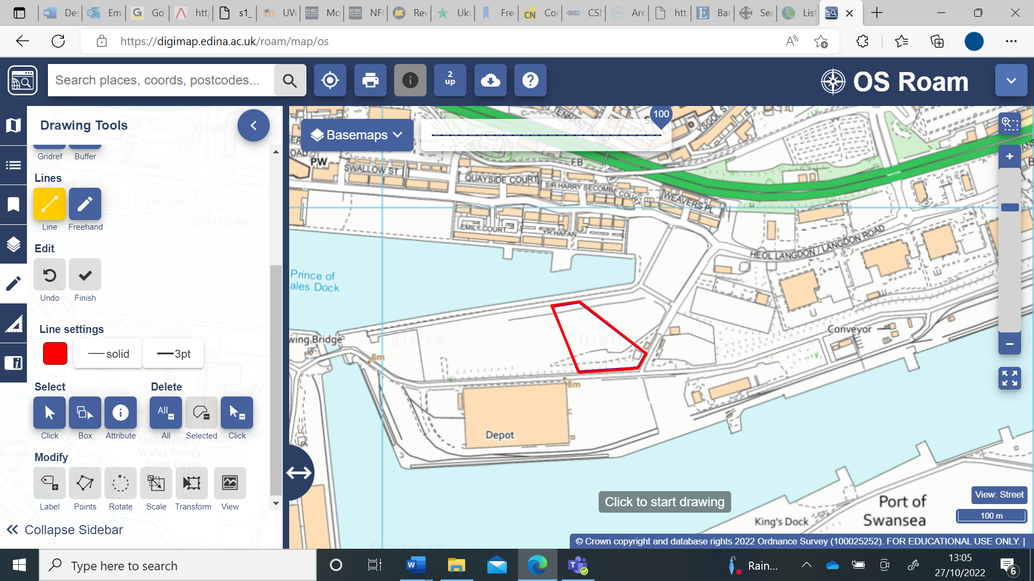
Figure 1 -Site Location and Study Area (Digimap, 2018)

2.0 Background Information

2.1 Supplied Information
The client has expressed that they have full ownership of the site, however no further information was passed over on purchase of the site.

2.2 Past and Present Use of the Building
The proposed site is a brown field site with no current building or occupancy. The site has previously been part of the Port Tennant copper works site in the early 1900’s and has had light industrial buildings within the boundaries. Rail lines have previously run through the proposed site but have been removed over 40 years ago as is consistent with much of the area surrounding the site.

2.3 Current/ Proposed Occupancy
As stated, there is no current use to the site. The proposed occupancy is to be based for higher level educational purposes with the potential for a multiuse function. The proposed maximum occupancy is to be around 1000 people based on the building being at max capacity of the proposed design.

3.0 Project Brief

3.1 Client Requirements
The proposed project features a landmark feature lecture hall building that consists of:
- Ten lecture rooms to facilitate thirty students each.
- Four lecture theatres for eighty students each split of three floors.
- One tiered lecture hall to facilitate three hundred people.
- Appropriate facilities.
- Options for the above facilities to be rented to external parties out of term time.
- Construction type is to aid the education process by using innovative technologies and sustainable materials.
- The grounds should be environmentally landscaped for community use and provide greater biodiversity.
- Parking for the facilities, including rechargeable spaces and sustainable transport options.

3.2 Operational Needs
The proposed project is to meet the building requirements set out by the Welsh Government including meeting requirements for the Welsh Government Digital Strategy for Wales. The proposed project is to meet the required performance standards and comply with all Welsh building standards.

3.3 Funding Provision
The funding for this project has been supplied by a private investor supporting the clients and are available to the clients when required. No maximum budget has been set but prices must be justified to the client team.

3.4 Programme Phasing
As set out in the CDM 2015 regulations, Empire Construction will be responsible for producing a construction phase plan. This Is to be completed before any work starts on site.
The document will include:
- An overview of the project covering all key dates and deadlines.
- An overview of the project management team, contractors, principal designer and suppliers.
- Management arrangements for each area of the project.
- Health and safety procedures for the project and emergency procedures.
- Security, training, and induction procedures.
- Control measures for significant risks.
- A detailed health and safety file.
- Project specific design and construction hazards.

4.0 Site/Location

4.1 Location Description
The site is located in the SA1 postcode of Swansea. It has access from two roads. Langdon Road to the North of the site and Kings Dock to the south of the site. This will provide good access for HGV’s and deliveries of materials without adding to the congestion. To the north of the site across from the Price of Wales dock is a new build estate with a modern look which uses Langdon Road for access.
Within the site boundaries the land is a brownfield site with no current occupation but with one small brick building. The land is comprised of grass and weeds, small areas of hard standing and tape denoting areas of Knotweed. Services are located on site and can be accessed through manhole covers.
The site has views over Swansea Bay. However, the proposed design will restrict some of the views of the residents to the north of Prince of Wales dock.

4.2 Legal Ownership
The client has legal ownership of the site and there are no disputed boundaries.

4.3 Site History
The site has a rich history previously being located in the Port Tennant Copper Works grounds in 1880 as seen in Figure 2. A search on Digimaps historical view shows the grounds of the site were used for industrial purposes. A further look at the historical data, showed that the land around the site is reclaimed land. Over beginning the 20th century a few small industrial buildings and sheds had been placed within the site boundaries. Towards the latter halve of the century these structures had been removed and the ground was being used for rail lines, in which multiple lines crossed over the site boundaries. The history of the site makes it highly likely that there are potential contaminations within the site boundaries.
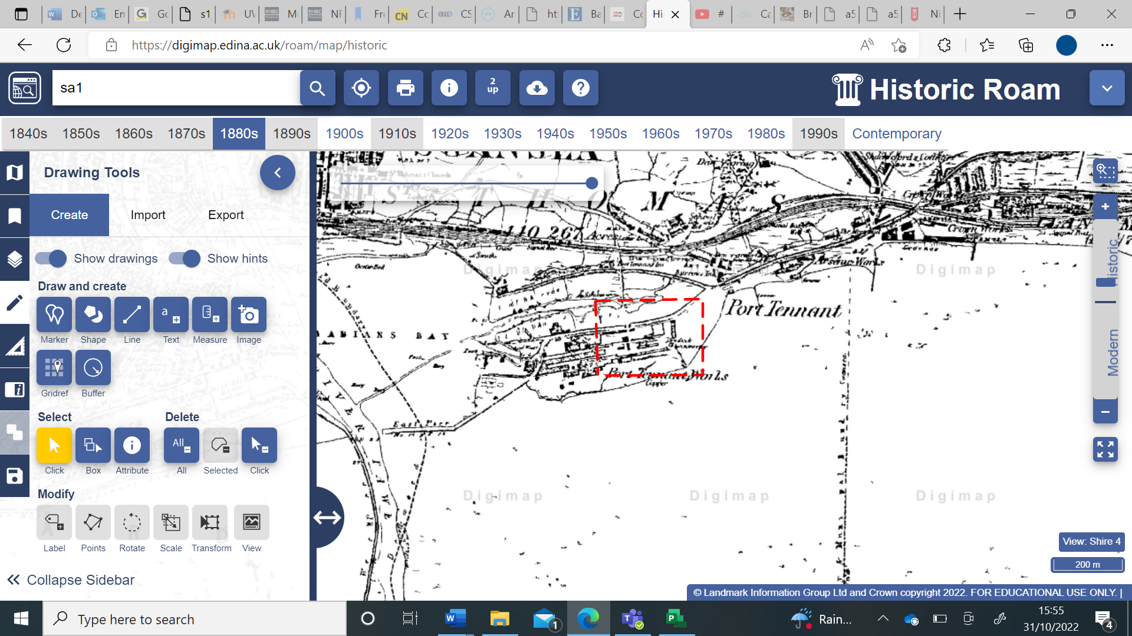
Figure 2 - 1880 Historical Map (Digimaps 2018)

4.4 Site Investigation
Recent borehole log taken from a close by site has been used to analyse the most likely conditions underneath the surface of our site. As shown below in Figure 3, the first 4.35 meters is consistent of made ground. This is common amongst much of Swansea waterfront as ash was used to make up the ground before laying the rail lines and is consistent with the data found from Digimaps where the site had previous rail lines running through it. Beyond 7.3 meters of depth the ground consists of stiffer boulder clay and at nearly 20 meters of depth, the ground turns to mudstone. The borehole log suggests that for a structure as large as the proposed one, a pile foundation will be required.
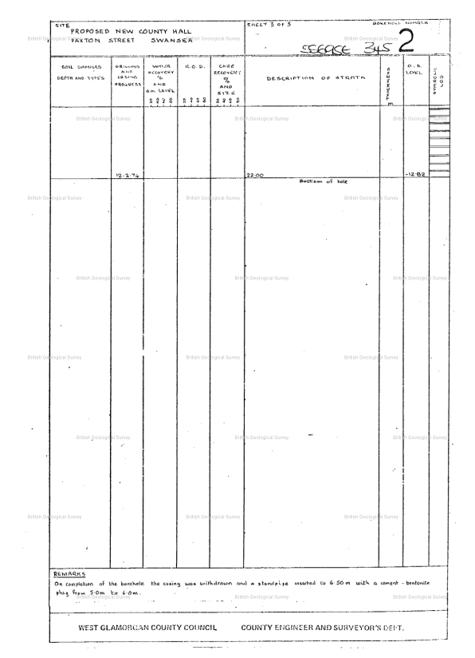
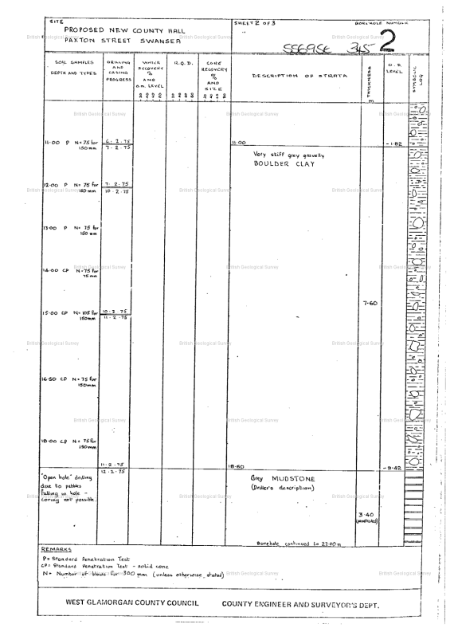
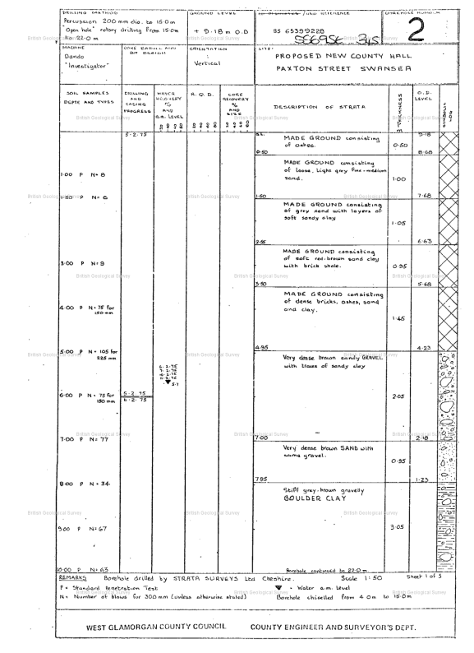
Figure 3 - Borehole Log of a Local Site

4.5 Site Contamination
Due to the history of the site, it is highly likely the ground will be contaminated from previous occupation. A ground contamination and gas test are to be arranged before any works on site. Prices for basic soil testing can vary from £100 - £250 or above per sample. It is strongly recommended to the client multiple samples are taken from various locations on the site to ensure contamination will not affect the sub-structure of the project. A suitable company to undertake the soil testing would be ‘The Testing Lab’. After soil collection they provide a comprehensive report in line with BS1377.

4.6 UXO Testing
The historical data surrounding the SA1 area of Swansea and World War II, suggests that the area within the site boundaries would have felt the effects of the Blitz carried out by the German Luftwaffe. Due to the risk of encountering an unexploded ordinance (UXO) while conducting the groundworks being high, it is strongly recommended and in line with CIRIA C681, CDM 2015 and the ‘Health and Safety at Work act 1974’, that the client proceeds with an intrusive UXO test to ensure the health and safety of their employees while at work. There are multiple companies offering both preliminary testing starting from £150 and an extensive test for a further fee based on the site. A recommendation is to go with 1st Line Defence to receive a full comprehensive report on the site findings.

4.7 Site Geology/ Substrata

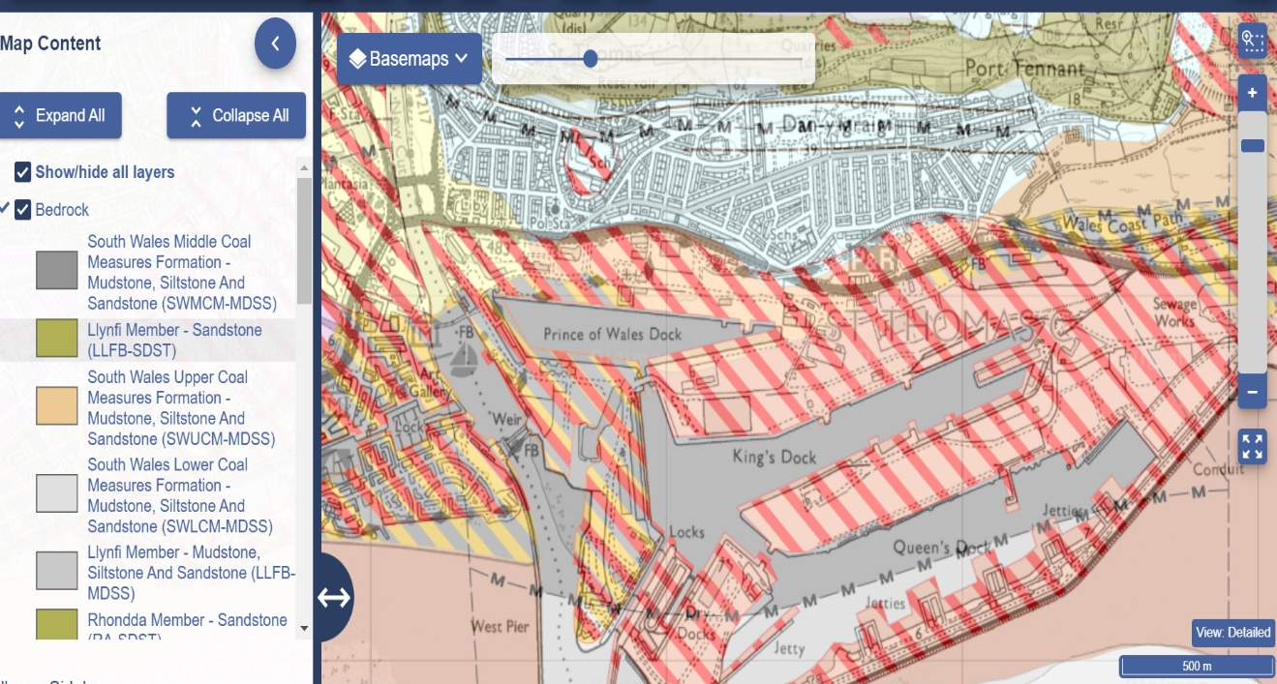
As seen in Figure 4, the geology of the site is consistent with the borehole log. The red and white hashing on the map denotes artificial man-made ground. The underlying grey colour denotes Mudstone, Siltstone and Sandstone, as also seen in the borehole log at a depth of 18 meters.

Figure 4 - Site Geology, Substrata Map (Digimaps, 2018)

This geology is vital for our project as it helps us understand the ground conditions and make informed decisions about the construction methods and materials to be used. The presence of Mudstone, Siltstone, and Sandstone at a depth of 18 meters indicates that the ground is relatively stable and can support the load of the proposed structure. The artificial man-made ground, denoted by the red and white hashing on the map, is also important to consider as it may affect the stability of the surrounding areas. By taking into account this geology information, we can implement appropriate measures to ensure the safety and stability of the construction site and the surrounding environment.

5 Development Constraints

5.1 Listed Buildings and Conservation Areas
Although there are 31 protected conservations sites within Swansea our site does not fall into any of these locations and therefore the site hasn’t got any development constraints placed upon it by CADW. The nearest conservation areas to our site are across the river Tawe and cover the Maritime Quarter and Wind Street. The site is not within either boarder or therefore does not need to consider these when planning. As CADW maps state, there are no listed buildings or buildings of interested near the site. Although there are multiple ancient monuments within a 5km radius, there is an adequate buffer of at least 2km.
Planning consent has not been granted yet for our specific concept, however due to other local projects such as the UWTSD Innovation Matrix building being granted planning permission within recent months it is fair to assume it is probable that planning consent will be granted providing all necessary procedures are followed.

5.2 Flood Consequence Assessment
As seen below in Figure 7, the site and the surrounding area are included in flood zone 2 and 3. Therefore a flood consequence assessment is to be carried out in accordance with chapter 7 of the new TAN 15 which is to be published June 2023.
The following categories are to be include in the assessment:
- All sources of flooding
- Coastal erosion risks
- Evidence from NRW including maps and modelling
- A range of climate change scenarios including 1000-year events
- The shoreline management plan polices for the area
- Natural flood and water management schemes including Sustainable Drainage Systems
- Options like managed coastal realignment and floodplain restoration where appropriate, for instance in areas where existing development is unsustainable, or in sparsely developed areas
- Relevant links with the Welsh Government National flood and coastal erosion risk management plan.

We recommend the flood consequence assessment is to be outsourced to Geo Smart Information. This would incur a fee starting from £1195 + VAT. The ‘Floodsmart Plus’ report satisfies all regulations regarding the assessment required.
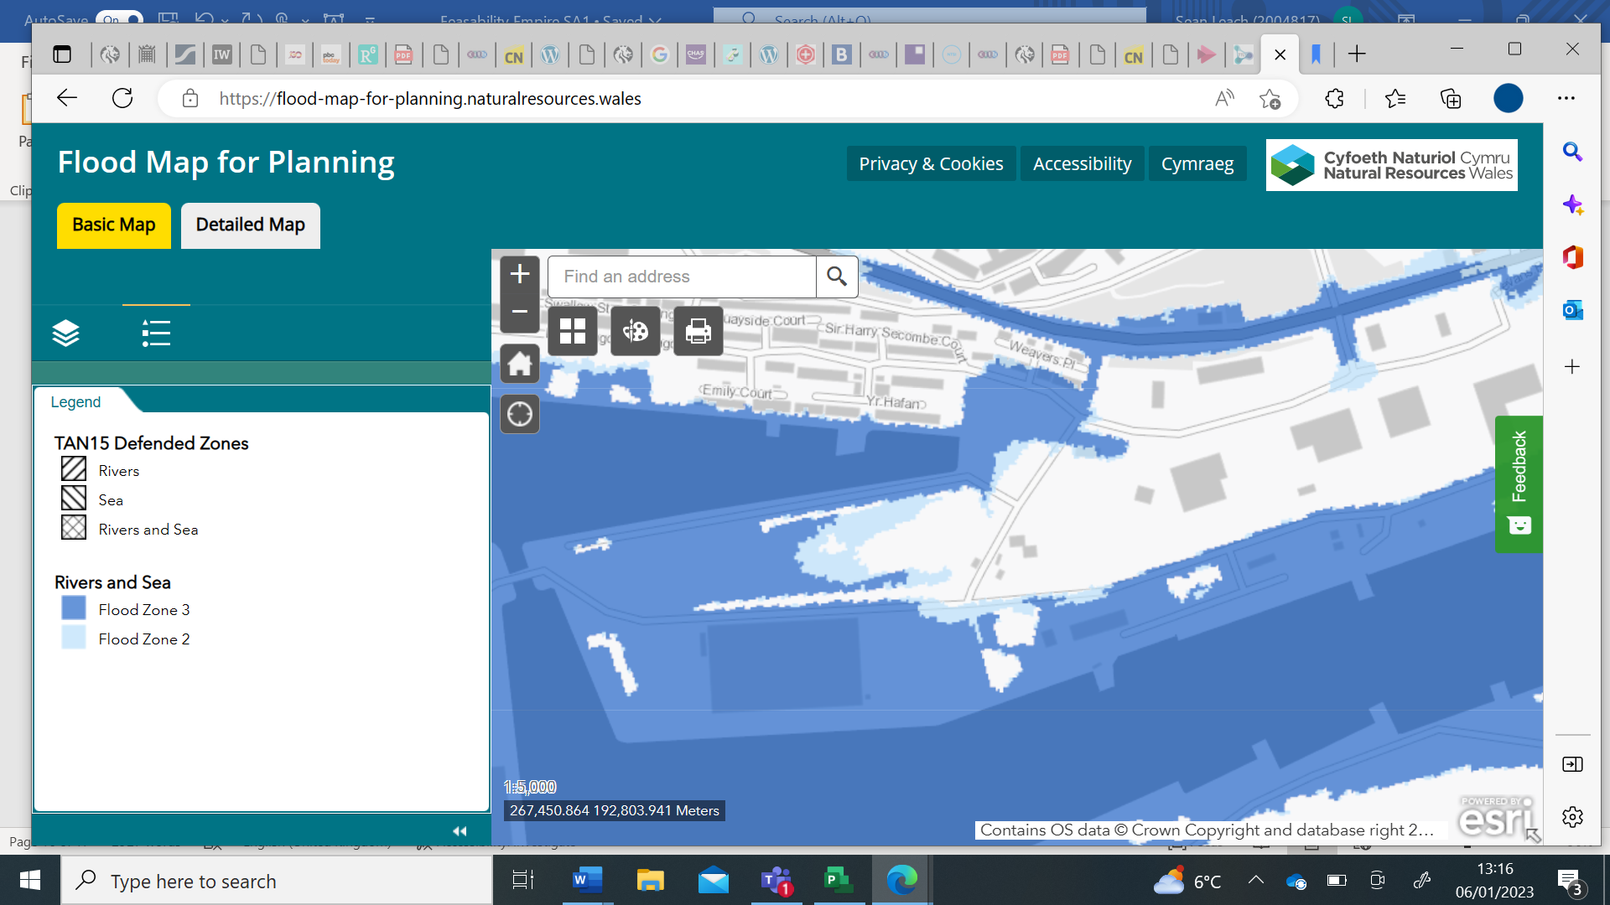
Figure 7 - Flood map for planning (NRW, 2022)
NRW’s comment on current food risk: The Addendum recognises that there is an existing flood risk to the development area and that when climate change allowances are applied this could increase. The latest tide levels have been considered and both climate change allowances and confidence levels have been applied to the 0.5% and 0.1% tide levels. The Addendum proposes that finished floor levels of commercial buildings will be set at a minimum of 7.13m AOD and for residential buildings this will be 7.50m AOD. We can confirm that this will ensure that the proposed buildings will comply with Tables A1.14 and A1.15 of TAN15.
The existing ground levels of the proposed development area for the SA1 development are above the assessed T200 plus climate change level of 7.13m. The site is accessed via Langdon road to the south and an unnamed works access road to the north and these roads satisfy the minimum requirements for flood evacuation routes being above the T200 flood level and no less than 0.30m below the T1000 flood level. Any basements or under croft car parking would need to be designated for suitable use in view of the flood risk with appropriate drainage facilities provided.

5.3 Environmental Protection Requirements

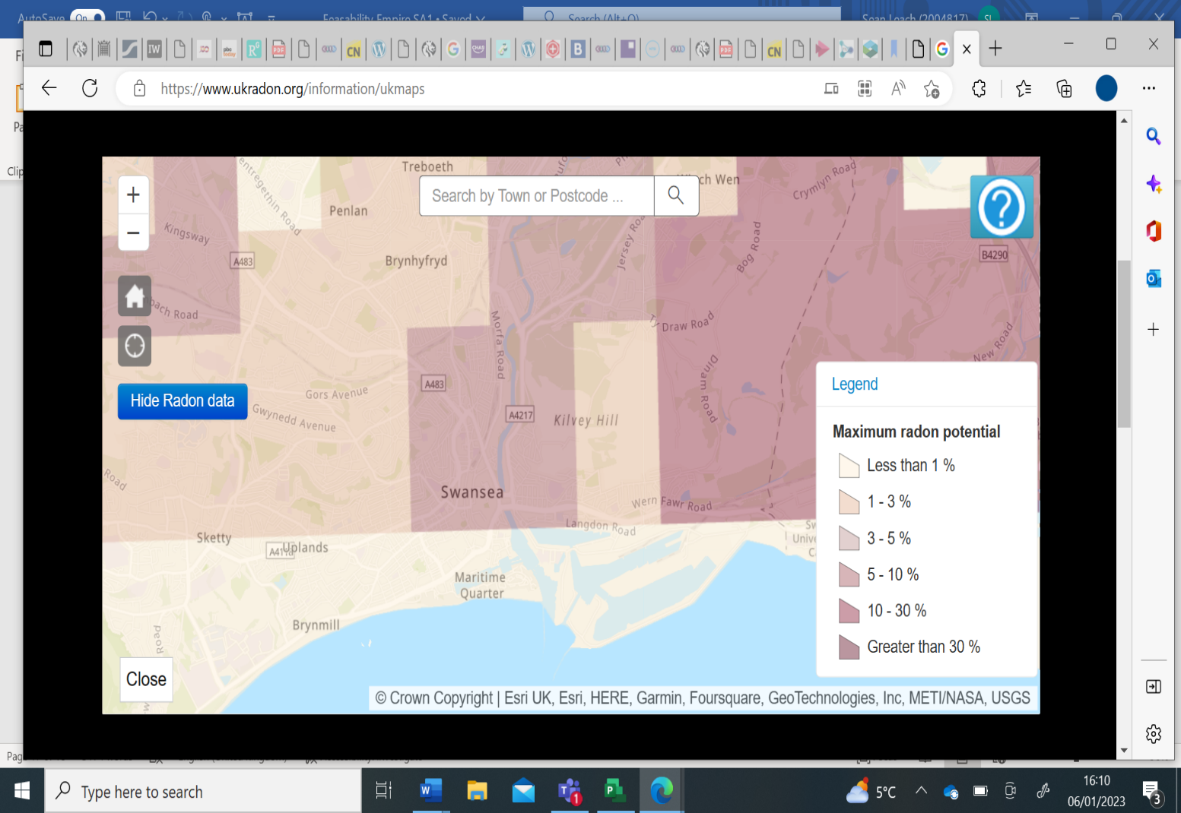
Building regulations dictate that every building must be designed and constructed in such a way that there will not be a threat to the building or the health of people in or around the building due to the presence of harmful or dangerous substances. Figure 8 shows the UK map outlining areas most likely to be affected by radon gas due to their bedrock types. Although the site boundaries fall outside any areas of high risk shown on the map, the design is the comply with relevant legislation and Welsh building regulations to ensure exposure the gas when the building is operational falls within the 400 Bq m³ limit, this can be archived by using an adequate damp proof membrane. If required a methane mitigation system can be designed into the build to take harmful gases and redirect them away from the occupants.

Figure 8 - UK Radon Information map (Public Health England, 2019)

5.4 Highways Constraints and Improvements

No highways complications have been identified for this project. Access from the M4 motorway at junction 42 provides great access for HGV’s or other large cargos to be transported to the site. The site layout allows for vehicles to enter from the South side and leave via the North exit, mitigating the needs for large vehicles to turn in tight spaces, this can be seen in Figure 9. Due to the site being close to the city centre, deliveries will need to be timed to minimise traffic to the surrounding area and site. Small amount of parking will be available on site for specific needs however, the IQ building car park will be available to use and is located within 800m.

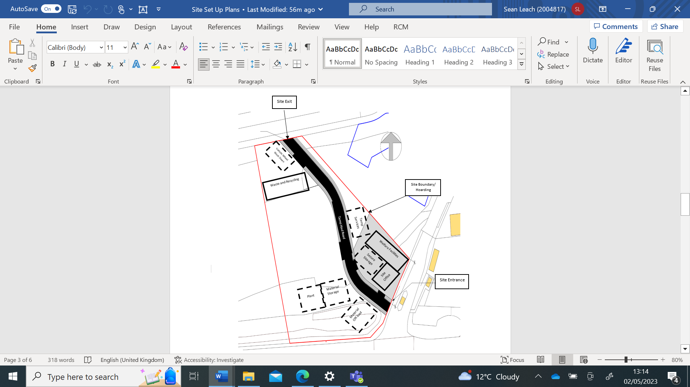
Figure 9 - Proposed Site Arrangement Plan

No major improvements are required for the highways to facilitate the proposed development, partially due to the nature of the development encouraging greener transport and proposed city bus links. The proposed city bus stop of Langdon road is to go ahead as scheduled.

5.5 Surrounding Development

The site falls within the boundaries of the Swansea Innovation Quarter outlined on the Swansea planning portal. Within the Swansea Innovation Quarter boundaries there has been lots of activity over recent years, these developments include construction of UWTSD’s IQ building and Y Forum, construction of residential dwellings and other educational buildings belonging to UWTSD. The proposed development will enhance the area and offer the local community various benefits. The surrounding area consists of newer buildings due to the development consisting of made ground.

5.6 Services Constraints
After consultation with Welsh Water these main points are of significance:
- Foul water and surface water discharges shall be drained separately from the site to protect the integrity of the public sewage system.
- No surface water shall be allowed to connect, either directly or indirectly, to the public sewerage system unless otherwise approved in writing by the Local Planning Authority.
- The development shall not commence until the developer has prepared a scheme for the comprehensive and integrated drainage of the site showing how foul water, surface water and land drainage will be dealt with and this has been approved by the Local Planning Authority.
- Some public sewers and lateral drains may not be recorded on our maps of public sewers because they were originally privately owned and were transferred into public ownership by nature of the Water Industry (Schemes for Adoption of Private Sewers) Regulations 2011.
Other services are presumed to be fine due to previous sites highlighting no issues.

5.7 Client Imposed Constraints
The client is yet to impose any constraints that will affect the project.

9.0 Programme

9.1 Project Programme
The outline brief includes a project handover date to be within Aug 2024. To ensure smooth delivery of the project, a comprehensive programme of works has been produced. The milestones of the project can be seen in the table below with the forecasted dates for completion.
Name | Finish
RIBA Stage 0 Complete | Tue 13/12/22
RIBA Stage 1 Complete | Tue 27/12/22
RIBA Stage 2 Complete | Tue 14/03/23
RIBA Stage 3 Complete | Tue 04/04/23
RIBA Stage 4 Complete | Fri 12/05/23
Substructure Complete | Wed 23/08/23
Building Envelope Sealed | Mon 08/01/24
Superstructure Complete | Fri 12/07/24
Landscaping Complete | Wed 05/06/24
RIBA Stage 5 Complete | Fri 02/08/24
RIBA Stage 6 Complete - Building Handed over and Operational | Fri 09/08/24
Project Completed | Mon 18/08/25

Upon completion of RIBA stage 5, the aftercare team will monitor and assist with operations of the building for one calendar year. A final report will be written on the buildings performance and this will be the official end of the project.

References

Digimap (2018). Historic Roam. [online] Edina.ac.uk. Available at: https://digimap.edina.ac.uk/roam/map/historic.

Digimap (2022). Digimap. [online] Edina.ac.uk. Available at: https://digimap.edina.ac.uk/roam/map/os.
‌
Digimap (2018). Geology Roam. [online] Edina.ac.uk. Available at: https://digimap.edina.ac.uk/roam/map/geology.
‌
NRW (2022). flood-map-for-planning natural resources Wales Story Map Series. [online] Available at: https://flood-map-for-planning.naturalresources.wales/.
‌
Public Health England (2019). UKradon - UK maps of radon. [online] Ukradon.org. Available at: https://www.ukradon.org/information/ukmaps.
‌

‌

Green headings – Jake
Blue Headings – Sean
Purple Headings – Sophie
Red Headings – Llew
Orange – Morgan

