Georgiana-Andreea Ene

1813123

Community Engagement

Lecturer: Gregory Cowan

Table of Contents
Reflective Evaluation of Pizza Express 3
Introduction 3
Evaluating the concept of reflective practice with reference to a reflective model 3
Explanation of the personal experience of the company 5
Analyzing the relationship between the theory and the actual experience 6
Job responsibilities….....………………………………………………………………………6

Issues in encountering the role-play activities 8
Role play experience 9
Conclusion 9
Reference List 10
Appendices 11
Peer Evaluation Role Play Feedback………………....…………………………………………12

Reflective Evaluation of Pizza Express

Introduction

Reflective practice refers to the concept of learning from experiences. It is a continuous process that ensures improvement in a work performed by an individual. There are two types of reflective practices- reflection in action and reflection on action it is regarded as an important tool that can be used as an after reaction of a critical event. It helps in the development of an individual's thinking power.

As suggested by Jiang and Liu (2015), it helps to reduce the gap between theoretical explanation and actual life experiences. As for a company, it is an adaptable process that would help in the development of intrapersonal skills, leadership quality, communication skills and self-management of its employees and management that would ensure improvement in the organizational framework of a company.

Evaluating the concept of reflective practice with reference to a reflective model

As stated earlier reflective practice refers to continuous process of learning from the activities that are performed individually or in a group. As opined by Wallace (2019), reflective practice is an important framework for developing intrapersonal skills that would help in the overall improvement of a company's organizational framework or in developing the skills of an individual.

As for working professional reflective processes plays an important role in Due to its importance many models have been proposed in relation to reflective practices.
Gibbs model is a popular model on reflective practices. The model is mainly influenced by learning cycle by Kolb's that helps in taking effective decisions during critical events. Gibbs model mainly consists of six major elements that operate in the form of an loop. The major elements are as follows:
- Description: This element is mainly concerned with collecting information about a particular event. The information that is collected at this stage should be relevant and true. Usually, conclusions are not drawn at this stage. The major questions that arise during this phase include what happened, How did it occur, When and how did it take place.

- Feelings: This element is solely concerned with an individual's personal experience about the incident that has taken place. According to Sabanci et al, (2016), main point of focus at this phase involves understanding of an individual's personal feelings. The questions that usually appear at this phase includes-What did you feel before the incident took place and how do you feel now about the incident. What are your views regarding the incident and what would be others reaction.

- Evaluation: This phase is solely concerned with the evaluation of the incident. The major questions that arise at this phase are entirely related to the incident that has occurred like what are the negative and positive effect of the incident, what impact would the incident has.

- Analysis: This element is totally concerned with analyzing the outcomes of the incident. According to Wallace (2019), the phase is also concerned with the positive and negative factors that are involved in influencing the particular incident.

- Conclusion: This phase provides feedback about the occurred incident. The main questions involved with this element are as follows-what lesson has the incident provided. How would one avoid the incident if its result were negative, what are the necessary recommendations for the incident.

- Action Plan: This phase deals with future strategies that could be taken when similar incidents occurred. The questions that occurred during this phase are what plan should be initiated for the incident. Attractive type of skills and training should be provided to help individuals during similar incidents.

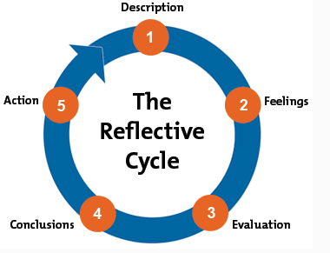
Figure 3: Gibbs Reflective Model
(Source: Influenced by the viewpoint of Wallace, 2019)

Explanation of the personal experience of the company

Pizza Express is one of the leading fast food company in Ireland and the UK that aims to provide delicious food and keeping customers satisfied (Pizzaexpress.com, 2019). The company’s organisational framework is divided into various departments which include finance, HR, marketing, IT, customer services, hotel industry and many more.

I personally worked as a marketing intern with the company for 6 months. During the internship phase, I was allotted the task of collecting quantitative and qualitative data are about the industry market and prepare a market research analysis to understand the potential risk associated with the business and help the management team with the strategy development procedure.

During the entire internship phase, I realized collaboration and cooperation with the entire company members is necessary to establish a productive working environment.
Apart from having professional skills, it is also necessary to have personal skills that help to communicate better with other members of the company.

During the internship phase, I also realized that it's necessary that there should be a good relationship between the management and the employees in order to get desired outcomes from a company's production. As a marketing intern, I too had certain negative experiences because as I was not so much connected with all the members of the team I often faced difficulties in performing the work given in changing working shifts.

Similarly, there were instances where few members were not willing to help me with certain software’s related queries which according to me were quite unprofessional on their behalf. Secondly, during the internship procedure, I also felt that the company lacked in providing good training skills to its interns and employees which can be a major drawback for its all-round development.

Analyzing the relationship between the theory and the actual experience

The Gibbs Reflective Theory model is an important framework that helps in continuous personal development which in turn helps an individual to work efficiently. As opined by Wallace (2019), the model for any incident that has taken place, the actions for that incident can broadly be divided into six phases.

The model states that the first step of any reflective model involves discussing the incident concerned. In the case of the assignment, the incident here can be considered to be my internship phase in the Pizza Express Company. During my internship period, I had worked as a marketing intern for 6 months
.
Job responsibilities:

Main job responsibilities included performing market research analysis for the company to assess the potential risk and helping the advertising department with promotions for the company. It has stated by Rashid and Qaisar (2017), the second phase of the Gibbs model is mainly concerned with the feelings that an individual has for a particular incident. In the case of my internship period, I too had negative and positive experiences related to my workplace.
There were certain instances where I felt obliged to be a part of the company as it helped me to develop many new skills apart from my professional skills development. On the other hand, Praxis effect due to lack of coordination and cooperation between the members of my team has affected my psychological strength. It can be seen that, there were several people who were completely isolated from the group working activity.

The third phase of the Gibbs cycle dealt with the evaluation procedure of the incident. In case of the internship as it was already mentioned that the period had both positive and negative impact, it, therefore, helped me to have a clear picture of the working environment in an office. Further, it also helped me to develop my intrapersonal skills which are very much necessary when I work in some other company.

Lopes et al, (2015) explained that analyzing of different experience can help to overcome the barriers related to work process within an organization. As per the outcomes of the incident, I think it is necessary for me to try to develop my communication skills that would help me to coordinate with my team members so that I would excel in my workplace and be able to develop my skills.
Accessing feedback is another necessary concern at the time of evaluating different factors in workplace experience Wallace (2019). This phase helped me to get a clear view of the working environment in the Pizza Express Company.

It further helped me to analyze the importance of developing self-management, coordination and cooperation skills so that I wouldn't face similar negative experiences in other offices. Besides this, I also felt that the company lacked to provide proper training skills to its employees.
According to the Praxis effect, it can be stated that measures should be taken by me to develop interpersonal skills so that I could communicate and coordinate more with my team members that in turn would help me to work efficiently.

Issues in encountering the role-play activities

During my internship period with the Pizza Express Company, there were many instances where I felt that the company lacked proper coordination skills and management. Being a marketing intern, main job responsibility involved performing a market analysis for the company in order to understand its position in the competitive market and to analyze the potential risk factors associated with it. Before working as an intern I had a notion that the company had a very good working culture.

At the time of role play, I had accessed detail knowledge about the issues inside the company work process. On the other hand according to Sabanci et al, (2016), positive experiences like communication development, self-engagement is really helpful that will create a positive influence in the future career. As per the Role-play segment, there is a problem in negotiating with changing working shifts which create barriers in achieving good output on behalf of the working unit.

Considering the praxis theory Lopes et al, (2015), stated that self-evaluation and problem-solving ability are the most necessary concern in a working process. Working with the company it can be realized that a proper coordinating system that is required to work efficiently was totally absent.
In order to encounter this issue, I have explained the problems that I faced as an intern in the work process. Rotation shift changing had created barriers in meeting with people, being an intern; it was not possible to be aware of all the people in the working place. Thus, I requested to access a single shift which will be helpful to meet the work process requirements in this venture.

Role play experience

As a marketing intern in the Pizza Express, it was experienced by me that cooperation is necessary for any type of managerial area. When I was an intern in the Pizza Express my colleagues and subordinates did not help me to understand the new job task. Sometimes I feel bored to continue my role as an intern in this organization. Marketing is an essential policy for any business process without which a business organization cannot run properly.

As reported by Rashid and Qaisar (2017), training is essential for the overall improvement of performance of an organization. It was noticed by me that Pizza Express do not provide effective skill development training to their staffs. Leaders within the core part of this organization are also not effective enough to motivate their staffs.

Lack of cooperation and collaboration is another important issue faced by this organization. Most of the subordinates and managers do not cooperate within the staffs as well as managers. As opined by Sabanci et al, (2016), management of staffs is essential to incorporate special value within the production process of organization. As per the feedback of senior manager in Pizza Express, collaboration has to be incorporated within the core part of Pizza Express. In future, I want to change overall culture of this organization. Cooperation and collaboration have to be given essential focus under my supervision.

Conclusion

From the overall discussion, it can be concluded that reflective practice is essential to understand the own personal demand. It is a continuous process that ensures improvement in work performed by an individual. In present context role pay, part is crucial for analysis of internal situation of Pizza Express in UK. As per Gibbs reflective model, it is essential to evaluate actual situation. After evaluation of the situation, it is necessary to feel their situation. Moreover, skill development training and collaboration is required as per the personal reflection of marketing intern in Pizza Express.

Reference List

Jiang, J.Y. and Liu, C.W., 2015. High performance work systems and organizational effectiveness: The mediating role of social capital. Human resource management review, 25(1),
pp.126-137.
Lopes, D.C., Gerolamo, M.C., Del Prette, Z.A.P., Musetti, M.A. and Del Prette, A., 2015. Social skills: A key factor for engineering students to develop interpersonal skills. International journal of engineering education, 31(1), pp.405-413.
Pizzaexpress.com(2019) [Online], About Us. Available from: https://www.pizzaexpress.com/ (Accessed on 25th March 2019)
Rashid, S. and Qaisar, S., 2017. Role play: A productive teaching strategy to promote critical thinking. Bulletin of education and research, 39(2), pp. 345-897.
Sabanci, A., Sahin, A., Sonmez, M.A. and Yilmaz, O., 2016. School managers' interpersonal communication skills in turkey. Online Submission, 6(8), pp.13-30.
Wallace, D., 2019. Parts of the Whole: Theories of pedagogy and kolb’s learning cycle numeracy, 12(1), pp.17-78.

Appendices

Appendix 1: Collaboration In work process
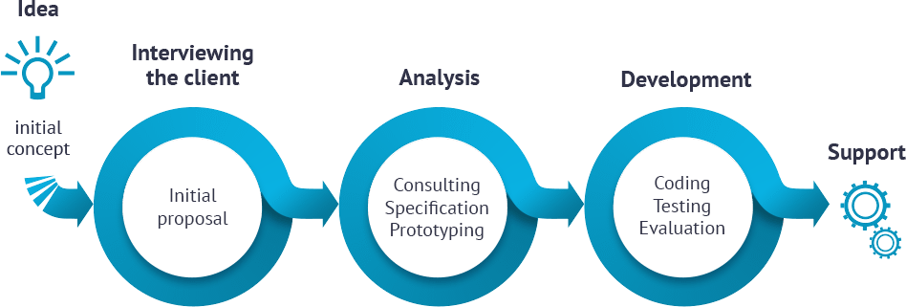
(Source: http://topahead.com/v5/index.php/working-process)



