Learning in the Digital Era
E-Portfolio
Olivia Lovell (2201654)
2023
Contents
Task 1 – Journal Article Summary 1
How adverse childhood experiences shape our brains 1
Article Reference 1
Task 2 – Video Presentation 1
Task 3 – Poster 1
Reflection 2
Evidence of Communication 2
References 3

Task 1 – Journal Article Summary

How adverse childhood experiences shape our brains
It has long been a core belief in the field of psychology that adverse childhood experiences (ACEs) have a negative impact on individuals. These experiences are shown to increase the likelihood of further difficulties in adult life, such as poorer mental health, increased levels of stress, and difficulties in recognising and processing emotions. People who have experienced ACEs also tend to expect the worst in events. Research has indicated that these individuals have experienced increased stimulation of the amygdala area of the brain, which in turn impacts their natural threat responses (Mothersill and Donohoe, 2016). However, this activity is not the complete story, as further research has shown that other brain areas can also be affected by ACEs. There are many different types of experiences with abuse and neglect, such as physical or emotional abuse. Contradicting the expected outcome of emotional abuse being the biggest factor of later life psychological difficulties, physical neglect was revealed to be the biggest contributor to this (Rokita et al., 2003). It is theorised that meeting physical needs builds a foundation for other areas, which is why abuse or neglect of this had the biggest impact on the later psychological difficulties present.
Another way to observe differences in brain activity between those with ACEs and those without is to examine the ‘default mode network’ (DMN) in the brain. This is typically active when individuals are at rest. It is also generally more active in adults (Mak et al., 2017). In a study of healthy participants as well as those with psychosis, participants with ACEs reported different results to those without. A ‘dysconnectivity’ was observed in the posterior and anterior areas of the brain in those who had experienced childhood adversity, contrasting those who had not. The findings of this study were analysed using similar experiments as reference.

Article Reference
Donohoe, G. (2022). How adverse childhood experiences shape our brains. The Psychologist. https://www.bps.org.uk/psychologist/how-adverse-childhood-experiences-shape-our-brains

Task 2 – Video Presentation
(Insert link here)
LitDE E-portfolio Task 2.pptx

Task 3 – Poster
LitDE Eportfolio poster.pdf
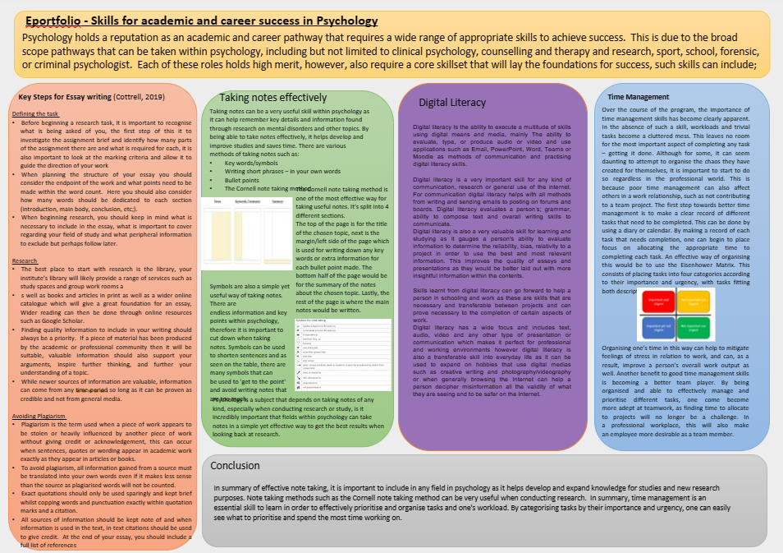

Reflection
For the group academic poster task, I worked on the time management section (including section conclusion). During the planning stages of the poster, each member of the group came up with an area of the course that we wished to cover. For my part, I wished to discuss time management, as I feel that it was something important to cover as it can be applied to all working environments. When drafting this section of the poster, I looked at additional references to build a bigger picture of what I wanted to mention, rather than simply referring to the available module content. As a group, we met up in person to finalise our ideas and work out any issues that had occurred. After this, I was able to implement my section into the final poster design. I also made a graphic for my section using Microsoft PowerPoint. After some editing, the section was complete.

Evidence of Communication
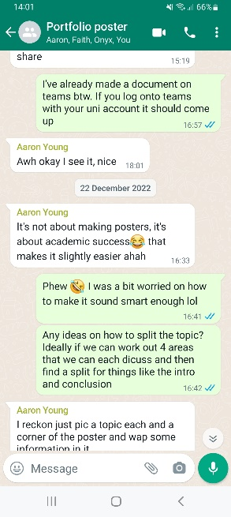 |  | 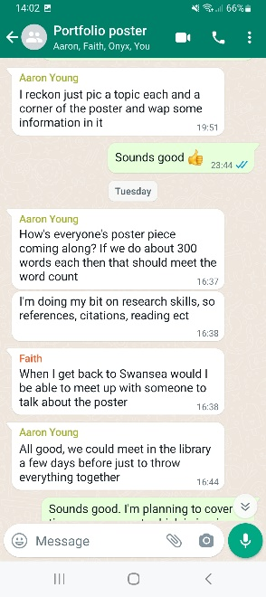 | 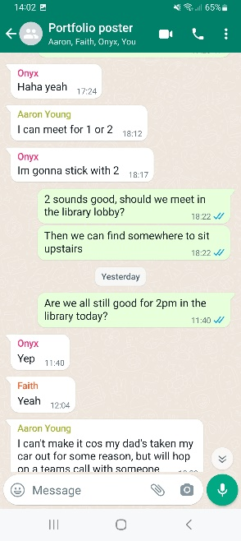

References
Barrett-Zahn, E. (2021). Digital literacy. Washington: National science teachers association science and children, 58 (5), 6.
Donohoe, G. (2022). How adverse childhood experiences shape our brains. The Psychologist. https://www.bps.org.uk/psychologist/how-adverse-childhood-experiences-shape-our-brains
Forsyth, P. (2013). Successful time management (3rd Ed). 35-57.
Howitt, D., Cramer, D. (2014). Introduction to research methods in psychology (4th Ed). 168-169.
Murray, S. A., Davis, J., Shuler, H. D., Spencer, E. C., Hinton, A. (2022). Time management for STEMM students during the continuing pandemic. Trends in biochemical sciences, 47 (4), 279-283.
Spataro, S. E., Bloch, J. (2018). “Can you repeat that?” Teaching active listening in management education. Journal of management education, 40 (2), 168-198.

