University of Wales Trinity Saint David School of Engineering
AWD Torque Vectoring
Advanced Motorsport dynamics (ACHA6011)
Rhodri Jenkins (1801396)
10/03/22

Contents
Abstract 3
1 Research 4
2 Torque vectoring systems 5
2.1Torque vectoring using differential 5
2.2 Torque vectoring using brakes 5
2.3 Electric torque vectoring 6
3 Ferrari FF investigation 7
3.1 lumped masses and dynamic index 7
3.2 Ferrari FF specification summary 10
3.3 Ferrari FF 4RM system Torque path 11
3.4 Clutch Pack 12
3.5 Maximum potential acceleration Ferrari FF 13
3.6 Handwheel position 13
4 Control algorithms 14
5 Summary 15
6 Conclusion 16
7 References 17

Figure 1-Honda NSX system Layout (Shah, 2020) 6
Figure 2-Excel of lumped mass of Ferrari FF (Jenkins. R,2022) 7
Figure 3-Excel calculations for Ferrari inertia and dynamic index (Jenkins. R,2022) 8
Figure 4-Clio Williams 'wheel cocking' (Dobie, 2013) 9
Figure 5- Ferrari FF side view (Sportscar fan, 2012) 10
Figure 6-Ferrari 4RM system diagram(Ferrari, 2021) 11
Figure 7-Clutch sizing results (Jenkins. R,2022) 12
Figure 8-Calculated forces and acceleration (Jenkins. R,2022) 13

Table 1- Ferrari FF Data (Ferrari,2011) 4
Table 2-Hyundai i30n data/calculations (Car Expert, 2021) 8
Table 3- Ferrari calculated base data (Jenkins. R,2022) 10

Abstract

This report analyses the all-wheel-drive system of the Ferrari FF and understands the effects on the vehicle dynamics and potential control strategies from front-wheel-drive torque vectoring systems. The Ferrari base data is collected to analyse the longitudinal centre of gravity and calculate various vehicle dynamic behaviour, Vehicle moment of inertia, 'Dynamic index'. Identification of the mechanical torque path and potential longitudinal acceleration on different surfaces such as snow and possible control algorithms. A Summary of all calculations and findings conclude the report.

1 Research
The Ferrari FF released in 2011 is Ferrari's first four-wheel-drive car in production hence the name (FF) "Ferrari Four" for four-wheel drive and four seats. Table 1 provides essential data published by Ferrari.
Wheelbase | 2990mm | Displacement | 6262cc
Front track | 1676mm | Max Power @ 8000rpm | 486Kw
Rear track | 1660mm | Max Torque @ 6000rpm | 683 n/m
Length | 4907mm | Compression ratio | 12.3:1
Kerb weight | 1880kg | Max speed | 208mph
Width | 1953mm | 0-62 | 3.7s
Height | 1379mm
Weight distribution | Front = 47% Rear = 53%
Table 1- Ferrari FF Data (Ferrari,2011)
Table 1 provides the data where calculations can be created to determine the longitudinal centre of gravity, dynamic index, etc.

The Ferrari FF has a 4RM system; this system aims to send power/torque/drive to the front wheels only when there is slip detected on the rear wheels; this then keeps the drive at the rear in normal conditions to keep the Ferrari RWD experience. (Wood, 2011) To do this, Ferrari uses a (PTU) power take-off unit, this unit controls and delivers torque directly from the crankshaft to each front wheel individually. this results in the power distribution, which can be individually distributed between the left and ride sides on the rear and front axle for maximum grip.(Wood, 2011) The unit delivers power through a series of gearbox ratios; this consists of using two independent wet carbon fibre clutch packs with half shafts to each wheel. This allows the system to perform fully to the rear wheels when no slip is detected.(Ferrari, 2011)
An advantage of having this (PTU) is that it is lighter in mass than a traditional 4-wheel drive by 50% (Ferrari, 2011) and is 170mm in length. This is complemented by an F1 dual-clutch, which offer improved gearshifts which perform quicker changes than standard automatic transmissions by changing gears in milliseconds, making it responsive.

2 Torque vectoring systems
In simplistic terms, torque vectoring systems are computer-controlled systems that manage the power output the engine sends to each wheel. This control system allows the vehicle to have more grip on a slippery surface and accelerate quicker than a vehicle without this system. Different vectoring systems operate differently but have the same aim of grip and performance.

2.1Torque vectoring using differential
A differential takes torque and power output from the engine and distributes it evenly between the drive wheels. However, a regular (Standard) differential which is also known as an open differential, cannot control which wheel receives the most torque; if there is a slip-on a wheel due to surface condition, the power from the engine will take the path of the least amount of resistance, this continues to spin the wheel which is experiencing slip rather than the wheel that still has traction.
A torque vectoring system electronically controls how that power is distributed to the wheels. This is done by using small clutches within the differential, which precisely control the amount of torque is sent to each wheel and therefore control how much the wheel is allowed to slip depending on the available grip and driver input. (Hirons, 2022)
A limited-slip differential (LSD) works similarly but is a mechanically controlled system compared to electrically. An Electronic system can actively redistribute the power and torque to the wheel with the most grip compared to the mechanical system (LSD), limiting the power to the wheel with the least grip. (Hirons, 2022)

2.2 Torque vectoring using brakes
Torque vectoring systems can also use brakes instead of a differential for this application; it works by using the brakes to stop a wheel from slipping to create a yawing motion. This allows more power to be sent to the driving wheels that have grip, which improves the acceleration of the vehicle on slippery roads or corner exits.
An advantage of having this sort of system is that its much cheaper and less complex to put into a vehicle. An example of a vehicle with this system is a Volkswagen polo GTI; due to the size of the vehicle and its price range target, a Differential Torque vectoring would be too expensive for the market. A significant disadvantage for these systems is greater wear and tear of the brake components in comparison to a differential system (Shah, 2020)

2.3 Electric torque vectoring
This system is more complex in terms of functionality than brake and differential systems. This system consists of having discrete electric motors mounted on each wheel of the vehicle. The motors can respond instantly to inputs from the driver or the onboard computer, enabling them to rapidly vary the power and torque they produce for maximum performance and stability. This system is known to be used in the Rimac Concept one hypercar; the system offers more flexibility on vehicle stability compared to brake and differential systems; this is due to the driver can choose the vehicle behaviour they desire through the onboard computer settings, for example, the driver can choose the car to understeer, oversteer or a balanced handling setting. Due to the flexibility of adjusting the power and torque on the Rimac, it works alongside the regenerative braking to precisely control the distribution of the power between the four motors during acceleration and braking.(Shah, 2020)
Another vehicle that combines this electric torque vectoring system and the differential system is the Honda NSX. Honda calls this system a super handling AWD (SH-AWD). This system consists of two electric motors on the front wheels to provide precise and flexible torque vectoring. The rear axle uses the mechanical LSD system. Honda channels instant power and torque through the LSD, which distributes it between the rear wheels by having a third electric motor that acts as a torque fill. While this system is complex, it offers a high degree of flexibility on torque distribution between the four wheels, enhancing the handling experience.(Shah, 2020)
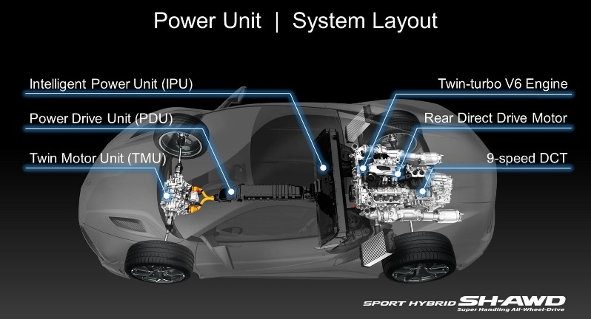
Figure 1-Honda NSX system Layout (Shah, 2020)

3 Ferrari FF investigation
For this section, an investigation is carried out for the Ferrari FF. A Spreadsheet is created based on published data from Ferrari from table 1. These calculations will be able to understand the vehicle performance and handling characteristics. One other investigation that can be carried out is the approximate specifications on the clutch package and the vehicle dynamic index.

3.1 lumped masses and dynamic index
The first investigation which can be carried out is a mass distribution model. Stated in table 1, the Ferrari has a weight distribution of 47% at the front and 53% at the rear. By knowing the mass and length of the vehicle, the centre of gravity can be calculated using the equation
$$Centre of gravity= \frac{{(m}_{2}*G)+(m_{3}*L)}{m_{1}+m_{2}+m_{3}}$$
By using the excel spreadsheet, this calculates to 1.57m from the front of the vehicle. The wheelbase of the Ferrari from the table 1 data is 2.99m; half this value equates to 1.45 to the nearest figure, which shows the Ferrari is rear bias weight distribution.
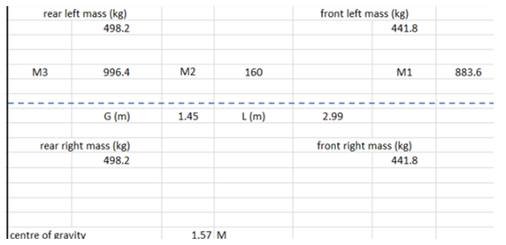
Figure 2-Excel of lumped mass of Ferrari FF (Jenkins. R,2022)
Figure 2 shows the masses across the Ferrari with wheelbase and centre of gravity. By having these results, the Ferrari's inertia can be calculated with the equation.

$$I=mk^{2}$$
The inertia equation can be calculated for all the masses (M1, M2, M3), which will lead to calculate the theoretical dynamic index of the Ferrari with the equation

$$Dynamic index=\frac{I_{total}}{m*a*b}$$
Where I total is the inertia for all masses, m is mass for the Ferrari, a is weight bias * wheelbase, and b is the wheelbase -a.
This is done through excel, which gives the following results
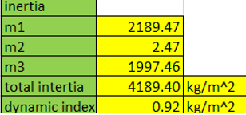
Figure 3-Excel calculations for Ferrari inertia and dynamic index (Jenkins. R,2022)
By doing the calculations as shown in figure 3, the theoretical dynamic index for the Ferrari FF is 0.92 kg/m^2
The dynamic index value is used to determine the handling characteristics of a vehicle; when the value of the dynamic index is greater than one, the vehicle's inertial conjugate is behind the rear axle, which reduces the rear tyre slip angle. When the dynamic index is lower than one, the inertial conjugate is ahead of the rear axle, which results in the rear of the car moving outward, which adds to the rear tyre slip angle, resulting in a more agile characteristic.(Blundell and Harty, 2015) Due to the Ferrari FF having a dynamic index of 0.92kg/m^2, this is considered a good compromise between vehicle control and agility. Vehicles with a dynamic index less than 0.6-0.7kg/m^2 are considered to have unpredictable vehicle dynamic behaviour. Using the excel calculator generated, a calculation can be used on various vehicles. The Data for a Hyundai i30n is inputted to compare with the Ferrari.
Table 2-Hyundai i30n data/calculations (Car Expert, 2021)
Hyundai i30n
Mass (Kg) | 1509
Weight distribution F/R | 63/37
Wheelbase (m) | 2.65
Calculated Dynamic index (kg/m^2) | 1.25

Table 2 shows the published information of the Hyundai i30n with the calculated dynamic index of 1.25 (kg/m^2). Due to the i30n being front-wheel drive, the vehicle has a front bias weight distribution. The disadvantage that occurs with many high-performance front-wheel drive vehicles is that the front tyres are required to handle the power and torque output while considering steering/handling input; this can cause the understeer in tight corners due to the tyres overheating, which is caused by tyre slip. In addition, the car being front weight biased reduces the work for the rear brakes, which results in less grip on the rear. Older front-wheel-drive cars have a similar issue and caused the rear inner turn wheel to be raised during the corner, which reduced the grip to the rear due to one tyre having contact with the surface.
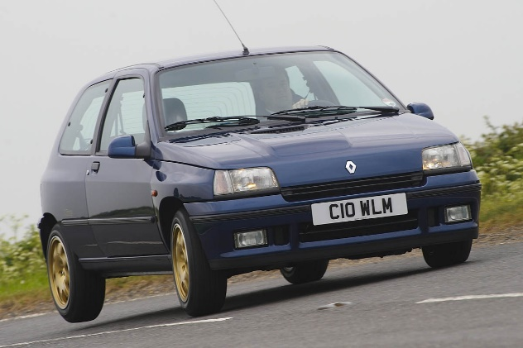
Figure 4-Clio Williams 'wheel cocking' (Dobie, 2013)
Figure 4 shows a Clio Williams. As the vehicle goes through the corner, the rear wheel is raised above the surface, which, as stated above, reduces the rear grip; this term is known as "wheel cocking". Also, by looking at figure 4, the weight transfer is acting entirely on the outside turning front wheel which is also responsible for power and torque output which will cause dramatic oversteer.

3.2 Ferrari FF specification summary

Table 3- Ferrari calculated base data (Jenkins. R,2022)
Ferrari FF base data calculated specification
Front weight distribution (kg) | 883.6 (47%)
Rear weight distribution (kg) | 996.4 (53%)
Dynamic index (kg/m^2) | 0.92
Inertial conjugate (m) | 1.46
Longitudinal Centre of gravity (m) | 1.57

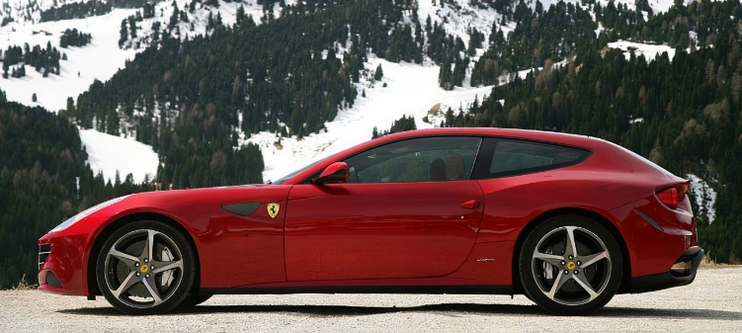

Figure 5- Ferrari FF side view (Sportscar fan, 2012)
The Ferrari FF has benefits with the specification; Due to the Ferrari being rear weight bias of 53%, this results in a load increase acting on the rear tyres, which also increases rear braking. Furthermore, having an increase in the rear braking will increase the front handling due to less demand from the front tyres, which could cause slip, resulting in overheating. By considering these factors and its torque vectoring system capabilities to provide up to 20% power to the two front wheels, the Ferrari will experience less slip from the rear wheels while accelerating and more control through corners which would reduce lap times on tracks. Furthermore, having this system on the vehicle would give the driver more confidence to use the available power in various environments/situations such as wet asphalt or snow and through corners. Using the data from table 1 and the provided equations, the theoretical dynamic index is 0.92 kg/m^2. This value for dynamic index results shows that the inertial conjugate is ahead of the rear axle, which would result in a responsive handling dynamic characteristic.

3.3 Ferrari FF 4RM system Torque path
The Ferrari FF uses a V12 engine positioned behind the front wheels for optimal weight distribution. To transfer this power, the Ferrari consists of two gearboxes: a transaxle F1 dual-clutch 7 speed box (placed in the rear) and the second gearbox (placed in front), which is driven by a conical gear off the nose of the crankshaft. (Austin, 2011) The second gearbox transmits up to 20% of the V12 engine power and torque to the front wheels. This gearbox is a helical gearset consisting of 3 gears: two forward speeds and a reverse.
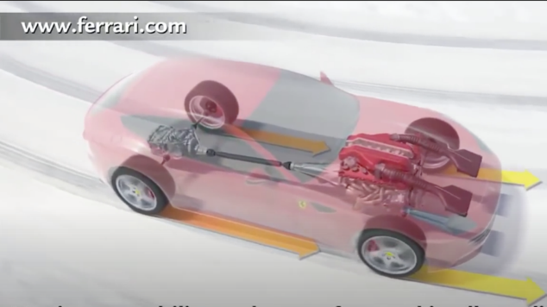
Figure 6-Ferrari 4RM system diagram(Ferrari, 2021)
Figure 6 shows the 4RM system components with engine and gearboxes
The gear ratio for reverse is the same as the reverse gear in the main F1 dual-clutch gearbox, But the forward speed gears work differently. The first gear in the second (front) gearbox is 6% longer than the second gear in the gearbox and the second gear in the second (front) gearbox is 6% longer than the fourth gear in the rear gearbox. So in more simplistic terms, the first gear in the front covers 1st and 2nd the second gear is for 3rd and 4th in the rear.
When the car is at fifth gear and above, the system will not deliver power to the front wheels. This is due to the torque on fifth gear can be handled by the rear tyres alone, which is claimed by Ferrari (Austin, 2011)
The power is delivered through two electronically controlled hydraulic wet multi-plate clutches mounted to the front transmission. Depending on the amount of slip the clutch is experiencing, the front transmission can match the rear wheel speed and additionally use the Torque vectoring system to distribute power side-to-side. Using this technology and components, the entire 4RM system weighs approximately ninety pounds, equating to half the weight of a conventional system. (Austin, 2011)
To summarise the 4RM system, The Ferrari FF can output 20% of the power to the front wheels for reverse up to fourth gear, higher selected gears will result in the Ferrari FF driving only from the rear wheels; this meets Ferrari's target for this car to be a grand tour vehicle that can be driven in various conditions.

3.4 Clutch Pack
The Ferrari can send 20% of the engine power to the front wheels, which results in the Ferrari sending up to 136N/m to the front wheels, which is done by two clutch packs; these clutch packs have four plates in each pack.
Two equations can be used to know the axial force required on the plates,
$$Uniform Pressure Theory= \frac{2T}{μ (r_{2}+r_{1})}$$
$$Uniform Wear Theory=\frac{3T(r_{2}^{2}-r_{1}^{2})}{2μ (r_{2}^{3}-r_{1}^{3})}$$

Uniform pressure theory is applied when the mating component in the clutch is in new condition, which means the contact between the surfaces remains good over the entire surface.
This theory is not valid for used clutches because the surfaces may have uneven friction, which is considered in the wear theory because the rate of wear is assumed to be proportional to the intensity of pressure and velocity of the rubbing surfaces.(Testbook, 2015)
A spreadsheet was created in excel to approximate the clutch size and torque capacity of the clutch packs. As used in the Ferrari FF, wet clutches (carbon fibre) have coefficient values between 0.1 and 0.14 (Stockinger et al., 2021). There are four Clutch plates which equate to having two contacted faces each. Due to the (PTU) in the Ferrari being 170mm wide means the clutch plate would not be larger than approximately 160mm.
The sizes of the plate diameter selected for the calculation is 110mm for the inner diameter and 160mm for the outer diameter for the maximum possible axial force.
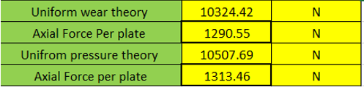
Figure 7-Clutch sizing results (Jenkins. R,2022)
Figure 7 shows that at 136N/m, the plates require 1290.55N of axial force each.

3.5 Maximum potential acceleration Ferrari FF
A spreadsheet can be used to calculate maximum initial acceleration by using Excel.

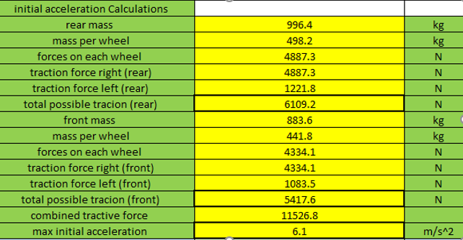
Figure 8-Calculated forces and acceleration (Jenkins. R,2022)
Using base data values from table 1 and calculated inertia values from figure 2 and using a perfect mu factor of 1 for maximum potential acceleration, by dividing the calculated combined forces with the mass of the Ferrari FF, Figure 8 shows the maximum potential acceleration is 6.1m/s^2.

3.6 Handwheel position
By using another set of calculations, and with data from figure 8, hand wheel angle can be calculated. To begin with, the asymmetric force needs to be calculated by using the value for tractive force right (front) and minus the tractive force left (front), which gives a value of 3250.5 N by calculating lateral force on the axle and knowing lateral tyre stiffness (1500 N) (Dudziak, Lewandowski and Waluś, 2020) the handwheel position is calculated at 13.7 degrees.

4 Control algorithms
One control algorithm used mostly on Electric vehicles is a direct yaw-moment control (DYC). On AWD electric vehicles, which have motors on each wheel, this controller monitors driving and braking torque on each wheel and independently. This is monitored by two controllers, a state feedback controller, which monitors the ideal transient response of yaw rate, which works alongside a sideslip angle observer and a steering wheel angle feedforward controller, which is designed to achieve the desired yaw rate steady gain.(Zhuoping et al., 2016)

5 Summary
To summarise the report, a full investigation is carried out on the Ferrari FF by researching base vehicle data to be able to create various calculations such as the centre of gravity and dynamic index and lead onto approximate clutch sizing and maximum acceleration values; further investigations in dynamic index values of the Ferrari 0.92kg/m^2 to understand what the dynamic characteristics the vehicle will have and compare it to another vehicle. In addition, research is done for the 4RM system for the Torque path and understanding how it operates and the gearbox system; this led to clutch sizing calculation for axial force on each plate to be 1290.55N.

6 Conclusion
To conclude this report, a successful investigation has been completed on the Ferrari FF with a new 4RM system to understand how it operates compared to other Torque vectoring systems.

7 References
Austin, M. (2011) Explaining the Ferrari FF’s Two-Gearbox Four-Wheel-Drive System. Available at: https://www.caranddriver.com/news/a18736603/funky-four-explaining-the-ferrari-ffs-two-gearbox-four-wheel-drive-system/
(Accessed: March 18, 2022).
Blundell, M. and Harty, D. (2015) “Simulation Output and Interpretation,” The Multibody Systems Approach to Vehicle Dynamics, pp. 535–602. doi:10.1016/B978-0-08-099425-3.00007-8.
Car Expert (2021) 2021 Hyundai i30 N PERFORMANCE LUX five-door hatchback Specifications | CarExpert. Available at: https://www.carexpert.com.au/hyundai/i30/2021-n-performance-lux-6ac9e7cb
(Accessed: March 17, 2022).
Dobie, S. (2013) Renault Clio Williams comeback | evo. Available at: https://www.evo.co.uk/renault/clio/13262/renault-clio-williams-comeback
(Accessed: March 15, 2022).
Dudziak, M., Lewandowski, A. and Waluś, K.J. (2020) “Static tests the stiffness of car tires,” IOP Conference Series: Materials Science and Engineering, 776(1). doi:10.1088/1757-899X/776/1/012071.
Ferrari (2011) Ferrari FF (2011) - Ferrari.com. Available at: https://www.ferrari.com/en-EN/auto/ff
(Accessed: March 10, 2022).
Ferrari (2021) FOUR-WHEELED FIRST. Available at: https://www.ferrari.com/ru-RU/magazine/articles/10-years-of-the-ferrari-ff-and-4rm
(Accessed: March 10, 2022).
Hirons, R. (2022) Torque vectoring explained | carwow. Available at: https://www.carwow.co.uk/guides/glossary/what-is-torque-vectoring#gref
(Accessed: March 12, 2022).
Shah, V. (2020) Torque vectoring explained | CarExpert. Available at: https://www.carexpert.com.au/car-news/torque-vectoring-explained
(Accessed: March 12, 2022).
Sports car fan (2012) Sports Cars Fans: First Drive: 2012 Ferrari FF. Available at: http://sportscarsfans.blogspot.com/2011/05/first-drive-2012-ferrari-ff.html
(Accessed: March 16, 2022).
Stockinger, U. et al. (2021) “Friction behavior of innovative carbon friction linings for wet multi-plate clutches,” Forschung im Ingenieurwesen/Engineering Research, 85(1), pp. 115–127. doi:10.1007/S10010-020-00436-9/FIGURES/15.
Testbook (2015) [Solved] The uniform wear theory for disc clutches states that: Available at: https://testbook.com/question-answer/the-uniform-wear-theory-for-disc-clutches-states-t--5f87631347b253873c297abd
(Accessed: March 19, 2022).
Wood, C. (2011) Ferrari FF 4RM All-Wheel Drive System Explained [Video] » AutoGuide.com News. Available at: https://www.autoguide.com/auto-news/2011/03/ferrari-ff-4rm-all-wheel-drive-system-explained-video.html
(Accessed: March 14, 2022).
Zhuoping, Y.U. et al. (2016) “CHINESE JOURNAL OF MECHANICAL ENGINEERING Direct Yaw Moment Control for Distributed Drive Electric Vehicle Handling Performance Improvement.” doi:10.3901/CJME.2016.0314.031.

