Managing projects in the Organisation

Module code: BMSW 5106

Student Name: Andrei Sarealba
Student ID: 1913748

Lecturer Name: Balendran Kandasemy

- Introduction………………………………………………………………………………………3
  - The pandemic and the baby shower…………………………………………………….3
- Project management tools and techniques………………………………………………4
  - Selection of the project management technique……………………………………….4
  - Work breakdown structure………………………………………………………………..5
  - Perth chart………………………………………………………………………………….7
  - Critical path…………….…………………………………………………………………..7
  - Project technique………………………………………………………………………….8
  - Network diagram…………………………………………………………………………..8
- Implementation plan………………………………………………………………………….9
  - Recruiting procedures…………………………………………………………………….9
  - Before the event……………………….…………………………………………………..9
- Risk assessment………………………………………………………….………………….12
  - Risk monitoring and control……………………………………………………………..13
  - Risk mitigation approach……………………………………………………………...…13
  - Stakeholder communication approach…………………………………………………13
- Conclusion…………………………………………………………………………………….13
References…………………………………………………………………………..…………….15

Introduction

Project management is the integration of procedures, strategies, expertise, information, and experience to accomplish project goals under agreed-upon guidelines, in accordance with the project approval requirements. The final deliverables in project management are bound by a finite timeframe and expenditure.
A project is a one-of-a-kind, temporary endeavor conducted to accomplish defined goals, which may be expressed in terms of outputs, consequences, or advantages. Generally, a project is considered effective if it meets it goals in accordance with their approval requirements, within the negotiated timeframe and budget. Each project is built on the foundations of time, expense, and efficiency (Juneja, 2015). Scheduling time is a set of strategies for developing and presenting schedules that indicate when work will be done.
Celebrating the birth of a new child is an unforgettable time. A lot of thought went into planning the ideal baby shower. It will be needed some spare time to plan entertainment, meals, and a guest list. The baby shower is a very special occurrence that occurs during pregnancy and may be one of the most enjoyable. This lovely party in honor of the baby boy/girl soon-to-be-born, will be an exciting and pleasurable experience for both parents and visitors. In this post, we will discuss how to plan the ideal baby shower.

  - The pandemic and the baby shower
In the United Kingdom, the pandemic situation of the coronavirus has constructed a devastating situation that can hold every occasional moment among the people. Hence, this specific project is initiated for event planning for the baby shower program. The coronavirus has disrupted the clearance of the occasion due to various governmental norms. Therefore, this particular project planning is giving chances to the pregnant women that enable them to enjoy this occasion with the proper maintenance of the social distancing and so on.
The baby shower is a ritualistic occasion among the expecting mother (Radujković and Sjekavica, 2017). This particular project planning has come to mind because; it is a positive and refreshing way of the treatment for the expected mother.
The pandemic situation of covid-19 has thrown stagnancy hence to break this stream this event tends to be organized that reflects happiness among the expected children. The step-by-step guide and control list helps one to walk through the baby shower planning process from the sending of baby showers and the purchase of decors to the ordering of a cake. Before nine to ten weeks of the event, several things must be considered like selection date and time, selection of venue, choosing the theme of the event.
The overall planning for this event is going through two months before the events. For this particular planning of the project, the expected mothers are the main beneficiaries because they will make this special day without any issues and the proper safety must be maintained for the coronavirus that can make them safe. According to Santos (2021), project management is the use of tools, skills, and expertise to achieve specific project objectives while adhering to project acceptance criteria and remaining within a schedule and budget.
Having a rationale for the project's need, creating and executing a strategy, motivating the project team to lead the project, communicating with stakeholders, and putting together a strategic plan to justify the investment are all key elements of project management.
- Project management tools and techniques
A further tool that will be utilized is a Network Diagram, that will illustrate how one action leads to another. Additionally, I will demonstrate how the planning is determining the longest duration of linked tasks and quantifying the time needed to perform them from start to finish using the Critical Path Method.
Most methods and procedures for project management can be used in different areas, but strategies are natively developed for certain tasks, and if they are not founded, these practices or projects cannot really work properly (Vaníčková, 2017). In the following the specific project management technique appropriate for contextual project plan is elaborately contextualized in the following.
  - Selection of the project management technique
PRINCE2 focuses on corporate justification, identifying an organization’s framework within the project management team by employing a product-based strategy. The focus is on splitting the project into controllable, flexible measures (Papke-Shields and Boyer-Wright, 2017), it gives strong leverage of project finances and improves the efficiency with which to manage market and project risk. It is a pre-project phase that ensures that the requirements for the project are met (Ismael and Raúl, 2019).
PRINCE2 has five project characteristics, according to Axelos (2017): change, uncertainty, transitory, unique, and cross-functional. By change, it is meant to imply that a project is being used to alter the company. Uncertainty that changing a project and developing something new are steps into the unknown. But, whenever a project team arrives at the same time, completes a task, and then departs, it is just temporary. Every project is different, with various individuals in various places, and when a project includes people with different talents and everyone has a distinct job, it is cross-functional.
Since, it is a comprehensively celebrated event instances of physical contact are relatively higher, thereby, risk of exposure to virus during the event is relatively higher as well. Since, the Prince 2 methodology is arranged through framework of starting, initiation planning, direction, managing, controlling, and closing with the additional emphasis on risk assessment and management, it offers greater opportunity to the project team to manage and control the project more effective to develop desired outcome (San Cristóbal, 2017).

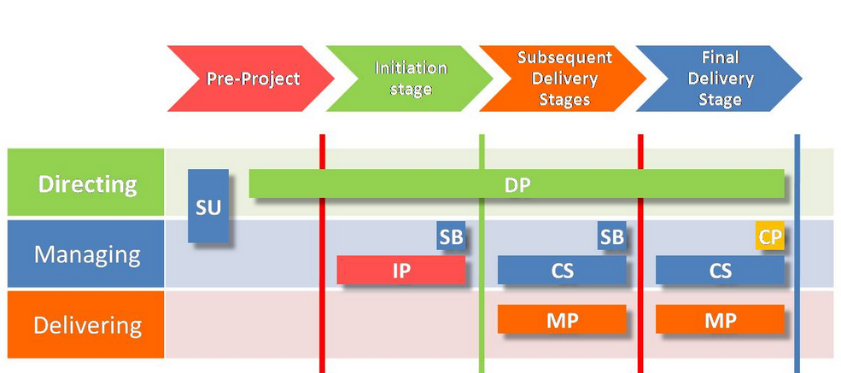
Figure: PRINCE 2 Methodological Process
(Source: Saltz and Crowston, 2017)

A technique that is not applicable to this project is Agile, which is a set of ideals and principles that is mostly utilized for software development. Agile, according to Teamwork.com (2020), is the capacity to move things forward rapidly while allowing for quick changes in direction.
According to Kashyap (2019) more than almost 86% of software developers admit to use Agile approach at work. In terms of project management, some of the qualities include: transparency, customer focus, adaptability, shared ownership and continuous improvement. Transparency implies that everyone engaged in the project must have the same understanding of the process, which requires greater clarity in how they cooperate and communicate.
Clients should receive what they need, not simply what they want, therefore the Agile project management method places a heavy focus on ongoing collaboration to ensure that customers are completely pleased. Another important idea in Agile project management is allowing organizations to respond to changes more rapidly and better.

  - Work breakdown structure
A work breakdown structure (WBS) is a deconstruction of a project that is visible, hierarchical, and focused on deliverables. It is a useful diagram for project managers because it enables them to work backwards from a project's end product to identify all of the actions required to complete the project successfully (Cohen, 2018)
A job breakdown structure is created in five stages. These are the general steps, which ultimately goes to the detailed level. However, it is beneficial to understand the essential components of what is required to build a comprehensive WBS.

- Define the project's objectives and aims. Begin with the project charter—its scope, goals, and participants— identify and explain what it is.

- Divide the broader project statement of purpose into a set of phases that will take it from conception to completion.

- Which of the following are the deliverables? Make a list of all of them and make a note of what is required for those deliverables to be considered effectively delivered (sub-deliverables, work packages, resources, participants, etc.).

- Take the deliverables listed above and decompose them into all of the tasks and subtasks required to complete them. Make a list of all those responsibilities.

- Assign the tasks to the team that they have been defined. Provide each team member with the tools, resources, and authority necessary to complete the task.

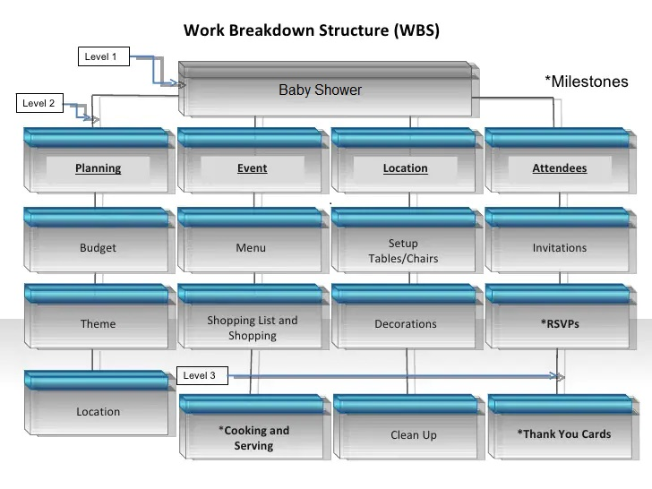
  - Perth chart
A PERT chart is a project management tool for planning, organizing, and coordinating work in a project. It is a technique for analyzing the tasks involved in completing a project, particularly the time required to accomplish each job, and determining the shortest time required to finish the whole project.

Project technique:
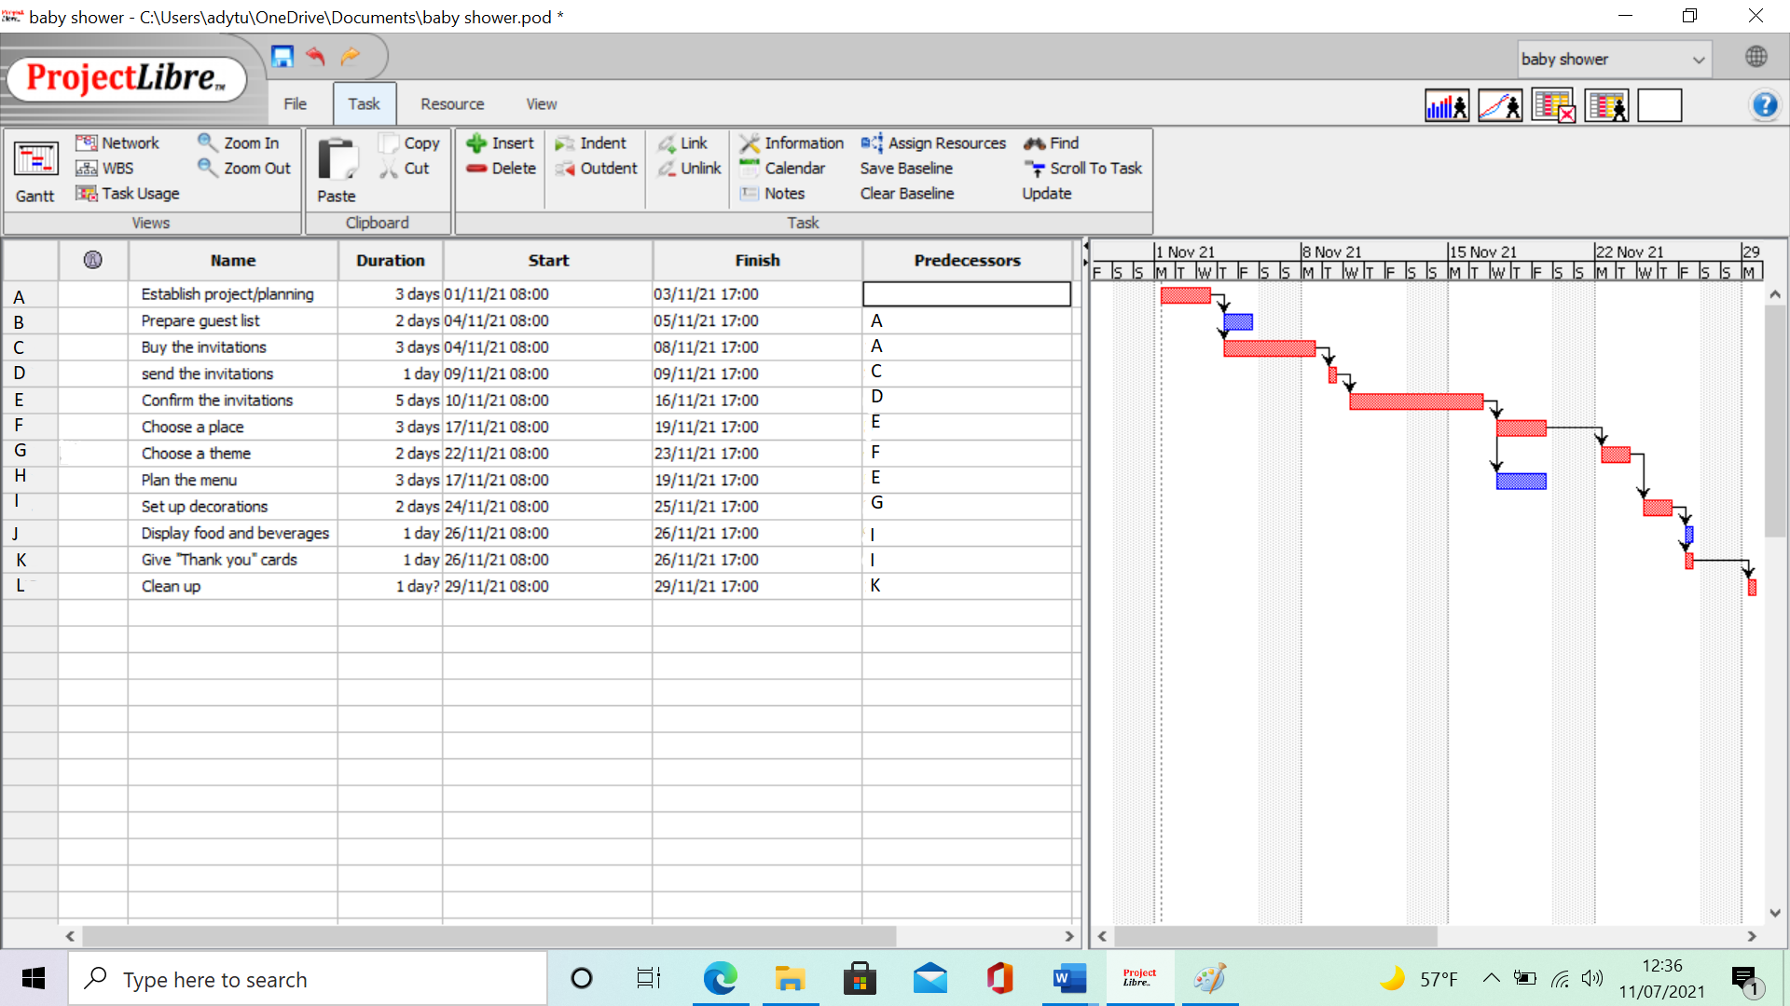

  - Critical path analysis
Identifying the key activities that drive the project schedule is referred to as the "critical path." The term "critical path analysis" refers to a project management methodology that includes the following steps (Eby, 2015):
- Creating a list of all the tasks needed to accomplish a project
- Calculating the time it will take to complete those jobs
- Identifying the connection between each activity, or its dependence
- Identifying the "critical" activities that drive the project's schedule

The critical path identified for this task is as follows:
A C D E F G I K L

  - Project technique
For project scheduling have been used Forward Pass and Backward Pass. Forward pass is a method for advancing the project duration and the critical path or free float of the project via the network diagram. Whereas backward pass means to reverse the final result in order to measure late start or find out whether the activity has slack (Alby, 2016).
ES | Task | EF
LS | Slack | LF

7 | E | 12
7 | 5 | 12
12 | F | 15
12 | 3 | 15
15 | G | 17
15 | 2 | 17
17 | I | 19
17 | 2 | 19

0 | A | 3
0 | 3 | 3
3 | C | 6
3 | 3 | 6
6 | D | 7
6 | 1 | 7

3 | B | 5
4 | 2 | 6
19 | K | 20
19 | 1 | 20
12 | H | 15
9 | 3 | 12
19 | J | 20
16 | 1 | 17

20 | L | 21
20 | 1 | 21

  - Network diagram
Visual representations of a project are called network diagrams. PERT and Gantt charts are used to supplement network diagrams in project management. In today's environment, network diagrams are essential in terms of planning and monitoring a project from start to finish. The critical route and scope of the project are both specified. A good project schedule network diagram will depict the project in a clear and simple manner (Online Project Management, 2017)
A network diagram enables a project manager to keep track of each project piece and rapidly communicate its status to others. Other advantages include:
- For stakeholders, there is a visual depiction of progress.
- Setting up project operations
- Keeping track of dependencies and any constraints

L
K
I
G
F
E
D
C
A

H
B
J
- Implementation plan

  - Recruiting procedure

The job description is the first step in the recruiting process. In this instance, for project management, we must ensure that every prospective employee has the necessary credentials and abilities, as well as the ability to fulfill the obligations and tasks necessary to complete and meet the project's requirements. Recruiting employees is critical to any organization, according to Rietsema (2021). In addition, the following are some of the steps in the hiring process:

- Determine the job description.

• How many workers will be required to finish the project, and what are their credentials and skills?

- Finding the appropriate people to hire

• One of the best places to look for qualified individuals is on social media.

- Choose the best prospects.

• Shift through all of the applications to ensure that the appropriate applicants are familiar with the work.

- The interviewing procedure.

• During the pandemic, most of the assessments are done over the phone; but, due to the COVID-19, some interviews are conducted via video conference like Microsoft teams or zoom.

- Checking for references.

• Checking references may be beneficial since it allows you to discover who has the greatest qualifications.

- Gathering the required papers

• Gathering personal papers may assist in ensuring that the individual is qualified for the position and is not working illegally in the United Kingdom.

  - Before the event

- Ten to twelve weeks before the event
- Make the financial plan.
- Locate and repair the problems at the location.
- Choose a date that works for everyone
- Make a list of the people who will be attending.

- Six to seven weeks before the event

- Select a theme for your project.
- Invitations should be sent out.
- Make a plan for your meal.
- Visit a store to buy something (foods, decorations, gifts, etc)

- A Month Ahead of Time

- Extra hands should be designated (cooking, serving, games, etc)
- Place an order for cakes and decorations (in case no one are not going to do it)
- Prepare the games.
- Approximately One Week Before
- Wait for the people who have not responded yet to the invitations.
- Gifts and treats should be packaged and assembled.
- Make arrangements for the shooting.
- Clear the clutter from the home.
- Purchase all of the meals and supplies needed.

- Three days prior to the event

- Completing all of the preparations for cooking is essential.
- Yesterday was a big day for me.
- Decorate the interior of the home.
- Prepare the venue for the gathering.
- Prepare the cake (if you planned to)
- On the day of the party
- Get hands on the goods (cakes, balloons, flowers, etc.)
- Make arrangements for the mother-to-assistance. be's (delivery of the gifts, driving to the party, etc)

Actually, the preparations for the baby shower are not quite as difficult as they may seem. Just remember to arrange the party in a manner that the recipient would find admirable, rather than according to your own preferences. However, after you have been appointed as the baby shower coordinator, you will be regarded as a very special person in the life of the expecting mother, as you will be well acquainted with her preferences (Momshealth.co, 2019).

Develop a budget plan.

The cost is determined by the anticipated number of visitors. It's used to pay for food, beverages, and other activities. Without costing a lot of money, it can be put together a nice and quick baby shower.
Financial Requirements and Cost and Benefits of the Project (approximative), depending on how many people and where the party will be held.
Cost and Profit index | Estimated Cost (£)
Total Funding Acquired | 18000
Project Expenses
Furniture and Fixtures | 1000
Wages | 300
Electricity | 50
Delivery Costs | 100
Operational costs | 500
Food and Accessories | 500
Decoration | 1000
Total Costs | 3450

Choosing a place
A public or private place should be used to host the baby shower. It might happen at the potential parents' house or at a friend's house. When choosing the place, it must be thought of how many people are going to be at the baby shower and if there are going to be kids too (Nevers, 2019).

Making a list of people who will be attending the group.
Involve the potential parents in the guest list-making phase. It must determine if it will be a mixed or all-women event, if there are kids or not. When the list is over, choose a date ahead of time after checking with the guests to see if they are accessible. Send out the invitations at least a month ahead of time to enable visitors to plan their schedules. If there are friends or family members that live far away, video calls may be used to connect with them (Glantz and Donovan, 2020).
- Hire photographer
Hiring a professional photographer or ask a visitor to assist as a favor are two options which may be taken in consideration. It is the photographer's responsibility to capture all of the best moments from the celebration. However, since this is going to be a homemade celebration with a limited number of guests due to technological advancements, there is no need to employ a photographer.

Theme
The majority of baby showers have a theme. The topic may be represented by a color or a design. In recent years, there have been many daring and distinctive theme trends that have resulted in one-of-a-kind celebration (Pilato, 2019).

Recreational activities
Regardless of whether or not there will be children present at the baby shower, there must be activities for them, too. It is possible to hire a babysitter if this is required. Everyone would have a wonderful time if things went this way. Create a separate play space for the children, complete with puzzles, dolls, and other activities. Adults attending the celebration will take part in the usual baby shower games and activities. One example is attempting to guess what kind of baby food is being prepared. Participation in non-competitive activities and dancing competitions are examples of what is meant by this. Do not be afraid to spend money on the games rewards. Songs may be arranged in advance if quests want to dance. For as long the group stays, play background music should continuously be played in the background. (Heather, 2020).

Allocation of space
During your baby shower, everybody must feel at ease. Whether there would be children or babies present, a separate place must be arranged for them in case if they need a nap. Prepare a shelter for the children to sleep in if the group is held outside. Do not forget to leave space for snacks, beverages, and presents (Toth, 2020)

Beverages and food
Meals and drinks must be planned on guest list, time constraints and especially on a budget. Depending on time, if there is not enough, the food can be ordered to save time. If family members are attending the baby shower, they can be asked to help with food and beverages. Prepare a variety of cocktail choices to fit everyone's preferences. Whether it decided to serve alcoholic liquor, it must make sure all drinks responsibly (Holt, 2012).

- Risk assessment
Due to the current situation when the risk of catching covid-19 virus is very high, there is going to be needed a risk assessment in place.

Poor décor and fixture arrangement | Unclear contract negotiation | Ineffective monitoring
Inadequate communication | Poor crowd control | Inadequate health security
Lack of finance | Ineffective emergency plan | Virus Breakout

Based on the identification of the key risks, a severity classification is made in the following:
Level of severity | Identified risks
Low Severity- can managed with minor adjustments | Poor décor and fixture arrangement.  Unclear contract negotiation  Inadequate communication
Moderate Severity- can be managed with major changes | - Lack of finance  - Poor crowd control  - Ineffective monitoring
High severity- extremely difficult to manage, must be avoided | - Inadequate health security  - Ineffective emergency plan  - Virus Breakout

Risk Monitoring and control

The monitoring and controlling will be instigated using MS project in which the activities will be scheduled and checked upon completion. With the pre-defined scopes, the completion of each will be verified and matched with the task criteria (Range, 2016). The team will also generate performance report over the effectiveness of each deliverables and risks and arrange for effective controllable solutions.

Risk mitigation approaches

Through extensive risk prioritization the identified risks will be managed thereby first the team will identify the drivers of the risks and ascertained the associated activities of the risks. Thereafter, the possible occurrences of the risks will be determined. In context of the identified risks, these will include installation of sanitary compound for guest sanitation prior to their entering of the event grounds, additional thermal checking, and crowd management on maintaining adequate social distancing during the festive (Before Baby, n.d). After from this, arrangement for medical support and contamination rooms will also be prepared in case of virus identification along with giveaways of safe masks to the visitors, to ensure additional human health safety (The Owner’s Role in Project Risk Management, 2005).

Stakeholder communication measures

For communicating with the stakeholders online group meetings will be held, in which discussion regarding the project schedule and deliverables will carried out. Use of Zoom or Google meet platforms along emails will here primarily be used for engaging and interacting with the stakeholders (Georgescu, Higham and Peters, 2018).

Conclusion

This particular research has been mainly focused the risk management in project development planning. In the United Kingdom, the pandemic situation for the coronavirus has thriven a disaster condition among the country. Therefore, the people gathering at an event must comply to the rules. Therefore, this particular report has been focused on an event management program with effective project management tools that can enhance health awareness among the people. The baby shower ceremony in the UK is made in the time of pandemic situation of the coronavirus.
The baby shower is a ritualistic program in society that can gather many people in a particular place. Therefore, it is important to create awareness among the people and take something effective initiation that make them safe. The governmental body of the United Kingdom has declared that there is nothing gathering in any place and always maintain the physical distance. Therefore, from the finding section in this report, it has been concluded that the project has taken the effective tools for sanitization for the invited people on this occasion. The project manager and their team are tending to attend some proper initiatives that are beneficial for the expected mothers. The temperature checking procedure is also representing in the event place. The temperature of each and every person has checked properly which can reduce the fear of Covid-19. If someone is suspected as a Covid-19 patient, then an isolated room has arranged for this patient.
On the occasion, there will construct an accurate sanitization process and give sanitizer to each guest to rub their hand with this. From this report, another most important fact has been disclosed that the project management team is also given awareness among the guests and family members of the pregnant women. Because, it has heard that, as rules and regulations of the coronavirus the physical distance is a core fact. Hence, from this report, it has seen that the project manager and its team also hardly maintain this fact. As a result, such kind of activities of the project development program is helpful for the event members and it makes them safe on this occasion.
In such cases there are some aspects that must be concerned for project planning due to the pandemic situation of coronavirus (mckinsey.com, n.d). The recommendations are given below:
- Policies placed in motion to flatten a coronavirus curve have already threatened and are likely to continue to threaten the supply of labor, supplies and other major assets. Further waves of the epidemic and global changes in magnitude and timing would make it difficult for project owners to anticipate the effects of balancing health outcomes with economic recovery.
- Supply chains and vendors would be strained, and project managers must be equipped for cash flow shortages for insolvency or bankruptcy. It would then encourage them to follow their project programme.
- Resources would be scarcer when stocks and the economy fall and recover, and the problem will be intensified by low currency. The project manager and their team should then adequately coordinate all tools.

References
Axelos (2017). PRINCE2 2017 Update | Project Management | AXELOS. [online] Axelos.com. Available at: https://www.axelos.com/prince2-2017.
Alby, T., 2016. www.project-management-knowledge.com. [Online]
Available at: https://project-management-knowledge.com/definitions/f/forward-pass/
[Accessed 26 08 2021].
Cohen, E. (2018). A Beginner-Friendly Guide to Work Breakdown Structures (WBS). [online] Workamajig.com. Available at: https://www.workamajig.com/blog/guide-to-work-breakdown-structures-wbs.
Eby, K. (2015). The Ultimate Guide to the Critical Path Method (CPM) | Smartsheet. [online] Smartsheet. Available at: https://www.smartsheet.com/critical-path-method.
Glantz, J. and Donovan, B. (2020). The Complete Guide to Making Your Wedding Guest List. [online] Brides. Available at: https://www.brides.com/story/people-to-cross-off-your-wedding-guest-list-and-why.
Holt, C. (2012). Party Food and Drink: Step 7 Of The Party Planning Checklist. [online] Smart Party Planning. Available at: https://smartpartyplanning.com/party-food-and-drink-step-7-of-the-party-planning-checklist/ [Accessed 27 Aug. 2021].
Heather, 2020. www.embracingchaoswithlove.com. [Online]
Available at: https://embracingchaoswithlove.com/baby-shower-activities/
[Accessed 22 08 2021].
Ismael, C.E. and Raúl, P.C., 2019. Project management Tools and Techniques (T&T) usage in building sector companies in Cartagena City, TCD.
Juneja, P., 2015. www.managementstudyguide.com. [Online]
Available at: https://www.managementstudyguide.com/management_process.htm [Accessed 20 08 2021].
Kashyap, V. (2019). What Is Agile Project Management?—A Strength Or Weakness? [online]
Nevers, B. (2019). The 15 Best Original Places to Throw a Baby Shower. [online] NeoLittle. Available at: https://neolittle.com/where-to-have-a-baby-shower/ [Accessed 27 Aug. 2021].
Online Project Management, 2017. www.sinnaps.com. [Online]
Available at: https://www.sinnaps.com/en/project-management-blog/network-diagram-project-management [Accessed 25 05 2021].
ProofHub. Available at: https://www.proofhub.com/articles/agile-project-management#:~:text=Agile%20Stats%20%282019%29%20Agile%20projects%20are%2028%25%20more [Accessed 26 Aug. 2021].
Papke-Shields, K.E. and Boyer-Wright, K.M. (2017). Strategic planning characteristics applied to project management. International Journal of Project Management, 35(2), pp.169–179.
Pilato, D. (2019). How to Plan a Baby Shower. [online] The Spruce. Available at: https://www.thespruce.com/baby-shower-planning-guide-1197063 [Accessed 27 Aug. 2021].
Rietsema, D., 2021. www.applicanttrackingsystems.net. [Online]
Available at: https://www.applicanttrackingsystems.net/recruitment-process/
[Accessed 20 08 2021].
Range, A. (2016). Project Monitoring & Project Controlling Andreas Range.
Radujković, M. and Sjekavica, M., 2017. Project management success factors. Procedia engineering, 196, pp.607-615.
Santos, J. M. D., 2021. www.project-management.com/. [Online]
Available at: https://project-management.com/top-10-project-management-software/?msclkid=308055111c551b969ade343642014a5d&utm_source=bing&utm_medium=cpc&utm_campaign=Top%2010%20PM%20Software_Bing&utm_term=%2Bproject%20%2Bmanagement&utm_content=General
[Accessed 25 08 2021].
San Cristóbal, J.R., 2017. Complexity in project management. Procedia Computer Science, 121, pp.762-766.
Toth, M. (2020). Adapting Shared Spaces in the Post COVID-19 Workplace. [online] Work Design Magazine. Available at: https://www.workdesign.com/2020/08/adapting-shared-spaces-in-the-post-covid-19-workplace/ [Accessed 26 Apr. 2021].

‌The Owner’s Role in Project Risk Management. (2005). [online] Washington, D.C.: National Academies Press. Available at: https://www.nap.edu/read/11183/chapter/6. (Accessed:23 August 2021).
Teamwork.com (2020). The Ultimate Guide To Agile Marketing. [online] www.teamwork.com. Available at: https://www.teamwork.com/blog/agile-marketing/ [Accessed 26 Aug. 2021].
Vaníčková, R., 2017. Application of PRINCE2 project management methodology. Studia Commercialia Bratislavensia, 10(38), p.227.

