

MODULE CODE: ECPT6006

ASSESSMENT COMPONENT: A Critical Evaluation of the Role of Digital Innovation in Professional Practice

STUDENT NAME: Christie Roberts

STUDENT NUMBER: 2305703

AI Acknowledgement
I confirm that I have not used any AI tools in the research and creation of this assignment.
I confirm that I have not presented any AI generated materials as my own work.
I confirm that I have copies of my drafts, notes, and other resources I used, which I may be asked to provide in evidence.

Literature Review (Assignment Word Count Total: 5,293)
Collaborative technology and digital creativity in
post-16 education

According to the UK Parliament (2018), professional practice standards have evolved, as a result of the development of digital creativity in the post-16 educational industry, requiring professionals to incorporate innovative and collaborative advances in technology, to promote learning. Educators are required to not only comprehend novel digital tools, but also critically assess their pedagogical significance, as educational settings place a greater emphasis on digital competency, which can be challenging (Artacho et al. 2020 and Fernandez-Batanero et al. 2021). However, Instefjord and Munthe (2015) argue that according to studies, educator's professional knowledge and expertise, disregards digital competence to be a crucial aspect.
Utilising firmly established theoretical views; to guide the decision-making process of professionals, this assignment will analyse the advantages and disadvantages of technological devices, that are utilised to foster collaboration and innovative participation, in post-16 contexts. In addition to frameworks like TPACK (Belda-Medina and Calvo-Ferrer, 2022) and SAMR (Wu et al. 2025) that provide structured methods of evaluating the integration of technology, debates within this assignment will specifically refer to theorists such as Jean Piaget (UC Berkeley, 2025) and Lev Vygotsky (Wibowo et al. 2025) and their constructivist approaches, which emphasise active knowledge building and social development.
According to Cheng and Wang (2020) learner independence, tailored education, and building knowledge collaboratively, can all be supported by digital tools, including internet-based educational settings, media that is interactive, and shared platforms for learning. However, Siyal (2025) argues that the utilisation of digital tools, additionally raises significant issues including digital disparities such as, learners being unable to access digital tools and high-quality instructional materials, therefore, impacting learner’s development, cognitive fatigue (Amini, (2025) and the potential that technology could be substituted rather than utilised, to enhance education (Ktoridou et al. 2020). This assignment seeks to create a balanced comprehension, of how digital innovation and teamwork, can significantly assist learning outcomes, by applying theoretical frameworks and examining both constructive and adverse elements.
Ultimately, this critical analysis will inform decisions about the most suitable digital tools for future lessons, ensuring alignment with pedagogical intent, learner needs, and curriculum requirements. Through a theoretically grounded evaluation, the assignment will support reflective and evidence-based digital practice within the post-16 sector.
According to Guralnick et al. 2024) recent studies suggest that post-16 academic learning, should prioritise innovative thinking and digital creativity. Auddya et al. 2025) highlights that digital devices provide features such as rapidly developing prototypes, utilisation of multiple communication methods and virtual application, and when used creatively, digital devices can promote problem solving abilities and brainstorming, which can broaden and modify conventional teaching techniques. However, Areba et al. 2025) argues that achieving these advantages requires a cohesive alignment of digital technology.
Keengwe (2017) states that a significant portion of the current research on the integration of technology, is based on two effective models: TPACK (Technology and Pedagogical Content Knowledge) and SAMR (Substitution, Augmentation, Modification, and Redefinition). The interconnected nature of technical, instructional, and subject matter expertise, is highlighted by Mishra and Koehler's TPACK model (Keller et al. 2023), and as opposed to seeing technology as an added extra, Keller et al. (2023) believes that effective instruction, requires teachers to navigate all three areas of expertise. According to Polly and Byker (2020), since there is an emphasis on how educational design affects learner's sense of purpose, TPACK is in line with Vygotsky’s societal-constructivist concept, in addition to Piaget’s constructivist theory (Khine, 2015) as tutors utilise their educational experiences with digital tools, and discover how to align technology applications, with subject material and efficient teaching methods.

According to Khalil (2024) technology proves beneficial when it enhances collaboration, social interactions and cognitive real-world activities. In contrast to this, Polkowski (2023) alleges that an effective and consistent way of assessing how tools alter activities, from simple substitution to pedagogically innovative change of perception, is provided by the SAMR framework (Substitution, Augmentation, Modification, Redefinition). Although Azar et al. (2025) believe that TPACK provides an in-depth teacher expertise lens, according to Caceres-Nakiche (2024) SAMR is beneficial for classifying instructional examples. When contrasting the two, SAMR assists educators in auditing activity design and gradual improvement, whereas TPACK encourages professional growth for educators and reflective practice (Alivi, 2019).
According to Vicherkova et al. (2022) recent studies and syntheses highlight that culture in institutions, assignment reliability, and evaluation procedures, are of greater significance than specific technological advances, therefore, institutions should ensure that training in digital tool application is available to educators, to obtain a balance, where leaners are able to achieve their greatest academic achievement. Isakov (2024) states that according to recent studies, increased creative productivity and motivation among post-16 students, have been continually linked to technologies that promote rapid development such as internet-based platforms and digital art tools. However, University Canada West (2025) argues that research and evidence also highlight the fact that while technology can support diverse viewpoints in project orientated education, it may restrict creativity when utilised for repetitive online exercises, or when employee confidence and availability are minimal (Tusiime et al. 2020). Therefore, Davletova et al. (2025) believes that whether electronic devices foster or limit creativity, is dependent on whether pedagogy is evaluation based, project orientated, or inquiry led.
Zahroh et al. (2025) suggests that according to recent studies, learners demonstrate increased engagement and greater application of information, when educators utilise TPACK-informed preparation and advance assignments toward SAMR's Modification/Redefinition levels (Chotithammaporn, 2024). In contrast to this, according to Sanders and Scanlon (2021) superficial usage of technology has minimal advantage and poses the risk of increasing disparities in equality.
According to Hemminki-Reijonen et al. (2025) Generative AI as a framework for brainstorming and constructive input, combined with specific cognitive education, simulation and virtual reality for practicing hands-on skills, are all viable applications in post-16 education. However, Garcia-Lopez and Trujillo-Linan (2025) and Fan et al. (2025) argues that in order to prevent irrational communication, any potential utilisation requires research on outcomes of learning, training for educators, and ethical measures. Despite this argument, Rana et al. (2025) claims that recent studies show that Generative AI enhances learner’s innovation, critical thinking abilities and ethical decision making.
While the SAMR method is more practical for instructional activity design, TPACK provides greater clarification for professional practice; however, both are essential (Pernantah, 2024). According to OECD (2026) creativity thrives when the culture of institutions, pedagogy, and evaluation, are in line with technological affordances, merely obtaining access to resources is inadequate. UNESCO's lawful and moral structures, in addition to national guidelines, offer the essential limitations and duties that should influence design choices (Shine, 2023).
According to Valencia et al. (2023) within post-16 settings, utilising videos as a teaching method, encourages student's literacy, enthusiasm, involvement, and collaboration. Furthermore, Liu (2024) alleges that by allowing tutors and students to record, examine, and reflect, in addition to fostering innovative thinking and imagination, the utilisation of video as a digital tool improves pedagogical effectiveness, new teaching methods, and reflective practices, resulting in a more extensive educational experience. However, Flanigan and Kim (2022) argue that learner's ability to take notes during lessons, might be adversely affected by digital distractions, which can impede student's learning. Despite this claim, recent studies have shown that utilising video as a teaching tool, increases the probability that learners will answer assessment questions accurately (Tani et al. 2022).
Information Resources Management Association (2018) suggests that by improving student engagement, enabling visual comprehension, clarification of content, and allowing students to review material at their own pace, the utilisation of video in lessons within the TPACK framework, strengthens the integration of pedagogy and technology. Information Resources Management Association (2018) also claim that supporting tasks that align with Bloom's taxonomy (Alqurashi, 2019), such as examining, assessing, and creating, such tasks assist in linking video to higher-order thinking, advancing student's cognitive abilities beyond simple memory. Furthermore, Shayeb and Daher (2024) allege that recent studies show that utilising video as a digital tool within the post-16 sector, enhances reflective practice for both tutors and students.
Walters et al. (2018) state that according to national standards (Department for Education, 2026), teachers are required to integrate technology into their lessons and by utilising video to generate digital narratives, students structure and select the verbal and visual content, to more effectively comprehend it. This encourages students to create significant tasks, which support Bruner's theory that narratives are the way individuals construct their own realities and make connections with the world (Walters et al. 2018). However, Shaner and Donmoyer (2022) argue that if information is obtained and, particularly, delivered via video content, certain individuals may not give consent to engage in the work or study. Additionally, Shaner and Donmoyer (2022) allege that utilising video content with a minority of individuals and in particular circumstances, may not be an efficient method to conduct research.
NCCE (2024) suggests that learners and teachers ought to receive relevant training on various cultures, technological literacy, and privacy in educational environments. Additionally, educational settings should establish robust data protection regulations, implement digital tools that ensure confidentiality, and utilise safe digital technologies that encourage safe online conduct (NCCE, 2024). Efficient utilisation of digital tools must also align with policy and legislation (Sharif et al. 2025) and (Department for Education, 2025).
The UK GDPR and the Data Protection Act of 2018 (Education Authority, 2025) mandate that teachers safeguard student information and utilise secure platforms. Additional significant legislation within higher education, is The Equality Act of 2010 (Government UK, 2024) which encourages inclusive accessibility, therefore stating that students with disabilities must be able to use digital resources.
According to Eloy et al. (2021) John Dewey is connected to digital technologies, through his philosophy of acquiring knowledge by action, and through teamwork, problem-solving, and hands-on experiences, technology facilitates practical, experiential learning. Eloy et al. (2021) also believes that in line with Dewey's belief that education should be interactive in nature, social, and genuine, digital tools like blogs and collaborative documentation, encourage reflective practice and engagement.
By delivering learning in organised, progressive steps, the utilisation of video content as a form of technology, improves scaffolding for students in post-16 learning, as educators can present worked examples that students may stop and replay, to reinforce comprehension, demonstrate professional thinking, and guide students through procedures step-by-step (Shelton et al. 2016). While enabling students to control their own pace, features like subtitles, visual indications, and integrated questions, provide additional cognitive support (Shelton et al. 2016). Lasmawan and Budiarta (2020) claim that Lev Vygotsky's Zone of Proximal Development is consistent with this progressive form of accountability, which promotes the transition from directed learning to independent competence.
According to Zhao et al. (2024) recent studies have shown that videos are a more effective tool for instruction, than other resources and conventional teaching techniques or tools. However, Colasante (2022) suggests that teachers must take into consideration, the video's functional objectives, including informational, educational, and instructional. Furthermore, Garg and Singh (2025) claim that comprehending and promoting student's cognitive development, will rely on the continuous applicability of Piaget's theory of cognitive development and the careful integration of technology.
In conclusion, technology will only consistently improve creativity, inclusivity, and learning results, if the post-16 industry pursues digital innovation that is closely linked to pedagogical aims, supported by continuous CPD and robust moral leadership. To ensure that innovations support educational goals rather than technological originality, future studies should give priority to long term impact assessments and participatory assessments which incorporate students.
Furthermore, research suggests that digital tools are essential for enhancing teaching and learning in post-16 education, as they promote academic performance and reinforce scaffolding techniques, while fostering learner independence, teamwork, creativity, the process of brainstorming and problem-solving. These results are supported by models such as TPACK and SAMR and are based on well-established educational theory. Despite the conceptual differences between these models, utilising them in tandem offers a methodical and successful strategy to digital integration. The advantages exceed the drawbacks, despite challenges with accessibility and the possibility of superficial substitution. Nonetheless, additional research and careful evaluation of the utilisation of instructional, educational and functional information, are still necessary.

Selection and Justification of appropriate teaching tool(s)
I purposefully utilised video content as a primary digital tool, to enhance my teaching and the learning process for students, while conducting a new rules session, for the netball officials of a local league. I created the movie myself using the Canva software, and it was intended to answer commonly asked questions prior to the seminar and show real-world examples, of how the new regulations could be applied through staged scenarios, in addition to allowing the seminar to be interactive, by including question and answer intervals, following each rule that was taught. My comprehension of the Technological Pedagogical Content Knowledge (TPACK) and Substitution Augmentation Modification and Redefinition (SAMR) frameworks guided my decision to utilise video content, which represented a synthesis of professional practice, pedagogical theory, and innovation.
Mishra and Koehler created the TPACK framework (Stephens-Himonides and Young, (2025) and according to Shamim et al. (2024) the model highlights how technological devices, pedagogy, and subject knowledge may be efficiently integrated to improve education. In this case, I was able to demonstrate my technological proficiency, by utilising Canva to create and edit an instructional video, in addition to my pedagogical understanding of how adults learn most effectively in collaborative academic environments, as suggested by Boateng et al. (2022) and my content knowledge of updated netball rules. These fields were able to truly connect due to the creative use of video, which ensured that technology was employed in a way that was compatible with professional practice, and as a conscious educational decision.
In my experience, when conveyed orally or just through written material, netball rules can be misleading. I was able to put the rules into context and add authenticity to the learning process, by enacting scenarios in a genuine social league setting. Constructivist learning theory, which claims that students develop understanding through active participation and social interaction, is consistent with this method (Smith and Borge, 2025). By serving as a creative link between theory and practice, the video content enabled officials to observe practical rule applications and debate collaboratively throughout the seminar.

Incorporating league members from every club into the video content, further improved collaboration. The participants were asked questions that they genuinely wanted addressed, and I responded to each of them on video. This creative method extended knowledge beyond the speaker and exemplified inclusive and shared responsibility-based professional conduct. I endorsed social constructivist ideas, which suggest that knowledge is developed together through debate and shared experiences, by including authentic participant voices (Smith and Borge, 2025).
According to Malcolm Knowle’s concept of andragogy, adults are more motivated to learn when education is problem-centred, collaborative, and relevant (New England Institute of Technology, 2021). By ensuring that the World Netball video demonstrations were accessible prior to the seminar, officials were guaranteed to arrive with a common understanding, which freed up the Q&A sessions, to concentrate on relevant conversation, rather than reiterating the same points. The innovative use of video demonstrated an integration of professional practice and pedagogical theory, as it directly addressed time management and learning effectiveness in real-world officiating scenarios.
Reflective thinking and differentiated learning were also aided, by the utilisation of video content, which is supported by Cruz et al. (2025). Prior to engaging in conversation, officials had time to stop, review, and consider the material. According to Mayer's Cognitive Theory of Multimedia Learning (2009), combining verbal and visual material, improves confidence and comprehension. By empowering officials to engage more proactively and collaboratively, this theoretical knowledge enhanced professional outcomes and guided my creative design decisions.
Professional standards were incorporated into the planning and execution of the lesson. I demonstrated professional knowledge, by providing precise and consistent rule clarifications, professional practice by utilising evidence-based teaching techniques, and professional participation by working with clubs and league members. The efficient use of digital technology demonstrated my capacity to incorporate innovation into professional practice, to improve interaction and education.

In conclusion, scientific research continuously demonstrates that video content may improve participation, collaboration, imagination, and comprehension in post-16 education, which is why I opted for video content as the main digital tool for my netball seminar. According to research, videos also facilitate simulation, reflective practice, and scaffolding, allowing students to visualise how rules are applied and implement learner's knowledge in real-world situations. Canva's accessibility, collaborative functions, and ability to successfully integrate multimedia, are among the primary factors as to why I chose this digital tool, to develop my resource.
Pedagogically, the utilisation of video content aligns with social educational theory, through collective evaluation of game scenarios and constructivist values, where students develop comprehension through visual context and debate. Video as a digital tool also supports the transition from guided learning to independent practice, by demonstrating scaffolding and the progressive release of responsibilities.
Research suggests that the utilisation of video content is in line with professional standards that support digital competency, inclusive practice, and efficient organisation. Accessibility was taken into ethical consideration, by utilising an inclusive design with clear images, and an effective structure. While SAMR directed intentional change beyond substitution, I ensured that content, technology and pedagogy, were all coherently integrated through TPACK.
My research led me to choose video content as a digital tool, since there is evidence that video content improves interactive instruction, participation, and innovation in post-16 contexts. Utilising educational theory-based TPACK and SAMR models as a guide, I created the netball seminar to guarantee that the integration of technology was meaningful. According to studies, when used in conjunction, the TPACK and SAMR frameworks enhance overall educational efficacy and innovation, by fostering individualised learning, collaboration, and real-world problem solving.
A personal choice to utilise video content as a digital tool therefore, exhibited a definite integration of professional practice, instructional theory, and innovation. The video content promoted efficiency, authenticity, and teamwork, while adhering to professional standards, pedagogical theory, and the TPACK and SAMR models. I also provided a professional educational environment that enhanced official’s confidence, clarity and comprehension of the new netball rules, by strategically incorporating technology.

Application of the chosen learning tool(s)

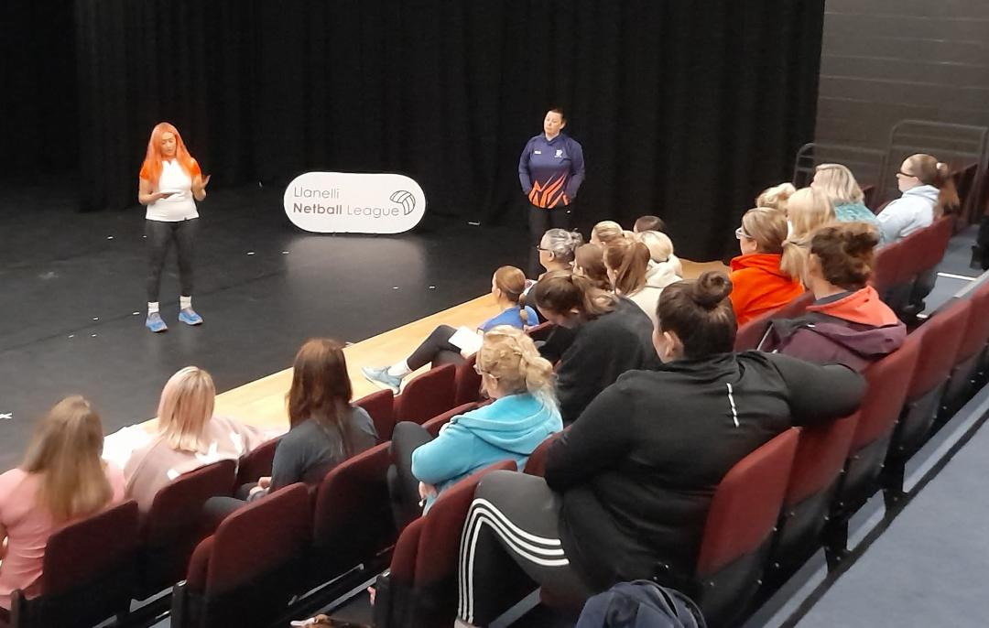 | 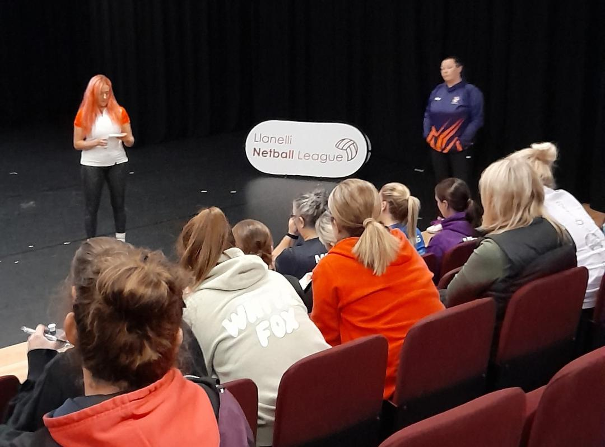
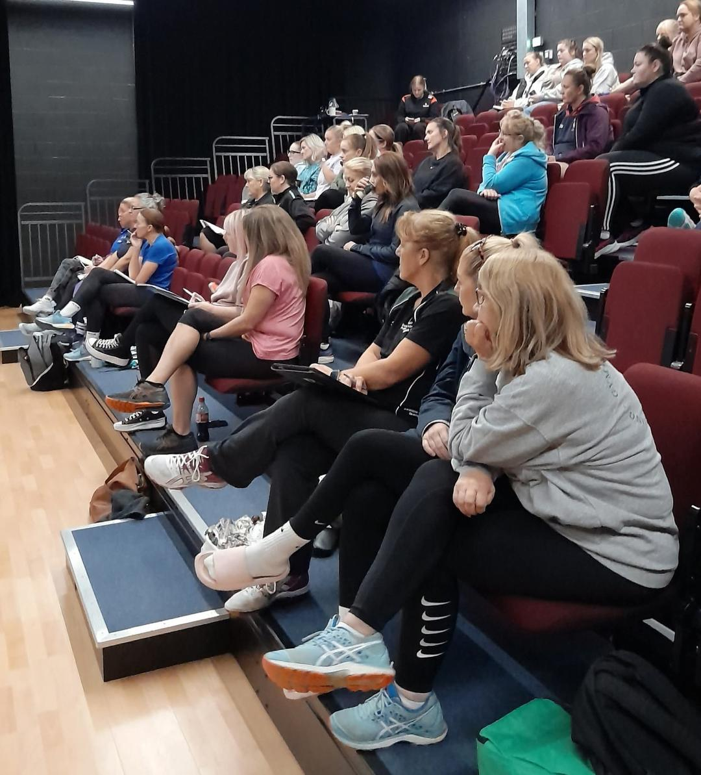 | 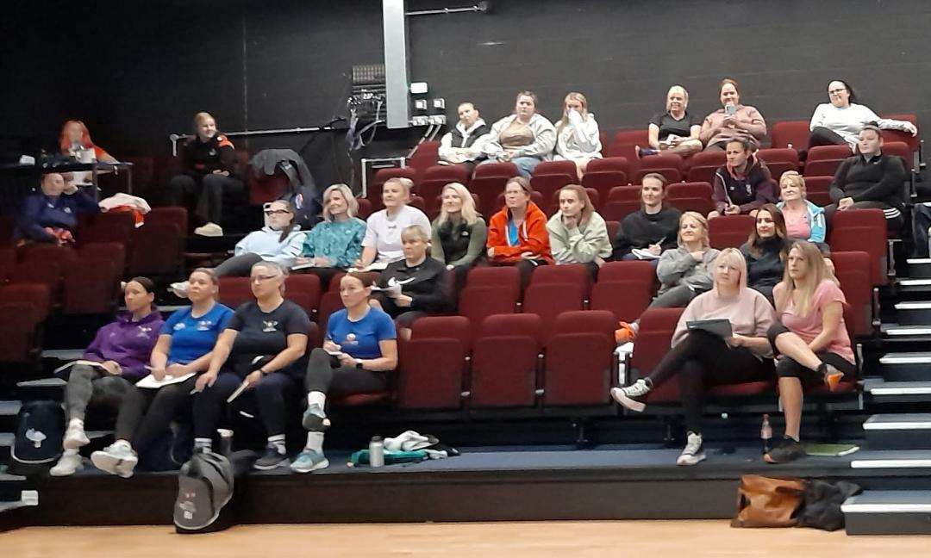
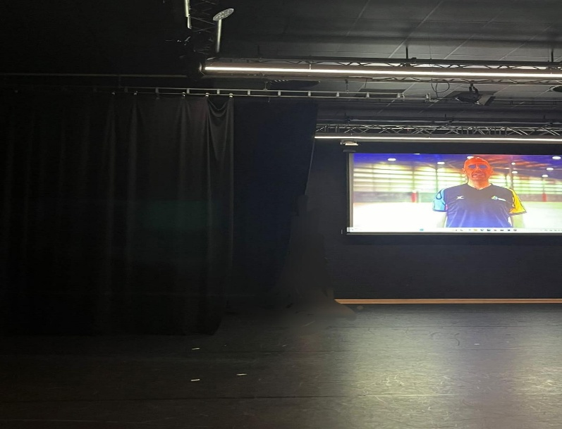 | 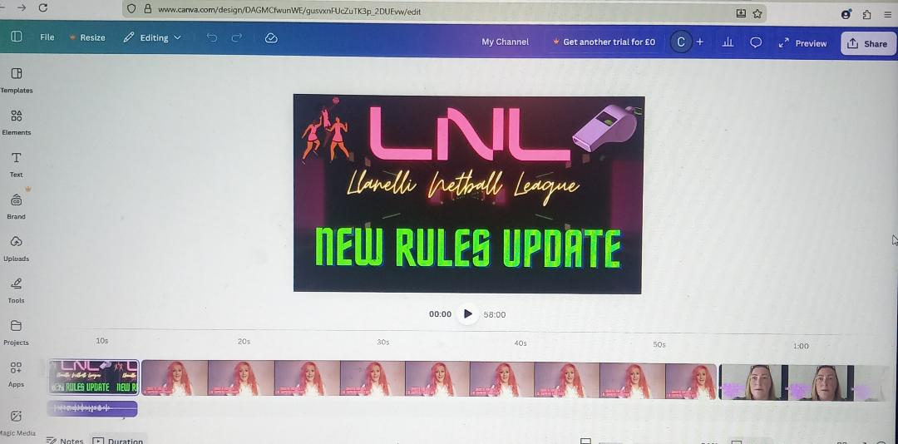

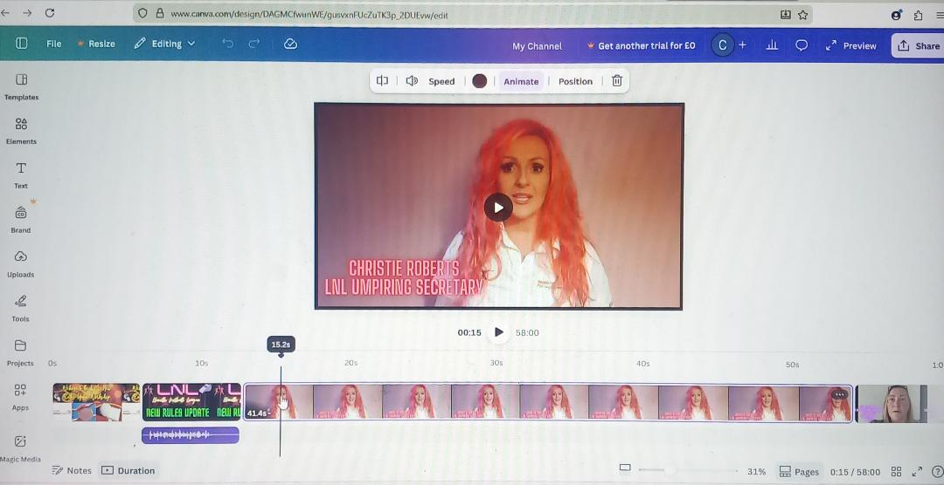 | 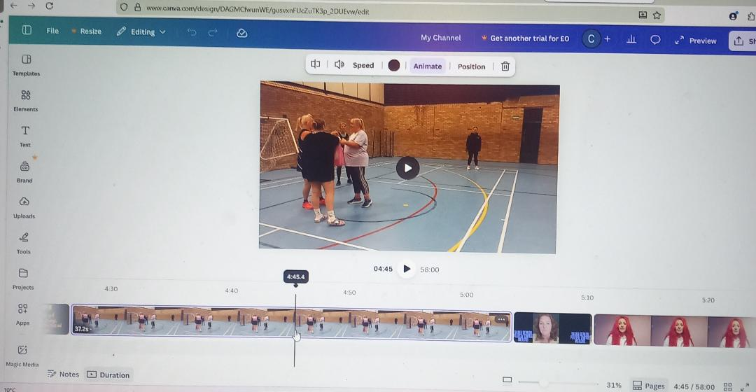
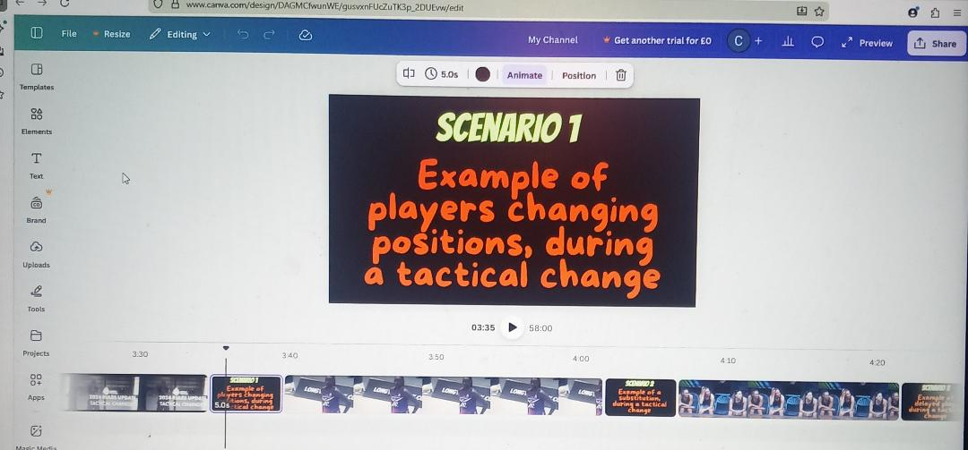 | 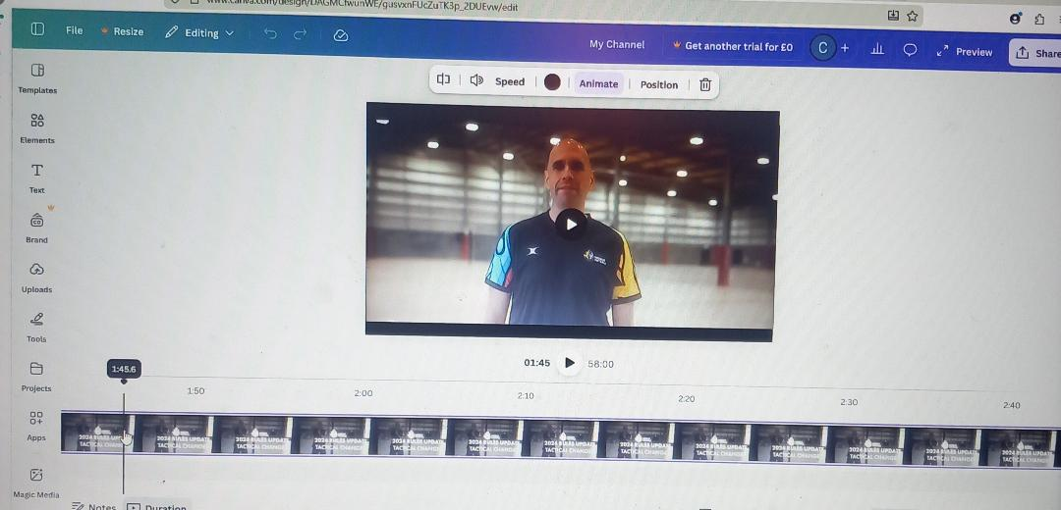
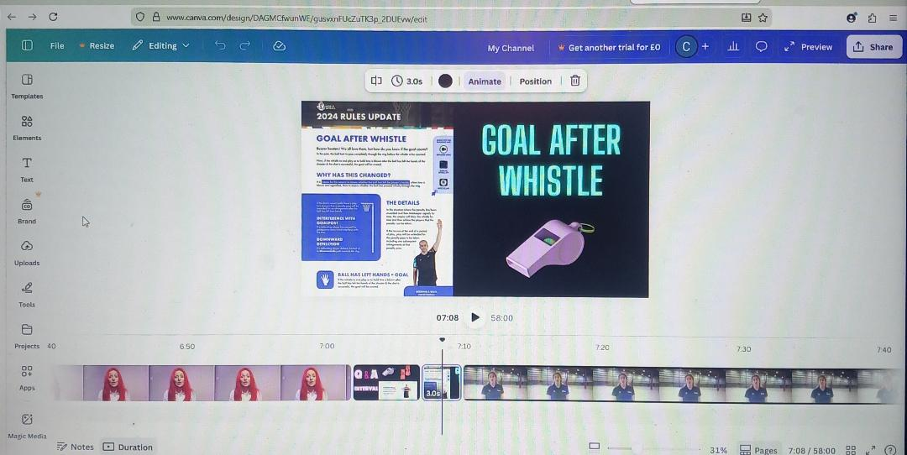 | 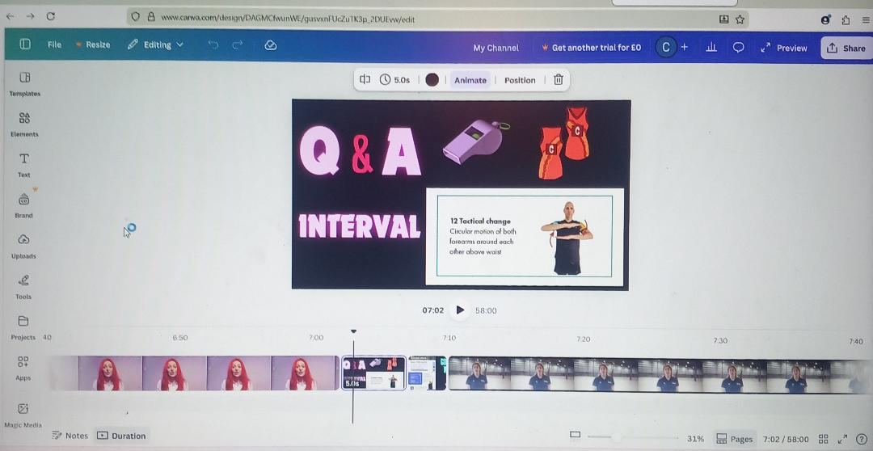



Lesson Plan

Topic: New Rules Seminar |  | Class: Llanelli Netball League Officials (Post-16)
Date: 4th January 2026 | Length of lesson: 120 Minutes |  | Number of students: 43
Resources required: Laptop, Big screen, USB, Paper, Pens, Attendee feedback forms.
Aim of Lesson
To improve confidence and consistency in officiating practice, by developing official’s comprehension, interpretation, and practical implementation of recently introduced netball rules, through film analysis and collaborative debate.
Learning Outcomes – By the end of the session, the Learners should be able to:
- Establish and explain the primary modifications introduced to the recently implemented netball rules, in compliance with the current World Netball regulations.
- Effectively comprehend and apply the modified rules to match play scenarios.
- Demonstrate increased confidence in decision making abilities, by utilising appropriate terminology and officiating protocols, to support rule interpretations.

Previous student knowledge required for the session:
The training is open to qualified umpires as part of their ongoing professional development. To ensure that everyone attending has a basic understanding of the rules and officiating standards, trainee officials may also take part, if they have successfully attended an approved officiating course offered by Wales Netball, within the last two years.
Anticipated difficulties (if applicable):
Video content may not load, due to technical challenges.
(Strategy – Bring a personal laptop, which will have the video content uploaded beforehand).
Experienced umpires may be reluctant to adopt new rule applications, since they could be relying on previously established practices and interpretations.
(Strategy – Circulate the World Netball new rule demonstration videos in advance, to gain initial understanding and to champion the new rules as an evolution of the sport).
Inexperienced officials may become overwhelmed when reviewing video footage, recalling rules, and decision making simultaneously.
(Strategy – Organise mixed experience groups to aid peer mentoring and implement scaffolded questioning for inexperienced umpires).

Professional Standards (where are these being met within the session)

Understand the importance of the Welsh culture and language as a bilingual nation –
In order to promote inclusive practice and conform to national standards, Welsh language components, such as rule terminology and visual aids, were incorporated into the session despite the majority of the instruction being delivered in English.
Value and promote diversity, equality of opportunity and inclusion –
Regardless of origins, expertise, or individual needs, all officials were able to participate meaningfully, as the session was conducted in a way that actively appreciated and encouraged diversity, equality of opportunity, and inclusive practice.
I utilised an inclusive leadership style that supported equality of opportunity and diversity throughout the seminar. Techniques including open discussion, diverse teaching approaches, and structured questioning were utilised, to guarantee equal participation and to establish a respectful learning atmosphere.
Demonstrate dignity, courtesy and respect towards others –
I demonstrated professional conduct and maintained a positive and encouraging learning atmosphere, by continually displaying dignity, and respect for participants throughout the session.
Actively listened to official's contributions, responded thoughtfully to queries, and created an environment where diverse points of view were respected and appreciated.
I interacted politely and fairly with each official, ensuring that all discussions were inclusive, professional, and in line with moral principles.
Demonstrate commitment to learners, their learning, safety and well-being –
By utilising a structured, learner-centred approach that placed an emphasis on engagement, clarity, and opportunities for explanation, I demonstrated my dedication to students and their growth, while ensuring that every official was supported in establishing their comprehension of the recently implemented regulations.
By outlining expectations precisely, facilitating productive conversations, and ensuring the material was presented in a way that was both structured and paced, to avoid cognitive overload and encourage efficient learning.
Enable learners to share responsibility for their own learning and assessment –
By utilising interactive conversation and structured questioning, I enabled students to take shared responsibility for their own education, requiring officials to analyse scenarios, justify their choices, and actively participate in the evaluation of rule application.
I established a collaborative learning environment, where students actively participated in assessing their understanding, during open-ended Q&A sessions and encouraged officials to provide examples from their own officiating experiences.

Lesson Detail:
Stage | Focus | Strategy | Time
Introduction  Development  Plenary/conclusion | Establish the objectives of the seminar, standards, and professional significance, to support official’s comprehension of how crucial it is, to apply recently introduced regulations consistently in a competitive environment.  Develop official's comprehension, interpretation, and application of all 12 recently introduced netball rules, through interactive questioning, scenario-based demonstrations, and a structured educational video.  Encourage reflective officiating practice, strengthen important concepts, and reinforce learning. | Briefly welcome all league officials and deliver a professional introduction.  Explain the rationale for the new rule updates, according to World Netball, and briefly outline the structure of the seminar (video content, acted out scenarios and interactive Q&A sessions), while providing an emphasis on the benefits of the seminar, such as enhanced clarity of the rules, increased consistency in matches, enhanced confidence in officiating and adherence to international and national standards.  The first new rule and the rule context are explained in the video introduction.  The World Netball’s official demonstration video then explains the correct interpretation. This is followed by acted out game scenarios, which demonstrate both the correct and incorrect application of the rule, in real-life match situations.  League questions that were previously submitted are presented on video, followed by my responses to clarify any misunderstandings.  Real-time pause opportunities for interactive Q&A conclude each rule, to enable officials to ask questions and engage in meaningful discussions.  The cycle then continues with the second new rule and so on.  While maintaining student interest, this repetitive teaching cycle, guarantees continual consolidation of knowledge, across all 12 rules.  Provide a summary of the key changes across all 12 newly introduced rules.  Highlight which officiating factors are frequently utilised, such as game management, positioning and timing application of advantage and vision.  Use reflective questioning to promote cognitive development: Which modification to the rules will affect your officiating practice the most? Which rule needs to be reviewed or clarified further?  Educate officials on where they may locate additional official World Netball documentation and guidelines.  Revisit the objectives of the officiating seminar, to ensure they have been met. | 10 minutes  100 minutes  (8 minutes per rule, transition 4 minutes)  10 minutes

Assessment Strategies: when and how are they included within the lesson?
Questioning – Utilise direct questioning, to gauge official's comprehension of each new regulation during the session and pause the video at strategic moments. It is necessary for participants to pinpoint the infringement, cite the relevant regulation, and justify the correct sanction, in addition to receiving prompt, constructive feedback.
Peer Assessment – Officials debate interpretations with peers during interactive Q&A sessions, prior to presenting their answers to the entire group. In addition to comparing decisions, participants offer constructive feedback on one another's terminology and reasoning, to foster critical thinking, establish clarity in rule interpretation, and foster shared accountability for learning through professional discussion.
Demonstration - Participants evaluate acted-out match scenarios, that demonstrate both proper and improper applications of the new regulations, in addition to utilising visual evidence, to assist with making appropriate officiating decisions.
Observation – Throughout the scenario debates and knowledge assessments, observation of participant's verbal responses, levels of interest, and competence in appropriate rule terminology, to evaluate interpretation accuracy, decision-making confidence, and level of comprehension.
Recap – Asking officials to determine which regulation, would have a significant impact on their practice and where further research and development was required during the session, in addition to reviewing key rule amendments, to reinforce understanding, encourage cognitive function, and provide an informal assessment of comprehension, of all 12 rules.
Revisit the seminar objectives also, during the session conclusion, to ensure all objectives have been met and to assess official's understanding.

Informal reflection (to be completed after the session)

Enhancing official’s comprehension and implementation of the recently introduced regulations was the main goal of the session, and I felt that this was accomplished. Participants were able to justify their choices, utilising correct terminology due to the structured use of acted out scenarios, video examples, and interactive questioning. The consistent structure of all 12 regulations appeared to encourage confidence and clarity in rule interpretation. Participant feedback was primarily favourable, with multiple participants describing the seminar, as an extremely informative and beneficial educational experience. Officials particularly appreciated being provided with an opportunity to pause, debate, and clarify all rule interpretations in a constructive setting.

However, feedback from participants also suggested that future seminars could improve learning even further, by including a practical component. By enabling officials to implement rule modifications in real time, a practical session could enhance the transfer of knowledge from theory to practice.

Evaluation and Reflection
The following reflective account, which was inspired by Gibbs' (1988) Reflective Cycle (Trimasse (2025), critically analyses my two-hour netball new rules seminar, in post-16 education. Utilising video content as the primary technological tool, the session's objective was to present and clarify newly introduced netball regulations. My recent literature review, which highlighted how digital tools enhance interaction, innovation, and participation within post-16 education, influenced my decision to implement video content. According to research, video content is more productive and efficient than passive or written resources, since it encourages active engagement, visual modelling, and shared problem-solving. I frequently considered strategy, delivery, and final outcomes, by utilising Gibbs' model, ensuring that each decision was supported by theory and evidence.
The integration of the TPACK model (Shamim et al. 2024) which combined technologies, pedagogical approaches, and subject comprehension, provided me with the assurance that the seminar was theoretically robust prior to delivery. Additionally, I utilised the SAMR methodology (Wijaya, 2021) with an aim to modify learning through interactive video Q&A sessions, group evaluation, and scenario-based debate, by extending beyond substitution toward adaptation and redefining. I did experience a concern, regarding whether the two hours of video content would maintain learner interest, particularly those students who might favour hands-on, practical exercises. I observed considerable amounts of collaboration and engagement during the session. Students collaborated in small groups, to evaluate game scenarios, justify regulation interpretations, and problem solve as a team. I realised, utilising Gibbs' reflective lens (Nind, 2023) that such exchanges strengthened my confidence, in the effectiveness of my technological and pedagogical decisions.
Higher-order thinking was displayed by the participants, who debated the application of rules and applied their comprehension and knowledge critically. According to Kraatz et al: (2020) this is consistent with Lev Vygotsky's social constructivist theory: expertise is developed together, through peer debate, discussion, and guided scaffolding. By providing distinct visual examples, where students could pause, consider, and discuss collectively, video content supported this method.
Feedback from students utilising Gibbs' technique (The University of Edinburgh, 2024) to assess the session was positively overwhelming. The training was "incredibly informative," "interesting," and "interactive," according to officials, who also mentioned that the video content promoted collaborative problem-solving and aided learners to visualise complicated rule modifications. In accordance with Jerome Bruner's guided approach to learning (Kitchener, 2025) the observing tutor also commended the carefully constructed integration of technology, the thoughtfully planned scaffolding, and the proficient use of questioning techniques. Both learners and the observing tutor suggested, however, that including a practical on-court lesson, may have increased experiential comprehension and reinforced theoretical expertise, which according to Neimann and Stelson (2020) aligns with John Dewey’s emphasis on learning through action. Additional constructive feedback emphasised the requirement for clearer wording of learning objectives, and further differentiated questioning, to challenge more experienced students.
Although the lesson was well-structured and supported by appropriate theory, I plan to incorporate purposeful tasks that are in line with the learning objectives in future delivery, to guarantee a more balanced, collaborative, and learner-centred seminar. This will also enable me to evaluate learner comprehension formatively and rectify misunderstandings in real time.
I discovered through evaluation utilising Gibbs' reflective method (Illingworth, 2025) that TPACK and SAMR combined, were fundamental for the effective integration of technology. SAMR directed transformative applicability as opposed to superficial substitution, while TPACK guaranteed consistency between material, pedagogy, and technological devices. Despite video content effectively encouraging participation, collaboration, and higher-order reasoning, I felt that kinaesthetic education and experience reinforcement were hindered, by the lack of real-world application. According to the current investigation, incorporating physical exercise improves recollection and application, contributing to significantly more comprehensive learning, regardless of digital technologies effectively promoting cognition and collaborative achievements, therefore, I would look to include a practical element to future seminars, based on this information and constructive feedback received.
In light of the conclusions reached utilising Gibbs' framework, I recognise that the session successfully encouraged participation, collaboration, critical thinking and innovation. Video content supported debate, visualisation, and scaffolded education more effectively than static technologies. However, there were opportunities to improve structural clarity, hands-on learning, and differentiation, guaranteeing that all student's individual requirements were met, and professional teaching standards were maintained. For example, I could provide more complex analytical tasks, including assessing challenges to implementation of any new rules, or linking the regulations to broader policy and professional standards, to challenge more advanced officials. Activities for extension could involve suggesting enhancements or anticipating unforeseen outcomes in game scenarios.
Additionally, I could encourage a critique of green and red teams, where I could assign one group to support the new rule’s effectiveness and another to challenge them critically. This structured group opposition, may promote evidence-based reasoning and strengthen critical thinking. I could also introduce an unforeseen ethical challenge, and ask groups to reevaluate their choices, and justifying them in regard to their obligations to safeguard others and their professional principles. Furthermore, in an attempt to foster professional judgment, I could present a fast-reaction scenario, in which officials must prioritise duties under time limitations.
In order to strengthen theoretical knowledge and kinaesthetic learning, I will include a structured practical component in my action plans for future seminars, which will be based on Gibbs' reflective cycle. This will enable learners to physically implement rule modifications. I intend to provide concise written explanations of the regulations, incorporate differentiated questioning to assess more experienced students, enhance time management, and reinforce reflection to strengthen learning objectives.
To enhance teamwork and student comprehension, I also intend to incorporate brief peer instruction sessions, where students are encouraged to clarify rules to one another. Gibbs' cycle supports me to consistently improve my practice, by methodically reflecting on each aspect of preparation, delivery, and feedback. This ensures that pedagogical theory, digital innovation, and experiential learning are successfully incorporated into post-16 education.

Reference List

Alivi, J. (2019) ‘A Review of TPACK and SAMR Models: How Should Language Teachers Adopt Technology?’ Journal of English for Academic and Specific Purposes, 2(2), pp. 1-11. Available at: https://doi.org/10.18860/jeasp.v2i2.7944
Alqurashi, E. (2019) Handbook of Research on Fostering Student Engagement with Instructional Technology in Higher Education. USA: IGI Global.
Amini, M. (2025) (ed.) Cutting-Edge Approaches in Translator Education and Pedagogy. USA: IGI Global Scientific Publishing.
Areba, G.N., Gisore, B.N., Njurai, E.W., Awuor, F.M. and Cyprian, R.M. (2025) (eds.) Transformative Leadership and Enhancing Equity in Technological Advancements in Higher Education. USA: IGI Global Scientific Publishing.
Artacho, E.G., Martinez, T.S., Martin, J.L.O., Marin, J.A.M. and Garcia, G.G. (2020) ‘Teacher Training in Lifelong Learning- The Importance of Digital Competence in the Encouragement of Teaching Innovation’, Sustainability, 12(7), p. 2852. Available at: http://dx.doi.org/10.3390/su12072852
Auddya, B., Shan, S., Sudarvizhi, A., Tiwari, S., Shree, P., Rajak, J.P. and Baurasi, V. (2025) (eds.) Multidisciplinary Research in Arts, Science and Commerce. USA: The Hill Publication.
Azar, A.S., Kotamjani, S.S., Milad, M. and Shah, S.S.A. (2025) (eds.) AI-Powered Solutions for Bilingual Proficiency and Communication. USA: IGI Global Scientific Publishing.
Belda-Medina, J. and Calvo-Ferrrer, J.R. (2022) ‘Integrating augmented reality in language learning: pre-service teacher’s digital competence and attitudes through the TPACK framework’, Education and Information Technologies, 27(12), pp. 123-146. Available at: https://doi.org/10.1007/s10639-022-11123-3
Boateng, J.K., Attiogbe, E.J.K. and Kunbour, V.M. (2022) ‘Influence of adult learners’ self-direction on group learning’, Cogent Social Sciences, 8(1), article. 2064592. Available at: https://doi.org/10.1080/23311886.2022.2064592
Caceres-Nakiche, K., Carcausto-Calla, W., Arrieta, S.R.Y. and Tupino, R.M.L. (2024) ‘The SAMR Model in Education Classrooms: Effects on Teaching Practice, Facilities, and Challenges’, Journal of Higher Education Theory and Practice, 24(2), pp. 160-172. Available at: https://doi.org/10.33423/jhetp.v24i2.6816
Cheng, Y. and Wang, Z.Q. (2020) ‘Strengthening the construction of digital course, Promoting the innovation of teaching mode in University’, Journal of Physics: Conference Series, p. 1486. Available at: https://doi:10.1088/17426596/1486/5/052005
Chotithammaporn, W. (2024) ‘Harnessing the SAMR model: Transformative Strategies for Academic Excellence and Student Innovation through Technology’, Faculty of Engineering and Industrial Technology, pp. 1-11. Available at: https://www.researchgate.net/publication/383869587_Harnessing_the_SAMR_Model_Transformative_Strategies_for_Academic_Excellence_and_Student_Innovation_through_Technology (Accessed: 17 December 2025).
Colasante, M. (2022) ‘Not drowning, waving: The role of video in a renewed digital learning world’, Australasian Journal of Educational Technology, 38(4), pp. 176-189. Available: https://doi.org/10.14742/ajet.7951
Cruz, M., Queiros, R. and Mascarenhas, D. (2025) Building teaching competencies for AI-driven and inclusive learning. USA: IGI Global.
Davletova, A., Nazarova, A., Alzhanova, A. and Lazareva, Y. (2025) ‘How does student creativity depend on teaching methods at the institute? Modern information technologies for education and creativity as manifestations of the specifics of the psyche’, Cogent Education, 12(1). Available at: https://doi.org/10.1080/2331186X.2025.2482502
Department for Education (2025) Generative artificial intelligence (AI) in education. Available at: https://www.gov.uk/government/publications/generative-artificial-intelligence-in-education/generative-artificial-intelligence-ai-in-education (Accessed: 26 January 2026).
Department for Education (2026) Meeting digital and technology standards in schools and colleges. Available at: https://www.gov.uk/guidance/meeting-digital-and-technology-standards-in-schools-and-colleges (Accessed: 18 February 2026).
Education Authority (2025) Data Protection Guidance. Available at: https://www.eani.org.uk/schools/policies-and-guidance/data-protection-guidance (Accessed: 26 January 2026).
Eloy, S., Viana, D.L., Morais, F. and Vaz, J.V. (2021) (eds.) Formal methods in architecture. Switzerland: Springer Nature Switzerland.
Fan, L., Deng, K. and Liu, F. (2025) ‘Educational impacts of generative artificial intelligence on learning and performance of engineering students in China’, Sci Rep, 15(1), article 26521. Available at: https://doi.org/10.1038/s41598-025-06930-w
Fernandez-Batanero, J.M., Roman-Gravan, P., Montenegro-Rueda, M., Lopez-Meneses, E. and Fernandez-Cerero, J. (2021) ‘Digital Teaching Competence in Higher Education: A Systematic Review’, Education Sciences, 11(11), p. 689. Available at: https://doi.org/10.3390/educsci11110689
Flanigan, A.E. Kim, J.H.Y. (2022) (eds.) Digital Distractions in the College Classroom. USA: IGI Global.
Garcia-Lopez, I.M. and Trujillo-Linan, L. (2025) ‘Ethical and regulatory challenges of Generative AI in education: a systematic review’, Frontiers in Education, 10, article 1565938. Available at: https://doi.org/10.3389/feduc.2025.1565938
Garg, S. and Singh, S. (2025) ‘The role of Piaget’s stages of development in understanding the cognitive growth of children in the digital age’, International Journal of Research Culture Society, 9(4), pp. 48-55. Available at: https://ijrcs.org/wp-content/uploads/IJRCS202504010-min.pdf (Accessed: 10 January 2026).
Government UK (2024) Meet the requirements of equality and accessibility regulations. Available at: https://www.gov.uk/guidance/meet-the-requirements-of-equality-and-accessibility-regulations (Accessed: 26 January 2026).
Guralnick, D., Auer, M.E. and Poce, A. (2024) (eds.) Creative Approaches to Technology-Enhanced Learning for the Workplace and Higher Education. Switzerland: Springer Nature Switzerland.

Hemminki-Reijonen, U., Hassan, N.M.A.M., Huotilainen, M., Koivisto, J.M. and Cowley, B.U. (2025) ‘Design of generative AI-powered pedagogy for virtual reality environments in higher education’, NPJ Sci Learn, 10(1), p. 31. Available at: https://doi.org/10.1038/s41539-025-00326-1
Illingworth, S. (2025) Bridging Scholarship and practice in higher education: Fostering innovative research and enhancing teaching. Oxfordshire: Routledge.
Information Resources Management Association. (2018) (ed.) Teacher Training and Professional Development: Concepts, Methodologies, Tools, and Applications. USA: IGI Global.
Instefjord, E. and Munthe, E. (2015) ‘Preparing pre-service teachers to integrate technology: an analysis of the emphasis on digital competence in teacher education curricula’, European Journal of Teacher Education, 39(1), pp. 77-93. Available at: https://doi.org/10.1080/02619768.2015.1100602
Isakov, A. (2024) ‘Creativity in a Digital Age: The Ways for Improving Creativity through Digital Tools’, International Multi-Disciplinary Journal of Education, 2(9), pp. 2994-9521. Available at: https://www.researchgate.net/publication/394022858_Creativity_in_a_Digital_Age_The_Ways_for_Improving_Creativity_through_Digital_Tools (Accessed: 13 December 2025).
Keengwe, J. (2017) (ed.) Handbook of Research on Mobile Technology, Constructivism, and Meaningful Learning. USA: IGI Global Scientific Publishing.
Keller, L., Michelsen, G., Dur, M., Bachri, S. and Zint, M. (2023) (eds.) Digitalization, New Media, and Education for Sustainable Development. USA: IGI Global Scientific Publishing.
Khalil, M., Saqr, M., Lopez-Pernas, S. and Hilliger, I. (2024) (eds.) Education reimagined: the impact of advanced technologies on learning. Switzerland: Frontiers.
Khine, M.S. (2015) (ed.) New Directions in Technological Pedagogical Content Knowledge Research: Multiple Perspectives. USA: Information Age Publishing.
Kitchener, M. (2025) A field guide to working in higher education: Transition from professional practice to academia. Oxfordshire: Routledge.
Kraatz, E., Nagpal, M., Lin, T.J., Hsieh, M.Y., Ha, S.Y., Kim, S. and Shin, S. (2020) ‘Teacher scaffolding of social and intellectual collaboration in small groups: A comparative case study’, Frontiers in Psychology, 6(11), article 587058. Available at: https://doi.org/10.3389/fpsyg.2020.587058
Ktoridou, D., Doukanari, E. and Eteokleous, N. (2020) (eds.) Fostering Meaningful Learning Experiences Through Student Engagement. USA: IGI Global Scientific Publishing.
Lasmawan, I.W. and Budiarta, I.W. (2020) ‘Vygotsky’s Zone of Proximal Development and the student’s progress in learning (A Heutagogcal Bibliographical Review)’, Journal of Pendidikan Indonesia, 9(4), p. 545. Available at: https://doi.org/10.23887/jpi-undiksha.v9i4.29915
Liu, X. (2024) (ed.) Innovation and Evolution in Higher Education. London: IntechOpen.
Mayer, R.E. (2009) Multimedia learning. 2nd edn. Cambridge: Cambridge University Press.
NCCE (2024) Protecting student privacy in the digital era: 6 strategies. Available at: https://ncce.org/protecting-student-privacy-in-the-digital-era-6-strategies/ (Accessed: 10 January 2026).
Neimann, T.D. and Stelson, U.M. (2020) Challenges and opportunities in global approaches to education. USA: IGI Global.
New England Institute of Technology (2021) ‘Everything you needed to know about adult learning theory’, New England Institute of Technology, 8 May. Available at: https://www.neit.edu/blog/what-is-adult-learning-theory (Accessed: 28 January 2026).
Nind, M. (2023) Teaching and learning social research methods. Cheltenham: Edward Elgar Publishing Limited.
OECD (2026) OECD Digital Education outlook 2026. Available at: https://www.oecd.org/en/publications/oecd-digital-education-outlook-2026_062a7394-en.html (Accessed: 29 January 2026).
Pernantah, P.S. (2024) ‘TPACK-Approach with SAMR model in social studies learning: A literature review’, Indonesian Journal of Social Science Education, 6(2), pp. 176-184. Available at: http://ejournal.uinfasbengkulu.ac.id/index.php/ijsse (Accessed: 19 December 2025).
Polkowski, Z., Borah, S., Mishra, S.K. and Desai, D. (2023) (eds.) Online Learning Systems: Methods and Applications with Large-Scale Data. Oxfordshire: CRC Press.
Polly, D. and Byker, E. (2020) ‘Considering the Role of Zone of Proximal Development and Constructivism in Supporting Teachers’ TPACK and Effective Use of Technology’, Revista de Educacion a Distancia, 64(20), p. 5, Available at: http://dx.doi.org/10.6018/red.408661
Rana, V., Verhoeven, B. and Sharma, M. (2025) ‘Generative AI in design thinking pedagogy: Enhancing creativity, critical thinking, and ethical reasoning in higher education’, Journal of University Teaching and Learning Practice, 22(4), article 53761. Available at: https://doi.org/10.53761/tjse2f36
Sanders, C, K. and Scanlon, E. (2021) ‘The Digital Divide Is a Human Rights Issue: Advancing Social Inclusion Through Social Work Advocacy’, Journal of Human Rights Social Work, 6(2), pp. 130-143. Available at: https://doi.org/10.1007/s41134-020-00147-9
Shamim, M.R.H., Jeng, A.M. and Raihan, M.A. (2024) ‘University teachers’ perceptions of ICT-based teaching to construct knowledge for effective classroom interaction in the context of TPACK model’, Department of Technical and Vocational Education, e28577, pp. 2405-8440. Available at: https://doi.org/10.1016/j.heliyon.2024.e28577
Shamim, M.R.H., Jeng, A.M. and Raihan, M.A. (2024) ‘University teacher’s perception of ICT-based teaching to construct knowledge for effective classroom interaction in the context of TPACK model’, Heliyon, 10, e28577. Available at: https://doi.org/10.1016/j.heliyon.2024.e28577
Shaner, P. and Donmoyer, R. (2022) ‘Digital education research: Advantages, disadvantages, and video illustrations’, LEARNing Landscapes, 15(1), pp. 337-348. Available at: https://files.eric.ed.gov/fulltext/EJ1347807.pdf (Accessed: 18 December 2025).
Sharif, M.S., Noor, A., Sajjad, M., Abdullah, H.M. and Tahir, M.S. (2025) ‘Digtial transformation in higher education: Evaluating policies for integrating technology in teaching and learning’, Review Journal of Social Psychology and Social Works, 3(3), pp. 543-555. Available at: https://doi.org/10.71145/rjsp.v3i3.339
Shayeb, S. and Daher, W. (2024) ‘The impact of using digital video recordings by prospective teachers on their technological pedagogical content knowledge’, Eur J Investig Health Psychol Educ, 14(9), pp. 2445-2462. Available at: https://doi.org/10.3390/ejihpe14090162
Shelton, C., Hale, A.E. and Archambault, L. (2016) ‘Exploring the use of interactive digital storytelling video: Promoting student engagement and learning in a University Hybrid course’, Tech Trends, 60(5), pp. 1-10. Available at: https://doi.org/10.1007/s11528-016-0082-z?urlappend=%3Futm_source%3Dresearchgate.net%26utm_medium%3Darticle
Shine, I. (2023) UNESCO wants to develop an ‘internet of trust.’ Here are its guidelines. Available at: https://www.weforum.org/stories/2023/11/social-media-governance-guidelines-digital-unesco/ (Accessed: 07 January 2026).
Siyal, S. (2025) (ed.) Impact of Digitalization on Education and Social Sustainability. USA: IGI Global Scientific Publishing.
Smith, B.K. and Borge, M. (2025) (eds.) Learning and collaboration technologies. Switzerland: Springer Nature Switzerland.
Stephens-Himonides, C. and Young, M. (2025) ‘Adding to the knowledge of the TPACK framework: a case study of female identity in performance, education, and technology’, Frontiers in Education, 10:1522739. Available at: https://doi.org/10.3389/feduc.2025.1522739
Tani, M., Manuguerra, M. and Khan, S. (2022) ‘Can videos affect learning outcomes? Evidence from an actual learning environment’, Educ Technol Res Dev, 70(5), pp. 1675-1693. Available at: https://doi.org/10.1007/s11423-022-10147-3
The University of Edinburgh (2024) Reflection Toolkit: Gibb’s Reflective Cycle. Available at: https://reflection.ed.ac.uk/reflectors-toolkit/reflecting-on-experience/gibbs-reflective-cycle (Accessed: 19 February 2026).
Trimasse, N. (2025) ‘The use of reflective reports in higher education’, Reflective Practice, 26(1), pp. 154-171. Available at: https://doi.org/10.1080/14623943.2024.2424520
Tusiime, W.E., Johannesen, M. and Gudmundsdottir, G.B. (2020) ‘Teaching art and design in a digital age: challenges facing Ugandan teacher educators’, Journal of Vocational Education and Training, 74(4), pp. 554-574. Available at: https://doi.org/10.1080/13636820.2020.1786439
UC Berkeley (2025) Cognitive Constructivism. Available at: https://gsi.berkeley.edu/gsi-guide-contents/learning-theory-research/cognitive-constructivism/ (Accessed: 09 December 2025).
UK Parliament (2018) Evidence on Fourth Industrial Revolution. Available at: https://committees.parliament.uk/writtenevidence/92272/pdf/ (Accessed: 09 December 2025).
University Canada West (2025) ‘Advantages and Disadvantages of AI in Education’, Education Career Tips, 21 May. Available at: https://www.ucanwest.ca/blog/education-careers-tips/advantages-and-disadvantages-of-ai-in-education (Accessed: 14 December 2025).
Valencia, R.A.M., Reyes, M.E.N., Puelles, E.Y.L. and Valdiviezo, J.M.S. (2023) ‘Effectiveness associated with learning with video and multimedia content in engineering student’s classroom sessions’, Journal of Higher Education Theory and Practice, 23(19), pp. 271-284. Available at: https://doi.org/10.33423/jhetp.v23i19.6738
Vicherkova, D., Malach, J. and Kolar, M. (2022) ‘School Assessment Culture in a Digital Learning Environment’, 16th International Technology, Education and Development Conference, pp. 10494-10500. Available at: https://doi.org/10.21125/inted.2022.2767
Walters, L.M., Green, M.R., Goldsby, D. and Parker, D. (2018) ‘Digital storytelling as a problem-solving strategy in mathematics teacher education: How making a math-eo engages and excites 21st century students’, International Journal of Technology in Education and Science, 2(1) pp. 1-16. Available at: https://files.eric.ed.gov/fulltext/EJ1227054.pdf (Accessed: 17 December 2025).
Wibowo, S., Wangid, M.N. and Firdaus, F.M. (2025) ‘The relevance of Vygotsky’s constructivism learning theory with the differentiated learning primary schools’, Journal of Education and Learning, 19(1), pp. 431-440. Available at: https://doi.org/10.11591/edulearn.v19i1.21197
Wijaya, T.T., Rizki, L.M., Yunita, W., Salamah, U., Pereira, J., Zhang, C., Li, Xinxin. and Purnama, A. (2021) ‘Technology integration to teaching mathematics in higher education during coronavirus pandemic using SAMR model’, Journal of Physics: Conference Series, 2123, article 012043. Available at: https://iopscience.iop.org/article/10.1088/1742-6596/2123/1/012043/pdf (Accessed: 16 February 2026).
Wu, J., Pan, J., Zhou, Y., Liu, M., Li, Y. and Huang, R. (2025) ‘An active instructional approach based on the SAMR framework: Integrating AIGC into undergraduate freshman learning’, The Internet and Higher Education, 68, 101056. Available at: https://doi.org/10.1016/j.iheduc.2025.101056
Zahroh, L., Sukendro. and Indryani. (2025) ‘Effectiveness of the Implementation of an Innovative Problem-Based Learning (PBL) Model Based on TPACK to Enhance Student Engagement and Learning Outcomes in IPAS’, Jurnal Penelitian Pendidikan IPA, 11(2), pp. 525-530. Available at: https://doi.org/10.29303/jppipa.v11i2.9369
Zhao, S., Abdullah, B., Saad, H.B.A. and Wang, Q. (2024) ‘The effect of using video in teaching to acquire content knowledge in physical education – A systematic review’, International Journal of Academic Research in Business and Social Sciences, 14(10), pp. 1332-1348. Available at: https://doi.org/10.6007/IJARBSS/v14-i10/22954

